Educational Attainment and Wage Differences
  - STOR 664 Project Plan | Male workers in the Mid Atlantic region

Research question and objective
How do wages differ across educational attainment groups after adjusting for age, recorded year, and job class? Our goals are estimation and hypothesis testing, with college graduates versus high school graduates as the primary comparison. This question connects education to earnings while distinguishing adjusted associations from causal effects.

Data and preliminary exploration
We will use ISLR::Wage, a teaching dataset containing 3,000 male-worker records and 11 variables for the Mid-Atlantic region [1]. The recorded years are 2003–2009 and ages range from 18 to 80. All variables have no missing values, so both the figure and planned model use 3,000 records. The response is logwage, verified to equal the natural logarithm of wage. Education has five categories; age, year, and jobclass are adjustment variables. The package credits Steve Miller with assembling the data from CPS supplementary data. We analyze the supplied teaching version, without survey weights or design variables.
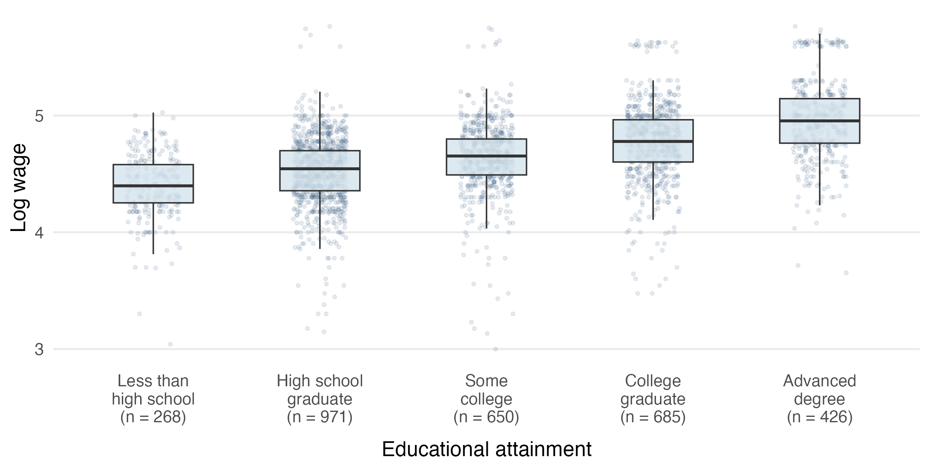
Figure 1. Unadjusted log wage distributions by education. Boxes show the middle 50% of observations; lines show medians. Points show individual records, and labels report group sizes. Source: ISLR::Wage.
Median log wages increase across the five education categories, but the distributions overlap substantially. The high-school group is largest (971 records), and the less-than-high-school group is smallest (268). These descriptive differences motivate regression adjustment; they do not establish causal effects.

Planned model and statistical inference
We will fit an ordinary least squares model with education, year, and job class as categorical predictors. High school graduation is the reference education level. Centering age at 40 gives a = age − 40; a quadratic term allows a curved age association while retaining a model linear in its coefficients. The R specification is:
logwage ~ education + a + I(a^2) + factor(year) + jobclass
The primary estimand is the college-graduate coefficient: the adjusted difference in mean log wages from high school graduates under this additive model. We will report its estimate and 95% confidence interval and test whether it equals zero using a t test. Exponentiating the coefficient and interval endpoints gives a ratio of conditional geometric mean wages, not an arithmetic mean wage difference.
We will also test the joint null hypothesis that the four education coefficients equal zero, using a partial F test comparing models with and without education on the same observations. Rejection indicates that at least one adjusted education contrast is nonzero; it does not establish every pairwise difference. No interactions or data-selected age thresholds are included in the primary model. Additional contrasts, if pursued, will be identified as secondary and accompanied by an explicit multiple-testing strategy.

Model checks and sensitivity analysis
We will examine residuals versus fitted values, a normal Q–Q plot, and influence diagnostics. Preliminary Q–Q plots show tail departures from normality, so Gaussian error assumptions will not be treated as verified. We will assess whether influential records or the age specification materially change the primary contrast. If unequal variance is a concern, heteroskedasticity-robust inference may supplement the course-based t and F analyses. We will also compare estimates with and without job class; these models target different conditional associations.

Main concern and interpretation
Ability, family background, and actual work experience are unmeasured and may relate to both education and wages. Adjusting for a broad job class does not resolve this problem. Conclusions will describe associations within the historical sample setting, not causal returns to education or population estimates for all US workers. Row independence is a working assumption; the teaching data do not provide enough survey-design information to reconstruct design-based uncertainty.

Reference
[1] ISLR package documentation. Mid-Atlantic Wage Data. https://trevorhastie.r-universe.dev/ISLR/doc/manual.html#Wage

Contributions and outside assistance
[Add each member’s name and actual contribution.] ChatGPT assisted with reviewing the design, drafting text and R code, and generating preliminary figures. Data dimensions, missingness, transformations, and figures were checked computationally. [Add the team’s own verification and revise this statement to match actual use.]

