Education Wage Gaps Across Two Job Classes
  - STOR 664 Project Plan Revised November 4 2026

Question and purpose
Does the college-versus-high-school difference in mean log wage vary between Industrial and Information job classes among workers of comparable ages and recorded years? Our goal is estimation and hypothesis testing of this difference between two education gaps. Education and job class are the substantive variables; age and year define the adjusted comparison. A single pooled college wage gap may conceal differences across broad job classes relevant to discussions of education and pay. We study conditional associations, without claiming a causal effect of education.

Data and preliminary evidence
We use ISLR::Wage, a CPS-derived teaching dataset with 3,000 male-worker records from the Mid-Atlantic region, with recorded years 2003–2009 and ages 18–80 [1]. Each observation represents one male-worker record in ISLR::Wage, containing wage and background information; all 11 variables have no missing values. The outcome is logwage, verified to equal log(wage). Education has five categories, and jobclass has only Industrial and Information; specific occupations such as doctor or professor are unavailable. Both education and job class will be categorical. Age is numeric and year is categorical.
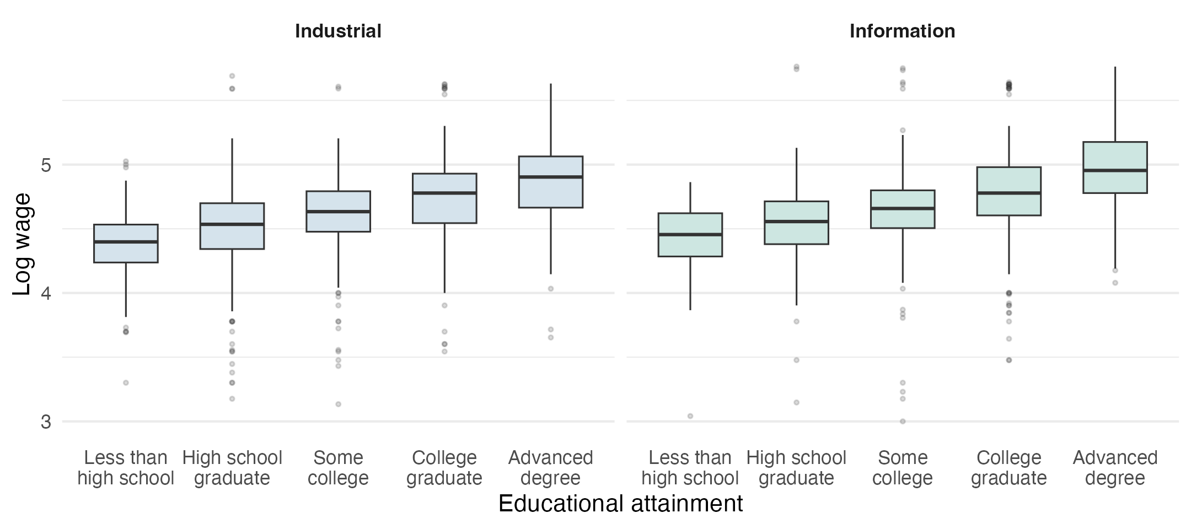
Figure 1. Unadjusted log wage distributions by education within each job class. Boxes show the middle 50% and lines show medians; points beyond the whiskers are displayed. Source: ISLR::Wage.
Medians generally rise with education in both classes, with substantial overlap. Job composition also differs: 34.5% of high-school graduates, 60.0% of college graduates, and 76.1% of advanced-degree workers are in Information jobs. The four focal cells contain 636 and 335 high-school graduates and 274 and 411 college graduates in Industrial and Information, respectively. These observations support comparison of the two gaps but do not determine their adjusted difference.

Model and primary estimand
Let a = age − 40. We will fit OLS with a quadratic age term and year indicators, comparing an additive model with an education-by-job-class interaction model:
M0: logwage ~ education + jobclass + a + I(a^2) + factor(year)
M1: logwage ~ education + jobclass + education:jobclass +
a + I(a^2) + factor(year)
High-school graduates and Industrial jobs are the reference categories. Let b be the college coefficient and d its Information interaction coefficient. The college-versus-high-school gap is b in Industrial and b + d in Information; the primary estimand is their difference, d. We will estimate d with a 95% confidence interval and test H0: d = 0 using a single linear contrast and t test. exp(d) is a ratio of conditional geometric-mean wage ratios, not a dollar difference.
As a secondary question, a partial F test compares M0 and M1 on the same records. H0: all four education-by-job-class interaction coefficients equal zero; H1: at least one is nonzero. This tests whether the education contrasts are the same across classes; it does not establish the primary college-specific contrast. Within-class intervals are descriptive, pointwise intervals, not simultaneous statements.

Variable choices and model checks
Job class is a potential modifier of the education association, rather than a nuisance variable automatically controlled away. Age allows comparison across differing age profiles, and year accounts for recorded-period differences. Current marital status, health, and insurance are not automatically added because their timing and roles relative to education and wages are unclear. Race will be examined only as a separately labelled sensitivity adjustment; region is constant and wage duplicates the transformed outcome.
We will examine residual, Q–Q, and influence plots. Initial plots show tail departures and changing residual spread; HC3 robust sensitivity inference will supplement conventional t/F inference [2], addressing unequal variance only. We will assess alternative age curves, additional race adjustment, and restriction to ages 25–64. Flagged observations remain in the primary analysis; diagnostic exclusions are stress tests, not cleaning rules.

Concern and scope
Unmeasured ability, family background, and work experience may relate to education, job class, and wages. Conditioning on job class changes the comparison and does not identify total or direct causal effects. Broad job categories, missing survey-design information, and the historical male-worker sample limit interpretation. This revised plan follows exploratory review of several model families; it is not a preregistered confirmatory analysis.

References
[1] ISLR. Mid-Atlantic Wage Data. https://trevorhastie.r-universe.dev/ISLR/doc/manual.html#Wage
[2] sandwich. vcovHC documentation. https://sandwich.r-forge.r-project.org/reference/vcovHC.html

Contributions and assistance
Bangyu Yan identified and confirmed the choice of dataset and proposed the initial ideas and analysis plan. Jialiang Yao drew on previous course projects to develop the approach, drafted the plan, and reviewed comments and revisions across its sections. ChatGPT assisted with design review, exploratory code, figures, and drafting, particularly with refining wording and expressing our ideas clearly. Checks included running the code and comparing data summaries and figures with the written interpretations.

