This is a hospital management system. This system is used by several actors (consumers) and they can do below tasks. To do These tasks, these consumers use services from some producers. See below table.

|  |  |  |
| --- | --- | --- |
| Actor (consumer) | Tasks, which actors can do | Producer, which service is taken from |
| Patient Consumer | Login | Patient Producer |
|  | See available doctors | Doctor Producer |
|  | Channel doctors | Doctor channel Producer |
|  | Request Lab tests | Lab Producer |
|  | See Lab results (unpaid labs tests) | Bill Producer |
|  | Collect medicine from pharmacy (unpaid medicines) | Bill Producer |
|  | Pay bills | Bill Producer |
| Doctor Consumer | Login | Doctor Producer |
|  | See patient channelings | Doctor channel Producer |
|  | See patient Records | Patient Producer |
|  | Create Patient Records | Patient Producer |
|  | Write prescriptions for patients | Pharmacy Producer |
| Lab Consumer | See lab requests from patients | Lab Producer |
|  | Create lab requests | Lab Producer |
|  | Login | Lab Producer |
| Pharmacy Consumer | See prescriptions | Pharmacy Producer |
|  | Ready medicines | Pharmacy Producer |
|  | Login | Lab Producer |
| Admin Consumer | Create users | User Store Producer |
|  | See users | User Store Producer |

**Producers and Consumers as a graph**

Purple color bundles – Producer bundles

Orange color bundles – Consumer bundles

NOTE: In this graph arrow tail pointed bundle uses (consumes), arrow head pointed bundle’s services. In another words, Arrow tail is pointed to consumers, and arrow head pointed to producers.

As you can see Some produces use services from other producers. So some producers act as both producers and consumers.

Eg. Patient producer (no. 4) act as a consumer when it consumes services from User store producer (no. 2). But Patient producer (no. 4) act as a producer when patient consumer (no. 10) consumes services from patient producer.

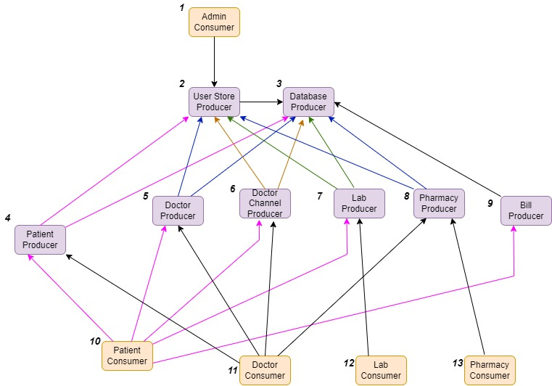

**Manifest Implementations**

1. Admin Consumer Text

   Description automatically generated
2. User Store Producer

1. Database Producer

(Here jbdc driver is imported in order to establish the connection with mySql database.)

1. Patient Producer

1. Doctor Producer

1. Doctor Channel Producer

1. Lab Producer

1. Pharmacy Producer

1. Bill Producer

1. Patient Consumer

1. Doctor Consumer

1. Lab Consumer

1. Pharmacy Consumer

**Screenshots**

**1.1 Admin consumer – Adding a user.**

**1.2 Admin consumer – Listing users**

**2.1 Patient consumer – channeling doctor**

**2.2 Patient consumer – creating lab test requests**

**2.3 Patient consumer – get lab reports and pay them**

**2.4 Patient consumer – get medicines and pay them**

**3.1 Doctor consumer – See channelings**

**3.2 Doctor consumer – create patient records**

**3.3 Doctor consumer – see patient records**

**3.4 Doctor consumer – write prescriptions**

**3.5 Doctor consumer – setting availability**

**4.1 Pharmacy consumer – see prescriptions**

**4.2 Pharamcy consumer – ready medicine**

**5.1 Lab Consumer – see lab requests**

**5.2 Lab Consumer – creating lab results**

