LABORATORY ACTIVITY #2 – View and Text Components
Name: Lourence S. Lariosa
Section: BSCS 3-4
Instructor: Hernz N. Ramones
I. Title
Laboratory Activity #2: View and Text Components in React Native
II. Objectives
• Familiarize themselves with the React Native environment.
• Learn the JavaScript syntax.
• Use View and Text components.
• Gain knowledge of the basics of React Native.
III. Introduction
React Native is a popular JavaScript-based framework used to develop mobile applications for Android and iOS. It uses components such as View and Text to display content on the screen.
• View – works like a container for UI elements
• Text – used to display readable text on the UI
This activity focuses on building a simple layout using these components inside App.js, while also applying basic styling.
IV. Materials
• Computer
• Internet Connection
• Snack Expo Online Editor: https://snack.expo.dev/
V. Procedure
• Open the Snack Expo link provided below.
• Navigate to App.js to work with the code.
• Create a simple profile UI using View and Text components.
• Apply styling using StyleSheet.
• Test, preview, and debug the layout using Snack’s emulator.
• Save and publish project.
VI. Code Implementation
Snack Project Link:
https://snack.expo.dev/@yesuu/lariosa_lab2_output1
VII. Output
Screenshot of the application output from Snack :
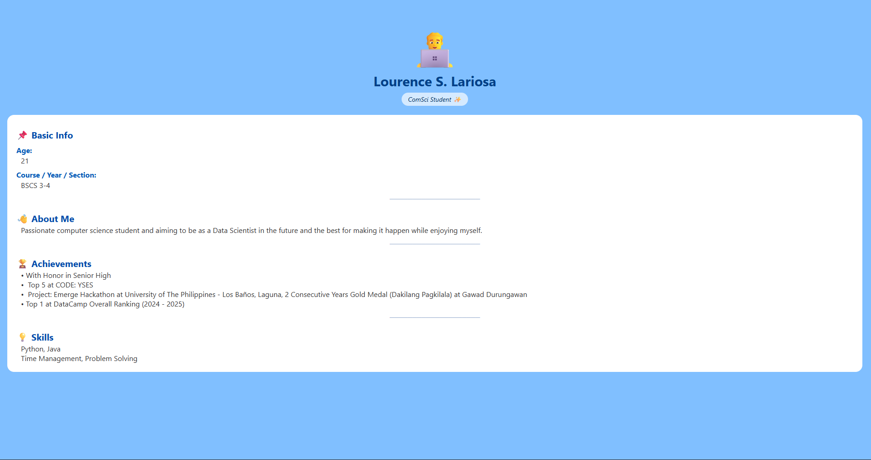
VIII. Results and Discussion
During this activity, the student successfully displayed different text data inside a View container. Styling was applied properly to adjust background color, alignment, and fonts. The code executed smoothly inside Snack Expo with instant preview results.
IX. Conclusion
In this laboratory activity, the student learned the importance of View and Text components as basic building blocks of React Native mobile interfaces. Through Snack Expo, the student was able to practice JavaScript syntax and apply styling to improve the layout’s appearance. This activity strengthened knowledge about the React Native development environment and served as a stepping stone for creating more interactive and complex mobile applications.

