Restaurant Data Analysis – Final Report
Cognifyz Technologies Internship
Name: Yashas M
Tools Used: SQL, Power BI

1. Business Objective
The objective of this project is to analyze restaurant data in order to understand customer behavior, pricing trends, cuisine popularity, service availability (online delivery and table booking), and overall restaurant performance. The goal is to derive meaningful insights that can help restaurants improve customer experience and optimize business strategies.

2. Dataset Summary
The dataset contains approximately 9,500 restaurant records with 21 columns, covering restaurant details, location information, pricing, ratings, and customer engagement metrics.
The dataset includes:
- Restaurant identification details (Restaurant ID, Name, City, Address)
- Location information (Latitude, Longitude)
- Business attributes (Cuisines, Average Cost for Two, Price Range)
- Service features (Online Delivery, Table Booking)
- Customer feedback (Aggregate Rating, Rating Category, Votes)
Before analysis, the dataset was reviewed for missing values and inconsistencies. All critical columns were found to be complete and suitable for analysis.

3. Data Cleaning and Preparation (SQL & Power Query)
SQL was used as the primary tool for data validation and preparation.
The following steps were performed:
- Imported the raw CSV file into SQL
- Inspected table structure and column data types
- Checked every column for NULL values, empty strings, and encoding issues
- Verified numeric columns such as Votes, Aggregate Rating, and Price Range
- Standardized column names for easier querying
- Confirmed categorical values for Online Delivery and Table Booking
After SQL validation, the dataset was loaded into Power BI, where Power Query was used to:
- Verify data types
- Ensure consistency across categorical fields
- Confirm that numeric columns were correctly formatted
Outcome
- No missing or duplicate records were found
- All columns were clean and consistent
- Dataset was fully ready for visualization and analysis

4. SQL Analysis Performed
The following analytical queries were executed using SQL:
- Identified top cuisines based on restaurant count
- Determined cities with the highest number of restaurants
- Calculated restaurant distribution across price ranges
- Compared average ratings for restaurants with and without online delivery
- Identified popular restaurant chains
- Analyzed customer engagement using votes
- Studied the relationship between price range and table booking availability
These queries provided the foundation for dashboard creation in Power BI.

5. Power BI Dashboard Summary
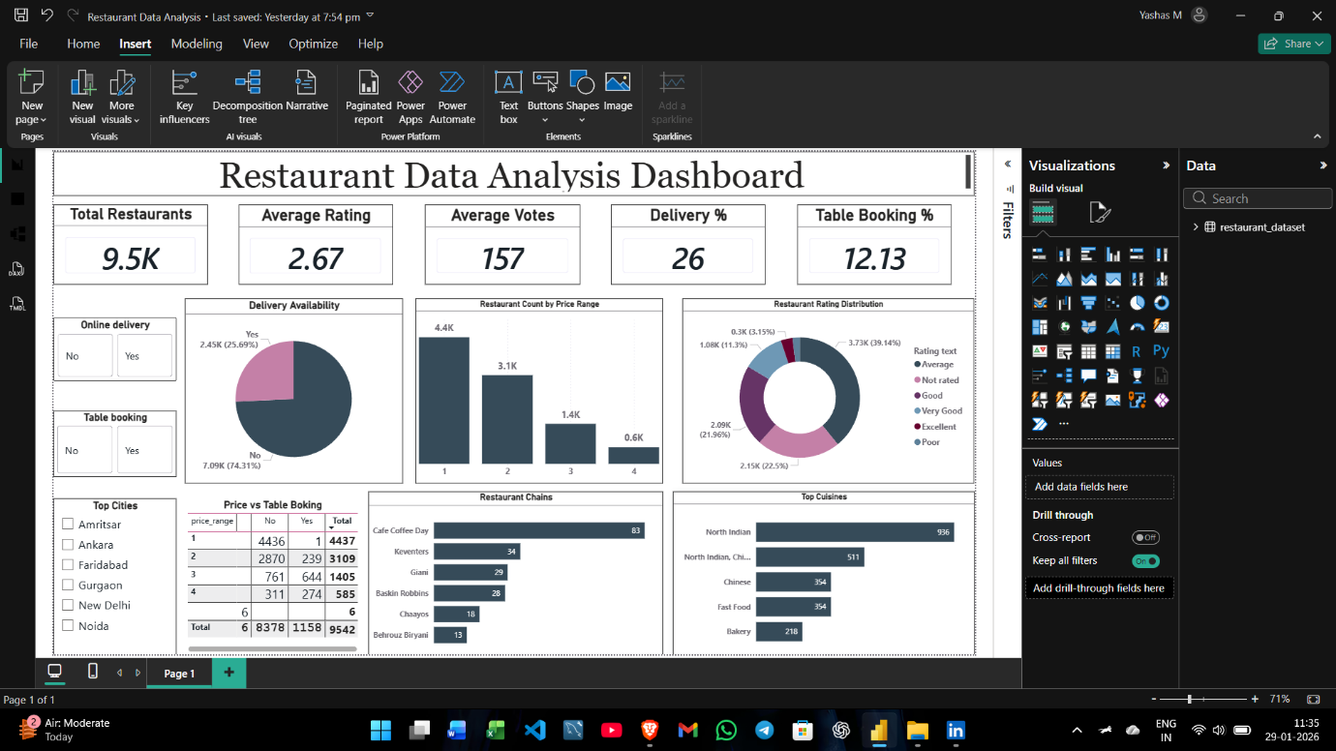
An interactive Power BI dashboard was created to visualize key findings.
KPIs Created:
- Total Restaurants
- Average Rating
- Average Votes
- Online Delivery Percentage
- Table Booking Percentage
Visuals Included:
- Delivery Availability (Donut Chart)
- Restaurant Count by Price Range (Column Chart)
- Rating Distribution (Donut Chart)
- Top Restaurant Chains (Bar Chart)
- Top Cuisines (Bar Chart)
- Price Range vs Table Booking (Matrix)
Interactive slicers were added for:
- City
- Online Delivery
- Table Booking
These allow users to dynamically filter and explore the data.

6. Key Insights
- Most restaurants fall into Price Range 1, showing a highly budget-focused market.
- Only about 26% of restaurants offer online delivery, but these restaurants have noticeably higher average ratings.
- North Indian cuisine is the most dominant cuisine category.
- Cafe Coffee Day is the most common restaurant chain.
- Customer ratings are mainly concentrated in the Average and Good categories.
- Higher-priced restaurants are more likely to provide table booking services.
- Customer votes show moderate engagement across the dataset, indicating reasonable customer participation.

7. Business Recommendations
Based on the analysis, the following actions are recommended:
- Increase adoption of online delivery services to improve customer reach and ratings.
- Budget restaurants should maintain affordability while improving service quality.
- Premium restaurants should focus on strengthening dine-in experiences through table booking.
- Restaurants should diversify cuisine offerings to reduce dependency on North Indian cuisine.
- Chains can use customer feedback to improve consistency across branches.
- Cities with high restaurant density should be prioritized for targeted marketing campaigns.

8. Conclusion
This project provided hands-on experience with real-world data analysis using SQL and Power BI. The workflow included data validation, dashboard development, and business insight generation.
The final dashboard effectively highlights restaurant trends, customer behavior, and service patterns. This internship strengthened practical skills in data preparation, visualization, and analytical thinking, providing a strong foundation for future data analyst roles.

