Customer Shopping Behaviour – Analysis Report

1.Business Objective
Analyze customer shopping patterns to identify high-performing categories, key customer segments, preferred payment and shipping methods, and seasonal revenue trends.
2. Dataset Summary
- Rows: 3,900, Columns: 18
- Data Type: Customer shopping transactions
Key Features:
- Customer Demographics:
Age, Gender, Location, Subscription Status
- Purchase Details:
Item Purchased, Category, Purchase Amount, Season, Size, Color
- Shopping Behavior:
Discount Applied, Promo Code Used, Previous Purchases, Shipping Type, Review Rating
- Data Quality:
Dataset required minor cleaning (standardizing text fields, fixing column names, ensuring numeric types). No major missing-value issues.

3. Data Cleaning (Excel / SQL )
The raw dataset contained inconsistent column names (spaces, special characters, mixed casing).
To prepare the data for analysis, all column names were standardized using SQL.
Steps Performed:
- Created a new database and loaded the raw table.
- Inspected the structure using DESCRIBE.
- Renamed all inconsistent columns using ALTER TABLE … RENAME COLUMN.
- Converted spaced column names to snake_case for easier querying
- Standardized column names
- Cleaned category, gender, season, and shipping values
- Converted Age, purchase_amt, previous_purchases to numeric
- Checked for missing or inconsistent fields
- Ensured the dataset was analysis-ready

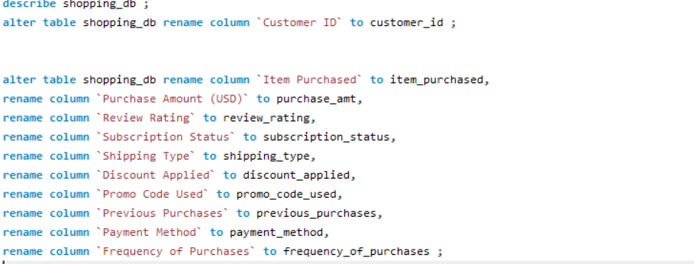
Outcome:
- All columns cleaned and standardized.
- No duplicate rows detected.
- Dataset ready for SQL analysis and Power BI dashboard creation.

4. SQL Analysis Performed
Category Revenue : Find which product category generates the highest total revenue
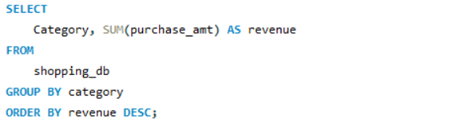

Payment Method Usage : Identify which gender and age group combination spends the most.
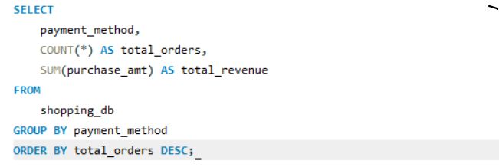

Discount Impact : Check whether customers spend more when discounts are applied.
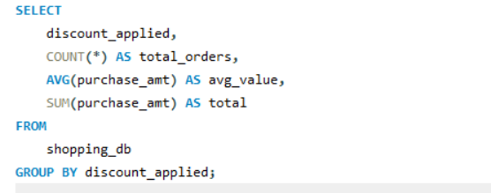

Subscription Spending Query : Compare spending between subscribed and unsubscribed customers.
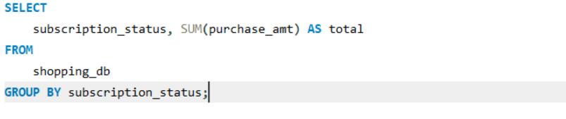

Seasonal Revenue : Find which season generates the highest sales.
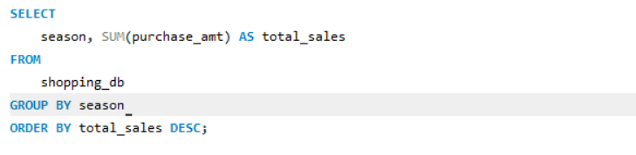

Location Revenue : Determine which location is the most profitable.
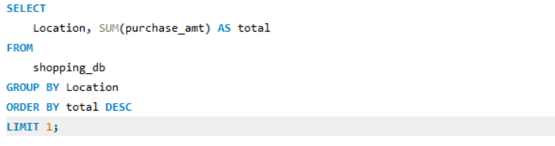

Shipping Type Usage : Find which shipping type customers choose most often.
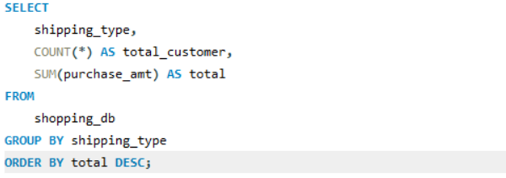

Frequency of Purchases Query: Identify which purchase frequency contributes the most revenue.
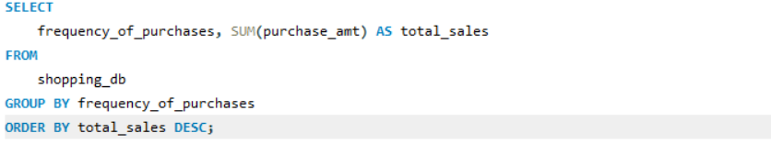

5. Power BI Dashboard Summary

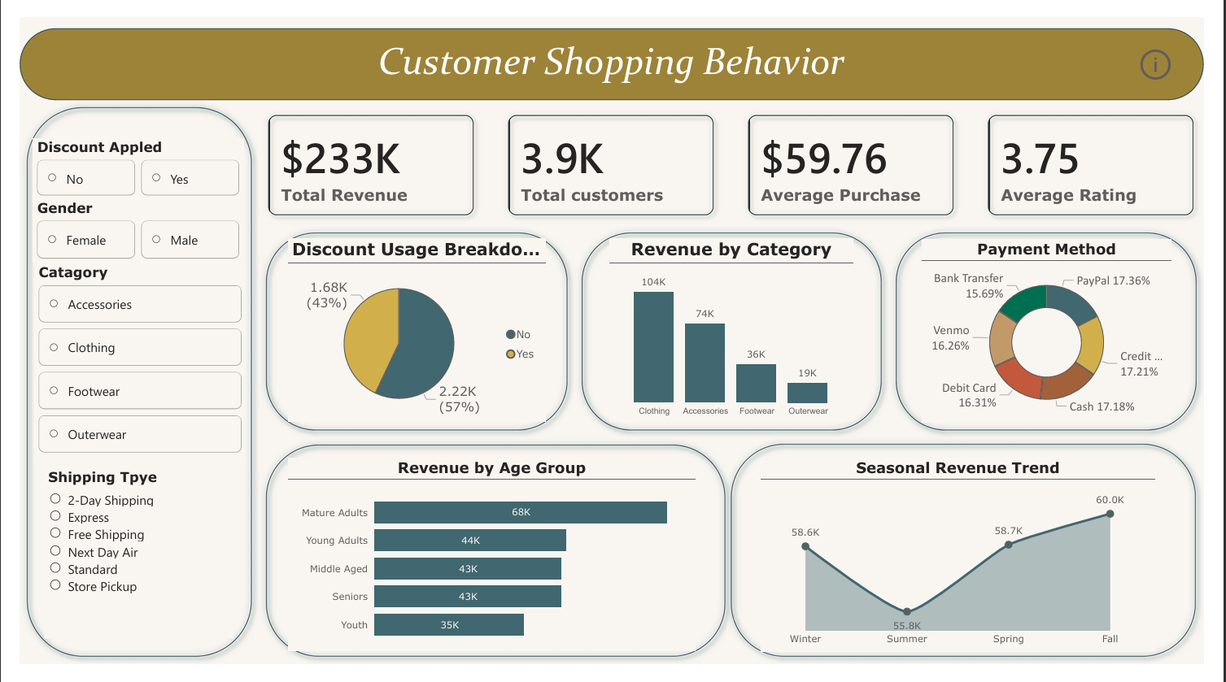

- KPIs: Total Revenue, Total Customers, Avg Purchase, Avg Rating
- Visuals:
  - Revenue by Category
  - Revenue by Age Group
  - Seasonal Revenue Trend
  - Payment Method Share
  - Discount Usage
  - Shipping Type Usage
- Added Age Group column (DAX)
- Added Season Order column (DAX) for correct sorting
- Slicers for Category, Gender, Season, Location, Discount, Shipping Type

6. Key Insights
- Clothing is the top revenue category with the highest total sales.
- Mature Adults (46–60) are the biggest spenders.
- Unsubscribed customers spend more than subscribed customers.
- PayPal is the most preferred payment method.
- Discounts do not increase spending — average purchase with/without discount is similar.
- Fall is the highest revenue season.
- Customers with 0–10 previous purchases spend the most currently.
- Montana is the most profitable location.
- Free Shipping is the most preferred shipping type.

7. Business Recommendations
- Increase inventory & promotions for Clothing.
- Target marketing to ages 46–60 (highest ROI).
- Improve the subscription program — it's currently underperforming.
- Offer PayPal-based incentives to increase conversion.
- Reduce unnecessary discounts — they don’t increase revenue.
- Focus marketing spend during Fall (peak season).
- Convert new customers aggressively — they bring strong value.
- Expand operations in Montana due to strong performance.
- Keep Free Shipping but apply a minimum order threshold.

