Sleep & Lifestyle Health Analytics – Analysis Report

1. Business Objective
The goal of this project is to understand how lifestyle factors—such as sleep duration, stress level, daily steps, BMI, and sleep disorders—affect overall health.
The analysis helps identify:
- Which groups have higher stress
- Which groups sleep more or less
- How sleep disorders affect heart rate and daily activity
- Patterns across BMI and age groups

2. Dataset Summary
- Rows: 374
- Columns: 13+ engineered columns (age_group, stress_category, bp_category etc.)
- Data Type: Health and lifestyle data for individuals
Key Features
- Demographics: Age, Gender, Occupation
- Health Metrics: Sleep Duration, Stress Level, Heart Rate, BMI Category, Blood Pressure
- Lifestyle Metrics: Daily Steps, Physical Activity Level
- Medical Conditions: Sleep Disorder
Data Quality
The raw dataset required cleaning:
- Columns had spaces and inconsistent formats
- Blood pressure was in a single field → separated into systolic/diastolic
- Stress level & age converted into categories
- Sleep disorder, BMI, and occupation values standardized
Dataset was cleaned using Excel + SQL and prepared for analysis.

3. Data Cleaning (Excel / SQL)
Steps Performed
- Loaded data into SQL database (health_care)
- Renamed all columns to snake_case using SQL
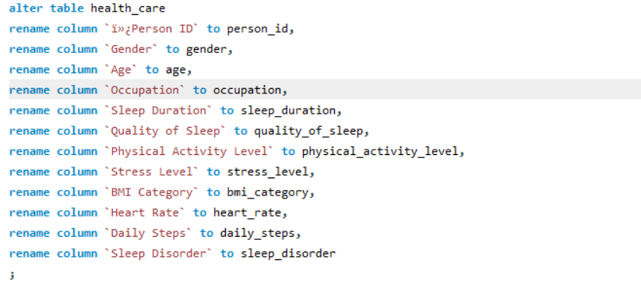
- Split blood pressure into systolic and diastolic
- Created calculated columns in Excel:
  - age_group (Adult, Middle Age, Older Adult)

  - stress_category (Low, Moderate, High)

  - bp_category (Normal, Prehypertension, Hypertension)

- Checked for missing or invalid values
- Confirmed dataset was ready for analysis
Outcome
- Clean, standardized dataset
- Easy-to-query SQL table
- Dataset ready for Power BI dashboard

4. SQL Analysis Performed
Total Records

Average Sleep Duration by Sleep Disorder
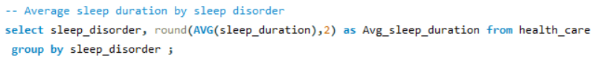

Average Stress Level by Sleep Disorder 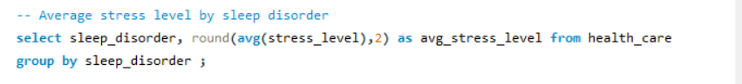

Average Sleep Duration by Age Group
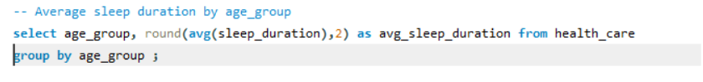

Stress Category Count by Age Group
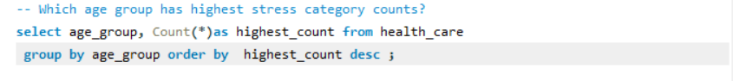
Average Heart Rate by Sleep Disorder
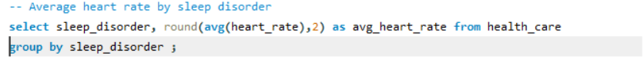

Which BP Category Has Most People

Average Daily Steps by Sleep Disorder

Average Sleep by Occupation
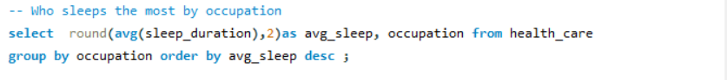

5. Power BI Dashboard Summary
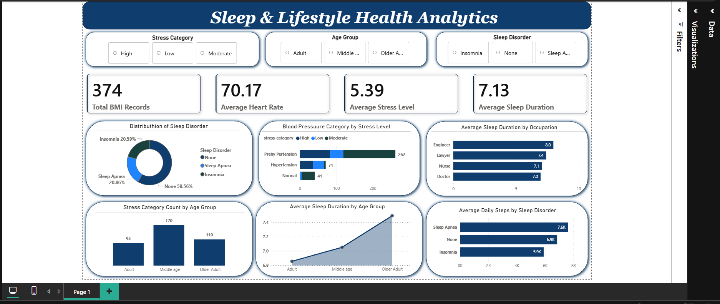

KPIs
- Total BMI Records
- Average Heart Rate
- Average Stress Level
- Average Sleep Duration
Visuals Used
- Sleep Disorder Distribution (Donut Chart)
- Blood Pressure Category by Stress Level (Clustered Bar)
- Total Sleep Duration by BMI Category (Column Chart)
- Average Sleep Duration by Age Group (Bar Chart)
- Stress Category Count by Age Group (Column Chart)
- Average Daily Steps by Sleep Disorder (Bar Chart)
- Heart Rate vs Sleep Duration by Sleep Disorder (Scatter Chart)
Slicers Added
- Stress Category
- Age Group
- Sleep Disorder

6. Key Insights
- Most people have no sleep disorder, followed by insomnia and sleep apnea.
- Middle-aged adults show the highest stress levels.
- Older adults sleep the most, while adults sleep the least.
- People with no sleep disorder sleep longer on average.
- Prehypertension is the most common blood pressure category.
- Heart rate tends to be lower when people sleep more.
- People with sleep apnea take the highest average daily steps.
- Engineers sleep the most among occupations.

7. Recommendations
- Encourage better stress management for middle-aged groups.
- Provide sleep improvement programs for insomnia and sleep apnea users.
- Promote healthy lifestyle habits (steps, activity) to reduce prehypertension risk.
- Focus on building awareness around sleep duration and heart health.
- Use the scatter chart insights to promote consistent sleep schedules.

