BBA · BUSINESS OPERATIONS EXCELLENCE
Final Project Report · Working Group 3
From 10 to 12 Excavators a Day
Applying Operations Excellence to the machine shop at Volvo Construction Equipment India, Peenya, Bengaluru
Item | Details
Company visited | Volvo CE India Pvt. Ltd., Peenya Industrial Area, Bengaluru
Date of industrial visit | 8 September 2026
Report and presentation due | 31 October 2026 (presentation on 3–4 November 2026)
Working group | Group 3: Operations Excellence in machine-shop operations
Group members (name, roll no.) | 1.  2.  3.  4.  5.

Contents
1. Introduction
2. Volvo CE worldwide: operations and products (Point 1)
3. Product segments by application and tonnage (Point 2)
4. Volvo CE India: operations and product offering (Point 3)
5. Group 3: Operations Excellence in the machine shop (Point 4)
5.1 Problem statement · 5.2 Assumptions · 5.3 Takt time · 5.4 Current state · 5.5 OEE analysis
5.6 Framework (VPS, Lean, TPM, TOC, Six Sigma) · 5.7 The six levers · 5.8 Line balancing
5.9 Results · 5.10 Protecting quality · 5.11 Roadmap · 5.12 Cost–benefit · 5.13 Risks
6. Conclusion
References
Appendix: Glossary of terms

Note on data: company facts come from published Volvo CE and Volvo Group sources and Indian trade press (see References). The machine-shop cycle times, losses and costs in Section 5 are assumptions made for the analysis, as the project brief allows, and are marked as such. Replace them with your own observations if your group recorded different figures.

1. Introduction
As part of the Business Operations Excellence curriculum, our BBA class visited the manufacturing plant of Volvo Construction Equipment India (Volvo CE India) in the Peenya Industrial Area, Bengaluru, on 8 September 2026. The visit opened with a presentation on Volvo CE India's operations, products and brands, followed by a walk through the shop floor: fabrication, machining, painting, the excavator assembly line with its digital takt-time board, and final inspection.
This report covers the four points set out in the project brief:
- Volvo CE's worldwide operations and the products the company offers;
- its product segments by application and tonnage;
- Volvo CE India's operations and product offering by application and tonnage; and
- the problem allocated to Working Group 3: how Operations Excellence can raise the production efficiency of the machine shop by 20%, from 10 to 12 excavators per 8-hour shift, without affecting quality.
Section 5, the core of the report, works through the problem the way a production manager at Peenya would. It starts with takt time and the current state, identifies the bottleneck, measures its losses with Overall Equipment Effectiveness (OEE), and then applies six Operations Excellence levers built on the Volvo Production System. It quantifies the result and ends with a 12-week implementation roadmap, cost–benefit analysis and risks.

2. Volvo CE worldwide: operations and products

2.1 Company profile and history
Volvo Construction Equipment (Volvo CE) is the construction-machinery business area of the Swedish Volvo Group (AB Volvo), whose 2025 net sales were about SEK 479 billion with roughly 99,000 employees. Volvo CE designs, manufactures, sells and services machines for construction, infrastructure, quarrying, mining, road building, waste handling and material handling.
Its roots go back to 1832, when Johan Theofron Munktell started a mechanical workshop in Eskilstuna, Sweden, which makes Volvo CE one of the oldest industrial companies still building construction equipment. Munktells merged with Bolinders in 1932 to form AB Bolinder-Munktell (BM), which Volvo acquired in 1950. The company became Volvo BM in 1973 and was renamed Volvo Construction Equipment in 1995. Volvo CE entered India in 1997 and later added the Bengaluru (Peenya) site, which dates back to 1978.

2.2 Scale and financial performance
Indicator | 2025 | 2024
Net sales | SEK 81.6 bn | SEK 88.3 bn
Adjusted operating income | SEK 10.9 bn | SEK 12.7 bn
Adjusted operating margin | 13.3% | 14.4%
Employees | ~13,000 (85 nationalities, Jan 2026) | n/a
Markets served | ~180, through the dealer network | n/a
Table 1. Volvo CE key figures (Volvo CE Q4 and full-year 2025 report; volvoce.com company information).
Region | Net sales 2025 (SEK bn) | Net sales 2024 (SEK bn) | Share of 2025
Europe | 27.8 | 26.9 | 34%
Asia | 23.4 | 26.6 | 29%
North America | 19.3 | 23.5 | 24%
Rest of world (South America, Africa, Oceania) | 11.2 | 11.3 | 14%
Total | 81.6 | 88.3 | 100%
Table 2. Net sales by region. Rest of world is derived as total minus the three named regions.
2025 was a softer year (sales −8%) as demand fell in North America and in Asia, where China remains weak. Europe grew slightly. Volvo CE still earned a double-digit margin, which reflects its premium positioning and growing service business.

2.3 Global manufacturing footprint
Volvo CE builds machines in Sweden, Germany, France, Poland, the United Kingdom (Scotland), the USA, Brazil, South Korea, China and India. Selected sites and their publicly reported roles:
Site | Country | Main role
Eskilstuna | Sweden | Head office, components; new crawler-excavator assembly plant (up to 3,500 machines a year, 14–50 t) under construction
Arvika | Sweden | Wheel loaders
Braås | Sweden | Articulated haulers, incl. electric haulers (expansion investment)
Konz / Hameln | Germany | Compact and wheeled excavators / road machinery (ABG pavers)
Belley | France | Compact excavators
Motherwell | Scotland, UK | Rokbak articulated haulers
Shippensburg, PA | USA | Excavators and loaders; EC230 and EC210 assembly ramping up 2026–27
Pederneiras | Brazil | Haulers, wheel loaders, compactors, crawler excavators
Changwon | South Korea | Global crawler-excavator hub; battery-pack plant
Shanghai | China | Crawler excavators (production hub after SDLG exit)
Bengaluru (Peenya) | India | Crawler excavators, soil compactors, asphalt pavers
Table 3. Selected Volvo CE production sites (company and trade-press sources; roles are indicative).

2.4 Brands and recent strategic moves
- Volvo: the premium brand for the full range of machines and services.
- Rokbak: articulated haulers (RA30, RA40) built in Motherwell, Scotland (formerly Terex Trucks).
- SDLG exit (2025): Volvo CE sold its 70% stake in China's SDLG to Lingong Group for about SEK 8 bn (announced June, closed 1 September 2025), to focus on premium Volvo-branded machines.
- Swecon acquisition (January 2026): Volvo CE bought its largest European dealer (Sweden, Germany, Baltics; about 1,400 staff) for SEK 7 bn, bringing retail in-house.
- Capacity and technology: a USD 261 m programme to expand crawler-excavator capacity (Shippensburg, Changwon and the new Eskilstuna plant), and a growing electric range (compact excavators and loaders, EC230 Electric, L120 Electric).
- Services: telematics-based uptime services, repair and maintenance agreements, and Equipment-as-a-Service (EaaS) offerings.

3. Product segments by application and tonnage
Volvo CE segments its portfolio by application (what the machine does and where) and by size class, expressed as operating weight in tonnes, or rated payload for haulers. Table 4 and Figure 1 summarise the global range.
Product line | Representative models | Size (tonnes) | Typical applications
Compact excavators | ECR18 → ECR88 (incl. ECR18/ECR25 Electric) | ≈1.5–9 t | Utilities, landscaping, urban sites, rental
Wheeled excavators | EW60 → EW240 | ≈6–24 t | Urban roadworks, utilities, material handling
Crawler excavators | EC140 → EC950 (incl. EC230 Electric) | ≈14–95 t | General construction, infrastructure, quarrying, mining
Compact wheel loaders | L20 → L50 (incl. L20/L25 Electric) | ≈4.5–10 t | Landscaping, agriculture, rental, municipal work
Wheel loaders | L60 → L350 (incl. L120 Electric) | ≈11–56 t | Aggregates, quarry face loading, waste and recycling, ports, forestry
Articulated haulers | A25 → A60; Rokbak RA30/RA40 | 24–55 t payload | Earthmoving, quarrying, mining, rough terrain
Road machinery | Soil and asphalt compactors (SD, DD, PT); ABG pavers | Compactors ≈1.5–22 t | Road building, highways, airports
Table 4. Volvo CE global portfolio by application and tonnage (approximate figures from Volvo CE specification pages).
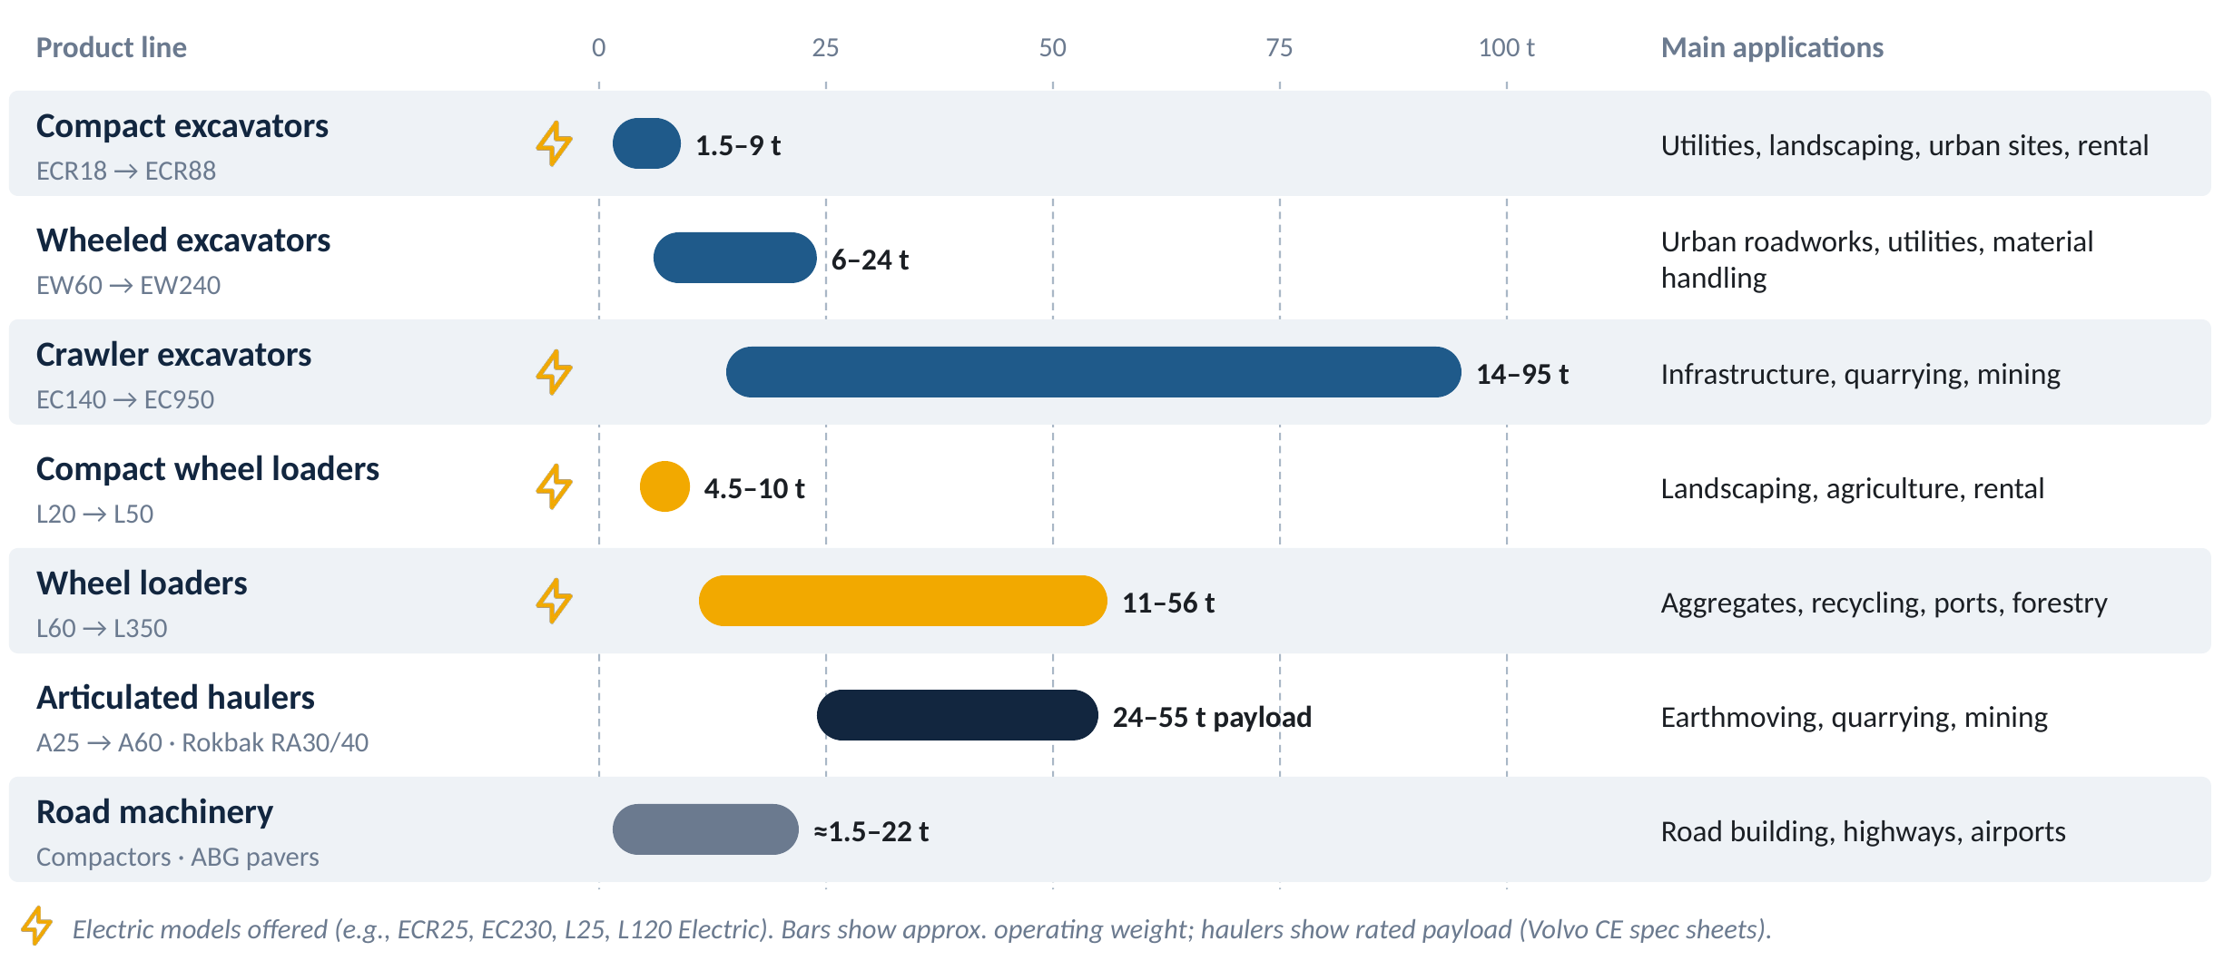
Figure 1. Size range of each Volvo CE product line (bars: operating weight; haulers: payload). Lightning marks show lines with electric models.

Reading the segments
- Compact (< 10 t): urban and utility work where access, low noise and low emissions matter most. This is where Volvo's electric machines are concentrated.
- Medium (10–30 t): general construction and infrastructure. The 20–22 t crawler excavator is the global (and Indian) workhorse.
- Heavy (30–50 t): quarrying, mass earthmoving and large infrastructure, paired with large wheel loaders and articulated haulers.
- Mining (> 50 t): mining excavators such as the EC650, EC750 and EC950 loading haulers in coal, iron-ore and limestone mines.
- Road building: a separate application chain (soil compaction → paving → asphalt compaction) served by compactors and pavers.

4. Volvo CE India: operations and product offering

4.1 The Peenya, Bengaluru plant
Volvo CE India Pvt. Ltd. has its Indian headquarters and manufacturing plant in the Peenya Industrial Area, Bengaluru. The site dates back to 1978, and Volvo CE has operated in India since 1997. In 2011 Volvo CE invested SEK 144 million (about ₹90 crore) to upgrade and partly rebuild the plant and opened a new excavator assembly line. The first locally built machines, an EC210B Prime and an EC290B, rolled off the line that September, and the upgrade was planned to triple factory capacity.
The plant specialises in crawler excavators, soil compactors and asphalt pavers. Localisation is high: the 21-tonne EC210 is about 70% localised. Peenya also exports to selected emerging markets with similar operating conditions. The Bengaluru Technology Centre, which Volvo CE is expanding, handles R&D, localisation and product development for India and global markets; it is developing the India-oriented medium wheel loaders planned for 2027. Volvo CE also draws on wider Volvo Group capabilities in India. For example, some compactors and the EC210E2 excavator use Volvo-Eicher CV5 engines shared with Eicher commercial vehicles.

4.2 How a machine moves through the plant
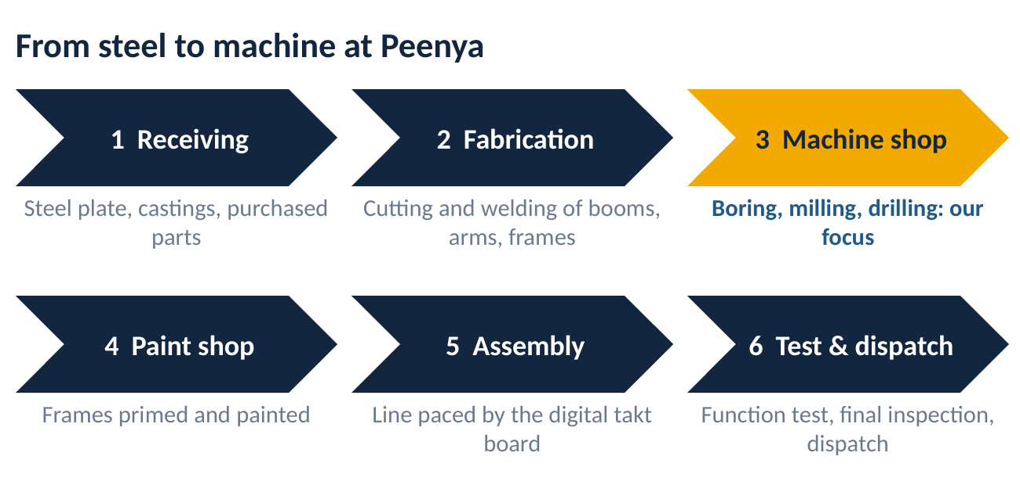
Figure 2. Manufacturing flow at Peenya, as presented and walked during the visit (simplified).
- Receiving: steel plate, castings and purchased parts (engines, hydraulics, cabs, undercarriage parts) are received and inspected.
- Fabrication: plates are cut and welded into the main structures: boom, arm (dipper), upper (revolving) frame and lower frame (car body and track frames).
- Machine shop (Group 3's focus): the welded structures are machined on horizontal boring mills and machining centres. Pin bores are bored to tight tolerances, the swing-bearing mounting face is milled flat, and bolt holes are drilled and tapped.
- Paint shop: frames and structures are cleaned, primed and painted before assembly.
- Assembly line: the excavator is built station by station, paced by a digital board showing takt time and cycle time.
- Testing, final inspection and dispatch: function testing, final quality inspection and dispatch to dealers and export customers.

4.3 Market position and network
- India's excavator market is about 30,000–35,000 units a year, of which the 20-tonne class is about 70%.
- Volvo CE India held about 4% of the 20 t excavator segment in 2024 and aims to more than double it. The managing director, Dimitrov Krishnan, has cited about 6.5% of the Indian construction-equipment market.
- Distribution: 19 dealers, 800+ dealer employees and 180+ touchpoints; recent additions include Time Equipment for North India.
- Positioning: premium machines sold on fuel efficiency, uptime and lifecycle cost, backed by connected services, repair and maintenance agreements and Equipment-as-a-Service.

4.4 Product offering in India by application and tonnage
Segment | Models | Tonnage | Typical applications in India | Built at Peenya
20–22 t crawler excavators | EC210, EC215 ('Made in Bharat'), EC220 | 20–22 t | Highways, irrigation canals, urban infrastructure, stone quarries | Yes
Heavy crawler excavators | EC300, EC380, EC480 | 30–48 t | Quarrying, mass earthmoving, overburden removal | Not confirmed
Mining excavators | EC650 (launched Sep 2026), EC750 | 65–75 t | Coal and iron-ore mining | Not confirmed
Wheel loaders | Premium L-series incl. L120 Electric | ≈20 t and above | Mining, cement, steel plants, ports (~100 units a year) | No (medium loaders planned 2027)
Soil compactors | SD110 / SD110C | ≈11 t | Highway embankments, sub-grade compaction | Yes
Asphalt compactors | DD90C, DD100C; PT220 pneumatic roller | ≈9–10 t (DD) | Bituminous surfacing | Not confirmed
Asphalt pavers (ABG) | P4370D wheeled; P5320D, P7920D, P8820D tracked | By paving width | National highways and expressways | Yes
Table 5. Volvo CE India offering by application and tonnage. 'Built at Peenya' reflects the plant's stated specialisation (crawler excavators, soil compactors, asphalt pavers); 'Not confirmed' means no public source states the site.

4.5 Recent developments
- EXCON 2025 (Bengaluru, December 2025): unveiled the EC215 'Made in Bharat' 20–22 t excavator ('Zyada Ka Vaada'), the SD110 compactor and the L120 Electric wheel loader, and previewed the EC650.
- bauma CONEXPO INDIA 2026 (Greater Noida, September 2026): launched the EC650, a 65-tonne mining excavator with a 435 hp Volvo D13E engine, available with immediate delivery and through EaaS, alongside the EC210/EC215/EC220 range.
- 2027 onwards: localised Volvo-branded medium wheel loaders to fill the gap left by the SDLG exit.
Why this matters for Group 3: if Volvo CE India doubles its 20 t share and grows exports, Peenya needs more excavators per shift. Raising machine-shop output by 20% without new machines or extra shifts is exactly the kind of improvement the plant needs.

5. Group 3: Operations Excellence in the machine shop

5.1 Problem statement
The brief asks: if the production manager must improve production efficiency by 20%, that is, produce 2 more excavators per day in an 8-hour shift, which Operations Excellence techniques should be applied to raise efficiency without affecting quality? The brief gives two numbers: an example of 10 excavators a day, and 12 units described as the 'current production rate'. Because +20% on 10 is exactly 2 more units, we read the problem as 10 units/day today → 12 units/day target.

5.2 Scope and assumptions
Parameter | Assumption used
Product family | 20–22 t crawler excavators (EC210 / EC215 / EC220); one 'set' of structures per excavator
Shift | 1 shift of 8 h = 480 min; lunch 30 min, two tea breaks of 10 min, 10 min start-up meeting and 5S
Available time | 420 min per shift
Current output | 10 excavators per shift (good units)
Target output | 12 excavators per shift (+20%), same shift, same headcount
Machine-shop routing | OP10 boom, OP20 arm, OP30 upper frame, OP40 lower frame, OP50 links and pins, OP60 wash and CMM inspection
OP30 machine | 5-face horizontal machining centre; ideal cycle 28 min, actual 30 min per frame
Model changeovers | 3 per shift at OP30 (EC210 ↔ EC215 ↔ EC220 frames), 15 min each
Quality | About 1 in 21 upper frames needs re-machining today (first-pass yield 95.2%)
Table 6. Assumptions (illustrative, as permitted by the brief).

5.3 Takt time: the pace the machine shop must keep
Takt time is the rate at which one unit must be completed to meet customer demand:
Takt time = Available time ÷ Demand
Today: 420 ÷ 10 = 42 min per excavator Target: 420 ÷ 12 = 35 min per excavator
To make 12 a day, every machine-shop operation must finish one excavator's parts in 35 minutes or less, after allowing for its losses. Takt falls by 17% (42 → 35 min), so the shop needs about 20% more capacity at its slowest point.

5.4 Current state: finding the bottleneck
Op | Part | Machine | Main operations | Effective cycle time today (min)
OP10 | Boom | Horizontal boring mill 1 | Boom-foot, cylinder and arm-pivot pin bores; boss facing; drilling | 39
OP20 | Arm (dipper) | Horizontal boring mill 2 | Arm-pivot, bucket-pin and cylinder bores | 36
OP30 | Upper (revolving) frame | 5-face machining centre | Swing-bearing face and bolt circle, boom-foot bores, mounting pads | 42 (bottleneck)
OP40 | Lower frame and track frames | Horizontal boring mill 3 | Swing-ring face, centre joint, track-frame interfaces | 38
OP50 | Links, pins, small parts | Vertical machining centre | Links, brackets, pins | 27
OP60 | All structures | Washer, deburr, CMM | Deburr, wash, coordinate-measuring check | 30
Table 7. Assumed machine-shop routing. Effective cycle time includes each station's losses.
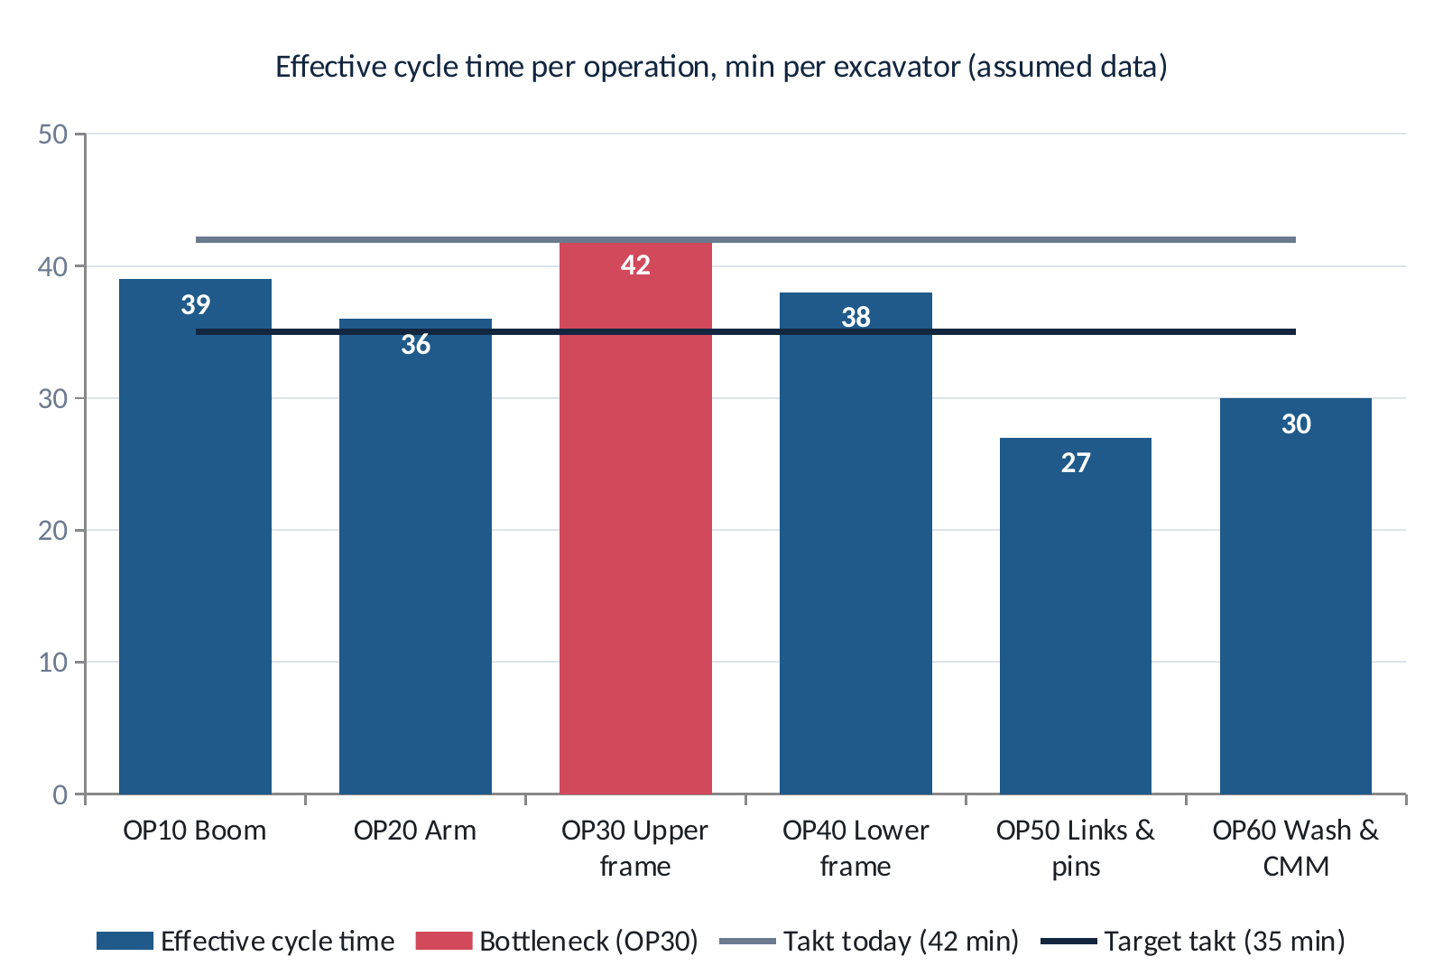
Figure 3. Effective cycle time per operation against today's takt (42 min) and the target takt (35 min).
Using the Theory of Constraints (Goldratt), step 1 is to identify the constraint. OP30, upper-frame machining, needs 42 minutes per excavator, exactly today's takt. It has no spare capacity, and every minute lost at OP30 is a minute of plant output lost. At the 35-minute target takt, OP10, OP20, OP30 and OP40 are all too slow; OP50 and OP60 have spare time that can absorb work from overloaded stations.
Typical machine-shop losses at a station like OP30, which we assume for this analysis: frames waiting for the shared overhead (EOT) crane and for first-off quality sign-off; manual dial-gauge alignment of each frame on the table; three model changeovers a shift; and occasional re-machining of bores when weld distortion pushes a frame out of position.

5.5 Loss analysis at OP30: Overall Equipment Effectiveness
OEE is the standard Operations Excellence measure of how well a machine's planned time turns into good output. It multiplies three factors: Availability (losses from stoppages), Performance (losses from running slower than ideal) and Quality (losses from defects). We split OP30's 420 minutes into Nakajima's six big losses:
Use of OP30 time | Minutes / shift | Share | OEE loss category
Value-adding machining (10 good frames × 30 min) | 300 | 71% | –
Model changeovers (3 × 15 min) | 45 | 11% | Availability: set-up and adjustment
Breakdowns and minor stops | 25 | 6% | Availability: equipment failure
Waiting for crane, parts, QC sign-off | 20 | 5% | Performance: idling and minor stoppages
Slow set-up (dial-gauge alignment) | 15 | 4% | Performance: reduced speed
Rework / re-machining (0.5 frame) | 15 | 4% | Quality: defects and rework
Total available | 420 | 100%
Table 8. Where OP30's 420 minutes go today (assumed).
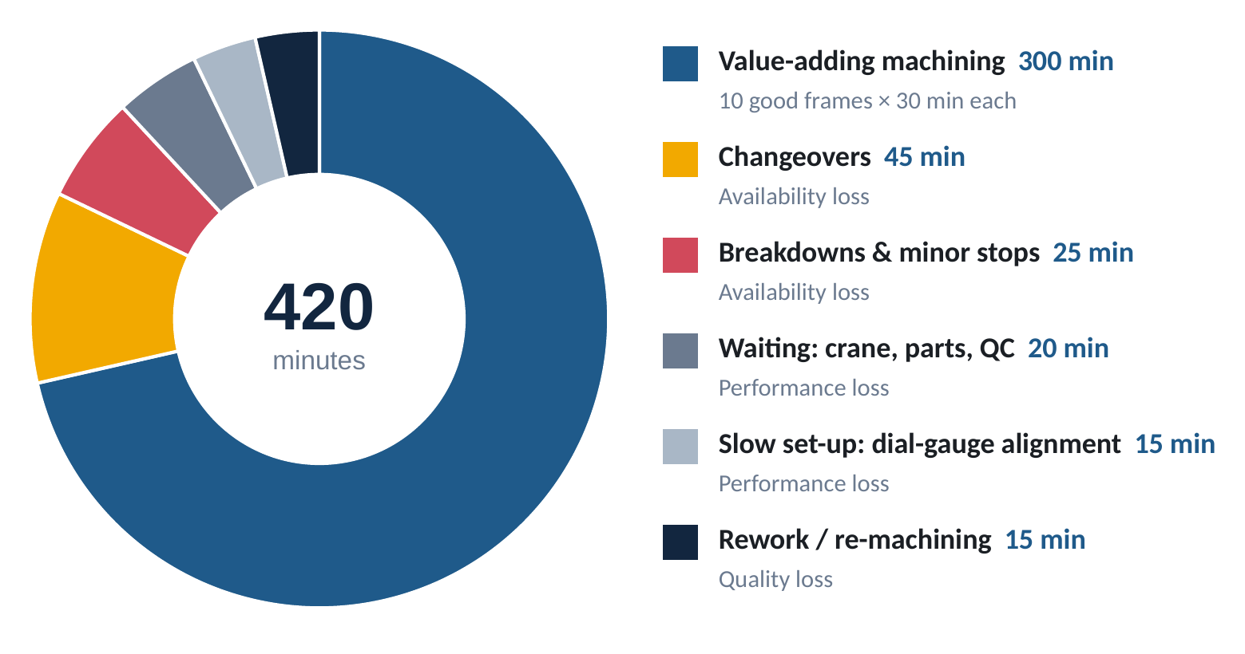
Figure 4. OP30's 420 minutes by use; 120 minutes a shift are lost.
Availability = (420 − 45 − 25) ÷ 420 = 350 ÷ 420 = 83.3%
Performance = (28-min ideal cycle × 10.5 frames) ÷ 350 min = 84.0%
Quality = 10 good ÷ 10.5 frames machined = 95.2%
OEE = 83.3% × 84.0% × 95.2% = 66.7% (check: 10 × 28 ÷ 420 = 66.7%)
An OEE of 66.7% is typical for a machine shop but well short of the world-class benchmark of about 85%. The key insight is that 120 minutes are lost every shift, equal to four excavators' worth of OP30 machining at 30 minutes each. Winning back about 60 of those minutes is enough for two more excavators, with no new machine, no extra shift and no pressure on operators to rush.

5.6 The Operations Excellence framework we apply
Operations Excellence means delivering what the customer needs at the right quality, time and cost by continuously removing waste and variation from processes. We use five complementary toolsets and anchor them in Volvo's own system:
- Volvo Production System (VPS): Volvo Group's lean production system, rolled out globally from 2007. It rests on Volvo's values (quality, safety, environmental care) and teamwork, with three pillars (process stability, built-in quality, just-in-time) and continuous improvement on top, all aimed at customer value.
- Lean / Toyota Production System (Ohno): eliminate the eight wastes (defects, over-production, waiting, unused talent, transport, inventory, motion, extra processing) through standard work, flow and pull.
- Total Productive Maintenance (TPM) (Nakajima): operators and maintenance together maximise equipment effectiveness; OEE is its measure.
- Theory of Constraints (TOC) (Goldratt): identify, exploit, subordinate, elevate, repeat. Improve the bottleneck first, because that is where output is decided.
- Six Sigma / DMAIC: reduce variation and defects with data (SPC, Cpk, root-cause analysis), so that faster flow never costs quality.
Loss at OP30 | Waste type | Lever | VPS principle
Changeovers 45 min | Waiting | 1. SMED quick changeover | Process stability
Breakdowns 25 min | Waiting, defects | 2. Total Productive Maintenance | Process stability
Waiting 20 min | Waiting, transport | 3. JIT flow, Kanban and kitting | Just-in-time
Slow set-up 15 min; cycle 30 min | Motion, extra processing | 4. Standard work, line balancing, CNC optimisation | Process stability / teamwork
Rework 15 min | Defects | 5. Built-in quality: poka-yoke, SPC, jidoka | Built-in quality
Sustaining all gains | Unused talent | 6. 5S, visual management, kaizen | Continuous improvement
Table 9. Mapping each loss to a waste type, an Operations Excellence lever and a VPS principle.

5.7 The six levers in detail

Lever 1: SMED (Single-Minute Exchange of Die)
Concept. Developed by Shigeo Shingo, SMED separates internal set-up (work that can only be done while the machine is stopped) from external set-up (work done while the machine is still cutting). It converts internal work to external and streamlines what remains.
Application at Peenya. A video of an OP30 changeover is broken into elements. The next model's fixture is pre-assembled on a changeover cart, tools are pre-set on a tool presetter and the CNC program is loaded while the current frame is still being machined. A zero-point quick-clamping system lets the fixture drop onto the table in a repeatable position, and an in-machine probe sets the datum automatically. A standard changeover checklist and sequencing frames by family (EC210 → EC215 → EC220) make each change smaller.
Changeover element | Before (min) | After (min) | How
Release previous fixture, clean table | 4 | 1 | Zero-point quick release; cleaning kit at machine
Fetch and position new fixture | 3 | 1 | Fixture preset on cart while machine runs (external)
Align fixture with dial gauge | 4 | 1 | Zero-point location plus probe auto-datum
Load tools and offsets | 2 | 0.5 | Tool presetter; offsets transferred digitally
Load program, first-off check | 2 | 1.5 | Program called by model; in-machine probing
Total per changeover | 15 | 5 | × 3 changeovers: 45 → 15 min per shift
Table 10. SMED applied to an OP30 changeover (assumed element times).
Impact. 30 minutes per shift freed at the bottleneck: about +1.0 excavator of capacity.

Lever 2: Total Productive Maintenance (TPM)
Concept. TPM aims for zero breakdowns, zero defects and zero accidents. Operators own basic care of their machines (autonomous maintenance), maintenance specialists run planned and predictive maintenance, and teams attack chronic losses through focused improvement.
Application at Peenya. Autonomous maintenance steps 1–3 (initial cleaning, eliminating contamination sources, cleaning and lubrication standards) on OP30 first. Operators complete a 10-minute CLIT check (clean, lubricate, inspect, tighten) within the existing start-up slot, so no production time is used. Maintenance runs a planned calendar covering way lubrication, coolant concentration, hydraulic clamp pressure and spindle vibration trending to catch bearing wear early. A critical-spares kit is kept at the machine to cut repair time. MTBF and MTTR are tracked on the shop-floor board.
Impact. Breakdowns and minor stops fall from 25 to 12 minutes per shift: +0.4 excavator.

Lever 3: Just-in-Time flow, Kanban and kitting
Concept. JIT supplies the right part, in the right quantity, at the right time. Under TOC's drum–buffer–rope logic, the bottleneck (the drum) is protected by a small buffer, and work is released to match its pace (the rope).
Application at Peenya. A FIFO lane holding two welded upper frames in front of OP30 means the bottleneck is never starved. Kanban signals pull weldments from fabrication at OP30's pace instead of pushing batches. Model-wise tool and fixture kits are prepared in advance. A dedicated jib crane at OP30 removes waiting for the shared overhead crane. First-off approval uses the probe's measurement report, so the machine does not wait for an inspector. Model mix is levelled across the day (heijunka) so fabrication and machining run at a steady rhythm.
Impact. Waiting falls from 20 to 6 minutes per shift: +0.5 excavator.

Lever 4: Standardised work, line balancing and CNC optimisation
Concept. Standardised work documents the current best method, time and sequence, giving a stable base for improvement. Line balancing (often shown on a Yamazumi chart) spreads work so that no station exceeds takt.
Application at Peenya. Time studies over ten cycles per operation feed standard work charts. In-machine probing replaces manual dial-gauge alignment. CNC programs are optimised to cut 'air-cutting' and unnecessary tool changes, and high-feed milling cutters and through-coolant drills are used within validated feeds and speeds. Each change is proven on five frames with a CMM and a capability study before release. Non-critical drilling and tapping move from the overloaded OP10 and OP40 to the under-used vertical machining centre at OP50.
Impact. Slow set-up falls from 15 to 6 minutes and the OP30 cycle from 30 to 29 minutes per frame: +0.7 excavator.

Lever 5: Built-in quality (poka-yoke, SPC, jidoka)
Concept. Built-in quality means building it right the first time rather than inspecting defects out later. Poka-yoke makes errors impossible or obvious; jidoka stops the process automatically at an abnormality; SPC tracks process variation before it becomes a defect.
Application at Peenya. Locating pins on each fixture make it impossible to clamp a frame the wrong way round. The probe measures critical pin bores before the frame is unloaded. SPC charts track bore position and diameter, with a capability target of Cpk ≥ 1.33. The machine stops itself on a tool-wear or out-of-tolerance alarm. A DMAIC project with the fabrication team tackles the main rework cause, weld distortion, using welding sequence and fixture improvements.
Impact. Rework falls from 15 to 6 minutes per shift and first-pass yield rises from 95.2% to 98.4%: +0.3 excavator, and fewer defects reach the paint shop and assembly line.

Lever 6: 5S, visual management and kaizen
Concept. 5S (Sort, Set in order, Shine, Standardise, Sustain) creates a clean, organised workplace where abnormalities are visible. Visual management and daily kaizen (PDCA) keep everyone improving.
Application at Peenya. Shadow boards for tools and gauges at each machine, floor marking for the FIFO lane, and an hour-by-hour production board, OEE and Andon calls on the shop's digital display. Daily tier-1 (cell) and tier-2 (shop) meetings review output, quality and safety. Operators feed a kaizen suggestion scheme, and a skill matrix builds multi-skilled operators who can cover breaks and absences.
Impact. No direct capacity is claimed, but this lever sustains the other five, so the gains last beyond the project.

5.8 Line balancing after the improvements
Op | Before (min) | After (min) | Main actions
OP10 Boom | 39 | 33 | Drilling moved to OP50; SMED and TPM roll-out
OP20 Arm | 36 | 31 | SMED and TPM roll-out; standard work
OP30 Upper frame | 42 | 32.5 | All six levers (bottleneck first)
OP40 Lower frame | 38 | 33 | Drilling and tapping moved to OP50; TPM
OP50 Links & pins | 27 | 30 | Takes on offloaded drilling (still below takt)
OP60 Wash & CMM | 30 | 28 | Kitting, standard work, probe data reduces CMM queue
Table 11. Effective cycle time per operation before and after; target takt is 35 min.
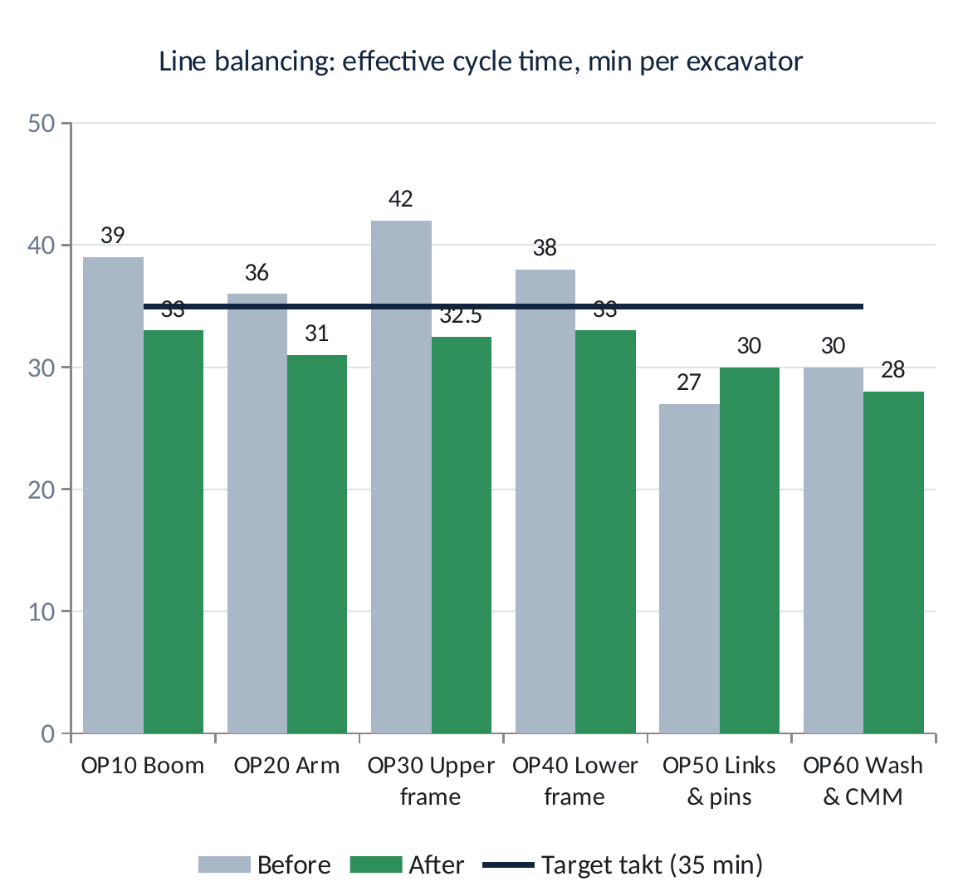
Figure 5. Line balancing: every operation ends at or below the 35-minute target takt.

5.9 Results
Loss at OP30 (min/shift) | Today | After | Freed | Lever
Changeovers | 45 | 15 | 30 | SMED
Breakdowns and minor stops | 25 | 12 | 13 | TPM
Waiting (crane, parts, QC) | 20 | 6 | 14 | JIT flow
Slow set-up | 15 | 6 | 9 | Standard work
Rework | 15 | 6 | 9 | Built-in quality
Total losses | 120 | 45 | 75
Table 12. OP30 losses before and after.
Good output after = (420 − 45 lost min) ÷ 29 min per frame = 12.9 excavators per shift
Availability = 393 ÷ 420 = 93.6%; Performance = 28 × 13.14 ÷ 393 = 93.6%; Quality = 98.4%; OEE ≈ 86%
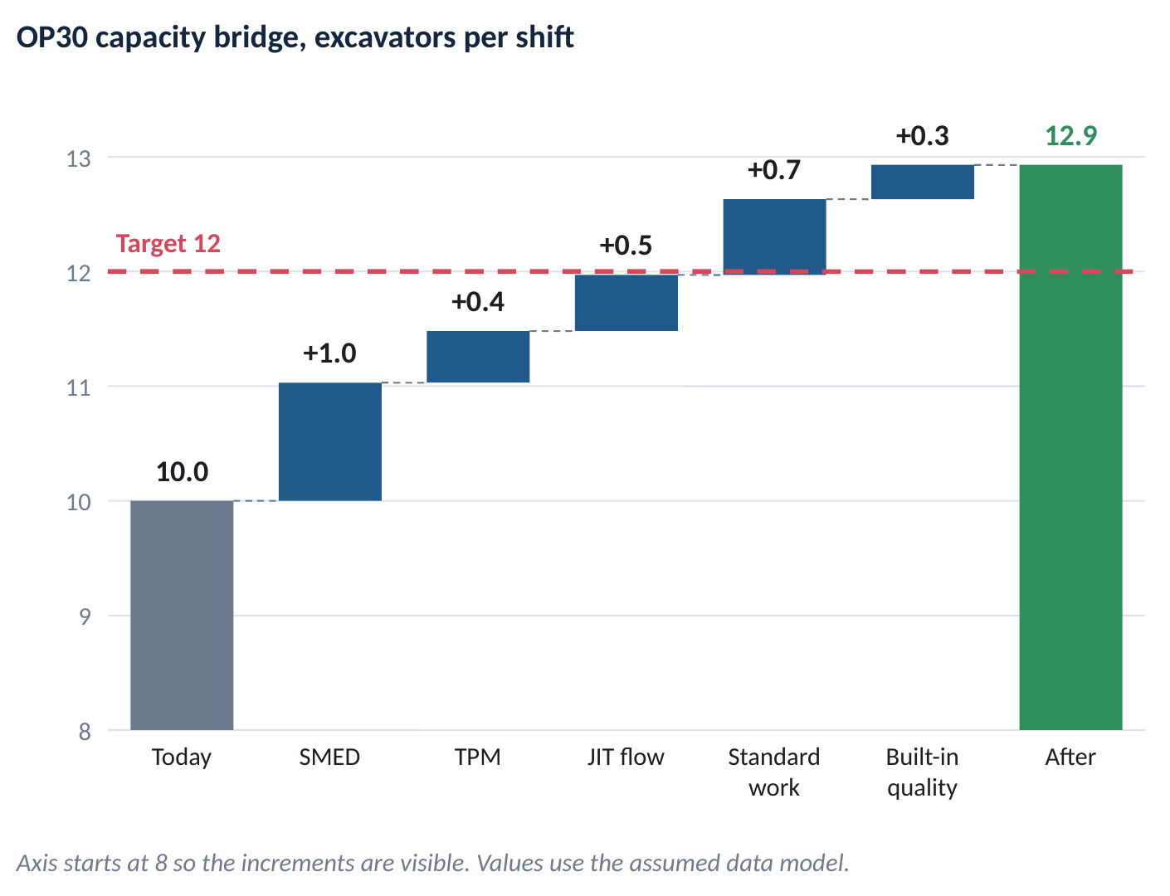
Figure 6. Capacity bridge at OP30: from 10 to 12.9 excavators per shift.
Scheduling 12 excavators per shift loads OP30 to 80% OEE and leaves about 7% protective capacity for variation in model mix, which TOC recommends at a bottleneck. The plan is robust: even if only 70% of the gains are realised, capacity is 10 + 0.7 × 2.93 = 12.05, still above target. An upside not counted in the plan: a multi-skilled relief operator keeps OP30 running through the two tea breaks (TOC's 'exploit the constraint'), adding about 20 minutes (+0.7 excavator).
KPI | Today | After 12 weeks
Output, excavators per shift | 10 | 12 (capacity 12.9)
Takt time | 42 min | 35 min
OEE at OP30 | 66.7% | 86% capability; 80% at plan
Effective cycle time at OP30 | 42 min | 32.5 min
Changeover time per model change | 15 min | 5 min
Breakdown loss per shift | 25 min | 12 min
First-pass yield at OP30 | 95.2% | 98.4%
Cpk on critical pin bores | Not tracked | ≥ 1.33
Table 13. KPI dashboard for the machine shop.

5.10 How quality is protected
The brief requires the 20% gain without affecting quality. Our plan protects quality by design:
- Waste, not speed: 75 of the 85 freed minutes come from removing losses. The only speed gain (30 → 29 min) comes from validated programs and tooling, not from operators working faster.
- No inspection step is removed: CMM checks continue, and in-machine probing adds a 100% check of critical bores before unloading.
- Stop-and-fix triggers: FPY below 98% or Cpk below 1.33 on a critical feature stops the change and starts a root-cause analysis (jidoka).
- Controlled change: every program or tooling change is trialled on five frames, measured and approved before release.
- Less firefighting: more stable machines and steady flow mean fewer rushed recoveries, the most common hidden cause of defects.

5.11 Implementation roadmap (12 weeks, PDCA)
Weeks | PDCA phase | Key activities | Expected output / shift
1–2 | Plan: diagnose | Gemba walks, time studies, OEE baseline at OP30, value-stream map of the machine shop, cross-functional kaizen team (production, maintenance, quality, industrial engineering, operators) | 10.0
3–6 | Do: quick wins | 5S and visual boards; SMED workshop at OP30; FIFO lane, kitting, jib crane; standard work charts | ≈11.0
7–10 | Do: structural | TPM steps 1–3; zero-point clamps, tool presetter, probing; CNC optimisation; poka-yoke; move drilling to OP50 | ≈11.6
11–12 | Check and Act | Verify output, FPY and Cpk; freeze standard work; layered process audits; roll out to OP10, OP20, OP40 | 12.0
Table 14. 12-week roadmap.
Change management. Operators are involved from day one, through kaizen workshops, suggestions and recognition, and the gains are not used to cut headcount. Daily tier meetings keep the team aligned. The plant manager sponsors the project, and the production manager owns the KPI board.

5.12 Cost–benefit (indicative)
Item | Indicative cost (₹ lakh)
Zero-point clamping system and two fixture pallets | 30
Tool presetter | 12
In-machine probe and software | 10
Dedicated jib crane at OP30 | 8
Poka-yoke locators, shadow boards, visual boards | 6
Training, kaizen events, TPM start-up | 6
Total | ≈ 72 (≈ ₹0.7 crore)
Table 15. Indicative investment (assumed figures for illustration).
The alternative of buying a second 5-axis machining centre would cost about ₹4–5 crore, with a 9–12 month lead time and foundation work, and would not fix the losses at the other stations. Running overtime or a second shift adds recurring labour cost, and fatigue raises the risk of quality problems. The Operations Excellence route costs about one-sixth as much, delivers within a quarter and builds capability that keeps paying back. Two more excavators per shift over about 250 working days is up to 500 more machines a year of capacity, ready for Volvo CE India's growth in the 20 t segment.

5.13 Risks and mitigation
Risk | Mitigation
Gains are not sustained | Standard work, layered process audits, daily tier meetings, KPI board
Faster cycles hurt quality | Validated parameters, capability studies, jidoka stop-and-fix triggers
Operator resistance | Involvement in kaizen, training and skill matrix, recognition, no headcount cuts
Fabrication cannot supply 12 sets | Extend the value-stream map upstream; Kanban; balance welding to 35-min takt
Paint shop or assembly line becomes the new bottleneck | Check every downstream takt; synchronise lines (TOC step 5: repeat)
OP30 still breaks down | Two-frame buffer, spares kit, preventive maintenance; staggered breaks as contingency
Table 16. Risks and mitigation.

6. Conclusion
Volvo CE combines nearly two centuries of engineering heritage with a premium global portfolio, from 1.5 t compact excavators to 95 t mining machines, sold in about 180 markets. In India, the Peenya plant in Bengaluru builds the 20–22 t excavators that make up the core of the Indian market, together with soil compactors and asphalt pavers. New launches such as the EC215 and EC650 and the company's ambition to double its share mean the plant must produce more.
Our analysis shows that the machine shop can raise output from 10 to 12 excavators per shift (+20%) without new machines, extra shifts or any compromise on quality. The bottleneck is upper-frame machining (OP30), where 120 of 420 minutes are lost every shift. Applying six Operations Excellence levers within the Volvo Production System (SMED, TPM, JIT flow, standardised work with line balancing, built-in quality, and 5S with kaizen) recovers 75 lost minutes and a minute of cycle time. That lifts OP30 capacity to about 12.9 excavators, OEE from 66.7% to about 86%, and first-pass yield from 95.2% to 98.4%. The plan reaches the target in 12 weeks for an indicative ₹0.7 crore, and still meets it if only 70% of the gains materialise.
The most important lesson from the visit is that capacity is often already in the plant, hidden in waste. Operations Excellence makes that waste visible and removes it, and keeps it out shift after shift.

References
- Volvo Construction Equipment (2026). Volvo CE demonstrates better earnings in Q4 2025 – Q4 and full-year 2025 results. volvoce.com.
- Volvo Construction Equipment (2026). Company information. volvoce.com/global/en/about-us/who-we-are/company-information.
- Volvo Construction Equipment. Our locations: Bangalore. volvoce.com/global/en/about-us/who-we-are/our-locations/bangalore.
- Volvo Construction Equipment (2011). Volvo Construction Equipment's Bangalore factory opens new excavator assembly line. Press release.
- Volvo Group (2025). Volvo Construction Equipment refocuses its presence in China – divests its shares in SDLG (24 June 2025); Volvo CE completes divestment of SDLG equity (September 2025).
- Volvo Construction Equipment (2026). Volvo Construction Equipment completes acquisition of Swecon. Press release, January 2026.
- Volvo Group (2025). Volvo Construction Equipment selects Eskilstuna, Sweden for its new crawler excavator assembly plant. November 2025.
- Autocar Professional (2024). Volvo CE India to double market share in 20-tonne excavator segment.
- Autocar Professional (2025). Volvo CE India unveils 'Made in Bharat' EC215 excavator at EXCON 2025.
- ANI / Manufacturing Today India (2026). Volvo CE launches EC650 mining excavator at bauma CONEXPO INDIA 2026. September 2026.
- Autocar Professional (2026). Volvo CE to launch localised medium wheel loaders in 2027 following SDLG exit. September 2026.
- The Machine Maker (2025–2026). Volvo CE India news and show reports; NBM&CW: Volvo CE's new production powerhouses for users in India.
- Goldratt, E. M. & Cox, J. (1984). The Goal: A Process of Ongoing Improvement. North River Press.
- Nakajima, S. (1988). Introduction to TPM: Total Productive Maintenance. Productivity Press.
- Netland, T. (2013). Exploring the phenomenon of company-specific production systems: one-best-way or own-best-way? International Journal of Production Research, 51(4), 1084–1097.
- Ohno, T. (1988). Toyota Production System: Beyond Large-Scale Production. Productivity Press.
- Shingo, S. (1985). A Revolution in Manufacturing: The SMED System. Productivity Press.
- Womack, J. P. & Jones, D. T. (1996). Lean Thinking. Simon & Schuster.

Appendix: Glossary of terms
Term | Meaning
Takt time | Available time ÷ customer demand; the pace each station must keep
Cycle time | Time a station actually takes to complete one unit
Bottleneck (constraint) | The slowest step, which limits the output of the whole system
OEE | Overall Equipment Effectiveness = Availability × Performance × Quality
SMED | Single-Minute Exchange of Die: reducing changeover time to under 10 minutes
TPM / CLIT | Total Productive Maintenance; Clean, Lubricate, Inspect, Tighten checks by operators
MTBF / MTTR | Mean time between failures / mean time to repair
JIT, Kanban, FIFO | Just-in-time; pull signal for replenishment; first-in-first-out lane
Heijunka | Levelling the model mix and volume over time
Poka-yoke | Mistake-proofing device or method
Jidoka | Automation with a human touch: stop automatically at an abnormality
SPC / Cpk | Statistical process control; process capability index (≥ 1.33 = capable)
FPY | First-pass yield: share of units right first time
Yamazumi | Stacked bar chart of work content per station, used for line balancing
5S | Sort, Set in order, Shine, Standardise, Sustain
PDCA / DMAIC | Plan-Do-Check-Act; Define-Measure-Analyse-Improve-Control
Gemba | The actual place where work happens (the shop floor)
VPS | Volvo Production System: Volvo Group's lean operating system

