|  |  |  |  |
| --- | --- | --- | --- |
| Trafigura Pte Ltd.   |  |  |  | | --- | --- | --- | |  | 10 Collyer Quay No. 29-01/05 Ocean Financial Centre Singapore 049315 |  | |

|  |  |
| --- | --- |
| Date: | SINGAPORE 08-NOV-2022 |
|  |  |
| Commodity: | 827.383 DMT OF LEAD CONCENTRATES |

|  |
| --- |
| **PROVISIONAL ASSAY CERTIFICATE** |

| **ELEMENT(S) /CONTENTS** |  |  | **ASSAY RESULT(S)** | |
| --- | --- | --- | --- | --- |
|  |  |  |  | |
| LEAD (PB) |  | 60.2 | | PCT |
| ANTIMONY (SB) |  | 0.5 | | PCT |
| COPPER (CU) |  | 0.8 | | PCT |
| GOLD (AU) |  | 0.6 | | G/DMT |
| SILVER (AG) |  | 440 | | G/DMT |
| ZINC (ZN) |  | 4.7 | | PCT |
|  | | | | |

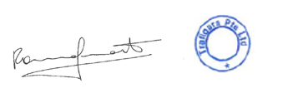

BENEFICIARY

**Trafigura Pte Ltd.**

10 Collyer Quay No. 29-01/05 Ocean Financial Centre Singapore 049315