|  |  |  |  |
| --- | --- | --- | --- |
| Trafigura Pte Ltd.   |  |  |  | | --- | --- | --- | |  | 10 Collyer Quay No. 29-01/05 Ocean Financial Centre Singapore 049315 |  | |

|  |  |
| --- | --- |
| Date: | SINGAPORE 08-NOV-2022 |
|  |  |
| Commodity: | 827.383 DMT OF LEAD CONCENTRATES |

|  |
| --- |
| **PROVISIONAL WEIGHT AND MOISTURE CERTIFICATE** |
|  |

|  |  |  |  |  |
| --- | --- | --- | --- | --- |
|  | **IN MT** |  |  |  |
|  |  |  |  |  |
| WET WEIGHT | **891** |  |  |  |
|  |  |  |  |  |
| MOISTURE CONTENT | **63.6174** |  | **7.14 PCT**  **(IN PERCENTAGE)** |  |
|  |  |  |  |  |
| DRY WEIGHT | **827.383** |  |  |  |

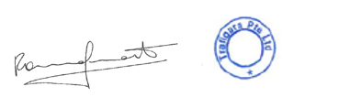  
BENEFICIARY

**Trafigura Pte Ltd.**

10 Collyer Quay No. 29-01/05 Ocean Financial Centre Singapore 049315