MOCK EXAMINATION

INSTRUCTIONS TO CANDIDATES
- Real final exam is a closed book examination.
- Only English solutions are accepted.
- Make sure your ER diagram is clear. You can use pencil for draft, but the final version on your answer sheet shouldn’t.

Question A
Consider the following tables:
fruit |  |  | ingredients
fruit_name | stock_kg |  | fruit_name | juice_name | amount_gram
apple | 15 |  | apple | Apple Juice | 330
avocado | 15 |  | avocado | Avocherry | 120
cherry | 11 |  | cherry | Avocherry | 160
mango | 20 |  | mango | Tropical Snow | 280
melon | 12 |  | melon | Melon Juice | 330
pear | 10 |  | pear | Tropical Snow | 100
juice
juice_name | volume_ml
Apple Juice | 330
Avocherry | 280
Melon Juice | 330
Tropical Snow | 400

The primary key for fruit is (fruit_name) and the primary key for juice is (juice_name). The ingredient table records the amount of fruit needed for each juice.
- Which of the following value(s) appear in the result of the following SELECT statement?
SELECT DISTINCT fruit.fruit_name, stock_kg FROM fruit
WHERE fruit_name LIKE '%a%'
AND fruit_name LIKE '%o%';
1. 10
2. 11
3. 20
4. 12
- Which of the following SQL statement can insert tuple ('Apple Juice',330) into the juice table?
1. ALTER juice ADD COLUMN ('Apple Juice',330);
2. SELECT 'Apple Juice', 330 FROM juice;
3. ALTER juice ADD TUPLE ('Apple Juice',330);
4. INSERT INTO juice VALUES ('Apple Juice',330);
- Which of the following values appear more than one time in the result of the following SELECT statement?
SELECT SUM(amount_gram) AS diff
FROM juice INNER JOIN ingredients USING (juice_name)
GROUP BY juice_name;
1. 330
2. 280
3. 380
4. 300
- Which of the following juice name appears in the result of query:
SELECT juice_name FROM fruit NATURAL JOIN ingredients
WHERE amount_gram > 300 and stock_kg < 14;
1. Apple Juice
2. Avocherry
3. Tropical Snow
4. Melon Juice

- Which of the following fruit name DOES NOT appear in the result of query:
SELECT fruit_name
FROM fruit INNER JOIN ingredients USING (fruit_name)
WHERE juice_name NOT IN
(SELECT juice_name FROM juice WHERE volume_ml = 330);
1. apple
2. avocado
3. pear
4. mango
- Which of the following fruit name appears in the result of query:
SELECT fruit_name FROM fruit AS f
WHERE NOT EXISTS (SELECT * FROM fruit AS g WHERE f.stock_kg > g.stock_kg);
1. mango
2. avocado
3. pear
4. melon
- Which of the following statements can increase the stock of all fruits shown in the table by 10 kg?
1. UPDATE fruit SET stock_kg = stock_kg + 10 WHERE ALL (fruit_name);
2. UPDATE fruit SET stock_kg = stock_kg + 10 WHERE stock_kg;
3. UPDATE fruit SET stock_kg = stock_kg + 10 WHERE fruit_name NOT NULL;
4. UPDATE fruit SET stock_kg = stock_kg + 10 WHERE stock_kg > 10;
- Which of the following statement adds a correct foreign key that works for ingredients and fruit tables, providing that the data types of the corresponding columns match?
1. ALTER TABLE ingredients ADD CONSTRAINT mykey FOREIGN KEY (amount_gram) REFERENCES fruit (stock_kg);
2. ALTER TABLE fruit ADD CONSTRAINT mykey FOREIGN KEY (stock_kg) REFERENCES ingredients (amount_gram);
3. ALTER TABLE ingredients ADD CONSTRAINT mykey FOREIGN KEY (fruit_name) REFERENCES fruit (fruit_name);
4. ALTER TABLE fruit ADD CONSTRAINT mykey FOREIGN KEY (fruit_name) REFERENCES ingredients (fruit_name);
- The ingredient table has a cardinality of:
1. 3
2. 6
3. 7
4. 21
- Which number is returned by the following SELECT statement:
SELECT COUNT(DISTINCT volume_ml)
FROM fruit f NATURAL JOIN ingredients i NATURAL JOIN juice j;
1. 6
2. 5
3. 4
4. 3

Part 2: Evaluate the results of following 3-valued logic expressions. If a result is a number, choose the Boolean value represented by that number. Each question is worth 2 marks
- True AND (Unknown = Unknown)
1. True
2. False
3. Unknown
- 15 + (Unknown OR True)
1. True
2. False
3. Unknown
- False AND Unknown
1. True
2. False
3. Unknown

- Unknown OR (16 - 19)
1. True
2. False
3. Unknown

- (1 - True) AND Unknown
1. True
2. False
3. Unknown

Question B
1. Difference between primary key and unique key?
2. Foreign key and reference options?
3. CHAR and VARCHAR?
4. Datetime and timestamp?
5. Binary?
6. How does CROSS JOIN, INNER JOIN, NATURAL JOIN… work?
…

Review slides thoroughly. You may also check “CPT103 SQL Knowledge Mind Map” on LMO module page.

Question C
Normalise the following table “T” into the 3rd Normal Form by clearly describing the normalisation process, i.e. the dependencies removed and how the table is split into sub-tables. Describe the primary key and functional dependencies for each resulting sub-tables.
A | B | C | D | E | F | G

Attributes (A, B, C) form the primary key and the functional dependencies:
A, B, C -> D, E, F, G
B, C -> E, F
F -> C
D -> G
[2NF]
B C -> E F is a partial dependency.
T will be split into:
T1: [B C E F] with PK (B, C)
T2: [A B C D G] with PK (A, B, C)
[3NF]
G is transitively dependent on (A, B, C) via D
T2 is split into:
T2-1: [D, G] with PK (D)
T2-2: [A B C D] with PK (A, B, C)
The final design is:
T1: [B C E F] with PK (B, C)
T2-1: [D, G] with PK (D)
T2-2: [A B C D] with PK (A, B, C)
Question D
You are asked to develop a database that is used by a reference manager application. Reference manager applications are tools used to create, organize and store references for conference papers or journal articles. The requirements for the database are provided below:
- The whole reference library is managed using tags. Tags are up to 15 characters long.
- Each reference can have zero or more tags.
- A same tag can be added to one or more references.
- Each tag can be described with some comments.
- Each reference has a unique citation key, a list of authors, a publish year, a title, the source of this reference (the name of the journal or conference), the type of reference (journal article or conference paper) and optionally a file path if the user owns the document.
- Each author has a unique ID called ORCID, a full name and the research institution he/she is currently working in.
- ORCID is always 16 digits long, the last digit can be the letter ‘x’.
- Sometimes a document contains a collection of articles.

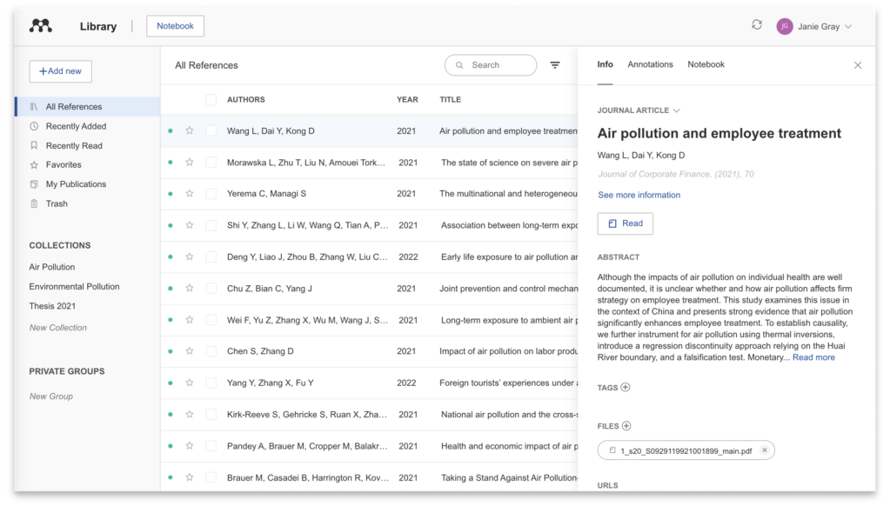
Task 1: Draw the entity relationship diagram.
Task 2: Based on your solution to Task 1 above, write the SQL code to create the tables for the database. You should include all the specified attributes and specify the appropriate primary and foreign keys. All primary keys and foreign keys must be added separately using ALTER statements.

