Question C: Normalisation
Normalise the following table “T” into the 3rd Normal Form by clearly describing the normalisation process, i.e. the dependencies removed and how the table is split into sub-tables. Describe the functional dependencies for each resulting sub-table.
A | B | C | D | E | F | G | H

Attributes (A, B) form the primary key. The relation has the following functional dependencies:
A, B -> C, D, E, F, G, H
B -> C
D -> E
E -> A
F -> G, H

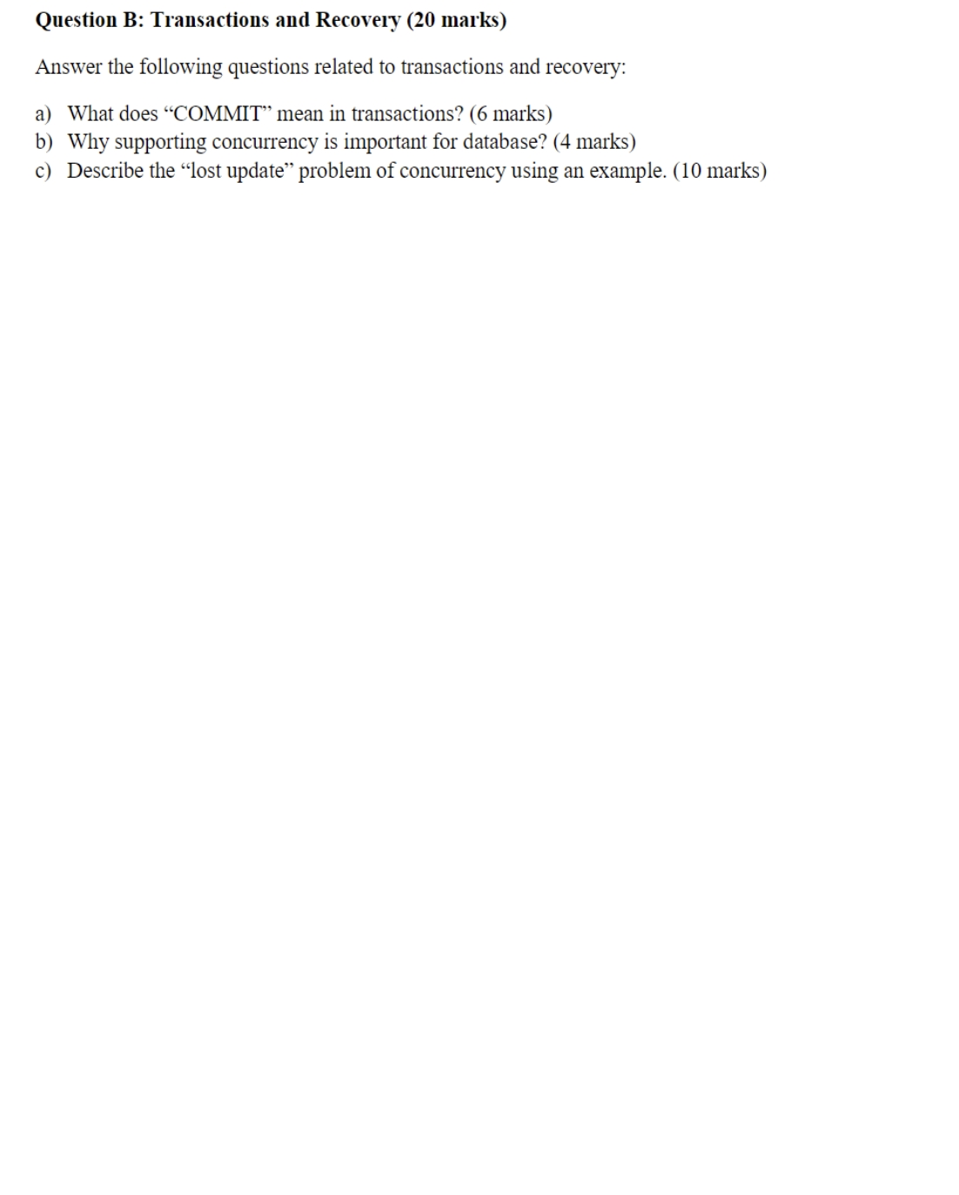
Question D: Entity-relationship Modelling
You are hired by a port company to develop a database for managing container and yard data. In this port, containers are placed in different container stows (stow = container stacking area). Each stow has an identifier, a maximum number of containers supported. A stow has several slots for containers, each slot is associated with a slot id. Each container has its container identifier, current stow, current slot in the stow, weight and size. A container transport task involves transporting one or two containers from their initial position to a same target position. The target position is described using a target stow identifier and a target stow position.
Task 1: Draw the entity relationship diagram for the port company’s database.
Task 2: Based on your solution to Task 1 above, write the SQL code to create the tables for the database. You should include all the specified attributes and specify the appropriate primary and foreign keys. Minor syntactical errors in your SQL code will not be penalised in the marking of this answer.

