CPT103 Introduction to Databases Lab 0

Part 1: Database Basics
Question 1
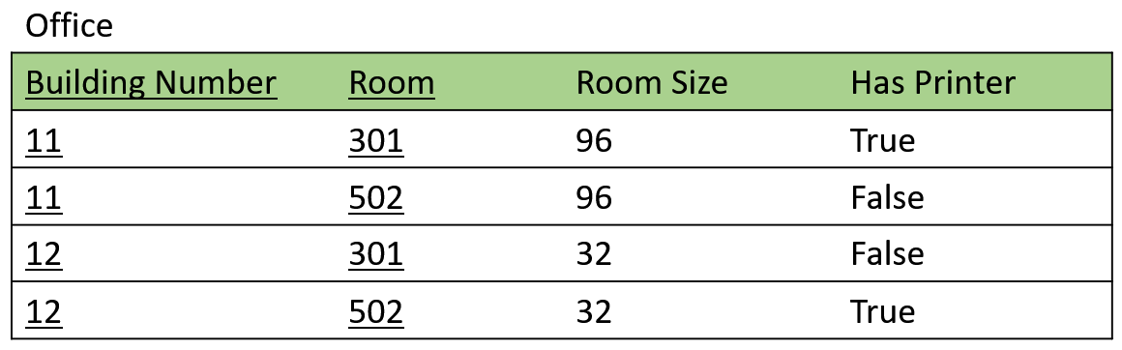
The degree of office relation is [ ]. Its cardinality is [ ].
How many offices in the above table have printers? [ ].

Which of the following items are the attributes of office?
- (11, 301, 96, True)
- 301
- Building Number
- Room Size

Which of the following items are superkeys of office?
- (Building Number, Room Size)
- (Room, Room Size)
- (Room Size, Has Printer)
- (Building Number, Room, Has Printer)
- (Room, Room Size, Building Number)

Which of the following statements about relation keys are correct?
- Candidate keys are also superkeys.
- Primary key uniquely identifies tuples in a table.
- A composite key can be a candidate key that consists of 3 attributes.
- A table can have 3 primary keys but only one candidate key is allowed.

Question 2
The table below is used to record the staying history of guests of a hotel. Assume that the hotel has only one building. The column ‘passport’ refers to the one who physically stayed in the room during a period,
room_number | Passport | start_date | end_date
101 | P1 | 2023-7-11 | 2023-7-16
102 | P3 | 2023-7-21 | 2023-8-1
103 | P4 | 2023-9-1 | 2023-9-5
101 | P2 | 2023-7-11 | 2023-7-16
101 | P3 | 2023-9-1 | 2023-9-5
…

What is/are the suitable candidate keys for this table? Remember that more than one person can stay in the same room.

Question 3
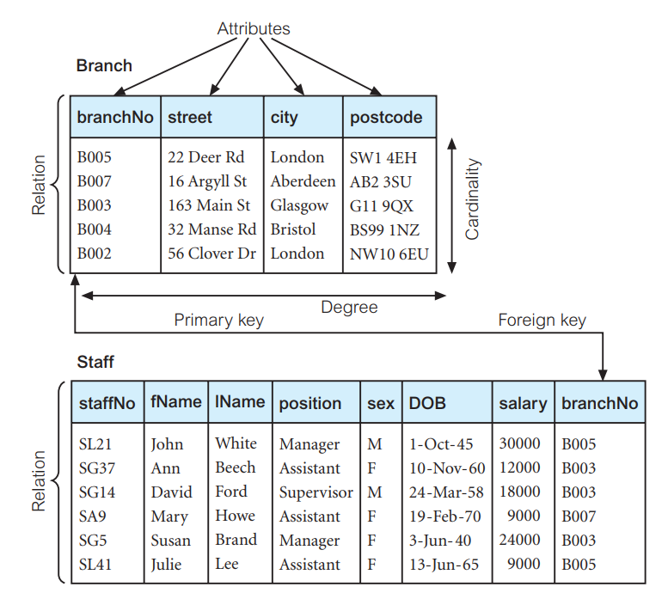
Given the two tables from the slides, answer the following questions:
- With current branches in Branch, one can add a new staff ‘SF12’ that belongs to B009. [Yes/No]
- List the staffNo of the staff who work in the branch with postcode ‘AB2 3SU’. [ ]
- List the staffNo of the staff who work in the branch with postcode ‘G11 9QX’. [ ]
- Based on the evidence showed in these two tables, branchNo from Branch is referencing branchNo from staff, meaning that the branchNo in branch must match a branchNo in staff? [Correct/Incorrect]

Question 4

Student
sid | name | email
1001 | S1 | S1@xjtlu.ac.uk
1002 | S2 | S2@xjtlu.ac.uk
1003 | S3 | S3@xjtlu.ac.uk

Module
mcode | name
CPT103 | Database
CPT105 | Java
CPT104 | OSC

Enrollment
sid | mcode
1001 | CPT103
1001 | CPT104
1002 | CPT103
1003 | CPT103
1003 | CPT104
1003 | CPT105

Answer the following questions related to the three tables above.
- Each tuple in Student table represents [ ].
- Each tuple in Module table represents [ ].
- The tuple (1001, CPT103) in Enrollment table means [ ].
- Student S3 is enrolled in modules [ ], [ ] and [ ].
- There are [ ] students in total enrolled in CPT104.
- Given the data shown in these tables, the candidate key(s) for Student table can be [ ], the candidate key(s) for Module table can be [ ] , the candidate key(s) for Enrollment table can be [ ]
- Describe the foreign keys that can be defined for these three tables: [ ] and
[ ]

Part 2: Creating Tables
Task 1: Answer the following questions:
- The following code can run without errors? Try it on phpMyAdmin
CREATE TABLE A (
id INT PRIMARY KEY,
name VARCHAR(30),
);

- The following two forms of creating table b are exactly the same? Try them on phpMyAdmin.
CREATE TABLE `B` (
`col1` INT PRIMARY KEY
);
CREATE TABLE B (
col1 INT PRIMARY KEY
);

Task 2: create a table called ‘account_balance’ and insert values like below:
account_balance
card_id | holder_name | balance
54321111 | Don Peterson | 999999999.12
47182222 | Maya Jones | 6250.23
66173333 | Harry Graham | 20.33

- Find appropriate data types for these attributes.
- Decide an appropriate primary key.
- Write the correct CREATE TABLE statement.
- Insert all of the tuples from the table above.
- Increase the account balance of Don Peterson by 0.01 using UPDATE. Does it work? (The correct balance is 999999999.13, incorrect balance could be 1000000000)

Task 3: create a table called ‘transactions’ and insert values like below:
transactions
from_card_id | to_card_id | amount | transaction_time
54321111 | 47182222 | 56.10 | 2021-1-12 12:00:00
47182222 | 54321111 | 79.00 | 2021-2-11 18:00:00
66173333 | 54321111 | 2000.00 | 2021-3-1 21:00:00

- Find appropriate data types for these attributes.
- Use ‘transaction_time’ as the primary key (let’s ideally assume one transaction can be done at a time).
- Decide appropriate foreign key(s) that references ‘account_balance’.
- Write the correct CREATE TABLE statement.
- Insert all of the tuples from the table above.
  - Date and datetime values are enclosed with single quotes.

Part 3: Foreign Key and Reference Options
Task 1: Create and initialise `staff` and `branch` using the following code:
CREATE TABLE `branch` (
`branchNo` char(4) NOT NULL,
`postcode` varchar(10) DEFAULT NULL,
PRIMARY KEY (`branchNo`)
);
CREATE TABLE `staff` (
`staffNo` char(4) NOT NULL,
`branchNo` char(4) DEFAULT NULL
);
insert into branch values ('B001', 'p1'),('B002', 'p2'),('B003', 'p3'),('B004', 'p4');

insert into staff values ('S001', 'B001'),('S002', 'B001'),('S003', 'B002'),('S004', 'B002'),('S005', 'B003'),('S006', 'B004');

Task 2: Use ALTER to add a foreign key so that:
- Staff table’s branchNo reference branch table’s branchNo.
- When a branch is deleted, all staff in this branch will also be deleted.
- When a branch number is changed, all staff in this branch will also be set to null.

Task 3: Attempt the experiments below:
- Delete ‘B001’ in branch, check whether ‘S001’ and ‘S002’ are deleted.
- Try to change ‘B003’ to ‘B004’ in branch, what will happen to the staff table? Write down your answer.
- Try to change ‘B004’ to ‘B005’ in branch, what will happen to the staff table? Write down your answer.
- Change the postcode of ‘B003’ to ‘p5’, what will happen to the staff table? Do the experiment and write down your answer.
- Try to drop ‘branch’ table, will it succeed? If not, how to successfully drop the branch table?

Task 4: You should have a clearer understanding of reference options now. Rebuild the tables using the code in step 1 and experiment with other reference options.

