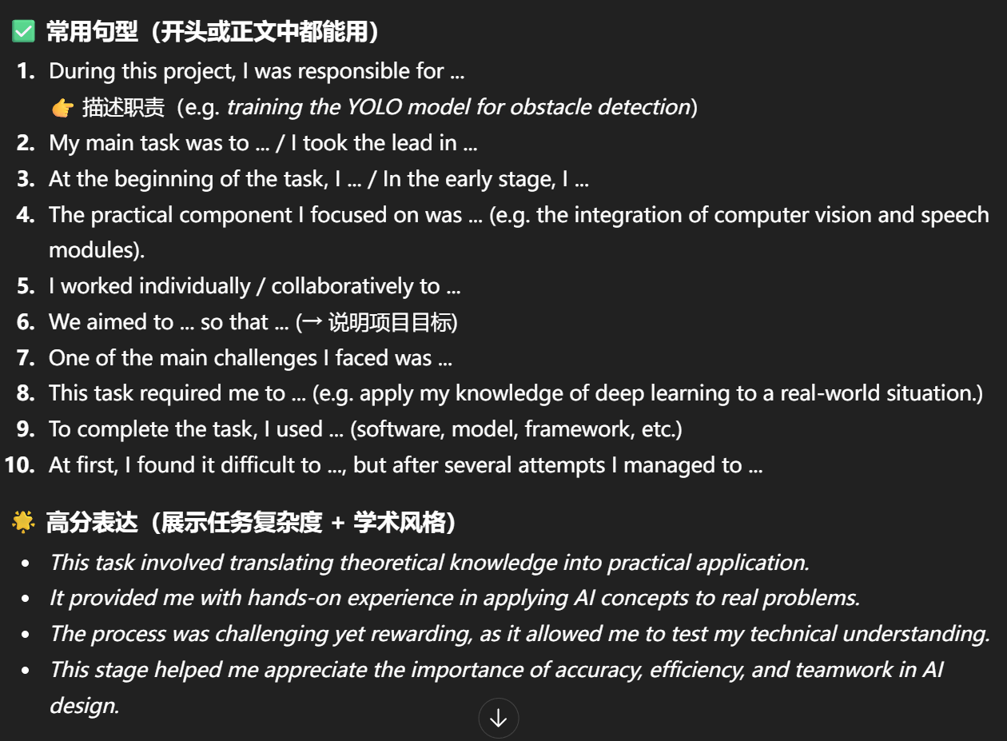
1.What - describe the fact

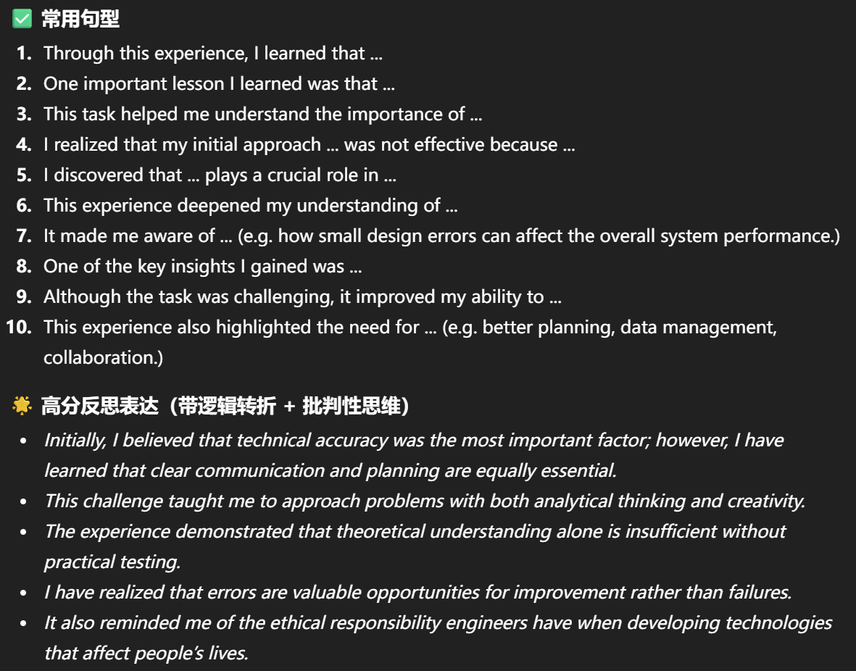
- So what - reflective analysis
- Now What
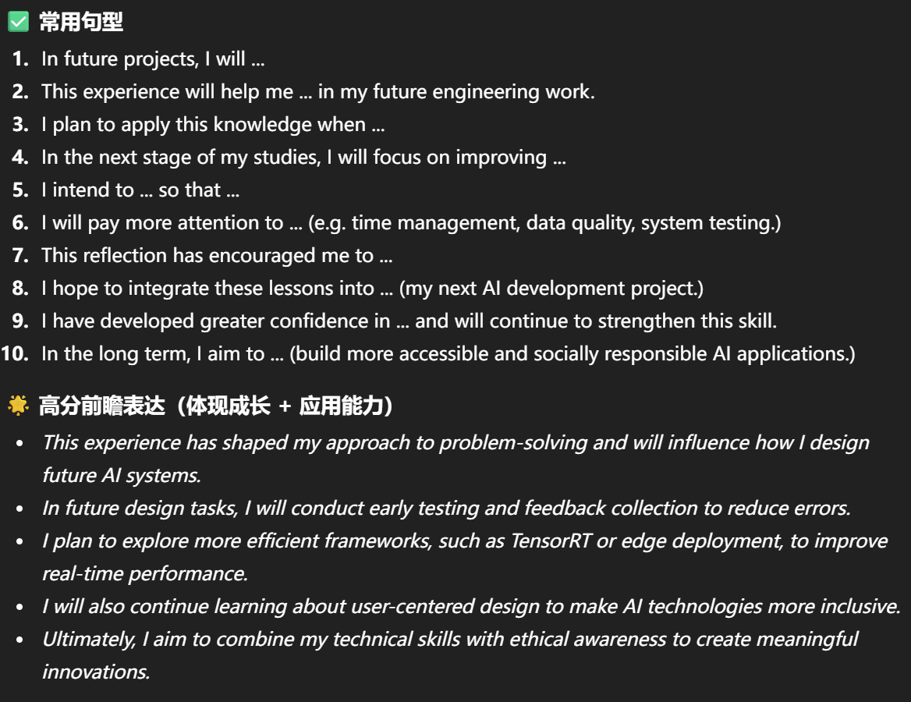
类型 | 可直接背诵句
项目介绍 | “Brighter is an AI-based wearable navigation device designed to help visually impaired users navigate safely and confidently.”
技术核心 | “The system combines computer vision, machine learning, and voice interaction to provide real-time feedback.”
动机 | “I want to connect my technical learning with social responsibility.”
技术发展 | “I plan to apply models like YOLOv8-Nano for lightweight real-time detection.”
批判分析 | “After comparing open-source projects, I realized the need to balance performance and efficiency.”
学习进展 | “Through reading papers and practicing on Kaggle, I improved my understanding of model training and evaluation.”
反思提升 | “This project taught me the importance of integrating software and hardware, and testing ideas in real-world conditions.”
未来计划 | “I will continue to explore embedded systems and refine the model to achieve better real-time interaction.”

What?
During the practical phase of my AI project “Brighter,” I focused on building a functional prototype that connects the computer vision model with the speech output module. My goal was to make the device recognize obstacles and provide real-time audio feedback to help visually impaired users navigate safely. I worked mainly on integrating YOLOv8-Nano, a lightweight object detection model, into a Raspberry Pi environment. Setting up the Linux system, installing PyTorch, and configuring the model to run efficiently on limited hardware took much longer than I expected. At first, the camera feed and voice output could not run smoothly together, which caused delays in the spoken alerts. I tested different optimization methods, such as reducing the image resolution and simplifying the processing loop. Gradually, I managed to make the system respond faster and give clear voice feedback when detecting nearby objects or traffic signs.
Another part of my work was testing the interaction design. I used simple voice commands such as “What’s in front of me?” and connected them to text-to-speech feedback. I also adjusted the voice timing to make the instructions sound natural. Although this was my first time connecting computer vision and speech modules in real time, the process helped me understand how AI can interact directly with users in daily life. Overall, this stage was challenging but also the most rewarding, because it transformed my ideas from previous reports into an actual working system.

So What?
Through this experience, I learned that building an AI application is not just about coding a model—it is about creating a complete system that can operate reliably in real environments. I realized that small delays in processing can make a big difference to user experience, especially for visually impaired people who depend on real-time feedback. This made me appreciate the importance of optimization, system testing, and human-centered design. It also deepened my understanding of how computer vision, natural language processing, and embedded systems must work together.
In addition, this task changed how I think about the relationship between theory and practice. In my earlier reflections, I mainly focused on model selection and algorithm performance. However, when I started implementing the project, I discovered that hardware limitations, noise, and lighting conditions can strongly influence results. I learned that designing for accessibility requires not only technical accuracy but also empathy for users’ needs. This practical experience helped me grow as an engineer who can balance innovation with social responsibility.

Now What?
In future projects, I will pay more attention to system efficiency and early-stage testing. I plan to explore faster frameworks such as TensorRT for real-time inference and continue improving my understanding of embedded AI deployment. I also hope to collaborate with peers in hardware engineering to design more compact and energy-efficient prototypes. Furthermore, I will conduct user testing to collect real feedback from visually impaired people, which will help refine the device for real-world use.
This project has strengthened my confidence in building AI systems that combine software and hardware effectively. I now understand that every technical decision—from model selection to interface design—affects the user’s safety and comfort. Moving forward, I aim to apply these lessons to future AI designs that promote accessibility, inclusion, and meaningful human–technology interaction. This experience not only improved my technical abilities but also reminded me why I started this project: to use AI for positive social impact.

