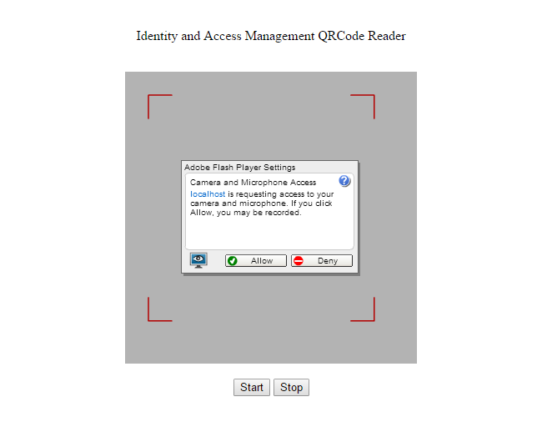

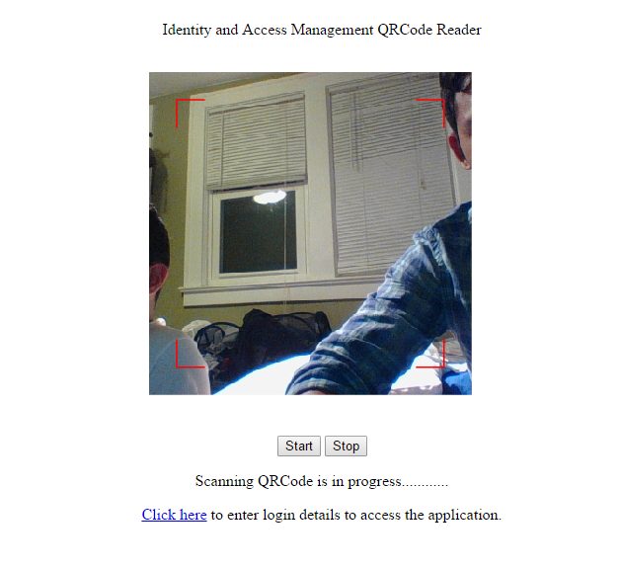

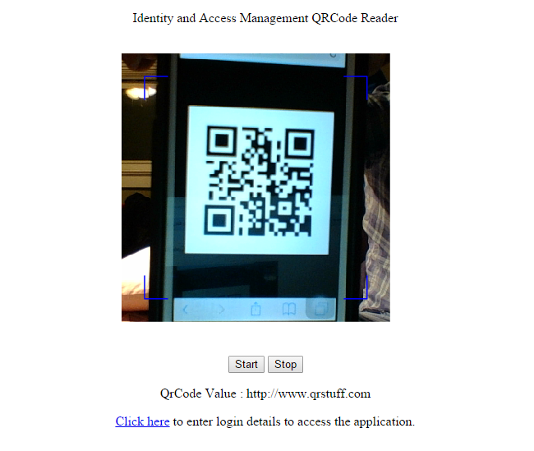

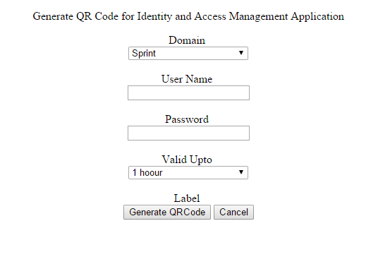

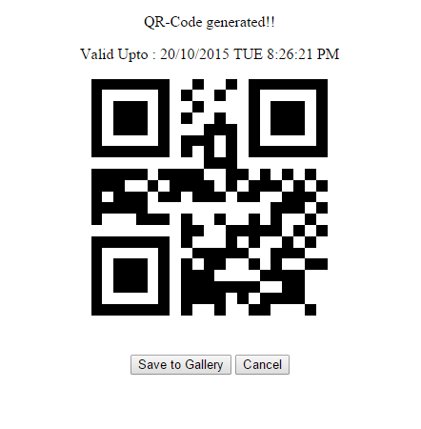

**Existing Services/API**

We used two Services for Identification management. The two services are listed below.

1. Generate QRCode by Google API
2. Read QRCode by Jquery Service
3. GeoLocation service

Generating QRCode: Google has provided the API for generating the qrcode online. The feature of this API is , we can embed the secret information into QRCode and later extracted from our web application.

Reading QRCode: JQuery have provided the jquery.qrcode service through which qrcode is read when it is scanned. It uses flash player to get started with the web camera. After camera starts it continuously searches for the qrcode. Once it gets the qrcode, the information is extracted and passed it to jquery code.

GeoLocation Service: We want to make sure, the qrcode is generated only when the user is in the allowed location. For this we use geolocation service and extract the user location(latitude and logitude). We calculate the range and if the user is in that range we will allow him to generate the qrcode.

**Detail Design of Services**

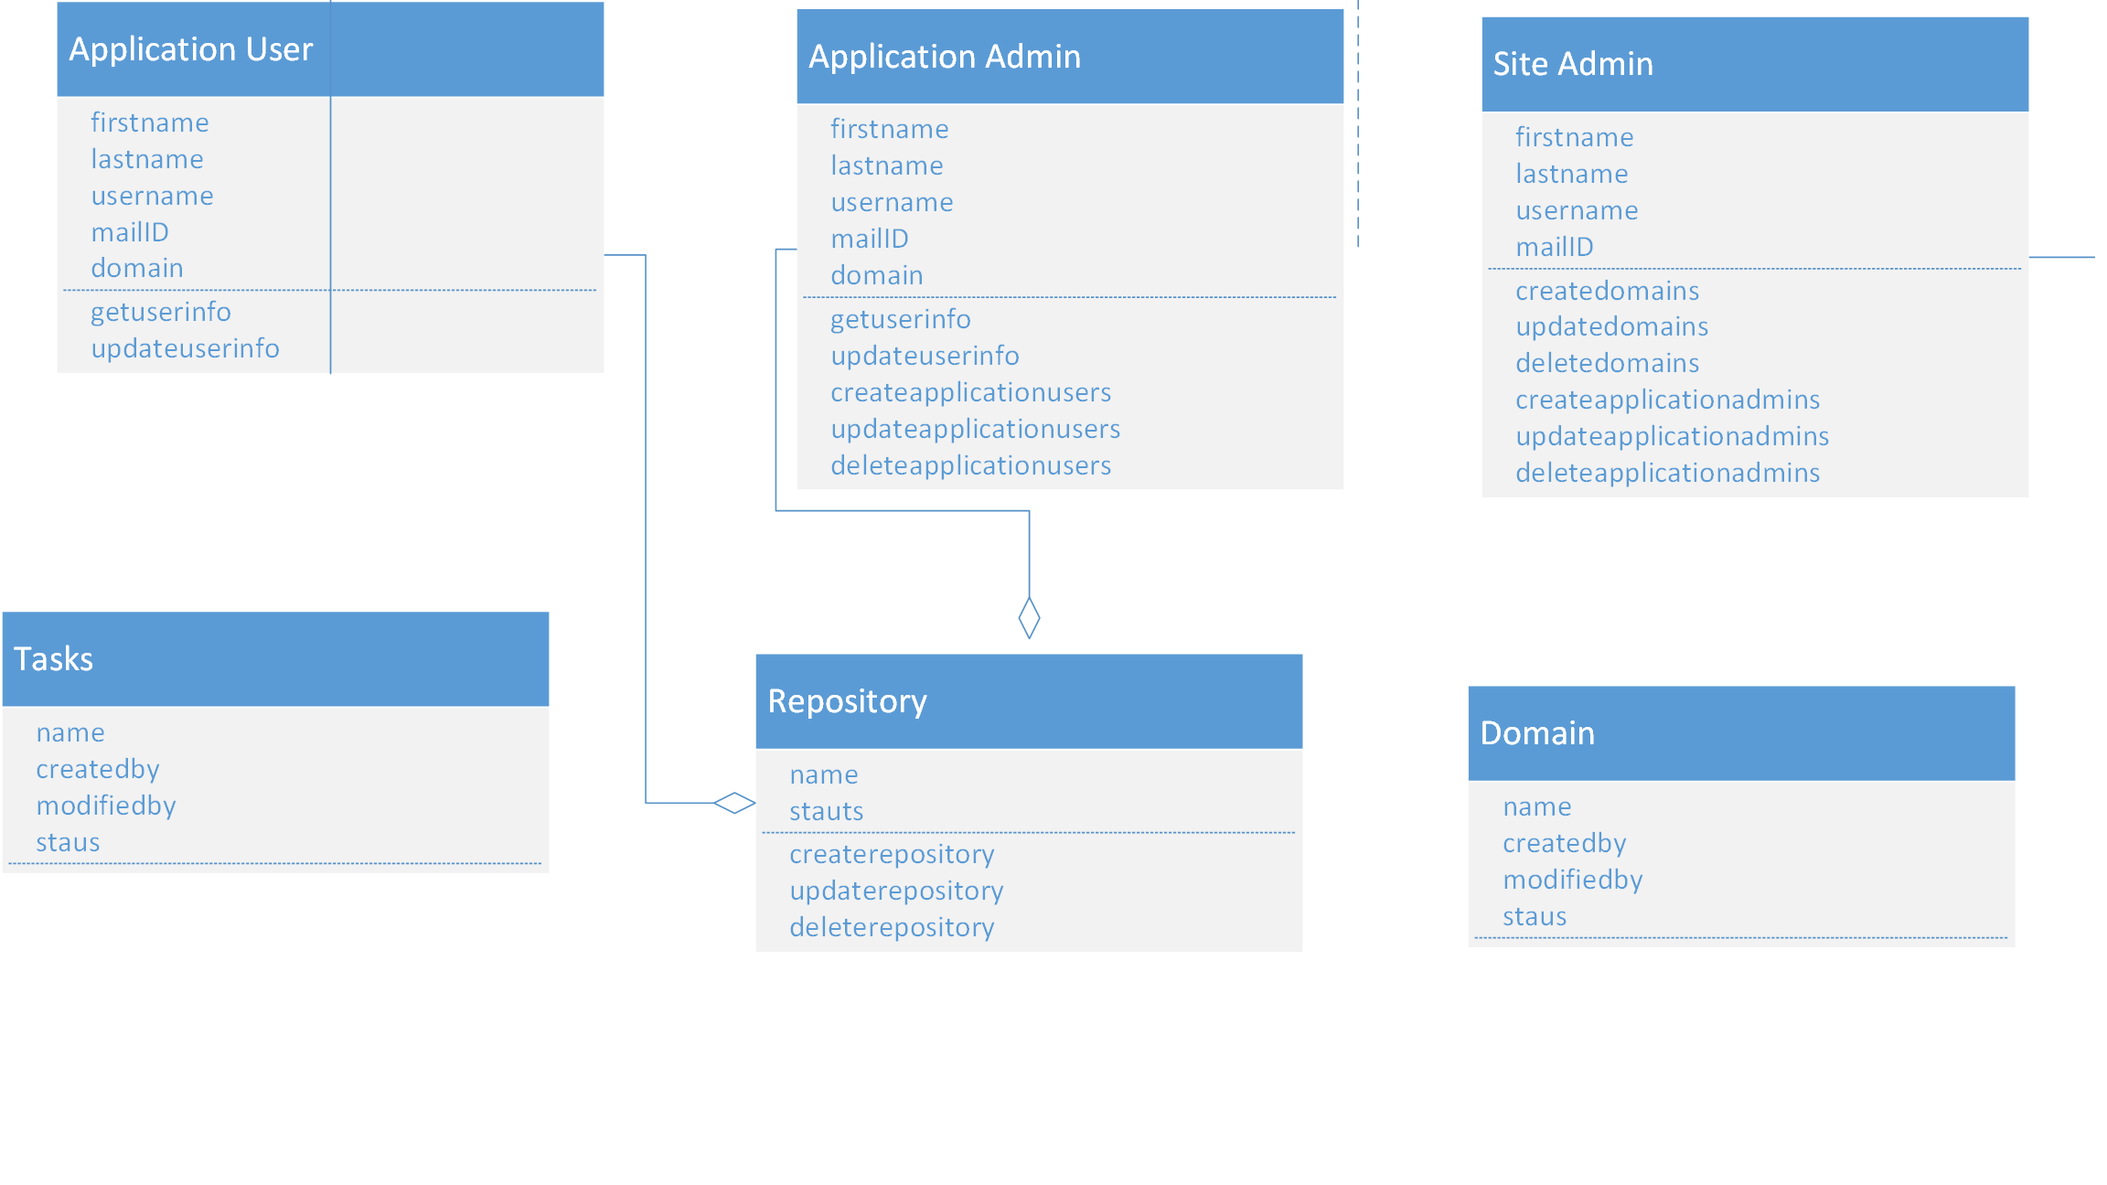

Use Case Scenarios

Scenario1: Application User first notifies the Application admin about his details. Application admin creates his details and username and temporary password will be sent to his email address. Application User logs into the mobile application for generating QRCode which is used in accessing the web application. User selects the domain and duration of time for which the qrcode has to be active for generating the qrcode. Once the qrcode is generated option is provided to save the qrcode to the local gallery which can be used for the feature purposes.

Scenario2: Application Admin is the one who has control over the particular domain. Application Admin can create users, update users, and create repositories which can be accessed over the domain. The main role the Application admin is setting the right access privileges to the corresponding users.

Scenario3: Site Admin, the one who is responsible for the creation of domains and the creation of application admins. The core part of application is handled by this admin. Whenever a change is required in all domains, the common place and the single change is enough in this core module.