Predicting Spotify Popularity of English Songs
from Audio Features and Lyrics

IS 507 Midterm Project Proposal
Team 13: Ya-Ciao Liang, Tsai-pei Yu
IS 507 Data, Statistical Models, and Information (UIUC iSchool, Fall 2026) Midterm Presentation: October 13, 2026
1. Motivation
We often listen to music on Spotify and hear songs that become popular on Instagram Reels. Some songs have very simple lyrics, but they are used in many short videos and become popular in a short time. This makes us wonder: Is a song's popularity mainly related to how it sounds, such as its rhythm and energy? Or can the lyrics also help explain why a song becomes popular? We want to study whether lyrics can give us useful information about song popularity beyond audio features.
- The cold-start problem: When a new song is released, there may not be enough listening data to understand its popularity. However, we can already get information from its audio and lyrics. If lyrics can improve predictions when we already know the audio features, music recommendation systems may have another useful source of information.
- For singers and record labels: Learning about the relationship between song features and popularity may help us understand what types of songs are more popular. For example, we can study whether longer or more repetitive lyrics are related to higher popularity.
2. Research Problem
2.1 What Are We Trying to Predict?
Table 1. Prediction Task
Item | Details | Simple Explanation
Target (Y) | Song popularity, from 1 to 100 | Predict a song's popularity score
Audio features (X) | 9 features, such as danceability, energy, and loudness | Describe how a song sounds
Lyrics features (X) | 10 basic features, such as length, repetition, and sentiment, plus TF-IDF for 20,000 words | Describe the lyrics and the words used
Main evaluation metric | MAE; we also use RMSE and R² | Measure how close our predictions are to the actual scores

Main Research Question: Which carries more predictive information about Spotify song popularity—audio features or lyrics—and how large is the gap?
We will study five smaller questions:
SQ1: Which audio features are most strongly associated with popularity? (Midterm)
SQ2: Which lyric features (length, repetition, sentiment, keywords) are associated with popularity? (Midterm)
SQ3: Does an audio-only or a lyrics-only model predict popularity better, and by how much? Does combining them help? (Final)
SQ4: Do popularity drivers differ by genre? Which genres are hardest to predict? (Final)
SQ5: How does popularity differ across release eras (2009–2025)? (Final)
Research Hypothesis. H1: We expect both the audio-only model and the lyrics-only model to perform better than the baseline model. We also expect the audio-only model to perform better than the lyrics-only model. In other words, we think how a song sounds may be more useful for predicting popularity than its lyrics alone. However, we still need to test whether lyrics can improve predictions when we add them to audio features.
3. Related Work
Previous studies have used audio features, lyrics, or both to study song popularity. However, these studies used different datasets and prediction goals. Our study will compare these types of information using the same set of songs.
- Audio Features Only.
Previous work has often focused on audio features. Jiang (2024), Araujo (2020), and Herremans et al. (2014) report that features such as danceability, energy, and loudness can be useful, while the most and least popular songs are often harder to predict.
- Lyrics Only.
Singhi and Brown (2014) used 31 rhyme, syllable, and meter features to distinguish hit songs from non-hits, showing that lyrics can contain useful popularity-related information even without audio features.
- Audio Features and Lyrics Together.
Dhanaraj and Logan (2005) found lyrics slightly more useful than audio for identifying hits, but combining both did not produce a large improvement. Zhao et al. (2023) reported that a model using Spotify, lyrics, and other song information performed best for predicting Billboard top-ten songs. Prevedello et al. (2024) found that lyric embeddings combined with other lyric and audio features improved early popularity prediction.
4. Data
4.1 What Does Our Data Look Like?
Table 2. Data Overview
Item | Details
Dataset | 550K Spotify Songs: Audio, Lyrics & Genres by Serkan Tüysüz on Kaggle
Data sources | Audio features and basic song information from Spotify; lyrics from LRCLIB, a public lyrics database maintained by its community
Raw data | 550,622 song records with 24 columns
After cleaning | 171,510 songs for audio analysis
Lyrics dataset | 171,096 songs with usable English lyrics
Each row | One song after we combine different versions of the same song
Data types | Numbers, genres, and lyrics text
Excluded information | Artist average popularity and follower count

We do not include artist average popularity or follower count because these values may be closely related to the popularity score we want to predict. Including them could give the model information that makes the prediction look better than it really is.
What Are the Nine Audio Features? We use nine features to describe how a song sounds. Danceability: How suitable the song is for
dancing. Energy: How intense and active the song sounds. Loudness: How loud the song is. Speechiness: How much the song sounds like speech, such as rap. Acousticness: How likely the song is to use acoustic instruments. Instrumentalness: How likely the song is to have little or no singing. Liveness: How likely the recording is to come from a live performance. Valence: How positive or happy the song sounds. Tempo: The speed of the music, measured in beats per minute (BPM). Except for loudness and tempo, the audio features are measured on a scale from 0 to 1.

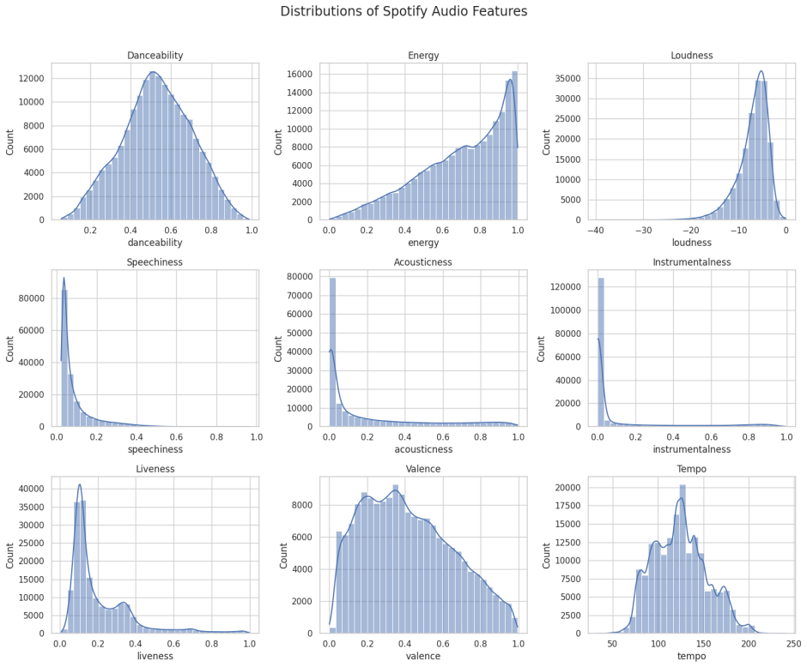
Figure 1. Audio Feature Distributions
What Are the Lyrics Features? We use 10 basic lyrics features in three groups.
- 1. Length: Total number of words. Number of lines. Average number of words per line. These features help us understand how long the lyrics are.
- 2. Repetition: Unique-word ratio, which measures how many different words are used. Line repetition rate, which measures how often lines are repeated. Share of the most repeated line. Compressibility, which measures how much the lyrics can be shortened by removing repeated patterns. These features help us understand whether the lyrics use many different words or repeat the same words and lines.
- 3. Sentiment: Average sentiment score. Percentage of positive words. Percentage of negative words. Sentiment means whether the words express positive or negative feelings. We use a tool called VADER to estimate sentiment from the lyrics.
What Is TF-IDF? We also use TF-IDF to study word choice. TF-IDF gives each word a score based on how often it appears in one song and how common it is across all songs. A word receives a higher score when it appears often in one song but is less common in other songs. We use the 20,000 words selected by our text-processing method. This allows us to study more than simple features such as song length and repetition.
4.2 Data Cleaning
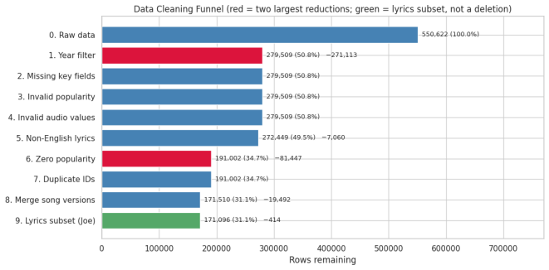
Figure 2. Data Cleaning Process
The original dataset contains 550,622 records. Each record represents a Spotify track version, so the same song may appear more than once as an album version, live version, remaster, or remix. We cleaned the data in nine steps to improve data quality, reduce duplicate songs, and make our model evaluation more reliable.
Step 1. Keep Songs Released from 2009 to 2025
We focus on songs released from 2009 to 2025. This period allows us to study songs released after Spotify began operating. This step removes 271,113 records, reducing the dataset from 550,622 to 279,509 records. It is the largest reduction in our cleaning process.
Step 2. Check Missing Values
We check for missing values in the dataset. This check does not remove any additional records, so the dataset still contains 279,509 records.
Step 3. Check Popularity Scores
We check for invalid popularity scores. For example, popularity scores should be between 0 and 100. This check does not remove any additional records, so the dataset still contains 279,509 records.
Step 4. Check Audio Feature Values
We check for unreasonable audio feature values. Audio features should have reasonable values. This check does not remove any additional records, so the dataset still contains 279,509 records.
Step 5. Exclude Non-English Lyrics
Our lyrics analysis focuses on English because our sentiment analysis tool mainly works with English text. We remove 7,060 records with non-English lyrics, leaving 272,449 records.
Step 6. Exclude Songs with Zero Popularity
The dataset contains 81,447 records with a popularity score of zero. We cannot tell whether these scores mean that the songs received no attention or whether they reflect how Spotify reports popularity. To avoid mixing these cases with songs that have positive scores, we exclude zero-popularity records from our main analysis. Only 20.7% of the zero-popularity records have another version of the same song with a popularity score above zero. This means that duplicate versions cannot fully explain the zero scores. After removing these records, we have 191,002 records. In the final report, we will add the zero-popularity songs back and check whether our results change.
Step 7. Check Duplicate Track IDs
We check for duplicate Spotify track IDs. This check does not remove any additional records, so the dataset still contains 191,002 records.
Step 8. Combine Different Versions of the Same Song
The same song may appear as an album version, live version, remaster, or remix. If different versions of the same song appear in both the training and test sets, the model may appear more accurate because it has already seen very similar songs during training. To reduce this problem, we combine different versions of the same song into one record. This removes 19,492 records and leaves 171,510 songs for audio analysis.
Step 9. Create the English Lyrics Dataset
For the lyrics analysis, we keep songs with usable English lyrics. Songs with fewer than 20 words are excluded because they may not contain enough text for a meaningful analysis. We end up with 171,096 songs for lyrics analysis, which is 414 fewer than the audio dataset. These 414 songs remain in the audio dataset. We exclude them only from the lyrics analysis.
Summary of Data Cleaning. We reduce the original 550,622 records to 171,510 songs for audio analysis. Of these, 171,096 have usable English lyrics. The largest reductions come from the release-year filter and the removal of zero-popularity records. However, excluding songs with zero popularity may affect how well our findings apply to all Spotify songs. We will check this issue in the final stage.
4.3 Challenges We Expect
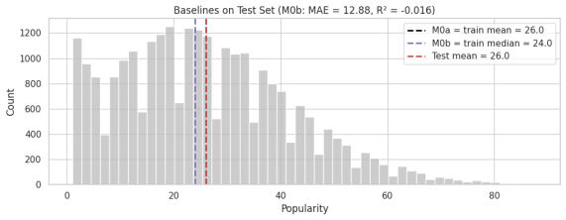
Figure 3. Popularity on the Test Set
Figure 3 shows that most songs in the test set have popularity scores between roughly 1 and 40, while only a small number have very high scores. The dashed lines show the training mean (26), the training median (24), and the test mean (26). We expect three main challenges.
- Challenge 1. Very Popular Songs Are Hard to Predict. Most songs have relatively low popularity scores, while very popular songs are less common. A model may perform well for most songs but still make large errors for popular songs. We will therefore examine prediction errors for highly popular songs separately.
- Challenge 2. The Model May Learn About Artists Instead of Lyrics. In the primary random split, 92.2% of test songs have a main artist who also appears in the training set. This means the model may learn an artist's usual word choices instead of learning patterns that apply to songs in general. In the final stage, we will also test the model using an artist-based split, where artists in the test set do not appear in the training set. This will help us check whether lyrics still improve predictions for artists the model has not seen before.
- Challenge 3. Too Many Word Features May Cause Overfitting. Our TF-IDF data contains 20,000 word features. Most songs use only a small number of these words, so most values are zero. A model may learn details that are specific to the training data instead of finding patterns that also work for new songs. This problem is called overfitting. We use Ridge Regression to reduce this risk. Some audio features are also closely related. For example, energy and loudness have a correlation of 0.78. This means that songs with higher energy scores often also have higher loudness scores. Their relationship makes it harder to understand the effect of each feature separately. We will consider these relationships when interpreting the model results.
- Preliminary Results
We have completed the first data analysis and the lyrics-only model experiments for the midterm. The figures in this section come from
our Google Colab notebook. A correlation close to zero means that two variables have little or no clear linear or monotonic relationship,
depending on the correlation method used. In this report, we describe correlations with an absolute value below 0.3 as weak. These
results help us understand the data, but they do not yet tell us whether adding lyrics improves prediction accuracy. We will answer that
question through the model comparison in the final stage.
5.1 Lyrics Features and Lyrics Models
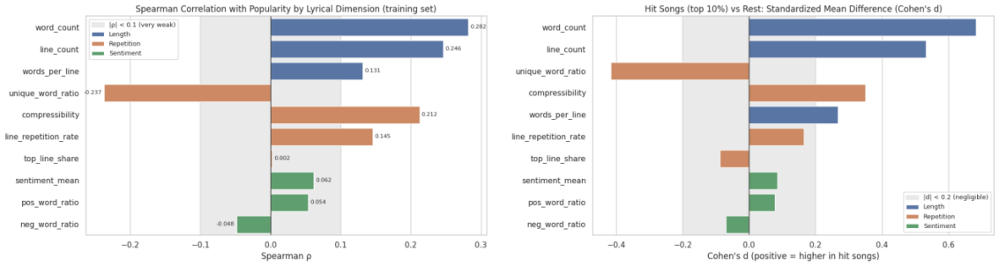
Figure 4. Relationships Between Lyrics Features and Popularity
The left side shows the Spearman correlation between the 10 basic lyrics features and popularity. The right side compares the top 10%
most popular songs with the other songs using Cohen's d. A value farther to the right means that the feature is higher among the most popular songs.
- Finding 1. Longer Lyrics Are Related to Higher Popularity. Total word count has a Spearman correlation of +0.28 with popularity. This is the strongest relationship among the basic lyrics features we examined. The difference in word count between the top 10% most popular songs and other songs has a Cohen's d of 0.68, which is a medium-sized difference. This suggests that more popular songs tend to have longer lyrics in our dataset. However, this does not mean that making a song longer will make it more popular.
- Finding 2. More Repetitive Lyrics May Have a Small Advantage. The unique-word ratio has a correlation of −0.24 with popularity. This means that songs using a wider variety of words tend to have slightly lower popularity scores. Put another way, songs that repeat words more often may have a small advantage. However, this relationship is weak, so we should not treat it as a strong rule about popular songs.
- Finding 3. Simple Sentiment Features Have Weak Relationships with Popularity. The positive-word ratio has a correlation of about +0.05, while the negative-word ratio has a correlation of about −0.05. Both values are close to zero. This suggests that the percentage of positive or negative words alone does not explain much about popularity in our data. More advanced methods may be needed to understand the meaning and context of lyrics.
5.2 Audio Features
Finding 1. Danceability Has the Strongest Positive Relationship with Popularity
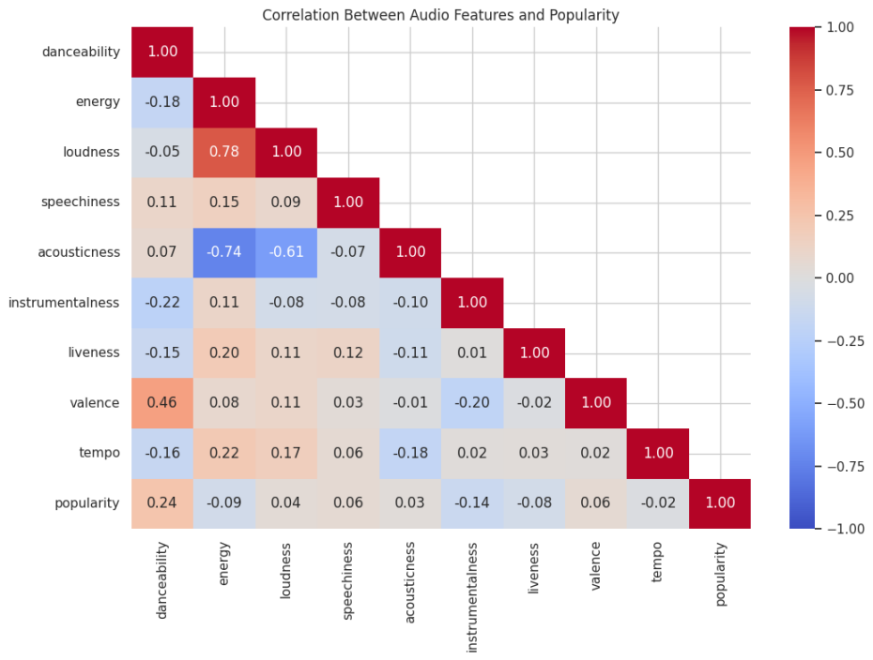
Figure 5. Correlation Between Audio Features
Correlation measures how two variables change in relation to each other. Its value ranges from -1 to +1. A positive value means two
variables tend to increase together, while a negative value means that one tends to decrease as the other increases. A value close to zero
indicates little or no linear relationship.

Among the nine audio features, danceability has the strongest positive correlation with popularity, at 0.24. This suggests that songs with
higher danceability scores tend to have higher popularity scores in our dataset. However, the relationship is not very strong, so
danceability alone cannot explain why a song becomes popular.

Instrumentalness has a negative correlation with popularity, at -0.14. This suggests that songs with stronger instrumental characteristics
tend to have lower popularity scores in our dataset. However, this does not mean instrumental music cannot be popular.Tempo has a
correlation of -0.02 with popularity, which is very close to zero. This indicates almost no linear relationship between tempo and
popularity. In other words, faster songs are not necessarily more popular than slower songs.

We also find a strong positive correlation of 0.78 between energy and loudness. This means that songs with higher energy values often
also have higher loudness values. Therefore, some audio features are closely related to each other rather than describing completely
separate characteristics.

Overall, danceability has the strongest positive correlation with popularity among the nine features, instrumentalness has a negative
correlation, and tempo has almost no linear correlation. Energy and loudness are also strongly related to each other. However,
correlation does not mean causation. These results describe patterns in our dataset, but they do not prove that any audio feature directly
causes a song to become popular.
6. Research Methods and Plan
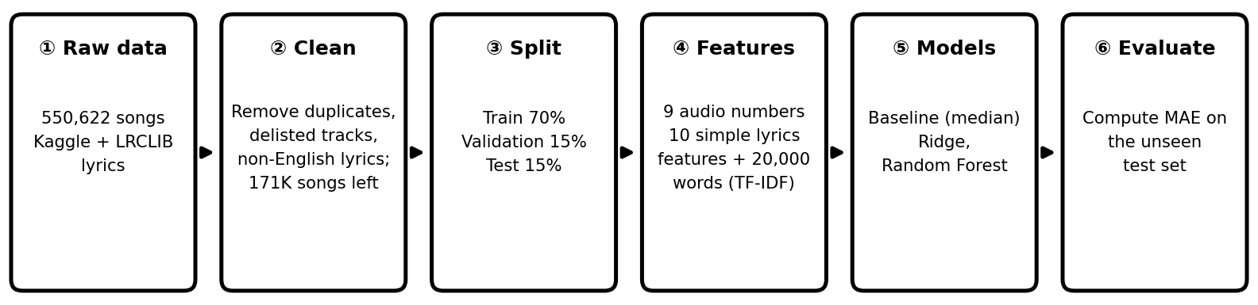
Figure 6. Research Workflow
6.1 Model Selection
We will compare several model variants built from three main approaches: a median baseline, Ridge Regression, and Random Forest.
Audio-only and lyrics-only models are compared separately, and the final stage will also test a combined Audio + Lyrics model.
Table 3. Model Plan
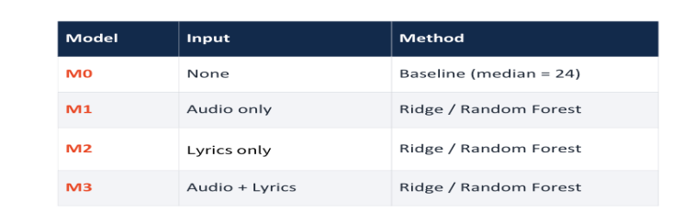
The baseline model predicts the same popularity score for every song. We use the median score of the training data, which is 24. This
provides a simple starting point for comparison. Any advanced model should make more accurate predictions to show that it can learn
useful patterns from the data.
Ridge Regression predicts popularity by combining different song features, such as audio characteristics and lyrics. It also limits the
size of the weights assigned to these features. This is useful because some features may contain similar information, and our lyrics
data includes a large number of word features. Ridge Regression is relatively simple and helps us understand how different features
relate to popularity.
Random Forest uses many decision trees to make predictions. Unlike Ridge Regression, it can learn more complex relationships
between features. For example, the relationship between lyrics and popularity might differ depending on a song's audio characteristics.
We will test whether Random Forest can capture these patterns and improve prediction accuracy.
By comparing these model variants, we can measure how much predictive information comes from audio features versus lyrics and
whether more complex models improve on the simple baseline.
6.2 Model Training and Evaluation
We divide our data into three groups. The training set is used to teach the models to recognize patterns. The validation set helps us
choose the best model settings. Finally, the test set is used to evaluate the models' performance on songs they have not used for
training or model selection. We will use Mean Absolute Error (MAE) as our main evaluation metric. MAE measures the average
difference between predicted and actual popularity scores. A lower MAE means the predictions are closer to the actual scores. To
make the comparison fair, we will also take steps to prevent data leakage. This means preventing the models from using information
during training that would not be available in a real prediction situation. For example, different versions of the same song should not
be placed in different data groups. We will also avoid using artist popularity and follower counts as input features because they may
provide information closely related to the popularity we want to predict.
6.3 Final Project Plan
Our main goal is to determine whether audio features or lyrics carry more predictive information about Spotify popularity, how large
the difference is, and whether combining both sources improves prediction.First, we will compare audio-only and lyrics-only models
on the same evaluation framework. We will then compare a combined Audio + Lyrics model with the single-source models to test
whether combining both types of information reduces prediction error. Next, we will conduct additional tests to check whether our
findings remain reliable. These tests will include predicting songs by artists not seen during training and predicting newer songs using
older songs for training. We will also examine whether our results change when we include songs with zero popularity scores or use a
different method to handle multiple versions of the same song. Finally, we will compare results across different music genres and
release periods to explore whether the models perform differently for different types of songs. Overall, our goal is to quantify the
predictive gap between audio features and lyrics, test whether combining them helps, and check whether these conclusions remain
reliable under different testing conditions.

