WPLN Speaking

Familiarisation Test – SET 1

Written Assessment Instruction to Candidate
Batch no:
- This is a closed book individual test.
- Written test time is 12 Minutes.
- Submit your answers on the answer sheet provided.

Candidate Name  (As in NRIC/WP) |  | Assessor Name
Candidate  Signature |  | Assessor Signature
Date |  | Date

8a. WPLN Speaking Test 1 (from British council)
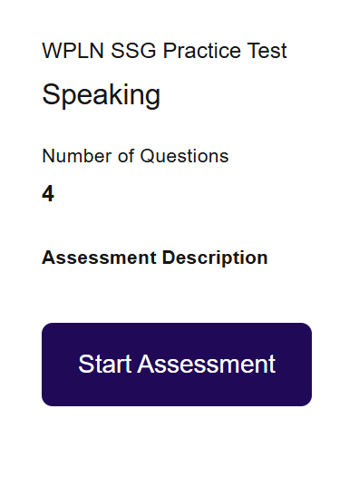

https://www.britishcouncil.sg/exam/wpln/prepare

Speaking instructions
You will answer some questions about yourself and then do three short speaking tasks.
Listen to the instructions and speak clearly into your microphone when you hear the signal.
Each part of the test will appear automatically.
The test will take about 12 minutes.

When you click on the next button, the test will begin.

Prompt 1 of 4
Part One – In this part, I am going to ask you three short questions about yourself and your interests. You will have 30 seconds to reply to each question.
Begin speaking when you hear this sound.
Part 1 of 3
Please tell me about a famous place in your country.

Please tell me about the last thing you saw on television.

Please tell me about your favorite film.

Question 2 of 4
Part Two – In this part, I’m going to ask you to describe a picture. Then I will ask you two questions about it. You will have 45 seconds for each response.
Begin speaking when you hear this sound.



Describe this picture.

Tell me about the time you gave or received a gift.

Why is it important to give people gifts on special occasions?

Question 3 of 4
Part Three – In this part, I’m going to ask you to compare two pictures, and I will then ask you two questions about them. You will have 45 seconds for each response.
Begin speaking when you hear this sound.


Tell me what you see in the two pictures.

What would it be like to work in these two places?

Which of these two places would you prefer to work in? Why?

Question 4 of 4
Part Four – In this part, I’m going to show you a picture and ask you three questions. You will have one minute to think about your answers before you start speaking. You will have to minutes to answer all three questions.
Begin speaking when you hear this sound. Look at this photograph.


Tell me about a time when you visited a very tall building.
How did you feel about it?
Why do you think so many cities have tall buildings?
You now have one minute to think about your answers. You can make notes if you wish.

--------------------------------------------------End----------------------------------------------

