WPLN Listening

Familiarisation Test – SET 1

Written Assessment Instruction to Candidate

- This is a closed book individual test.
Batch no:
- There is a total of 5 questions in the test.
- Written test time is 35 Minutes.
- Submit your answers on the answer sheet provided.

Question No | Marking Criteria | Total Marks | Marks Obtained
Question 1-10 | 1 Mark each correct answer | 10
Question 11 -13 | 2 Marks each correct answer | 6
Question 14 | 3 Marks each correct answer | 12
Question 15 | 2.5 Marks each correct answer | 10
Question16 | 3 Marks each correct answer | 6
Question 17 | 3 Marks each correct answer | 6
 | Total Marks | 50

Estimated Levels
Marks: 0 – 10 Level 1
Marks: 11 – 17 Level 2
Marks: 18 – 23 Level 3
Marks: 24 – 28 Level 4
Marks: 29 – 33 Level 5
Marks: 34 – 39 Level 6
Marks: 40 – 44 Level 7
Marks: 45 – 50 Level 8

Candidate Name  (As in NRIC/WP) |  | Assessor Name
Candidate  Signature |  | Assessor Signature
Date |  | Date

6a. WPLN Listening Practice Test 1 (from British council)
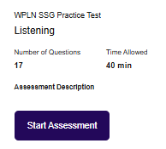

Listening instructions
You will listen to seventeen recordings.
Double Click on the ICON inside the box PLAY button to listen to each recording.
You have 40 minutes to complete the test.
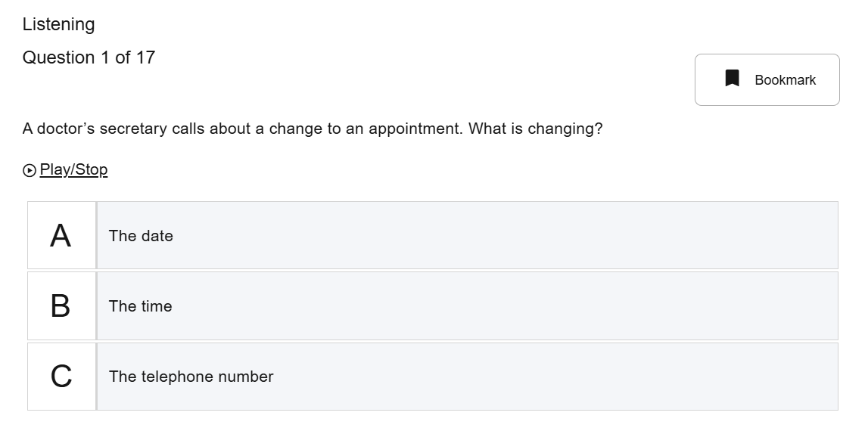
When you click on the next button, the test will begin. You can tick at the correct answer for the question 1 to13.

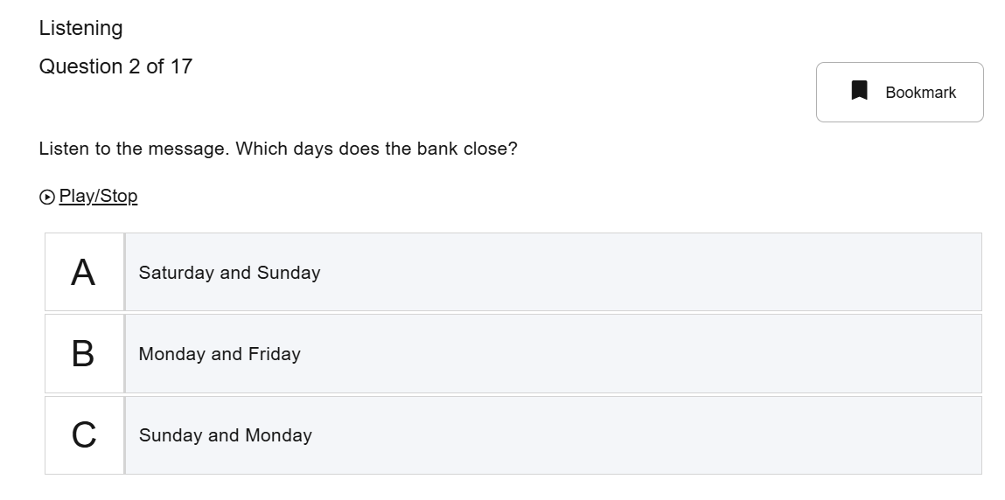
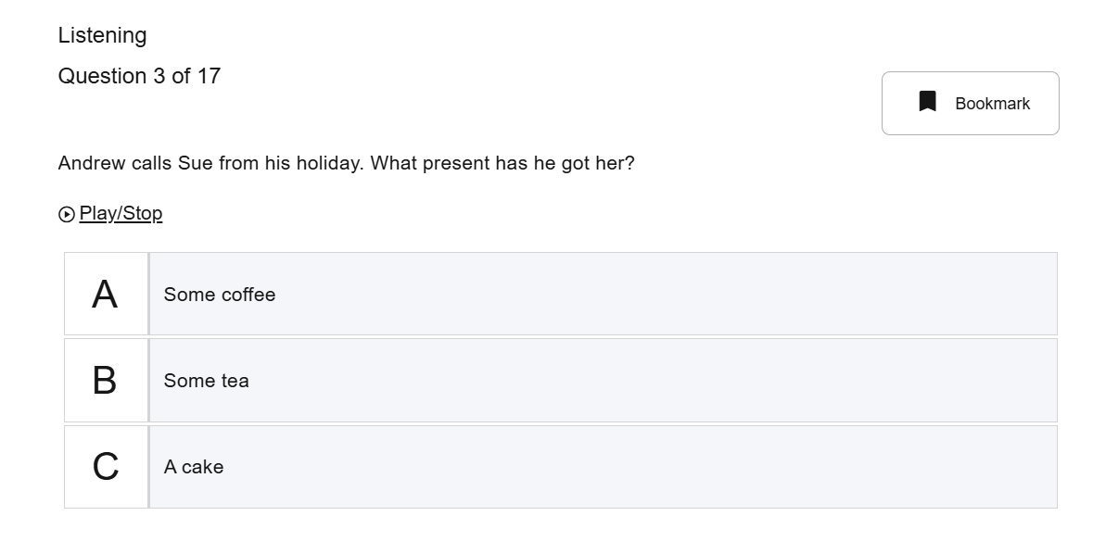
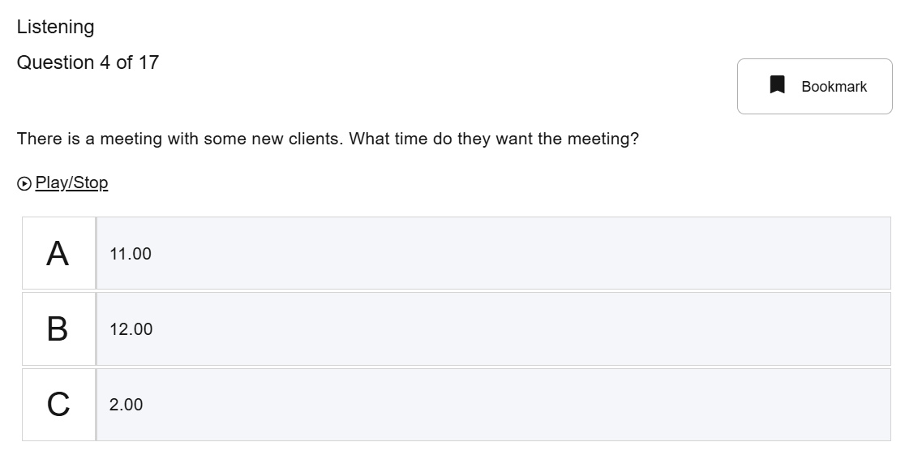
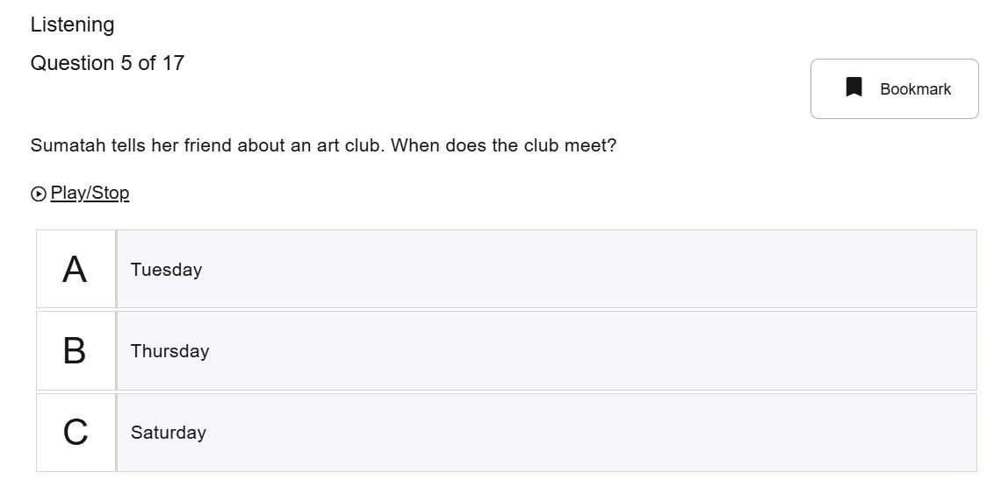

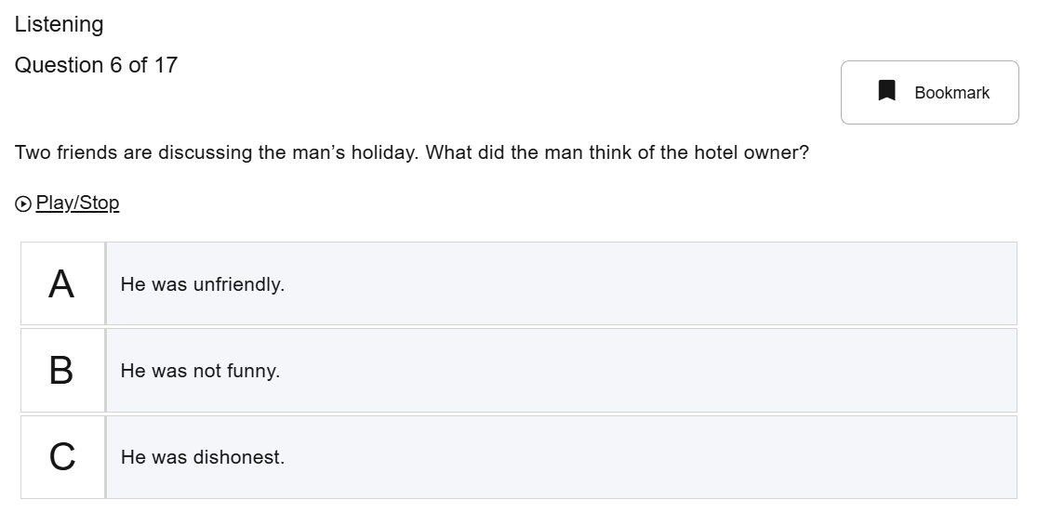
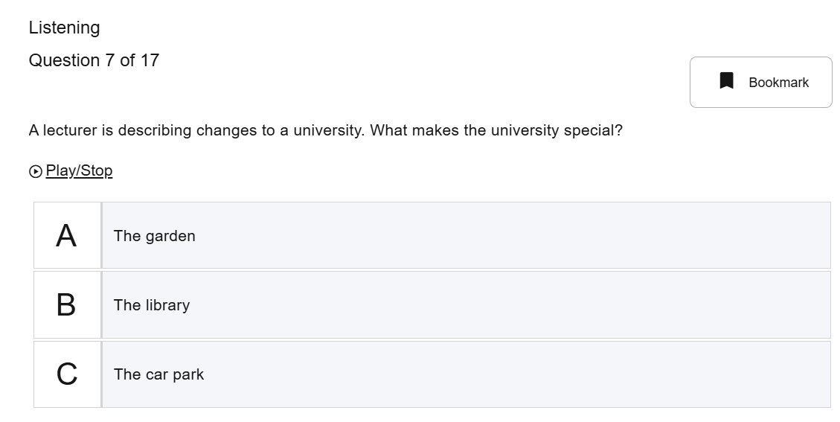
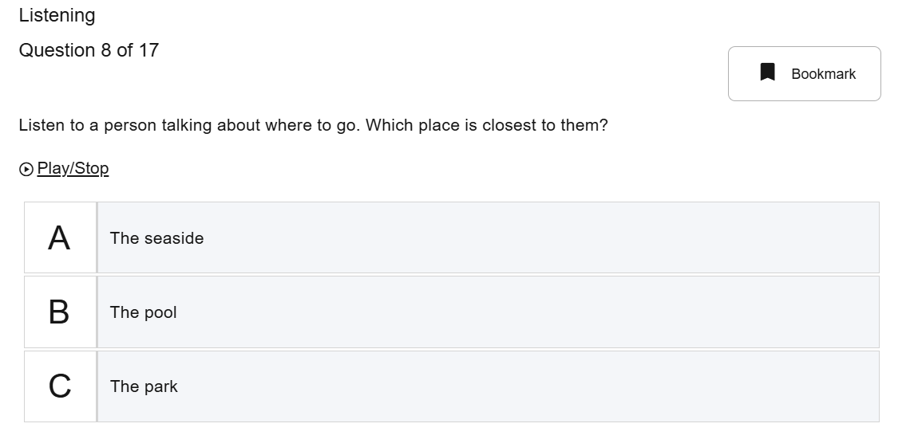

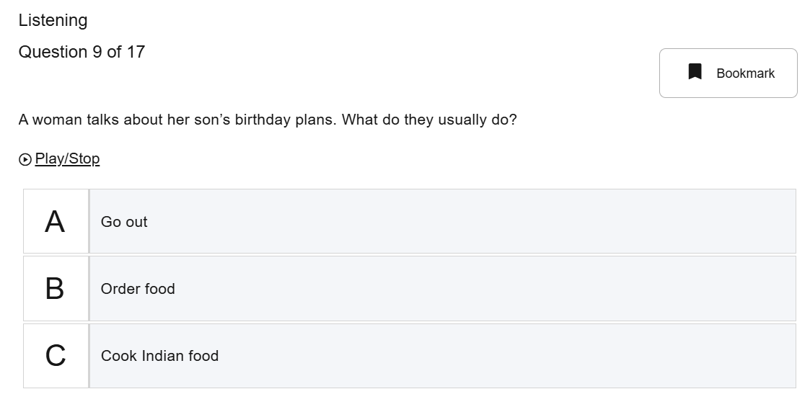
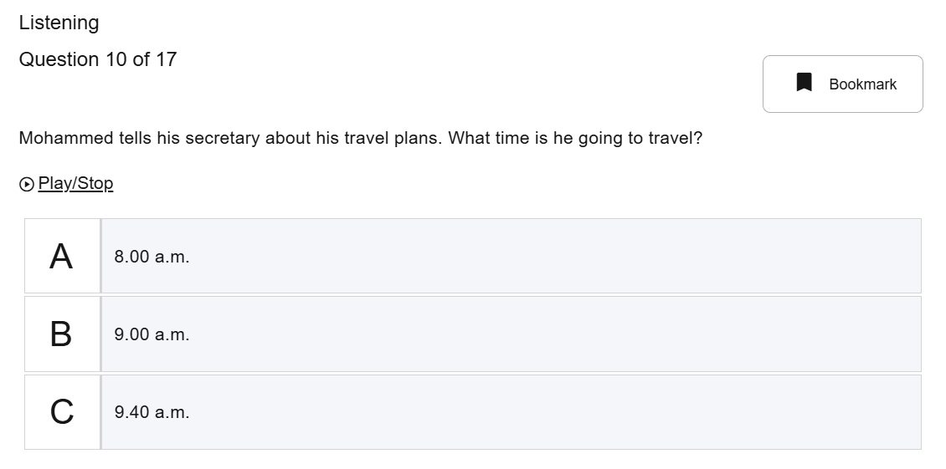
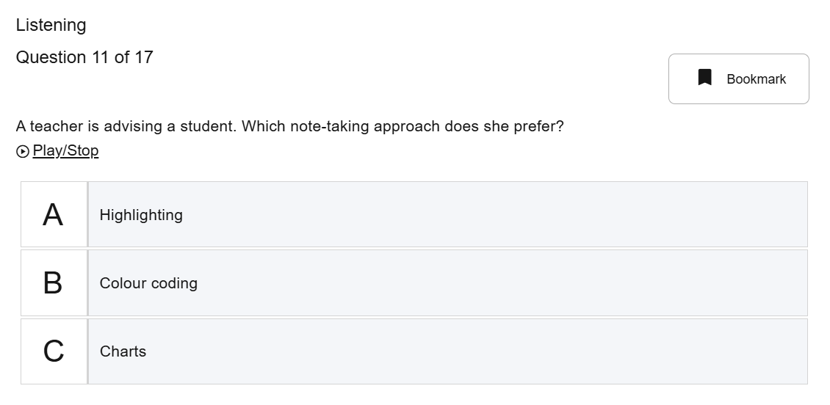

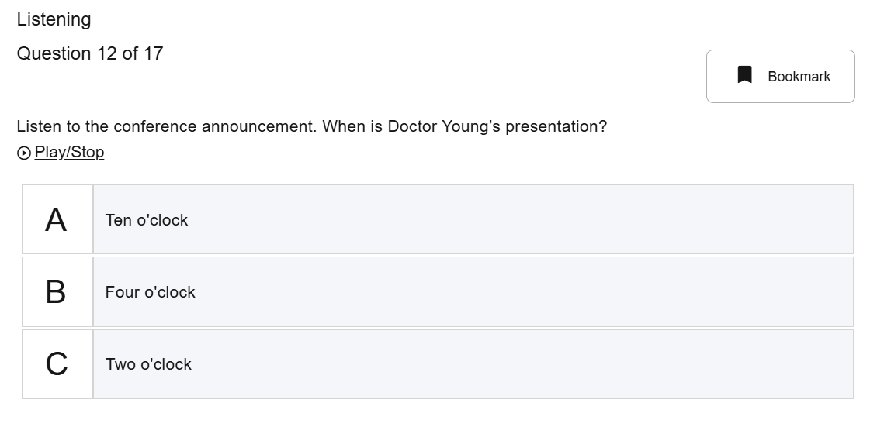
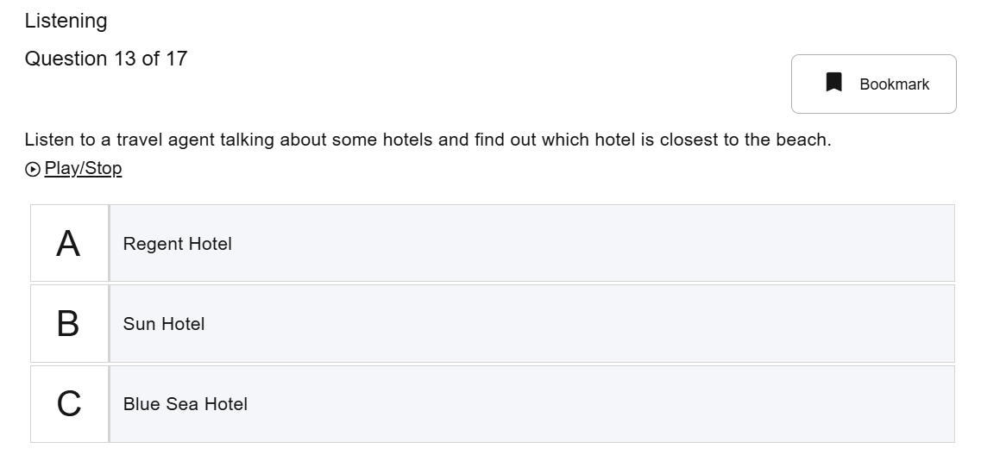

Write the answer in the box.
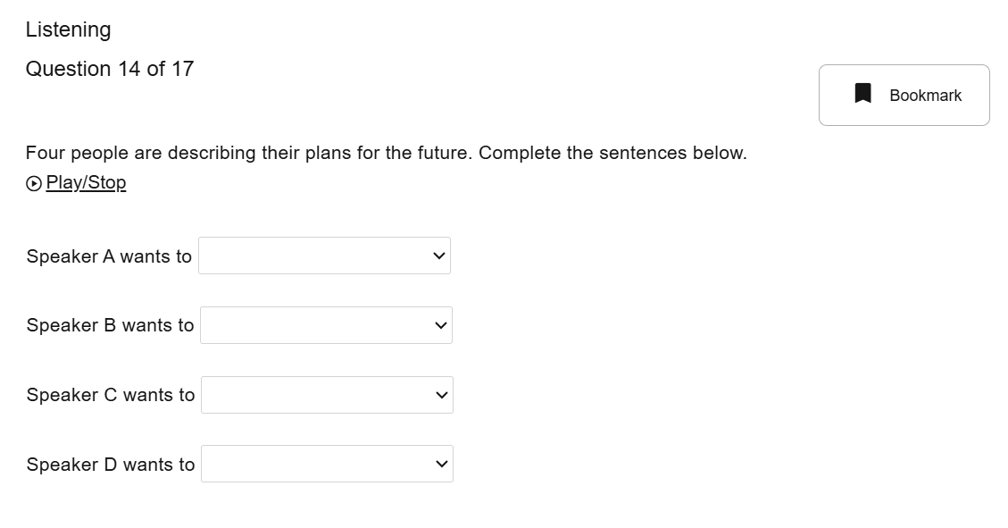



Write the answer in the box.
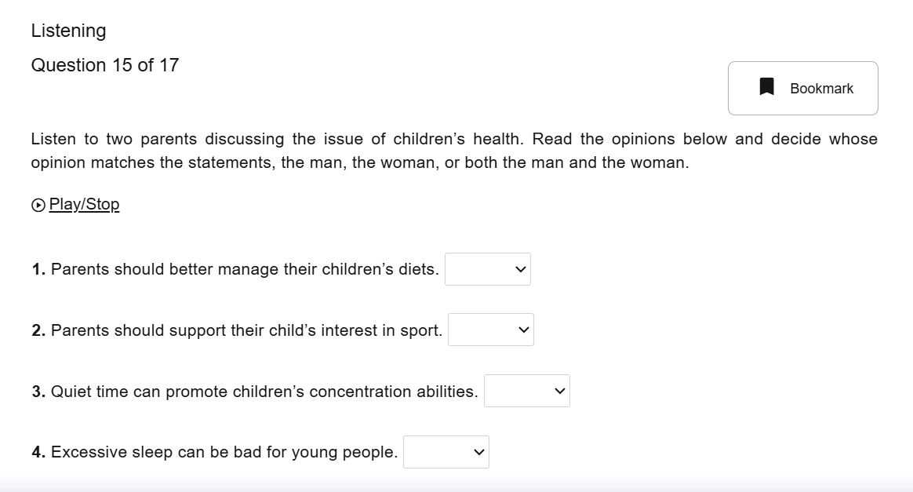


You can tick at the correct answer for the question 16 to17.
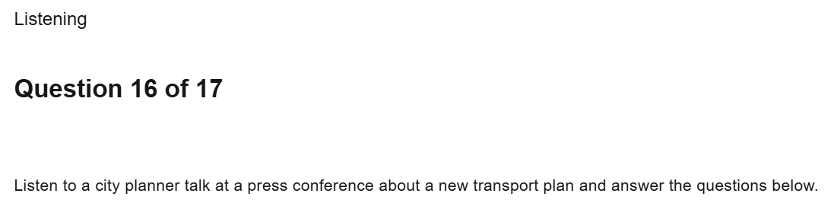
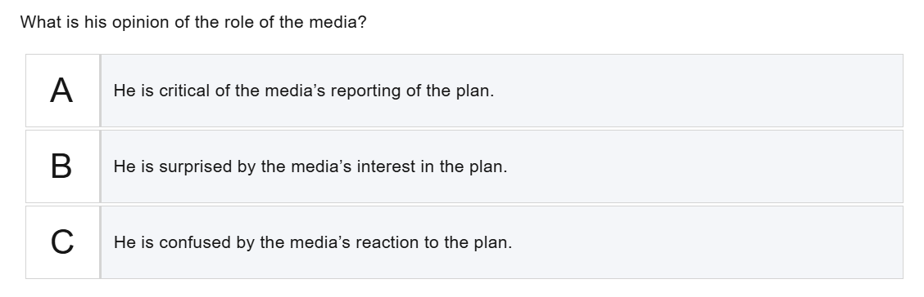
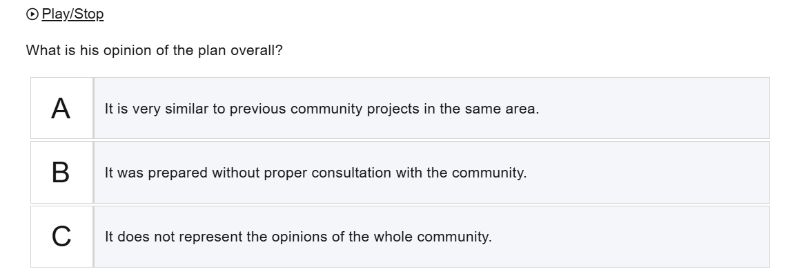
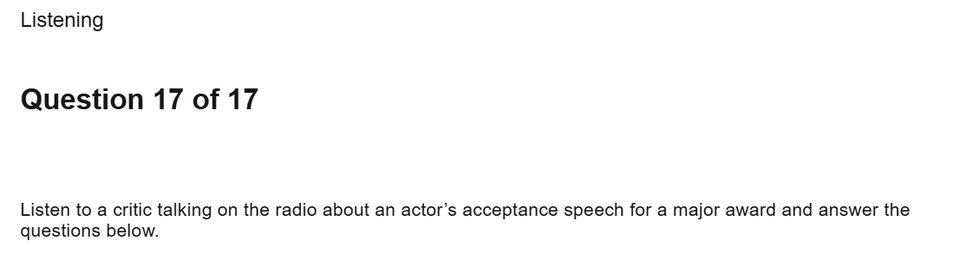

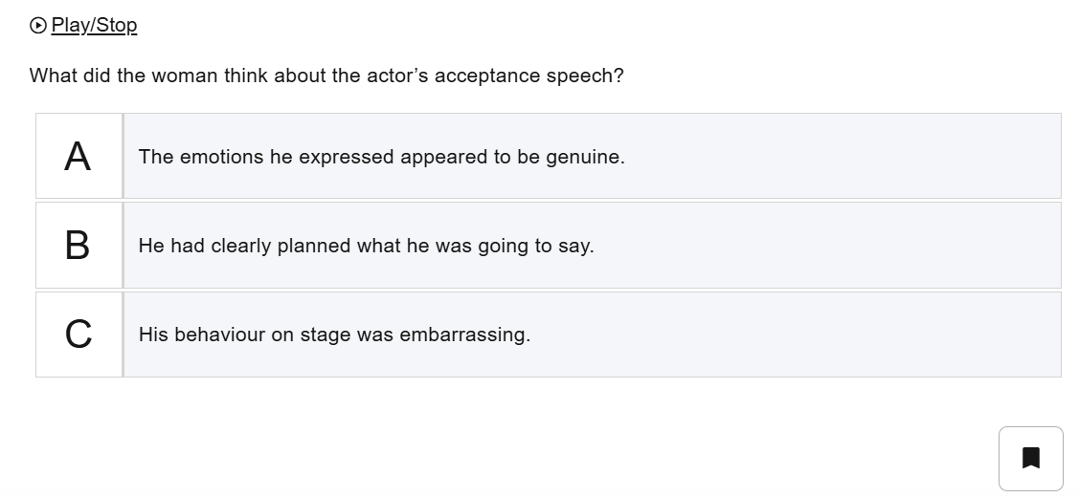
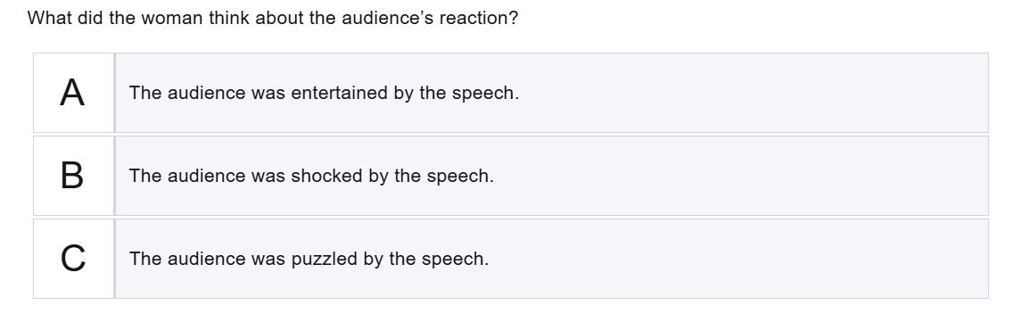

--------------------------------------------------End----------------------------------------------

