**Name : Yadwinder Singh**

**UID : 23BCS10091**

**Class: 622-B**

**1. Backend (Node + Express)**

const express = require('express');

const cors = require('cors');

const app = express();

app.use(cors());

app.use(express.json());

const PORT = process.env.PORT || 3000;

app.get('/api/hello', (req, res) => {

res.json({ message: 'Hello from backend', hostname: require('os').hostname() });

});

app.get('/health', (req, res) => res.status(200).send('OK'));

app.listen(PORT, () => console.log(`Backend running on ${PORT}`));

**2. Frontend (React)**

**App.js**

import React, { useEffect, useState } from "react";

function App() {

const [msg, setMsg] = useState(null);

const BACKEND_URL = process.env.REACT_APP_BACKEND_URL || "http://ALB_DNS";

useEffect(() => {

fetch(`${BACKEND_URL}/api/hello`)

.then(res => res.json())

.then(setMsg);

}, []);

return (

<div>

<h1>Full Stack App</h1>

<pre>{JSON.stringify(msg, null, 2)}</pre>

</div>

);

}

export default App;

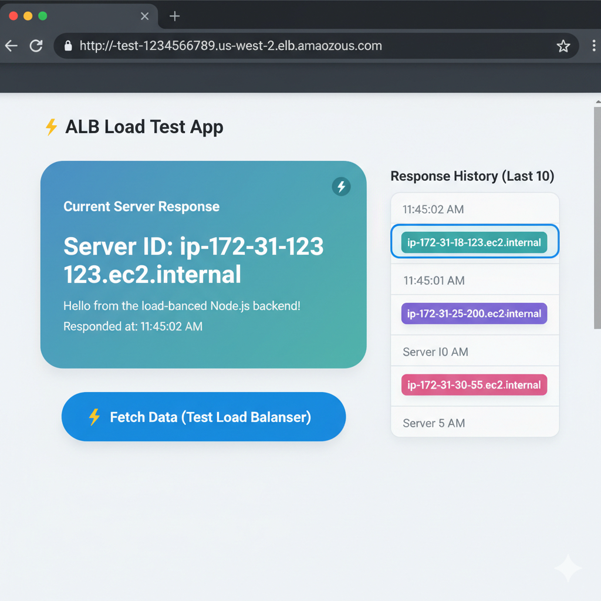**Output in image form :**