Step 1 : Open Power BI Desktop. This is what your Power BI Desktop looks like

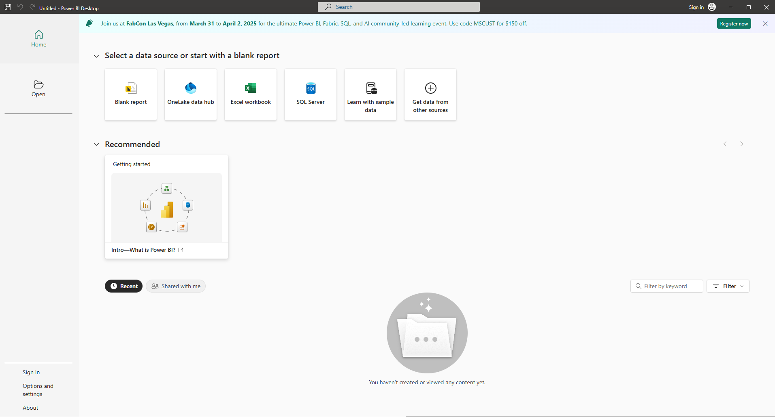

Step 2 : Click the Blank report to start a new report from scratch.

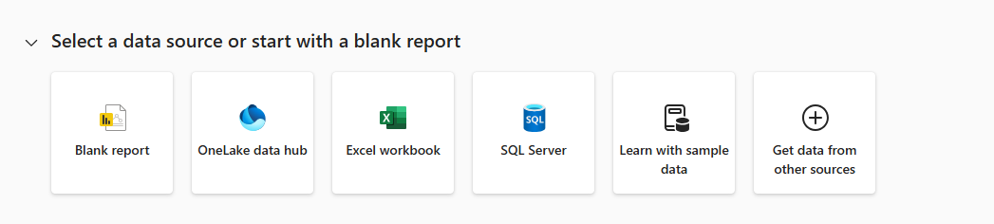

Step 3 : Once you click on Blank report, your Power BI window will look like this.

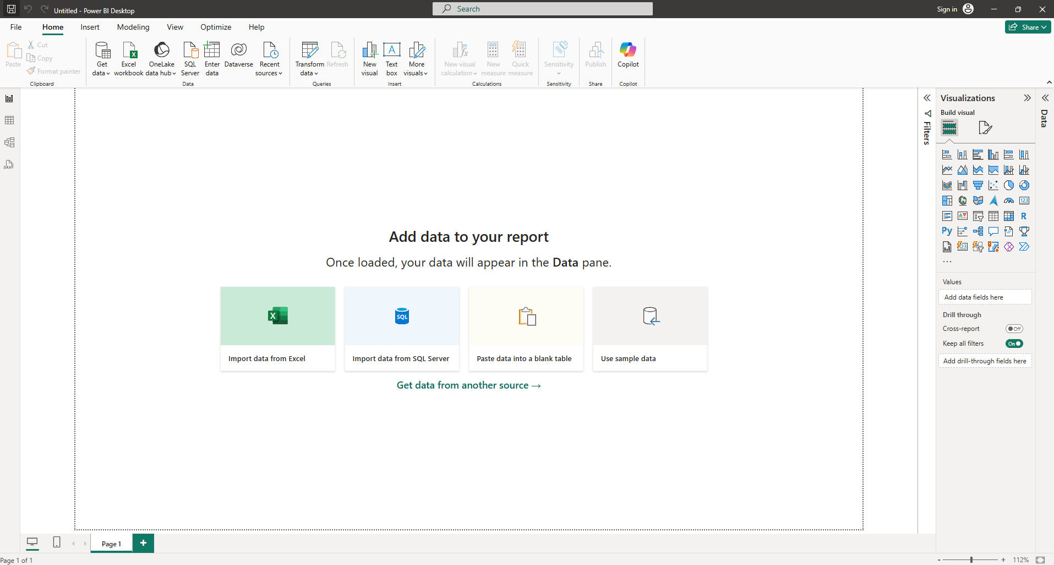

Ribbon (Top) : The ribbon at the top provides access to various functions organized into tabs:

File : Options for saving, opening, and managing Power BI files.

Home : Common tasks like getting data, transforming data, and adding visualizations.

Insert : Adding new elements to the report, like text boxes, shapes, and images.

Modeling : Tools for creating relationships between data tables and creating calculated columns and measures.

View : Options for customizing the Power BI interface, such as showing or hiding panes.

Optimize : Tools to improve report performance.

Help : Access to documentation, tutorials, and support resources.

Report View/Canvas (Center) : This is the main workspace where you'll build your report. Currently, it displays the message "Add data to your report" and "Once loaded, your data will appear in the Data pane," prompting you to connect to a data source.

Data Pane (Right) : This pane is where your data tables and fields will appear after you've connected to a data source. It's currently empty because no data has been loaded.

Visualizations Pane (Right, above Data) : This pane contains the different visualization types (bar charts, line charts, tables, etc.) that you can add to your report.

Filters Pane (Left): This pane allows you to add filters to your reports to narrow down the data shown in visuals.

Data Connection Options (Center): These shortcuts provide quick access to common data sources:

Import data from Excel: Imports data from Excel files.

Import data from SQL Server : Connects to SQL Server databases.

Paste data into a blank table : Allows you to manually enter or paste data.

Use sample data : Provides pre-built datasets for practice and exploration.

Get data from another source : Opens a window with a wider variety of data connectors.

Page Tabs (Bottom) : The "Page 1" tab indicates the current report page. You can add more pages for multi-page reports.

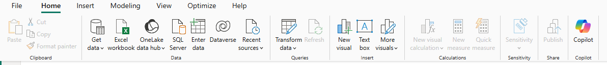

Clipboard:

Paste: Pastes copied content.

Cut: Removes selected content and places it on the clipboard.

Copy: Copies selected content to the clipboard.

Format Painter: Copies formatting from one element to another.

Data: This is the most important section for connecting to and managing data.

Get Data: Opens a menu with a wide variety of data sources you can connect to (Excel, databases, online services, etc.). This is the primary way to import data into Power BI.

Excel workbook: A shortcut to import data directly from an Excel file.

OneLake data hub: Connects to data stored in Microsoft OneLake.

SQL Server: A shortcut to connect to a SQL Server database.

Enter data: Allows you to manually type or paste data into a table.

Dataverse: Connects to Microsoft Dataverse (formerly Common Data Service).

Recent sources: Shows a list of recently used data sources for quick access.

Queries: This section is for data transformation and manipulation.

Transform data: Opens the Power Query Editor, where you can clean, transform, and reshape your data.

Refresh: Updates the data in your report from the original data source.

Insert: This section is for adding elements to your report page.

New visual: Adds a new visualization (chart, table, etc.) to your report.

Text box: Adds a text box for adding titles, descriptions, or other text to your report.

More visuals: Accesses the Power BI visuals marketplace to download custom visuals.

Sensitivity : This section is related to data security and compliance.

Sensitivity: Allows you to apply sensitivity labels to your reports to classify and protect data.

Share:

Publish: Publishes your report to the Power BI service for sharing with others.

Copilot:

Copilot: Integrates AI assistance within Power BI for tasks like generating DAX measures, creating visuals and answering questions about your data.

Step 4 : Click 'Get Data' to Extract data from various sources.

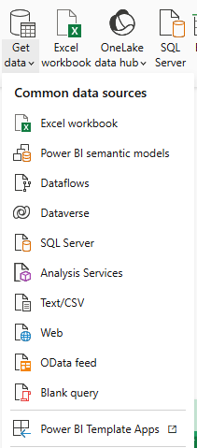

Excel workbook : Connects to data stored in Microsoft Excel files (.xls, .xlsx, .xlsm, .xlsb).

Power BI semantic models : Connects to existing published Power BI datasets (semantic models) in the Power BI service. This allows you to reuse existing data models.

Dataflows : Connects to dataflows, which are self-service, cloud-based ETL (Extract, Transform, Load) processes in Power BI.

Dataverse : Connects to Microsoft Dataverse (formerly Common Data Service), a cloud-based business application platform.

SQL Server : Connects to Microsoft SQL Server databases (both on-premises and in Azure).

Analysis Services : Connects to SQL Server Analysis Services (SSAS) multidimensional and tabular models.

Text/CSV : Connects to data stored in plain text files (.txt) or comma-separated value files (.csv).

Web : Connects to data available on the web via URLs (often used for accessing APIs or web tables).

OData feed : Connects to data exposed through the Open Data Protocol (OData), a web standard for accessing data.

Blank query : Opens the Power Query Editor with a blank query, allowing you to build custom data connections and transformations.

Power BI Template Apps : Connects to pre-built Power BI reports and dashboards designed for specific services or industries. These often come with sample data and can be customized.

Step 5 : Choose a CSV file and click to connect



CSV file : **Comma-separated value files (.csv)**  These are a specific type of text file where the data values are separated by commas. CSV files are a common way to exchange data between different applications.

Step 6 : Choose a file, then click Open to open it.

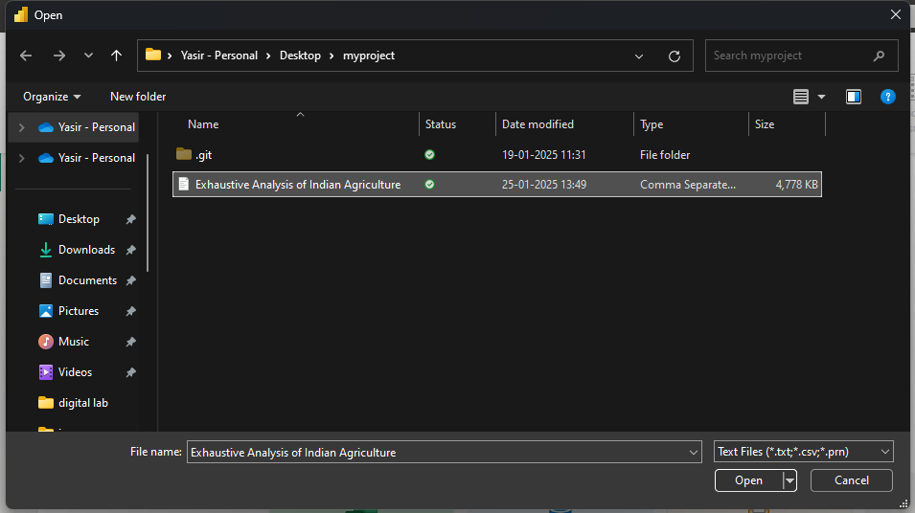

After opening the file, your Power BI window will look like this.

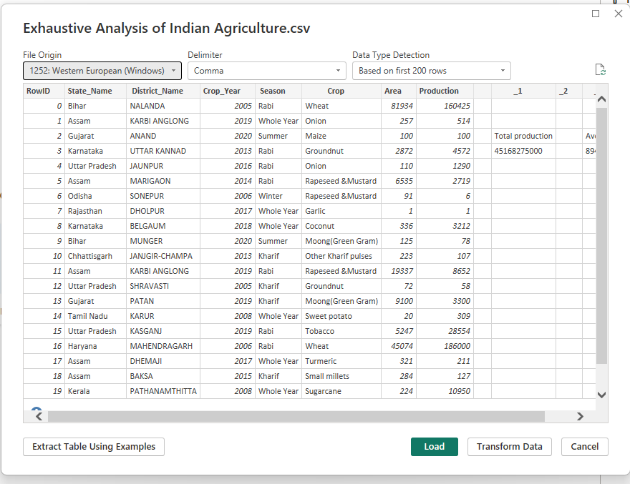

BUTTONS :

Extract Table Using Examples : This option is for more complex data extraction scenarios, such as when the data isn't in a standard table format.

Load : This button loads the data directly into Power BI without any further transformations.

Transform Data : This button opens the Power Query Editor, where you can perform more advanced data cleaning, transformation, and shaping operations.

Cancel : This button cancels the import process.

Step 7 : Click the Load button and wait for the data to process. After the process completes, your Power BI window will look like this, displaying various visualization types. Choose report view

**Report view :** Report view is where you create and design your reports. It's the visual canvas where you add charts, tables, maps, and other visuals to tell a story with your data.



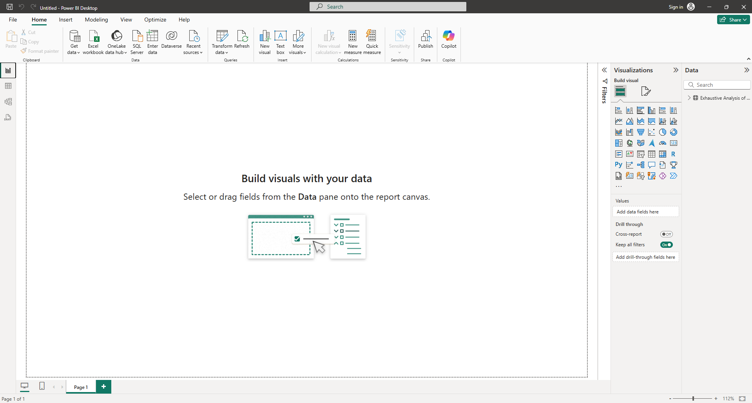

**Table view** : Table view is for inspecting and exploring the raw data itself, ensuring its quality and understanding its structure.



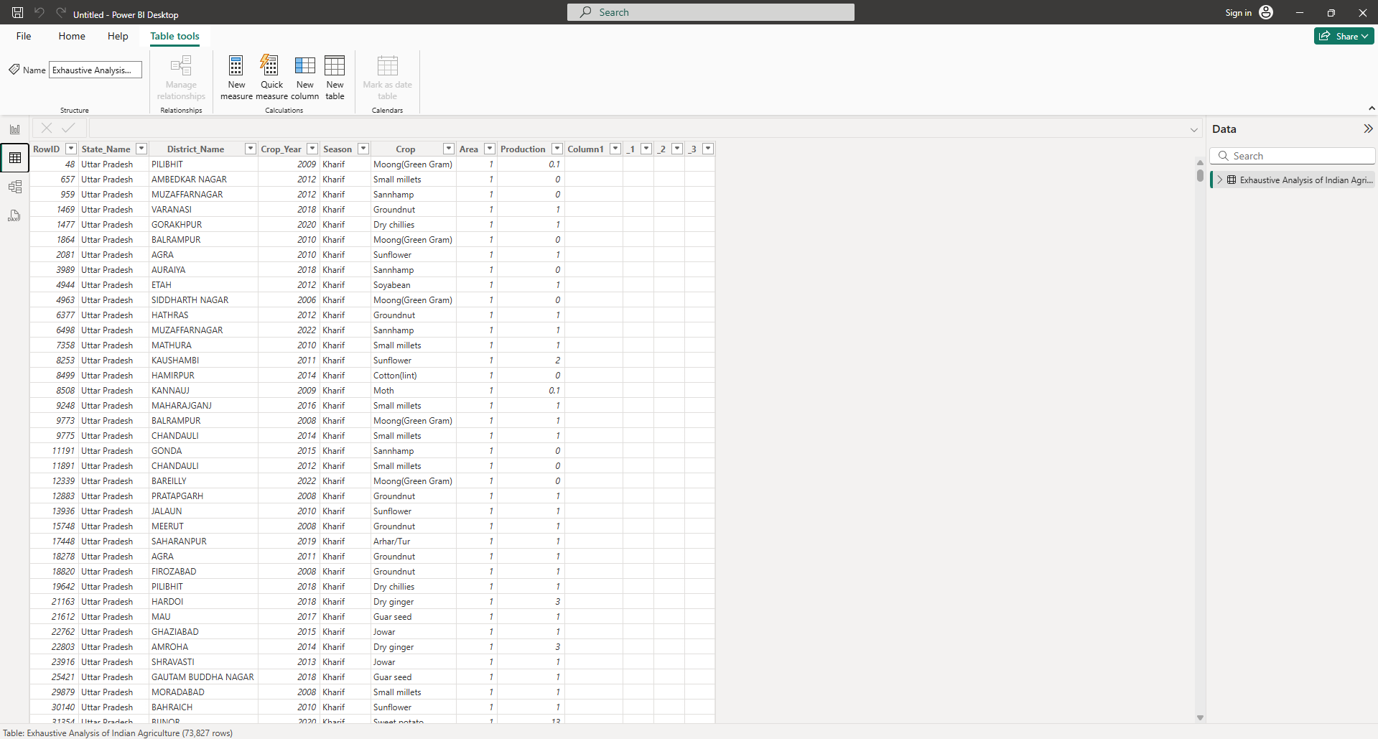

**Model view :** Model view in Power BI Desktop is where you manage the relationships between your data tables. It's crucial for creating accurate and efficient reports, especially when working with data from multiple sources



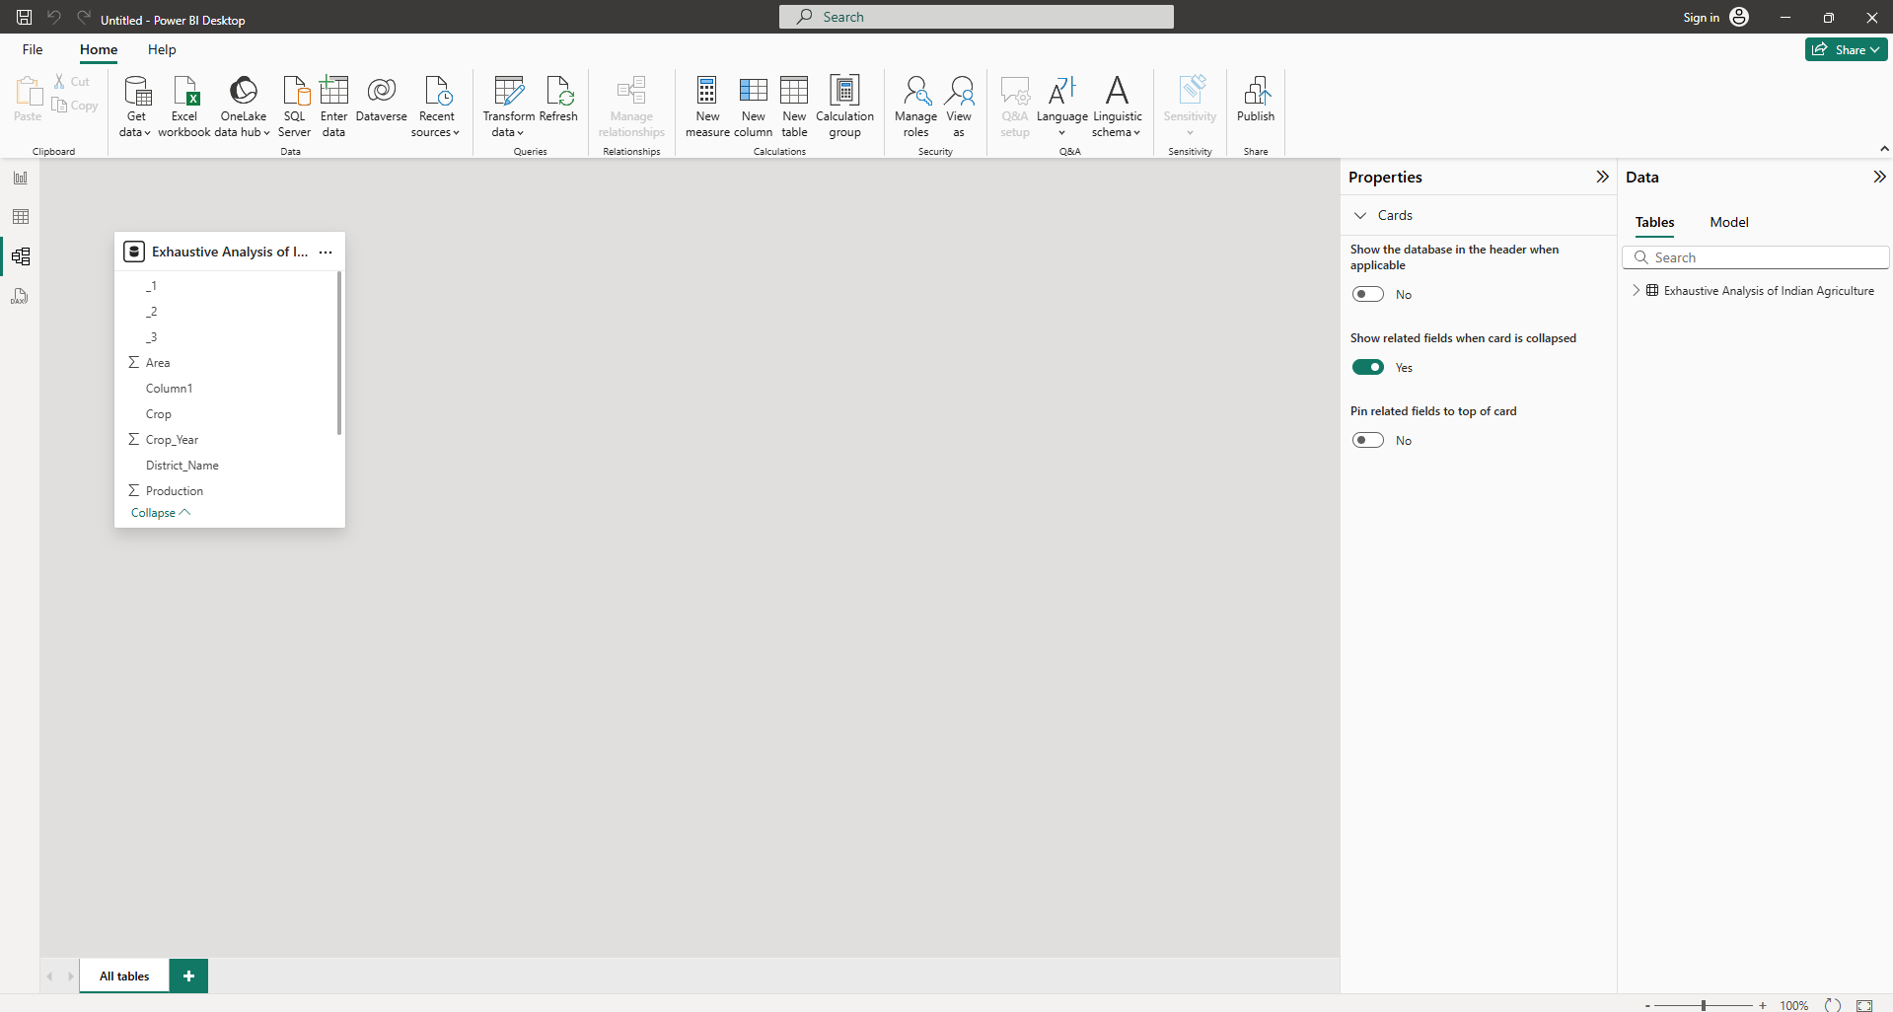

DAX query view :



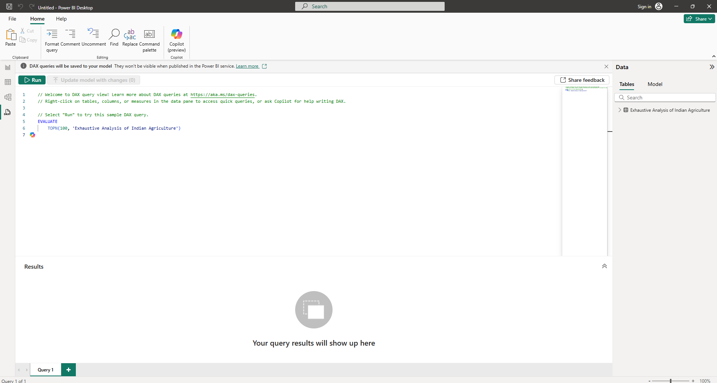

Step 8 : Click Transform data on the Home tab to open the Power Query Editor. After clicking, your Power BI Desktop window will look like this.

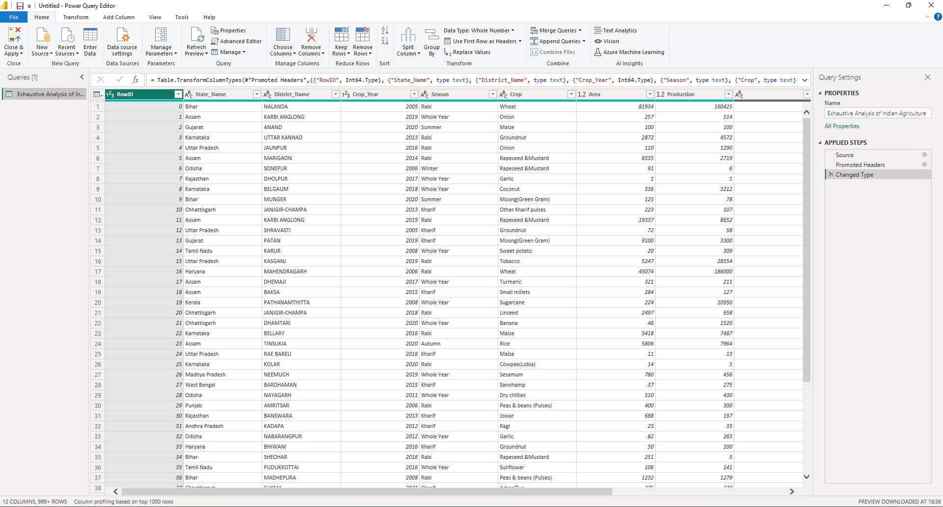

Power Query Editor : The power query editor is a powerful data transformation and preparation tool built into Power BI Desktop . it allows you to connect to various data sources , clean , transform , and reshape your data before loading it into the Power BI data model for reporting and analysis



New Query Group :

New Source : This is the starting point for importing data. Clicking this opens a dropdown menu with a wide variety of data sources you can connect to (Excel files, databases, web pages, online services, etc.).

Recent Sources : This shows a list of recently used data sources, providing quick access to connections you've already established.

Enter Data : This allows you to manually create a table by typing or pasting data directly into the Power Query Editor. This is useful for small lookup tables or test data.

Data Sources Group :

Data Source Settings : This allows you to manage the credentials and privacy levels for your data sources. You can edit existing connections or remove them entirely.

Parameters Group :

Manage Parameters : Parameters are variables that you can define and use in your queries. They can be used to make your queries more flexible and dynamic, allowing you to easily change values like dates, file paths, or filter criteria.

Query Group :

Advanced Editor : This is where you can write or edit M code directly. M is the formula language used by Power Query. Using the Advanced Editor gives you maximum control over your data transformations, allowing you to perform complex operations that might not be possible through the graphical interface alone.

Properties : Displays the properties of the selected query, such as its name and description.

Refresh Preview : Refreshes the data preview in the Power Query Editor. This is useful if the underlying data has changed and you want to see the updated results of your transformations.

Manage Columns Group :

Choose Columns : This opens a dialog box where you can select or deselect columns to keep or remove. This is a quick way to narrow down the data you're working with.

Remove Columns : This directly removes the selected columns from the query.

Reduce Rows Group :

Keep Rows : This allows you to keep only specific rows based on various criteria (e.g., top rows, bottom rows, rows with specific values).

Remove Rows : This allows you to remove specific rows based on criteria (e.g., top rows, bottom rows, duplicate rows, blank rows, rows with errors).

Sort Group :

Sort : This allows you to sort the data based on one or more columns in ascending or descending order.

Transform Group :

Split Column : This splits a single column into multiple columns based on a delimiter (e.g., comma, space, tab) or other criteria (e.g., number of characters).

Group By : This groups rows based on values in one or more columns and performs aggregations (e.g., sum, average, count, min, max) on other columns.

Replace Values : This allows you to replace specific values in a column with other values. This is useful for correcting errors or standardizing data.

Use First Row as Headers : This promotes the first row of data to become the column headers. This is often necessary when importing data from files where the first row contains the column names.

Data Type : This allows you to set or change the data type of a column (e.g., Text, Number, Date, Time, Boolean). Setting the correct data type is important for calculations and visualizations.

Combine Group :

Merge Queries : This combines two or more queries based on matching columns (like a SQL JOIN). This is useful for combining data from different sources or tables.

Append Queries : This combines two or more queries by appending rows from one query to the end of another. This is useful for combining data from multiple files or tables with the same structure.

Step 9 : To remove unwanted columns, single-click on the column header and then select Remove .

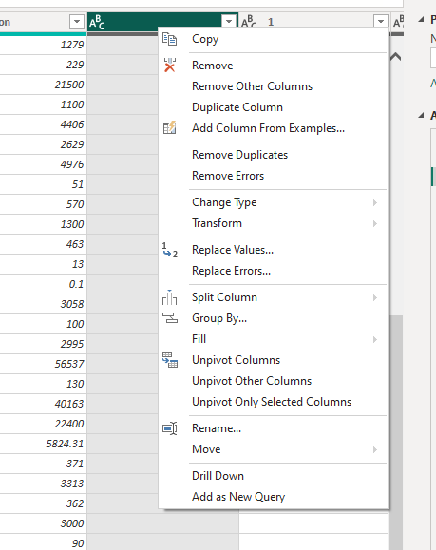

If you accidentally removed a column you can usually undo that action.

Locate the "Applied Steps" pane: look for the "Applied Steps" pane, usually located on the right side. This pane shows a list of all the transformations you've applied to your data.

Find the "Remove Columns" step: Locate the step that says "Removed Columns" in the "Applied Steps" pane. This step represents the action where you removed the column.

Click the "X" (cross symbol) next to the "Remove Columns" step: This will remove that step from the query, effectively undoing the column removal.

Review the data: After removing the step, check the data preview to verify that the column has been restored.

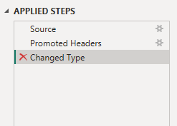

Step 10 : Check for null or missing values using Column Quality :

Go to the "View" tab: In the Power Query Editor ribbon, click on the "View" tab.

Enable "Column Quality": In the "Data preview" section of the "View" tab, check the box next to "Column Quality."

Observe the Column Quality indicators: Below each column header, you'll now see three indicators:

Valid : Shows the percentage of values in the column that are valid (i.e., not errors or empty).

Error : Shows the percentage of values that are errors (e.g., data type conversion errors).

Empty : Shows the percentage of values that are null or missing.

Focus on "Empty" : To specifically find null or missing values, look at the "Empty" indicator. If it shows a percentage greater than 0%, it means that column has missing values.

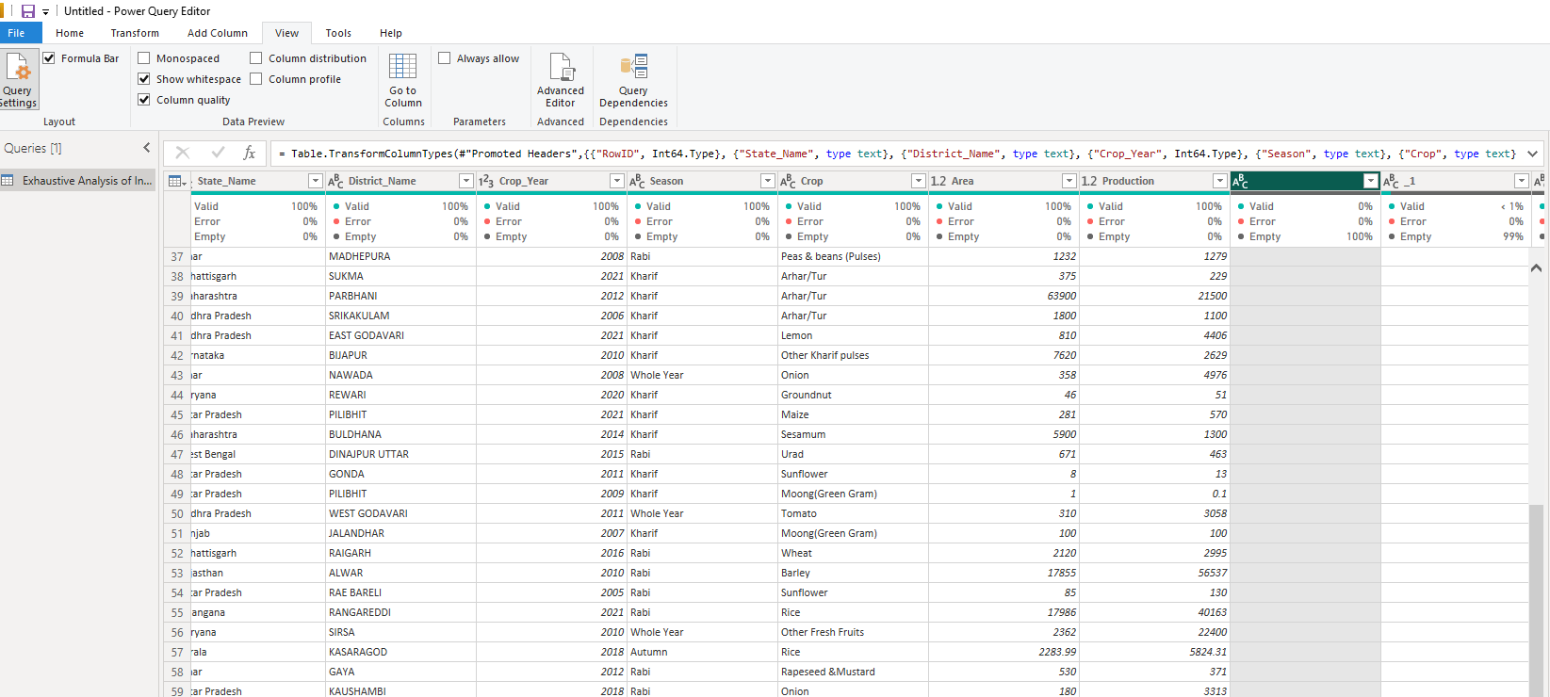

Step 10 : After completing all the above steps, click the Close & Apply button.

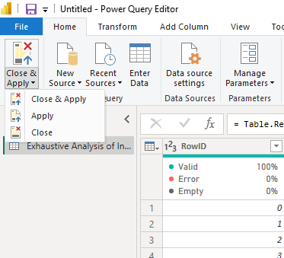

Step 11 : Then, go to Table view to see the final output

