# **Functional Requirements**

**FR01: Authentication & Onboarding**

**FR01-01: User Registration (Sign Up)**

|  |  |
| --- | --- |
| **FR01-01-01** | The system shall allow users to register by providing their email, password, and basic account information. |
| **i** | The system shall validate the user information before creating an account to ensure a valid email format and a strong password policy. |
| **ii** | The system shall send an email verification link to the user after successful registration to confirm the email address |
| **iii** | The registration process shall ensure secure data handling by encrypting passwords using industry-standard encryption methods. |

**FR01-02: User Login (Sign In)**

|  |  |
| --- | --- |
| **FR01-02-01** | The system shall allow registered users to log in using their email and password. |
| **i** | The system shall validate user credentials to ensure that only registered users can access their accounts. |
| **ii** | The system shall provide options for password recovery through email, which includes sending a reset link to the registered email address. |
| **iii** | The login system shall protect against brute force attacks by implementing a lockout mechanism after multiple failed attempts. |

**FR01-03: User Onboarding**

|  |  |
| --- | --- |
| **FR01-03-02** | The system shall guide the user through the onboarding experience to create their first store. |
| **i** | The onboarding process shall include interactive tutorials and prompts to assist users in setting up their store. |
| **ii** | The system shall offer templates and quick-start configurations to streamline the onboarding experience. |

**FR02: Payment Integration**

|  |  |
| --- | --- |
| **FR02-01** | The system shall integrate with popular payment systems to facilitate transactions. |
| **i** | The system shall support integrations with PayPal, Stripe, and major credit card providers. |
| **ii** | The payment integration shall ensure secure processing by complying with PCI DSS (Payment Card Industry Data Security Standard). |
| **iii** | Users shall be able to configure their preferred payment gateways through an admin dashboard. |

**FR03: Stock Management**

**FR03-01: Real-time Stock Updates**

|  |  |
| --- | --- |
| **FR03-01-01** | The system shall automatically update product stock levels from drop-shipping suppliers. |
| **i** | The system shall connect with supplier APIs to receive real-time inventory data. |
| **ii** | Stock updates shall reflect in the store’s inventory dashboard within seconds of a change from the supplier. |
| **iii** | The system shall handle stock discrepancies and notify the user of any synchronization issues. |

**FR03-02: Low Stock Alerts**

|  |  |
| --- | --- |
| **FR03-02-01** | The system shall notify store owners when stock for certain products is running low. |
| **i** | The system shall allow users to set a threshold for low stock alerts |
| **ii** | Notifications shall be sent via email and displayed in the store dashboard. |
| **iii** | The system shall prioritize low stock alerts for high-demand products. |

**FR04: Order Management**

**FR04-01: Order Processing**

|  |  |
| --- | --- |
| **FR04-01-01** | The system shall automatically forward order details to the drop-shipping supplier for fulfillment. |
| **I** | The system shall send order details to the supplier via secure API integration. |
| **Ii** | Order processing shall include customer details, shipping preferences, and product information. |
| **Iii** | The system shall confirm successful transmission of order data to the supplier. |

**FR04-02: Order Status Tracking**

|  |  |
| --- | --- |
| **FR04-02-01** | The system shall track the status of orders within the dashboard. |
| **i** | Users shall be able to view order statuses, including pending, shipped, and delivered. |
| **ii** | The system shall provide real-time status updates by syncing with supplier systems. |
| **iii** | Users shall receive notifications for status changes, such as shipping updates. |

**FR04-02: Automatic Invoice Generation**

|  |  |
| --- | --- |
| **FR04-02-01** | The system shall generate and email invoices to customers automatically after order confirmation. |
| **i** | Invoices shall include product details, pricing, and customer information. |
| **ii** | The system shall format invoices to comply with standard accounting practices. |
| **iii** | Invoices shall be stored in the user’s account for future reference |

**FR05: Product Management**

**FR05-01: Product Sourcing**

|  |  |
| --- | --- |
| **FR05-01-01** | The system shall automatically fetch product data from drop-shipping suppliers. |
| **I** | The system shall support integration with suppliers like AliExpress, Oberlo, Sadadropshipping, and hrdropshipping. |
| **Ii** | Product data shall include descriptions, images, and pricing. |
| **Iii** | Users shall have the option to review and modify fetched product data before listing it in their store. |

**FR05-02: AI-Enhanced Product Descriptions**

|  |  |
| --- | --- |
| **FR05-02-01** | The system shall use AI to generate SEO-optimized product titles, descriptions, and tags. |
| **i** | AI-generated content shall be customizable to fit different marketing strategies. |
| **ii** | The system shall evaluate product keywords and trends to improve search engine visibility. |
| **iii** | Users shall have the option to edit AI-suggested descriptions before publishing. |

**FR05-03: Bulk Products Upload**

|  |  |
| --- | --- |
| **FR05-03-01** | The system shall allow users to upload multiple products at once. |
| **i** | Users shall be able to use CSV or Excel file formats for bulk uploads. |
| **ii** | The system shall validate the data in the upload file and notify users of any errors. |
| **iii** | Bulk uploads shall be processed efficiently, with progress tracking available. |

**FR06: Store Creation & Setup**

**FR06-01: AI-Assisted Store Setup**

|  |  |
| --- | --- |
| **FR06-01-01** | The system shall use AI to assist users in creating a fully functional e-commerce store. |
| **I** | AI shall generate product listings, descriptions, and images based on user preferences. |
| **Ii** | The setup wizard shall include prompts for branding elements, such as logos and themes. |
| **Iii** | Users shall receive recommendations for optimizing their store layout and content. |

**FR06-02: Template Selection**

|  |  |
| --- | --- |
| **FR06-02-01** | The system shall provide users with a range of pre-designed store templates. |
| **I** | Templates shall be categorized by industry and design style. |
| **Ii** | Users shall preview templates before selecting them for their store. |
| **Iii** | Templates shall be customizable after selection. |

**FR06-03: Customization Options**

|  |  |
| --- | --- |
| **FR06-03-01** | The system shall allow users to modify the layout, colors, fonts, and overall design. |
| **i** | Customization tools shall include a user-friendly interface for real-time changes |
| **ii** | Users shall save changes and revert to previous versions if needed. |
| **iii** | The system shall support custom CSS and HTML for advanced users. |

**FR06-04: Domain Integration**

|  |  |
| --- | --- |
| **FR06-04-01** | The system shall offer an option for users to use a custom domain or a subdomain provided by DroPilot. |
| **i** | Domain setup shall include step-by-step instructions for connecting external domains. |
| **ii** | The system shall provide SSL certificates for secure browsing. |
| **iii** | Users shall receive domain management support. |

**FR07: Analytics & Reporting**

**FR07-01: Sales Report**

|  |  |
| --- | --- |
| **FR06-01-01** | The system shall generate reports on daily, weekly, or monthly sales performance. |
| **I** | Sales data shall include metrics such as total revenue, best-selling products, and average order value. |
| **Ii** | Users shall have the option to export reports in standard file formats (e.g., PDF, Excel). |
| **Iii** | Reports shall include visual representations like charts and graphs for better comprehension. |

**FR07-02: Product Profitability Analysis**

|  |  |
| --- | --- |
| **FR06-02-01** | The system shall offer detailed insights into product profitability, including costs and margins to help users understand financial performance. |
| **I** | Profit analysis shall include metrics such as gross and net profit calculations. |
| **Ii** | The system shall automatically highlight the most profitable products and suggest potential areas for reducing costs or optimizing product margins. |
| **Iii** | Users shall be able to access a detailed cost breakdown that includes product prices, shipping fees, supplier fees, and overall revenue to help them make informed decisions. |

# **Non-Functional Requirements**

##### NFR01: Performance

|  |  |
| --- | --- |
| NFR01-01 | Home page must load within 10 seconds. |
| NFR01-02 | System must respond within 10 seconds on user request. |

##### NFR02: User Friendly

|  |  |
| --- | --- |
| NFR02-01 | Display of our application will be very user friendly. |

##### NFR03: Portability

|  |  |
| --- | --- |
| NFR03-01 | Our web application can be operating on any platform. (Mac, Windows, Linux) |
| NFR03-02 | Our mobile application can be operating on Android platform. |

##### NFR04: Accuracy

|  |  |
| --- | --- |
| NFR04-01 | Our application will generate results that will be reasonably accurate. |

##### NFR05: Disaster Recovery

|  |  |
| --- | --- |
| NFR05-01 | If system crashes, all data should be recoverable within 30 minutes of the crash. |

##### NFR06: Defect Maintenance

|  |  |
| --- | --- |
| NFR06-01 | Post release bug fixing should not take more than 4 hours. |

##### NFR07: Security

|  |  |
| --- | --- |
| NFR07-01 | No user can access database except the Admin. |
| NFR07-02 | System must provide access only through login module to authorized users. |

**Software Development Life Cycle Model:**

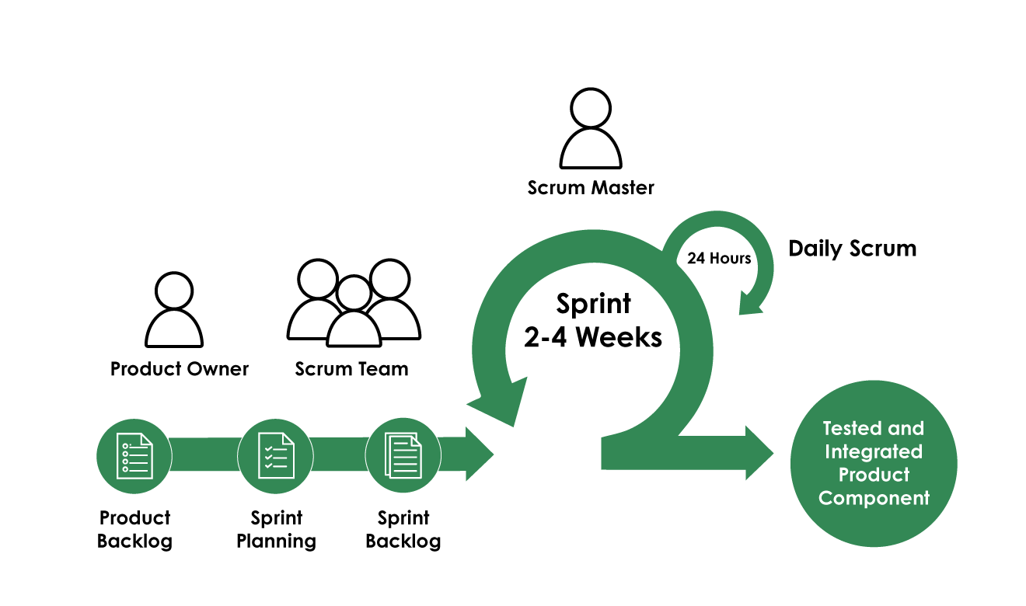

**Reasons:**

**a) Iterative Development:** Allows for incremental development of features, which is crucial for a complex system with multiple functionalities.

**b) Flexibility:** Can adapt to changing requirements or market needs, which is important for an e-commerce platform.

**c) Continuous Feedback:** Regular sprints and reviews allow for continuous improvement and alignment with user needs.

**d) Faster Time-to-Market:** Core features can be developed and released quickly, with additional features added in subsequent sprints.

**e) Risk Mitigation:** Regular testing and reviews help identify and address issues early in the development process.

**Database Diagram**



**Usecase Diagram**

**User Registration**



**Sign In**



**User Onboarding**



**Payment Integration**



**Real-time Stock Updates**



**Low Stock Alerts**



**Order Processing**



**Order Status Tracking**



**Automatic Invoice Generation**



**Product Sourcing**



**AI-Enhanced Product Descriptions**



**Bulk Product Upload**



**AI-Assisted Store Setup**



**Template Selection**



**Customization Options**



**Domain Integration**



**Sales Report**



**Profitability Analysis**



**Work Breakdown Structure:**



**Activity Daigrams:**

**Sign Up**



**Login**



Update Stocks



Stock Alert



Add Proucts



Supplier added a product



Export Order to CSV Excel



**Generation of Invoice**



Order Forwarding



Sales Details



Store Setup Domain Setup



Online Payment Store Owners



Online Payment for Droplet Owners



**Sequence Diagram’s:**

**Sign Up**



**Login**



**Store Creation**



Product Management



Order Processing



Sales & Analytics View



**Collaborative Diagram’s:**

Authentication



Store Creation



Order Processing



Product Management



Payment Processing



Analytics & Reporting



Analytics & Reporting

