**Assignment-03**

**DATE:** 14/17/2024

**COURSE:** CSC354 – Assignmen3 – ML – Support Vector Machines

**NAME:** YAHYA IRFAN MUFTI

**REG#:** FA21-BSE-044

**Answer to Question-01:**

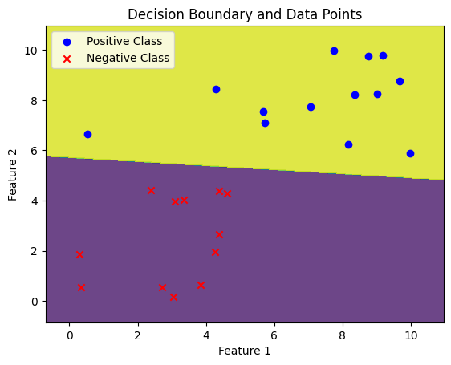

1. There's a clear split between the groups, seen in how the positive and negative examples gather together
2. There are no data points that appear to be outliers

**Answer to Question-02:**

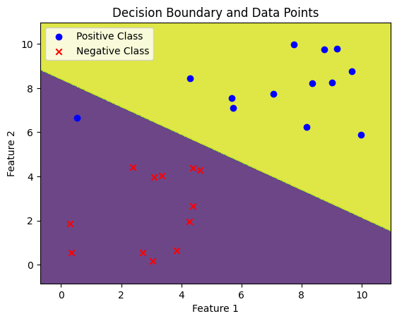









1. When C = 0.01: When C is very small (e.g., C = 0.01), the margin is very wide, and the classifier gives more chances of misclassifications. As in the plotting there is an outlier where a positive class data point comes to negative class region.
2. When C is (100, 300, 700, 1000): As C increases, the margin becomes narrower, and the classifier gives less chances of of misclassifications. As we can see in all the plots there isn,t any outlier present.

**Answer to Question-03:**

Accuracy with polynomial kernel: 0.8333333333333334

Accuracy with Gaussian kernel: 0.9

C = 0.1 , Degree = 2 , Accuracy: 0.9

C = 0.1 , Degree = 3 , Accuracy: 0.8333333333333334

C = 0.1 , Degree = 4 , Accuracy: 0.8

C = 1 , Degree = 2 , Accuracy: 0.8333333333333334

C = 1 , Degree = 3 , Accuracy: 0.8333333333333334

C = 1 , Degree = 4 , Accuracy: 0.8

C = 10 , Degree = 2 , Accuracy: 0.9

C = 10 , Degree = 3 , Accuracy: 0.8

C = 10 , Degree = 4 , Accuracy: 0.8

C = 0.1 , Sigma = 0.1 , Accuracy: 0.3

C = 0.1 , Sigma = 1 , Accuracy: 0.8333333333333334

C = 0.1 , Sigma = 10 , Accuracy: 0.3

C = 1 , Sigma = 0.1 , Accuracy: 0.8333333333333334

C = 1 , Sigma = 1 , Accuracy: 0.9

C = 1 , Sigma = 10 , Accuracy: 0.3

C = 10 , Sigma = 0.1 , Accuracy: 0.6666666666666666

C = 10 , Sigma = 1 , Accuracy: 0.9

C = 10 , Sigma = 10 , Accuracy: 0.9

Answers:

1. Which kernel settings result in better performance? Accuracy with polynomial kernel: 0.8333333333333334 Accuracy with Gaussian kernel: 0.9 The Gaussian kernel resulted in better performance with a slightly higher accuracy of 0.9 compared to the polynomial kernel's accuracy of 0.8333333333333334.
2. Variating both C and degree for the SVM with polynomial kernel:

Combination 1: C = 0.1, Degree = 2, Accuracy: 0.9 Combination 2: C = 1, Degree = 3, Accuracy: 0.8333333333333334 Combination 3: C = 10, Degree = 2, Accuracy: 0.9 We observe that the SVM with polynomial kernel achieves the highest accuracy of 0.9 when C = 0.1 and Degree = 2.

1. Variating both C and sigma for the SVM with Gaussian kernel:

Combination 1: C = 0.1, Sigma = 0.1, Accuracy: 0.3 Combination 2: C = 1, Sigma = 1, Accuracy: 0.9 Combination 3: C = 10, Sigma = 1, Accuracy: 0.9 Here, we can see that for both combinations where C = 1 and C = 10 with Sigma = 1, the SVM with Gaussian kernel achieves the highest accuracy of 0.9.

**Answer to Question-04:**

Optimal values:

**C:** 10

**Sigma:** 0.1

**Accuracy:** 0.961538461538461