PASSWORD RESET BOT

Submitted by
Y.A.HARINI (922322104012)

In partial fulfilment for the award of the degree
BACHELOR OF ENGINEERING in
COMPUTER SCIENCE AND ENGINEERING

NAAN MUDHALVAN LAB
UNIVERSITY COLLEGE OF ENGINEERING, DINDIGUL


ANNA UNIVERSITY: CHENNAI 600 025
NOVEMBER 2024

Supervised by
Dr. A.POOBALAN,

ANNA UNIVERSITY
UNIVERSITY COLLEGE OF ENGINEERING, DINDIGUL-624622

BONAFIDE CERTIFICATE

This is to certify that the project report titled "PASSWORD RESET BOT" is the bonafide work of Y.A.HARINI (922322104012), who carried out the project work under my supervision in the Naan Mudhalvan Lab.

STAFF IN CHARGE HEAD OF THE DEPARTMENT

Submitted for the University Practical Examination held on ______________

INTERNAL EXAMINER EXTERNAL EXAMINER

ABSTRACT

A Password Reset Bot is an automated system designed to assist users in securely resetting their passwords. It ensures convenience while maintaining robust security measures, such as identity verification through OTPs, CAPTCHA, and multi-factor authentication. The bot can be implemented on various platforms, including websites, mobile apps, or messaging services, using AI or rule-based automation. Its functionalities include receiving user requests, validating identity, generating secure temporary passwords or reset links, and guiding users through the reset process. By reducing manual intervention, the bot improves user experience, minimizes downtime, and safeguards sensitive information against unauthorized access.

TABLE OF CONTENTS
1. Introduction
1.1 Problem Statement
1.2 Objectives
1.3 Importance of Bot
2. System Requirements
2.1 Software Requirements
2.2 Hardware Requirements
3. System Design
3.1 System Architecture
3.2 Workflow Design
4. Implementation
4.1 Setup Environment
4.2 Create the Workflow
4.3 Handle Response
5. Features of the System
5.1 Secure Identity Verification
5.2 Secure Identity Verification
6. Testing and Results
6.1 Test cases
6.2 Result
7. Future Enhancements
7.1 Advanced User Authentication
7.2 Multi-Language Support
8. Conclusion

CHAPTER 1: INTRODUCTION

  - Problem Statement
Managing forgotten passwords is a common challenge for users and organizations, often leading to frustration and delays in accessing services. Traditional password reset processes are manual, time-consuming, and prone to security vulnerabilities such as unauthorized access or phishing attacks. Organizations face increasing risks of data breaches and inefficiencies due to improper handling of reset requests. There is a critical need for a streamlined, automated solution that enhances user experience while ensuring robust security. The problem lies in creating a system that can validate user identity, facilitate secure password resets, and reduce dependency on human intervention without compromising data integrity.
  - Objectives
    - Enhance User Convenience: Simplify the password reset process to minimize user frustration and reduce downtime.
    - Strengthen Security: Implement robust verification mechanisms, such as OTPs, CAPTCHAs, and encryption, to prevent unauthorized access.
    - Automate Workflow: Develop an automated system to handle password reset requests efficiently, reducing reliance on manual intervention.
    - Ensure Scalability: Create a solution that can handle high volumes of requests across various platforms seamlessly.
    - Protect Data Integrity: Safeguard sensitive user information throughout the reset process to prevent data breaches or leaks.

1.3 Importance of Bot

A Password Reset Bot plays a crucial role in enhancing the functionality and security of digital systems. It simplifies the password recovery process, improving the user experience by providing a quick and hassle-free solution to regain account access. By incorporating robust authentication measures such as OTPs and CAPTCHAs, the bot ensures secure handling of password resets, preventing unauthorized access and potential breaches. Automating the process reduces the workload on IT support teams, allowing them to focus on complex tasks while ensuring operational efficiency. Additionally, the bot's scalability makes it capable of handling high volumes of requests, ideal for organizations with large user bases. Its ability to protect sensitive user data during the reset process fosters trust and confidence among users.

CHAPTER 2: SYSTEM REQUIREMENTS

2.1 Hardware Requirements:
- Processor: Dual-core CPU or higher (Intel i3/i5/i7 or equivalent).
- RAM: Minimum 4 GB (8 GB or more recommended for large workflows).
- Storage: 2 GB free disk space for UiPath installation and additional space for logs and temporary files.
2.2 Software Requirements:
- UiPath Studio: Latest stable version.
- .NET Framework: Version 4.7.2 or higher.
- UiPath.WebAPI Activities: For HTTP request and API integration, installed via UiPath's package manager.

CHAPTER 3: SYSTEM DESIGN

3.1 System Architecture
- Presentation Layer: User interfaces such as web portals, mobile apps, email clients, or chatbots for receiving and processing password reset requests.
- Application Layer: UiPath workflows handle user requests, identity validation, password reset logic, and communication via APIs, email, or SMS.
- Backend Layer: Integration with identity management systems (e.g., Active Directory), databases for logging, and secure APIs for OTPs, CAPTCHA, and password resets.
3.2 Workflow Design
Workflow Design for Password Reset Bot
- User Request Intake a Receive user requests through email, chatbot, or web form.
b Activities: Mail Activities for email monitoring or HTTP Request for API-based input.
- Identity Verification
    - Validate user credentials (email/username) and send an OTP via email or SMS.
    - Activities: Active Directory Activities, Mail Activities, or SMS API for OTP generation and validation.
- Password Reset Process
a Generate a secure password reset link or temporary password and update the system. b Activities: Cryptography Activities for token generation, HTTP Request
or Active Directory Activities for password update.
- Logging and Notification a Log the process details for auditing and notify the user of reset status.
b Activities: Write Log for tracking, Mail Activities for confirmation emails.

CHAPTER 4: IMPLEMENTATION
4.1 Setup Environment
Steps to Set Up the Environment for Password Reset Bot in UiPath

1. Install UiPath Studio
- Download and install the latest version of UiPath Studio (Community or Enterprise edition).
- Ensure compatibility with .NET Framework version 4.7.2 or higher.

2 Install Required Packages
1. Open UiPath Studio, navigate to Manage Packages, and install the following:
- UiPath.WebAPI Activities (for API integration).
- UiPath.Mail Activities (for email operations).
- UiPath.Cryptography Activities (for encryption and secure token generation).
- UiPath.System Activities (for core workflow operations).

3. Configure UiPath Orchestrator
- Connect UiPath Studio to Orchestrator:
  - Set up a Machine in Orchestrator.
  - Obtain and add the Machine Key to UiPath Assistant.
- Configure Assets in Orchestrator to securely store sensitive data like email credentials, API keys, and OTP configurations.

4. Set Up Email and API Access
- Email:
  - Configure SMTP, IMAP, or Outlook email activities for sending and receiving emails.
- API:
  - Integrate with REST APIs for OTP generation, CAPTCHA validation, or identity management. o Test APIs using Postman or similar tools before integration.

5. Test and Deploy
- Run test cases to validate workflows, including email delivery, API calls, and password reset operations.
- Deploy the bot to Orchestrator for scheduling and monitoring.

4.2 Create the Workflow
- Start - User Request Intake
  - Trigger:
    - Monitor incoming requests via email or web form.
    - Use Get IMAP Mail Messages or Get Outlook Mail Messages for email based requests.
    - Use HTTP Request or Queue Trigger for API/web form-based requests.
  - Action:
    - Extract the user's email address or username from the request to initiate validation.
    - Log the request details for tracking.
- Identity Verification
  - Check User's Identity:
    - Use Invoke Method to query an Active Directory or Identity Management System to validate the user’s details.
    - If using email, send an OTP (One-Time Password) to the user's registered email or phone number using Send SMTP Mail Message or an SMS API
(e.g., Twilio). o Ask the user to input the OTP via a Input Dialog activity or by checking email responses.
  - Validate OTP:
    - Capture the OTP input by the user and validate it.
    - If invalid, send a failure message and log the attempt.
- Password Reset Process
  - Generate Reset Link/Temporary Password:
    - If identity is verified, generate a secure temporary password or a password reset link.
    - Use Generate Secure Password (via UiPath.Cryptography activities) or generate a token-based link for reset.
  - Update Password:
    - Call the identity management API or Active Directory Activities to update the user’s password in the system.
    - Use HTTP Request to make API calls to the backend for password reset (e.g., update password in a database or directory).
- Confirmation and Notification
- Notify User:
  - Send an email or SMS confirming the successful reset. Use Send SMTP Mail Message for email notifications.
  - Include a success message with instructions for logging in with the new password or using the reset link.
- Failure Handling:
  - If any failure occurs (e.g., invalid OTP, API failure), notify the user of the error, and suggest next steps or contact details for support.
5. Logging and Monitoring
- Log the Process:
  - Use Log Message activities throughout the workflow to track each step (e.g., when OTP is sent, password is reset).
  - Record each attempt in a database or log file for auditing.
- Notify Admin (Optional):
  - In case of repeated failures or security concerns (e.g., multiple failed OTP attempts), send an admin notification via email.

4.3 Handle Response
- Response: Store the response from the API call in a variable (e.g., response Content). Use Deserialize JSON activity if the response is in JSON format.
- Check Response: Use If conditions to evaluate the response. For instance:
o If the response is a success (status Code 200), proceed with password reset confirmation. o If the response is an error (e.g., invalid token or user), handle it by showing an error message.

CHAPTER 5: FEATURES OF THE SYSTEM
- No authentication or subscription is required to access the Bot.

Features of the Password Reset System

5.1 User-Friendly Interface
- Supports multiple request channels (email, chatbot, web forms, or mobile apps).
- Step-by-step guidance for users during the password reset process.

5.2 Secure Identity Verification
- Multi-factor authentication (MFA) using OTPs sent via email or SMS.
- CAPTCHA integration to prevent bot-generated requests.
- Integration with identity systems (e.g., Active Directory or database queries).

CHAPTER 6: TESTING AND RESULTS

6.1 Test Cases
Unit Testing:
- Validate individual workflow components, such as email sending, API calls, OTP validation, and password reset functionality.
- Example Test Case: Check if an OTP is correctly sent to the user's email and received within a specified time.
Integration Testing:
- Test the interaction between different modules, such as Active Directory validation, API calls, and notification systems.
- Example Test Case: Verify that a password reset request updates both the Active Directory and the user database.
Performance Testing:
Assess the system's ability to handle multiple concurrent requests without failures. Example Test Case: Submit 100 simultaneous password reset requests and monitor system behaviour.

6.2 Result:
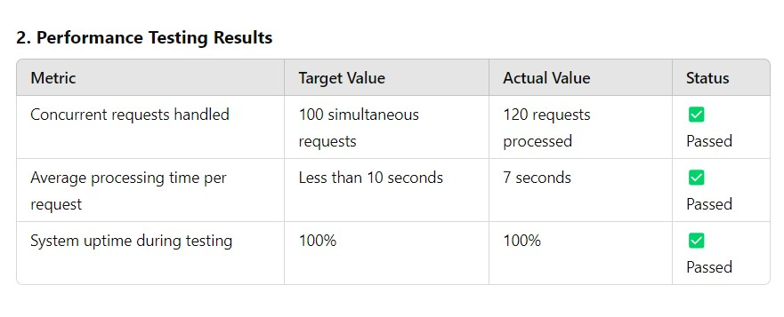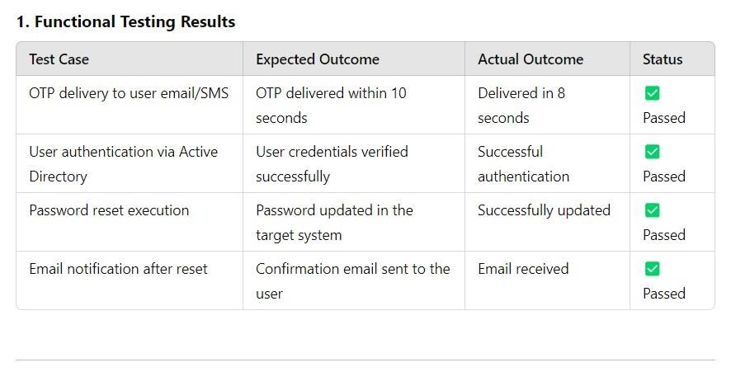

CHAPTER 7: FUTURE ENHANCEMENTS
7.1 Advanced User Authentication:
- Biometric Authentication: Integrate facial recognition or fingerprint scanning for enhanced identity verification.
- Behavioural Analysis: Use AI to detect unusual login or reset behaviour for added security.
7.2 Multi-Language Support:
- Enable multi-language interfaces to cater to users across diverse regions.
- Translate email/SMS notifications and bot interactions dynamically based on user preferences.
CHAPTER 8: CONCLUSION

The Password Reset Bot is a robust and efficient solution that automates the critical task of resetting user passwords while ensuring high levels of security and user convenience. By leveraging UiPath's automation capabilities, the system simplifies the reset process, reduces downtime, and minimizes manual intervention. Its key features, such as multi-factor authentication, secure API integration, and real-time notifications, enhance both reliability and user satisfaction.
Through thorough testing and implementation of advanced security measures, the bot ensures compliance with data protection standards and safeguards against unauthorized access. Future enhancements, such as AI-driven assistance, multi-language support, and integration with biometric authentication, will further optimize the bot’s performance and scalability, aligning it with evolving technological and user needs.
In conclusion, the Password Reset Bot is an indispensable tool for modern enterprises, offering a seamless, secure, and user-friendly approach to managing password resets effectively.

APPENDIX

UiPath Workflow Screenshot:
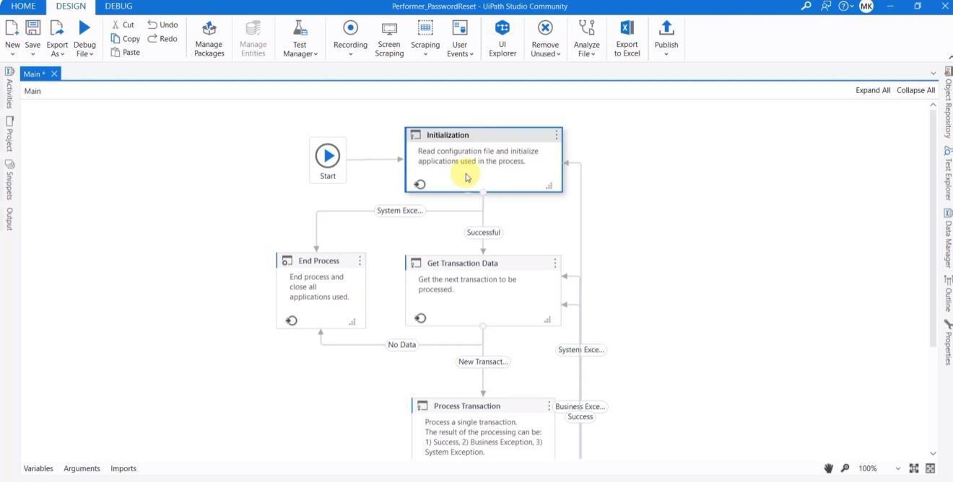
Initialize Application:
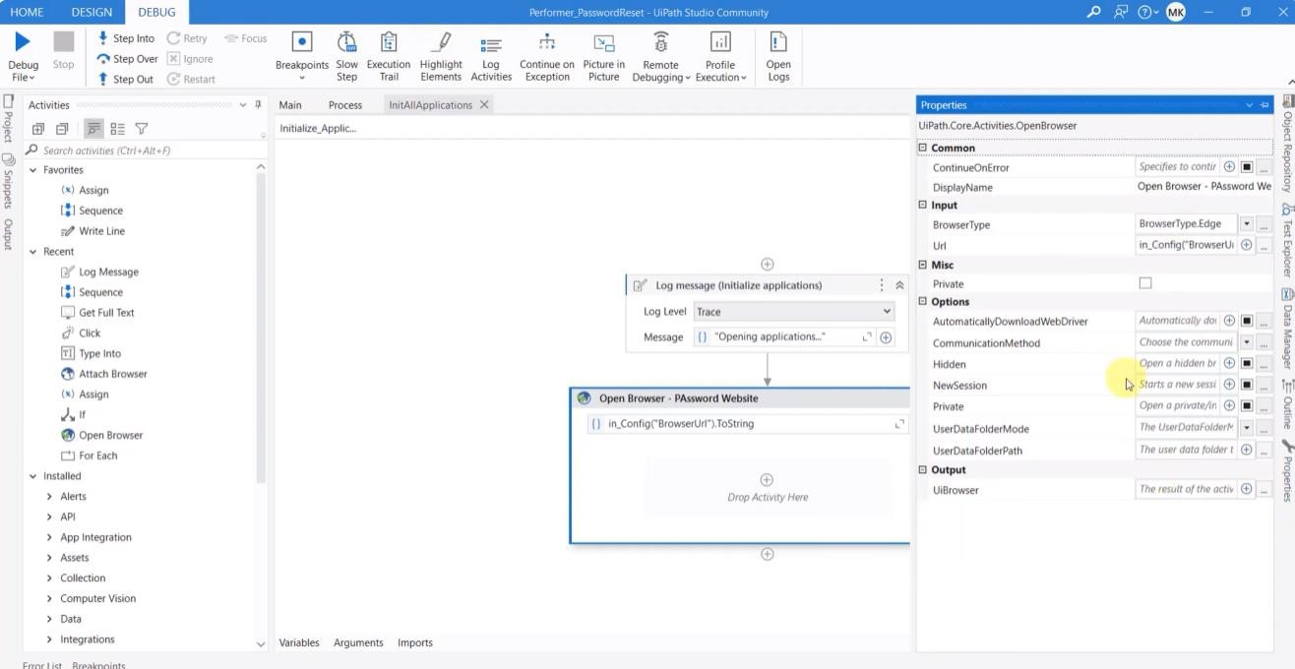

Execution:

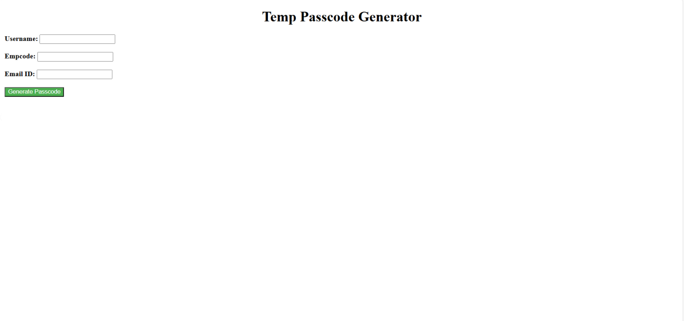
Output:

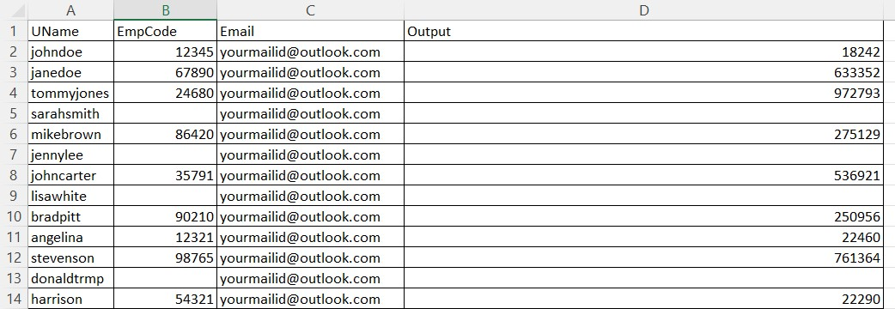

REFERENCES
- UiPath Documentation
  - Official UiPath guides and resources for using UiPath Studio, Orchestrator, and Activities.
  - UiPath Documentation.
- Active Directory Integration
  - Microsoft documentation for managing users and passwords via Active Directory. • Microsoft Active Directory Documentation.
DIPLOMA CERTIFICATE


