Step Counter: a PyTorch Neural Net on an Ankle IMU
ME193 – AI in Mobile Robots · Yash Kulkarni
Code: github.com/YAKU-2003/LEGO-ROBOT → step_counter
🎥 Demo video: (add link here)
🎬 How-it-works animation (made with Claude): (add link here – file: step_counter/laptop/models/how_it_works.mp4)
TL;DR – The gait wearable (Arduino UNO Q + MPU6050 on the ankle) streams all six IMU channels at 50 Hz to the laptop over MQTT. A 30k-weight 1-D convolutional neural net, trained in PyTorch on my own counted walks, turns that into a live step count shown on a dashboard and on the board's LED matrix. On walks it never saw it got 90.3% of steps right, and in a live test it showed 30 for a walk I counted as 27–28.

1. The system
This project extends the gait identifier and reuses the same wearable and board app. Nothing is computed on the ankle except reading the sensor: the board is a sensor + display, the laptop is the brain.
Part | What it does
MPU6050 (on the outside of the ankle) | Accelerometer x/y/z (g) and gyroscope x/y/z (rad/s) – all six sensors are used
Arduino UNO Q | Reads the IMU every 20 ms (50 Hz), publishes it on MQTT topic gait/imu, shows the count it gets back on gait/steps as digits on its LED matrix
Mosquitto (laptop) | MQTT broker connecting the board and the laptop over Wi-Fi
app.py + web dashboard | Record tab (counted walks), Model tab (train + uncertainty report), Count tab (live count ± uncertainty)
StepNet (PyTorch) | Turns the last 6 s of IMU data into a step density; the count is its sum

MPU6050 → UNO Q --MQTT gait/imu (50 Hz)--> laptop: StepNet (PyTorch) --MQTT gait/steps--> UNO Q LED matrix

2. The data (all real, recorded on my own sensor)
Ground truth is me: I counted every step out loud while walking and typed the total into the dashboard when I stopped. Steps count both feet (every footfall), which is what a pedometer reports. To teach the net what is not a step, I reused the standing and biking recordings from the gait identifier project – the same sensor on the same ankle – as 0-step data.
Recording | Steps (counted) | Length | Used for
walk_120steps_walk3 | 120 | 73 s | steps + timing
walk_150steps_walk3 | 150 | 113 s | total count only
walk_200steps_walk1 | 200 | 133 s | steps + timing
4 standing recordings (gait project) | 0 | 4.0 min | what isn't a step
3 biking recordings (gait project) | 0 | 3.0 min | what isn't a step

Placing each step in time: the gyro sees each swing of the strapped leg (= 2 steps, the other foot lands halfway between). Those times are only trusted if their total matches my count; walk3 (150) didn't match (the gyro found 170), so it trains the net through its total only. One recording (walk2) came back with all-zero readings after a loose cable and was excluded, not deleted.

3. How the neural net works
What goes in and what comes out. Every sample of the IMU becomes 8 numbers: the three accelerations, the three rotation rates, and the total size of each (|a| − 1 g and |ω|), so the net doesn't depend on exactly how the strap is rotated. StepNet is a 1-D convolutional neural net: four Conv1d layers, each with 32 filters that are 9 samples wide, followed by BatchNorm, ReLU and Dropout. The layers are dilated (1, 2, 4, 8), so each layer looks at a wider stretch of time than the last, and every output sample ends up “seeing” about 2.4 s of signal – roughly two strides. A final 1×1 convolution and a softplus give one non-negative number per sample: a step density. It's about zero between steps and makes a bump around each footfall whose area is one step, so the step count is simply the sum of the density. The whole net has 30,369 weights.
How it learns (PyTorch and back-propagation). Training takes random 8-second crops of my recordings, 32 at a time. The forward pass produces a density for each crop, and the loss compares it with the truth in two ways: a shape loss (the density should look like bumps at the labelled step times) and a count loss ((sum of density − counted steps)²), which is the only term for recordings whose step times aren't trusted. Calling loss.backward() makes PyTorch run back-propagation: it applies the chain rule backwards through every layer and works out how much each of the 30k weights contributed to the error. Adam then nudges every weight a little in the direction that lowers the loss, and this repeats 1,500 times (about 40 s on the laptop GPU). Each crop is randomly tilted (±25°, as if the strap were put on differently), scaled and stretched in time, so the net learns steps rather than memorising my exact recordings.
How it counts live. Every 0.5 s the laptop gives the net the last 6 s of IMU data and adds up the density for the half second that ended 1 s ago. Using a slightly delayed window means every step is judged with signal on both sides of it and counted exactly once; the cost is that the display lags about 1 s behind your feet. The count is sent back to the board over MQTT and drawn on the LED matrix.
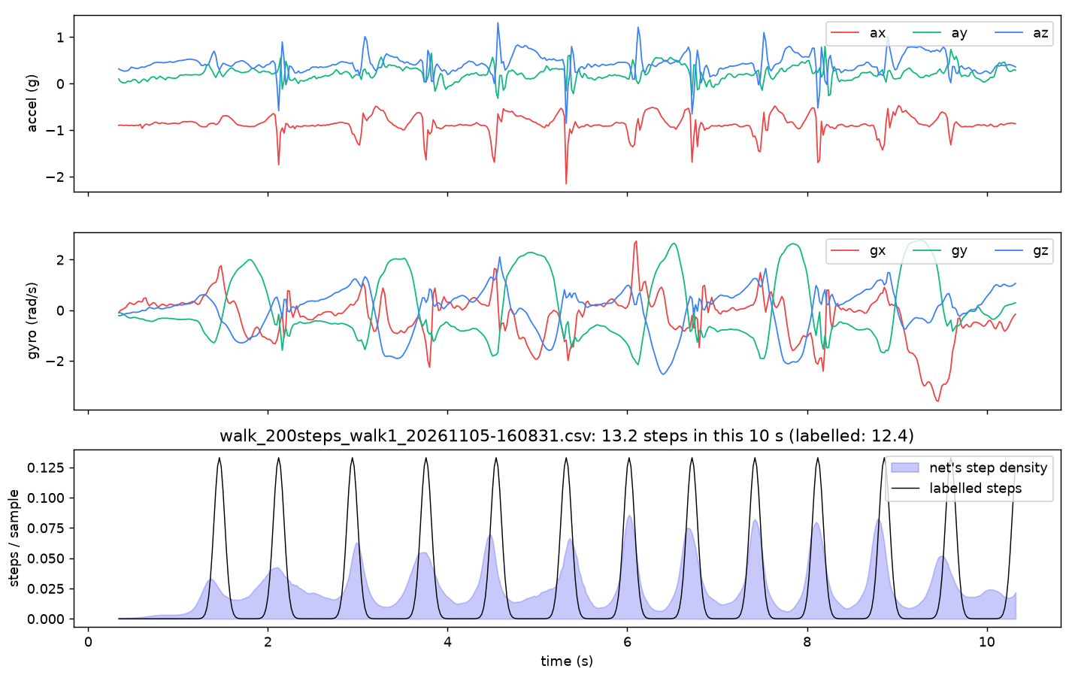
Real data from walk1: the 6 sensor inputs (top two), and the trained net's step density vs. the labelled steps (bottom). Each bump is one step.
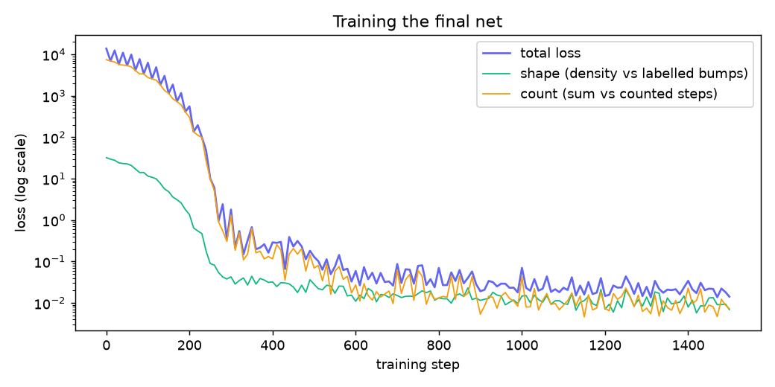
Training loss (shape + count) going down over the 1,500 back-propagation steps.

4. Uncertainty analysis
Method: leave-one-recording-out. For each recording, a brand-new net is trained on all the other recordings and then counts the held-out one exactly the way the live counter does. So every number below is from data the net never saw. The same recordings are also counted by two classical pedometers for comparison: an |a| peak counter and 2 × the gyro leg swings.
Walk | True | Neural net | |a| peaks | 2 × gyro
walk_120steps_walk3 | 120 | 118.6 | 117 | 118
walk_150steps_walk3 | 150 | 171.7 | 178 | 172
walk_200steps_walk1 | 200 | 222.6 | 204 | 200

Method | Accuracy on walks | False steps / min (standing + biking)
Neural net (PyTorch) | 90.3% | 13.3
|a| peak counter | 92.6% | 30.3
2 × gyro swings | 94.9% | 46.3

Result: the net got 90.3% of steps right on walks it never saw. Its errors have a bias of +8.2% (it tends to over-count) and a spread of 8.3%, so a count of N steps is N × 1.08 ± 16% (95%, Bland–Altman). The live page shows this as the ± next to the count.
Where it beats the classic pedometers: not-walking. Peak counters count every pedal stroke as a step (69–73 'steps' per minute of biking). The net learned that biking isn't walking: it gave less than 1 step on two of the three biking recordings and about 1 step per minute standing. The exception is one biking recording (89 steps when held out) – with only three biking recordings, holding one out leaves too little biking to learn from, which is why the average false-step rate is 13.3/min.
Sources of uncertainty (honest list):
- Too few walks. With 3 counted walks, every held-out test leaves just 2 to learn from, so the ± is itself very uncertain (the 95% CI on the mean error is 1.2–14.5%). An earlier version trained on only 2 walks showed ±65 steps for exactly this reason.
- Ground truth. My own count is ±1–2 steps, and on walk3 (150) all three methods agree on ~172, so my count there may be the thing that's off.
- Start/stop. The first and last shuffles of a walk and fidgeting while standing add fractions of a step, which is where most of the over-count bias comes from.
- Sensor dropouts. The board sometimes lost Wi-Fi/power mid-recording (22–75 s gaps in the broker log); those recordings were cut or excluded.
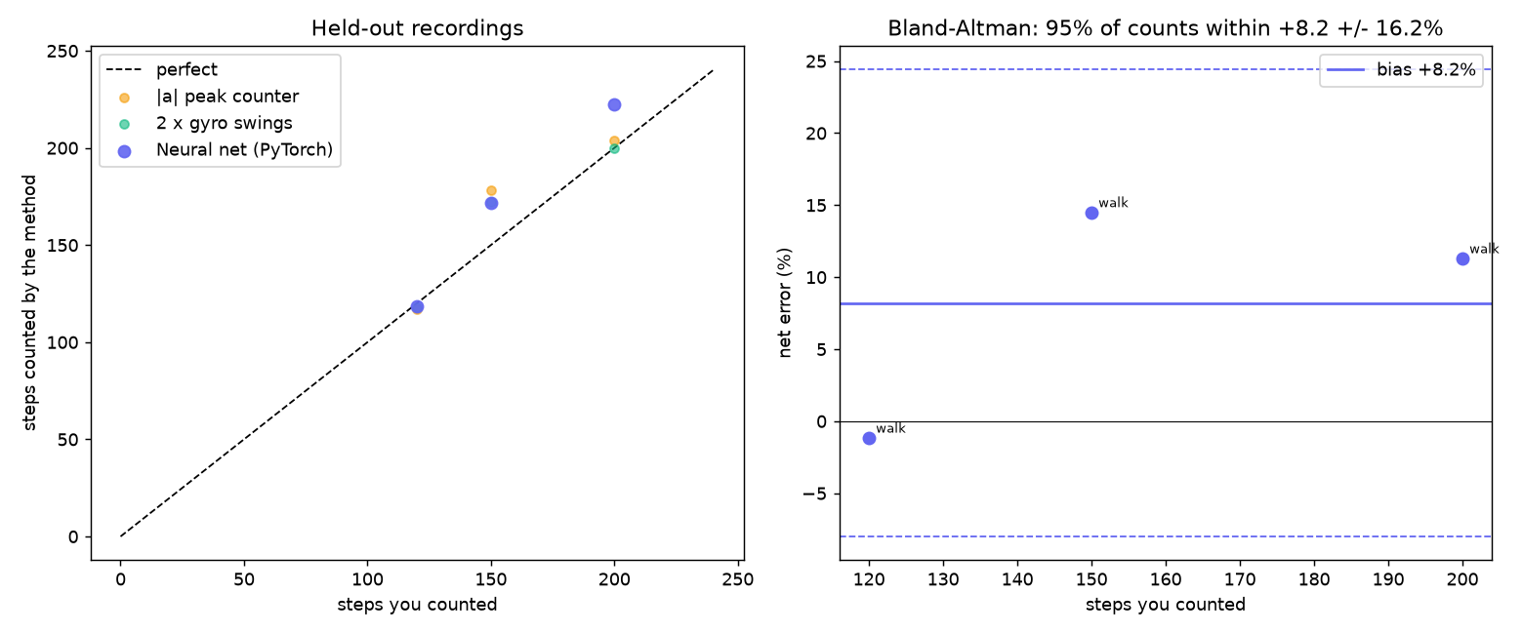
Left: held-out counts vs. my counts for all three methods. Right: Bland–Altman plot of the net's % error with the bias and 95% limits.
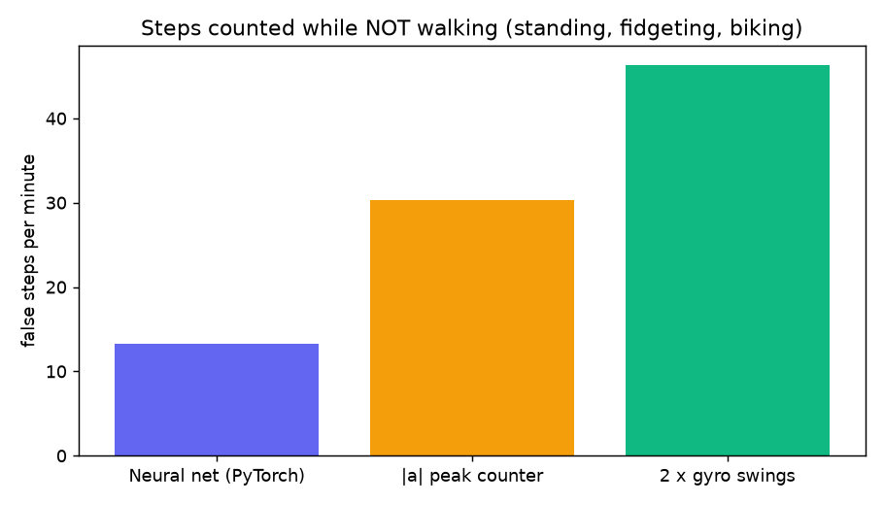
False steps per minute on the 0-step recordings (standing and biking).

5. Live demo
On the dashboard's Count tab I pressed Start counting and walked while counting out loud. I counted 27–28 steps; the net showed 30 – 2–3 steps over, consistent with the +8% bias found in the uncertainty analysis. The count also appears on the UNO Q's LED matrix.
🎥 Video: (add link here)

6. Experiment: pre-training on public data (and why I turned it off)
Because I only had a few counted walks, I tried transfer learning: pre-train the net on the open IPOL 2023 healthy-gait dataset (Voisard et al., doi:10.5201/ipol.2023.497 – 19 people, 110 walks, 3,831 hand-checked heel strikes from foot-mounted IMUs), then fine-tune on my own data.
- Pre-training worked on the public data itself: 96.2% accuracy on people it never saw (better spread than a peak counter, 3.1% vs 6.1%).
- Getting there exposed two real bugs: resampling 100 → 50 Hz with zero padding faked a jolt at the start of every recording, and the conv layers' zero padding did the same at the edges. Fixing both (line padding, replicate padding) took the validation from 70% to 96%.
- But it didn't transfer: the public sensors are on the foot, mine is on the ankle, and the zero-shot net counted 30–100 'steps' while I stood still. When fine-tuned with only standing/biking data of my own, it learned the shortcut “the ankle sensor never steps”.
So the final net trains on my recordings only (python train_steps.py), and transfer learning is an opt-in flag (--transfer) for when I have more data to compare fairly.

7. Reflection

What worked?
Turning step counting into a density whose sum is the count. It lets one net both place steps in time and count them, lets recordings with only a total still train it, and makes live counting a simple running sum. Reusing the gait identifier's hardware, MQTT link and 0-step recordings also meant the whole pipeline worked from the first walk.

What didn't, and what I learned?
Data quantity and quality mattered far more than the model. A disconnected cable gave a recording of zeros, counting one foot instead of both halved my labels, and a net trained on two walks looked great on one test and failed completely on the other. Public data looked like an easy fix but came from a different body location, and a net will happily learn a shortcut ("ankle = no steps") if the data allows it. Testing on held-out recordings is what exposed every one of these problems.

Is the neural net better than a simple pedometer?
On clean walking, not yet: the classic counters scored 93–95% vs the net's 90% with only 3 walks. Where the net already wins is rejecting things that aren't walking – biking and standing – which is exactly where pedometers fail. With more walks (and stairs) I expect its walking accuracy to catch up, because unlike a fixed threshold it can keep learning.

What would I do next?
- Record 5–6 more counted walks, plus stairs and stop-and-go, so the uncertainty estimate becomes reliable.
- Fix the power/Wi-Fi dropouts (secure cable, buffer samples on the board).
- Run the trained net on the UNO Q itself, so the step counter works without the laptop.

How I used Claude
Claude helped write the PyTorch training code, the dashboard and the uncertainty analysis, found the two padding bugs, and made the how-it-works animation, which is rendered from the trained net's real activations, gradients and loss curve. I recorded and counted all the data, ran the tests, and decided which approach to keep.

References
Voisard C. et al., “A Reference Data Set for the Study of Healthy Subject Gait with Inertial Measurement Units,” Image Processing On Line 13 (2023) 314–320, doi:10.5201/ipol.2023.497.
PyTorch – pytorch.org · Mosquitto MQTT broker – mosquitto.org

