⊖
In [ ]:

In [1]:
%reload_ext sql
%config PPMagics.fastload = True
import pandas as pd
import numpy as np
from decimal import Decimal
import datetime
from datetime import datetime, timedelta, date
import logging as log

import matplotlib.pyplot as plt
In [2]:
# import logging
# # log.basicConfig(filename='/logs/demo_test1.log', filemode='w', level=log.INFO, format = '%(asctime)s:%(name)s:%(message)s')
# logging.basicConfig(filename='demo_test1.log', filemode='w', level=log.INFO)

# my_logger = logging.getLogger('My Logger')
# my_logger.info('Starting Alerts Script')
In [ ]:
%%teradata_simba
select session
In [4]:
# my_logger = log.getLogger('Peak/Valley')
#being used under flow_peak
In [5]:
ALERTED = False
COUNT = 0
#being used under flow_peak
In [6]:
def run_query(sql, framed=False):
"""
Simple function to execute a query
Option to return results as a dataframe
"""
query = %teradata_simba $sql

if framed:
df = query.DataFrame()
return df
In [ ]:
sql_table2 = """
select * from PP_FDCC_TABLES.alert_count_hourly
order by alert_timestamp desc
"""
table2 = run_query(sql_table2, framed = True)
In [8]:
table2.head()
Out[8]:
 | alert_timestamp | alert_name | alert_count
0 | 2022-03-02 20:00:00 | GEO Mismatch Account Count at Routing Number L... | 834
1 | 2022-03-02 20:00:00 | CMID(NotEC) Account Count Trend Alert @Login | 410
2 | 2022-03-02 19:00:00 | GEO Mismatch Account Count at Routing Number L... | 1002
3 | 2022-03-02 19:00:00 | Supercookie Session Count Velocity Alert @Onbo... | 9
4 | 2022-03-02 19:00:00 | CMID(NotEC) Account Count Trend Alert @Login | 474
In [9]:
def get_table3(df):

df3_1 = df.pivot(index='alert_timestamp', columns='alert_name', values='alert_count')
df3_2 = df3_1.fillna(0)
df3_2['alert_timestamp']= df3_2.index

cols = list(df3_2.columns)
cols = [cols[-1]] + cols[:-1]
df3_3 = df3_2[cols]

df3_4 = df3_3.sort_values(by=['alert_timestamp'], ascending=False)
df3_5 = df3_4.reset_index(drop=True)
df3_5.columns = df3_5.columns.str.replace('?', ' ')

df3_6 = df3_5.set_index(['alert_timestamp']).sort_index(ascending=True).asfreq(freq ='H', fill_value = 0)
df3_7 = df3_6.rolling('12H').sum()
df3_8 = df3_7.sort_index(ascending=False)
df3_9 = df3_8.iloc[::12, :]
df3_9.reset_index(inplace=True)
df3_10 = df3_9.rename(columns = {'index':'alert_timestamp'})
table3 = df3_10

return table3
In [10]:
# table4 = table3.set_index(['alert_timestamp']).sort_index(ascending=True).asfreq(freq ='H', fill_value = 0)
# table4.head(10)
# table5 = table4.rolling('12H').sum()
# table5.head()
# table6 = table5.sort_index(ascending=False)
# table6.head(10)

# table7.reset_index(inplace=True)
# table8 = table7.rename(columns = {'index':'alert_timestamp'})
In [11]:
table3 = get_table3(table2)
table3.head()
Out[11]:
alert_name | alert_timestamp | Account Creation IP Mismatch Volume Alert - by Geo Country | Account creation volume with disposable emails | Artificial Typing Speed Account Count Trend Alert @PostSignup | Artificial Typing Speed Account Count Velocity Alert @PostSignup | CMID(EC) Account Count Trend Alert @Login | CMID(EC) Account Count Trend Alert @PostSignup | CMID(EC) Account Count Velocity Alert @Login | CMID(EC) Account Count Velocity Alert @PostSignup | CMID(EC) Session Count Trend Alert @Login | ... | VID Account Count Velocity Alert @PostSignup | VID Session Count Trend Alert @Login | VID Session Count Trend Alert @OnboardingGC | VID Session Count Velocity Alert @Login | VID Session Count Velocity Alert @OnboardingGC | VM Volume @Login | VM Volume Alert | VPN Volume @Login | VPN Volume Alert | fdcc_emulator_login
0 | 2022-03-02 20:00:00 | 0.0 | 568.0 | 0.0 | 0.0 | 0.0 | 0.0 | 0.0 | 719.0 | 0.0 | ... | 0.0 | 0.0 | 135.0 | 2906.0 | 0.0 | 0.0 | 0.0 | 0.0 | 0.0 | 0.0
1 | 2022-03-02 08:00:00 | 0.0 | 0.0 | 0.0 | 0.0 | 0.0 | 361.0 | 0.0 | 1439.0 | 0.0 | ... | 525.0 | 0.0 | 0.0 | 430.0 | 0.0 | 0.0 | 0.0 | 0.0 | 0.0 | 0.0
2 | 2022-03-01 20:00:00 | 0.0 | 333.0 | 0.0 | 17.0 | 0.0 | 0.0 | 0.0 | 594.0 | 0.0 | ... | 0.0 | 0.0 | 253.0 | 9058.0 | 0.0 | 0.0 | 0.0 | 0.0 | 0.0 | 0.0
3 | 2022-03-01 08:00:00 | 311.0 | 303.0 | 0.0 | 16.0 | 0.0 | 0.0 | 0.0 | 960.0 | 0.0 | ... | 562.0 | 0.0 | 0.0 | 16297.0 | 0.0 | 0.0 | 0.0 | 86342.0 | 0.0 | 0.0
4 | 2022-02-28 20:00:00 | 4775.0 | 0.0 | 0.0 | 17.0 | 0.0 | 0.0 | 0.0 | 739.0 | 0.0 | ... | 0.0 | 0.0 | 0.0 | 17559.0 | 0.0 | 0.0 | 0.0 | 0.0 | 0.0 | 0.0
5 rows × 65 columns
In [12]:
# tabel3['CMID(EC) Account Count Trend Alert @PostSignup']
In [13]:
name_list = list(table3)
name_list
Out[13]:
['alert_timestamp',
'Account Creation IP Mismatch Volume Alert - by Geo Country',
'Account creation volume with disposable emails',
'Artificial Typing Speed Account Count Trend Alert @PostSignup ',
'Artificial Typing Speed Account Count Velocity Alert @PostSignup ',
'CMID(EC) Account Count Trend Alert @Login',
'CMID(EC) Account Count Trend Alert @PostSignup',
'CMID(EC) Account Count Velocity Alert @Login',
'CMID(EC) Account Count Velocity Alert @PostSignup',
'CMID(EC) Session Count Trend Alert @Login',
'CMID(EC) Session Count Velocity Alert @Login',
'CMID(NotEC) Account Count Trend Alert @Login',
'CMID(NotEC) Account Count Trend Alert @PostSignup',
'CMID(NotEC) Account Count Velocity Alert @Login',
'CMID(NotEC) Account Count Velocity Alert @PostSignup',
'CMID(NotEC) Session Count Trend Alert @Login',
'CMID(NotEC) Session Count Velocity Alert @Login',
'GEO Mismatch Account Count Alert @Login',
'GEO Mismatch Account Count at Routing Number Level Velocity Alert @WithdrawalAttempt',
'GEO Mismatch Session Count Alert @AddCC',
'GEO Mismatch Session Count at Bin Level Trend Alert @AddCC',
'GEO Mismatch Session Count at Bin Level Velocity Alert @AddCC',
'GEO Mismatch Session Count at Routing Number Level Trend Alert @WithdrawalAttempt',
'GEO Mismatch Session Count at Routing Number Level Velocity Alert @Deposit ',
'IP CC Hash Count Trend Alert @AddCC',
'IP CC Hash Count Velocity Alert @AddCC',
'LinkerID Account Count Trend Alert @Login',
'LinkerID Account Count Velocity Alert @Login',
'LinkerID Session Count Trend Alert @Login',
'LinkerID Session Count Velocity Alert @Login',
'SubscriberID Account Count Velocity Alert @Login',
'SubscriberID Account Count Velocity Alert @PostSignup',
'SubscriberID Session Count Trend Alert @Login',
'SubscriberID Session Count Velocity Alert @Login',
'Supercookie Account Count Trend Alert @Login',
'Supercookie Account Count Trend Alert @OnboardingGC',
'Supercookie Account Count Trend Alert @PostSignup',
'Supercookie Account Count Velocity Alert @Login',
'Supercookie Account Count Velocity Alert @OnboardingGC',
'Supercookie Account Count Velocity Alert @PostSignup',
'Supercookie Session Count Trend Alert @Login',
'Supercookie Session Count Trend Alert @OnboardingGC',
'Supercookie Session Count Velocity Alert @Login',
'Supercookie Session Count Velocity Alert @OnboardingGC',
'Traffic alert cntry --- HoldsAssessment',
'Traffic alert xclick_cntry_plus --- HoldsAssessment',
'VID Account Count Trend Alert @AddCC',
'VID Account Count Trend Alert @ConsolidatedFunding',
'VID Account Count Trend Alert @Login',
'VID Account Count Trend Alert @OnboardingGC',
'VID Account Count Trend Alert @PostSignup',
'VID Account Count Velocity Alert @AddCC',
'VID Account Count Velocity Alert @ConsolidatedFunding',
'VID Account Count Velocity Alert @Login',
'VID Account Count Velocity Alert @OnboardingGC',
'VID Account Count Velocity Alert @PostSignup',
'VID Session Count Trend Alert @Login',
'VID Session Count Trend Alert @OnboardingGC',
'VID Session Count Velocity Alert @Login',
'VID Session Count Velocity Alert @OnboardingGC',
'VM Volume @Login',
'VM Volume Alert',
'VPN Volume @Login',
'VPN Volume Alert',
'fdcc_emulator_login']
In [14]:
def thresholding_algo(y, lag, threshold, influence):

# y is alert_count in the next get_peaks function;
# lag, threshold, influence are all parameters in flow_peak

# signals is used to judge in each point is peak or valley,
# after judge the treshold is more than 3
# then judge y[i] is more or less than mean.y[0:7] or not,
# if more, it will be defind as a peak
# if less, it will be defind as a valley
# in the begin, signals = [0,0,0,0,0,0,0,0,0,0,0,0,0...0,0,0]
# in the result, signals = array([0,0,0,1,0,0,1,0,0....0,1,0])
# in most cases, signals will be 0, because not more than 3sd, one ABS diff of y[i] and y[0:7] is more than 3 sd,
# then to judge it is 1 or -1

signals = np.zeros(len(y))
filteredY = np.array(y)
avgFilter = [0]*len(y)
stdFilter = [0]*len(y)
avgFilter[lag - 1] = np.mean(y[0:lag]) # when lag is 7, as the aler_court in desc, means the alert_count value in most recent 7 timestamp
stdFilter[lag - 1] = np.std(y[0:lag])

for i in range(lag, len(y)):

if abs(y[i] - avgFilter[i-1]) > threshold * stdFilter [i-1]: # when treshold is 3 means, the |Y[i] - mean.Y[0:7]| is more than 3 sd.Y[0:7]

if y[i] > avgFilter[i-1]:
signals[i] = 1
else:
signals[i] = -1

filteredY[i] = influence * y[i] + (1 - influence) * filteredY[i-1]
avgFilter[i] = np.mean(filteredY[(i+1-lag):(i+1)])
stdFilter[i] = np.std(filteredY[(i+1-lag):(i+1)])
else:
signals[i] = 0
filteredY[i] = y[i]
avgFilter[i] = np.mean(filteredY[(i+1-lag):(i+1)])
stdFilter[i] = np.std(filteredY[(i+1-lag):(i+1)])

return dict(signals = np.asarray(signals),
avgFilter = np.asarray(avgFilter),
stdFilter = np.asarray(stdFilter))

# input is 4,including alert_count and other 3 parameters, which will be designed in flow_peak
# output is 3 arrays
# signals used to judge it is potential peak or valley by 1 and -1

# ie.: y=[3,5,2,4,20]
# if influence=1
# filteretedY[i]=y[i]
# filteretedY= y
# if influence=-1
# filteretedY[i]= 2 filtertedY[i-1] - y[i] ??????means what?? if 1, all y; if -1, all this value

# in whichever case, the other 2 outputs will be array of each 7 duration of filteredY avg and std

# the output, only signals is used in get_peaks function, the other output not being used. They are potentially
# to be used in get_peak function in the original drafts.
In [ ]:

In [15]:
def get_peaks(query_dict, imageName, force_plot=False):

# input is 3, query_dict is the flow in peak_flow, get_peaks is used under peak_flow, there pass query_dict = low
# by calling pet_peaks function.
# also get imageName = "img/{}_layer.png".format(flow['layer']) under peak_flow, is the second pair in the dict,
# imageName is the value of 'alert_name' in second pair

lag = query_dict['lag']
threshold = query_dict['threshold']
influence = query_dict['influence']
column = query_dict['column']

df = get_table3(table2)

# need to pass table3 to df here, df = get_table3(df)
# get_table3() is function of getting table3

alert_count = df[column].tolist()

d = df['alert_timestamp'].tolist() # d is timestamp column transfer to list, d is time

# d = df.index.tolist()

alert_count = np.array(alert_count).astype(np.float)

result = thresholding_algo(alert_count, lag=lag, threshold=threshold, influence=influence)
# go back to line
# return dict(signals = np.asarray(signals),
# avgFilter = np.asarray(avgFilter),
# stdFilter = np.asarray(stdFilter))

if result['signals'][-1]==1 or force_plot:

plot_peaks(query_dict,result,alert_count, d, imageName) # d = df['alert_date'].tolist()
# refering the next plot_peaks function, alert_count = t in the next function

return [d[-1],query_dict['alert_name'],alert_count[-1], alert_count[-8:], d[-8:]]

# return is 5 values
# d is timestamp list,
# last timestamp, alert_name is second pair in peak_flow, last alert_count, last 7 alert_count, last 7 timestamp
In [16]:
# with 30 points in this function__original

def plot_peaks(query_dict,result,t,d, imageName): # d = df['alert_date'].tolist()
# input variables are 7
# 1.query_dict is in peak_flow, same as in get_peak function
# 2.result is the 3 array for result in thresholding_algo
# 3.t is alert_count refering the line above return in get_peaks function.
# 4.d is d = df['alert_date'].tolist() under get_peaks function
# 5.ts_peaks is timestamp value in d, being appended to ts_peaks, by for loop and judge for signal under get_peaks
# 6.peaks is aler_count value, or 1 and -1 value??????? it is appended in the same way as ts_peak
# 7.get imageName = "img/{}_layer.png".format(flow['layer']) under peak_flow, is the second pair in the dict,
# imageName is the value of 'alert_name' in second pair
y = list(table3[query_dict['alert_name']])
y1 = list(map(int, y))
Y = np.array(y1)
avg_y = np.mean(Y[1:15])
std_y = np.std(Y[1:15])

plt.figure(figsize=(16, 8)) # d = df['alert_date'].tolist()
plt.plot(d[0:60], t[0:60], label='Alert_count') # should we change a name of the visual title?? t is alert_account
plt.plot(d[0], t[0],"ro", label='Peak')
plt.plot(d[0], t[0],"ro", label='Peak')
plt.legend(fontsize=12)
plt.ylabel('Alert Count', fontsize=14)
plt.xlabel('Timestamp',fontsize=14)
plt.title(query_dict['alert_name'], fontsize=18)
plt.axhline(y = avg_y + query_dict['threshold']* std_y, color = 'b', linestyle = 'dotted')
plt.savefig(imageName, bbox_inches = "tight")

return plt
In [17]:
def format_query(txt,*args):
"""
Format query text based on *args
"""
formatted = txt.format(*args)
return formatted
In [18]:
#Alerts
# my_logger.info('Starting Alerts Script')
In [19]:
alert_name_list = list(table3)[1:]
len(alert_name_list)
Out[19]:
64
In [20]:
alert_name_list
Out[20]:
['Account Creation IP Mismatch Volume Alert - by Geo Country',
'Account creation volume with disposable emails',
'Artificial Typing Speed Account Count Trend Alert @PostSignup ',
'Artificial Typing Speed Account Count Velocity Alert @PostSignup ',
'CMID(EC) Account Count Trend Alert @Login',
'CMID(EC) Account Count Trend Alert @PostSignup',
'CMID(EC) Account Count Velocity Alert @Login',
'CMID(EC) Account Count Velocity Alert @PostSignup',
'CMID(EC) Session Count Trend Alert @Login',
'CMID(EC) Session Count Velocity Alert @Login',
'CMID(NotEC) Account Count Trend Alert @Login',
'CMID(NotEC) Account Count Trend Alert @PostSignup',
'CMID(NotEC) Account Count Velocity Alert @Login',
'CMID(NotEC) Account Count Velocity Alert @PostSignup',
'CMID(NotEC) Session Count Trend Alert @Login',
'CMID(NotEC) Session Count Velocity Alert @Login',
'GEO Mismatch Account Count Alert @Login',
'GEO Mismatch Account Count at Routing Number Level Velocity Alert @WithdrawalAttempt',
'GEO Mismatch Session Count Alert @AddCC',
'GEO Mismatch Session Count at Bin Level Trend Alert @AddCC',
'GEO Mismatch Session Count at Bin Level Velocity Alert @AddCC',
'GEO Mismatch Session Count at Routing Number Level Trend Alert @WithdrawalAttempt',
'GEO Mismatch Session Count at Routing Number Level Velocity Alert @Deposit ',
'IP CC Hash Count Trend Alert @AddCC',
'IP CC Hash Count Velocity Alert @AddCC',
'LinkerID Account Count Trend Alert @Login',
'LinkerID Account Count Velocity Alert @Login',
'LinkerID Session Count Trend Alert @Login',
'LinkerID Session Count Velocity Alert @Login',
'SubscriberID Account Count Velocity Alert @Login',
'SubscriberID Account Count Velocity Alert @PostSignup',
'SubscriberID Session Count Trend Alert @Login',
'SubscriberID Session Count Velocity Alert @Login',
'Supercookie Account Count Trend Alert @Login',
'Supercookie Account Count Trend Alert @OnboardingGC',
'Supercookie Account Count Trend Alert @PostSignup',
'Supercookie Account Count Velocity Alert @Login',
'Supercookie Account Count Velocity Alert @OnboardingGC',
'Supercookie Account Count Velocity Alert @PostSignup',
'Supercookie Session Count Trend Alert @Login',
'Supercookie Session Count Trend Alert @OnboardingGC',
'Supercookie Session Count Velocity Alert @Login',
'Supercookie Session Count Velocity Alert @OnboardingGC',
'Traffic alert cntry --- HoldsAssessment',
'Traffic alert xclick_cntry_plus --- HoldsAssessment',
'VID Account Count Trend Alert @AddCC',
'VID Account Count Trend Alert @ConsolidatedFunding',
'VID Account Count Trend Alert @Login',
'VID Account Count Trend Alert @OnboardingGC',
'VID Account Count Trend Alert @PostSignup',
'VID Account Count Velocity Alert @AddCC',
'VID Account Count Velocity Alert @ConsolidatedFunding',
'VID Account Count Velocity Alert @Login',
'VID Account Count Velocity Alert @OnboardingGC',
'VID Account Count Velocity Alert @PostSignup',
'VID Session Count Trend Alert @Login',
'VID Session Count Trend Alert @OnboardingGC',
'VID Session Count Velocity Alert @Login',
'VID Session Count Velocity Alert @OnboardingGC',
'VM Volume @Login',
'VM Volume Alert',
'VPN Volume @Login',
'VPN Volume Alert',
'fdcc_emulator_login']
In [21]:
mylist = alert_name_list

peek_flow_test1 = []

lag = 60
threshold = 1.5
influence = -1
mode1 = 'Peaks'
mode2 = 'Valley'

for i in range(len(alert_name_list)):
dict = {}
dict['column'] = mylist[i]
dict['alert_name'] = mylist[i]
dict['lag'] = lag
dict['threshold'] = threshold
dict['influence'] = influence
if influence == -1:
dict['mode'] = mode1
else:
dict['mode'] = mode2
peek_flow_test1.append(dict)
del(dict)

print(peek_flow_test1[:15])
[{'mode': 'Peaks', 'lag': 60, 'column': 'Account Creation IP Mismatch Volume Alert - by Geo Country', 'threshold': 1.5, 'influence': -1, 'alert_name': 'Account Creation IP Mismatch Volume Alert - by Geo Country'}, {'mode': 'Peaks', 'lag': 60, 'column': 'Account creation volume with disposable emails', 'threshold': 1.5, 'influence': -1, 'alert_name': 'Account creation volume with disposable emails'}, {'mode': 'Peaks', 'lag': 60, 'column': 'Artificial Typing Speed Account Count Trend Alert @PostSignup ', 'threshold': 1.5, 'influence': -1, 'alert_name': 'Artificial Typing Speed Account Count Trend Alert @PostSignup '}, {'mode': 'Peaks', 'lag': 60, 'column': 'Artificial Typing Speed Account Count Velocity Alert @PostSignup ', 'threshold': 1.5, 'influence': -1, 'alert_name': 'Artificial Typing Speed Account Count Velocity Alert @PostSignup '}, {'mode': 'Peaks', 'lag': 60, 'column': 'CMID(EC) Account Count Trend Alert @Login', 'threshold': 1.5, 'influence': -1, 'alert_name': 'CMID(EC) Account Count Trend Alert @Login'}, {'mode': 'Peaks', 'lag': 60, 'column': 'CMID(EC) Account Count Trend Alert @PostSignup', 'threshold': 1.5, 'influence': -1, 'alert_name': 'CMID(EC) Account Count Trend Alert @PostSignup'}, {'mode': 'Peaks', 'lag': 60, 'column': 'CMID(EC) Account Count Velocity Alert @Login', 'threshold': 1.5, 'influence': -1, 'alert_name': 'CMID(EC) Account Count Velocity Alert @Login'}, {'mode': 'Peaks', 'lag': 60, 'column': 'CMID(EC) Account Count Velocity Alert @PostSignup', 'threshold': 1.5, 'influence': -1, 'alert_name': 'CMID(EC) Account Count Velocity Alert @PostSignup'}, {'mode': 'Peaks', 'lag': 60, 'column': 'CMID(EC) Session Count Trend Alert @Login', 'threshold': 1.5, 'influence': -1, 'alert_name': 'CMID(EC) Session Count Trend Alert @Login'}, {'mode': 'Peaks', 'lag': 60, 'column': 'CMID(EC) Session Count Velocity Alert @Login', 'threshold': 1.5, 'influence': -1, 'alert_name': 'CMID(EC) Session Count Velocity Alert @Login'}, {'mode': 'Peaks', 'lag': 60, 'column': 'CMID(NotEC) Account Count Trend Alert @Login', 'threshold': 1.5, 'influence': -1, 'alert_name': 'CMID(NotEC) Account Count Trend Alert @Login'}, {'mode': 'Peaks', 'lag': 60, 'column': 'CMID(NotEC) Account Count Trend Alert @PostSignup', 'threshold': 1.5, 'influence': -1, 'alert_name': 'CMID(NotEC) Account Count Trend Alert @PostSignup'}, {'mode': 'Peaks', 'lag': 60, 'column': 'CMID(NotEC) Account Count Velocity Alert @Login', 'threshold': 1.5, 'influence': -1, 'alert_name': 'CMID(NotEC) Account Count Velocity Alert @Login'}, {'mode': 'Peaks', 'lag': 60, 'column': 'CMID(NotEC) Account Count Velocity Alert @PostSignup', 'threshold': 1.5, 'influence': -1, 'alert_name': 'CMID(NotEC) Account Count Velocity Alert @PostSignup'}, {'mode': 'Peaks', 'lag': 60, 'column': 'CMID(NotEC) Session Count Trend Alert @Login', 'threshold': 1.5, 'influence': -1, 'alert_name': 'CMID(NotEC) Session Count Trend Alert @Login'}]
In [ ]:
peek_flow2 = peek_flow_test1[:3]

for flow in peek_flow2:
y = list(table3[flow['alert_name']])
y1 = list(map(int, y))
Y = np.array(y1)
avg_y = np.mean(Y[1:15])
std_y = np.std(Y[1:15])
if std_y == 0:
threshold = 0
else:
threshold = (y1[0] - avg_y) / std_y
# threshold = abs(y1[0] - avg_y) / std_y

if threshold > 3:
print('yes')
print('threshold is')
print(threshold)
print(flow['alert_name'])
print(y1[0:15])
print('Peak for {}. Email sent.'.format(flow['alert_name']))
print(' ')

else:
print('no')
print('threshold is')
print(flow['alert_name'])
print(y1[0:15])
print('NO peak for {}. No email to sent.'.format(flow['alert_name']))
print(' ')
In [23]:
# table3_1=table3.iloc[14: , :]
# name_list1 = list(table3_1)
# alert_name_list = list(table3_1)[1:]

# mylist = alert_name_list

# peek_flow_test1 = []

# lag = 14
# threshold = 3
# influence = 1
# mode1 = 'Peaks'
# mode2 = 'Valley'

# for i in range(len(alert_name_list)):
# dict = {}
# dict['column'] = mylist[i]
# dict['alert_name'] = mylist[i]
# dict['lag'] = lag
# dict['threshold'] = threshold
# dict['influence'] = influence
# if influence == 1:
# dict['mode'] = mode1
# else:
# dict['mode'] = mode2
# peek_flow_test1.append(dict)
# del(dict)

# peek_flow2 = peek_flow_test1

# for flow in peek_flow2:
# y = list(table3_1[flow['alert_name']])
# y1 = list(map(int, y))
# Y = np.array(y1)
# avg_y = np.mean(Y[1:61])
# std_y = np.std(Y[1:61])
# if std_y == 0:
# threshold = 0
# else:
# threshold = (y1[0] - avg_y) / std_y

# # count how many 'yes'

# result_1_5 = []
# if threshold < -1.5:
# i = 'yes'
# else:
# i = 'no'
# result_1_5.append(i)

# count_yes = result_1_5.count('yes')
# print(result_1_5)
# print('Count of under 1.5 std:', count_yes)
In [24]:
# 3sd, lag =3
# del (dict)
peek_flow2 = peek_flow_test1

for flow in peek_flow2:

imageName = "img5_3/{}_AlertType.png".format(flow['alert_name'])
result = get_peaks(flow, imageName, force_plot=True)
/etl/LVS/dmetldata11/scaas/anaconda3/lib/python3.5/site-packages/matplotlib/pyplot.py:537: RuntimeWarning: More than 20 figures have been opened. Figures created through the pyplot interface (`matplotlib.pyplot.figure`) are retained until explicitly closed and may consume too much memory. (To control this warning, see the rcParam `figure.max_open_warning`).
max_open_warning, RuntimeWarning)
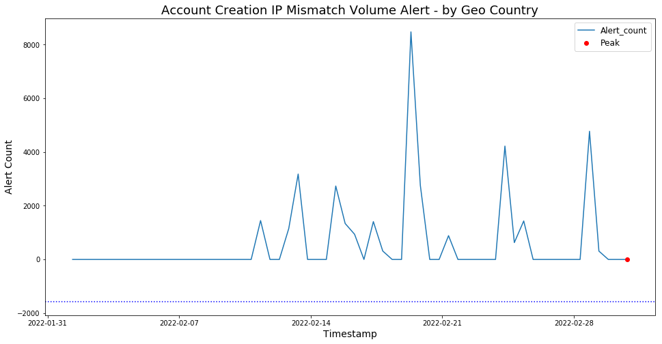
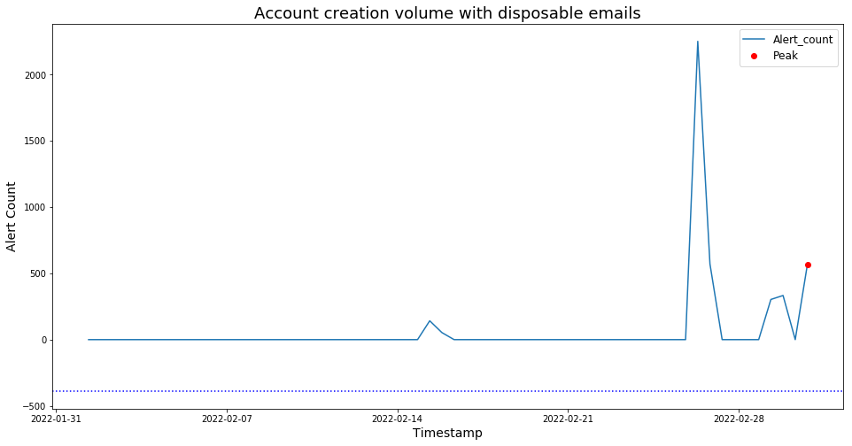
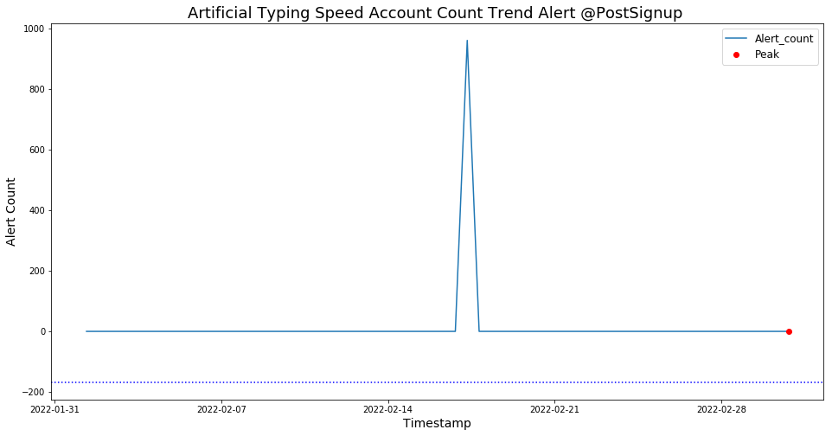
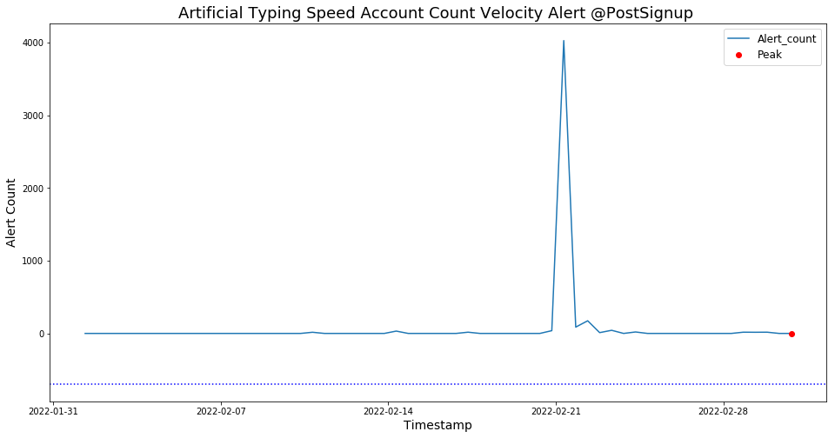
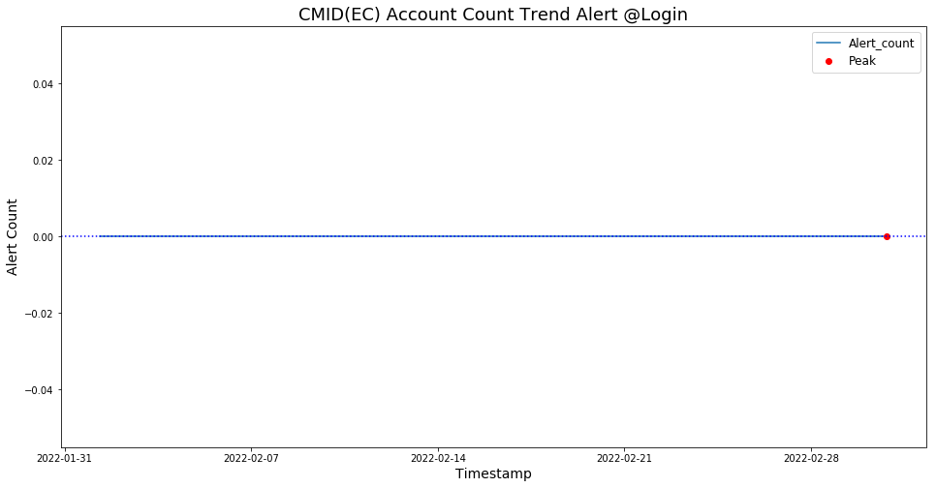
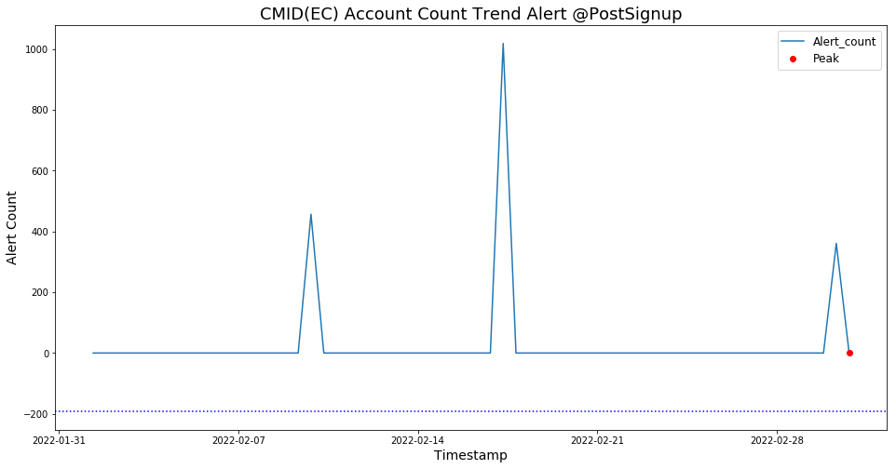
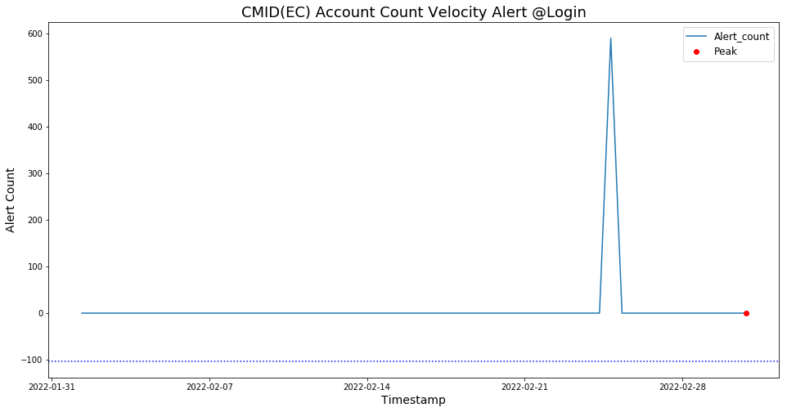
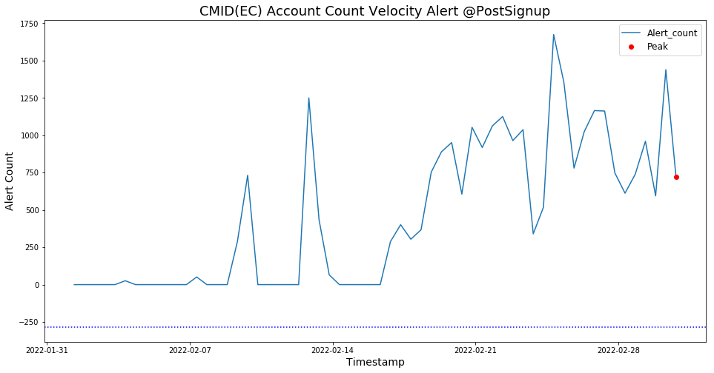
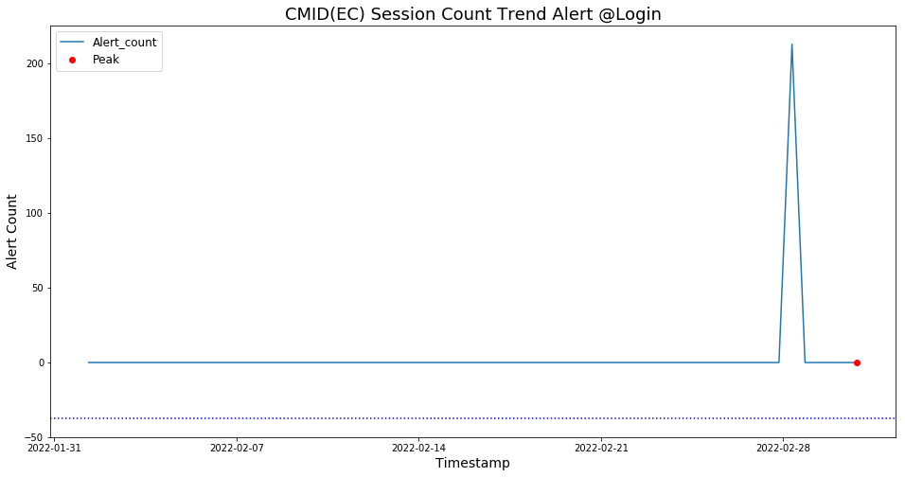
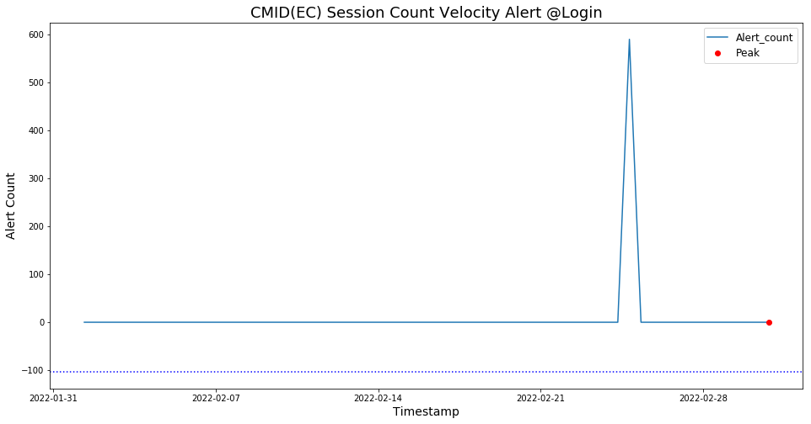
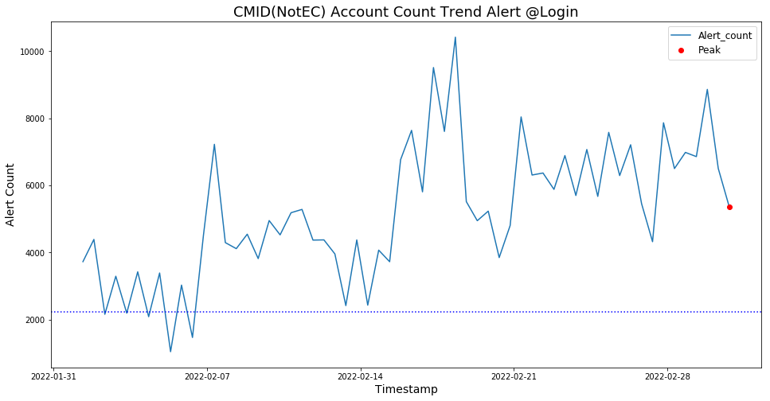
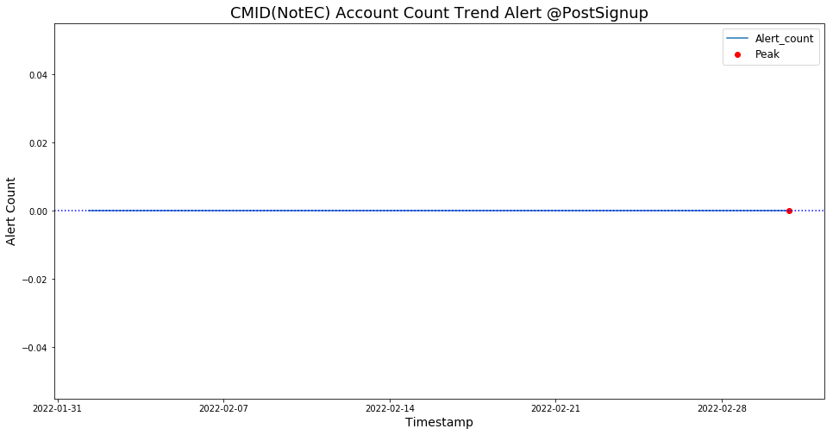
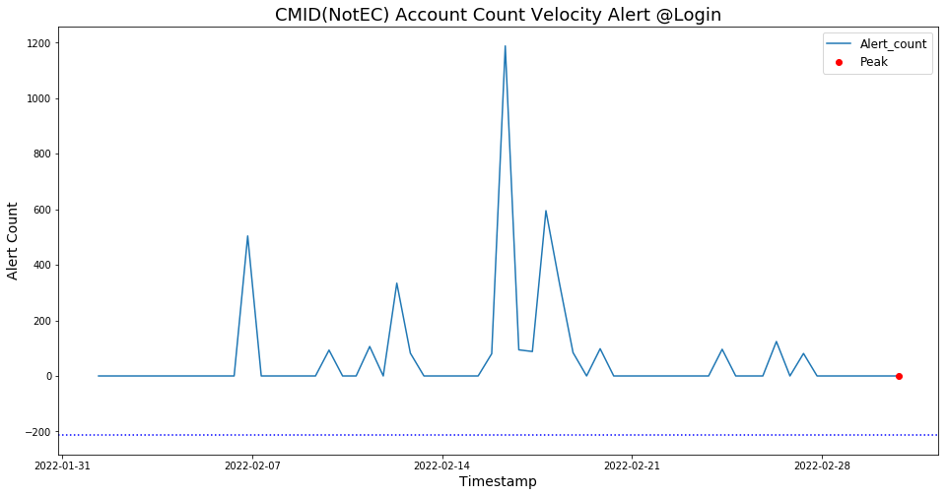
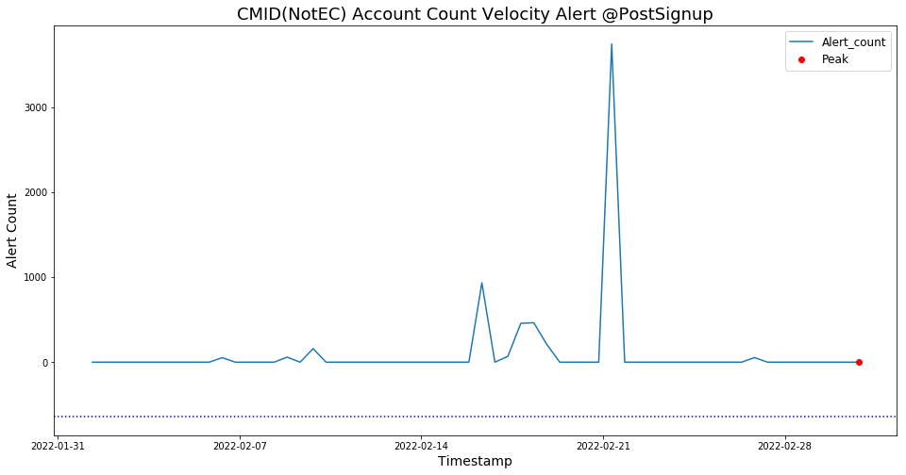
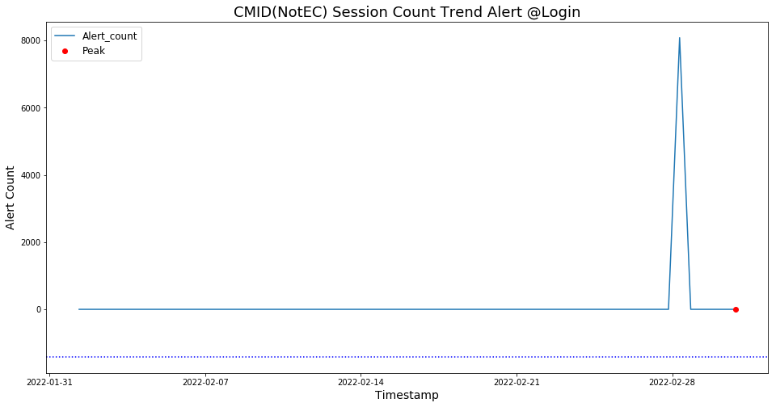
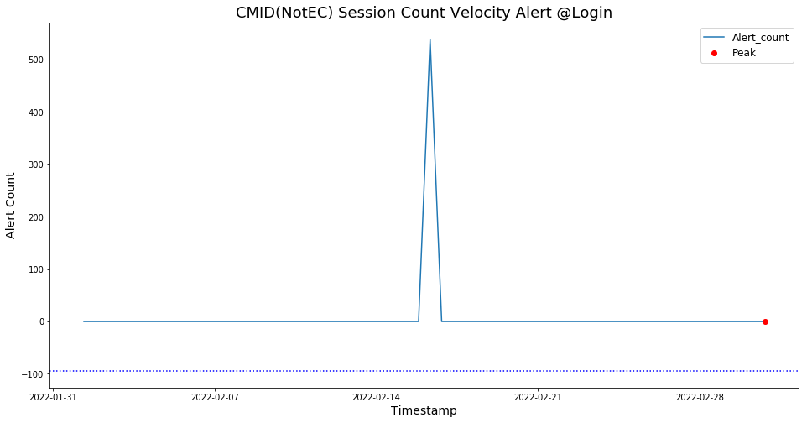
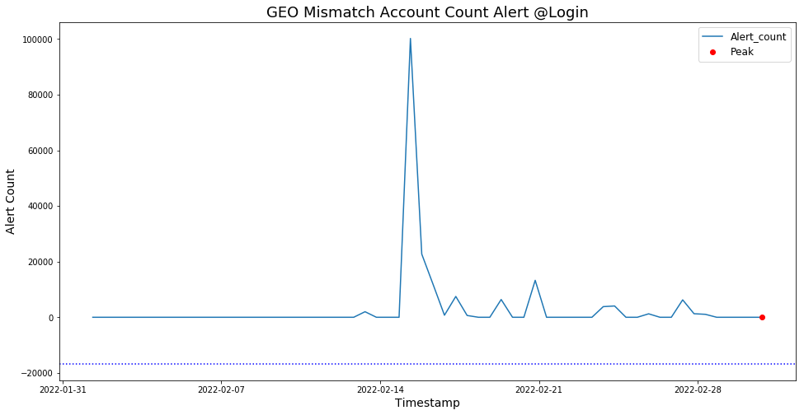
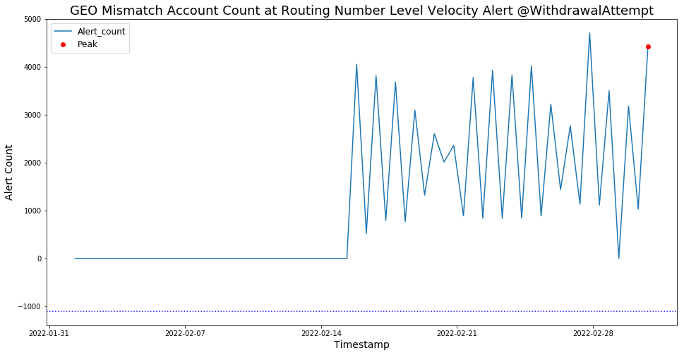
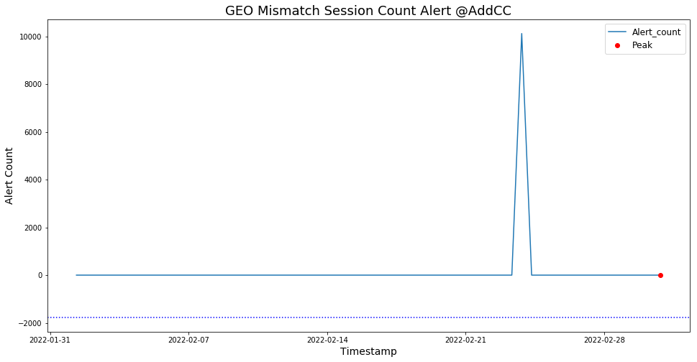
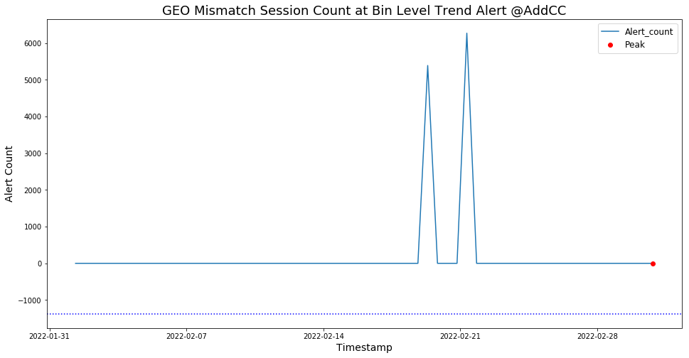
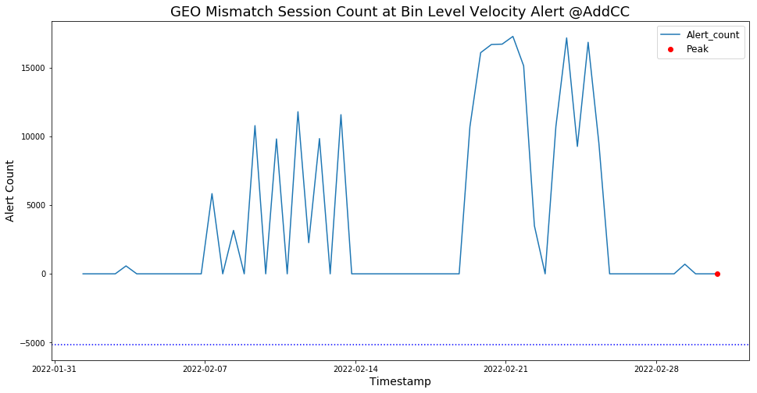
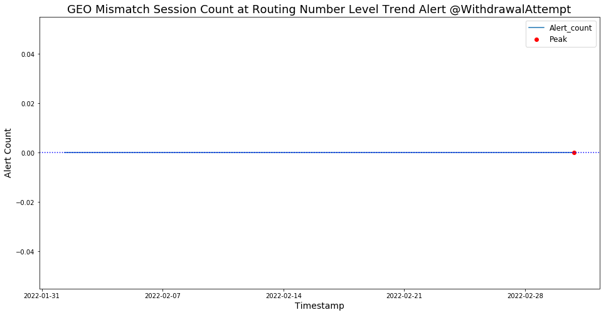
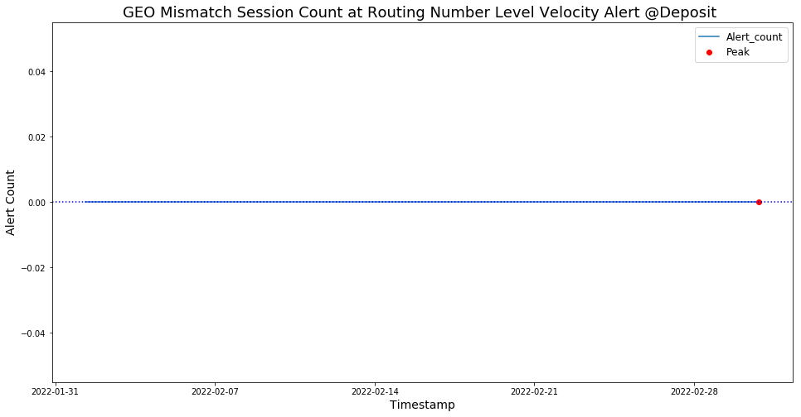
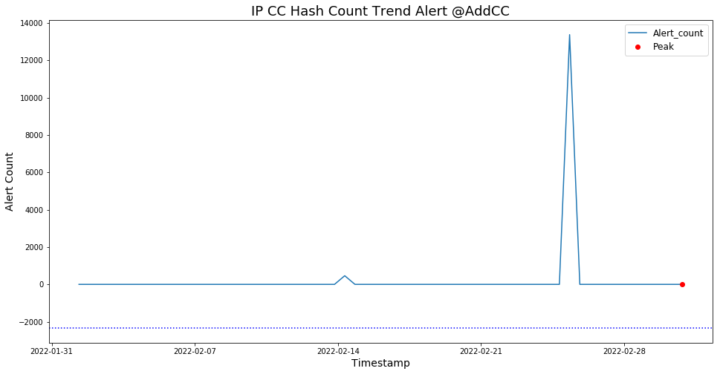
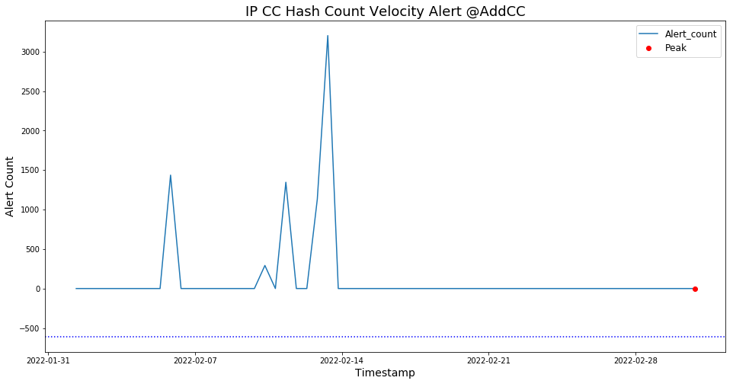
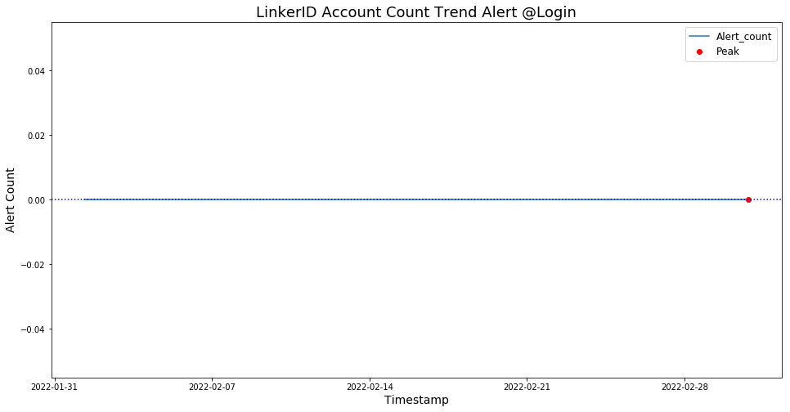
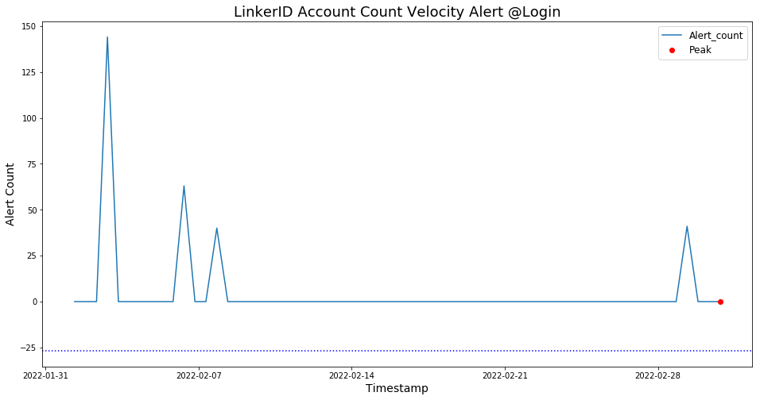
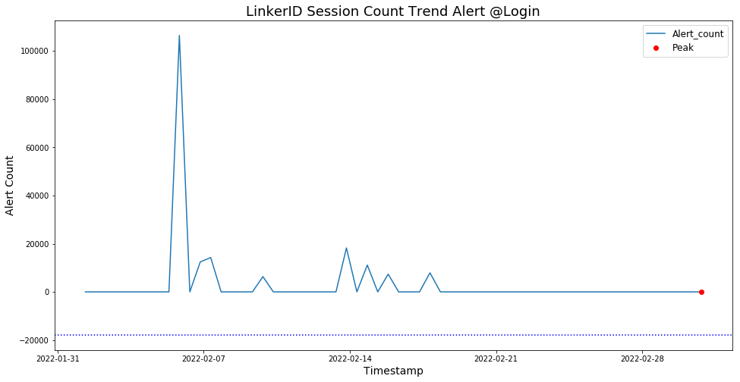
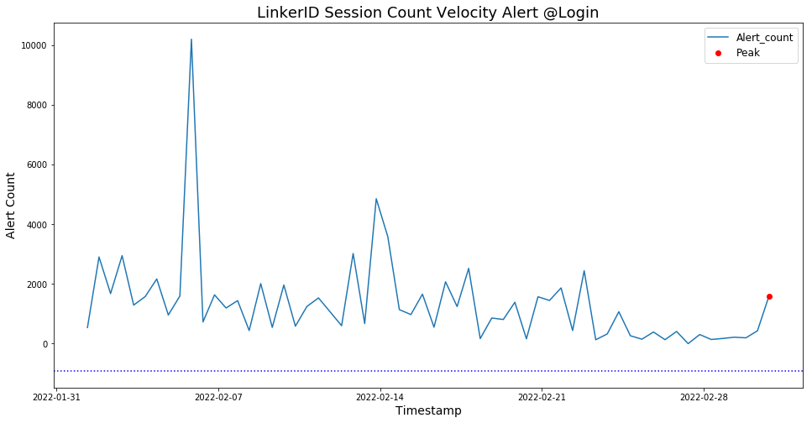
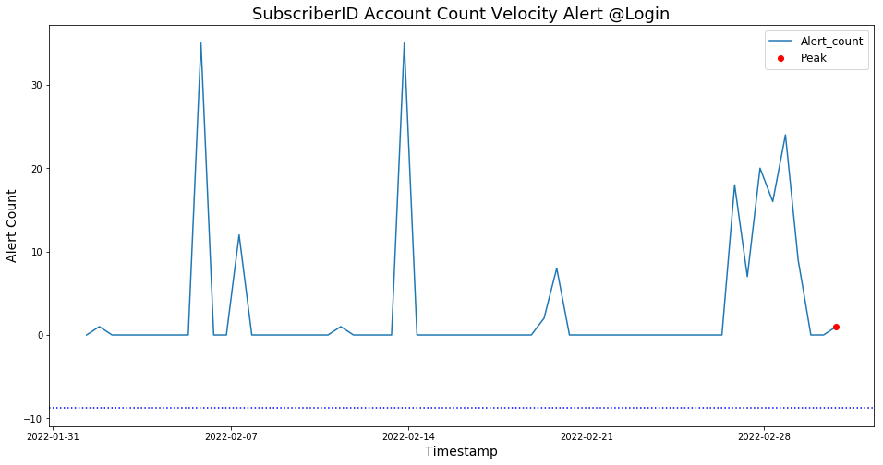
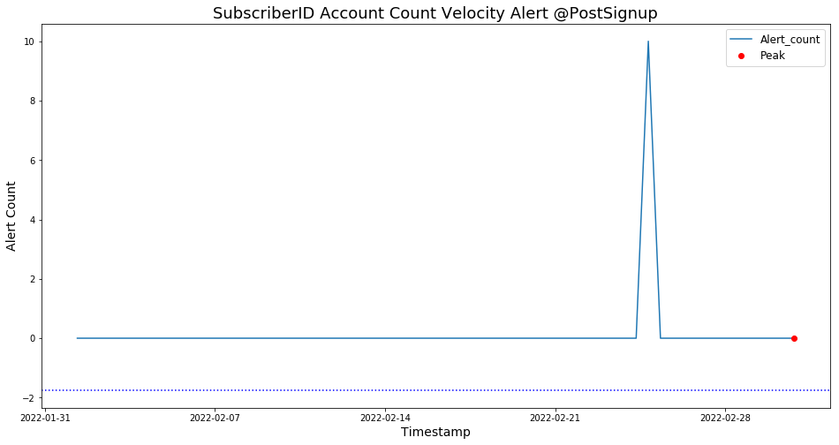
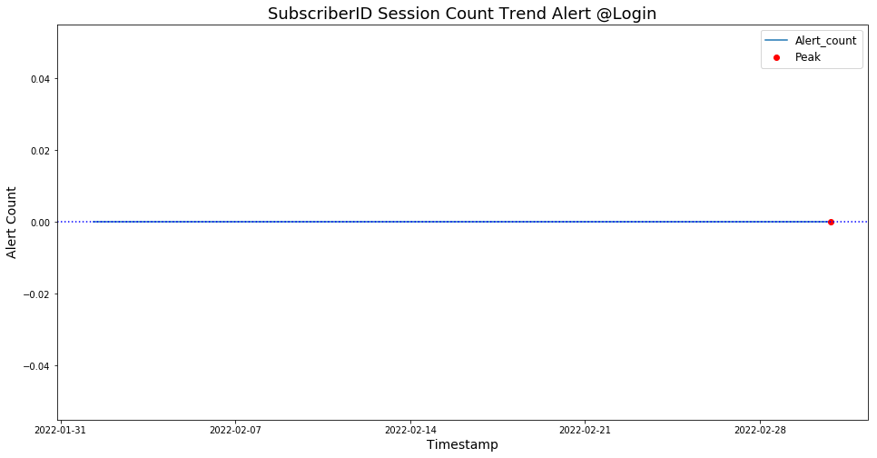
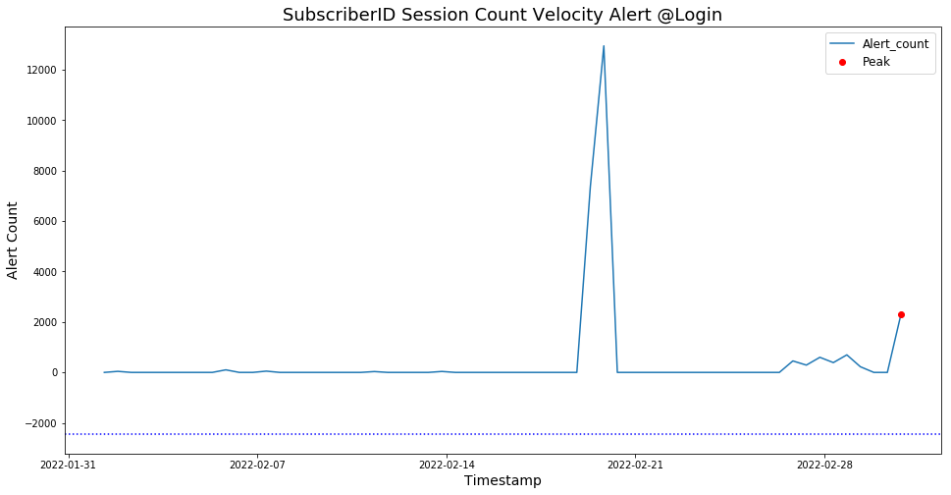
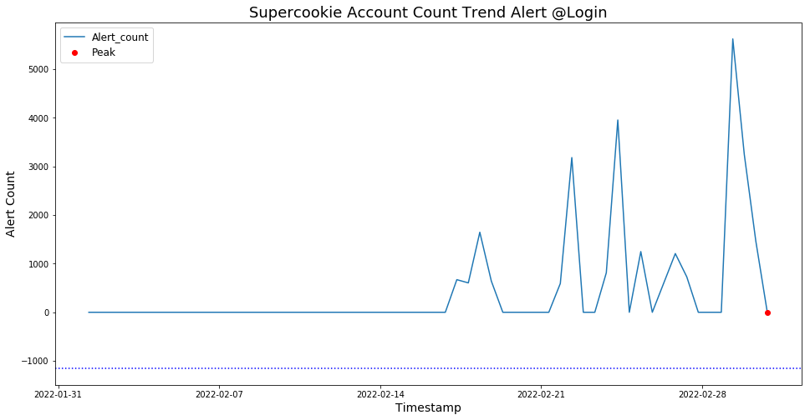
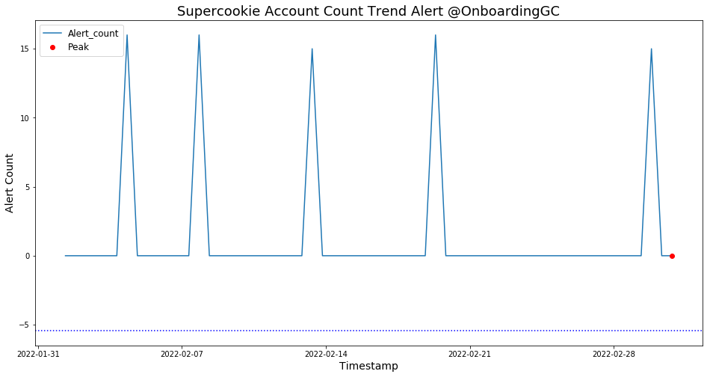
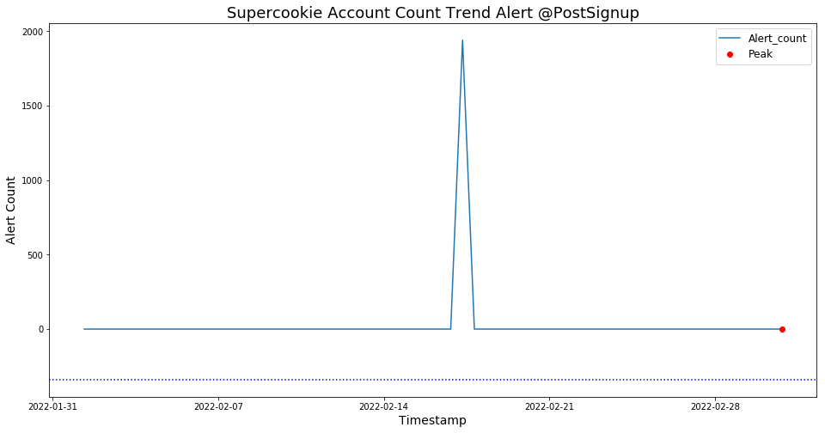
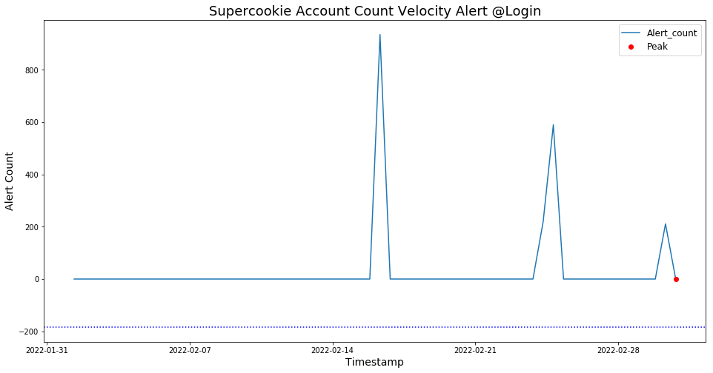
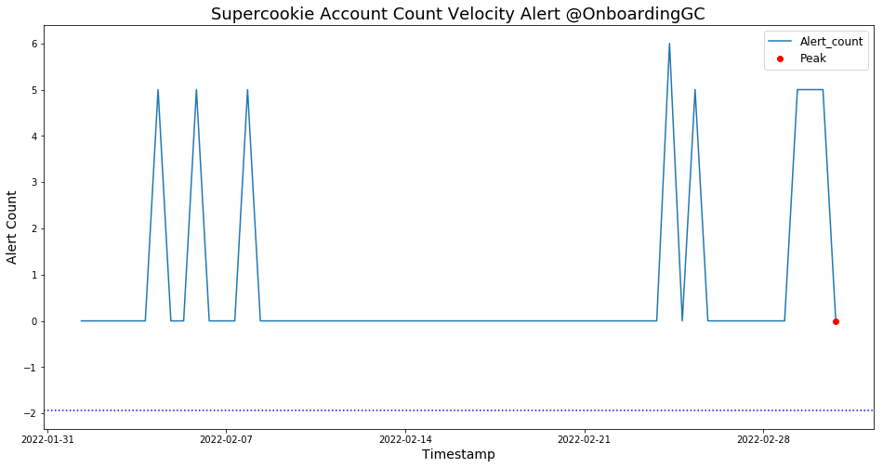
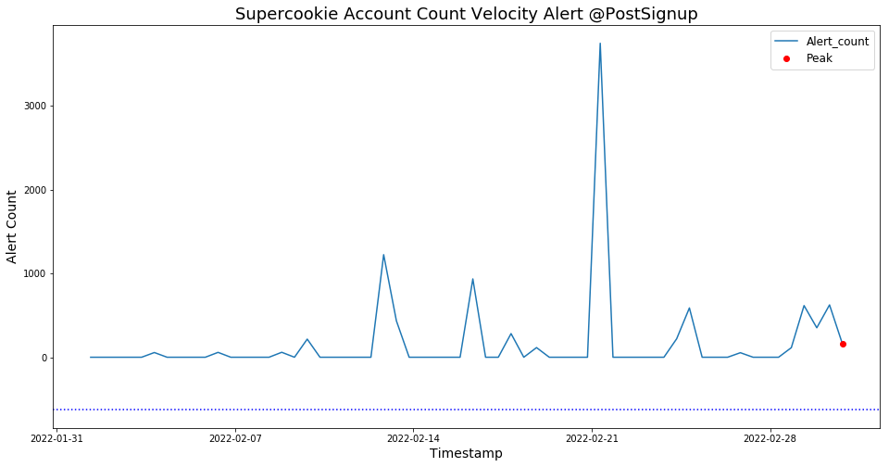
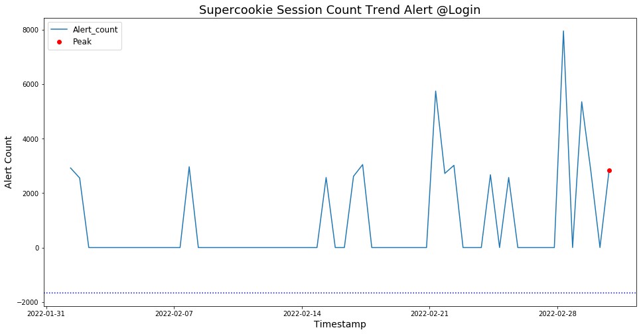
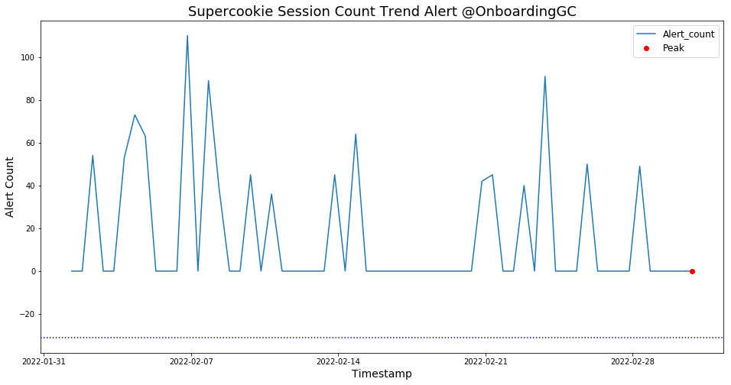
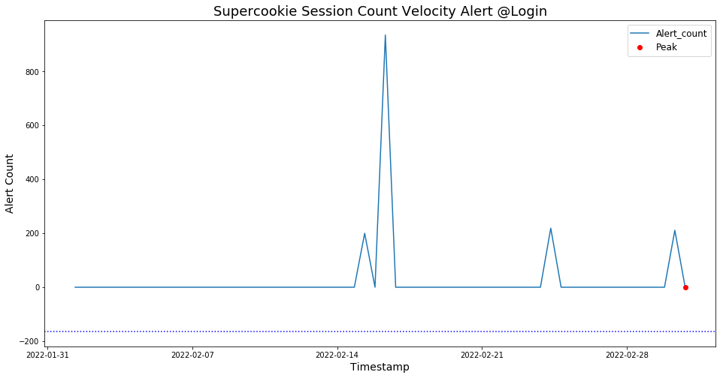
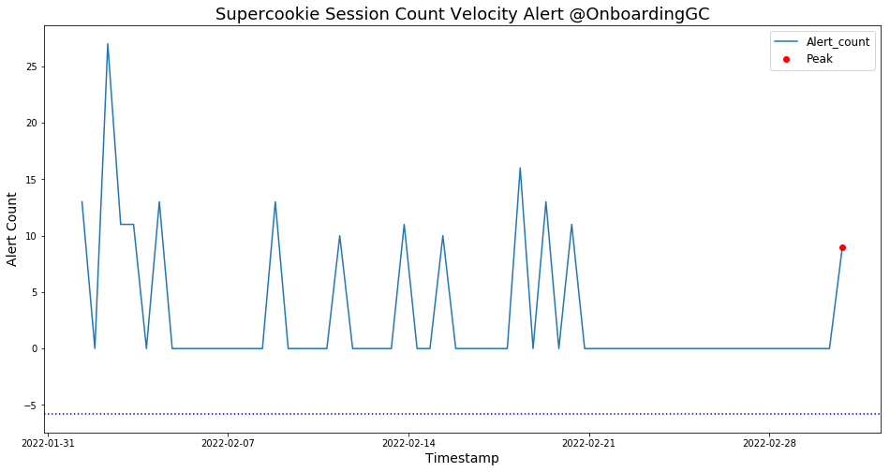
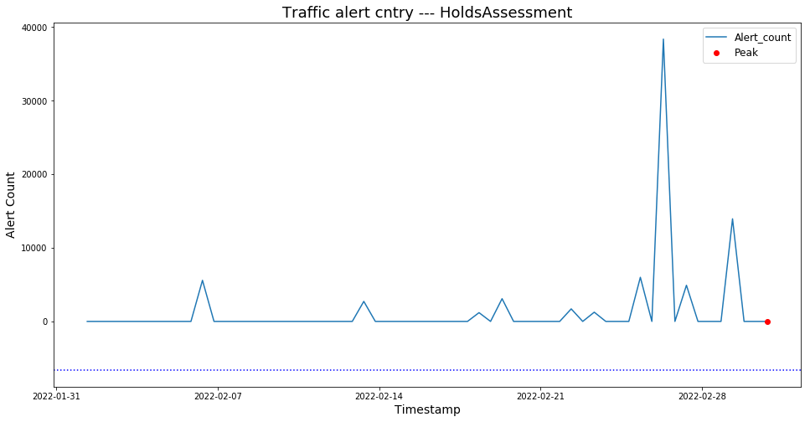
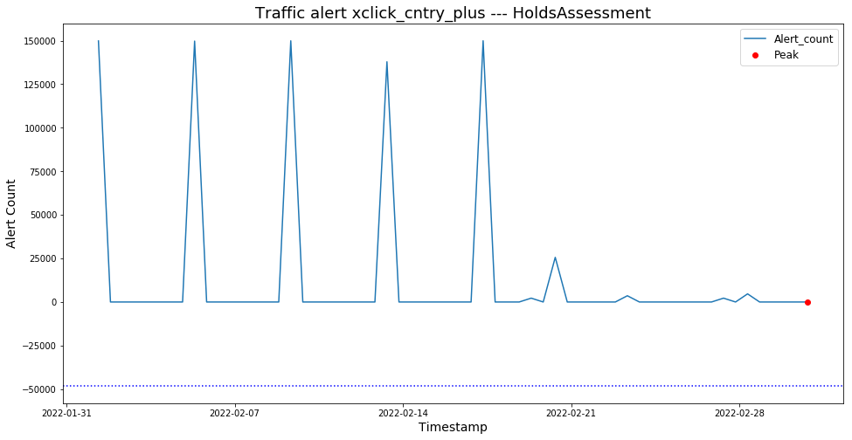
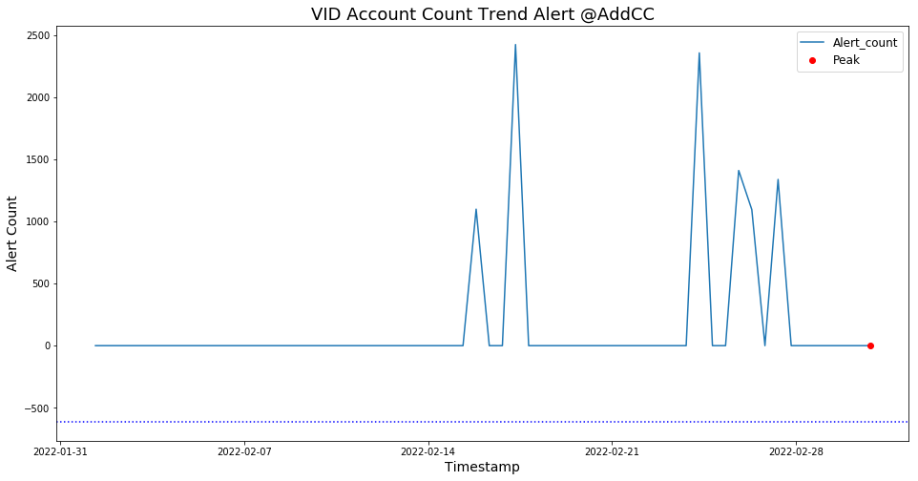
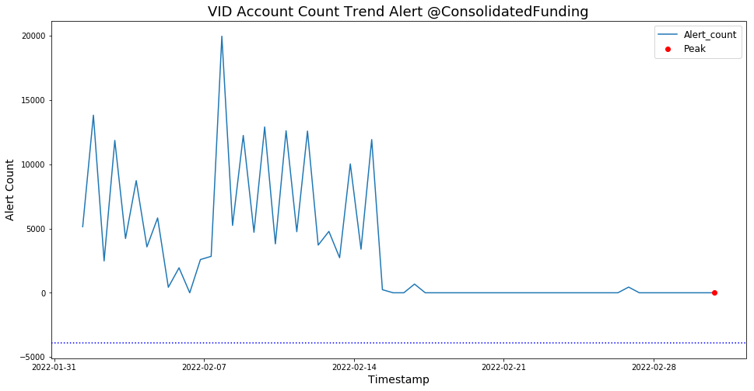
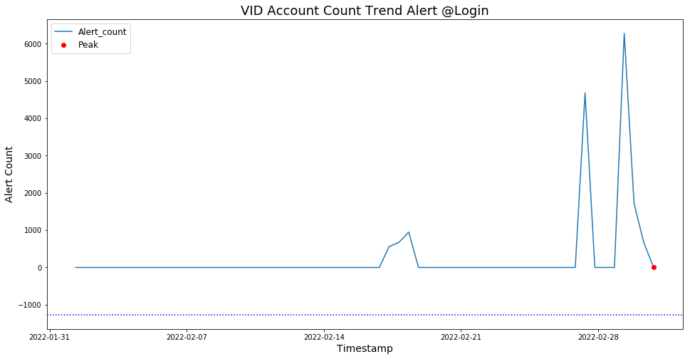
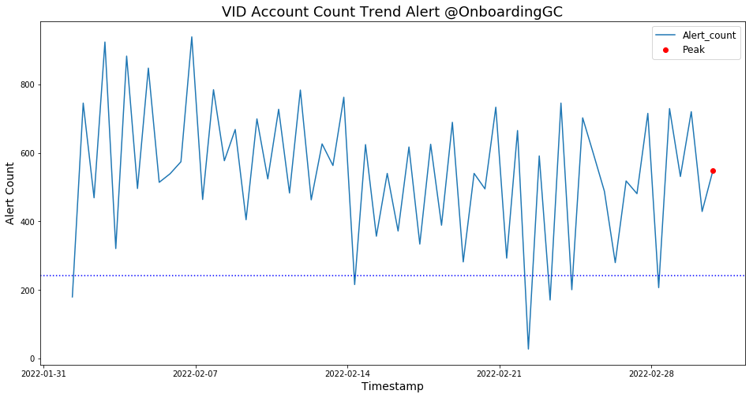
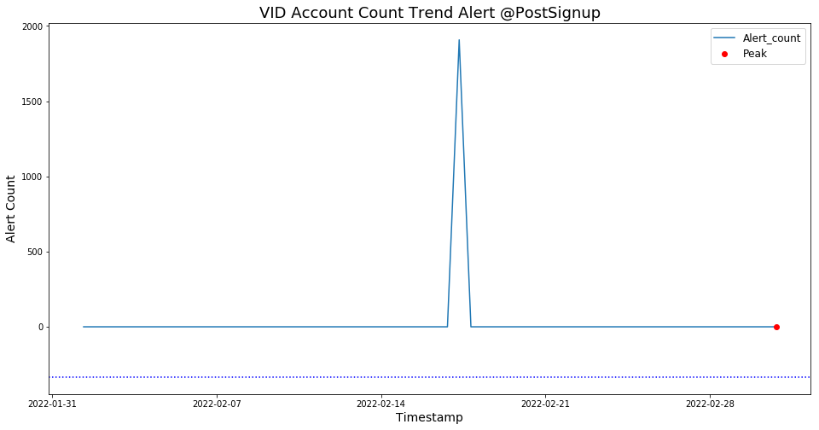
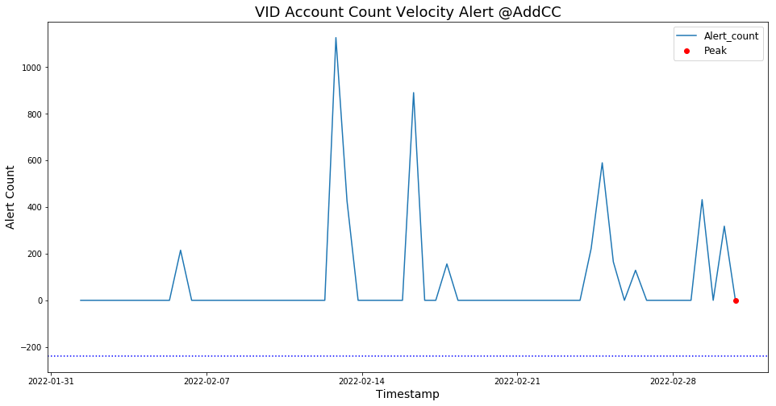
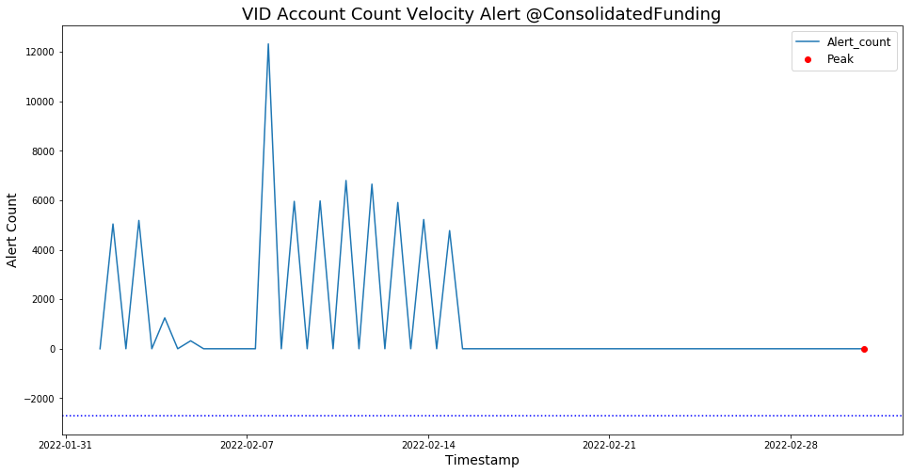
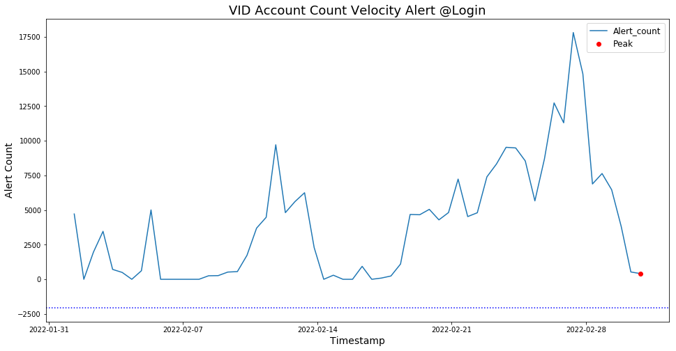
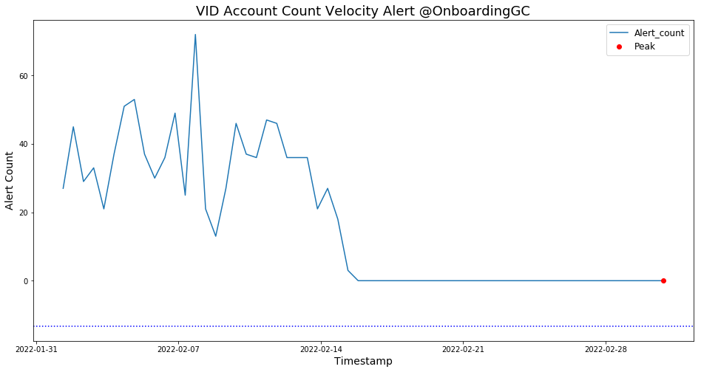
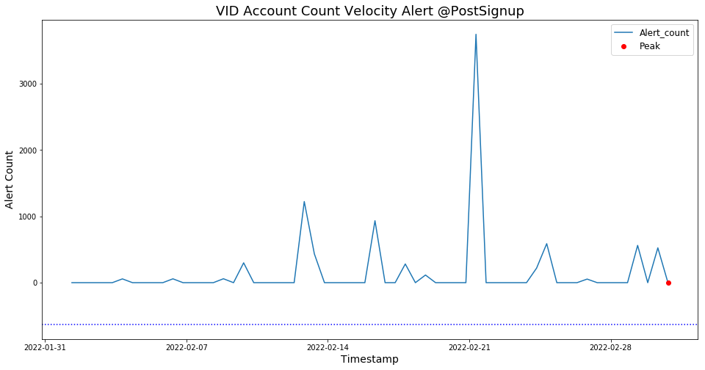
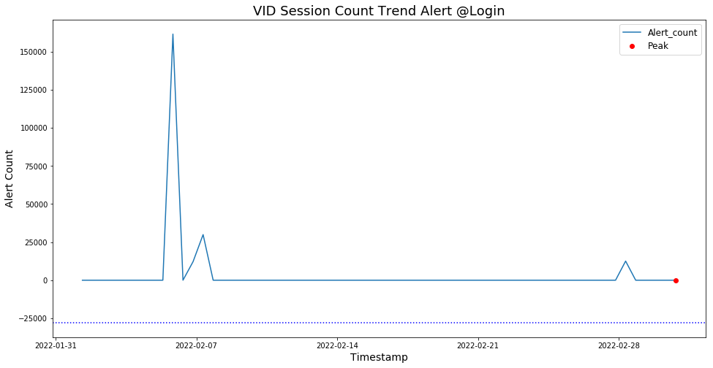
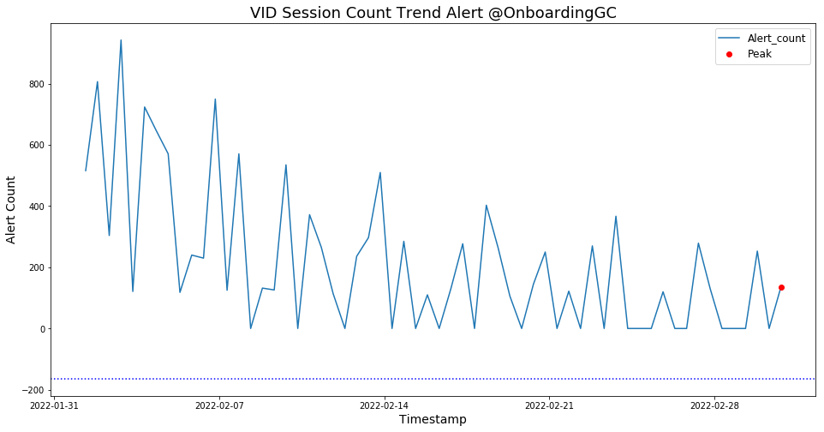
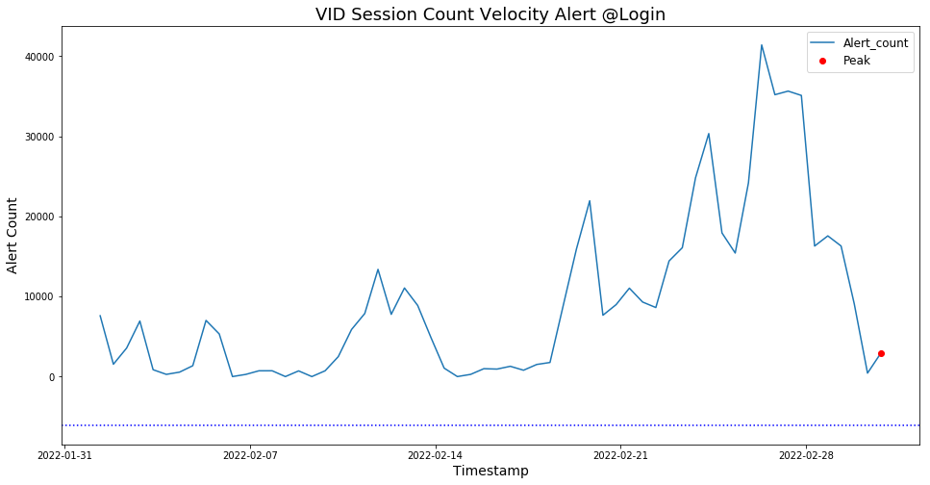
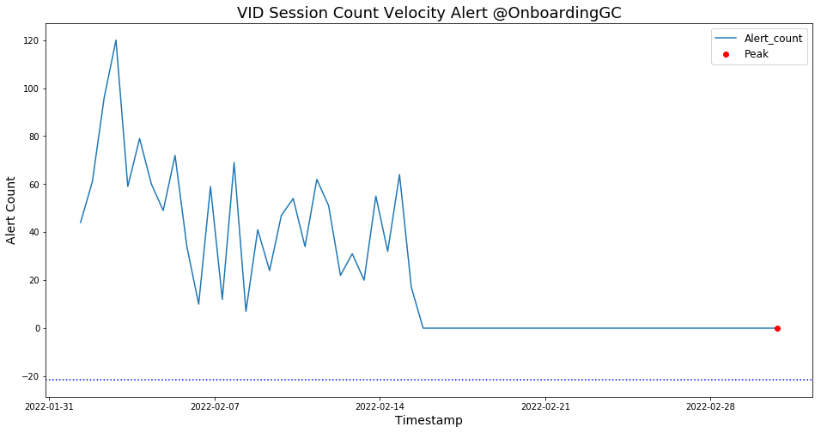
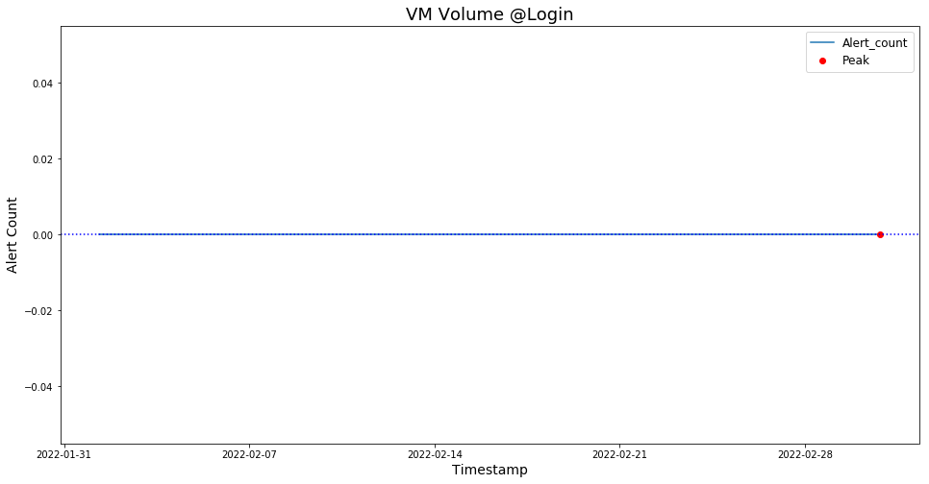
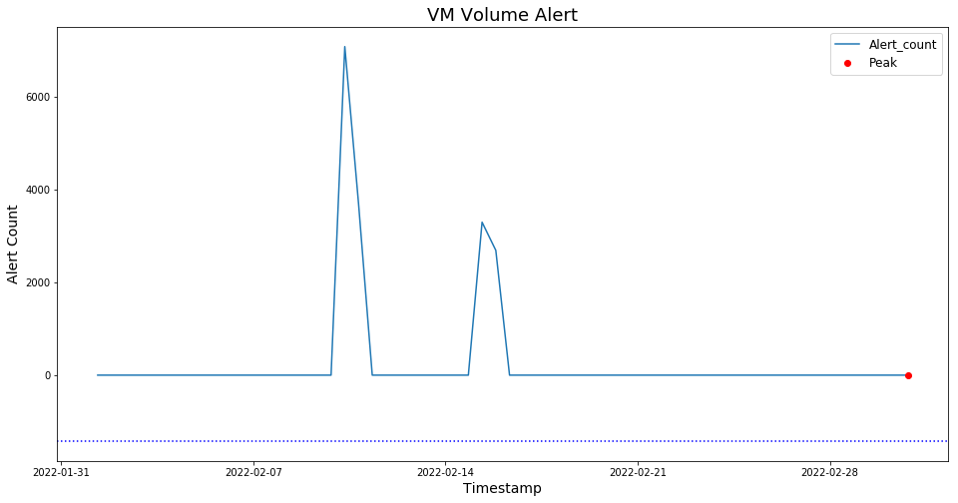
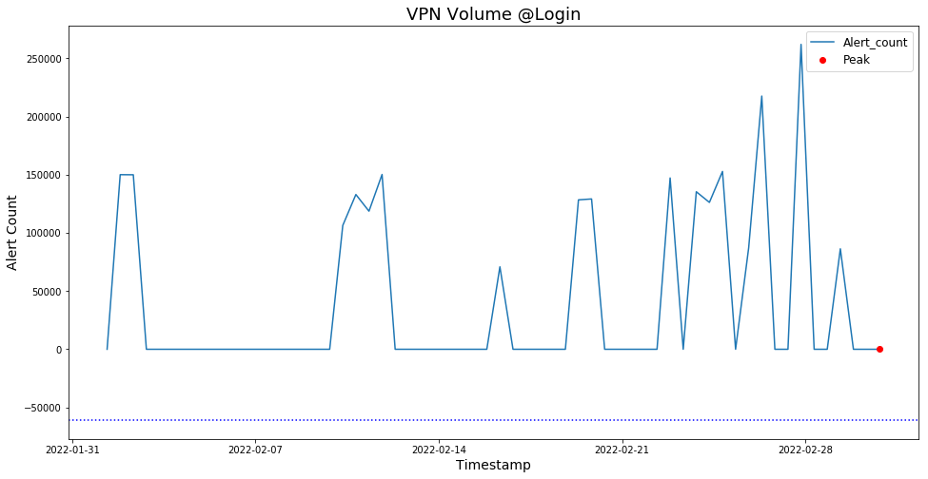
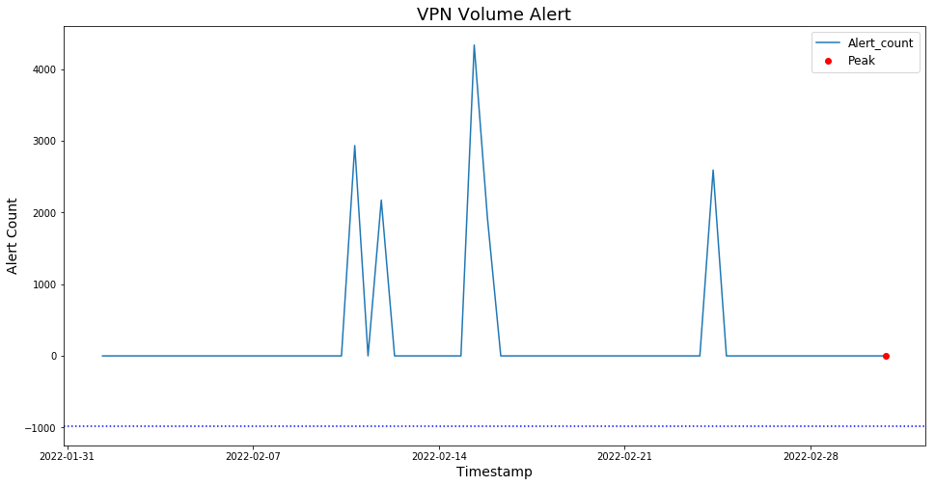
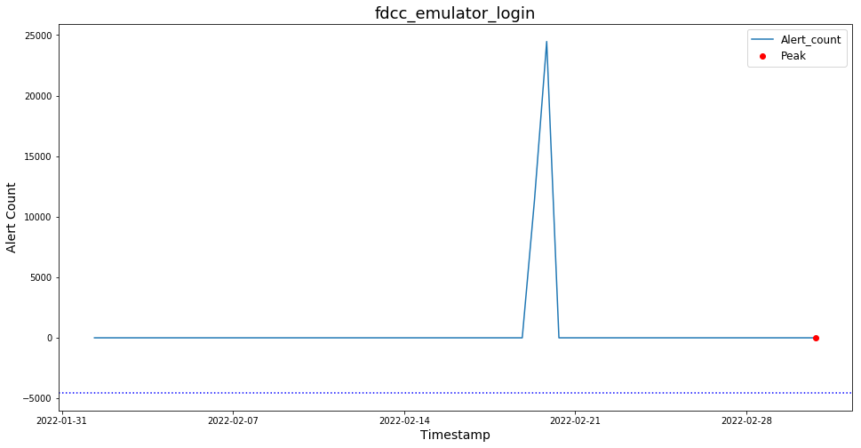
In [ ]:

In [25]:
dict_link = {'Account Creation IP Mismatch Volume Alert - by Geo Country':'https://phx-spias-u01.paypalcorp.com/spider/index.html#/alertDetail/5e901b70014b580dc478052b',
'Account creation volume with disposable emails':'https://phx-spias-u01.paypalcorp.com/spider/index.html#/alertDetail/5e9d74a9014b580dc47809aa',
'Artificial Typing Speed Account Count Velocity Alert @PostSignup ':'https://phx-spias-u01.paypalcorp.com/spider/index.html#/chartDetail/6055a265fff22e949c7515e0',
'Artificial Typing Speed Account Count Trend Alert @PostSignup ':'https://phx-spias-u01.paypalcorp.com/spider/index.html#/chartDetail/6055936cfff22e949c7515ca',
'CMID(EC) Account Count Trend Alert @Login':'https://phx-spias-u01.paypalcorp.com/spider/index.html#/chartDetail/6055ad92fff22e949c7515ec',
'CMID(EC) Account Count Trend Alert @PostSignup':'https://phx-spias-u01.paypalcorp.com/spider/index.html#/chartDetail/6055936cfff22e949c7515ca',
'CMID(EC) Account Count Velocity Alert @Login':'https://phx-spias-u01.paypalcorp.com/spider/index.html#/chartDetail/60559e6bfff22e949c7515d9',
'CMID(EC) Account Count Velocity Alert @PostSignup':'https://phx-spias-u01.paypalcorp.com/spider/index.html#/chartDetail/605599e1fff22e949c7515d3',
'CMID(EC) Session Count Trend Alert @Login':'https://phx-spias-u01.paypalcorp.com/spider/index.html#/chartDetail/6055ae5dfff22e949c7515f1',
'CMID(EC) Session Count Velocity Alert @Login':'https://phx-spias-u01.paypalcorp.com/spider/index.html#/chartDetail/6055ab29fff22e949c7515e5',
'CMID(NotEC) Account Count Trend Alert @Login':'https://phx-spias-u01.paypalcorp.com/spider/index.html#/chartDetail/6055ad92fff22e949c7515ec',
'CMID(NotEC) Account Count Trend Alert @PostSignup':'https://phx-spias-u01.paypalcorp.com/spider/index.html#/chartDetail/6055936cfff22e949c7515ca',
'CMID(NotEC) Account Count Velocity Alert @Login':'https://phx-spias-u01.paypalcorp.com/spider/index.html#/chartDetail/60559e98fff22e949c7515db',
'CMID(NotEC) Account Count Velocity Alert @PostSignup':'https://phx-spias-u01.paypalcorp.com/spider/index.html#/chartDetail/60559a5ffff22e949c7515d5',
'CMID(NotEC) Session Count Trend Alert @Login':'https://phx-spias-u01.paypalcorp.com/spider/index.html#/chartDetail/6055ae5dfff22e949c7515f1',
'CMID(NotEC) Session Count Velocity Alert @Login':'https://phx-spias-u01.paypalcorp.com/spider/index.html#/chartDetail/6055b01ffff22e949c7515f3',
'GEO Mismatch Account Count Alert @Login':'https://phx-spias-u01.paypalcorp.com/spider/index.html#/chartDetail/60b869ee5c92b118685688aa',
'GEO Mismatch Account Count at Routing Number Level Velocity Alert @WithdrawalAttempt':'https://phx-spias-u01.paypalcorp.com/spider/index.html#/chartDetail/609e2af6382d2f1adddc2038',
'GEO Mismatch Session Count Alert @AddCC':'https://phx-spias-u01.paypalcorp.com/spider/index.html#/chartDetail/608240c74449ad172dd36aa9',
'GEO Mismatch Session Count Alert @Login':'https://phx-spias-u01.paypalcorp.com/spider/index.html#/chartDetail/60b870d55c92b118685688b2',
'GEO Mismatch Session Count at Bin Level Trend Alert @AddCC':'https://phx-spias-u01.paypalcorp.com/spider/index.html#/chartDetail/6082425c4449ad172dd36aae',
'GEO Mismatch Session Count at Bin Level Velocity Alert @AddCC':'https://phx-spias-u01.paypalcorp.com/spider/index.html#/chartDetail/6082432a4449ad172dd36ab5',
'GEO Mismatch Session Count at Routing Number Level Trend Alert @WithdrawalAttempt':'https://phx-spias-u01.paypalcorp.com/spider/index.html#/chartDetail/609e2ce3382d2f1adddc203d',
'GEO Mismatch Session Count at Routing Number Level Velocity Alert @Deposit ':'https://phx-spias-u01.paypalcorp.com/spider/index.html#/chartDetail/609e0f94382d2f1adddc1fe9',
'GEO Mismatch Session Count at Routing Number Level Velocity Alert @WithdrawalAttempt':'https://phx-spias-u01.paypalcorp.com/spider/index.html#/chartDetail/609e2eba382d2f1adddc2043',
'IP CC Hash Count Trend Alert @AddCC':'https://phx-spias-u01.paypalcorp.com/spider/index.html#/chartDetail/607949144449ad172dd36343',
'IP CC Hash Count Velocity Alert @AddCC':'https://phx-spias-u01.paypalcorp.com/spider/index.html#/chartDetail/60794b054449ad172dd36349',
'LinkerID Account Count Trend Alert @Login':'https://phx-spias-u01.paypalcorp.com/spider/index.html#/chartDetail/6055ad92fff22e949c7515ec',
'LinkerID Account Count Velocity Alert @Login':'https://phx-spias-u01.paypalcorp.com/spider/index.html#/chartDetail/6046f39ca02ddf1b419e3613',
'LinkerID Session Count Trend Alert @Login':'https://phx-spias-u01.paypalcorp.com/spider/index.html#/chartDetail/6055ae5dfff22e949c7515f1',
'LinkerID Session Count Velocity Alert @Login':'https://phx-spias-u01.paypalcorp.com/spider/index.html#/chartDetail/60559ef6fff22e949c7515dd',
'SubscriberID Account Count Velocity Alert @Login':'https://phx-spias-u01.paypalcorp.com/spider/index.html#/chartDetail/60559d9cfff22e949c7515d7',
'SubscriberID Account Count Velocity Alert @PostSignup':'https://phx-spias-u01.paypalcorp.com/spider/index.html#/chartDetail/6055993dfff22e949c7515d1',
'SubscriberID Session Count Trend Alert @Login':'https://phx-spias-u01.paypalcorp.com/spider/index.html#/chartDetail/6055ae5dfff22e949c7515f1',
'SubscriberID Session Count Velocity Alert @Login':'https://phx-spias-u01.paypalcorp.com/spider/index.html#/chartDetail/6055a7a6fff22e949c7515e2',
'Supercookie Account Count Trend Alert @Login':'https://phx-spias-u01.paypalcorp.com/spider/index.html#/chartDetail/608ba207382d2f1adddc176e',
'Supercookie Account Count Trend Alert @OnboardingGC':'https://phx-spias-u01.paypalcorp.com/spider/index.html#/chartDetail/60b0a3235c92b11868568472',
'Supercookie Account Count Trend Alert @PostSignup':'https://phx-spias-u01.paypalcorp.com/spider/index.html#/chartDetail/608b6c48382d2f1adddc1736',
'Supercookie Account Count Velocity Alert @Login':'https://phx-spias-u01.paypalcorp.com/spider/index.html#/chartDetail/608ba45e382d2f1adddc1776',
'Supercookie Account Count Velocity Alert @OnboardingGC':'https://phx-spias-u01.paypalcorp.com/spider/index.html#/chartDetail/60b0ac1a5c92b1186856848a',
'Supercookie Account Count Velocity Alert @PostSignup':'https://phx-spias-u01.paypalcorp.com/spider/index.html#/chartDetail/608b7740382d2f1adddc1741',
'Supercookie Session Count Trend Alert @Login':'https://phx-spias-u01.paypalcorp.com/spider/index.html#/chartDetail/608ba6f9382d2f1adddc177d',
'Supercookie Session Count Trend Alert @OnboardingGC':'https://phx-spias-u01.paypalcorp.com/spider/index.html#/chartDetail/60b0af085c92b11868568495',
'Supercookie Session Count Velocity Alert @Login':'https://phx-spias-u01.paypalcorp.com/spider/index.html#/chartDetail/608ba968382d2f1adddc178a',
'Supercookie Session Count Velocity Alert @OnboardingGC':'https://phx-spias-u01.paypalcorp.com/spider/index.html#/chartDetail/60b0b0765c92b1186856849d',
'Traffic alert cntry --- HoldsAssessment':'https://phx-spias-u01.paypalcorp.com/spider/index.html#/alertDetail/5e1fedcf7d9718bc4821f788',
'Traffic alert xclick_cntry_plus --- HoldsAssessment':'https://phx-spias-u01.paypalcorp.com/spider/index.html#/alertDetail/5e1fedcd7d9718bc4821f77b',
'VID Account Count Trend Alert @AddCC':'https://phx-spias-u01.paypalcorp.com/spider/index.html#/chartDetail/60c02a475c92b11868568d48',
'VID Account Count Trend Alert @ConsolidatedFunding':'https://phx-spias-u01.paypalcorp.com/spider/index.html#/chartDetail/60bdd6215c92b11868568b16',
'VID Account Count Trend Alert @Login':'https://phx-spias-u01.paypalcorp.com/spider/index.html#/chartDetail/6082441c4449ad172dd36abb',
'VID Account Count Trend Alert @OnboardingGC':'https://phx-spias-u01.paypalcorp.com/spider/index.html#/chartDetail/60b484435c92b11868568573',
'VID Account Count Trend Alert @PostSignup':'https://phx-spias-u01.paypalcorp.com/spider/index.html#/chartDetail/608b5faf382d2f1adddc1724',
'VID Account Count Velocity Alert @AddCC':'https://phx-spias-u01.paypalcorp.com/spider/index.html#/chartDetail/60c0301c5c92b11868568d5e',
'VID Account Count Velocity Alert @ConsolidatedFunding':'https://phx-spias-u01.paypalcorp.com/spider/index.html#/chartDetail/60bdd7ba5c92b11868568b19',
'VID Account Count Velocity Alert @Login':'https://phx-spias-u01.paypalcorp.com/spider/index.html#/chartDetail/608245334449ad172dd36ac1',
'VID Account Count Velocity Alert @OnboardingGC':'https://phx-spias-u01.paypalcorp.com/spider/index.html#/chartDetail/60b488895c92b1186856857b',
'VID Account Count Velocity Alert @PostSignup':'https://phx-spias-u01.paypalcorp.com/spider/index.html#/chartDetail/608b6449382d2f1adddc172c',
'VID Session Count Trend Alert @Login':'https://phx-spias-u01.paypalcorp.com/spider/index.html#/chartDetail/608245fb4449ad172dd36ac5',
'VID Session Count Trend Alert @OnboardingGC':'https://phx-spias-u01.paypalcorp.com/spider/index.html#/chartDetail/60b48ab15c92b11868568581',
'VID Session Count Velocity Alert @Login':'https://phx-spias-u01.paypalcorp.com/spider/index.html#/chartDetail/608246ea4449ad172dd36acd',
'VID Session Count Velocity Alert @OnboardingGC':'https://phx-spias-u01.paypalcorp.com/spider/index.html#/chartDetail/60b48d1f5c92b11868568588',
'VM Volume @Login':'https://phx-spias-u01.paypalcorp.com/spider/index.html#/chartDetail/5f449f65a4f555338c0a2a12',
'VM Volume Alert':'https://phx-spias-u01.paypalcorp.com/spider/index.html#/alertDetail/5f4e29b9a4f555338c0a2e6e',
'VPN Volume @Login':'https://phx-spias-u01.paypalcorp.com/spider/index.html#/alertDetail/5f4e29b9a4f555338c0a2e6e',
'VPN Volume Alert':'https://phx-spias-u01.paypalcorp.com/spider/index.html#/alertDetail/5f476cd8a4f555338c0a2b9f',
'fdcc_emulator_login':'https://phx-spias-u01.paypalcorp.com/spider/index.html#/alertDetail/5ffeb8fa168ae11877e8d345'}
In [26]:
len(dict_link)
Out[26]:
66
In [27]:
# email template design

peeks_template = """
<html>
<head>
<style>
table {18}

td, th {19}

tr:nth-child(even) {20}
</style>
</head>
<body>

<p> {0} has a peak at {2} EST with {1:,} count. </p>
<p> The 12 HOURS COUNT result for the {0} is more than THREE standard deviation above last SEVEN days' average. </p>
<p> Find the dashboard here: {21} </p>
<p> * Result delay caused by data latency. </p>

<table>
<caption style='text-align:center'>Results - Past Seven Checks</caption>
<tr>
<th style='text-align:center'>{9}</th>
<th style='text-align:center'>{8}</th>
<th style='text-align:center'>{7}</th>
<th style='text-align:center'>{6}</th>
<th style='text-align:center'>{5}</th>
<th style='text-align:center'>{4}</th>
<th style='text-align:center'>{3}</th>
<th style='text-align:center'>{2}</th>
</tr>
<tr>
<td style='text-align:center'>{17:,}</td>
<td style='text-align:center'>{16:,}</td>
<td style='text-align:center'>{15:,}</td>
<td style='text-align:center'>{14:,}</td>
<td style='text-align:center'>{13:,}</td>
<td style='text-align:center'>{12:,}</td>
<td style='text-align:center'>{11:,}</td>
<td style='text-align:center;background-color:#00FF00'>{10:,}</td>
</tr>

</table>
<br>
See attachment for visualization chart.
<p> FDCC Data Engineering Team
</body>
</html>
"""
In [28]:
peek_flow2 = peek_flow_test1

# print(imageName)

for flow in peek_flow2:
imageName = "img5_3/{}_AlertType.png".format(flow['alert_name'])
result = get_peaks(flow, imageName)

y = list(table3[flow['alert_name']])
y1 = list(map(int, y))
Y = np.array(y1)
avg_y = np.mean(Y[1:15])
std_y = np.std(Y[1:15])
if std_y == 0:
threshold = 0
else:
threshold = (y1[0] - avg_y) / std_y

if threshold > 3:
layer = str(flow['alert_name'])
peek = int(list(table3[flow['alert_name']])[0])
days = [d.strftime("%m/%d/%Y, %H:%M:%S") for d in list(table3['alert_timestamp'])[:10]]
num = [int(n) for n in list(table3[flow['alert_name']])[:10]]

table = """
{font-family: arial, sans-serif;
border-collapse: collapse;
width: 80%;}
"""

tb = """
{border: 1px solid #dddddd;
text-align: left;
padding: 8px;}
"""

back = """
{background-color: #dddddd;}
"""

# doc_link = """
# <p><a href='https://engineering.paypalcorp.com/confluence/display/SRPMO/Add+Card+Metrics' > Methodology </a></p>
# """

k = flow['alert_name']
dict_link[k]

email_text = (format_query(peeks_template, layer, peek,
days[0], days[1], days[2], days[3], days[4], days[5], days[6], days[7],
num[0], num[1], num[2], num[3], num[4], num[5], num[6], num[7],
str(table), str(tb), str(back)))

# email_text = "{0} has a peak".format(flow['alert_name'])

subject = "Peak - {0}".format(flow['alert_name'])

# %sendmail -to "yalyan@paypal.com" -cc "rasun@paypal.com" -sub "$subject" -bod "$email_text" -a "$imageName"
%sendmail -to "yalyan@paypal.com, rasun@paypal.com, fdcc-ops@paypal.com, ausato@paypal.com" -sub "$subject" -bod "$email_text" -a "$imageName"
# %sendmail -to "yalyan@paypal.com" -sub "$subject" -bod "$email_text" -a "$imageName"

print('yes')
print('threshold is')
print(threshold)
print(flow['alert_name'])
print(y1[0:15])
print('Peak for {}. Email sent.'.format(flow['alert_name']))
print(' ')

else:
print('no')
print(threshold)
print(flow['alert_name'])
print(y1[0:15])
print('NO peak for {}. No email to sent.'.format(flow['alert_name']))
print(' ')
no
-0.4189693805120381
Account Creation IP Mismatch Volume Alert - by Geo Country
[0, 0, 0, 311, 4775, 0, 0, 0, 0, 0, 0, 1433, 628, 4223, 0]
NO peak for Account Creation IP Mismatch Volume Alert - by Geo Country. No email to sent.

no
1.690967332576953
Account creation volume with disposable emails
[568, 0, 333, 303, 0, 0, 0, 0, 571, 2251, 0, 0, 0, 0, 0]
NO peak for Account creation volume with disposable emails. No email to sent.

no
-0.13018891098082386
Artificial Typing Speed Account Count Trend Alert @PostSignup
[0, 0, 0, 0, 0, 0, 0, 0, 0, 0, 0, 0, 0, 0, 0]
NO peak for Artificial Typing Speed Account Count Trend Alert @PostSignup . No email to sent.

no
-0.1460741095605164
Artificial Typing Speed Account Count Velocity Alert @PostSignup
[0, 0, 17, 16, 17, 0, 0, 0, 0, 0, 0, 0, 0, 20, 0]
NO peak for Artificial Typing Speed Account Count Velocity Alert @PostSignup . No email to sent.

no
0
CMID(EC) Account Count Trend Alert @Login
[0, 0, 0, 0, 0, 0, 0, 0, 0, 0, 0, 0, 0, 0, 0]
NO peak for CMID(EC) Account Count Trend Alert @Login. No email to sent.

no
-0.2063168771513655
CMID(EC) Account Count Trend Alert @PostSignup
[0, 361, 0, 0, 0, 0, 0, 0, 0, 0, 0, 0, 0, 0, 0]
NO peak for CMID(EC) Account Count Trend Alert @PostSignup. No email to sent.

no
-0.13018891098082389
CMID(EC) Account Count Velocity Alert @Login
[0, 0, 0, 0, 0, 0, 0, 0, 0, 0, 0, 0, 590, 0, 0]
NO peak for CMID(EC) Account Count Velocity Alert @Login. No email to sent.

no
0.5643232899438967
CMID(EC) Account Count Velocity Alert @PostSignup
[719, 1439, 594, 960, 739, 612, 748, 1162, 1165, 1024, 780, 1356, 1674, 518, 340]
NO peak for CMID(EC) Account Count Velocity Alert @PostSignup. No email to sent.

no
-0.13018891098082386
CMID(EC) Session Count Trend Alert @Login
[0, 0, 0, 0, 0, 213, 0, 0, 0, 0, 0, 0, 0, 0, 0]
NO peak for CMID(EC) Session Count Trend Alert @Login. No email to sent.

no
-0.13018891098082389
CMID(EC) Session Count Velocity Alert @Login
[0, 0, 0, 0, 0, 0, 0, 0, 0, 0, 0, 0, 590, 0, 0]
NO peak for CMID(EC) Session Count Velocity Alert @Login. No email to sent.

no
0.09261269385456004
CMID(NotEC) Account Count Trend Alert @Login
[5364, 6504, 8861, 6858, 6983, 6502, 7866, 4322, 5454, 7211, 6293, 7580, 5672, 7070, 5699]
NO peak for CMID(NotEC) Account Count Trend Alert @Login. No email to sent.

no
0
CMID(NotEC) Account Count Trend Alert @PostSignup
[0, 0, 0, 0, 0, 0, 0, 0, 0, 0, 0, 0, 0, 0, 0]
NO peak for CMID(NotEC) Account Count Trend Alert @PostSignup. No email to sent.

no
-0.3566767630790003
CMID(NotEC) Account Count Velocity Alert @Login
[0, 0, 0, 0, 0, 0, 0, 81, 0, 124, 0, 0, 0, 96, 0]
NO peak for CMID(NotEC) Account Count Velocity Alert @Login. No email to sent.

no
-0.20840226537724543
CMID(NotEC) Account Count Velocity Alert @PostSignup
[0, 0, 0, 0, 0, 0, 0, 0, 54, 0, 0, 0, 0, 0, 0]
NO peak for CMID(NotEC) Account Count Velocity Alert @PostSignup. No email to sent.

no
-0.13018891098082386
CMID(NotEC) Session Count Trend Alert @Login
[0, 0, 0, 0, 0, 8080, 0, 0, 0, 0, 0, 0, 0, 0, 0]
NO peak for CMID(NotEC) Session Count Trend Alert @Login. No email to sent.

no
-0.1301889109808238
CMID(NotEC) Session Count Velocity Alert @Login
[0, 0, 0, 0, 0, 0, 0, 0, 0, 0, 0, 0, 0, 0, 0]
NO peak for CMID(NotEC) Session Count Velocity Alert @Login. No email to sent.

no
-0.2306253315373894
GEO Mismatch Account Count Alert @Login
[0, 0, 0, 0, 0, 1062, 1280, 6261, 0, 0, 1243, 0, 0, 4062, 3824]
NO peak for GEO Mismatch Account Count Alert @Login. No email to sent.

no
2.2395190275915575
GEO Mismatch Account Count at Routing Number Level Velocity Alert @WithdrawalAttempt
[4434, 1032, 3184, 0, 3504, 1115, 4712, 1137, 2770, 1438, 3222, 889, 4022, 845, 3831]
NO peak for GEO Mismatch Account Count at Routing Number Level Velocity Alert @WithdrawalAttempt. No email to sent.

no
-0.13018891098082383
GEO Mismatch Session Count Alert @AddCC
[0, 0, 0, 0, 0, 0, 0, 0, 0, 0, 0, 0, 0, 0, 10120]
NO peak for GEO Mismatch Session Count Alert @AddCC. No email to sent.

no
-0.1851495094800149
GEO Mismatch Session Count at Bin Level Trend Alert @AddCC
[0, 0, 0, 0, 0, 0, 0, 0, 0, 0, 0, 0, 0, 0, 0]
NO peak for GEO Mismatch Session Count at Bin Level Trend Alert @AddCC. No email to sent.

no
-0.6332302675649385
GEO Mismatch Session Count at Bin Level Velocity Alert @AddCC
[0, 0, 0, 700, 0, 0, 0, 0, 0, 0, 0, 9506, 16831, 9261, 17150]
NO peak for GEO Mismatch Session Count at Bin Level Velocity Alert @AddCC. No email to sent.

no
0
GEO Mismatch Session Count at Routing Number Level Trend Alert @WithdrawalAttempt
[0, 0, 0, 0, 0, 0, 0, 0, 0, 0, 0, 0, 0, 0, 0]
NO peak for GEO Mismatch Session Count at Routing Number Level Trend Alert @WithdrawalAttempt. No email to sent.

no
0
GEO Mismatch Session Count at Routing Number Level Velocity Alert @Deposit
[0, 0, 0, 0, 0, 0, 0, 0, 0, 0, 0, 0, 0, 0, 0]
NO peak for GEO Mismatch Session Count at Routing Number Level Velocity Alert @Deposit . No email to sent.

no
-0.1346956168463303
IP CC Hash Count Trend Alert @AddCC
[0, 0, 0, 0, 0, 0, 0, 0, 0, 0, 0, 13370, 0, 0, 0]
NO peak for IP CC Hash Count Trend Alert @AddCC. No email to sent.

no
-0.26825189416436207
IP CC Hash Count Velocity Alert @AddCC
[0, 0, 0, 0, 0, 0, 0, 0, 0, 0, 0, 0, 0, 0, 0]
NO peak for IP CC Hash Count Velocity Alert @AddCC. No email to sent.

no
0
LinkerID Account Count Trend Alert @Login
[0, 0, 0, 0, 0, 0, 0, 0, 0, 0, 0, 0, 0, 0, 0]
NO peak for LinkerID Account Count Trend Alert @Login. No email to sent.

no
-0.2279537063531715
LinkerID Account Count Velocity Alert @Login
[0, 0, 0, 41, 0, 0, 0, 0, 0, 0, 0, 0, 0, 0, 0]
NO peak for LinkerID Account Count Velocity Alert @Login. No email to sent.

no
-0.2193936060066246
LinkerID Session Count Trend Alert @Login
[0, 0, 0, 0, 0, 0, 0, 0, 0, 0, 0, 0, 0, 0, 0]
NO peak for LinkerID Session Count Trend Alert @Login. No email to sent.

no
0.16141109285473335
LinkerID Session Count Velocity Alert @Login
[1598, 430, 194, 215, 174, 139, 305, 0, 408, 132, 389, 149, 264, 1070, 325]
NO peak for LinkerID Session Count Velocity Alert @Login. No email to sent.

no
-0.2694551737983685
SubscriberID Account Count Velocity Alert @Login
[1, 0, 0, 9, 24, 16, 20, 7, 18, 0, 0, 0, 0, 0, 0]
NO peak for SubscriberID Account Count Velocity Alert @Login. No email to sent.

no
-0.13018891098082389
SubscriberID Account Count Velocity Alert @PostSignup
[0, 0, 0, 0, 0, 0, 0, 0, 0, 0, 0, 0, 10, 0, 0]
NO peak for SubscriberID Account Count Velocity Alert @PostSignup. No email to sent.

no
0
SubscriberID Session Count Trend Alert @Login
[0, 0, 0, 0, 0, 0, 0, 0, 0, 0, 0, 0, 0, 0, 0]
NO peak for SubscriberID Session Count Trend Alert @Login. No email to sent.

no
1.0059413763718106
SubscriberID Session Count Velocity Alert @Login
[2288, 0, 0, 225, 696, 389, 599, 290, 455, 0, 0, 0, 0, 0, 0]
NO peak for SubscriberID Session Count Velocity Alert @Login. No email to sent.

no
-0.41227537169777034
Supercookie Account Count Trend Alert @Login
[0, 1467, 3245, 5624, 0, 0, 0, 728, 1208, 604, 0, 1249, 0, 3956, 813]
NO peak for Supercookie Account Count Trend Alert @Login. No email to sent.

no
-0.33314079976829947
Supercookie Account Count Trend Alert @OnboardingGC
[0, 0, 15, 0, 0, 0, 0, 0, 0, 0, 0, 0, 0, 0, 0]
NO peak for Supercookie Account Count Trend Alert @OnboardingGC. No email to sent.

no
-0.13018891098082389
Supercookie Account Count Trend Alert @PostSignup
[0, 0, 0, 0, 0, 0, 0, 0, 0, 0, 0, 0, 0, 0, 0]
NO peak for Supercookie Account Count Trend Alert @PostSignup. No email to sent.

no
-0.225644099747924
Supercookie Account Count Velocity Alert @Login
[0, 211, 0, 0, 0, 0, 0, 0, 0, 0, 0, 0, 590, 219, 0]
NO peak for Supercookie Account Count Velocity Alert @Login. No email to sent.

no
-0.39129334731196974
Supercookie Account Count Velocity Alert @OnboardingGC
[0, 5, 5, 5, 0, 0, 0, 0, 0, 0, 0, 5, 0, 6, 0]
NO peak for Supercookie Account Count Velocity Alert @OnboardingGC. No email to sent.

no
0.006745745913335531
Supercookie Account Count Velocity Alert @PostSignup
[165, 624, 351, 616, 114, 0, 0, 0, 54, 0, 0, 0, 588, 220, 0]
NO peak for Supercookie Account Count Velocity Alert @PostSignup. No email to sent.

no
1.1655617560199845
Supercookie Session Count Trend Alert @Login
[2847, 0, 2809, 5355, 0, 7958, 0, 0, 0, 0, 0, 2574, 0, 2674, 0]
NO peak for Supercookie Session Count Trend Alert @Login. No email to sent.

no
-0.5701426498723858
Supercookie Session Count Trend Alert @OnboardingGC
[0, 0, 0, 0, 0, 49, 0, 0, 0, 0, 50, 0, 0, 0, 91]
NO peak for Supercookie Session Count Trend Alert @OnboardingGC. No email to sent.

no
-0.2055775329290935
Supercookie Session Count Velocity Alert @Login
[0, 211, 0, 0, 0, 0, 0, 0, 0, 0, 0, 0, 0, 219, 0]
NO peak for Supercookie Session Count Velocity Alert @Login. No email to sent.

no
1.0723061207494218
Supercookie Session Count Velocity Alert @OnboardingGC
[9, 0, 0, 0, 0, 0, 0, 0, 0, 0, 0, 0, 0, 0, 0]
NO peak for Supercookie Session Count Velocity Alert @OnboardingGC. No email to sent.

no
-0.24827460307265384
Traffic alert cntry --- HoldsAssessment
[0, 0, 0, 13946, 0, 0, 0, 4913, 0, 38375, 0, 5995, 0, 0, 0]
NO peak for Traffic alert cntry --- HoldsAssessment. No email to sent.

no
-0.31740528875591045
Traffic alert xclick_cntry_plus --- HoldsAssessment
[0, 0, 0, 0, 0, 4668, 0, 2206, 0, 0, 0, 0, 0, 0, 0]
NO peak for Traffic alert xclick_cntry_plus --- HoldsAssessment. No email to sent.

no
-0.31340948384898537
VID Account Count Trend Alert @AddCC
[0, 0, 0, 0, 0, 0, 0, 1337, 0, 1094, 1409, 0, 0, 2355, 0]
NO peak for VID Account Count Trend Alert @AddCC. No email to sent.

no
-0.6959065927565846
VID Account Count Trend Alert @ConsolidatedFunding
[0, 0, 0, 0, 0, 0, 0, 0, 441, 0, 0, 0, 0, 0, 0]
NO peak for VID Account Count Trend Alert @ConsolidatedFunding. No email to sent.

no
-0.25374837035375164
VID Account Count Trend Alert @Login
[0, 665, 1718, 6279, 0, 0, 0, 4682, 0, 0, 0, 0, 0, 0, 0]
NO peak for VID Account Count Trend Alert @Login. No email to sent.

no
0.024166471330662246
VID Account Count Trend Alert @OnboardingGC
[549, 429, 720, 531, 729, 207, 715, 481, 518, 280, 488, 596, 702, 201, 745]
NO peak for VID Account Count Trend Alert @OnboardingGC. No email to sent.

no
-0.13018891098082383
VID Account Count Trend Alert @PostSignup
[0, 0, 0, 0, 0, 0, 0, 0, 0, 0, 0, 0, 0, 0, 0]
NO peak for VID Account Count Trend Alert @PostSignup. No email to sent.

no
-0.3682585340952792
VID Account Count Velocity Alert @AddCC
[0, 318, 0, 432, 0, 0, 0, 0, 0, 129, 0, 165, 590, 222, 0]
NO peak for VID Account Count Velocity Alert @AddCC. No email to sent.

no
-0.45917790440947515
VID Account Count Velocity Alert @ConsolidatedFunding
[0, 0, 0, 0, 0, 0, 0, 0, 0, 0, 0, 0, 0, 0, 0]
NO peak for VID Account Count Velocity Alert @ConsolidatedFunding. No email to sent.

no
-0.8983114476257125
VID Account Count Velocity Alert @Login
[410, 529, 3798, 6463, 7635, 6881, 14824, 17814, 11297, 12732, 8704, 5662, 8542, 9482, 9528]
NO peak for VID Account Count Velocity Alert @Login. No email to sent.

no
-0.857833815749923
VID Account Count Velocity Alert @OnboardingGC
[0, 0, 0, 0, 0, 0, 0, 0, 0, 0, 0, 0, 0, 0, 0]
NO peak for VID Account Count Velocity Alert @OnboardingGC. No email to sent.

no
-0.29219186937341596
VID Account Count Velocity Alert @PostSignup
[0, 525, 0, 562, 0, 0, 0, 0, 54, 0, 0, 0, 588, 220, 0]
NO peak for VID Account Count Velocity Alert @PostSignup. No email to sent.

no
-0.1713618779443462
VID Session Count Trend Alert @Login
[0, 0, 0, 0, 0, 12540, 0, 0, 0, 0, 0, 0, 0, 0, 0]
NO peak for VID Session Count Trend Alert @Login. No email to sent.

no
-0.367612991064127
VID Session Count Trend Alert @OnboardingGC
[135, 0, 253, 0, 0, 0, 130, 279, 0, 0, 120, 0, 0, 0, 367]
NO peak for VID Session Count Trend Alert @OnboardingGC. No email to sent.

no
-0.6282365469528808
VID Session Count Velocity Alert @Login
[2906, 430, 9058, 16297, 17559, 16289, 35086, 35625, 35178, 41389, 24175, 15417, 17924, 30328, 24805]
NO peak for VID Session Count Velocity Alert @Login. No email to sent.

no
-0.7991852234427831
VID Session Count Velocity Alert @OnboardingGC
[0, 0, 0, 0, 0, 0, 0, 0, 0, 0, 0, 0, 0, 0, 0]
NO peak for VID Session Count Velocity Alert @OnboardingGC. No email to sent.

no
0
VM Volume @Login
[0, 0, 0, 0, 0, 0, 0, 0, 0, 0, 0, 0, 0, 0, 0]
NO peak for VM Volume @Login. No email to sent.

no
-0.24629570543696216
VM Volume Alert
[0, 0, 0, 0, 0, 0, 0, 0, 0, 0, 0, 0, 0, 0, 0]
NO peak for VM Volume Alert. No email to sent.

no
-0.5874762331945462
VPN Volume @Login
[0, 0, 0, 86342, 0, 0, 262028, 0, 0, 217620, 87226, 0, 152836, 126225, 135382]
NO peak for VPN Volume @Login. No email to sent.

no
-0.2873843100162454
VPN Volume Alert
[0, 0, 0, 0, 0, 0, 0, 0, 0, 0, 0, 0, 0, 2593, 0]
NO peak for VPN Volume Alert. No email to sent.

no
-0.17405112594235309
fdcc_emulator_login
[0, 0, 0, 0, 0, 0, 0, 0, 0, 0, 0, 0, 0, 0, 0]
NO peak for fdcc_emulator_login. No email to sent.


In [ ]:

In [ ]:

In [ ]:

In [ ]:

In [ ]:

In [ ]:

