Sentiment Analysis on Twitter Data

INDEX
Sr. No. | Topic | Page No.
1. | Introduction | 3
2. | Objectives | 6
3. | - Technology Stack | 7
4. | Features | 9
5. | - System Architecture | 12
6. | - Module Description | 14
7. | - API Endpoints | 17
8. | Database Schema | 18
9. | Installation and Setup | 19
10. | - Usage Guide | 20
11. | Output / Results | 23
12. | Challenges Faced | 25
13. | Future Enhancements | 26
14. | Conclusion | 27

- Introduction
📝 Project Description
The AI Sentiment Analysis Dashboard is a full-stack web-based application developed to analyze, interpret, and visualize sentiment from textual data in an efficient and intelligent manner. The system is designed to accept user input in multiple formats, including single text input, batch input, and CSV file uploads, thereby supporting both small-scale and large-scale data processing requirements.
The application leverages Natural Language Processing (NLP) techniques to process textual data and classify it into different sentiment categories. The analyzed results are systematically stored in a MongoDB database, enabling persistent storage, historical tracking, and further analytical processing.
A key distinguishing feature of this project is the replacement of traditional chatbot-based interaction with a dedicated AI Insights Panel. Instead of requiring users to manually query the system, the dashboard automatically generates data-driven insights, summaries, and recommendations. This approach enhances usability by transforming raw analytical outputs into meaningful, decision-oriented information.
Overall, the system functions as an intelligent analytics platform that integrates sentiment analysis, trend detection, predictive modeling, and visualization into a unified dashboard, making it highly suitable for real-world applications such as customer feedback analysis and social media monitoring.
❗ Problem Statement
In the modern digital ecosystem, organizations and individuals continuously generate vast amounts of textual data through platforms such as social media, customer reviews, and feedback systems. Analyzing this data manually presents several challenges.
Firstly, the process is time-consuming and inefficient, especially when dealing with large datasets. Secondly, manual analysis is often subject to human bias and inconsistency, leading to unreliable conclusions. Furthermore, traditional dashboards primarily focus on presenting data through charts and graphs, but they fail to provide deeper analytical insights.
As a result, several critical questions remain unanswered:
- What do the observed sentiment trends actually signify over a period of time?
- Which specific topics or keywords are contributing to negative sentiment?
- Are there any unusual spikes or anomalies that require immediate attention?
- Can future sentiment trends be predicted based on historical data?
The inability to answer these questions limits the effectiveness of existing systems, as users are required to interpret the data themselves without sufficient analytical support.
✅ Solution Approach
To overcome the limitations of traditional sentiment analysis systems, this project proposes a comprehensive and intelligent solution by integrating multiple analytical techniques into a single platform.
1. Sentiment Analysis Using NLP
The core functionality of the system is built using the VADER (Valence Aware Dictionary and sEntiment Reasoner) model, which is specifically optimized for analyzing social media text. The input data undergoes preprocessing steps such as text normalization and tokenization before being classified into three primary sentiment categories:
- Positive
- Negative
- Neutral
This enables accurate and efficient sentiment classification even for informal text data.
2. Emotion Detection
In addition to sentiment classification, the system performs emotion detection to provide a deeper understanding of user feedback. Using lexicon-based and heuristic methods, the system identifies emotional tones such as:
- Happiness
- Anger
- Sadness
- Excitement
This feature enhances the analytical capability by going beyond simple sentiment categorization.
3. Trend Analysis
The system stores all processed data in MongoDB, allowing it to perform time-based analysis. By aggregating historical data, the dashboard identifies patterns and trends in sentiment over time.
This enables users to:
- Monitor changes in sentiment
- Identify long-term patterns
- Understand user behavior dynamics
4. Spike and Anomaly Detection
To detect unusual patterns, the system implements a baseline and deviation-based approach. This allows the identification of sudden increases or decreases in sentiment, particularly negative sentiment.
For example, if there is a sudden surge in negative feedback, the system generates alerts such as:
“Negative sentiment spike detected on [specific date]”
This feature is critical for real-time monitoring and quick decision-making.

5. Predictive Analytics
The project incorporates lightweight predictive modeling techniques to forecast future sentiment trends. Methods such as moving averages and basic regression analysis are used to estimate upcoming patterns.
This enables the system to provide insights such as:
- Expected increase or decrease in sentiment
- Potential future trends based on historical data
6. AI Insights Panel (Key Innovation)
The most significant contribution of this project is the introduction of the AI Insights Panel, which replaces the need for a chatbot.
Instead of requiring user interaction, the system automatically generates:
- Executive summaries
- Key observations
- Actionable recommendations
For instance:
- “Negative sentiment is primarily driven by delivery-related issues.”
- “Overall sentiment has shown improvement over the past week.”
This feature bridges the gap between raw data and meaningful interpretation, making the system highly user-friendly and efficient.
🎯 Summary
The AI Sentiment Analysis Dashboard provides a comprehensive solution for analyzing textual data by combining multiple advanced techniques, including sentiment analysis, emotion detection, trend analysis, anomaly detection, and predictive modeling.
By integrating these components into a single platform and introducing an automated insights generation mechanism, the system transforms raw data into actionable intelligence. This makes it a powerful tool for organizations seeking to derive meaningful insights from large volumes of textual data.

- Objectives
The primary objective of the AI Sentiment Analysis Dashboard is to design and develop an intelligent system capable of analyzing textual data and transforming it into meaningful insights. The system aims to provide both basic and advanced analytical capabilities while ensuring usability, scalability, and accuracy.
One of the key objectives of the system is to enable multi-format sentiment analysis, allowing users to input data in various forms. The application supports single text input, where users can analyze individual sentences or phrases; batch input, where multiple text entries can be processed simultaneously; and CSV file uploads, which allow large datasets to be analyzed efficiently. This flexibility ensures that the system caters to both individual users and enterprise-level data processing needs.
Another important objective is to provide detailed sentiment evaluation metrics. Instead of returning only a sentiment label, the system generates a comprehensive output that includes confidence scores, compound sentiment scores, and a detailed breakdown of positive, negative, and neutral components. This enhances the interpretability and reliability of the results.
The system also focuses on data persistence and historical analysis by storing all processed results in a MongoDB database. This enables users to revisit past analyses, perform drill-down exploration, and generate insights based on historical trends. The stored data serves as the foundation for advanced analytics and reporting features.
A major objective of the project is the implementation of a dedicated AI Insights Panel, which eliminates the need for manual querying or chatbot interaction. This panel automatically generates summaries, key observations, recurring issue identification, and structured recommendations, thereby simplifying decision-making for users.
In addition, the system aims to provide advanced analytical capabilities, including:
- Trend analysis, to monitor sentiment variations over time
- Spike and anomaly detection, to identify unusual patterns
- Predictive analytics, to forecast future sentiment trends
- Emotion distribution analysis, to capture deeper emotional context
Overall, the objective is to build a comprehensive, automated, and intelligent sentiment analysis platform that not only processes data but also delivers actionable insights.

- Technology Stack
The development of the AI Sentiment Analysis Dashboard involves a combination of modern web technologies, backend frameworks, database systems, and Natural Language Processing tools. The chosen technology stack ensures high performance, scalability, and seamless user experience.
🌐 Frontend Technologies
The frontend of the application is developed using React.js, a widely used JavaScript library for building dynamic and responsive user interfaces. React enables the creation of reusable components, efficient rendering, and smooth user interactions.
To enhance code quality and maintainability, the project utilizes TypeScript, which provides static typing and improves error detection during development. This ensures a more robust and scalable codebase.
For data visualization, the system integrates Recharts, a powerful charting library built on React. Recharts is used to create interactive graphs and visual representations such as:
- Line charts for trend analysis
- Bar charts for sentiment distribution
- Area charts for predictive visualization
These visual components play a crucial role in improving data interpretability.
🖥️ Backend Technologies
The backend of the system is implemented using Python, chosen for its strong support for data processing and Natural Language Processing tasks.
The application framework used is FastAPI, which is known for its high performance and support for asynchronous operations. FastAPI allows the development of scalable RESTful APIs with minimal latency.
To handle database interactions efficiently, the system uses Motor, an asynchronous MongoDB driver. This ensures non-blocking database operations and improved performance, especially when handling large datasets.
Security is implemented using JWT (JSON Web Token)-based authentication, which protects API endpoints and ensures that only authorized users can access sensitive functionalities.
🗄️ Database
The system uses MongoDB, a NoSQL database that stores data in flexible, JSON-like documents. MongoDB is particularly suitable for this application because:
- It supports unstructured and semi-structured data
- It allows easy scalability
- It provides fast read and write operations
All sentiment analysis results, including metadata and computed insights, are stored in MongoDB for future retrieval and analysis.
🤖 AI and NLP Technologies
The project incorporates several Natural Language Processing techniques to process and analyze textual data effectively.
The NLTK (Natural Language Toolkit) library is used for fundamental NLP tasks, including:
- Tokenization – breaking text into words or sentences
- Stopword removal – eliminating commonly used words that do not add significant meaning
- Lemmatization – reducing words to their base or root form
For sentiment analysis, the system uses the VADER (Valence Aware Dictionary and sEntiment Reasoner) model. VADER is particularly effective for analyzing social media and informal text, as it considers context, punctuation, and intensity.
Additionally, the system performs keyword extraction to identify important terms that influence sentiment. These keywords are later used in generating insights and recommendations.
The AI Insights Panel is powered by deterministic NLP techniques and predefined templates. Instead of relying on conversational AI, it generates structured outputs based on:
- sentiment distribution
- keyword recurrence
- historical patterns

- Features
The AI Sentiment Analysis Dashboard offers a wide range of features, categorized into core functionalities and advanced analytical capabilities.
✅ Core Features
The system provides essential functionalities required for performing sentiment analysis efficiently.
1. Sentiment Analysis (Single Input)
Users can input a single piece of text and receive a detailed sentiment analysis. The output includes:
- Sentiment classification (Positive, Negative, Neutral)
- Confidence score indicating prediction reliability
- Compound score representing overall sentiment polarity
- A breakdown of positive, negative, and neutral scores
- Identification of key influencing words or phrases
This feature is useful for quick and precise sentiment evaluation.
2. Batch Text Analysis
The system supports batch processing, where users can input multiple text entries simultaneously. Each line is treated as a separate input, and the system returns:
- Individual sentiment results for each entry
- Aggregated summary showing overall sentiment distribution
This feature significantly improves efficiency when analyzing multiple data points.
3. CSV File Upload Analysis
Users can upload CSV files containing large volumes of textual data. The system:
- Automatically detects the relevant text column or allows manual selection
- Processes a configurable number of rows for performance optimization
- Returns structured sentiment analysis results
This feature is particularly useful for enterprise-level data analysis.
4. History and Data Storage
All analysis results are stored in MongoDB, enabling:
- Historical data tracking
- Drill-down analysis
- Report generation
This ensures that users can revisit past data and derive long-term insights.
5. Data Export Functionality
The system provides export options to enhance usability and reporting:
- CSV Export for raw data analysis
- PDF Export for professional reports and presentations
This feature supports external sharing and documentation.
🔥 Advanced Features
The advanced features differentiate this project from traditional sentiment analysis tools by providing deeper insights and intelligent analytics.
🧠 AI Insights Panel (Core Innovation)
The AI Insights Panel is the central component of the system. It automatically generates:
- Executive summaries of sentiment trends
- Key insights derived from historical data
- Recommendations based on recurring issues
- Emotion distribution summaries
The insights are generated using stored MongoDB data, keyword frequency analysis, and sentiment patterns. This eliminates the need for a chatbot and provides a more structured and user-friendly experience.
😄 Emotion Detection
The system extends sentiment analysis by identifying emotional tones in the text. It uses lexicon-based matching and pattern recognition techniques to classify emotions such as:
- Happiness
- Sadness
- Anger
- Excitement
The output includes both individual emotion labels and overall emotion distribution, enhancing the depth of analysis.
📈 Trend Analysis
Trend analysis is performed using aggregated historical data. The system:
- Groups sentiment data by time intervals (e.g., daily)
- Identifies patterns and changes in sentiment
- Provides drill-down capabilities for detailed inspection
This helps users understand how sentiment evolves over time.
🚨 Spike and Anomaly Detection
The system identifies unusual patterns in sentiment data using statistical methods such as:
- Rolling averages
- Standard deviation
- Threshold-based deviation detection
When anomalies are detected, alerts are generated to notify users of significant changes, especially in negative sentiment.
🔮 Predictive Analytics
The system includes a lightweight predictive model that forecasts future sentiment trends. Using techniques such as linear regression and historical trend analysis, it:
- Predicts potential sentiment changes
- Displays forecasted values on trend charts
This feature helps users anticipate future outcomes and make proactive decisions.
🎯 Conclusion of This Section
The combination of robust objectives, a modern technology stack, and a comprehensive feature set makes the AI Sentiment Analysis Dashboard a powerful and intelligent analytical platform. It not only performs sentiment classification but also delivers deeper insights, predictive capabilities, and automated recommendations, making it highly valuable for real-world applications.

- System Architecture
The AI Sentiment Analysis Dashboard follows a modular and layered system architecture that ensures scalability, maintainability, and efficient data processing. The architecture is designed to handle the complete lifecycle of data, starting from user input to insight generation and visualization.
The system operates through an end-to-end pipeline, integrating frontend interaction, backend processing, Natural Language Processing (NLP), database storage, and intelligent insight generation.
🔄 End-to-End System Flow
1. Frontend Layer (User Interface)
The frontend of the system is developed using React and serves as the primary interaction point for users. It provides a user-friendly interface where users can input data and access analytical dashboards.
Users can perform the following actions:
- Submit text for sentiment analysis (single input, batch input, or CSV upload)
- Navigate to different analytical pages such as the AI Insights Panel, Trends Dashboard, Emotion Analysis, and History Page
The frontend is responsible for capturing user input and sending structured requests to the backend APIs.
2. Backend Layer (API and Processing Logic)
The backend is implemented using FastAPI and acts as the intermediary between the frontend and the processing engine. It handles:
- API request routing
- Input validation
- Business logic execution
Upon receiving a request, the backend forwards the data to the NLP engine for processing. It also manages authentication, ensuring secure access to protected endpoints.
3. NLP and Sentiment Processing Engine
The NLP engine is the core analytical component of the system. It processes textual data through multiple stages:
- Text Cleaning: Removal of unnecessary characters, symbols, and noise
- Tokenization: Splitting text into meaningful units (words/tokens)
- Stopword Removal: Eliminating common words that do not contribute to sentiment
- Lemmatization: Converting words to their base form
- Sentiment Scoring: Using the VADER model to compute compound sentiment scores
- Classification: Assigning sentiment labels (Positive, Negative, Neutral)
- Keyword Extraction: Identifying important words influencing sentiment
This structured pipeline ensures accurate and meaningful sentiment analysis.
4. Database Layer (MongoDB Storage)
After processing, the results are stored in a MongoDB database. The database acts as a central repository for all analysis records.
Stored data includes:
- Input text
- Sentiment classification and scores
- Extracted keywords
- Timestamps and metadata
This stored data is later used for generating analytics, trends, and insights.
5. AI Insights Generation Layer
The AI Insights Panel is generated using stored historical data from MongoDB. This layer performs:
- Sentiment distribution analysis
- Identification of frequently occurring negative keywords
- Pattern recognition across time
Based on these computations, the system generates:
- Executive summaries
- Key insights
- Actionable recommendations
This layer transforms raw data into meaningful business intelligence.
6. Frontend Visualization Layer
The final step involves presenting the processed data and insights to the user through interactive UI components. The frontend displays:
- AI-generated summaries and recommendations
- Graphs for sentiment trends and predictions
- Emotion distribution charts
- Historical analysis data
This visualization layer ensures that users can easily interpret complex analytical outputs.
- Module Description
The system is divided into multiple functional modules, each responsible for a specific aspect of the application. This modular approach improves maintainability and scalability.
System Architecture Diagram

6.1 Architecture Diagram
Data Flow Diagram (DFD)
Figure 6.2: Context Level 0 & Level 1 Data Flow Diagram of AI Sentiment Analysis Dashboard
🖥️ 1. Dashboard Module
The Dashboard serves as the central overview page of the application. It provides a summary of key metrics and insights, enabling users to quickly understand the overall sentiment landscape.
Key functionalities include:
- Display of sentiment distribution (Positive, Negative, Neutral)
- Summary of confidence scores and trends
- Overview of system usage and recent activity
This module acts as a quick snapshot of system analytics.
📝 2. Analyze Module
The Analyze module is the core interaction point for performing sentiment analysis. It supports multiple input formats:
- Single Text Analysis: Allows users to analyze individual text inputs
- Batch Analysis: Processes multiple text entries simultaneously
- CSV Upload Analysis: Handles large datasets through file uploads
The results are displayed with detailed metrics such as sentiment scores, confidence levels, and keyword influencers. This module ensures flexibility and usability for different data sizes.
🧠 3. AI Insights Panel Module
This module is the most innovative component of the system. It automatically generates intelligent insights based on historical data.
The module provides:
- Executive summaries of sentiment trends
- Lists of key insights derived from data patterns
- Recommendations based on recurring issues
- Emotion distribution snapshots
Additionally, a refresh feature allows users to recompute insights for a selected time range, ensuring up-to-date analysis.
📊 4. Trends Module (Advanced Analytics)
The Trends module provides advanced analytical capabilities beyond basic visualization. It enables users to explore sentiment data in depth.
Features include:
- Time-series analysis for sentiment comparison
- Moving average smoothing to reduce noise
- Spike and anomaly detection alerts
- Predictive analytics overlays for future forecasting
- Trending keyword analysis for both positive and negative sentiment
- Drill-down functionality for detailed data exploration by date
This module is essential for identifying patterns and making data-driven decisions.
🗂️ 5. History Module
The History module allows users to access previously analyzed data stored in the database.
Key features include:
- Search and filtering capabilities
- Pagination for efficient data handling
- Detailed view of stored sentiment results
This module supports long-term analysis and reporting.

- API Endpoints
The backend exposes a set of RESTful API endpoints to handle different functionalities of the system. Secure endpoints are protected using JWT-based authentication.
✅ Analysis Endpoints
These endpoints handle sentiment analysis operations.
- POST /analyze
This endpoint processes a single text input and returns detailed sentiment analysis results.
- POST /analyze/batch
This endpoint accepts multiple text inputs and returns individual as well as aggregated sentiment results.
- POST /analyze/batch/csv
This endpoint allows users to upload CSV files and perform sentiment analysis on large datasets.
- POST /analyze/public
A public endpoint that performs sentiment analysis without authentication and does not store results in the database.
🧠 AI Insights Endpoint
- GET /insights
This endpoint generates and returns the AI Insights Panel output, including summaries, sentiment distributions, and key insights.
📊 Trends and Analytics Endpoints
- GET /history/tweets-by-date
Retrieves detailed sentiment records for a specific date, enabling drill-down analysis.
- GET /history/keywords-trend
Provides trending keywords over time, categorized by sentiment.
😄 Emotion Analysis Endpoint
- GET /emotions
Returns emotion distribution data along with per-item emotion labels.

- Database Schema
The system uses MongoDB to store sentiment analysis results in a collection named history. Each document represents a single analysis record.
📌 Structure of History Document
Each record in the database contains the following fields:
- User Information
  - user_id: Unique identifier of the user
  - user_email: Email address of the user
- Input Data
  - text: The analyzed text (trimmed for storage efficiency)
- Sentiment Results
  - sentiment: Classification (Positive, Negative, Neutral)
  - confidence: Confidence score (range: 0 to 1)
  - compound_score: Overall sentiment polarity score
- Score Breakdown
  - positive: Positive sentiment score
  - negative: Negative sentiment score
  - neutral: Neutral sentiment score
- Model Information
  - model_used: Name of the sentiment analysis model (e.g., VADER)
- Keyword Analysis
  - keywords: List of objects containing:
    - word: Extracted keyword
    - score: Sentiment influence score
    - type: Sentiment category (positive/negative/neutral)
- Metadata
  - created_at: Timestamp of analysis
This schema supports efficient querying, analytics, and insight generation.

- Installation and Setup
The system can be set up locally by configuring both the backend and frontend environments.
✅ Backend Setup
To set up the backend server, follow these steps:
- Navigate to the backend directory
- Create a virtual environment
- Install dependencies
cd backend
python -m venv .venv
.\venv\Scripts\activate
pip install -r requirements.txt
After installing dependencies, run the FastAPI server:
uvicorn app:app --reload --port 8000
✅ Frontend Setup
To set up the frontend application:
cd frontend
npm install
npm run dev
🌐 Running the Application
Once both servers are running, open the application in your browser:
- http://localhost:5173
The frontend will communicate with the backend APIs to provide a complete working system.
🎯 Conclusion of This Section
The system architecture, modular design, API structure, and database schema collectively ensure that the AI Sentiment Analysis Dashboard is scalable, efficient, and capable of handling real-world data analysis scenarios. The structured flow from data input to insight generation highlights the robustness and practicality of the system.

- Usage Guide
The AI Sentiment Analysis Dashboard is designed to provide a seamless and intuitive user experience. The following steps outline how users can effectively interact with the system and utilize its full functionality.
Initially, the user must open the application in a web browser. Once the application is loaded, the user is required to register or log in using valid credentials. This authentication step ensures secure access to personalized features such as history tracking and insights generation.
After successful login, the user is redirected to the main interface, where they can navigate to the Analyze Page, which serves as the primary workspace for sentiment analysis.
Within the Analyze Page, the user can choose from multiple input modes depending on their requirements:
- Single Text Input, for analyzing individual sentences or short text
- Batch Text Input, for processing multiple text entries simultaneously
- CSV File Upload, for analyzing large datasets efficiently
Once the desired input method is selected, the user submits the data, and the system processes it to generate detailed sentiment analysis results.
Following the analysis, users can access the AI Insights Panel, which provides automatically generated summaries, key observations, and actionable recommendations based on recent data.
For deeper analytical exploration, users can navigate to the Trends Module, where they can visualize time-series sentiment data, detect anomalies or spikes, and observe predictive trends.
The History Module allows users to search, filter, and review previously analyzed data, enabling long-term tracking and comparison.
Finally, the system provides options to export results in CSV or PDF format, making it convenient for reporting, sharing, and documentation purposes.
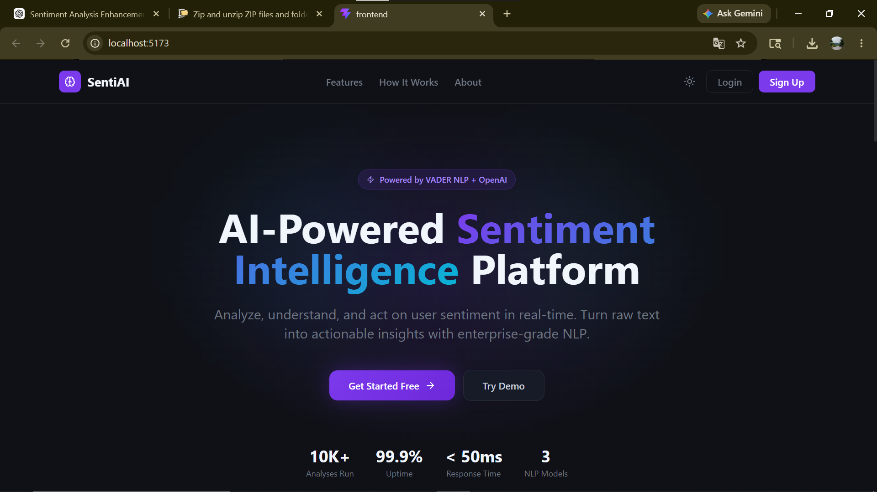
10.1 Landing Page

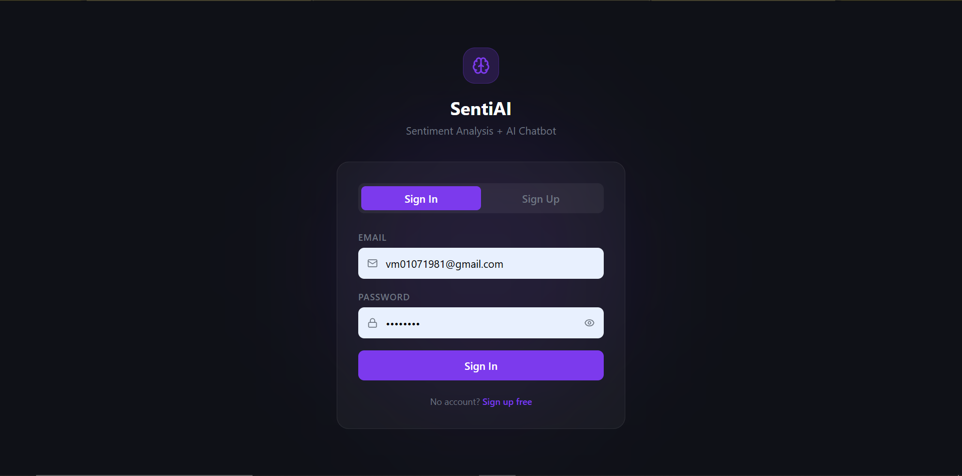
10.2 Sign In page
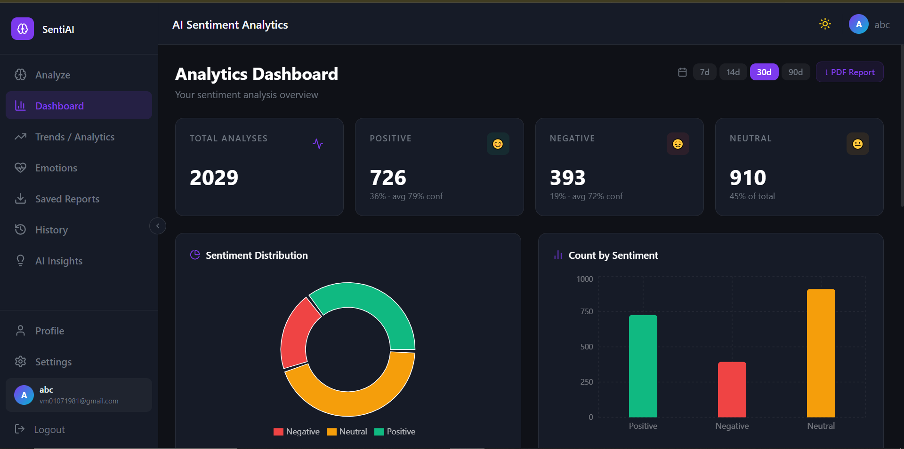
10.3 Dashboard
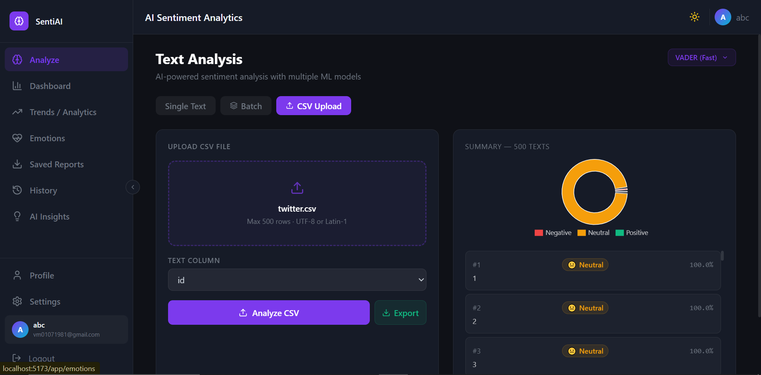
10.4 Analyze Page
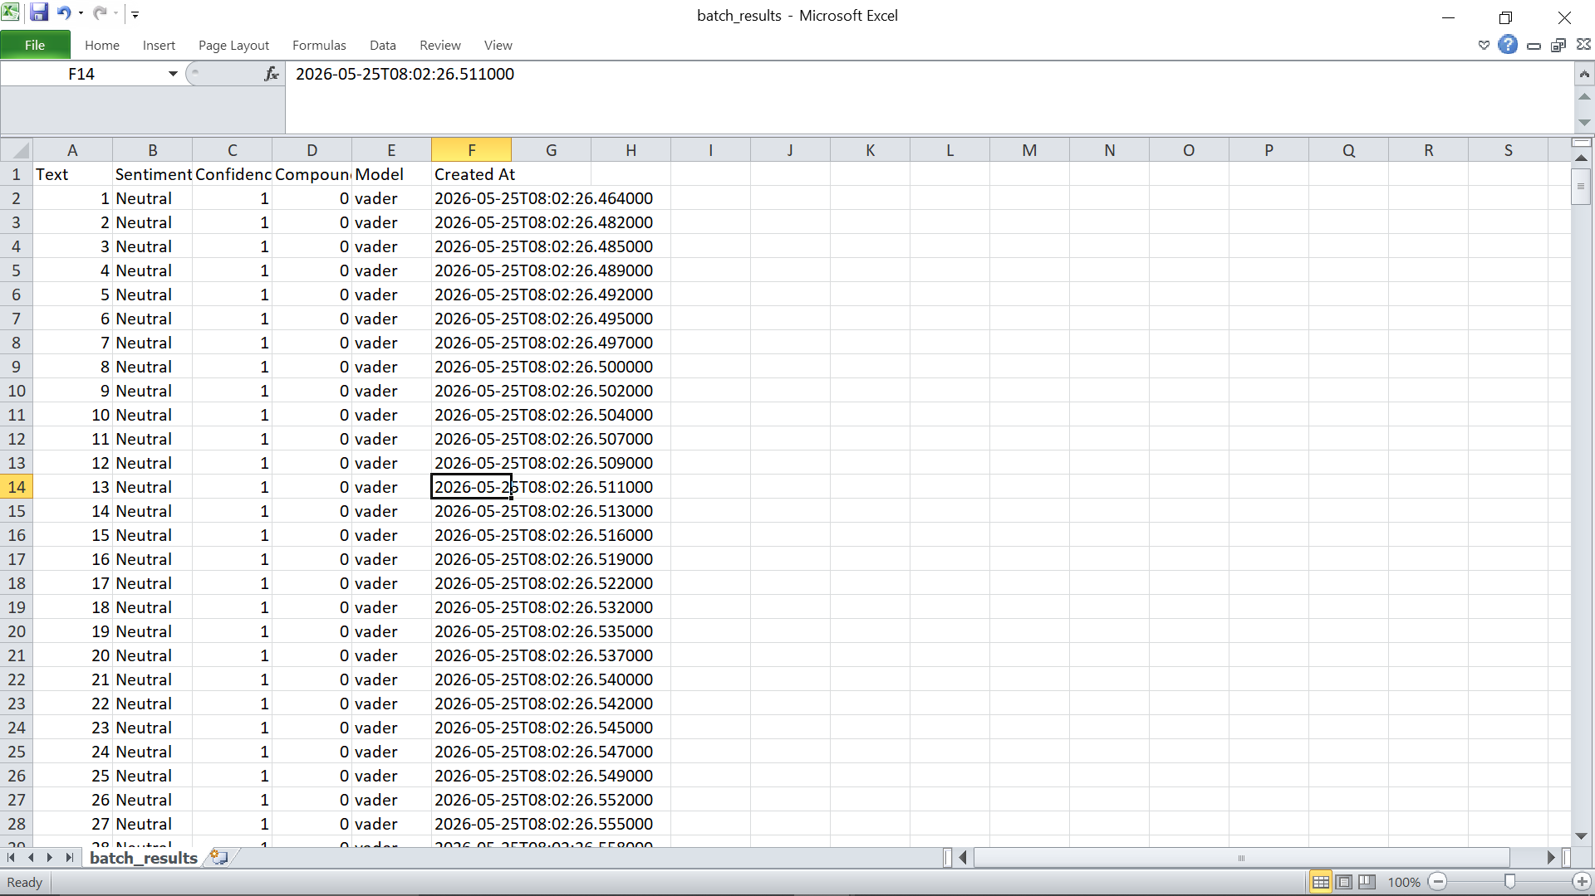
  - Analyzed Report

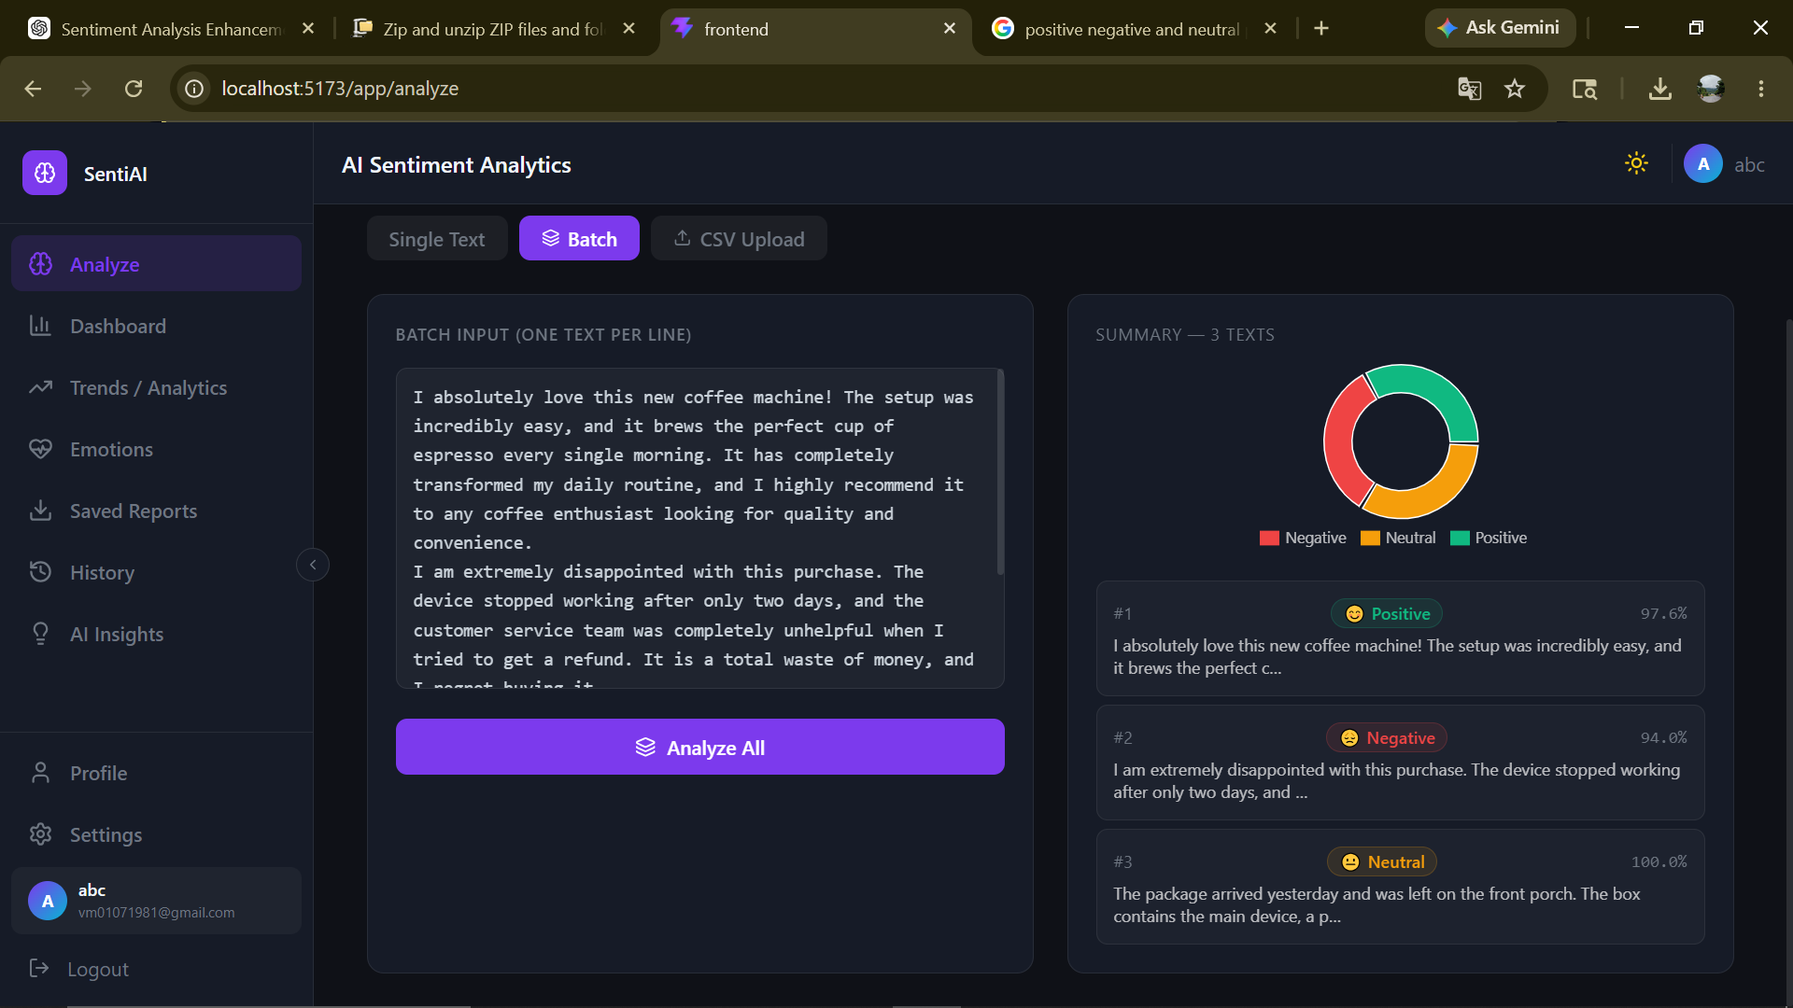
10.6 Analyze Page Batch Analysis

- Output / Results
The system generates multiple types of outputs, each designed to provide detailed insights into textual data analysis.
✅ Sentiment Analysis Output
For every analyzed input, the system produces a structured output containing the following elements:
- Sentiment Label: Classifies the text as Positive, Negative, or Neutral
- Confidence Score: Indicates the reliability of the predicted sentiment
- Compound Score: A normalized value representing overall sentiment polarity
- Score Breakdown: Provides individual scores for positive, negative, and neutral components
- Keyword Influencers: Identifies key terms that contributed to the sentiment classification
- Processing Time: Displays the time taken to analyze the input (in milliseconds)
This detailed output ensures transparency and helps users understand how the sentiment was derived.
🧠 AI Insights Panel Output
The AI Insights Panel generates high-level analytical summaries based on historical data stored in the system.
The output includes:
- Executive Summary: A concise overview of recent sentiment trends
- Sentiment Distribution: Percentage representation of positive, negative, and neutral sentiments
- Top Negative Keywords: Frequently occurring terms associated with negative sentiment
- Insights and Recommendations: Structured observations and suggested actions for improvement
This output bridges the gap between raw analytical data and meaningful decision-making.
📈 Trend Analysis Output
The Trends Module provides time-based analytical outputs that help users understand how sentiment evolves.
Key outputs include:
- Daily Sentiment Series: Displays sentiment values over time
- Moving Average Line: Smooths fluctuations to highlight overall trends
- Spike Markers: Identifies anomalies or sudden changes in sentiment
- Prediction Overlay: Visual representation of forecasted sentiment trends
These outputs enable users to identify patterns and anticipate future changes.
😄 Emotion Analysis Output
The system also generates emotion-based insights to complement sentiment analysis.
Outputs include:
- Emotion Distribution: Percentage breakdown of detected emotions such as happiness, sadness, anger, and excitement
- Per-Item Emotion Labels: Emotion classification for individual data entries (limited for UI optimization)
This feature provides a deeper understanding of user intent and emotional context.

- Challenges Faced
During the development of the AI Sentiment Analysis Dashboard, several technical and practical challenges were encountered.
1. API Performance and Scalability
One of the primary challenges involved handling large datasets efficiently. Since analytics endpoints rely on scanning historical data stored in MongoDB, performance can degrade as the dataset grows.
Additionally, processing large CSV files can increase computation time and affect system responsiveness. To address this, limits were imposed on the number of rows processed during CSV analysis, ensuring a balance between performance and usability.
2. Integration Challenges
Ensuring seamless communication between the frontend and backend posed another challenge. Both layers needed to maintain consistent data formats (response structures) and API contracts to avoid errors.
Moreover, during local development, configuring Cross-Origin Resource Sharing (CORS) correctly was essential to allow smooth interaction between different server ports.
These integration issues required careful debugging and standardization of API responses.

- Future Enhancements
The current system provides a strong foundation; however, several enhancements can further improve its capabilities and performance.
1. Real-Time Data Processing
Future versions of the system can incorporate real-time dashboards using technologies such as WebSockets or Server-Sent Events (SSE). This would allow live updates of sentiment data without requiring manual refresh.
2. Advanced NLP Models
The system can be enhanced by integrating transformer-based models (such as BERT or similar architectures) to improve sentiment analysis accuracy, especially for complex and contextual text.
3. Enhanced AI Insights Panel
The AI Insights Panel can be further improved by incorporating more advanced NLP techniques, enabling deeper context understanding and more sophisticated recommendations.
4. Improved Emotion Detection
Current emotion detection relies on lexicon-based methods. Future improvements may include the use of pretrained emotion classification models, which can provide more accurate and nuanced emotion detection.
5. Advanced Forecasting Techniques
Predictive analytics can be strengthened by implementing advanced time-series forecasting models such as:
- ARIMA
- Prophet
These models would provide more accurate and reliable future predictions.
6. Enhanced Anomaly Detection
Spike detection can be upgraded to include:
- Severity ranking of anomalies
- Root cause explanations
This would make anomaly detection more informative and actionable.

- Conclusion
The AI Sentiment Analysis Dashboard successfully delivers a comprehensive solution for analyzing and interpreting textual data. By integrating Natural Language Processing techniques with modern web technologies, the system provides an efficient and scalable platform for sentiment analysis.
A key highlight of the project is the AI Insights Panel, which transforms raw analytical outputs into structured summaries and actionable recommendations. This eliminates the need for manual interpretation and enhances decision-making capabilities.
Furthermore, the inclusion of advanced features such as trend analysis, anomaly detection, predictive analytics, and emotion detection significantly extends the system’s analytical depth.
In conclusion, the project demonstrates how intelligent data processing and visualization can be combined to create a powerful tool for understanding sentiment patterns, identifying issues, and supporting data-driven decision-making in real-world scenarios.

