User manual for DFT calculation inside YASARA

ORCA and MOPAC are well-known tool for Density functional theory (DFT) calculation of any molecule at a quantum level. But to develop the input files in the same atom order is sometimes very difficult for inexperienced users. Although, the exact protocol to calculate the DFT is not known to a new user which may resist the user to initiate and analyze the calculation.
This plugin will enable the user to perform the DFT calculation of any molecule by using ORCA and MOPAC through YASARA by providing a graphical user interface (GUI) for running calculations normally performed via a command-line interface.

INSTALLATION:

The plugin was developed using Python programming language. To install the plugin user needs to install YASARA (Structure), ORCA (version 5.0 or letter), MOPAC (MOPAC2016) and Python (3.8 or heigher) in the system. After installation of the described packages, the user must put the plugin in the plg folder inside YASARA installation path (/home/…/yasara/plg/). Installing the plugin adds a DFT CALCULATION dropdown menu in YASARA .

DESCRIPTION OF THE PLUGIN:

sml_QM.py :
After clicking on this plugin a window will appear like Fig 1, where the user must need to give the path of the working directory and have to select between ORCA and MOPAC from the list to indicate the method of DFT calculation. Users should be aware of the fact that ORCA does an ab initio level quantum calculation whereas, MOPAC does a semiempirical quantum calculation.
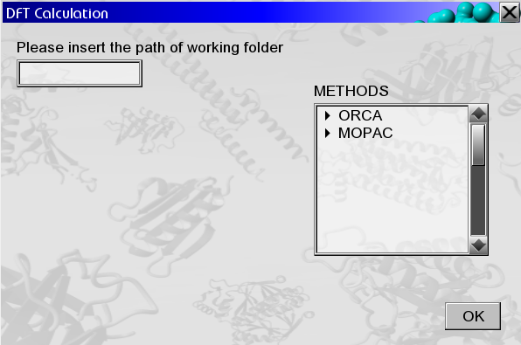
Fig 1: yasara plugin window to define the working path and method
Fig 1: yasara plugin window to define the working path and method
After providing the working directory information, a small window will appear on the yasara screen for the installation of essential python modules. If user click ‘Yes’, That will direct the user to go to the python environment and the plugin will automatically generate a module installation instruction file named as ‘module_command.txt’. In this ‘module_command.txt’ file all the instruction for module installation will be written thoroughly. User should follow the instruction and should manually install the modules. This window (Fig 1.1) for module installation will appear for the very first time of using the plugin.
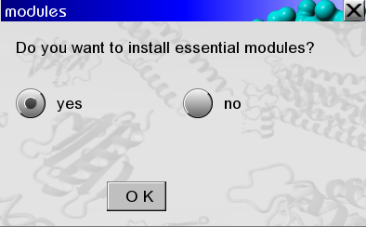

Fig 1.1: yasara plugin window to install essential modules

After providing the working directory and method of calculation information, a small window will appear like Fig 2, where the user must give the installation path of ORCA or MOPAC (for orca, the path should be the folder containing the "orca.exe" file and for mopac, the path should be the folder containg “MOPAC2016.exe” file). This window will appear for the very first time of running the plugin. After that, the plugin will store the path information of ‘ORCA’ and ‘MOPAC’ and will automatically recall that information for next time calculation.

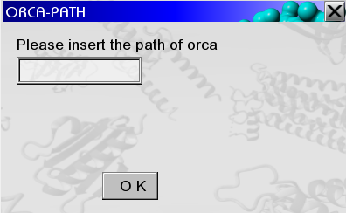
Fig 2: Yasara plugin window to define the installation path of ORCA

Next to that, another window will appear for selecting the type of calculation. If user selects ‘ORCA’ , then the user will be asked to select the type of experiment (Fig 3). Currently, the plugin is only restricted to calculate Single point, Geometry, Transition state, UV-Vis spectroscopy, Vibrational frequencies, HOMO-LUMO energy gap , Fukui function, QM-MM and multilevel QM- QM2 calculation. User can provide his/her own ‘ORCA’ input file for calculation. In that case, user must select ‘None of these’ option.
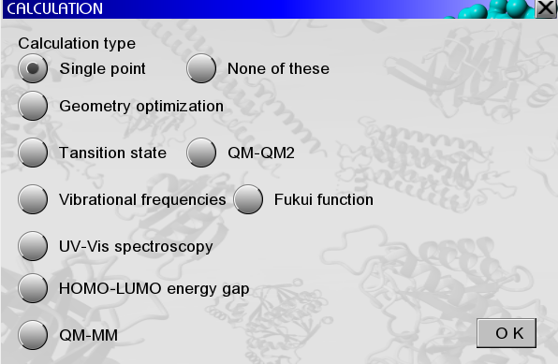

Fig 3: Yasara plugin window to select the experiment for ORCA

If user indicates a ‘MOPAC’ semiempirical calculation, then another window will appear in front of user to select the type of calculation (Fig 4).
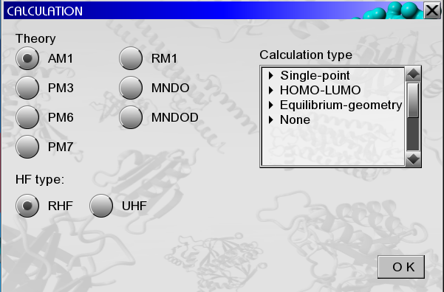

Fig 4: Yasara plugin window to select the experiment for MOPAC

For semiempirical calculation in MOPAC, user must select specific theory, restricted or unrestricted Hartree–Fock (RHF of UHF) method and the type of calculation. User can provide their own input file by selection the ‘None’ option from the list.

ORCA calculation:
For Single point, Geometry optimization, Vibrational frequencies, UV-Vis spectroscopy, HOMO-LUMO energy gap, Fukui function, multilevel QM-QM2 and QM-MM calculation through ORCA, user must select the options from the calculation window and have to select any specific functional set and basis set for calculation (Fig 5). If the user wants to define his/her own functional and basis set keywords then the user must select the 'None of these' options from the functional set and 'none' option from the basis set. Then just need to click 'OK'. That will initiate a new small window to appear in front of the user like Fig 6 and will ask for the user's own functional and basis set keywords. User must select an DFT functional and basis set for Fukui function calculation of any molecule.
Then, user will be asked to build or select (if more than one object is present in the structure) the experimental object.
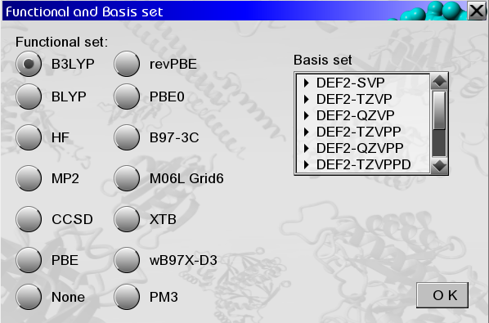

Fig 5: Yasara plugin window to select the functional set and basis set

That will initiate the ORCA calculation and the results of calculation will be stored in user provided path.

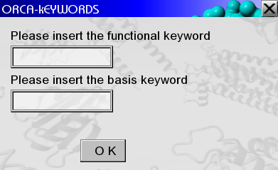
Fig 6: Yasara plugin window to define functional set and basis set keywords by user

For Transition state calculation, the user will be asked to build a reactant molecule(s) by the plugin (Fig 7) and after the development of the reactant, the user should click to continue to build the product molecule(s). To build a product molecule, the user must need to modify the reactant molecule by addition and deletion of bonds, and during the modification of the bonds, the user should not update the hydrogens (Fig 8). By disabling the 'update hydrogens' checkbox during bond addition, the user can prevent the update of the hydrogens (Fig 8). Also, the user should keep in mind that, the user can not add, delete or swab any atom to develop the product molecules.
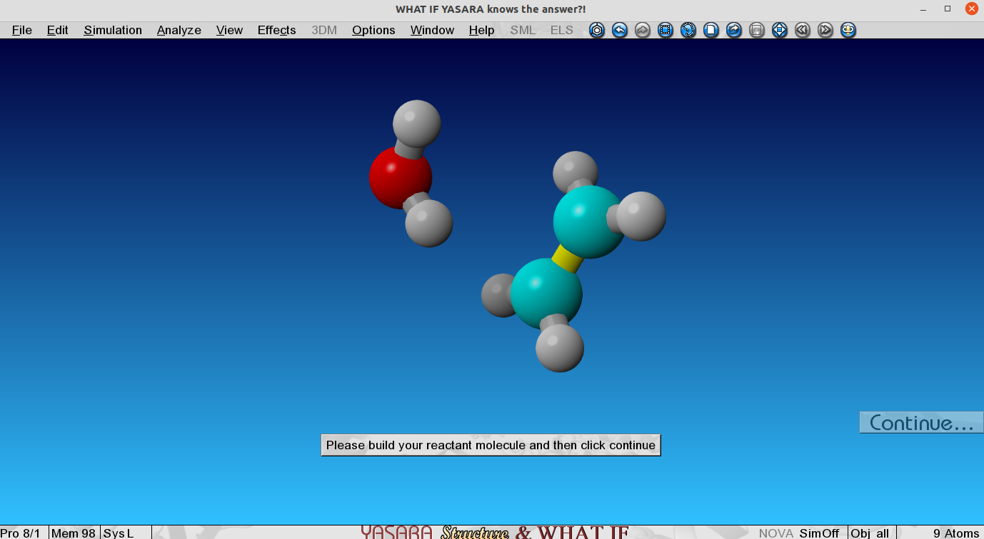
Fig 7: Development of reactant molecules

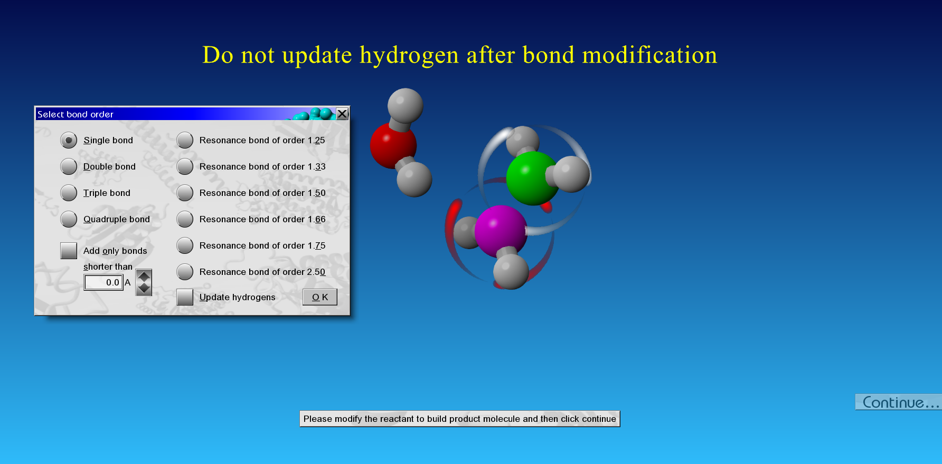
Fig 8: Development of product molecules

After the development of reactant and product molecules, another window will appear where the user must select any specific functional set and basis set to initiate the geometry optimization of both reactant and product (Fig 5).
By taking all the user input information, the plugin will automatically optimize the geometry of reactant and product molecule(s) and after that, it will initiate the TS calculation by Nudged Elastic Band method (NEB-TS).
Once the TS calculation is complete, another window will appear to visualize the trajectory of TS (Fig 9). If the user selects 'Yes' option, the minimum energy pathway (MEP) trajectory will be visualized in YASARA.

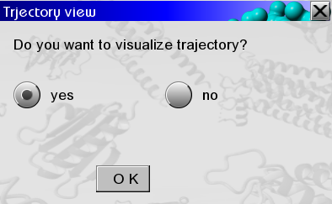

Fig 9: Yasara plugin window to visualize the MEP trajectory

The user can get all the results of the TS calculation in 'ts.out' and 'ts.log' files which will be generated after the successful completion of TS calculation.
For QM-MM calculation, user must load a complex structure (Ex: protein-ligand complex) in the yasara window. Then user must select the specific objects or residues by selection box for which the user wants to perform the QM calculation (Fig 10).
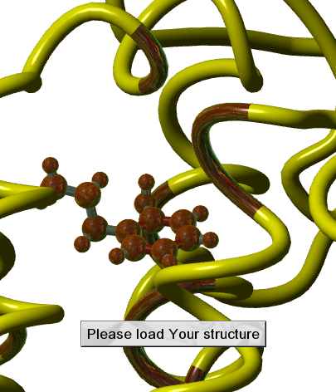

Fig 10: Selection of QM objects (Red) from a complex structure

After the selection of the QM objects, the plugin will ask the user to additionally select the residues user wants to restrain during the calculation. In the Fig 10, the read color atoms were selected for QM calculation and the yellow color residues were additionally selected for restraining. In principle, it is impossible for a biological system to be present in a free space. It is always surrounded by some other atoms which may have some restriction on the biological system’s movement.
In this QM-MM calculation, the plugin will ask user to select restrain the position of the atoms which may have some effect in the movement of quantum objects. That will help for more accurate and exact calculation.

The plugin will automatically restrain the selected residues and will perform a geometry optimization of the QM objects. After that, user needs to modify the QM object for transition state calculation without updating the hydrogen or adding any atom (Fig 8). Then the plugin will further initiate the geometry optimization of the newly modified structure and will perform the transition state calculation. The results will be stored in the working directory as ‘ts.out’ file format.

The plugin can also perform a Multilevel (QM-QM2) transition state calculation for any receptor ligand complex system. To start the calculation user needs to click on QM-QM2 option from the plugin. After that user should be asked to select the basis set for first level QM atoms (QM region) and then again user will asked to select the basis set for second level QM atoms (QM2 region). Currently, the plugin can use XTB functional for QM2 region in linux system. To download XTB please visit the following link.
https://github.com/grimme-lab/xtb/releases/tag/v6.5.1

For multilevel QM-QM2 calculation in windows system, user can select PM3 as an alternative functional of XTB.
User should keep in mind, XTB or PM3 is a semiempirical method and does not
Need any other basis set information for calculation. So, user can select ‘None’ option from the basis set list of the plugin.
After selection of basis set for QM and QM2 region, the user will be asked to select the QM atoms and additionally QM2 atoms from the structure. Then the plugin will automatically perform the multilevel DFT calculation and results will be stored in the working directory as ‘ts.out’ file format. The trajectory can also be visualized by analyzing ‘ts_MEP_trj.xyz’ file.

The plugin can also perform the condensed Fukui function of any given molecule.
The geometry optimization of a molecule will be performed by user provided DFT basis set. Then it will perform the geometry optimization of the anion and cation by removing and adding one electron from the structure. Then for each atom hirshfeld
charge will be computed for anion and cation structure. From the average hirshfeld charge of anion and cation for each atoms of the molecule, the condensed fukui function will be calculated and will be labeled on each atom of the structure on yasara window.

MOPAC calculation:
To initiate a semiempirical calculation user must select the type of calculation from list of experiment of MOPAC (Fig 4). Then the user will be asked to build or select specific object for calculation. After that the calculation will be initiated and results will be stored in the user provide path.

*Yasara missing package installation:
To run the DFT calculation plugin, user needs to install some python modules (os, sys, time, pandas, numpy, matplotlib, csv, shutil and platform). Out of these modules os and sys are already installed by default. To install any of the missing python modules, user needs to perform the following steps.

User needs to write the following command in the plugin (insert these two commands after line number 39 in the DFT calculation plugin), before importing the missing module (Fig 10).

import sys
print(sys.executable)

As the plugin will be executed in yasara, the path of python will be printed in the yasara terminal (e.g: C:\pyhton33\yasaraw.exe).
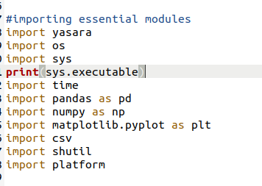

Fig 10: Importing sys module and executing the python path

The user must go to python path (e.g., C:\python33) by using CMD (Windows) or a shell window (Linux). Make sure that the Python interpreter version used by YASASA is greater or equal to 3.7. To check the interpreter version, the user can run the following command in a terminal window: c:\python33\python -v. If Python version is greater or equal to 3.7, the user can continue with steps 3 and 4. If Python version is lower than 3.7, the user must switch to Python 3.7 (see How to force version switch paragraph below).

Run the following command to install the missing package: python -m pip install pandas. Change pandas with the name of the missing package, if different.

How to force version switch
Users can force the switch from Python 3.3 (or from the default Python interpreter used by YASARA) to Python 3.7:
- by installing the latter into a different folder (e.g., C:\python37), OR
- by renaming the default directory (e.g., C:\python33 renamed in C:\python33.backup), OR
- by changing the correct version directory to the previous default directory name (e.g., C:\python37 renamed in C:\python33).

