Extended Analysis of MATISSE-Derived Pocket-Volume Dynamics in 5NF9
Rationale
To obtain a more representative description of the time-dependent behavior of the 5NF9 binding cavity, the original short-timescale analysis was extended to a set of independent molecular-dynamics trajectories. The principal aim was to determine whether the MATISSE-derived effective pocket volume (Ve) exhibits only an initial transient response following ligand removal or whether appreciable volumetric fluctuations persist over a longer sampling interval. A replicate-based design was used because a single trajectory cannot distinguish trajectory-specific behavior from reproducible features of the pocket. The analysis was therefore expanded from isolated maximum and minimum Ve values to the complete temporal and statistical distribution of the pocket volume. The early part of the trajectories was considered separately from the subsequent sampling period, and the post-10 ps interval was subdivided into consecutive time blocks to evaluate whether the ensemble displayed progressive contraction or expansion. In parallel, the molecular volume of the removed crystallographic ligand was calculated to provide an independent physical reference for the magnitude of the MATISSE-derived cavity volume. The ligand volume and the pocket volume were not expected to be identical, because the MATISSE representation describes a water-accessible binding cavity rather than the molecular volume occupied by the ligand itself.
The extended analysis was restricted to pocket volume and volumetric variability. No independent pocket-depth descriptor was calculated; consequently, changes in Ve were not interpreted as changes in pocket depth.
Methods
Ten independent 100 ps molecular-dynamics simulations of 5NF9 were performed from the same prepared starting structure. The co-crystallized ligand was removed, the resulting binding cavity was hydrated according to the MATISSE preparation procedure, and the same minimization and preparation protocol was applied to all simulations. A common ligand-free hydrated structure was then used as the initial coordinate set for all replicates. Independent trajectories were generated by assigning different random velocity seeds while maintaining identical starting coordinates.
The analyzed dataset contained 121 saved frames per replicate, corresponding to 1210 frames in total over the 0–100 ps interval. The median interval between saved frames was approximately 0.8325 ps. Adjacent molecular-dynamics frames were treated as temporally correlated observations and were used to characterize the distribution and temporal variation within each trajectory, whereas the independently seeded trajectories were used to assess replicate-level reproducibility.
For each saved structure, MATISSE was used to reconstruct the local water-based pocket representation. The total sphere volume was denoted V, the pairwise sphere-intersection contribution was denoted Vi, and the effective pocket volume was calculated as Ve.
For temporal analysis, the 0–10 ps interval was treated as the early trajectory region, while the 10–100 ps interval was used for the principal statistical analysis. For each replicate, the mean, standard deviation, median, minimum, maximum, and coefficient of variation of Ve were calculated. The post-10 ps region was further divided into 10–40, 40–70, and 70–100 ps blocks. A 5 ps running average was additionally calculated to visualize slower local changes within individual trajectories.
The molecular volume of the crystallographic ligand was calculated from its original three-dimensional structure using the RDKit grid-based molecular-volume procedure with a 0.20 Å grid spacing. The calculated ligand molecular volume was 449.84 Å³. This value was used solely as a geometric reference for comparison with the MATISSE-derived effective pocket volume.
Results
The ten independent 100 ps simulations showed substantial time-dependent variation in Ve throughout the sampled interval. During the principal 10–100 ps analysis region, the mean effective pocket volume calculated across the ten independent replicate means was 842.7 ± 134.9 Å³. Individual replicate means ranged from 681.5 to 1051.2 Å³, indicating that the trajectories sampled partially different volumetric regimes rather than converging to a single narrowly defined pocket volume.
Marked fluctuations were also observed within individual trajectories. The within-replicate standard deviations of Ve were approximately 208–273 Å³, with coefficients of variation ranging from 21.8% to 36.8%. The distribution-based analysis confirmed that these fluctuations represented broad sampling of pocket-volume states rather than a small number of isolated extreme values. Although the distributions of the ten replicates overlapped substantially, their centers and widths differed, reflecting replicate-dependent sampling of the local cavity.
Table 1. Post-10 ps effective pocket-volume statistics for the ten independent trajectories.
Replicate | Mean Ve (Å³) | SD (Å³) | Median (Å³) | CV (%) | 0–10 to 10–100 ps change (%)
1 | 1017.3 | 250.1 | 1014.0 | 24.58 | +8.88
2 | 747.0 | 272.6 | 685.0 | 36.50 | -4.41
3 | 738.2 | 240.7 | 749.5 | 32.61 | -14.18
4 | 681.5 | 251.1 | 700.0 | 36.84 | +19.23
5 | 804.6 | 207.6 | 793.5 | 25.80 | +24.33
6 | 829.1 | 212.2 | 862.5 | 25.59 | +4.57
7 | 837.9 | 232.9 | 818.0 | 27.79 | -16.87
8 | 1051.2 | 229.3 | 1072.0 | 21.81 | +14.06
9 | 1004.3 | 226.9 | 1003.5 | 22.59 | +29.65
10 | 716.0 | 239.6 | 692.0 | 33.46 | -25.27

Comparison of the early and extended trajectory regions did not reveal a uniform directional response across the replicates. The ensemble mean Ve during 0–10 ps was 825.0 ± 139.4 Å³, compared with 842.7 ± 134.9 Å³ during 10–100 ps. More importantly, the direction of the change differed among trajectories. Some replicates showed an increase in their mean Ve after 10 ps, whereas others showed a decrease. The relative changes ranged from -25.3% to +29.6%. Thus, the trajectories did not exhibit a common monotonic relaxation pattern following ligand removal.
The ensemble block analysis showed a comparatively stable average behavior over the post-10 ps interval. Mean Ve values across the ten replicate means were 851.9 ± 128.3 Å³ for 10–40 ps, 837.7 ± 212.0 Å³ for 40–70 ps, and 838.5 ± 155.2 Å³ for 70–100 ps. The total range among these three post-10 ps ensemble block means was 14.2 Å³, corresponding to approximately 1.68% of their mean. Therefore, despite substantial fluctuations within individual trajectories, the ensemble did not show a sustained progressive expansion or contraction over the 10–100 ps interval.
Table 2. Ensemble block analysis of Ve.
Interval | Mean of replicate means Ve (Å³) | SD between replicate means (Å³) | Replicates
0–10 ps | 825.0 | 139.4 | 10
10–40 ps | 851.9 | 128.3 | 10
40–70 ps | 837.7 | 212.0 | 10
70–100 ps | 838.5 | 155.2 | 10
The removed crystallographic ligand had a molecular volume of 449.84 Å³. This value was substantially smaller than the mean post-10 ps MATISSE-derived effective pocket volume of 842.7 ± 134.9 Å³. The mean cavity volume was therefore approximately 1.87-fold larger than the ligand molecular volume. The difference is consistent with the distinct geometrical quantities represented by the two measurements: the ligand volume describes the molecular space occupied by the ligand, whereas Ve represents the broader water-accessible cavity reconstructed by MATISSE.
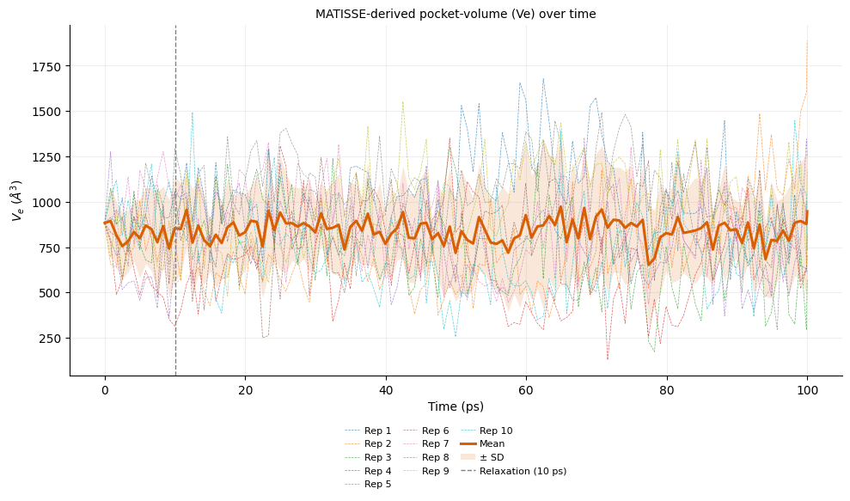
Figure 1. Time-dependent MATISSE effective pocket volume (Ve) for the ten independent 100 ps trajectories. The thick line represents the ensemble mean and the shaded region represents ± SD across replicates. The dashed vertical line indicates 10 ps.
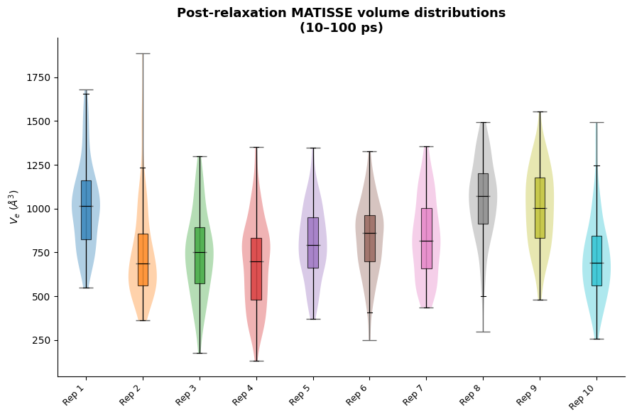
Figure 2. Distribution of MATISSE-derived Ve values during the 10–100 ps interval for the ten independent trajectories.
Discussion
The extended simulations indicate that the 5NF9 cavity is not represented by a single static MATISSE volume over the 100 ps timescales. Instead, each trajectory exhibits broad short-timescale fluctuations in Ve, with substantial within-trajectory variability and partially different mean values among independent replicates. The persistence of these fluctuations beyond the earliest part of the simulations indicates that the volume changes are not confined to the immediate response following removal of the crystallographic ligand.
At the same time, the trajectories do not support a simple model in which all systems undergo the same initial relaxation and subsequently converge to an identical pocket volume. The early-to-late change in mean Ve occurs in both directions across the independent simulations. This behavior is more consistent with trajectory-specific local reorganization and continued sampling of different short-timescale cavity configurations than with a single uniform relaxation pathway.
The block analysis provides an important ensemble-level perspective. Although individual trajectories show pronounced local increases and decreases, the ensemble means for 10–40, 40–70, and 70–100 ps remain closely similar. The difference among these block means is only 1.68% of their average, indicating the absence of a sustained directional drift in the ensemble after 10 ps. The results therefore support an approximately stationary ensemble-level volume regime superimposed on substantial replicate-dependent short-timescale fluctuations.
The ligand-volume comparison provides an additional physical context for the MATISSE values. The calculated ligand volume of 449.84 Å³ is smaller than the average post-10 ps Ve of 842.7 ± 134.9 Å³. This difference is expected because the MATISSE volume represents the water-accessible cavity surrounding the ligand-binding region and may include local void space and cavity extensions that are not occupied by the ligand in the crystallographic complex. Accordingly, the ligand-to-pocket comparison should be interpreted as a geometric reference rather than as a quantitative occupancy measure.
Overall, the 100 ps replicate analysis supports the interpretation that MATISSE captures persistent short-timescale volumetric variability of the 5NF9 pocket while the ensemble-averaged cavity volume remains approximately stable over the post-10 ps period. These simulations are not intended to establish long-timescale conformational equilibrium of the protein. In addition, because no explicit depth descriptor was calculated, the observed changes in Ve are interpreted strictly as changes in pocket volume and not as changes in pocket depth.

