YAMACS USER MANUAL

v1.1
05/05/2022

University of Salerno
Soft Matter Lab

Summary

Installation 2
YAMACS plugins 4
1. System preparation (YAMACS_1_PDB2GMX.py): 4
2. System equilibration (YAMACS_2_equilibration.py): 5
3. MD run (YAMACS_3_MD.py): 5
4. MD play (YAMACS_4_MdPlay.py): 6
5. Select atom (YAMACS_5_Select_atom.py): 6
YAMACS structure 8
Changelog 9
Copyright 10
YAMACS is a collection of plugins that enable users to perform GROMACS Molecular Dynamics (MD) simulation through YASARA, providing a graphical user interface (GUI) for running calculations normally performed via command-line interface. Currently, the plugins are supported on Linux systems only because of GROMACS compatibility.

Installation
The plugins were developed using Python programming language. YAMACS is based on GROMACS and is available for Linux only. It requires YASARA (View or Structure), GROMACS (2020.4 or higher) and Python (2.7 or higher). YASARA and GROMACS have to be installed separately. Python is by default installed on Linux machines.
YAMACS is available for download on https://github.com/YAMACS-SML/YAMACS and is released under GPL-3.0 license.
To install the plugins, you must put the needed files in the plg folder inside YASARA installation path (/home/…/yasara/plg/). Installing the plugin adds a YAMACS dropdown menu in YASARA (Fig. 1). A selection of GROMACS commands is also available through the YASARA atom- and residue- context menus.

- Download and install GROMACS ver. 2020.4 or higher on your system. Downloads and installation instruction can be found on https://www.GROMACS.org/.
- Download and install YASARA (View or Structure) on your system. Downloads and installation instruction can be found on http://www.YASARA.org/.
- Download the plugin package from YAMACS GitHub page. To install the plugins, copy the five .py files and unpack the .zip file in the plg folder, inside YASARA installation directory (e.g., home/user/yasara/plg). The .zip file contains the background .png files of the plugins and the mar2019 version of CHARMM36 force field, needed for the Molecular Dynamics simulations.

The files contained in the .zip file must be extracted inside YASARA installation folder, in the plg directory, along with the plugins.py Python script files. The files are needed for the correct functioning of the plugins.
To ensure that everything is installed correctly, check that the path of the files are the following:
- for Python scripts
/home/.../yasara/plg/YAMACS_script_name.py
- for background PNG files
/home/.../yasara/plg/BG_number.png
- for CHARM36 force field
/home/.../yasara/plg/charmm36/charmm36-mar2019.ff

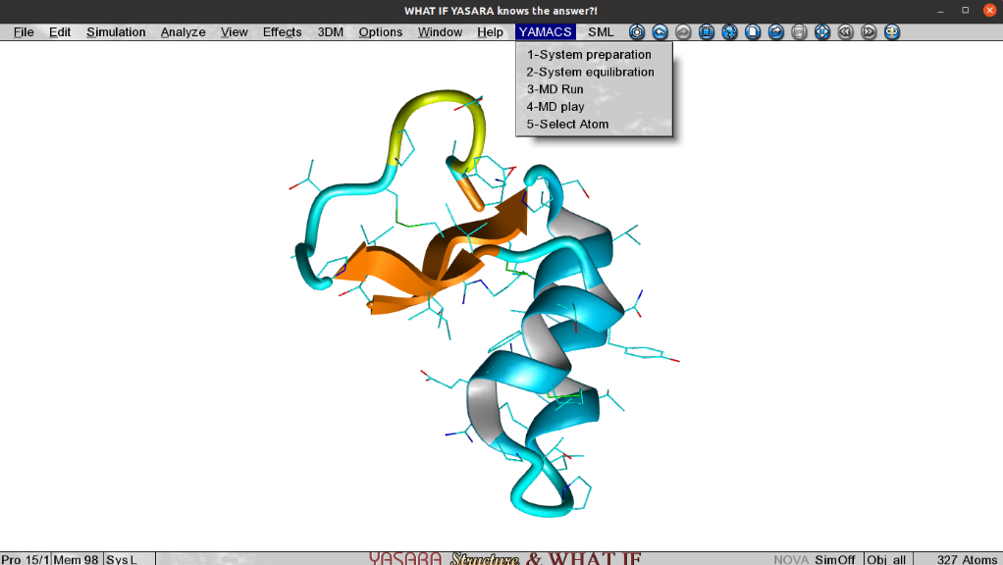
The YAMACS option becomes available in YASARA. The menu contains several items, each with a different function.
1-System preparation: using this plugin, the files needed to start an MD simulation will be generated.
2-System equilibration: this plugin performs water and ion addition, energy minimization, NVT and NPT equilibration of the system.
3-MD Run: this plugin is used to run MD simulations of the system, with user defined simulation time.
4-MD play: this plugin allows to visualize GROMACS simulation trajectory in YASARA.
5-Select Atom: this plugin allows the selection of atoms to perform further analyses.

YAMACS plugins
YAMACS can perform Molecular Dynamics (MD) simulations for several system types:
- Apoproteins
- Protein-ligand complexes
- Membranes
- Membranes-protein complexes
- Membrane-protein-ligand complexes
- Small molecules

1. System preparation (YAMACS_1_PDB2GMX.py):
This plugin converts the input file of the system into GROMACS file format and generates the essential topology file (topol.top) file of the input system. By running the plugin, the following window will pop up:

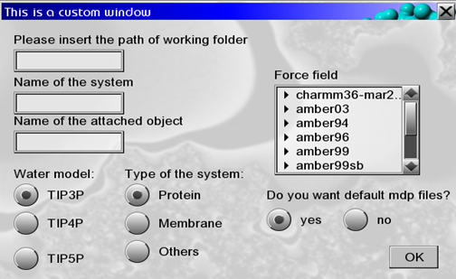

In this window, you should provide the path of the working folder, the name of the system and the name of the additional object attached to the system (e.g., ligand, membrane).

You can select the preferred water models (TIP3P, TIP4P and TIP5P) for water addition. Note: CHARMM36 force field does not work with TIP5P water model.

You can define the type of system by selecting the appropriate item:
- Protein is used for any system containing a protein (apoproteins, protein-ligand complexes, membrane-protein complexes, membrane protein-ligand complex systems).
- Membrane is used for scenes with membrane only.
- Others is used for any other system (small molecules).

Before running the MD simulation, you must select an appropriate Force Field (FF) from the list:
- For protein-ligand complexes and small molecules the MD simulation can be run with CHARMM36 FF. The plugin automatically generates the necessary .itp file of the ligand using the Swiss Param web server (https://www.swissparam.ch/). In order to use different FFs, you must first generate the input files of the system using CHARMM GUI web server (https://www.CHARMM-GUI.org/). The CHARMM-GUI file obtained from the web server must be placed in the working directory (folder /…/yasara/plg/charmm36/). CHARMM36 FF is already provided in the .zip file downloaded from the GitHub page.
- For membrane, membrane-protein complex, and membrane-protein-ligand complex systems the input files must be generated using CHARMM GUI web server (https://www.CHARMM-GUI.org/). For membrane-protein systems GROMOS96 FF can be used. An external .itp file generated with GROMOS96 FF is required, however; YAMACS only generates .itp files for CHARMM36.
You can select the default .mdp files, which can be generated by YAMACS (select Yes option) or put a different .mdp file in the working folder (select No option).

2. System equilibration (YAMACS_2_equilibration.py):
This plugin performs water and ion addition, energy minimization, and NVT-NPT equilibration of the system. By clicking on the plugin, the following window will pop up:

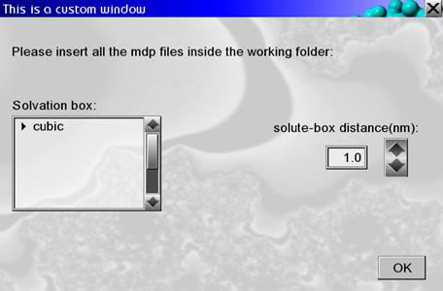

In this window, you should set a value of solute-box distance (in nanometers) which can satisfy the periodic boundary conversion. At the moment, the simulation box can only be cubic, which satisfies the triclinic box condition for YASARA as well as GROMACS.

3. MD run (YAMACS_3_MD.py):
This plugin is used to run MD simulations of the system. By clicking on the plugin, the following window will pop up:

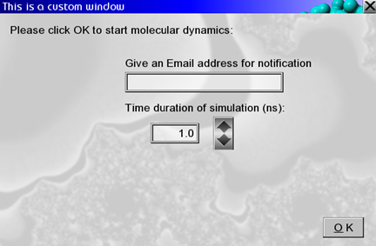

In this window, you can provide the desired time duration of the simulation (in nanosecond). To get an email notification at the end of the simulation, insert your email address in the relevant field. The MD simulation will automatically start after clicking OK. This plugin will calculate the total number of frames for the selected simulation time and will load every frame into YASARA window, allowing to visually keep track of the MD advancement. After the simulation has ended an automated email will be sent.

System preparation can be performed using YASARA Structure (licensed version) instead of YAMACS plugins. After preparing the system with YASARA, and generating the appropriate files, GROMACS MD can be run clicking on the 3-MD run plugin directly. Before doing so, please check that temporary.ini file is not present in the plg folder of YASARA installation path. This file contains all the input information of the system and is generated when running YAMACS plugins in order. If you bypass YAMACS preparation steps, a tempo.ini file will be generated, containing all the input information of the system. This plugin will generate all the necessary files to run MD simulations (e.g., topology files, etc.). At the end of the run, another window will pop up asking to extend the simulation:

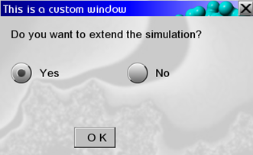

By selecting No, the plugin will stop. By selecting Yes, a prompt to select the time of the extended simulation will pop up:

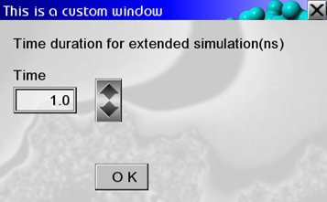

The plugin will start the extended MD simulation and will update the total number of frames. After the completion of the extended MD simulation, the plugin will concatenate the previously simulated .xtc file with extended .xtc file. The original .xtc file will be stored in the Prev_xtc folder.

4. MD play (YAMACS_4_MdPlay.py):
This plugin is used to visualize the simulation trajectory obtained with GROMACS. You must insert the path of the working folder in the prompt that will pop up by starting the plugin. This plugin will load the trajectory into YASARA.

5. Select atom (YAMACS_5_Select_atom.py):
Using this plugin, you can select single or multiple atoms using YASARA. The output is a yas_index.ndx file that can be read by GROMACS to carry out various analyses. So far, the following analyses are included and calculated by the plugin: Root Mean Square Deviation (RMSD), Root Mean Square Fluctuation (RMSF), Radius of gyration (Rg) And Solvent Accessible Surface Area (SASA).

By starting the plugin, you will be asked to provide the path where to save the file and the installation path of YASARA. Once the required data has been entered, a new YASARA window will open. You have to load your system on the new window using YASARA File menu (File > Load), and then select atoms or groups of atoms (Edit > Select > New). Once the selection is over, press Continue. A message will pop up and you can close the new YASARA window to continue.

The output is a yas_index.ndx file, saved in the preferred folder. The .ndx file generated by GROMACS has the name of the selected group of atoms as header and the numbers of the atoms belonging to the group below. After running the plugin and selecting the atoms, GROMACS will calculate RMSD, RMSF, Rg and SASA of the selected atoms. The output is stored in a .xvg file. Further analyses will be implemented in time.

YAMACS structure
The following workflow represents the logic of the base YAMACS plugins. The workflow shows how YASARA interfaces with GROMACS engines.

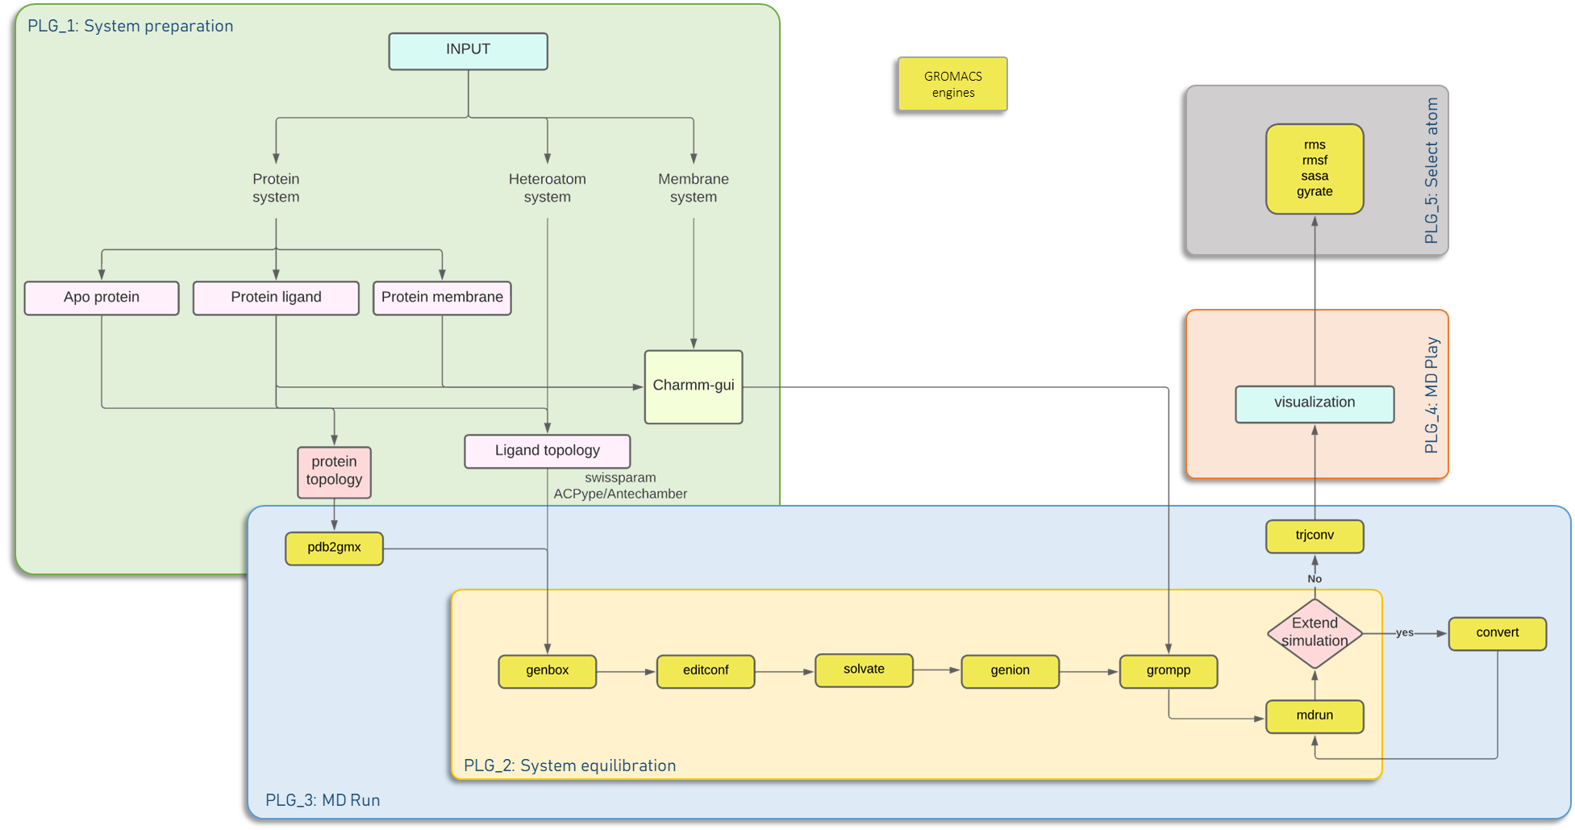

Changelog

What's new in 1.1:
- Small edits, reworked workflow

What's new in 1.0:
- Initial release of YAMACS

Copyright

This software is available to you under the terms of the GPL-3.0 license. Software is created and maintained by Soft Matter Lab at University of Salerno and by all GitHub contributors.

Contributors:
- Stefano Piotto piotto(at)unisa.it
- Arkadeep Sarkar asarkar(at)unisa.it
- Jacopo Santoro j.santoro1992(at)unisa.it
- Luigi Di Biasi ldibiasi(at)unisa.it
- Francesco Marrafino fmarrafino(at)unisa.it

