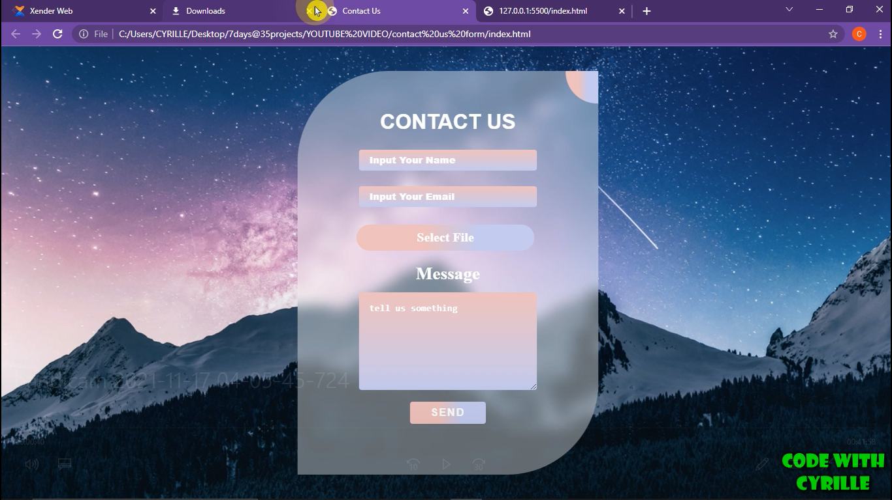

GLASSMOPHISM CONTACT US FORM USING JUST CSS