Western Blotting – Invitrogen system

Date: _______________
Project: ____________________________________________________________________
Gel type (%): ___________________________________________; Homemade/Precast

Samples preparation
- Prepare sample buffer and appropriate reducing agent
- If using Laemmli sample buffer (LSB) + β-mercaptoETOH (Keep 4ºC for 1-2 months)
  - 50µl of β-ME per 950µl LSBx2; 100µl of β-ME per 900µl LSBx4; 125µl of β-ME per 875µl LSBx5.
- Note: β-mercaptoETOH is a severe irritant and is readily absorbed through the skin; use in a fume hood.
- Prepare samples:
- Dilute samples with PBS X1 for equal loading volumes, as necessary.
- Typical loading amount is 30-40µg.
- Dilute 1:1 sample to LSBx2+β, 3:1 for LSBx4+β, 4:1 for LSBx5+β.
Sample | Conc. (µg/µl) | Sample  (µl, for ____ µg) | + PBS (µl) | LSB X__ buffer (µl) | Total (µl)
Size standard | - | - | - | - | 5
- Boil samples 5' or keep 30' at 37ºC, put cap holder on tubes before boiling
- Do not heat standard, Keep on ice

Running samples on homemade/precast gel (Invitrogen Mini Gel Tank)
- Make 400 ml Running buffer X1 for each Mini Gel Tank chamber to be used.
- Assemble Mini Gel Tank chamber and fill with Running buffer X1 up to cathode.
- Rinse wells 3 times w/ buffer and place cassette into chamber with wells facing forward. Hold the cassette in a raised position and close clamp.
  - If using precast gel, peel away the tape at the bottom before inserting the gel cassette
  - If running only one gel, remove the second cassette clamp
- Optional: load small amount of sample buffer into each well and run for a minute to make sure all wells are in order.
- Put in well guide to assist loading and carefully load samples and size standard into gel:
1.______ 2.______ 3.______ 4.______ 5.______ 6.______ 7.______ 8.______ 9.______ 10.______

- Can wash tip in running buffer for reuse between samples
- Load up to 40 µl DDW carefully in each well on top of samples
- Open clamp and slowely lower the gel cassette
- Run gel until the blue line disappears:
- For homemade gels: run at 130-200V (approx 1h)
- For precast gels: run at 225V (25-40') or refer to specific instructions
- Carefully remove gel (using the well guide or spatula) and place in Transfer buffer X1 or DDW (if using "Transfer stacks") for equilibration 5-30'. Cut a corner of gel to mark orientation
- Start time: ___________; _______V, _______mA
Finish time: ___________; _______V, _______mA

Membrane transfer – semi-dry (Invitrogen Power Blotter)
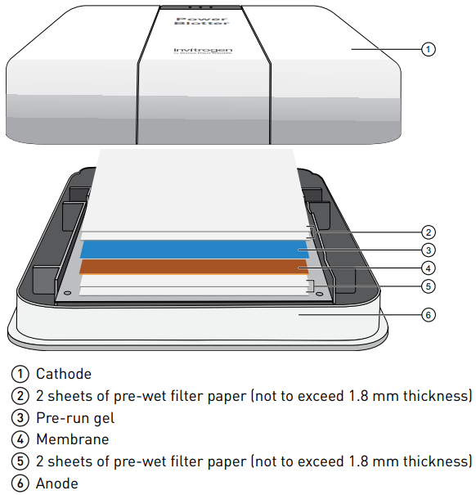
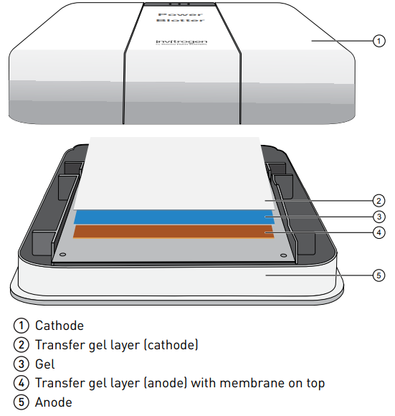
  - Perform blotting within 15' of sandwich assmebly
  - Make sure to remove all bubbles during assembly
  - Handle membrane carefully with clean gloves

- If using "Transfer Stacks":
  - No need for Transfer buffer
  - Carefully place bottom stack on the anode
  - Cut a corner of the membrane to mark orientation and place the gel on the membrane
  - Place top stack w/o the separator
  - Lock casette with cathode and slide into the Blotter

- If making your own stack or using pre-cut stacks:
  - Make 50 ml Transfer buffer X1
- Cut 4 Whatman papers and 1 membrane to size
- Cut a corner of the membrane to mark orientation
- Equilibrate papers + membrane in Transfer buffer X1 5'
- Asseble on anode (buttom):
Whatman x2 membrane gel Whatman x2
- Lock casette with cathode and slide into the Blotter

- Choose correct program in Power Blotter
- Choose between 1 or 2 mini gels to be transferred
- Choose transfer method by required protein sizes
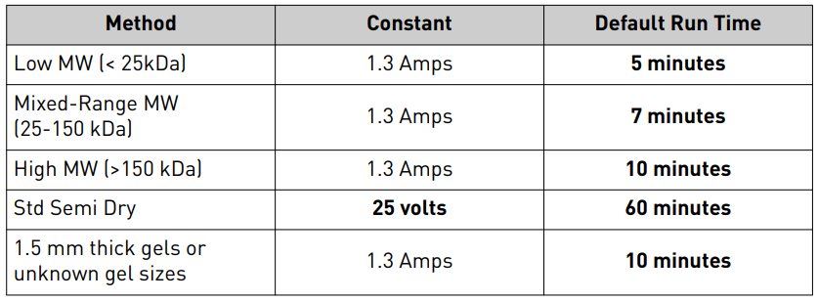
- Pre-programmed transfer methods:
- For large proteins >150 kDa, may need to increase the run time to 8-10 min
- For small proteins <25 kDa, may need to reduce the run time to 4-6 min

- Post-transfer:
- Stain membrane with Ponceau (save for reuse); mark lanes and marker values.
- Wash ponceau off membrane by shaking in PBS X1.
- Keep membrane refrigerated, wrapped in saran wrap and wet with PBS X1.

Optional: Coomassie Blue gel staining
- Stain gel with 0.1% Coomassie Blue solution up to 1 hr.
- Destain gel in destaining solution (225 ml ETOH + 225 ml DDW + 50 ml glacial acetic acid), may take up to overnight RT on shaker.
- Use sponge cuts during destain.

Date: _______________
Project: ____________________________________________________________________

Blocking
- Make 30-50ml 5-10% dry milk in Tween20 0.2% and PBS X1 (PBS-T-M).
- Block membrane by incubating in PBS-T-M overnight 4ºC or 1-2 hr RT, on rocker.
- Rinse the membrane for 5" in PBS-T after blocking.

Primary antibody
- Incubate w/ primary ab diluted in 1-10 ml PBS-T-M or Advanblock 1-2 hr RT or overnight 4ºC, on rocker.
- Primary ab used: _____________________________________________________
- Dilution: ___________________________________________________________
- Wash in PBS-T (0.2%) 6x5' or 3x10' (make up to 1L).
- Keep primary ab for reuse
  - If diluted in PBS-T-M, add NaAzid for preservation

Secondary antibody
- Incubate w/ secondary ab diluted in 10 ml PBS-T-M on rocker for 1hr RT.
- Secondary ab used: ____________________________________________________
- Dilution: ____________________________________________________________
- Wash in PBS-T (0.2%) 6x5' or 3x10'.
- Wash in PBS-T (3%) 3' and in PBS X1 (w/o Tween) 10'.
- Keep sample of ab aside as markers for ECL.

ECL
- Mix both solutions in 1:1 ratio (~1 ml each solution per membrane).
- Make control HRP-ab (secondary ab) markers dotted on small membrane piece.
- Incubate membranes 1-3' on parafilm in dark box.
- Drip on blotting paper to remove excess ECL solution, shake slightly and expose membrane and control piece on Saran wrap.
- After filming, shake with PBS X1 for 10'. Wrap in saran wrap and keep refrigerated.

Film at TAMI RUBINEK's lab (Fusion Pulse TS VILBER LOURMAT)
- Make sure that the camera is set on 1 (upper right wheel)
- Press Chemiluminesence and put blot on tray 1
- Press Preview to adjust blot in the right place and adjust lighting
- Press Multiple jul and Auto (to adjust blot time exposure press Manual)
- Press start
- Mark the marker and press paste selection and OK
- Save all images in compatibility TIF or JPG
- Leave the software and camera on

Stripping (up to 2-3 times)
- Option 1: Mix 1.25 ml Tris (1M, pH=6.7) + 140 µl β-mercaptoETOH + 2 ml SDS 20%. Adjust volume to 20 ml with DDW. Soak at 50ºC for 30'. Wash with PBS-T 0.5% 2x10'.
- Option 2: Mix 2 ml Glycine (1M pH=2.5) in 20 ml DDW (1:10) per membrane. Soak for 30-60' RT a rocker. Wash 3 times in PBS before blocking.
- Option 3: Use commercial Stripping solution.
- React with ECL, make long exposure and film to ensure full stripping.
- Shake with PBS X1 for 10'. Wrap in saran wrap and keep refrigerated.

