Lipofectamine 3000 protocol
- Seed cells in 24 well plate
- Cell type_____________________
- No. of cells___________________
- Cell should be 70-90% confluent
- Reduce medium from 500µl to 350µl to improve transfection -
- Prepare two mixes –
  - Optimem and Lipofectamine
- 25µl Optimem per well ____________________
- 1µl Lipofectamine per well __________________
  - Optimem, DNA and P3000 Reagent – add P3000 last
- 25µl Optimem per well ____________________
- 500 ng DNA per well ____________________
- 1µl P3000 Reagent per well ____________________
- Mix well (no need to vortex)
- Add DNA Mix to the Lipofectamine mix
- Incubate 10-15 min and drop-wise 50µl mix
- Check cells in microscope
- Spin down plate
- Change medium at the end of the day (2.5h minimum)
- Incubate cells for 2-4 days at 37°C
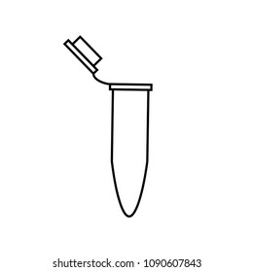

_________ Lipofectamine _________ Optimem
_________ Optimem _________ DNA
_________ P3000


_________ Lipofectamine _________ Optimem
_________ Optimem _________ DNA


_________ P3000
_________ Lipofectamine _________ Optimem
_________ Optimem _________ DNA
_________ P3000
* For 6-well plate 2500ng DNA per well, 5µl P3000 Reagent and 5µl Lipofectamine
* For 96-well plate 100ng DNA per well, 0.2µl P3000 Reagent and 0.2µl Lipofectamine

