

**Playtest Report(May 28)**

**Class name : GAM150S19KR**

**Semester and year : Spring 2019**

**Team : APEX**

Team ***APEX*** Roster

Junseok **Yang** - Producer (junseok.yang)

(item/map)

Wonju **Cho** - Lead Designer (wonju.cho)

(character image)

Jookyung **Lee** - Technical Director (jookyung.lee)

(physics/ character ui/ domination round)

Haewon **Shon** - Test Manager (haewon.son)

(Game logic)

Table of content

2 [Introduction](https://drive.google.com/open?id=1e0SBjw76PCqNjEkcwA_HsiWUYBHb7DMyRB960JM7AHs)

2 [High Concept](https://drive.google.com/open?id=1e0SBjw76PCqNjEkcwA_HsiWUYBHb7DMyRB960JM7AHs)

2 [Game Summary](https://drive.google.com/open?id=1e0SBjw76PCqNjEkcwA_HsiWUYBHb7DMyRB960JM7AHs)

2 [Target Audience](https://drive.google.com/open?id=1e0SBjw76PCqNjEkcwA_HsiWUYBHb7DMyRB960JM7AHs)

2 Playtest

environment

3 [Playtest Outline](https://docs.google.com/document/d/1e0SBjw76PCqNjEkcwA_HsiWUYBHb7DMyRB960JM7AHs/edit)

4 [Playtest summary](https://docs.google.com/document/d/1e0SBjw76PCqNjEkcwA_HsiWUYBHb7DMyRB960JM7AHs/edit)

5 [Work Items](https://docs.google.com/document/d/1e0SBjw76PCqNjEkcwA_HsiWUYBHb7DMyRB960JM7AHs/edit)

**Introduction**

The purpose of this document is to record the playtesting which held in the lobby of main engineering building at May 31. The environment for playtest, test player’s reaction during playing APEX and result of surveys from test players after playing APEX were recorded.

**High Concept**

APEX is a local multiplaying 2D platformer action battle game which contains several rounds with different win conditions.

**Game Summary**

Players can choose their unique character between four different characters. Each character has different status and visuals. Players can fight in give map, they can push each other and achieve the goal to win. There is only dominating round now, rounds will be added more.

## **Target Audience**

APEX is a simple 2D action battle game so everyone will be fun to play regardless of age or gender.

## **Playtest Environment**

Playtest held in the lobby of Engineering building 1, Keimyung university. People who passed the lobby were invited to playtest. Test players who came with friend(s) played APEX with friend. Test players who came alone played with one of the team member. APEX ran on released mode in Visual Studio 2017 on Haewon Shon’s and Junseok Yang’s laptop.

## **Playtest Outline**

The objectives of the playtest were observing reaction of test players while playing APEX, finding unnoticed bugs in APEX and collecting survey result about what test players thought about APEX after playing the game.

Before playtest, simple instruction on paper about hotkeys for each player was provided to test players.

Instruction includes:

Hotkeys for player 1

A/D to move left and right, W to jump, H to attack, J to set trap

Hotkeys for player 2

Left/Right arrow keys to move left and right, Up arrow key to jump

numpad 1 to attack, numpad 2 to set trap

After finishing playtesting, test players answered to following survey questions:

1.Which side were you in game?

-1P -2P

2.What character did you play?

- Junseok -Jookyung -Wonju -Haewon

3.Controlling character was easy enough?

-Very easy and intuitive -Fair enough -Hard and cannot understand

4.Was the game tempo fast enough to enjoy?

-Yes -No, game was too fast -No, game was too slow -etc(et cetera)

5.Anything else that you want to add in game or change something from game.

## **Playtest Summary**

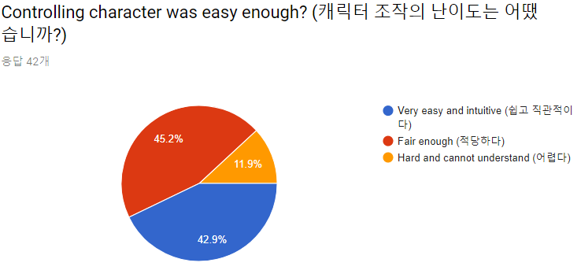In APEX open play test, we focused on getting as many feedbacks as we can. First, audiences responded about our character control. Mostly it was good enough, but 11.9% of users responded that it was hard to recognize.

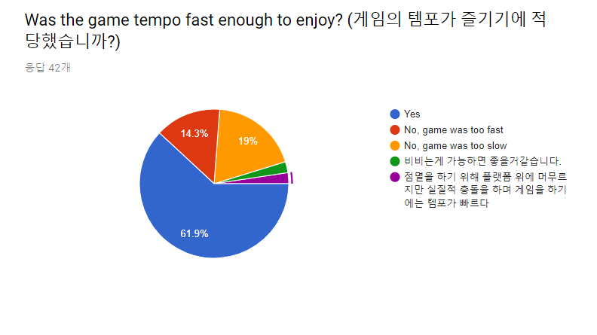In APEX it is important to maintain the game tempo appropriately. So in survey, users gave some feedbacks about game tempo. Users have had answered “Yes” mostly and two specific feedbacks. First, one of the users said that, how about let the players hold domination when both players on the dominating platform together. The other answer was that fighting while dominating makes game too much faster. Both of these responses were helpful.

In short-answer question, few players gave very helpful feedbacks. For example, one of the players said that he could not figure out how the attack function works and he did not know it was domination round. In this case, it is possible to add intuitive user interface to settle this problem.

**Work Items**

* + add tutorial: There were no tutorials in playtest. Many players were confused about APEX and required some details to play. It seems APEX needs to be more kind. For players, adding tutorial level seems good enough to let them understand and play better of our game. In tutorial, the contents will be how to control the character, what does specific items do, and how to win the level. Wonju cho will add tutorial.
  + balance between platform attacker/defender: In game, it was obvious to know who can win if one player dominates first. The reason why is that dominating platform was in high place and the balance between knock back cool down was not appropriate so the characters could not go up easily. To solve this problem, adding some items that can break the advantage and making the dominating platform bigger will help. Junseok Yang will add these functions.
  + show respawn time / trap cooldown: In open play test, players thought the game was ended when their characters have fallen outside the map. In this case, we will add some interface that let users indicate when their character revive. Also, players keep pressing trap button to use it, but there were cool downs so players did not know why it was not working. Like, revive cool down, it looks good to add interface for in traps also. Jookyung Lee will add these functions.
  + distinguish the team when same character selected: When players select same characters, it was hard to distinguish between 1p and 2p. There will be an addition of graphics such as, accessories when players choose same character. Haewon Shon will add these functions.