# **PLAN**

**TEAM** PINATA

**Game Name** lonely mercenary

**GAM200F19KR**

**<TEAM MEMBER>**

**MINHO CHAE** PRODUCER

**JUNSEOK YANG** GRAPHICS

**WONYONG LEE** ARCHITECTURE

**INYEONG HAN** DESIGNER

**PROJECT STATUS**

Currently, our games have most of the functions necessary for basic game play, game making (e.g., creating art, animation, font generation, object movement, sound). Our game engine is an object-type engine that creates an object in sprites, and uses the INIT function of sprites to create the main character and the enemy. Each level is managed by the stage manager. We recorded plans to further develop the game in "SCOPE REPORT." Our members have successfully performed their respective roles.

**TEAM ROLE STRUCTURE**

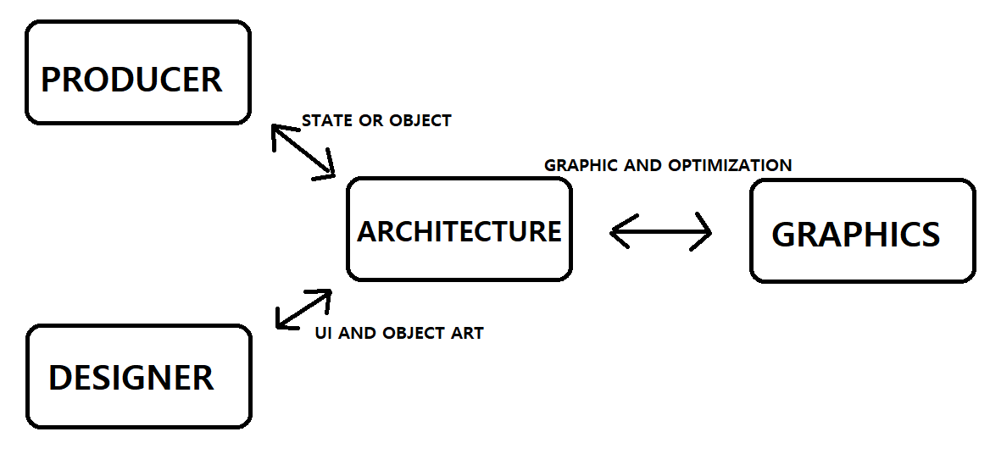

|  |  | **Minho Chae(BSGD)**  **PRODUCER** | **Wonyong Lee(RTIS)**  **ARCHITECTURE** |
| --- | --- | --- | --- |
| **December** | **After Final** | **Modifying animation method**  **change animation method to cut sprite**  **sheet not only the x-axis but also to the y-axis.** | **Redeem main algorithms.**  From now on, the main algorithms  isn't so good (optimized) |
| **January** | **Week 1** | **Modifying Data-driven method**  change Data-driven to read and write any type of information. | **Optimizing initialize steps** when step levels to level, the main algorithms  should be similar like **'Object pool'** |
| **Week 2** | **Designing playable character**  Making character which has unique design. | **Segmentation of game character**  (player, enemy) classes, **envision**  **the village and shops** algorithms. |
| **Week 3** | **Making special skill of designed**  **character**  Making unique skill which goes well with  the designed character. | Start working on **implement village and**  **shops** (also money), **re-make health**  **bar UI and selected cards** (over player head) |
| **Week 4** | **Realizing character as code**  Create algorithms needed to implement  designed character | **Trim & optimizing algorithms**, envision  new enemies, players and achivements that stands for unlock new characters. |
| **February** | **Week 1** | **Making Items**  Making various items which can effect the  game play. | **Working on implementing new stages and**  **characters,** it is must important & hard works  during the vacations. |
| **Week 2** | **Realizing items as code**  Create algorithms needed to implement items | **Still adding new stages and new characters**, it does not accomplished in one week. Also, **applying game items into the game**. |
| **Week 3** | **Designing bosses**  Making bosses which has unique design and skill. | **Still adding new stages and new characters, help teammates** to implement bosses, **optimizing previous works** for bug-free. |
| **Week 4** | **Realizing bosses as code**  Create algorithms needed to implement designed bosses | **Trim the animations**, it parts of the **pollishing,** adding more attack, defence and special effects  it makes game more pollished. |

|  |  | **Inyeong Han(RTIS)**  **TEST MANAGER** | **Junseok Yang(RTIS)**  **GRAPHICS** |
| --- | --- | --- | --- |
| **December** | **After Final** | **Play test in real world**  not in computer, find what we need more **Adjust battle difficulty** players felt that it is not need to use defense than attack | **To tidy up Graphics engine.**  **Graphics part function simplify.** |
| **January** | **Week 1** | **Discuss about what we make playable characters, enemies, and bosses.**  **determine special skill**  **Drawing new characters** | **Adding Font**  **study the sprite base font**  **set up advanced new GL base engine** |
| **Week 2** | **Designing playable character**  Making character which has unique  design. | **Adding Font**  **Texture coordinate size of the upper and lower case letters.**  **set up advanced new GL base engine** |
| **Week 3** | **Making special skill of designed**  **character**  Making unique skill which goes well with the designed character. | **Adding Font**  **using korean support.**  **set up advanced new GL base engine** |
| **Week 4** | **Realizing character as code**  Create algorithms needed to implement designed character  **Drawing chracter's acteffect** | **Adding Font**  **using any text support.**  **set up advanced new GL base engine** |
| **February** | **Week 1** | **Making Weapons**  Making various weapons which can effect the game play.  **Drawing items** | **Adding sprite particle**  **study the sprite base particle.**  **set up advanced new GL base engine** |
| **Week 2** | **Realizing weapons as code**  Create algorithms needed to implement weapons  **Drawing weapons** | **Adding sprite particle**  **make the basic game prticle.**  **set up advanced new GL base engine** |
| **Week 3** | **Designing bosses**  Making bosses which has unique design and skill.  **Drawing bosses.** | **Adding sprite particle**  **make the spawn function.**  **set up advanced new GL base engine** |
| **Week 4** | **Realizing bosses as code**  Create algorithms needed to implement designed bosses  **Drawing boss's act effect.** | **Adding sprite particle**  **Apply to the particle speed.**  **set up advanced new GL base engine** |

**We will meet once in the last week of February, evaluate each other for what we did during the vacation, and plan what we will do during the spring semester.**

| **RISK & MITIGATION** | | | | | |
| --- | --- | --- | --- | --- | --- |
| **RISK** | **Vacation**  **Team**  **Meeting** | Time and place of our team members do not match during the winter vacation. | | | |
|
| **MITIGATION** | **1** | During the winter vacation, time finds the right time for the team members and makes and makes a team plan in advance. | | | |
|
| **2** | During the winter vacation, we meet on a discord or online because, there is a long distance between the team members. | | | |
|