**Beta Milestone Report**

**Looter**

**by**

**Team Neoul**



**GAM250**

**6.13.2021**

**Spring**

**Team Member**

Producer & Engine Programmer & Graphic Programmer : Sehyun Kim

Physics Programmer : Seungguk Jang

UI Designer & Programmer : Junseok Yang

Lead Designer & Test Manager & Programmer : Hyeonmin Kim SoundManager & Programmer : Haneul Lee

**Playtest Survey**

Round2(<https://docs.google.com/forms/d/1bm3uMlyP0xoFFAgABlszbc7quyEB03EBmTK4nykSLhs/edit?usp=sharing>)

1. **What is your name?**

It is a general question to identify who is the player. In week 15, we have to report a final milestone with names of our play testers.

1. **How much time do you play the game per week?**

It is a general question whether he or she is familiar with the game or not. Some experienced players may know how to control the WASD movement, but others may not. We can categorize what type of players.

As we calculate average game play time, it is about 9.5 hours per week. So we know that our play testers for the second week of the beta test are averagely good at playing games.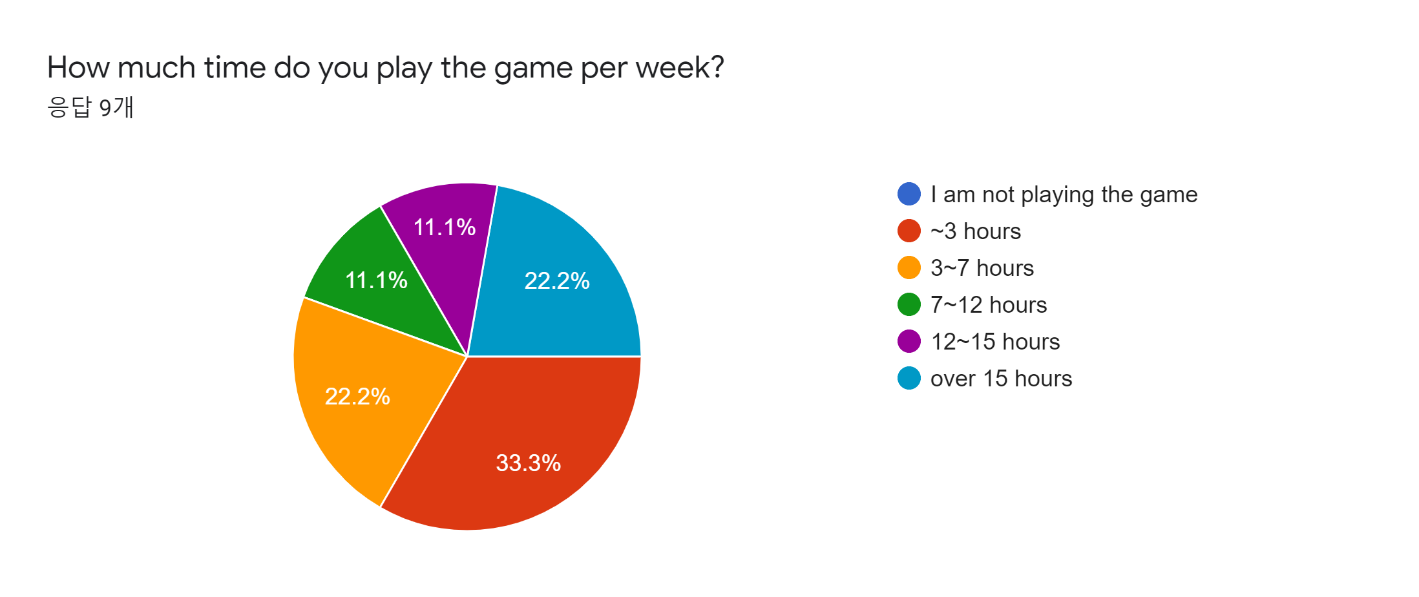

1. **Is the volume of sound enough?**

It is a general question in order to balance the volume of sound in the game.

This is the survey result we got in the second week of the Beta test. Number 1 in a row means “Too small” and Number 5 means “Too big”. We know that our sound effects and background music are a bit loud to hear. So we are trying to slow down after we get this feedback.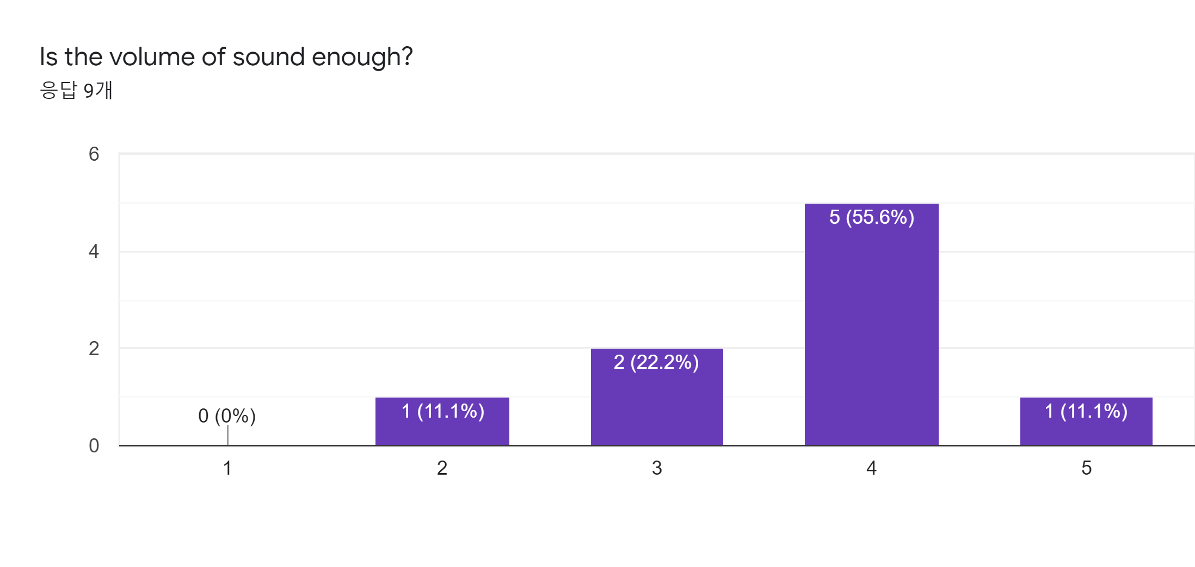

1. **How fast does our game feel to find a way out? (Level 1 to Level 3)**

It is a good question to figure out how the player feels pace in our game because we cannot know his or her feelings. We thought it was not good to just simply ask “Our game is fun?”. If he or she feels bored in the game, his or her answer would be “slow”. However, “fast” answer is a different kind of situation, we should slow down our game. The player’s movement in the game is really fast or enemies are so fast to the player.

This is the survey result we got in the second week of the Beta test. Number 1 in a row means “Too Slow” and Number 5 means “Too Fast”. So on average we can know that each level is difficult.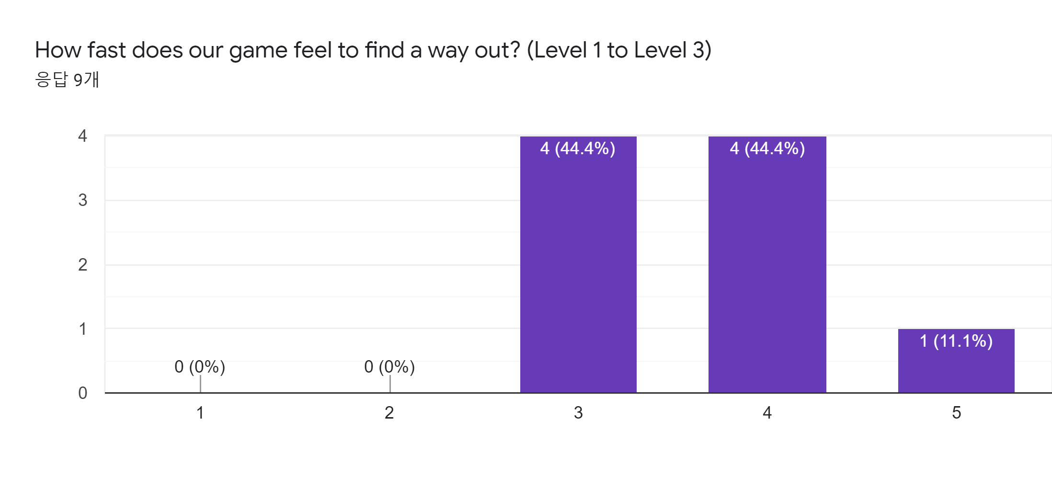

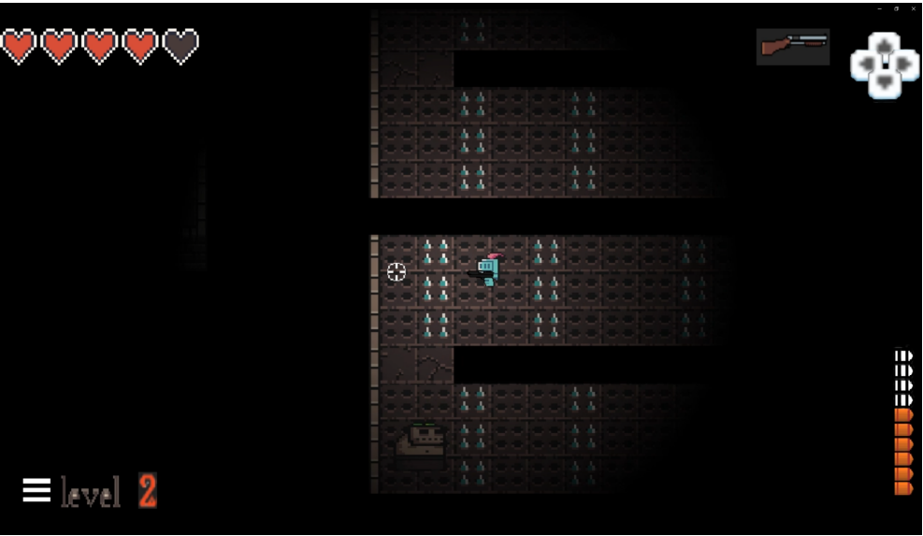

After watching the video sent by the play tester and analyzing it, you can see that level 2 trap rooms are still taking much more time than you think. So we will try to update this room more easily.

1. **Are you clear about what a boarded red box does?**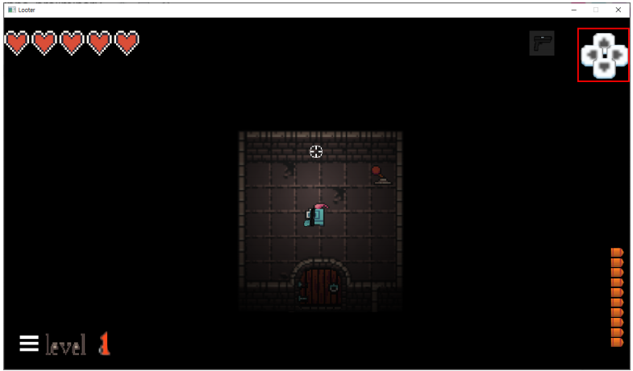

This ui is a keyboard description. We updated this a few weeks ago from the Beta test so we need some feedback about how playtesters feel about this. But on the surface, I asked because I thought it might be difficult for users to understand.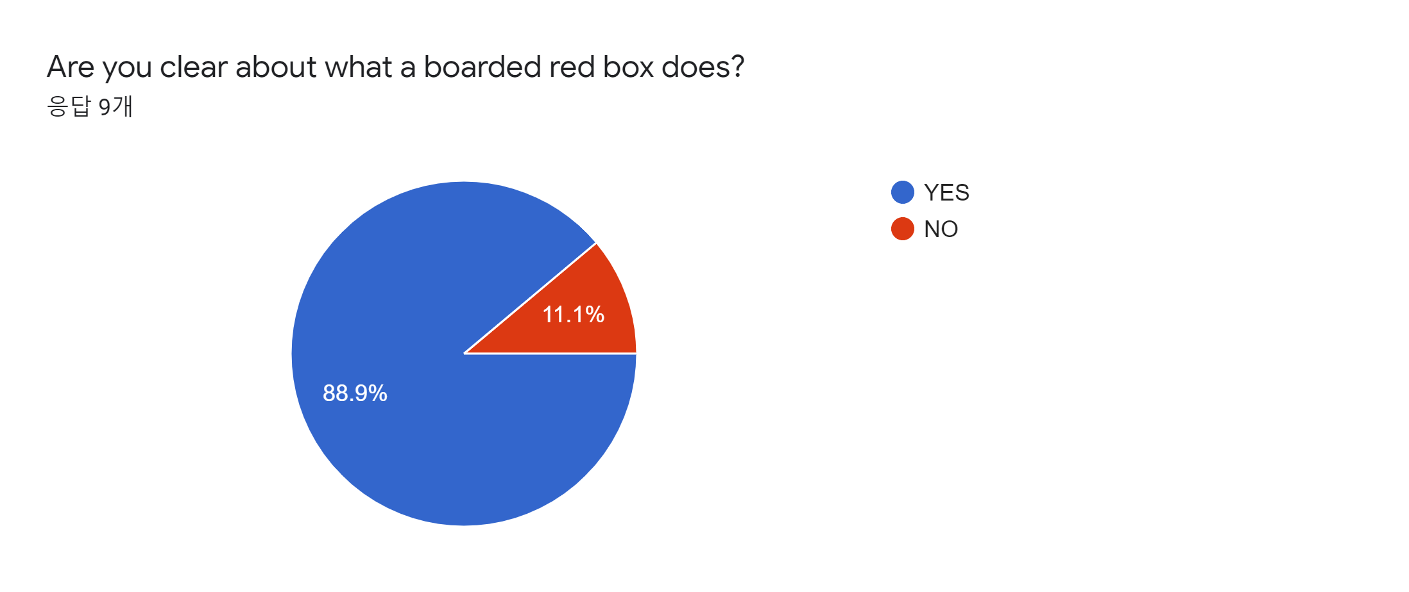

According to the results of the vote, there are eight(8) people who know for sure what the redboard is, and one(1) person who doesn't know. Most of them know what the role of the new UI means. But we need to care about 1 person who doesn't know and the solution we thought will be shown in Question 7’s analysis.

1. **Did you notice the role of the trigger is opening the door when using the trigger in level2?**

It is a good question. We cannot figure out this question from only a stats log and playback videos. If many players do not notice what is happening, we will make better feedback about it.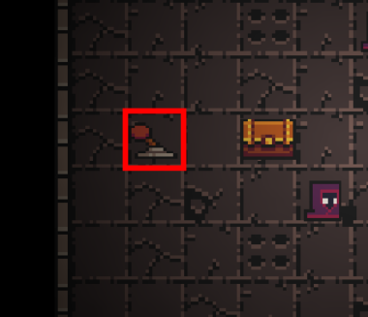

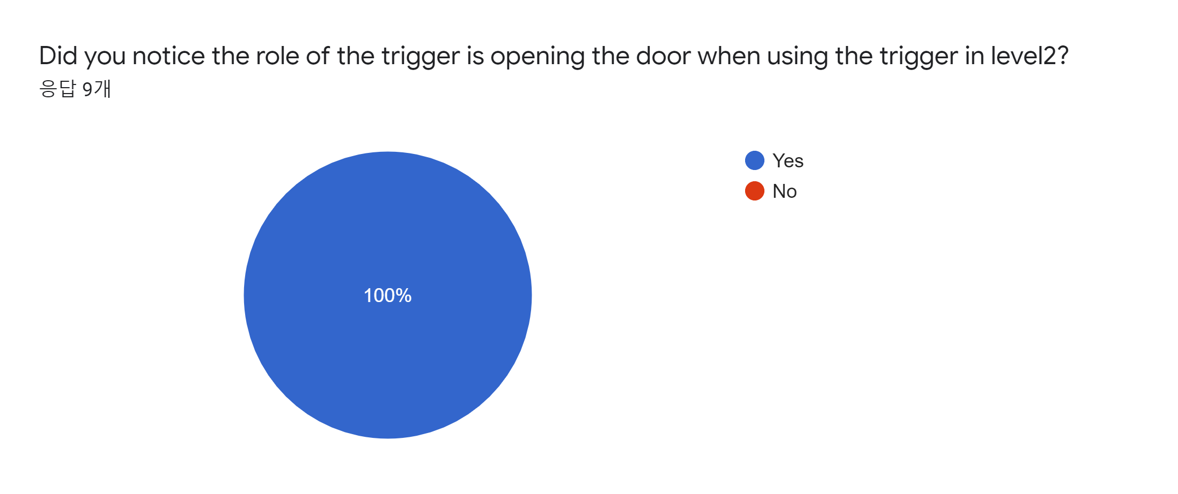

Everyone(All) has confirmed that level 2 triggers are responsible for opening doors. We thought that the distance between the trigger and the door was far. So we want to care about this one.

1. **Did you easily distinguish between using skills and not using skills?**

**(1 (easy to distinguish)~5 (hard to distinguish))**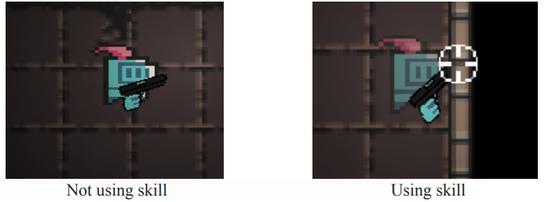

It is a good question. Because we think that just a little degree of transparency cannot inform the player’s state of using skill or not. We can modify the degree of transparency through this question when the player uses skill.

We have a special skill and shift key in our game, and according to the vote, there were three(3) people who knew it and six(6) people who didn't. So with Question 4, we thought that it is better to make some tutorial level or keyboard key binding to show instructions about control.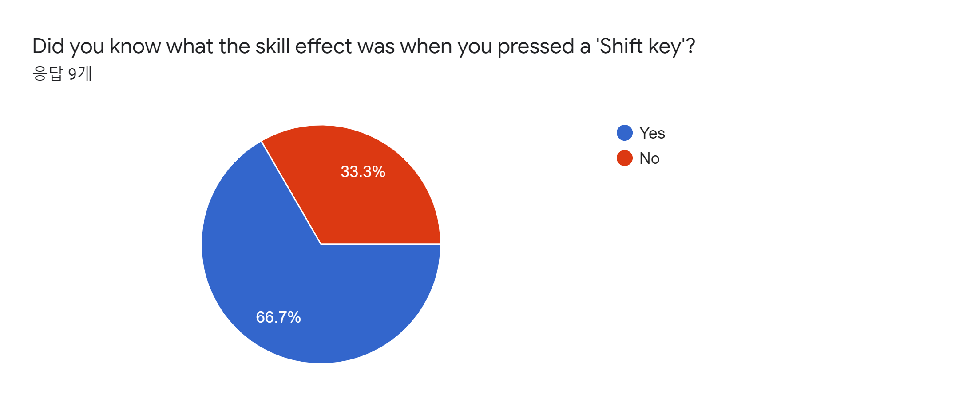

1. **Do you have any additional suggestions or comments about our game?**

It is a general question. Most surveys are finalized with this question. Because it is a good opportunity for some players to leave their opinion for our game freely.

**Opinions or Feedback(* means got same opinion)**

1. Problems that keep getting stuck in the wall or between tiles.***

2. The shotgun is too strong.

3. The laser gun is hard to predict the reflected trajectory, so it would be good to show the trajectory once reflected.

Sometimes the launch doesn't work.

4. Mini map function.

5. I wish I had skills like rolling and dashing.

6. Monsters don't follow me sometimes, I think it would be good to boost the monster's stamina.

7. I hope the duration of the skill is indicated.

**Solution**

1. Some improvements have been made, but I know that there are bugs that get caught in the effects. We will improve it by the next test.
2. I'll adjust the shotgun damage when I adjust the balance.
3. The trajectory of the laser gun is still hard to show. If we have time later, we plan to build a gun that shows a trajectory. Sometimes we don't know what's going on, so we'll look at it again.
4. thought the map was difficult, so I fed back the mini map. However, our goal is to be a difficult map and with a mini map, it becomes too easy to play.
5. Instead of rolling and dash skills, what we thought of is the invincible skill shift. I'm also planning to add a fast run later.
6. I think it's because of the simple ai that monsters don't follow, but we don't need ai in our game, but it's worth improving and we'll see. The monster's physical strength looks good, but I thought ordinary monsters, not the boss, didn't need it.
7. Our plan is not to show skill time.

**Play test Game Data**

Statistics Table

Round2(<https://docs.google.com/spreadsheets/d/1Ad8jgchZvhBTYbYdAodjroBDD94vlRJDgM9qGvwO3JA/edit?usp=sharing>)

**Playtest Survey**

Round3(<https://docs.google.com/forms/d/1zDoEW_2hkh-nSDHPrtq0dQjeBsD63G2aDMSe4b7BeAw/edit#responses>)

1. **Is the gun reloading speed appropriate?**

This is a questionnaire to balance the prime minister reloading speed of our game. If they feel the speed of reloading is fast, they will give a high score.

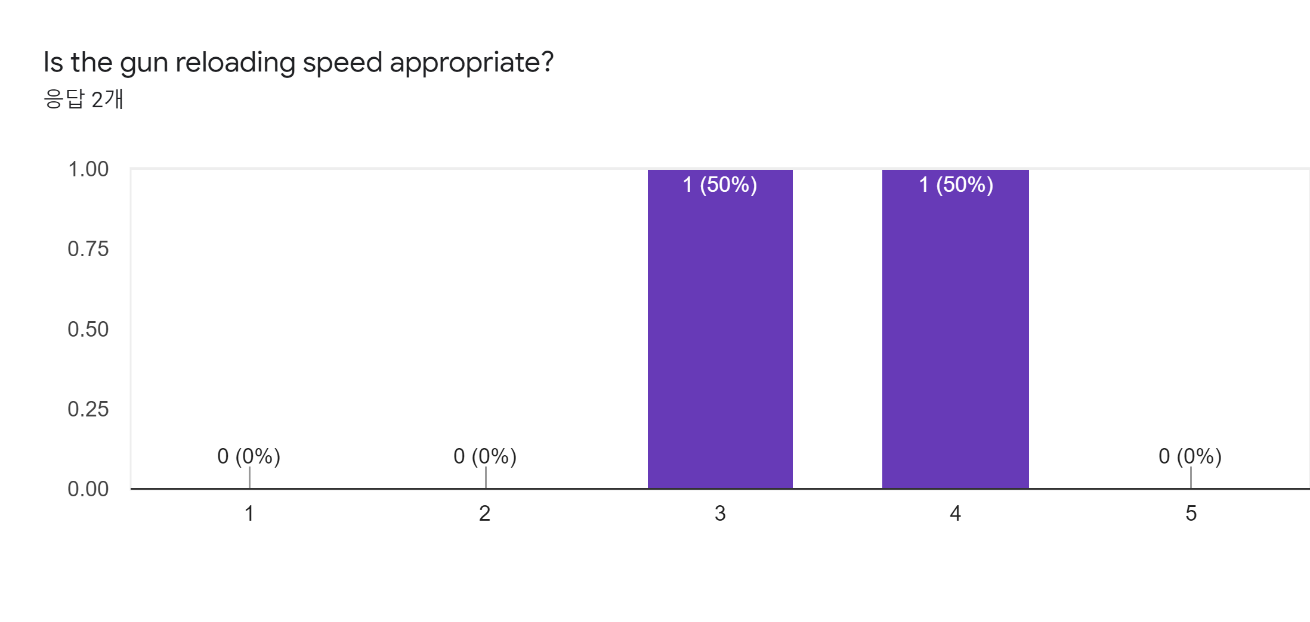

This is the survey result we got in the third week of Beta test. Number 1 in a row means “Too Slow” and Number 5 means “Too Fast”. In the last survey, two people responded, and the average loading speed was 3.5 and it was appropriate.

1. **Is it hard to move your player to avoid something?**

(ex: enemies, traps and walls)

This question is about map design, how many things like monsters, traps, and walls that are hard to avoid.

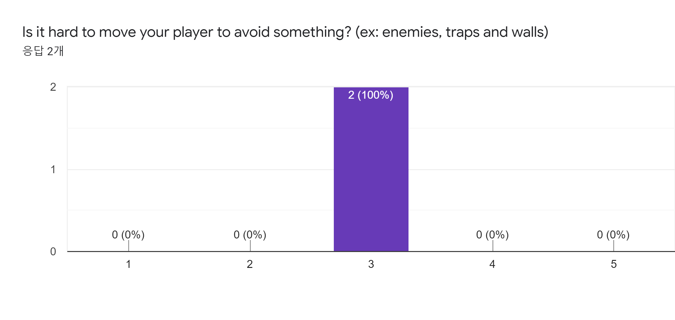

This is the survey result we got in the third week of the Beta test. Number 1 in a row means “No” and Number 5 means “Yes”. So on average we can know that each level is difficult. In the last survey, two people responded, and the average loading speed was 3 and it was appropriate.

1. **Do you have any additional suggestions or comments about our game?**

Ask questions to ask what is missing further.

**Opinions or Feedback**

1. It will better indicate the remaining time of Invincibility skill on the game screen.
2. Shotguns are too overpowered, and in contrast others are too useless. And avoiding spike traps is too hard. I think it's better to enhance friction.

**Solution**

1. The remaining time of skill is appropriate not to show in the concept of our game.
2. The balance of shotguns is still under way. The spike trap part is being adjusted more easily and slowly.

**Play test Game Data**

Statistics Table

Round3(<https://docs.google.com/spreadsheets/d/1Ad8jgchZvhBTYbYdAodjroBDD94vlRJDgM9qGvwO3JA/edit#gid=2108891953>)

**Game Stats Log**

Our game gathers stats information that saves a log file(a json file) for each scene in the document\Looter directory. An example of the file are as follows:

{

"numDiedPlayer": 0,

"numDamagedTotal": 0,

"numDamagedByEnemies": 0,

"numDamagedByTrap": 0,

"numKilledTotalEnemies": 0,

"numKiledBossEnemies": 0,

"numUnlockDoors": 0,

"numUnlockChestBoxes": 0,

"numUsedTriggers": 0,

"numUsedTeleporters": 0,

"numUsedStairs": 0,

"numUsedPotion": 0,

"numSwitchLevels": 0,

"numSwitchBlinds": 0,

"numGeneratedBullets": 0,

"numGeneratedBulletsLaser": 0,

"timeUsedShotgun": 0.0,

"timePlayed": 0.0,

"timeCollideTraps": 0.0,

"timeCollideEnemies": 0.0,

"timeCollideWalls": 0.0,

"isClearLevel": false

}

All variables are based on the player in the game.

● **numDiedPlayer**

: How many times has the player died, this indicator is useful to decide if this scene is hard or easy.

**● numDamagedTotal**

: It is the count of total damages that is given by the player. This indicator is useful to decide if this scene is hard or easy, that is we can modify enemies position or velocity or number using other indicators.

**● numDamagedByEnemies**

: The count of damages of the player by enemies. We can use this data for knowing if an enemy's AI is difficult to clear the level(though it is simple, but we should need to update some value like timer or delay variables)

**● numDamagedByTrap**

: The count of damages of the player by traps. If this number is too high, then it means that traps are also too much for playing games and clear each level.

**● numKilledTotalEnemies**

: The count of how many times Player killed enemies. Players can just pass the enemies(not eliminate them). So if there are few enemies that are not eliminated by Player, then we need to fix their position or AI.

**● numKilledBossEnemies**

: The count of how many times a Player killed Bosses. If it is too high, we modify the boss's hp or velocity, vice versa.

**● numUnlockDoors**

: The count of how many times Player unlocks the doors. This indicator and numUsedTriggers should be the same.

**● numUnlockChestBoxes**

: The count of how many times Player needs Healing. This is useful to decide if this scene is hard or easy. If high, we make the scene easier and vice versa.

**● numUsedTriggers**

: The count of how many times Player. This indicator and numUnlockDoors should be the same. If not, we know there will be some problems.

**● numUsedTeleporters**

: The count how many times Players go to the next level. This indicator should be the same as the number of levels. If not, we know there will be some problems.

**● numUsedStairs**

: The count of how many times the Player uses stairs(locating player to other spots). If this number is too high we modify the stair’s size to be smaller or locate other positions.

**● numUsedPotion**

: The count of how many time Player uses a health potion. If this number is too high, we modify the scene to be easy.

**● numSwitchLevels**

: The count of how many times Player changes scenes. This indicator should be the same as the number of levels or numUsedTeleporters. If not, we know there will be some problems.

**● numSwitchBlinds**

: Number of rooms the player has been to. How many rooms the player has been while the player clears the level. So, If it is smaller than the number of rooms in the scene, we allocate more chestboxes to rooms that the player does not want to go to.

**● numGeneratedBullets**

: Number of bullets the player has shot. If it is too high, we can know if the player is hard to clear the scene or fun to shoot using other indicators(numDamagedTotal, numDamagedByEnemies and so on…)

**● numGeneratedBulletsLaser**

: Number of Laserbullets the player has shot. We can know the player

**● timeUsedShotgun**

: The time the player is holding the shotgun. We can see how useful or enjoyable a player is to use a laser gun.

**● timePlayed**

: The time the player plays our game. If this time is too high, we can know the player enjoys our game or it is hard to clear the scene using other indicators.

**● timeCollideTraps**

: The total amount of time the player is stepping on the traps. If it is too high, we modify the number of traps or traps' positions to make the game easier.

**● timeCollideEnemies**

: The total amount of time the player collides with the enemy. If it is too high, we modify the number of the enemies or size vice versa.

**● timeCollideWalls**

: The total time the player hits walls. If it is too low, we can know the player is inconvenient to collide with walls.

**● isClearLevel**

: The count of how many times Player clears levels. This indicator should be same with numUsedTeleporter and number of game’s levels.

We will use this data as the average value of all play testers. We received surveys and log data and accepted most of the feedback.So we could make a positive modification to the project using log data.

**Play Testers**

Thank you for play testing,

1. **Byungchan Park(Pre-Freshman)**

* **round1**

1. **Daehyeon Kim(Freshman)**

* **round 1**

1. **Hyunjin Kim(Freshman)**

* **round 1**

1. **Jaeyeong An(Pre-Freshman)**

* **round 1, 2, 3**

1. **Jemin Shin(Pre-Freshman)**

* **round 1, 3**

1. **Jonghyeon Lee(Pre-Freshman)**

* **round 1, 2, 3**

1. **Junsu Jang(Freshman)**

* **round 1**

1. **Junhyeong Kim(Pre-Freshman)**

* **round 2, 3**

1. **Chaerin Park(Pre-Freshman)**

* **round 3**