Internet of Things Technology (Summer 2022)

Report on LAB 2

* Student: JUNYAN, YANG（杨钧彦）
* Student Number: 212320028
* Date: 20/07/2022

1. Task Statement
2. Draw a room providing the space for customers and the kitchen.  
   2. Place guests tables. At least, 4.  
   3. Arrange guests' service area. At least 16 seats and the waiting area outdoors.  
   4. Arrange input customers flows by groups of 2,3 or 4 persons.  
   5. Create a robotic waiters. At least 2.   
   6. Simulate 2 delays of customers: reading the menu and then eating. This is a patch. Later, you will model the cooking process.  
   7. Arrange the activation of waiters after the customer have made the choice.  
   8. Arrange the transport of orders from the customer's table to the kitchen.  
   9. Run the model to be convinced the costomers' flow simulates correctly.  
   10. Write the report describing your project.  
   11. Send me only .PDF not .ZIP not .DOC not .ALP files.
3. Environment：

Win10, AnyLogic

1. Screenshot for lab1：

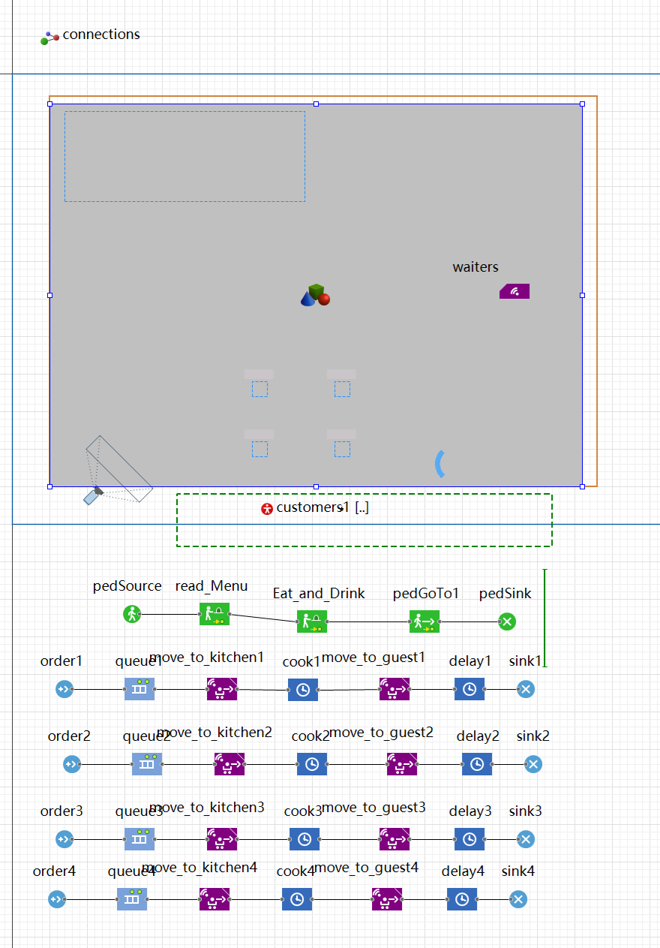

1. Screenshot for lab2：

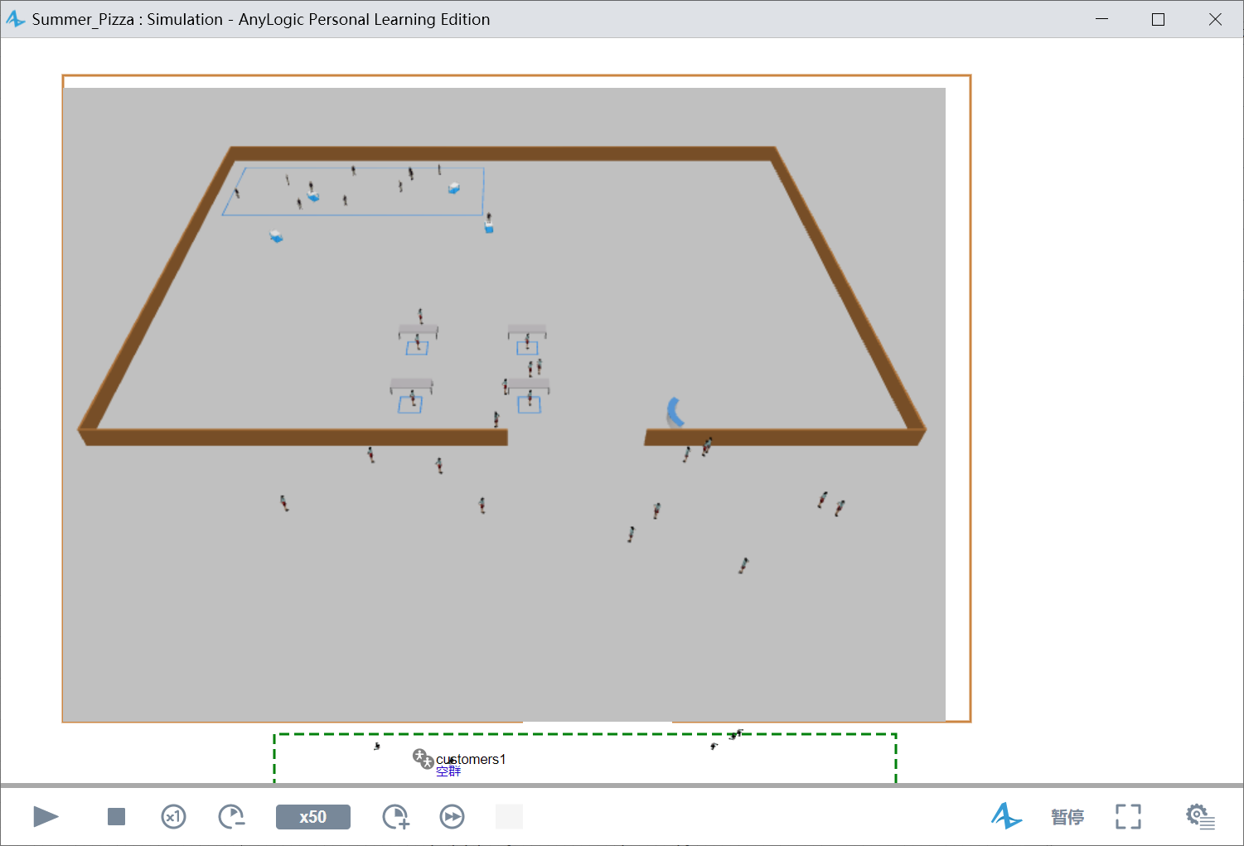

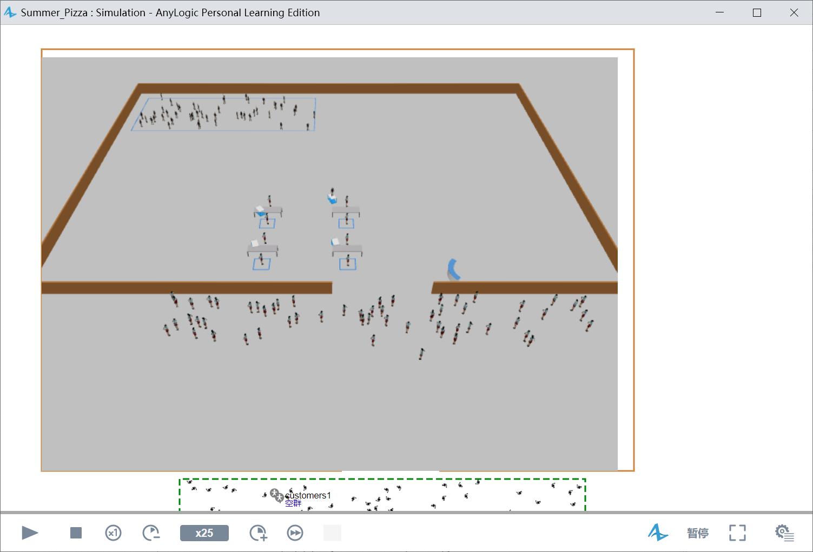

1. Detail of Configures：

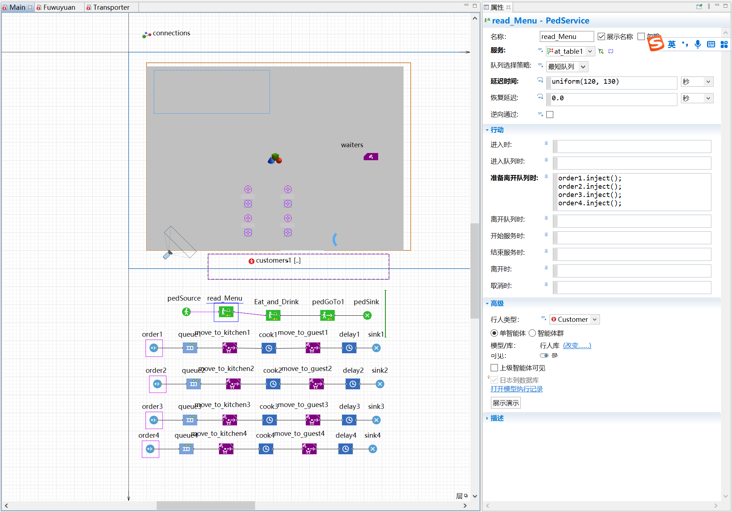

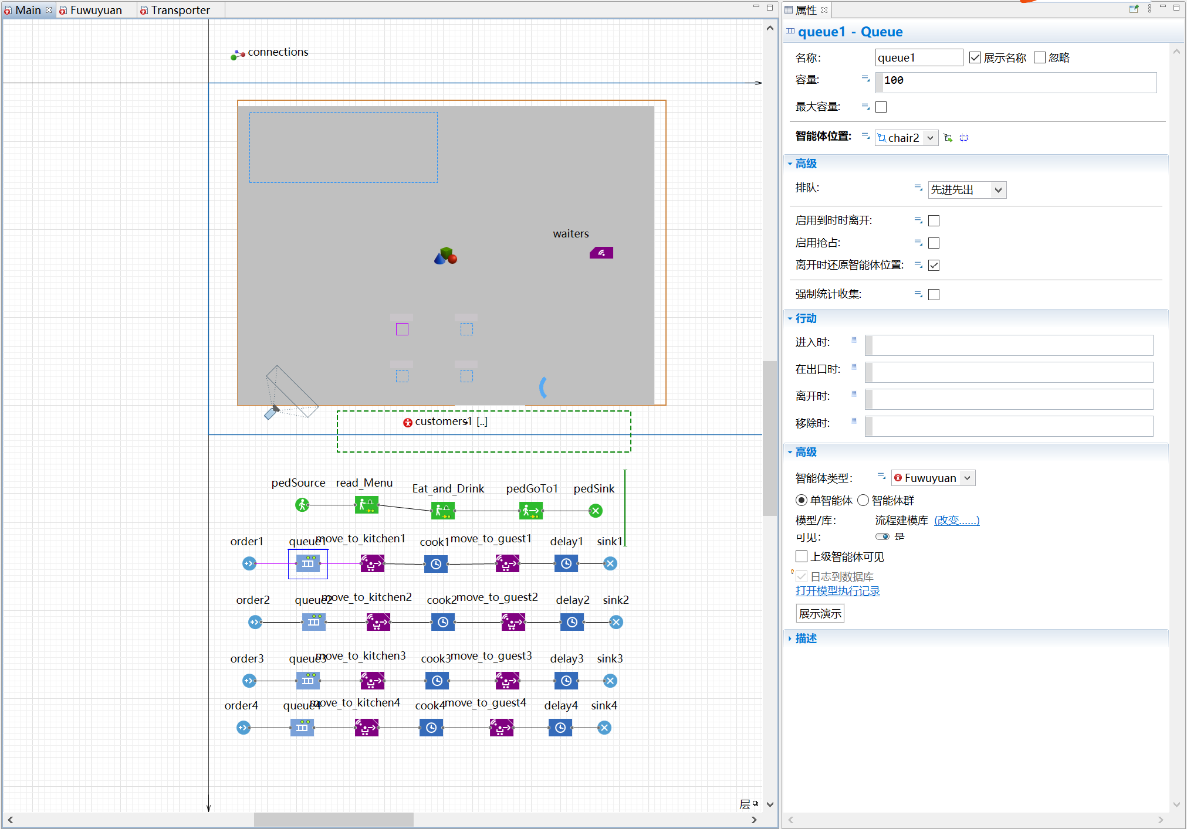

1. Summary

I arranged 4 tables for customers and for each table I arrange an array of robotic waiters, and initially the difficulty which confused me was how to arrange the activation of waiters after the customer have made the choice. Then I used “order.inject()” to solve it. Also I used two “Ped Service” to simulate 2 delays of customers: reading the menu and the eating.

**The most important of All !!!** This LAB reminds me that AnyLogic can be used to simulate the process of covid-19 infection and analyze the transmission speed and its possible impact. This modeling software is very practical in solving some problems in life.