Internet of Things Technology (Summer 2022)

Report on LAB 3

* Student: JUNYAN, YANG（杨钧彦）
* Student Number: 212320028
* Date: 22/07/2022

1. Task Statement

Using the already built restaurant environment:  
1. Equip the kitchen at least by two robootic cooks. If it is a pizza house one cook prepares the base and toppings an the other one loads and unloads pizzas to and from the oven.  
2. Robots cooks can be modeles as Transporters. Or, you can arrange a conveyor where the waiters put the orders onto the begin and then cooks are the stations at the conveyor.  
3. Oven is to be modelled as a Storage.   
4. The robotic waiter wakes up when a dish is ready and carries it onto the guest's table.

1. Environment：

Win10, AnyLogic

1. Screenshot for lab3：

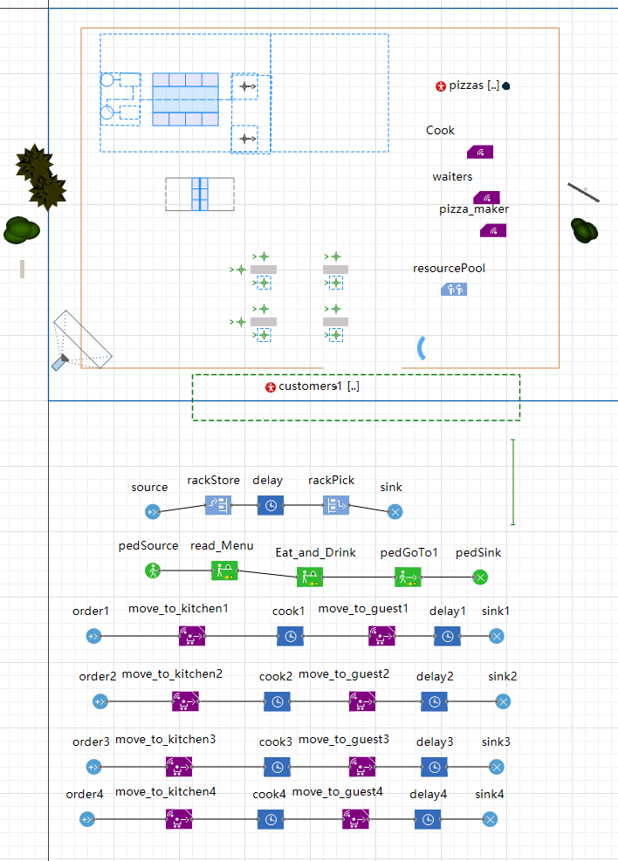

1. Screenshot for lab3：

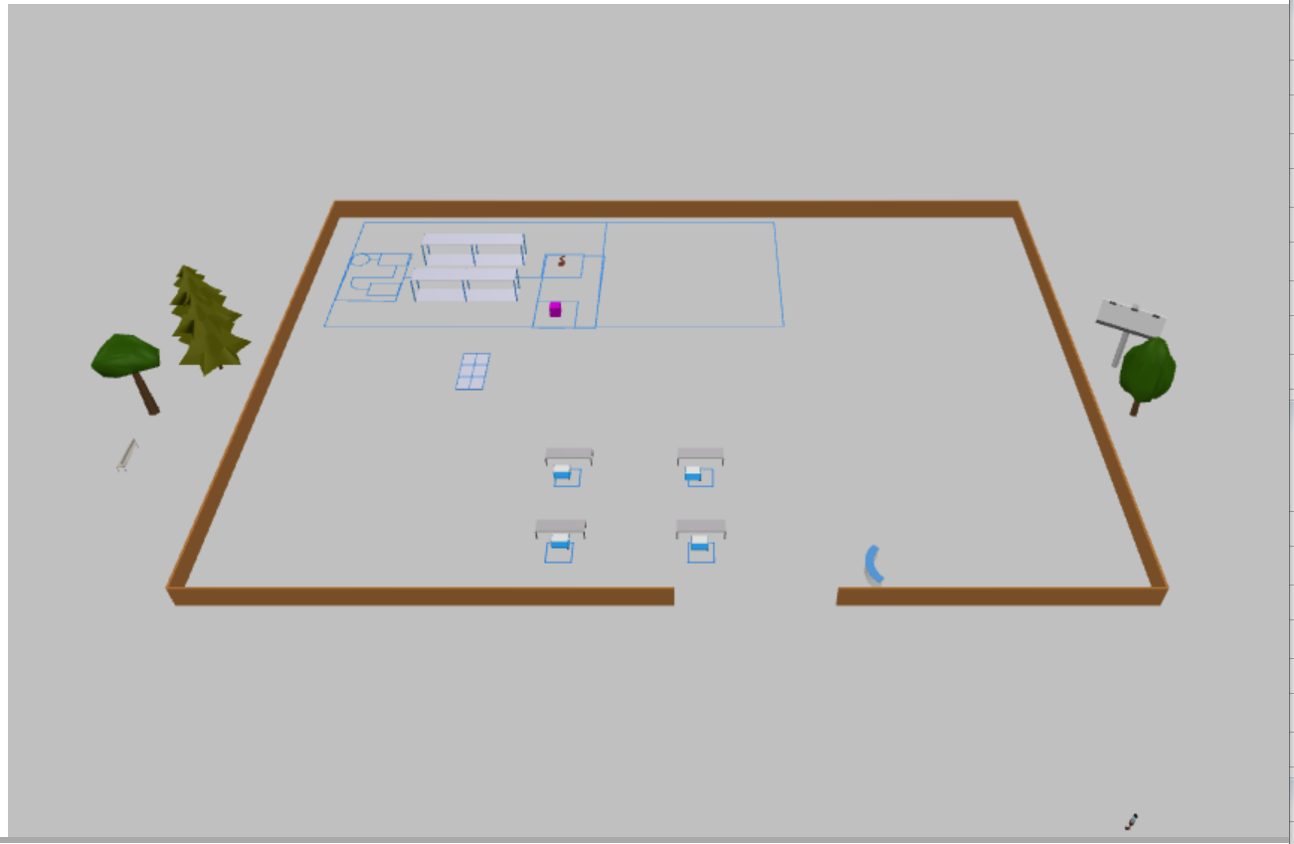

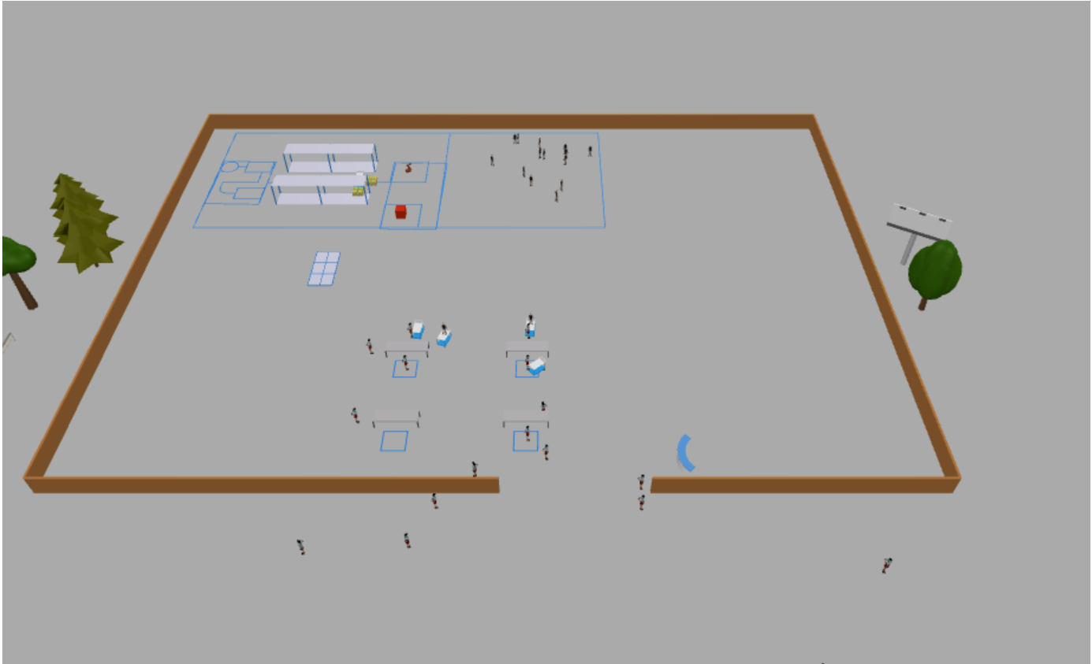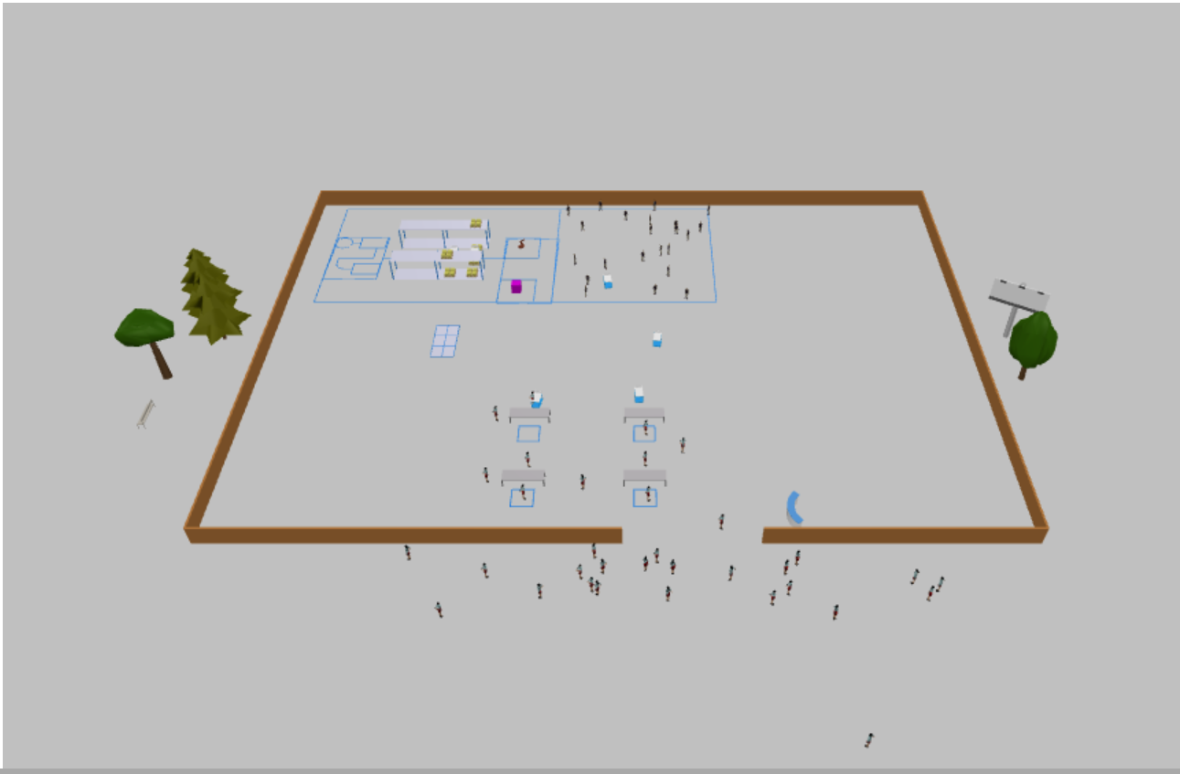

1. Detail of Configures：

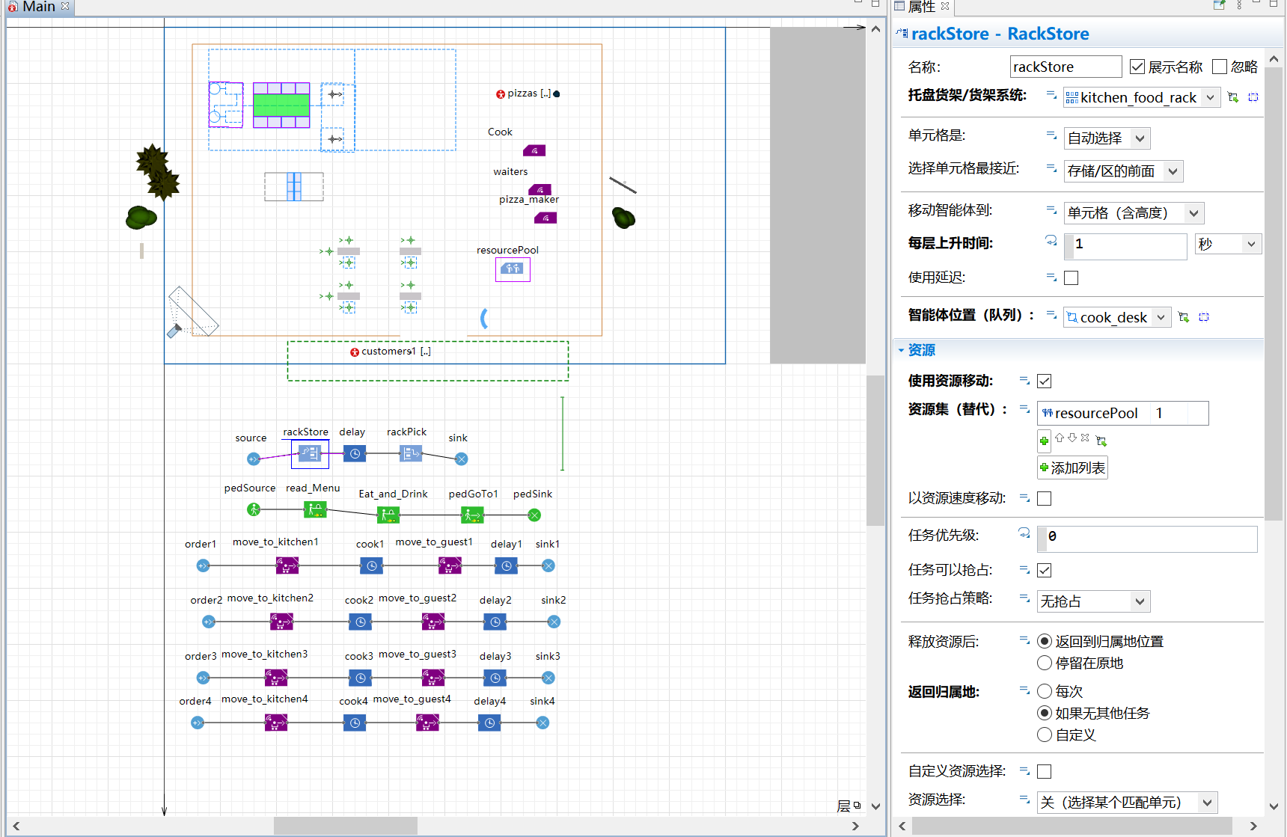

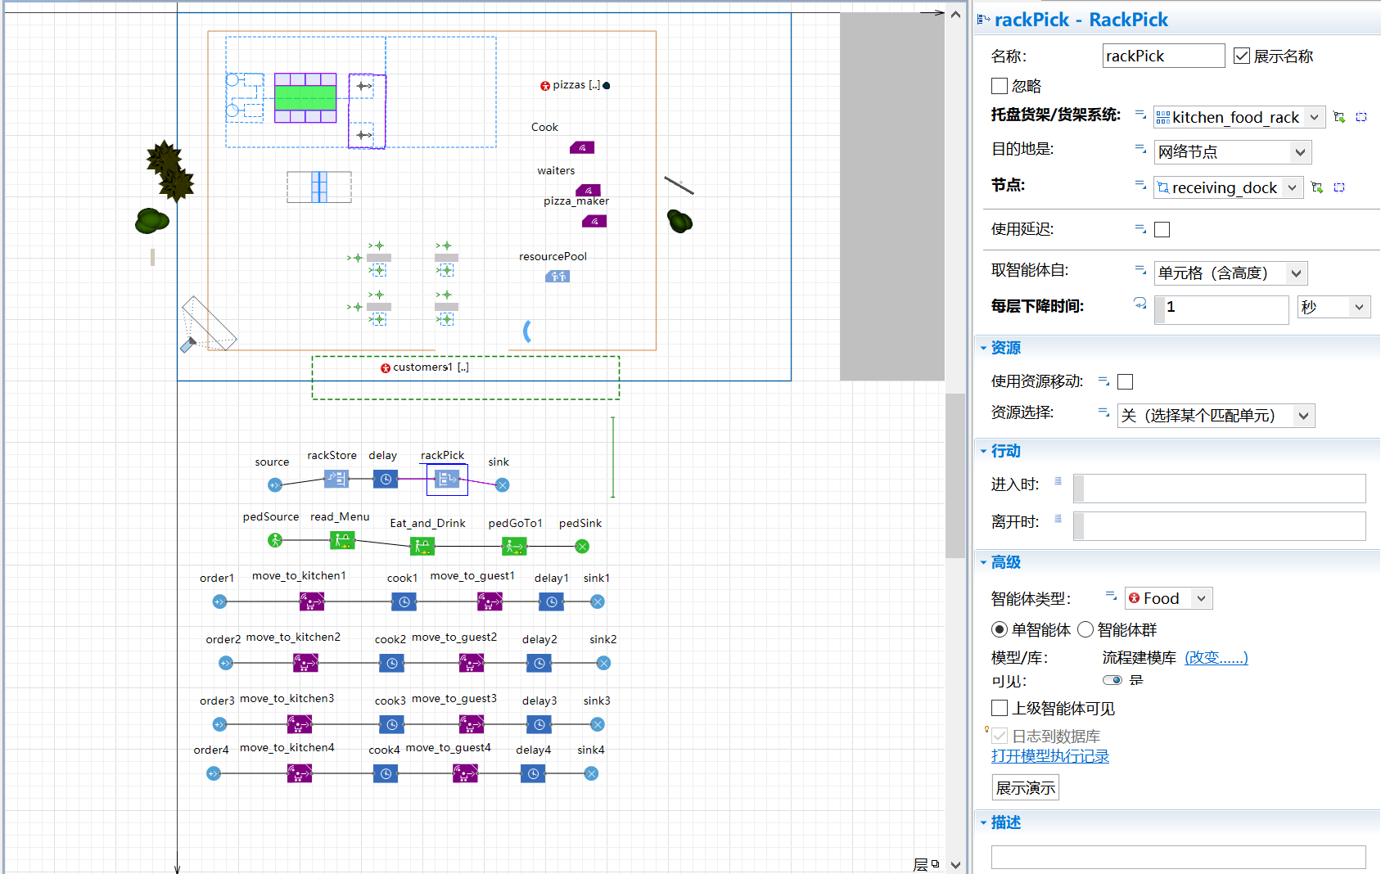

1. Description

As the picture given, in the top left area, which is called “Back kitchen”, I arrange two robotic cooks, one prepares the base and toppings, and another loads and uploads pizzas from the oven.

Then robotic machines will put pizzas on the transporters, which will be taken by robotic waiters soon, robotic waiters then will take those foods to customers when dish is ready.

And instead of using “Transporter Fleet” module, I have used “Store” module to build model to imitate the making of pizza.

Finally I add some decorations to this model.

1. Summary

Through this lab, I am able to realize a model by AnyLogic, which greatly trains my logic thinking ability.