Internet of Things Technology (Summer 2022)

Report on LAB 4

* Student: JUNYAN, YANG（杨钧彦）
* Student Number: 212320028
* Date: 27/07/2022

1. Task Statement

Using the already built restaurant environment:

Create the kitchen with at least two cooks.

Model the restaurant and find the maximum productivity and customers delight.

1. Environment：

Win10, AnyLogic(Personal Learning Edition)

1. 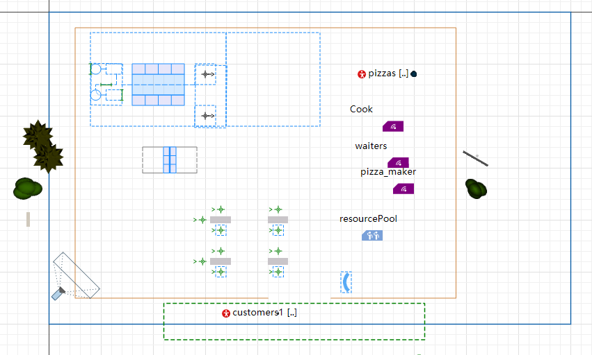Screenshot for lab4：

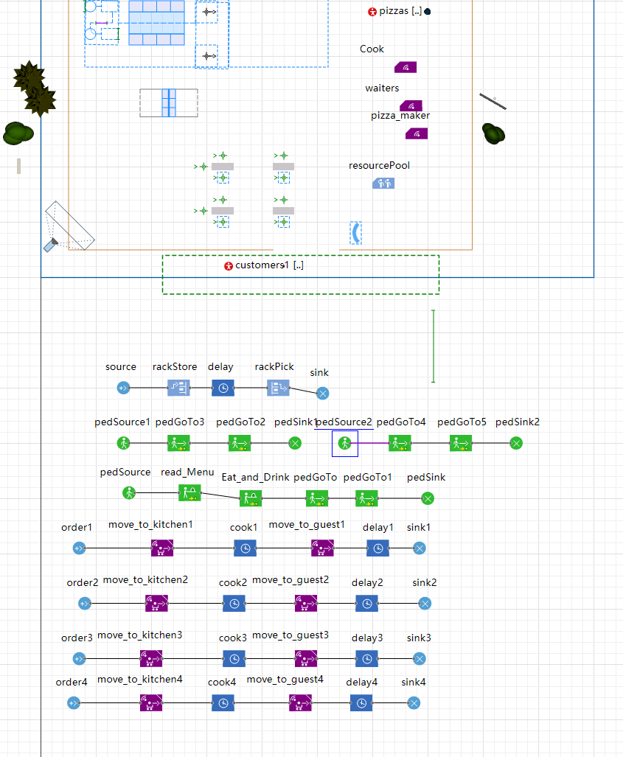

1. Screenshot for lab4：

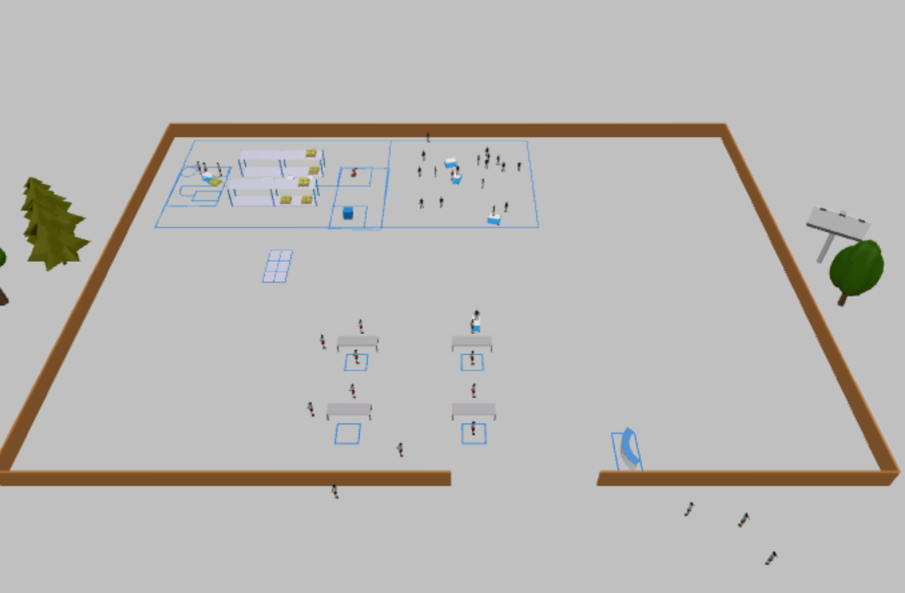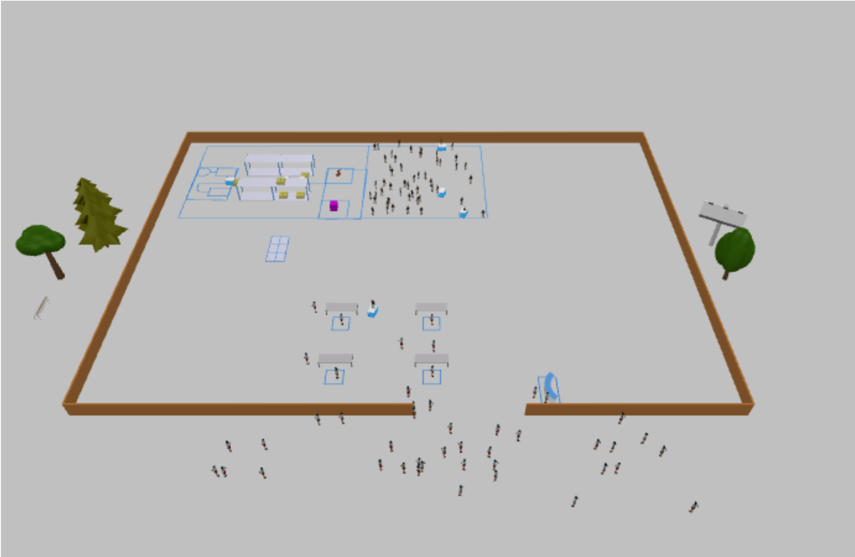

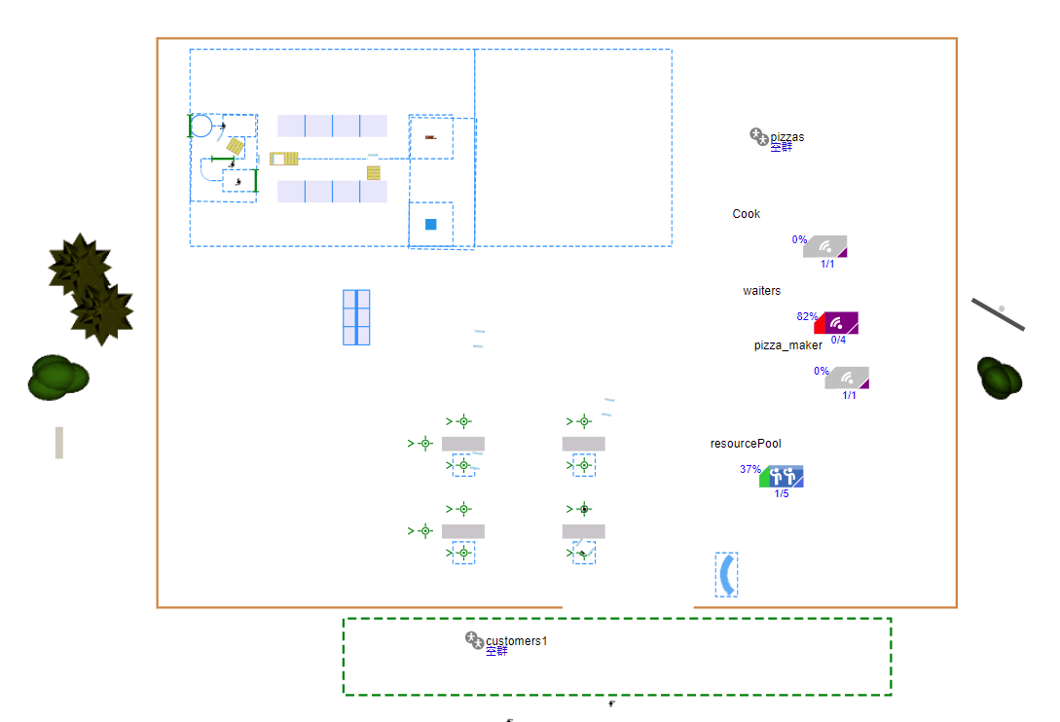

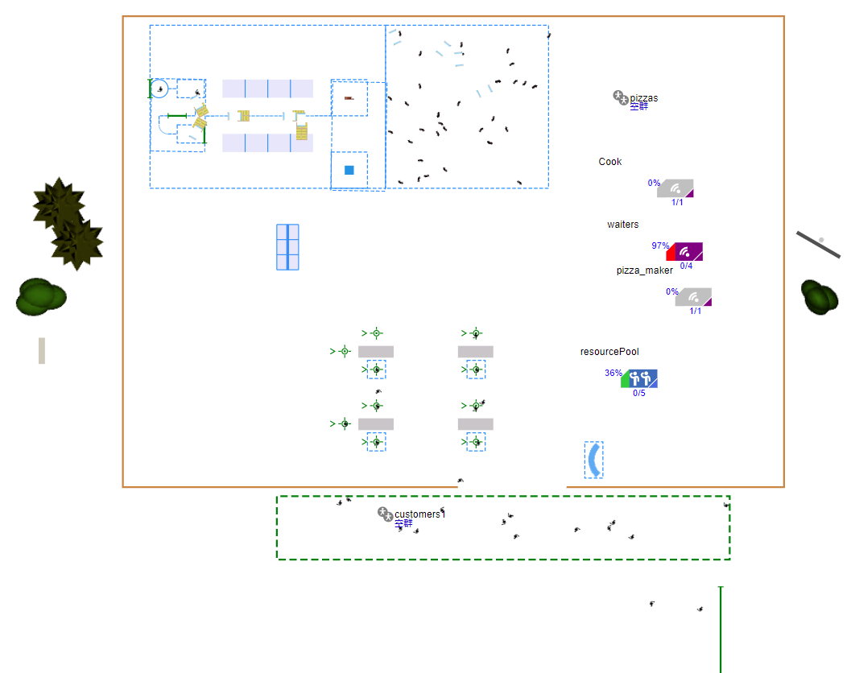

1. Detail of Configures：

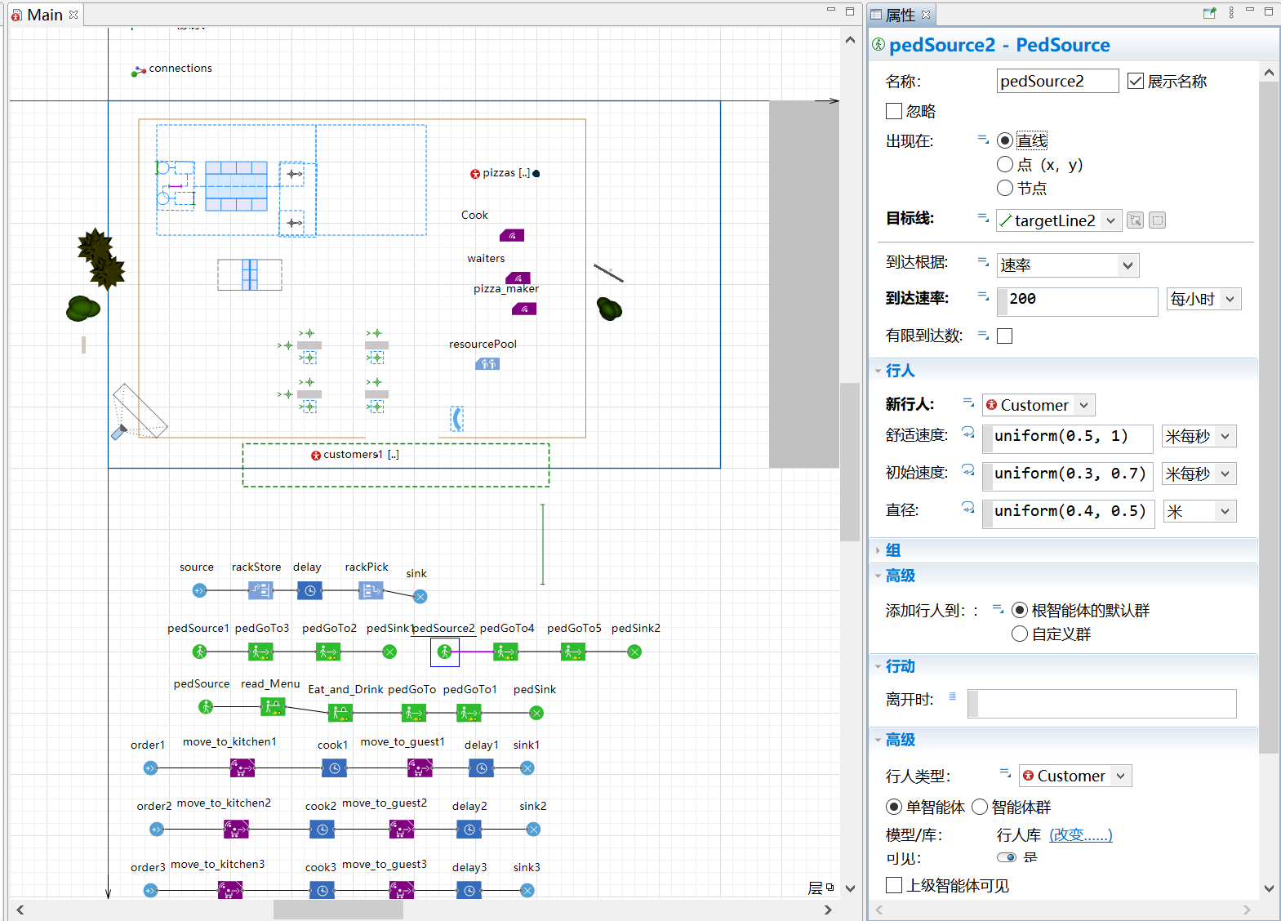

1. Description and Conclusion

As the picture given, in the top left area, which is called “Back kitchen”, I arrange two robotic cooks, one prepares the base and toppings, and another loads and uploads pizzas from the oven.

Moreover, at the position near the door, I arrange a “Reception Desk” where customers will pay their cash before go out.

About maximum productivity and customers delight, through experiments, 60-70 people/hour maybe the maximum productivity. If the restaurant covers an area of 100m2, maybe about 15 tables with about 20 “fuwuyuan”(servers) will be a good number for the customer delight.

1. Summary

Through this lab, I know how to build a model using AnyLogic and have a consciousness of how restaurant works and how to manage a restaurant better using internet of thins technology.

After that, I will use this software to simulate covid-19 infection model, which may help me understand how why covid-19 spreads so fast and how to do epidemic prevention.