
Wee Kim Wee School of Communication and Information

Group Project Report

New Energy Vehicle Storyboard

IN6221 Information Visualization
Course instructor: Kien Weng, Luke Tan

Summitted By Group 6
Zhou Nan (G2304128K)
Yang Keyan (G2304496H)
Fang Zhuohao (G2304641D)
Zhang Miao (G2304514K)

Date: November 12, 2023

Content
1. Introduction 3
1.1. Background 3
1.2. Problem Statement 3
2. Data Collection 4
3. Application of Visual Design Elements and Theories 6
3.1. Elements of Design 6
3.1.1. Dashboard 1: 6
3.1.2. Dashboard 2: 7
3.1.3. Dashboard 3: 8
3.1.4. Dashboard 4: 9
3.1.5. Dashboard 5: 10
3.1.6. Dashboard 6: 11
3.1.7. Dashboard 7 : 12
3.1.8. Dashboard 8: 13
3.2. Principles of Visual Design 14
3.2.1. Proximity (Gestalts Theory of Visual Perception) 14
3.2.2. Similarity (Gestalts Theory of Visual Perception) 15
3.2.3. Closure (Gestalts Theory of Visual Perception) 16
3.2.4. Figure/Ground (Gestalts Theory of Visual Perception) 16
3.2.5. Unity 17
3.2.6. Balance 18
4. Evaluation of Storyboard 18
5. Conclusion 19
Reference 20

Introduction

Background
The problem of climate change and global warming has reached a tipping point, demanding urgent action. To protect our planet, we must actively pursue more sustainable solutions to meet our current requirements. One such solution is the adoption of New Energy Vehicles (NEVs), which are automobiles that rely primarily on electricity instead of traditional fuels. These electric vehicles offer a significantly cleaner and more environmentally friendly option as they generate no direct emissions.
The NEV industry stands at the forefront of transformative advancements in the automotive sector, embodying a paradigm shift towards sustainable and environmentally conscious transportation solutions. In this storyboard, we delve into the multifaceted landscape of NEVs, exploring their pivotal role in shaping the future of mobility. As we navigate through this presentation, our overarching objective is to advocate for the widespread adoption of NEVs, surpassing the limitations of traditional combustion engine vehicles. By shedding light on the significance, benefits, and technological strides within the NEV sector, we aim to instill a collective understanding of the imperative need to transition towards cleaner, more sustainable modes of transportation. Through this comprehensive exploration, we endeavor to cultivate a nuanced appreciation for the positive impact that embracing New Energy Vehicles can have on our environment, economies, and the overall well-being of our communities.

Problem Statement
Within the burgeoning landscape of NEVs, a series of challenges and issues emerge. Despite the evident strides in technological innovation, there exists a nuanced set of obstacles that impede the seamless integration of NEVs into mainstream transportation systems. Key challenges include concerns about limited charging infrastructure, range anxiety, and the comparatively higher initial costs associated with these vehicles. Moreover, the lack of comprehensive policy frameworks and incentives acts as a bottleneck, hindering the transition from conventional vehicles to NEVs. The dearth of awareness among consumers and stakeholders further exacerbates these challenges, perpetuating a status quo that favors traditional combustion engine vehicles. It is against this backdrop of challenges that we underscore the critical need for heightened awareness and robust policy support for New Energy Vehicles.
By addressing these challenges head-on and advocating for strategic measures, we endeavor to lay the groundwork for a more conducive environment that fosters the widespread acceptance and integration of NEVs into our daily transportation fabric.
Therefore, we will accomplish the following through our storyboarding:
- Introduce the concept of NEVs and their environmental benefits
- Provide an overview of the NEVs technology to promote eco-friendliness
- Highlight the significant growth and market potential of NEVs

Data Collection
The foundation of our exploration into the New Energy Vehicle (NEV) landscape rests upon a rigorous and comprehensive data collection process. Our approach involves tapping into diverse sources to acquire accurate, reliable, and up-to-date information. The primary sources encompass industry reports, academic publications, and peer-reviewed journals that provide insights into the latest technological advancements, market trends, and the overall trajectory of the NEV sector.
- A comprehensive and synthetic dataset for global, regional and national greenhouse gas emissions by sector 1970-2018 with an extension to 2019
A dataset on anthropogenic GHG emissions 1970-2019 with a broad country and sector coverage was provided. The dataset was built from recent releases from the “Emissions Database for Global Atmospheric Research” (EDGAR) for CO2 emissions from fossil fuel combustion and industry (FFI), CH4 emissions, N2O emissions, and fluorinated gases and use a well-established fast-track method to extend this dataset from 2018 to 2019.
- Global EV Outlook 2023
The Global EV Outlook is an annual publication that identifies and discusses recent developments in electric mobility across the globe. It is developed with the support of the members of the Electric Vehicles Initiative (EVI). Combining historical analysis with projections to 2030, the report examines key areas of interest such as electric vehicle and charging infrastructure deployment, energy use, CO2 emissions, battery demand and related policy developments.
- Personal Vehicles Evaluated against Climate Change Mitigation Targets
Greenhouse gas emissions account for the entire lifecycle, including vehicle production and battery production, supply chains raw materials. The dataset includes details on the calculation of costs, greenhouse gas emissions, and emission targets.
- xEV Share tracker by country
Monthly Shares of BEV, PHEV, HEV, MHEV & FCEV vehicles country by country. Derived from total vehicle markets and xEV shares (Excel)
- Electricity prices, March 2023
The chart shows the price of electricity for households and businesses in over 100 countries. The prices are per kWh and include all items in the electricity bill such as the distribution and energy cost, various environmental and fuel cost charges and taxes.
- Cost (S$) For Cars Registered in Sep 2023
The datasetprovides comprehensive information on the financial expenditures associated with cars registered in Singapore in September 2023, offering insights into the diverse costs incurred by vehicle owners during the registration period.

Application of Visual Design Elements and Theories

Elements of Design
In this section we will present Elements of Design in dashboard order. It is worth mentioning that we have used the richest possible form of diagrams and added a lot of interactions.

Dashboard 1:
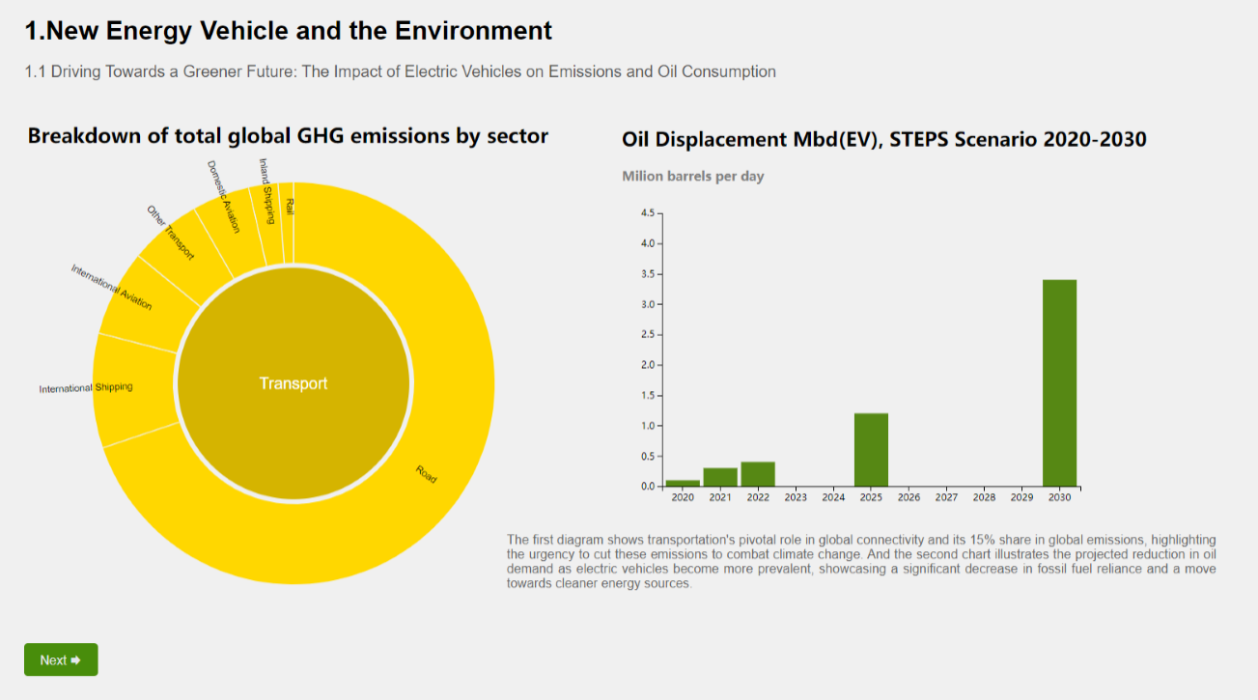
Data Hierarchy: Utilizes a donut chart, bringing the Transport sector's emission impact to the fore—a key narrative focus.
Color Emphasis: Shifts to a dichromatic scheme, highlighting Transport with yellow, denoting urgency and commanding viewer attention.
Interactive Engagement: Offers an interactive color transition, fostering an enriched understanding through viewer participation.
Temporal Analysis: The bar chart provides a temporal view of Oil Displacement, inviting viewers to assess future environmental shifts.
Typography & Structured Layout: Employs a sans-serif font for clarity, with a layout that guides the viewer through the data narrative seamlessly.
Narrative Integration: The text below the charts succinctly ties the data to the environmental impact of vehicle choices, emphasizing the trend towards sustainable energy.

Dashboard 2:
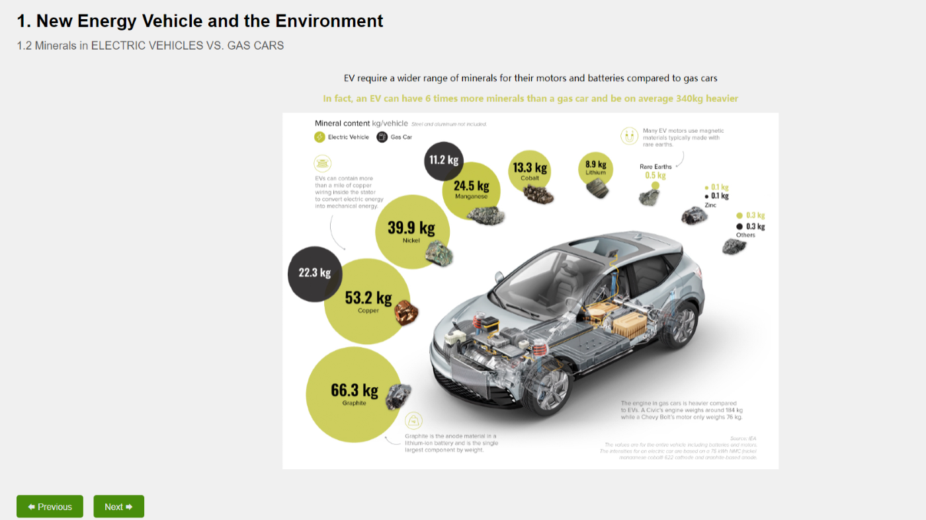
Visual Clarity and Information Layering: The graphic utilizes a cutaway illustration of a vehicle, layered with quantitative data on mineral usage. This method highlights the comparison between electric and gasoline vehicles in a direct, visually engaging manner.
Color Usage and Differentiation: Color coding distinguishes between the mineral types used in electric vehicles (EVs) versus gas cars, facilitating immediate visual differentiation and comprehension.
Layout and Information Flow: The layout strategically guides the viewer through the information, from the general to the specific, using the vehicle illustration as an anchoring focal point.
Typography and Data Presentation: The use of legible typography and the placement of data points around the vehicle balance aesthetic appeal with informational value, ensuring that the viewer is neither overwhelmed nor under informed.
Rationale Behind Visual Choices: The visual elements are chosen to reflect the complex nature of the data, simplifying the comparison of mineral weights in a manner that is accessible to a broad audience, including those not specialized in automotive or environmental science.
Contextualization of Data: The graphic's design, with the vehicle at the center surrounded by specific mineral data, contextualizes the information within the real-world application, making the abstract data tangible and relatable.

Dashboard 3:
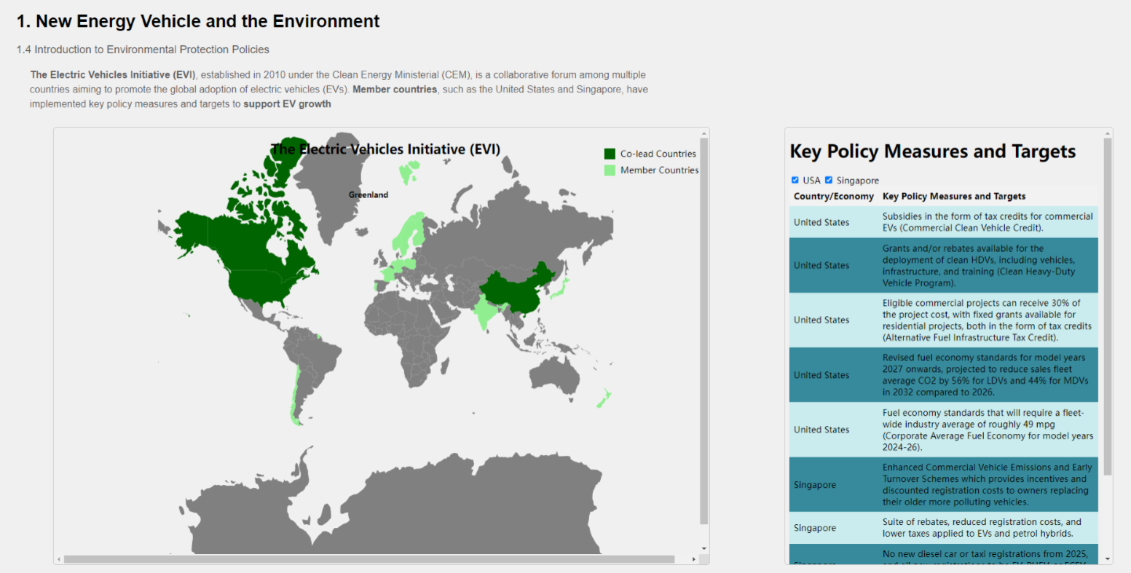
Geographic Data Representation: The map employs a dual-color coding system to distinguish between co-lead countries and member countries in the Electric Vehicles Initiative (EVI), facilitating immediate geographical comprehension of global EV policy engagement.
Policy Information Integration: The side panel listing key policy measures and targets provides a direct, accessible summary of incentives and regulations, juxtaposing the geographic distribution with specific policy details.
Visual Balance and Hierarchy: The map and side panel are balanced in a way that neither overshadows the other, allowing for an integrated reading of spatial and textual information, highlighting the international approach to EV promotion.
Legibility and Accessibility: The map's simplistic color scheme and the side panel's clean typography ensure that the information is easily digestible to a wide audience, including policymakers, industry stakeholders, and the general public.
Design Rationale: The visualization's design choices cater to the data complexity and the diverse global audience, presenting a clear picture of the international policy landscape shaping the future of EVs.
Contextual and Comparative Analysis: This design allows for a comparative analysis of different countries' commitments to EVs, reflecting the global nature of environmental policy and its implications for energy and automotive sectors.

Dashboard 4:
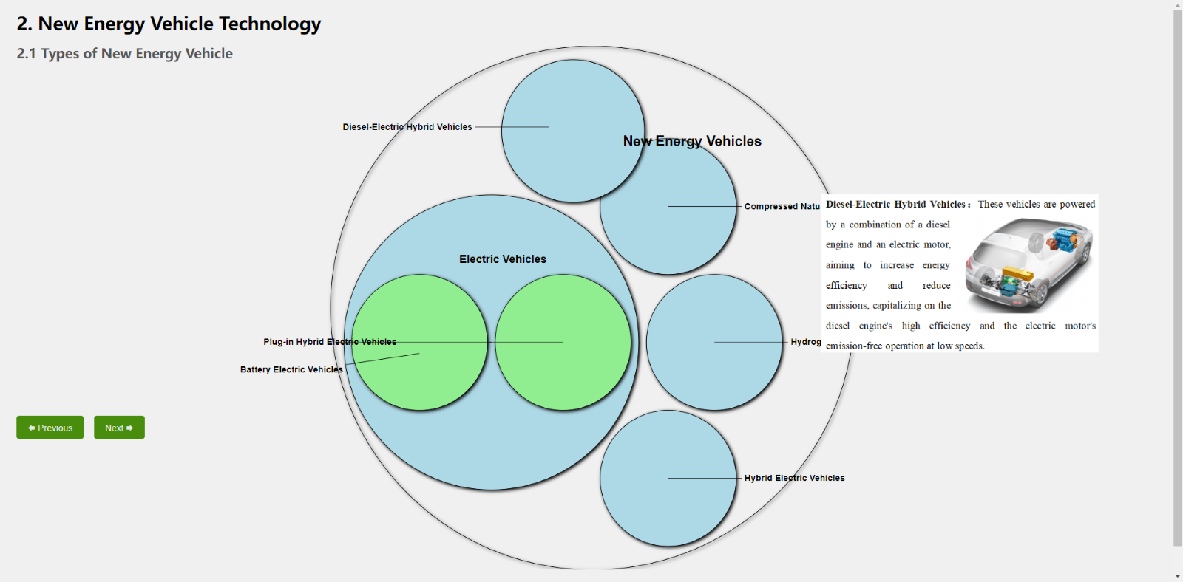
Interactive Data Exploration: The visualization employs interactive bubbles to represent different types of new energy vehicles, fostering an exploratory learning experience as viewers engage with each category.
Information Hierarchy: The largest circle represents the broader category of new energy vehicles, with subcategories differentiated by size and proximity, indicating the relationship between different vehicle types.
Visual Cues and User Guidance: Mouse over interaction reveals detailed descriptions of each vehicle type, which is an intuitive way to present complex information without cluttering the visual space.
Aesthetic Consistency and Focus: The consistent use of blue tones maintains visual harmony, while the green highlights draw attention to electric vehicles, subtly emphasizing their environmental friendliness.
Design Logic: This approach is designed with the viewer's cognitive load in mind, presenting a high-level overview while allowing for deeper dives into specific information on demand.
Content Integration: Textual explanations accompanying the interactive elements provide context and detailed insights, bridging the gap between high-level categorization and in-depth understanding of each vehicle type.

Dashboard 5:
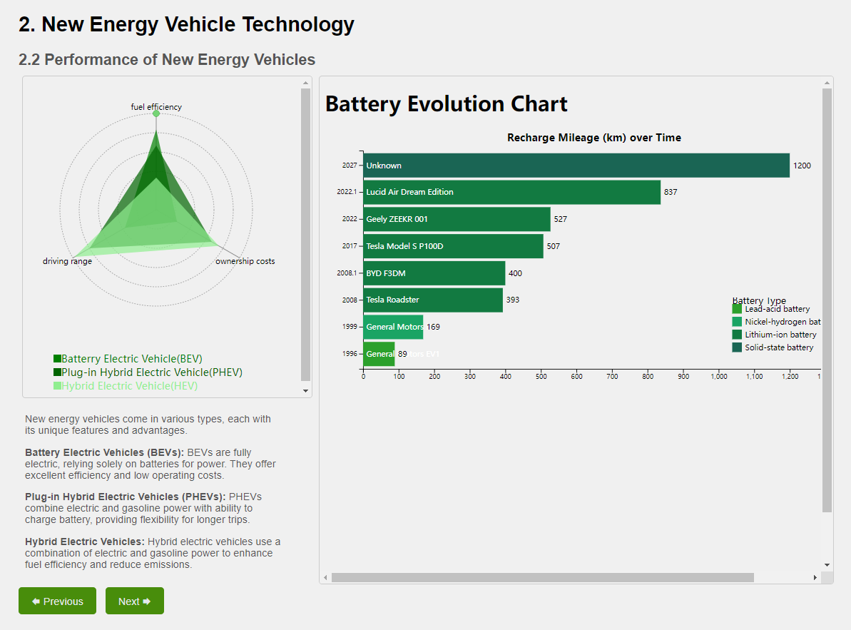
Multidimensional Comparison: The radar chart concisely contrasts new energy vehicle attributes, offering insights into efficiency, range, and costs.
Battery Technology Timeline: The 'Battery Evolution Chart' highlights advancements over time, showcasing industry progress and emerging trends.
Visual Distinction: Color distinctions in the bar chart clarify battery types, aiding rapid technological identification.
Clarity in Complexity: The dual-chart approach balances detail with readability, effectively conveying complex data.
Design for Comprehension: The visual layout enables comparative analysis without overwhelming the viewer, aligning with educational objectives.

Dashboard 6:
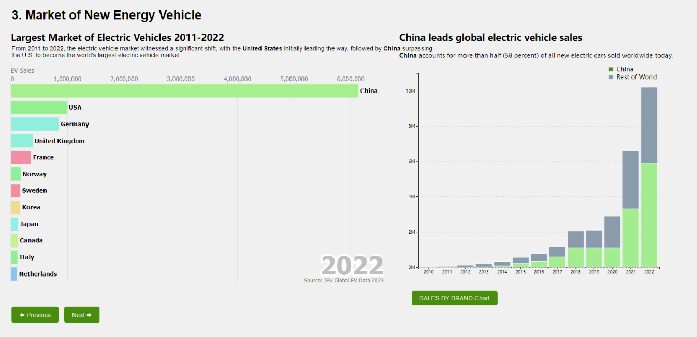
Global Market Analysis: The horizontal bar chart displays the largest markets for electric vehicles, highlighting China's dominant position. It's effective for comparing the scale of EV adoption across countries at a glance.
Trend Visualization: The secondary bar chart illustrates the explosive growth of China's market over time, contrasting it with the rest of the world and reinforcing China's leadership in global electric vehicle sales.
Strategic Color Use: The green color in both charts symbolizes the environmental aspect of EVs, while also drawing attention to China’s substantial market share.
Data Presentation: The clear, descending order of the countries in the horizontal bar chart, alongside the ascending timeline in the secondary chart, allows for easy historical and comparative analysis.
Simplicity and Focus: The design forgoes unnecessary visual elements, focusing solely on the data, which makes the significant trends and key messages stand out without distraction.

Dashboard 7 :
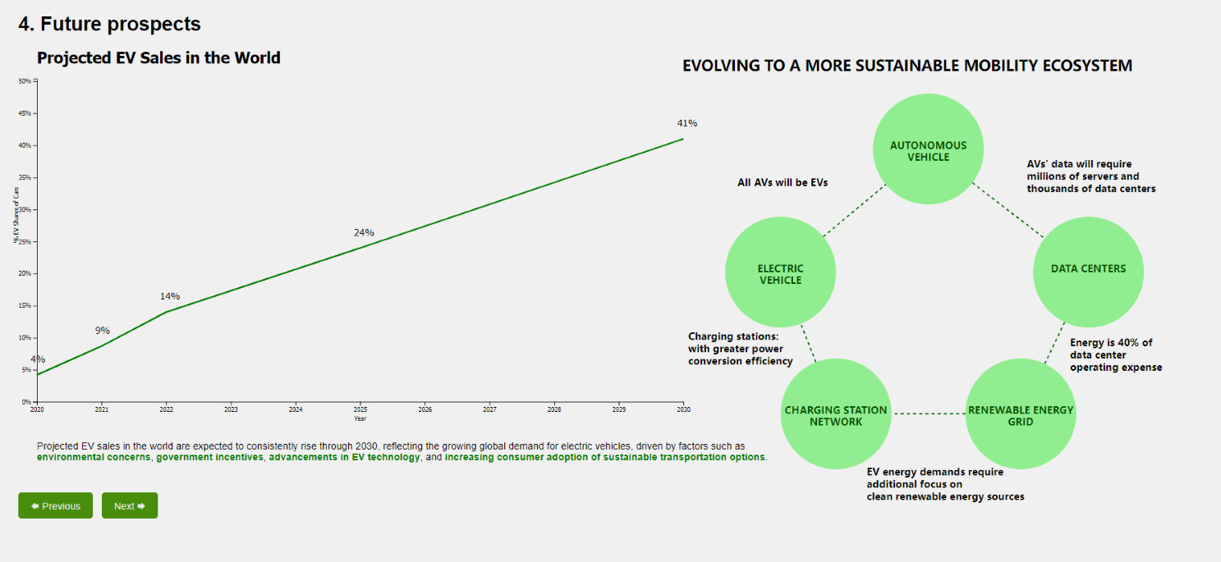
Future Growth Projection: The line chart illustrates a steady increase in global EV sales, projecting a significant rise by 2030. This trend underscores the growing consumer shift towards sustainable transportation.
Sustainability Network: The interconnected bubble diagram emphasizes the evolving ecosystem of sustainable mobility, including electric vehicles, autonomous technology, and the necessary expansion of charging stations and data centers, with a nod to the increasing need for renewable energy integration.
Strategic Highlighting: The larger bubbles for 'Electric Vehicle' and 'Data Centers' draw attention to the critical areas of development within the sustainable mobility ecosystem.
Data Centricity: By linking autonomous vehicles to data centers, the visualization acknowledges the data-driven nature of future mobility and the energy demands this will entail.
Educational Value: The chart educates viewers on the multifaceted aspects of EV adoption, beyond just the vehicles themselves, encompassing infrastructure and energy considerations.

Dashboard 8:
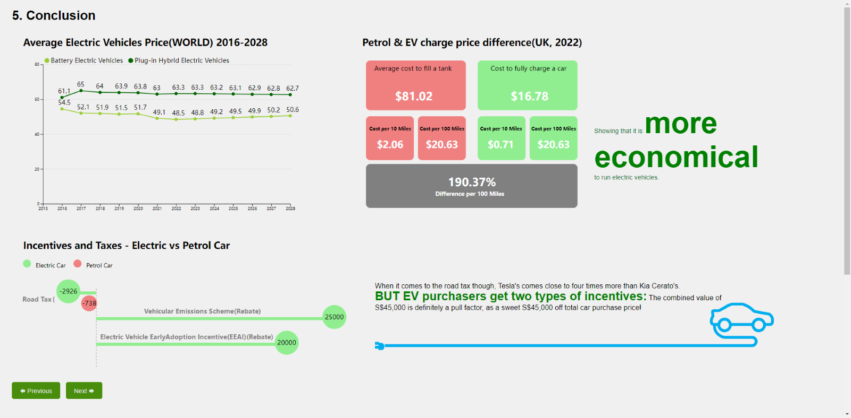
Color Contrast: Utilizes green to denote electric vehicles, symbolizing affordability and environmental benefits, against the red of petrol cars, suggesting higher costs.
Price Trend and Typography: Showcases a clear downward trend in EV prices, with bold and prominent typography underscoring the economic edge of EVs.
Layout for Logical Flow: Organizes data from market trends to financial specifics, leading the viewer to a conclusion of cost savings with electric vehicles.
Key Message Highlight: The phrase "more economical" is emphasized in size and placement, driving home the cost-effectiveness of EVs.

Dashboard 9:
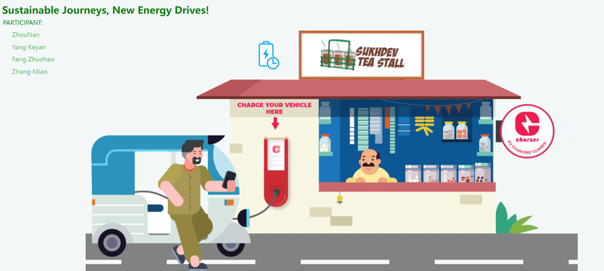

Principles of Visual Design
In this section we will present the different Principles of Visual Design in a decentralized order of specific diagrams.In this storyboarding exercise, we have created a total of seventeen diagrams.

Proximity (Gestalts Theory of Visual Perception)
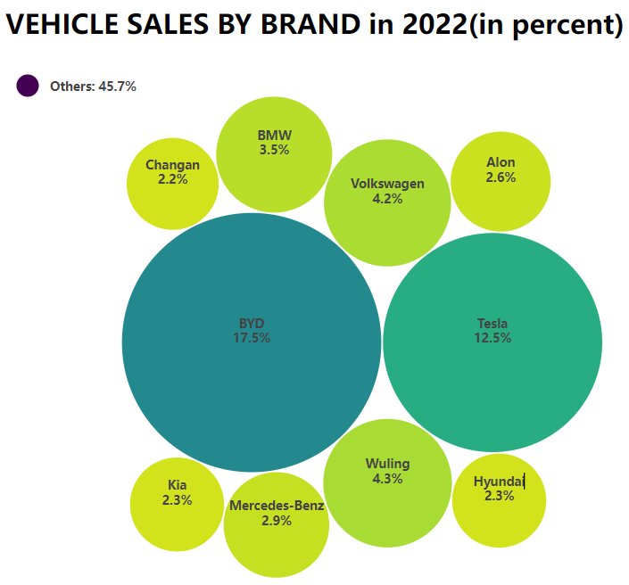
In the above figure on “Vehicle Sales by Brand in 2022”, the principle of proximity is employed by grouping the circles representing various brands near each other. Despite the use of distinct colors to signify variations in the percentage of vehicle sales, the spatial arrangement of the circles takes precedence, surpassing the visual impact of the color differences.

Similarity (Gestalts Theory of Visual Perception)
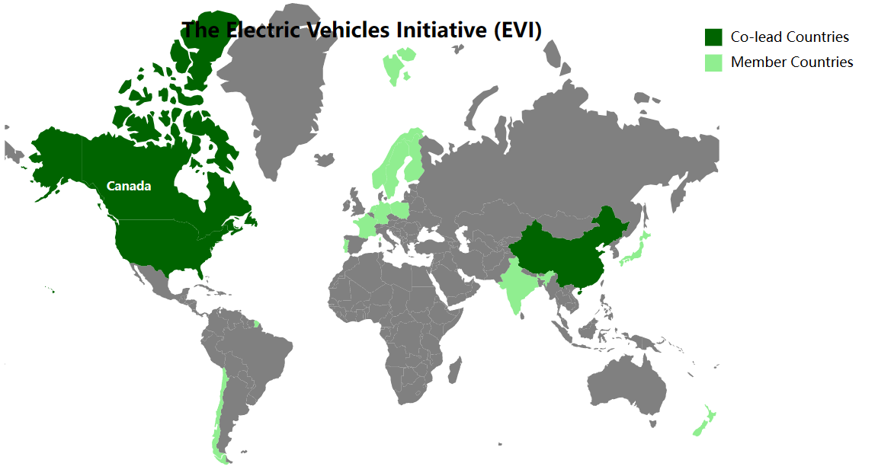
For the above map, the principle of similarity is applied through having the same color to depict one type of country. This way even though the countries are positioned far from one another in the map, such as China and United States, viewers can still perceive them to be in the same group.

Closure (Gestalts Theory of Visual Perception)
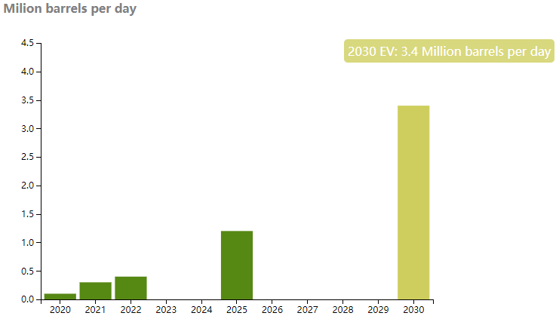
The principle of closure is utilized to enable users to intuitively connect the progression of vertical bars, indicating a consistent increase across time from 2022 to 2030.

Figure/Ground (Gestalts Theory of Visual Perception)
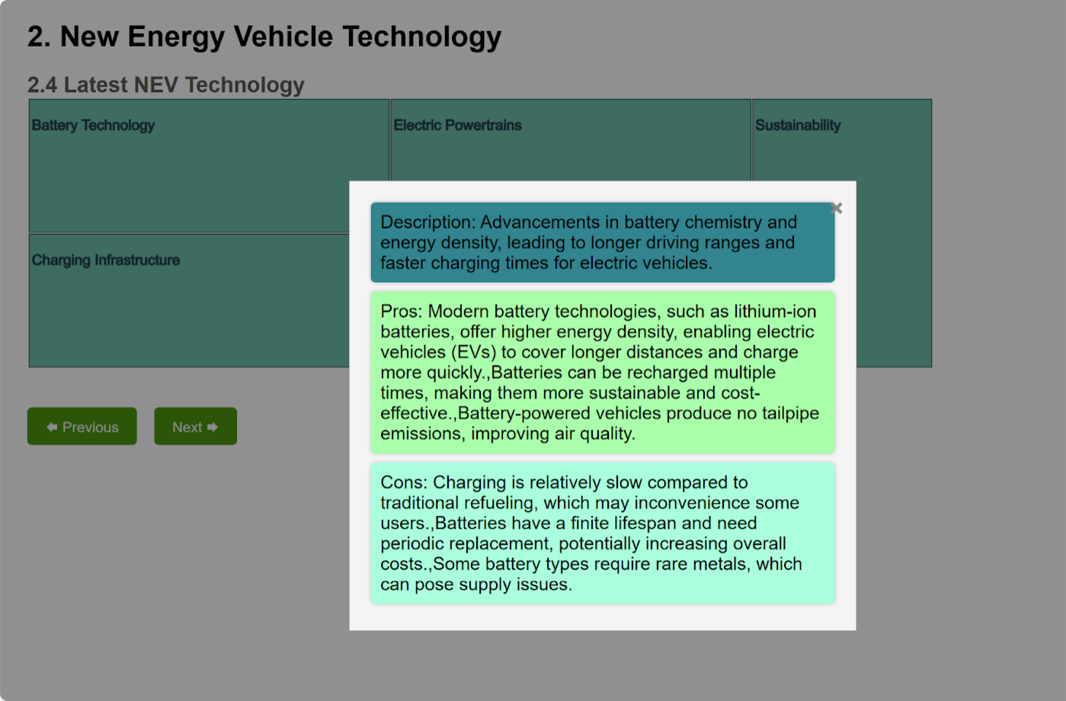
The background is dimmed upon the appearance of the modal to facilitate viewers in readily identifying the modal as the focal element in this context.

Unity
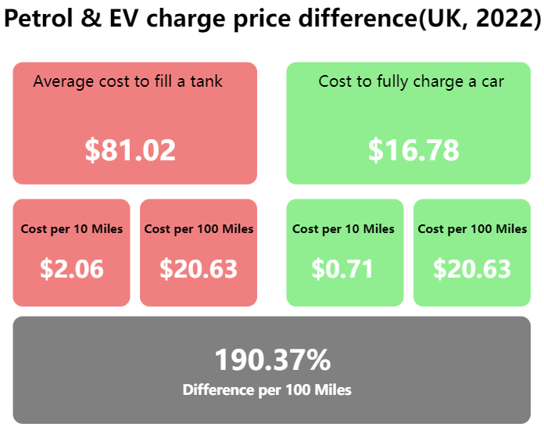
The principle of unity is implemented in the arrangement of rectangular boxes, where identical metrics are aligned in the same row to structure related information cohesively. The deliberate repetition of the rectangular shape contributes to a harmonious visual, reinforcing a sense of cohesion.

Balance
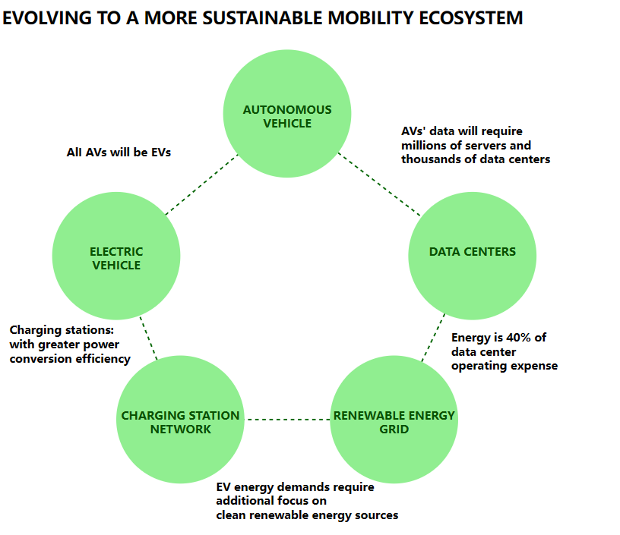
The circles representing various components of the mobility ecosystem are intentionally symmetrical in both shape and size. This design choice emphasizes the equal importance of these components. It suggests that only through a balanced integration of all these elements can the goal of a more sustainable mobility ecosystem be successfully attained.

Evaluation of Storyboard
The storyboard effectively employs a diverse range of visualizations to underscore the persuasive message advocating the adoption of New Energy Vehicles (NEVs) over traditional combustion engine vehicles. Notably, the use of stacked area charts and scatter plots offers a compelling depiction of global greenhouse gas emissions, with a specific emphasis on the transportation sector. This visual strategy effectively communicates the urgency of transitioning to cleaner alternatives.
The inclusion of interactive features, such as clickable charts and a comparative view between traditional and NEVs, enhances reader engagement by providing a personalized experience. These interactive elements not only captivate the audience but also empower them to explore the information at their own pace, contributing to the overall persuasiveness of the storyboard.
Moreover, the logical flow of the narrative and the clarity in messaging contribute to a reader-friendly experience. The storyboard excels in distilling complex information into digestible segments, ensuring that readers can easily comprehend the environmental and economic advantages of NEVs. The inclusion of tooltips and hover-over information further enhances the clarity and accessibility of the content. Overall, the storyboard effectively utilizes visual and interactive elements to engage readers and communicate the benefits of NEVs convincingly.

Conclusion
In conclusion, the storyboard adeptly summarizes key points, covering global environmental trends, technological advancements in NEVs, and the market growth of these vehicles. The concluding remarks successfully reinforce the significance of embracing NEVs, tying back to the key advantages discussed throughout the narrative. However, to further enhance its impact, the storyboard could benefit from a more explicit call to action. Encouraging readers to actively consider NEVs, advocate for supportive policies, or share the information with others would strengthen the overall message and motivate real-world action.
In the closing thoughts, while the emphasis on the importance of sustainable transportation options is evident, a stronger call to action could inspire readers to contribute actively to the shift towards cleaner alternatives. By urging individuals to make informed choices and play a role in supporting sustainable initiatives, the storyboard has the potential to inspire meaningful change and contribute to a more sustainable future.

Reference
- Yuan, X., Liu, X., & Zuo, J. (2015). The development of new energy vehicles for a sustainable future: A review. Renewable and Sustainable Energy Reviews, 42, 298-305.
- Lee, Z. H., Sethupathi, S., Lee, K. T., Bhatia, S., & Mohamed, A. R. (2013). An overview on global warming in Southeast Asia: CO2 emission status, efforts done, and barriers. Renewable and Sustainable Energy Reviews, 28, 71-81.
- Jan C. Minx, William F. Lamb, Robbie M. Andrew, Josep G. Canadell, Monica Crippa, Niklas Döbbeling, Piers Forster, Diego Guizzardi, Jos Olivier, Julia Pongratz, Andy Reisinger, Matthew Rigby, Glen Peters, Marielle Saunois, Steven J. Smith, Efisio Solazzo, & Hanqin Tian. (2022). A comprehensive and synthetic dataset for global, regional and national greenhouse gas emissions by sector 1970-2018 with an extension to 2019 [Data set]. Zenodo. https://doi.org/10.5281/zenodo.6483002
- IEA (2023), Global EV Outlook 2023, IEA, Paris https://www.iea.org/reports/global-ev-outlook-2023, License: CC BY 4.0
- Miotti, M., Supran, G. J., Kim, E. J., & Trancik, J. E. (2016). Personal vehicles evaluated against climate change mitigation targets. Environmental science & technology, 50(20), 10795-10804.
- EV-volumes.com. (2023). xEV Share tracker by country. EV Data Center. https://www.ev-volumes.com/datacenter/
- GlobalPetrolPrice. (2023, March). Electricity prices. Retrieved from https://www.globalpetrolprices.com/electricity_prices/
- Singapore Land Transport Authority. (2023). Cost (S$) For Cars Registered in Sep 2023. Retrieved from https://www.lta.gov.sg/content/ltagov/en/who_we_are/statistics_and_publications/statistics.html
- Karim, D. M. (2017). Creating an innovative mobility ecosystem for urban planning areas. Disrupting Mobility: Impacts of Sharing Economy and Innovative Transportation on Cities, 21-47.

