Report for assignment#2
- Introduction
  - Introduction to the COVID-19 pandemic

The COVID-19 pandemic, caused by the novel coronavirus SARS-CoV-2, has been one of the most significant global health crises in recent memory. The virus quickly spread to every corner of the globe, leading to a profound impact on human health, economies, and daily life. Therefore the World Health Organization(WHO) declared COVID-19 a pandemic on March 11, 2020.

The pandemic has strained healthcare systems, challenging the capacity of hospitals and healthcare workers. It has resulted in countless lives lost, leaving families and communities in mourning. Additionally, the virus prompted governments to implement a range of measures to curb its spread, including lockdowns, travel restrictions, mask mandates, and social distancing protocols.

  - Background and challenges faced by Singapore

Singapore, a city-state in Southeast Asia, faced a unique set of challenges when dealing with the COVID-19 pandemic. As a densely populated and globally connected nation, Singapore was especially vulnerable to the rapid spread of the virus.

Densely Populated Urban Center: Singapore is known for its dense urban population, with people living in close quarters. This made the potential for community spread of the virus a significant concern. Social distancing and isolation measures were critical to prevent outbreaks.

International Hub: As a major international travel and business hub, Singapore had a high volume of incoming and outgoing travelers. This not only exposed the nation to imported cases but also posed challenges in terms of contact tracing and quarantine measures.

Healthcare Capacity: Although Singapore boasts a robust healthcare system, the rapid surge in COVID-19 cases could potentially overwhelm hospitals and healthcare facilities. Ensuring healthcare capacity was a priority.

Limited Domestic Space: With limited land space, Singapore faced challenges in creating isolation and quarantine facilities for patients and close contacts. The government had to find innovative solutions for this issue.

Multicultural Society: Singapore is home to a diverse and multicultural population. Communicating public health measures and information effectively across different language and cultural groups was a crucial consideration.

- Data Collection
  - Data sources
- COVID-19 Weekly Stats (Ministry of Health (MOH)):

https://beta.data.gov.sg/collections/522/datasets/d_0d1da54a73733d33e40f662f757af537/view
- Covid-19 Case in Singapore: Details on the individual cases of confirmed Covid-19 in Singapore(Ministry of Health (MOH)):

https://beta.data.gov.sg/collections/519/view
- HSA's Regulatory Information and Consumer Advisories on COVID-19(Health Sciences Authorities):

https://www.hsa.gov.sg/covid-19-information-and-advisories
- COVID-19 MENTAL WELLNESS TASKFORCE REPORT(Ministry of Health (MOH)):

https://www.moh.gov.sg/resources-statistics/reports/covid-19-mental-wellness-taskforce-report
- REPORT ON EXCESS MORTALITY DURING THE COVID-19 PANDEMIC UP TO JUNE 2022(Ministry of Health (MOH)):

https://www.moh.gov.sg/resources-statistics/reports/report-on-excess-mortality-during-the-covid-19-pandemic-up-to-june-2022
- Tracking: Coronavirus 19 outbreak in Singapore (Singapore Lianhe Zaobao):

https://interactive.zaobao.com/2020/novel-coronavirus-cases-in-singapore/
- Possible dataset for assignment 2 (NTULEARN)

- Storyboard

This tableau storyboard started with an overall overview, then showed the beginning of the outbreak, focusing on the timeline of the outbreak and key time points, and then did a simple graphical analysis of the initial case dataset, including case characteristics and locations visited. Next, a side-by-side comparison is made between Singapore's response to the epidemic and that of other countries in the world and in Southeast Asia. It then highlights the measures taken by the government (vaccination/quarantine/tracking) and the effectiveness of their implementation. Finally, the story of the Singaporean government's fight against the epidemic is concluded.

To build this tableau storyboard, I chose to make the data as complete and official as possible, with a rich visual representation, coordinated colors, and some image inserts of my own created outside of the tableau charts to aid in the reader's understanding.

  - Page 1: Overview&Start
- Overview:

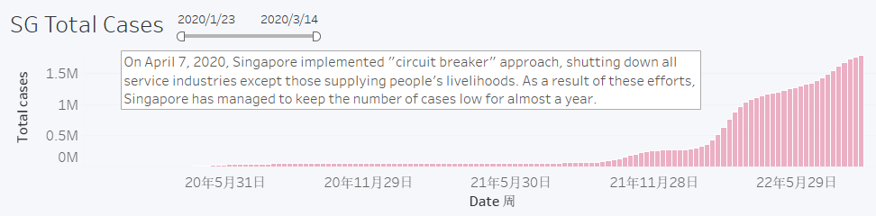
- Start:

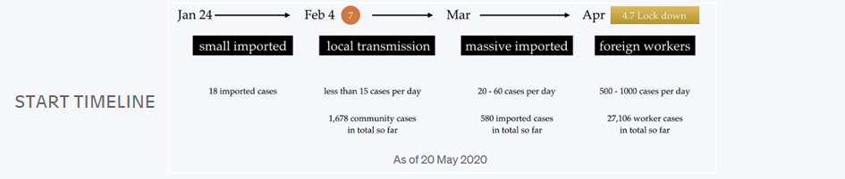

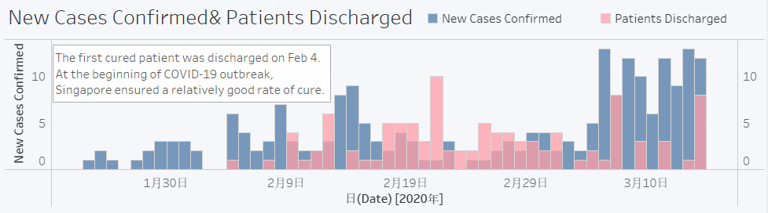

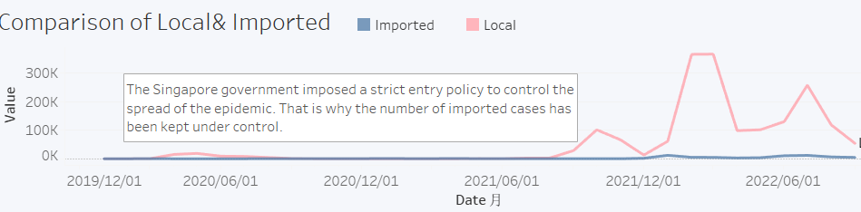

  - Page 2: Outbreak of infection in the dormitories
There are about 1,200 Migrant worker dormitories in Singapore, each accommodating 50 to 100 people, and some even up to 500. Once the first case appeared there, the spread was rampant. This has so far been responsible for 92% of all of Singapore's confirmed cases.
The virus spreads quickly in these dormitories because of the high population density and unsatisfactory accommodation. It was a major outbreak of infection in the dormitories of migrant workers that prompted the Government to adopt more stringent circuit breaker measures on 7 April.

  - Page 3: Cases Analysis
- Age distribution:

The data show that there are fewer female cases of COVID-19. This trend may be influenced by gender differences in social interaction, occupation and lifestyle. However, further research is needed to find out the exact cause of this gender difference.
- Nationality diversity:

The cases show a rich diversity of nationalities, a large proportion of which are from Southeast Asia. This diversity coincides with the multicultural nature of Singapore, which is home to immigrants from different countries and regions.

  - Page 4: Areas Visited Most
Top 10 Areas Visited by Infectes Cases:
SOMERSET
JURONG REGIONAL
CENTRAL
SENTOSA
MARINE PARADE
BUGIS
CENTRAL
GEYLANG EAST
TAMPINES EAST
CHANGIAIRPORT
TANJONG RHU
YUNNAN
It can be seen from the statistics that the areas most visited by infected persons are mainly residential areas, transportation hubs or airports of entry. The western part of Singapore is more common.

  - Page 5: Compare With WORLD

Singapore is recognized worldwide as one of the most successful countries in the global response to the outbreak. As a small country with a total population of just over 5.5 million, although millions of cases have been diagnosed, the severe disease and death rates have been kept at a very low level, with an overall morbidity and mortality rate of about 0.12 per cent, the healthcare system has not collapsed, and the society has been able to maintain its normal functioning.

  - Page 6: Performance in Southeast Asia

Singapore excelled among South-East Asian countries in that its effective control measures, transparent communication and robust health infrastructure contributed to the effective management of the outbreak and reduced its social, economic and health impacts.

  - Page 7: Singapore Measures

Singapore's main measures fall into three categories:
- Tightening border controls to reduce imported cases;

Singapore recognized the need to limit the importation of new cases from international travelers. To achieve this, the following measures were implemented.

Travel Restrictions: The government imposed strict travel restrictions, including entry bans or quarantine requirements for travelers from high-risk regions. These measures reduced the inflow of potentially infected individuals.

Mandatory Quarantine: Travelers arriving in Singapore were required to undergo a mandatory quarantine period. This helped to identify and isolate potential cases before they could spread the virus within the community.

Testing on Arrival: On top of quarantine, travelers were subjected to COVID-19 testing on arrival in Singapore. This additional layer of screening aimed to quickly identify and isolate positive cases.
- Early detection, tracing and isolation;

The introduction of the Trace Together App and Trace Together Token by thegovernment has already gone a long way in improving the efficiency of trackingclose contacts of patients and is a beneficial tool in controlling the spread of thevirus in the community.
- Emphasizing social responsibility and personal hygiene.

Singapore recognized the importance of individuals' roles in preventing the spread of the virus. The government emphasized the following:

Community Involvement: Singaporeans took personal responsibility by adhering to guidelines, participating in contact tracing efforts, and supporting the most vulnerable in the community.

Mask-Wearing and Hygiene Practices: Widespread mask-wearing and the practice of good personal hygiene became cultural norms. Citizens recognized their role in protecting themselves and others.

  - Page 8: Stay Home Policy
On 25 March 2020, the Singapore Government worked with hotel managers to provide specialized quarantine facilities only for persons returning from the United Kingdom and the United States to enforce the 14-day home quarantine order. At the same time, Singapore has imposed severe penalties for breaches of the home quarantine regime, and after July 2020, Singapore has further tightened quarantine measures to control the impact of imported cases.

  - Page 9: Vaccination
- Vaccination progress

The Singapore Government invested more than one billion Singapore dollars to sign advanced purchase agreements and made early down payments on promising vaccine candidates, such as Pfizer BioNTech, Moderna and CoronaVac. Singapore has a very high vaccination rate, with more than 92% of its total population (and more than 93% of its eligible population) having completed their vaccination regimen.
- Vaccination rates comparisons with other countries
Singapore's vaccination rate is clearly one of the highest in Southeast Asia, as the government promotes universal vaccination.

- Conclusion
- Key factors contributing to Singapore's success

Effective outbreak control measures: Singapore took early, swift and robust measures, including early travel restrictions, social isolation, mass testing and contact tracing. This helped contain the spread of the virus at an early stage.

Transparent communication: The Government has maintained transparent and open communication through channels such as regular press releases and social media to convey information to the public, making it easier for people to understand the severity of the outbreak and the measures taken.

Medical infrastructure and healthcare system: Singapore has a strong medical infrastructure and healthcare system that provides quality medical care to patients, which helped reduce the severity of the outbreak.

Scientific basis: Government decisions are largely based on scientific data and expert advice, which helps ensure that measures taken are well-founded.

Quarantine and isolation facilities:An essential component of Singapore's strategy in combating the COVID-19 pandemic involved the establishment and efficient utilization of quarantine and isolation facilities. These facilities played a crucial role in preventing the spread of the virus, safeguarding public health, and mitigating the burden on healthcare resources.

Social cooperation: Singaporean society generally adheres to the government's guidance, which helps reduce community transmission and protect vulnerable groups.

- Lessons learned from Singapore's experience
While Singapore has done well in responding to the outbreak, there have been some challenges and criticisms, such as outbreaks in some foreign workers hostels, which have raised concerns about foreign workers rights and accommodation conditions.
In addition, Singapore has experienced a number of outbreak fluctuations and has needed to continually adapt its measures to the outbreak.

Also, there are many lessons can be learned from Singapore's experience:

Early Preparedness is Key: Singapore's experience underscores the importance of early preparedness and having robust public health systems in place before a pandemic hits. The nation's prior experiences with SARS and H1N1 flu helped shape its response to COVID-19.

Swift and Clear Communication: Clear and transparent communication from government authorities was instrumental in managing public perception and compliance. Regular updates, press conferences, and public health campaigns helped keep the population informed.

Data-Driven Decision-Making: Singapore's use of data analytics and technology for contact tracing, testing, and monitoring proved to be highly effective. Data-driven decision-making allowed for the rapid identification of clusters and the isolation of cases.

Quarantine and Isolation Facilities: The use of a variety of facilities, including repurposed dormitories, hotels, and community centers, demonstrated the importance of flexibility and innovation in managing quarantine and isolation.

Mental Health and Well-being: Singapore's focus on addressing the mental health and well-being of individuals in quarantine or isolation facilities demonstrated the importance of providing psychological support during times of crisis.

In conclusion, Singapore's response to the COVID-19 pandemic serves as a case study in effective pandemic management. The lessons learned from its experience underscore the importance of early preparedness, data-driven decision-making, clear communication, public cooperation, and global collaboration. These lessons can guide other nations in developing more effective strategies to combat future health crises.

