In this chapter, we are going to introduce two SmartApp built by Smart Block. Frist SmartApp in Fig 21 offers the service turning the lights on when motion is detected. In addition, we can see the generated groovy code in Fig 23. This SmartApp is provided with SmartThings Developer Workspace as a template.

*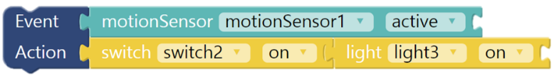*

1. Example of ECA rules on SmartApp

Second example of SmartApp in Fig 22 offers the service turning on heater if user is present when the temperature drops below 8 degree setting and fan when the temperature rises above 22 degree.

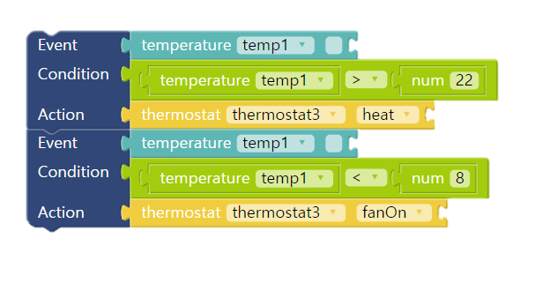

1. Example of ECA rules on SmartApp

*

