1: Summary

1.1 overview

SRDA and SRDB are two EEG based stereogram recognition datasets, which contain 24 dynamic random dot stereograms (DRDS) with three categories of different parallax. The two databases are mainly different from SRDA, which adopts high-contrast DRDS, and SRDB, which adopts low-contrast DRDS. These graphics are presented on the 3D display in the form of DRDS videos. Subjects recognize different types of stereograms when wearing 3D glasses.

1.2 The experimental paradigm:

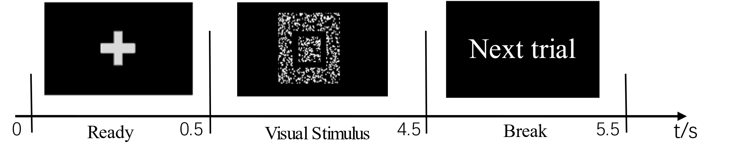

1.3 The collection process of EEG signals

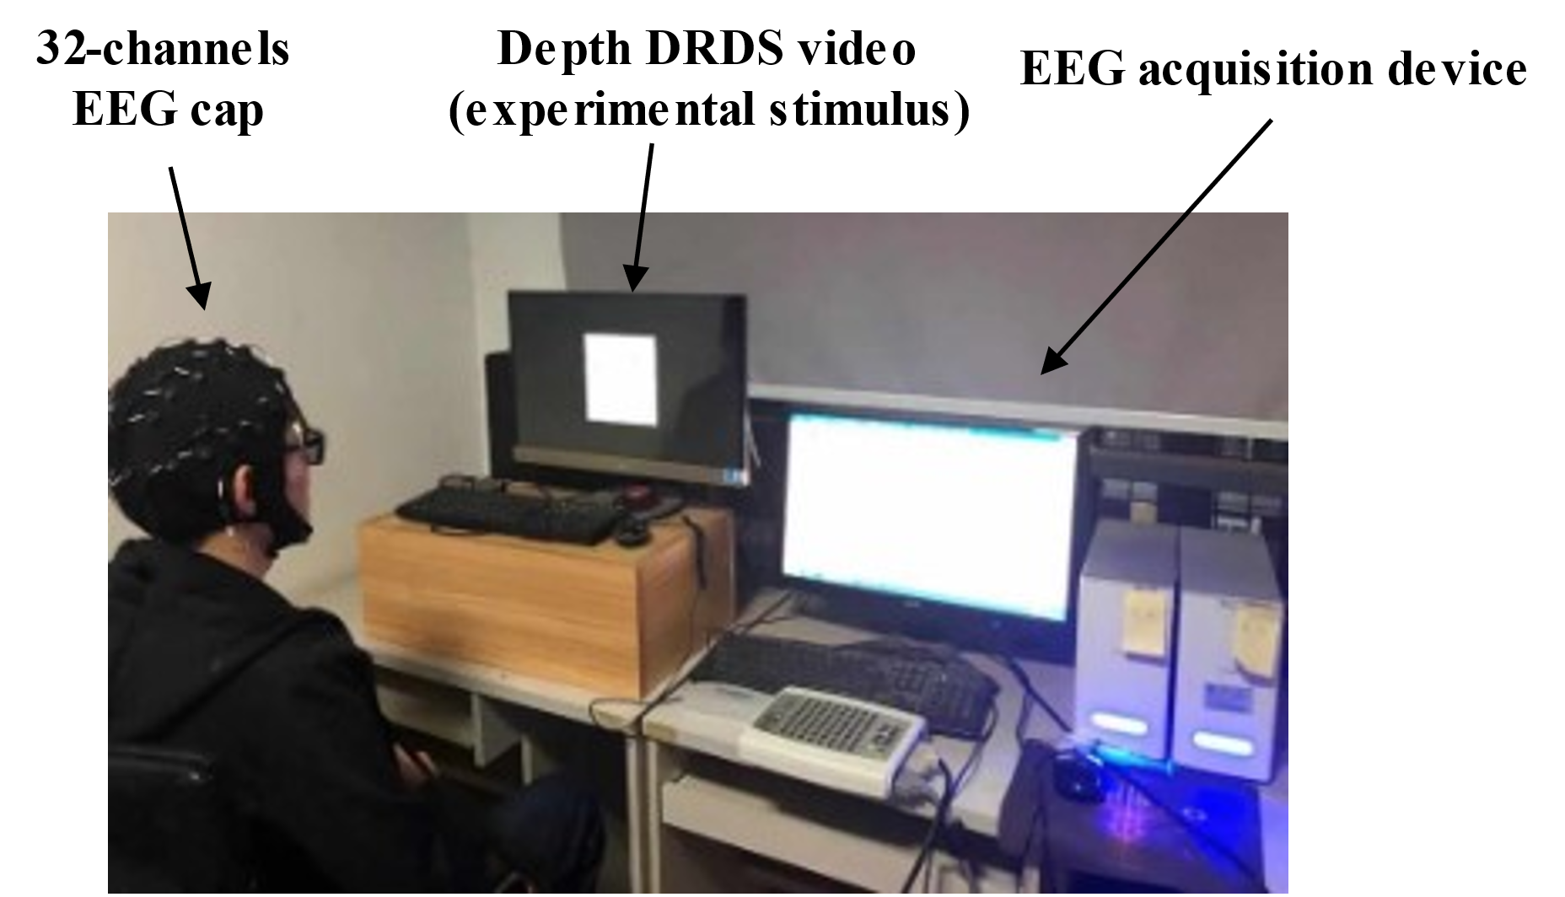

More details can be found in：

Shen Lili, Dong Xinxin. Analysis and classification of hybrid EEG features based on the depth DRDS videos[J]. Journal of Neuroscience Methods, 2020, 338:1-8.

if you use this dataset, please cite the above paper:

2 Download method

2.1 Term & Conditions

(1) SRDA and SRDB database are available for non-commercial research purposes only.

(2) The EEG acquisition experiment was carried out in the EEG Laboratory, School of Electrical Automation and Information Engineering, Tianjin University.

(3) You agree not to reproduce, duplicate, copy, sell, trade, resell or exploit for commercial purposes, any portion of the clips, and any derived data.

(4) You agree not to further copy, publish, or distribute any portion of the SRDA and SRDB database. Except for internal use at a single site within the same organization, it is allowed to make copies of the dataset.

2.2 how to download

(1) This database is publicly available. It is free for professors and researcher scientists affiliated to a University. The download link is as follows:

https://pan.baidu.com/s/1iivDwKVVA4oQFYAUbGjieA

(2)Permission to use but not reproduce or distribute the SRDA and SRDB database is granted to all researchers given that the following steps are properly followed:

Send an E-mail to Lili Shen (sll@tju.edu.cn) before downloading the database. You will need a password to access the files of the SRDA and SRDB database. Your E-mail MUST be set from a valid University account and MUST include the following text:

Subject: Application to download the SRDA and SRDB Database

Name: <your first and last name>

Affiliation: <University where you work>

Department: <your department>

Position: <your job title>

Email: <must be the email at the above mentioned institution>

I have read and agree to the terms and conditions specified in the DFEW facail expression database webpage.

This database will only be used for research purposes.

I will not make any part of this database available to a third party.

I'll not sell any part of this database or make any profit from its use.

(3) Content Preview：

