**FUTURE SALES PREDICTIONS**

**NAAN MUDHALVAN PHASE-2**



**INTRODUCTION:**

* **In the fast-paced world of modern business, accurate sales prediction is a linchpin for success.**

* **It enables organizations to navigate changing market dynamics, optimize resources, and make informed decisions.**
* **Sales prediction leverages data and analytics to anticipate future trends and customer behaviour, offering a vital edge in a competitive landscape.**
* **This document delves into the essence of sales prediction, detailing methodologies, data sources, and techniques.**
* **From dataset selection to machine learning application, we provide a concise guide to implementing predictive models. An included flowchart offers a visual aid in comprehending the predictive process.**

**DATASET:**



**SALES:**

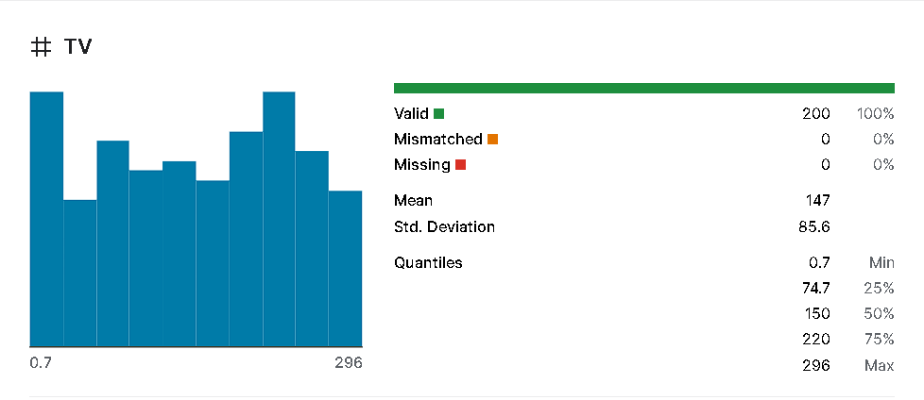

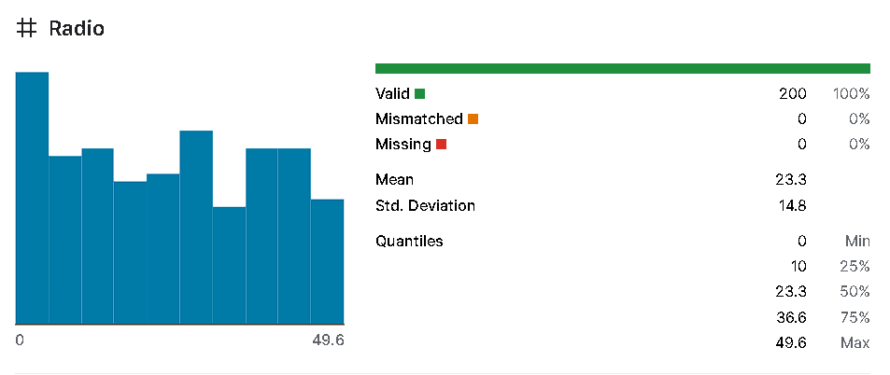

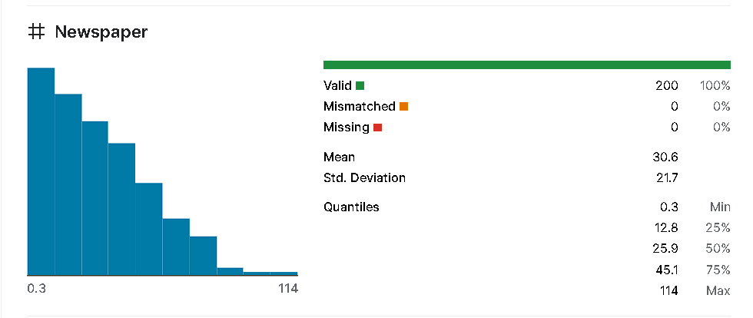

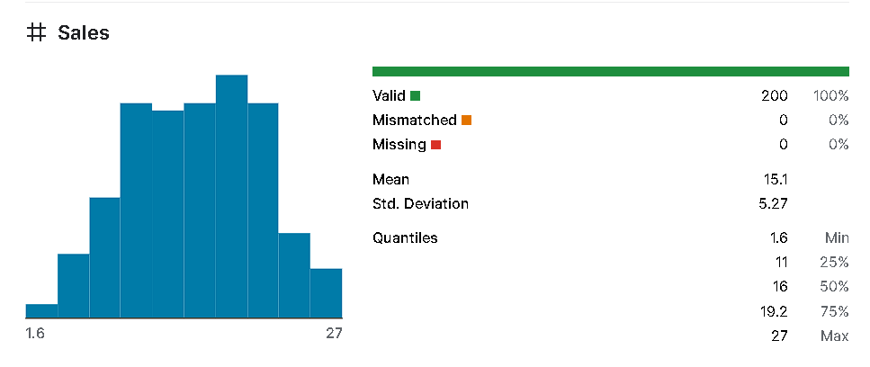

**DETAILS ABOUT COLOUMS:**

**Predicting future sales in the context of TV, newspaper, radio, and online sales involves analyzing various factors, trends, and data to forecast consumer behavior and purchasing patterns. While I don't have access to specific future data or events beyond my training cutoff in September 2023, I can provide general insights into the types of information and factors that are typically considered when predicting future sales in these mediums.**

1. **TV Sales:**
   * **Audience Demographics: Analyzing the demographics of TV viewers, such as age, gender, location, and preferences, to tailor advertising strategies.**
   * **Programming Trends: Studying popular TV shows, genres, and viewing habits to determine potential advertising reach and effectiveness.**
   * **Advertising Slots: Evaluating the cost and availability of advertising slots during peak viewing times and specific programs to maximize exposure.**
   * **Technological Trends: Considering advancements in TV technology (e.g., 4K, smart TVs) and their impact on consumer purchasing decisions.**
2. **Newspaper Sales:**
   * **Circulation Data: Analyzing circulation numbers, distribution areas, and subscription trends to understand the potential reach of newspaper advertisements.**
   * **Readership Profile: Identifying the demographics and interests of newspaper readers to tailor advertising content and placement.**
   * **Editorial Content: Assessing the popularity and relevance of different sections or topics within the newspaper to optimize ad placement.**
   * **Digital Integration: Considering the impact of online platforms and digital editions on traditional print newspaper sales.**
3. **Radio Sales:**
   * **Listener Demographics: Understanding the demographics and preferences of radio listeners to target advertising effectively.**
   * **Programming and Genre Trends: Analyzing popular radio programs, music genres, and listenership patterns to identify suitable advertising opportunities.**
   * **Ad Timing and Frequency: Optimizing the timing and frequency of radio advertisements to ensure maximum impact and recall.**
   * **Streaming and Digital Platforms: Considering the rise of digital streaming platforms and their influence on traditional radio advertising.**
4. **Online Sales:**
   * **Website Traffic and User Behavior: Analyzing website traffic, user behavior, and conversion rates to understand online sales patterns.**
   * **SEO and SEM Performance: Assessing the effectiveness of search engine optimization (SEO) and search engine marketing (SEM) strategies in driving online sales.**
   * **Social Media Impact: Analyzing the reach, engagement, and conversions generated from social media advertising and campaigns.**
   * **E-commerce Trends: Studying online shopping trends, e-commerce platforms, and consumer preferences to forecast future online sales.**

**It's important to note that predicting future sales is a complex task, and it's crucial to use advanced analytical models, historical data, market research, and industry expertise for accurate predictions. Additionally, external factors such as economic conditions, technological advancements, cultural shifts, and unforeseen events can significantly impact sales and should be considered in any sales prediction analysis.**

**CONCEPTUAL FRAMEWORK:**

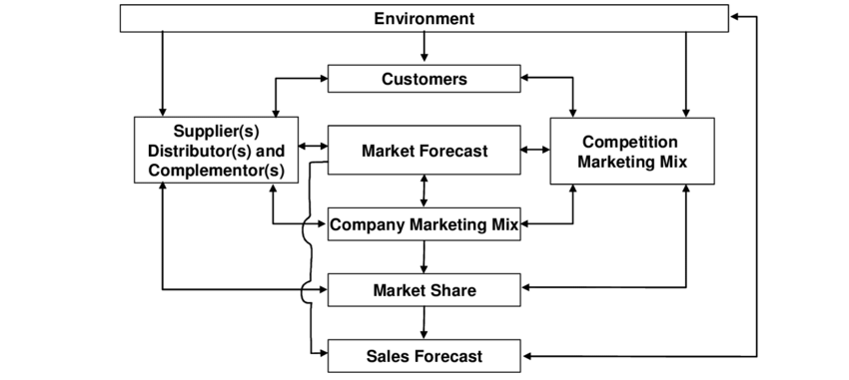

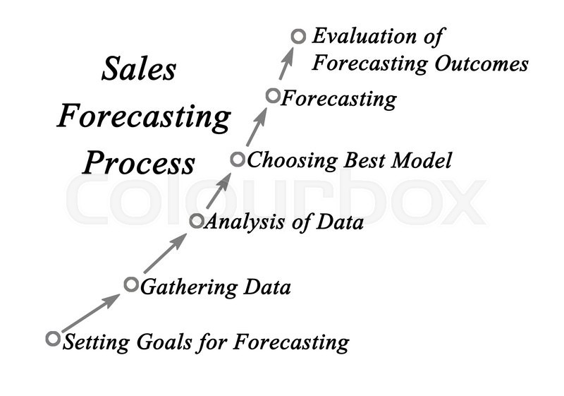

**DATA SET SOURCE LINK:**

**CLICK TO ACCESS THE DATA:** [**https://www.kaggle.com/datasets/chakradharmattapalli/future-sales-prediction**](%20https://www.kaggle.com/datasets/chakradharmattapalli/future-sales-prediction)

**DETAILS OF LIBRARIES:**

**To perform future sales prediction, you'll need to use various libraries and tools for data analysis, machine learning, and visualization. Here are some commonly used libraries and steps to download them:**

1. **Python:** **Python is a popular programming language for data analysis and machine learning tasks.**
   * **Download and Install Python:** **Visit the official Python website (**<https://www.python.org/>) **to download the latest version of Python for your operating system. Follow the installation instructions provided on the website.**
2. **Libraries for Data Analysis and Manipulation:**
   * **Pandas: Pandas is a powerful library for data manipulation and analysis in Python.**

pip install pandas

pip install pandas

1. **Libraries for Machine Learning:**
   * **Scikit-Learn:** **Scikit-Learn is a widely-used library for machine learning tasks such as regression, classification, and clustering.**

pip install scikit-learnpip

install scikit-learn

1. **Libraries for Visualization:**
   * **Matplotlib:** **Matplotlib is a popular library for creating static, animated, and interactive visualizations in Python.**

pip install matplotlibpip

install matplotlib

* + **Seaborn: Seaborn is built on top of Matplotlib and provides a high-level interface for drawing attractive and informative statistical graphics.**

pip install seabornpip in

stall seaborn

1. **Libraries for Time Series Analysis:**
   * **Statsmodels:** **Statsmodels is a library for estimating and testing statistical models.**

pip install statsmodelspip i

nstall statsmodels

1. **Libraries for Deep Learning (Optional for advanced predictions):**
   * **TensorFlow:** **TensorFlow is an open-source deep learning framework**.

pip install tensorflowpp install tensorflow

* + **Keras: Keras is a high-level neural networks API that can be used with TensorFlow.**

pip install keraspip i

nstall keras

1. **Libraries for Data Visualization (Optional):**
   * **Tableau, Power BI, or similar:** **These tools are helpful for creating advanced visualizations and dashboards from your analyzed data.**
   * **Jupyter Notebook (Recommended):** **Jupyter Notebook is an open-source web application that allows you to create and share documents that contain live code, equations, visualizations, and narrative text.**

pip install jupyterlabpip

**HOW TO TRAIN AND TEST:**

1. **Data Collection and Preparation:**
   * **Collect historical sales data including features such as date, product details, marketing efforts, and other relevant factors that could affect sales.**
   * **Preprocess the data by handling missing values, encoding categorical variables, scaling features, and structuring it in a way suitable for machine learning.**
2. **Feature Engineering:**
   * **Extract relevant features from the data that can be used to predict future sales. These could include historical sales, seasonal trends, marketing expenses, and more.**
3. **Splitting the Data:**
   * **Divide the historical sales data into training and testing sets. The training set is used to train the model, while the testing set is used to evaluate its performance.**
4. **Model Selection:**
   * **Choose a suitable machine learning model for sales prediction. Common models for time series prediction include Linear Regression, ARIMA, Exponential Smoothing, and machine learning models like Random Forest, XGBoost, or deep learning models like LSTM.**
5. **Training the Model:**
   * **Train the selected model using the training dataset. Input historical sales data and features to predict future sales.**
6. **Model Evaluation:**
   * **Use the testing dataset to evaluate the model's performance. Common evaluation metrics for sales prediction include Mean Absolute Error (MAE), Mean Squared Error (MSE), Root Mean Squared Error (RMSE), and R-squared.**
7. **Hyperparameter Tuning (Optional):**
   * **Optimize the model by tuning hyperparameters, adjusting the model's settings to achieve better predictive performance.**
8. **Validation (Cross-Validation):**
   * **Implement cross-validation techniques (e.g., k-fold cross-validation) to ensure the model's stability and performance across different subsets of the data.**
9. **Predict Future Sales:**
   * **Once the model is trained and evaluated, use it to predict future sales based on new or unseen data.**
10. **Monitoring and Updating:**
    * **Continuously monitor the model's performance as new sales data becomes available. Update and retrain the model periodically to maintain its accuracy and relevance for future predictions.**
11. **Visualization and Reporting:**
    * **Visualize the predicted sales alongside the actual sales data to assess the accuracy of the predictions. Report the results and insights derived from the prediction analysis**

**REST OF EXPLAINATION:**

**1.Time Series Analysis:**

* + **Use methods like ARIMA, SARIMA, or Exponential Smoothing for time-dependent sales data.**

**2.Feature Scaling:**

* + **Standardize or normalize features for consistent scales and model accuracy.**

**3.Model Optimization:**

* + **Experiment with hyperparameters and architectures for improved performance.**

**4.Ensemble Learning:**

* + **Combine multiple models for better accuracy and robust predictions.**

**5.Include External Factors:**

* + **Integrate external influences like economic data or events for enhanced predictions.**

**6.Short vs. Long-Term Predictions:**

* + **Distinguish between short-term and long-term sales forecasting.**

**7.Deployment and Automation:**

* + **Deploy models and automate predictions for regular insights.**

**8.Continuous Monitoring:**

* + **Monitor model performance and retrain with updated data for accuracy.**

**9.Feedback Loop and Iteration:**

* + **Gather feedback to enhance the model and align with business needs.**

**10.Interpretability and Explainability:**

* + **Ensure models are interpretable and provide clear explanations for predictions.**

**11.Documentation and Knowledge Sharing:**

* + **Document the process and share knowledge for collaboration and understanding**

**METRICS USED FOR THE ACCURACY CHECK:**

1. **Mean Absolute Error (MAE):**
2. **Mean Squared Error (MSE):**
3. **Root Mean Squared Error (RMSE):**
4. **Mean Absolute Percentage Error (MAPE):**
5. **Coefficient of Determination (R-squared or *R*2):**
6. **Percentage Error:**
7. **Symmetric Mean Absolute Percentage Error (SMAPE):**
8. **Forecast Bias:**
9. **Theil's U Statistic:**
10. **Prediction Intervals:**

**CONCLUSION:**

1. **Data Prep**: **Collect and prepare historical sales data.**
2. **Model Choice**: **Select suitable predictive models.**
3. **Training and Tuning**: **Train models, fine-tune them, and optimize parameters**.
4. **Evaluation Metrics**: **Use metrics like MAE, RMSE for evaluation**.
5. **Incorporate Factors**: **Consider external influences and adjust predictions.**
6. **Deployment and Monitoring**: **Deploy models and continuously monitor and improve them.**

**Accurate sales predictions empower businesses to optimize strategies and operations for future success**

**:**