Process-based modelling of grapevine downy mildew symptom onset and potential fungicide savings in subtropical double-cropping vineyards
Running title: First symptom onset modelling in subtropical vineyards
Linjia Yao ^{a #}, Bin Chen ^{b #}, Vittorio Rossi ^{c}, Ling Yin ^{d}, Shumei Wei ^{d}, Qi Tian ª, Changqing Yan ^{e}, Hui Wang ^{f}, Antonio Fernandes Nogueira Júnior ^{g}, Yu Huang ^{h}, Qiang Yu ^{b *}, Junjie Qu ^{d *}, Gang Zhao ^{b *}
ª College of Natural Resources and Environment, Northwest A & F University, Yangling 712100, China
^{b} State Key Laboratory of Soil and Water Conservation and Desertification Control, College of Soil and Water Conservation Science and Engineering, Northwest A&F University, Yangling, Shaanxi 712100, China
^{c} Research centre on Plant Health Modelling (PHEM), Università Cattolica del Sacro Cuore, Piacenza, Italy
^{d} Guangxi Crop Genetic Improvement and Biotechnology Key Lab, Guangxi Academy of Agricultural Sciences, Nanning 530007, China
^{e} College of Intelligent Equipment, Shandong University of Science and Technology, Taian 271019, China
^{f} Institute of Plant Protection Beijing Academy of Agriculture and Forestry Sciences, 100097 Beijing, China
^{g} KWS SAAT SE & Co. KGaA, Einbeck, Germany
^{h} Grape and Wine Research Institute, Guangxi Academy of Agricultural Sciences, Nanning, Guangxi 530007, China
* Corresponding author: Prof. Qiang Yu, E-mail: yuq@nwafu.edu.cn; Prof. Junjie Qu, E-mail: qujunjie@gxaas.net; Prof. Gang Zhao, E-mail: gang.zhao@nwafu.edu.cn
# These authors contributed equally to this work.

Abstract
BACKGROUND: Double cropping of grapevines (Vitis L.) in humid subtropical vineyards can maintain green host tissue across production cycles, allowing asexual inoculum of Plasmopara viticola (Berk. & M.A. Curtis) Berl. & De Toni to remain available. Models developed for oospore-driven seasonal initiation do not fully represent this setting. The First Seasonal Infection Model (FSIM) was developed to link airborne sporangial inoculum, weather and host development to first symptom-onset windows during the first crop growing season. A spore-constrained extension (FSIM-S) incorporated field monitoring.
RESULTS: Across six site–years in Guangxi, China (2022–2024), sporangia were detected 9–43 days before the first symptom-positive assessment. Leave-one-site–year-out cross-validation yielded interval-based mean absolute errors of 5.67 days for FSIM and 3.83 days for FSIM-S, a 32.4% reduction. Regional FSIM simulations for 2000–2024 showed earlier mean onset in eastern and southeastern Guangxi and later onset in the west and northwest. Grid-cell mean symptom-window midpoints averaged day of year 130.4 and 136.3 under the table- and wine-grape scenarios, respectively. Potential savings across all grids relative to the reference spray programme averaged 3.5 and 4.0 early applications per season, respectively.
CONCLUSION: Representing airborne sporangial inoculum supports modelling of first symptom onset under subtropical double cropping, with spore monitoring improving predictive performance. Prospective field evaluation is needed to confirm whether the estimated fungicide savings can be achieved while maintaining disease control. The framework provides a basis for adapting early-season protection to local disease risk and crop development.
Keywords: Agroclimatic modelling; Airborne sporangia; Disease-onset estimation; Fungicide timing; Subtropical viticulture

1 INTRODUCTION
Grapevine (Vitis L.) downy mildew, caused by Plasmopara viticola (Berk. & M.A. Curtis) Berl. & De Toni, threatens production in humid subtropical regions, where warm, rainy conditions coincide with the emergence of susceptible leaves and development of inflorescences.^{1,2} Epidemics can impair canopy photosynthesis, damage inflorescences and berries, and cause substantial yield loss.³ Disease control depends heavily on repeated preventive fungicide applications. ^{4,5} Timing based on calendar schedules, grower experience or qualitative weather cues may be poorly aligned with infection risk. Understanding when inoculum can establish infection is therefore central to protecting susceptible tissue before symptoms appear. Preventive management based on infection risk requires joint consideration of inoculum availability, host susceptibility and environmental suitability.⁶
Empirical models such as the “3–10 rule” and the Etat Potentiel d’Infection (EPI) model use weather and phenological indicators to guide control timing.⁷ They do not resolve the biological sequence from inoculum availability to symptom appearance. Process-based models provide a more explicit representation by linking the inoculum source, spore maturation or production, dispersal, deposition, zoospore release, infection and incubation.^{8–10} Rossi et al.⁸ used cohorts to represent primary infection from overwintered oospores, whereas Brischetto et al.¹⁰ modelled sporangia produced on lesions and the subsequent infections. Together, these studies describe the complete sequence of infection processes with greater biological interpretability than empirical rules, but they begin from distinct inoculum states: germinating oospores or existing visible lesions.
These initial conditions do not fully represent humid subtropical vineyards. The long growing season and mild winters support commercial double cropping in southern China, including Guangxi. The first crop growing season is typically the summer cropping cycle; pruning and bud forcing after the first harvest then initiate a second crop growing season in winter. Two harvests per year can increase annual yield and extend the marketing season.^{11,12} However, successive crops also extend the availability of green grapevine tissues, allowing the pathogen to persist on living hosts and replenish airborne sporangia through repeated asexual reproduction between cropping cycles.¹³ This continuity contrasts with the temperate disease cycle, in which resting oospores survive winter in the absence of susceptible host tissue and germinate to provide the initial inoculum.^{4,14} Predominantly clonal populations, asexual persistence or limited oospore occurrence have been reported in subtropical or warm viticultural regions, including São Paulo, South Africa and most surveyed Western Australian vineyards.^{13,15,16} Asexual sporangia may therefore be an important source of initial inoculum in Guangxi. Models initialized from oospores or visible local lesions do not directly represent this source before symptoms appear, leaving a gap in predicting disease onset during the first crop growing season.
To address this gap, we conducted orchard observations and monitoring experiments in three representative vineyards in Guangxi, China, during 2022–2024. Disease-onset assessments, airborne sporangia monitoring, grapevine phenology, and meteorological records were combined to construct and validate a process-based model for estimating first visible symptom onset under the regional double-cropping system. This study design was intended to establish whether integrating recurrent airborne inoculum with weather and host phenology can provide a regionally applicable basis for identifying early disease risk and timing preventive protection, thereby supporting more efficient fungicide use and stable grape production in subtropical orchards.

2 MATERIALS AND METHODS

2.1 Study design and overall workflow
Field observations and monitoring were conducted during 2022–2024 at two commercial vineyards and one experimental site in Nanning, Guilin and Hechi, Guangxi, China. Plot-level records of grapevine phenology, dates of first visible downy mildew lesions and agronomic management were compiled alongside meteorological data and airborne sporangium observations to develop the First Seasonal Infection Model (FSIM) and its spore-constrained extension (FSIM-S) (Figure 1).
FSIM represents the processes leading to the first visible downy mildew lesions during the first crop growing season under a double-cropping system. FSIM-S incorporates a relative spore-pressure field derived from measured airborne sporangium counts to regulate sporangial cohort generation. Both models were calibrated and evaluated using interval-censored disease-onset observations under leave-one-site–year-out cross-validation. FSIM was subsequently applied across Guangxi to reconstruct disease-onset timing during 2000–2024 and assess the potential to reduce fungicide applications.
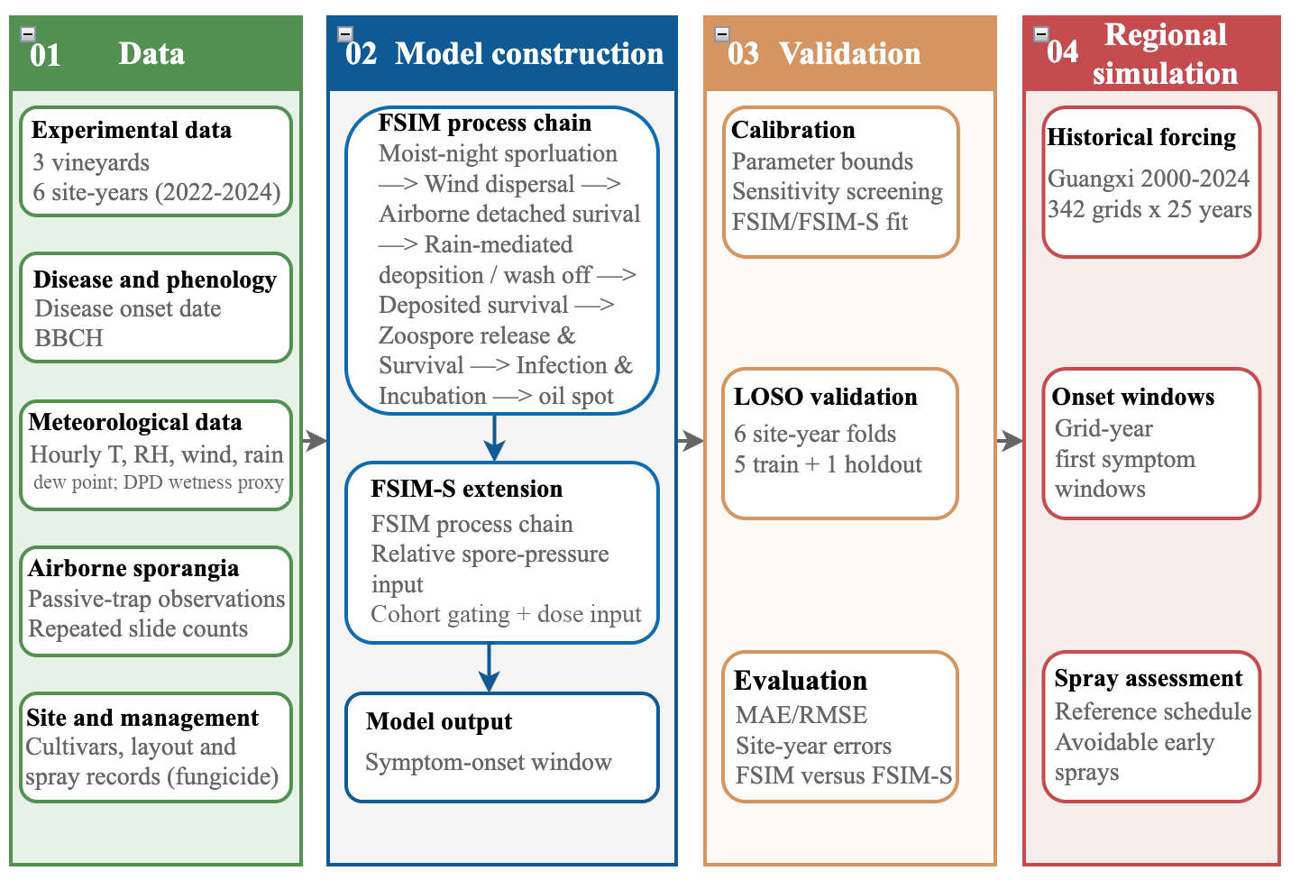
Figure 1: Overall workflow of this study. LOSO, leave-one-site–year-out cross-validation.

2.2 Field experiments and data collection

2.2.1 Site description, climate, vineyard layout
Field experiments were conducted from 2022 to 2024 in three grape production orchards in Guangxi, China: Xing’an in Guilin, Du’an in Hechi, and Jiangnan in Nanning. The orchards were selected to represent common local production scales and cultivars, and their site characteristics are summarized in Table 1 (Figure 2a,b).
The study sites have suitable autumn–winter conditions, with relatively mild temperatures, high humidity, and recurrent rainfall (Figure 3). Orchards surrounding the experimental sites commonly use a double-cropping production system.
Under this system, vines are pruned and forced again after the first crop is harvested. The autumn crop then continues to develop through autumn and is harvested in January of the following year, allowing grape production to continue through the cool season.
At each vineyard, two management treatments were established to distinguish natural infection dynamics from management-modified disease pressure: a traditional treatment (TT), in which fungicides were applied following local management calendars, and a no-spray control (CK), in which no fungicides were applied. A completely randomized design was used, with three replicates per treatment, resulting in six observation plots per vineyard. Each plot consisted of six uniformly growing vines, which were used for subsequent phenological and disease monitoring.
Table 1 Characteristics of experimental vineyard sites in Guangxi, China.
City/County | Lat, Lon | Cultivar | Orchard type | Planting year | Grape use | Row $×$ Spacing (m)
Xing’an, Guilin | 25.45°N, 110.80°E | Wink (WK) | Commercial | 2018 | Table | 2.5$×$2.5
Du’an, Hechi | 23.83°N, 108.10°E | Yeniang No. 2 (MPT) | Commercial | 2015 | Wine | 2.5$×$2.5
Jiangnan, Nanning | 22.61°N, 108.23°E | Kyoho (JF) | Experimental | 2020 | Table | 3.2 $×$3.0
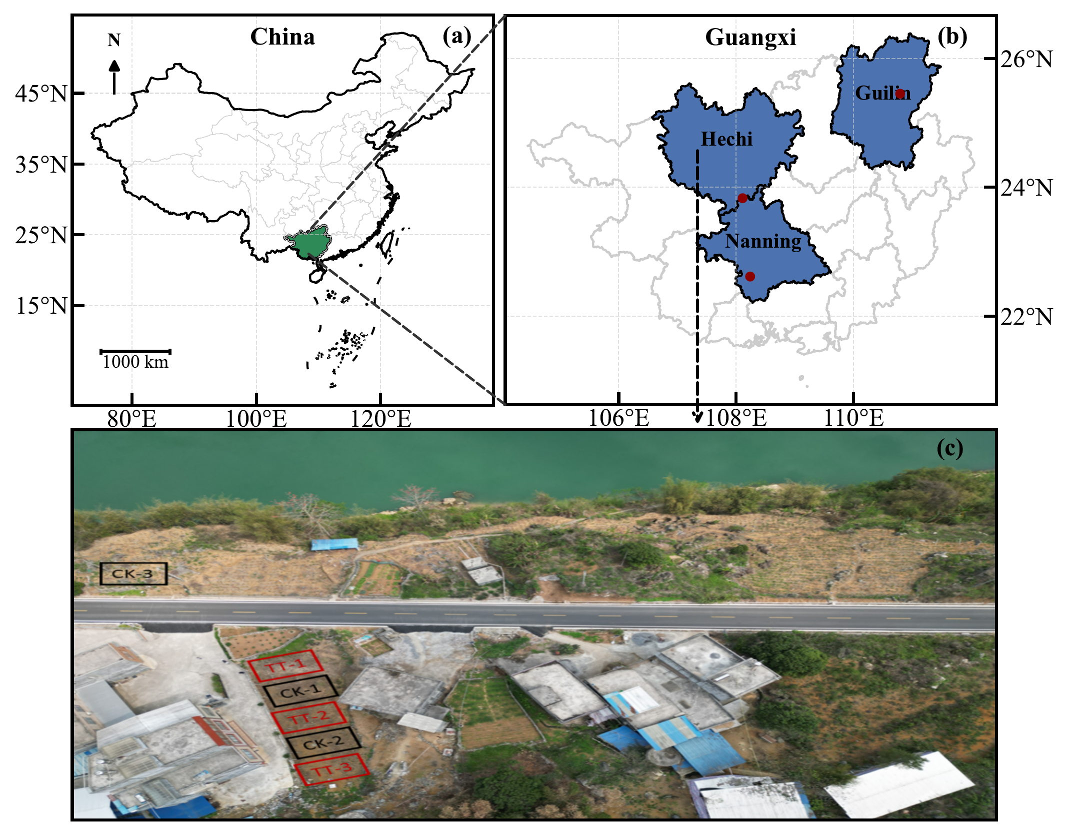
Figure 2: Study sites and field layout. (a) Location of Guangxi within China. (b) Spatial distribution of the three field experiment sites (Guilin, Hechi, and Nanning) in Guangxi Province; red circles indicate the locations of the experimental orchards. (c) Plot layout at the Du’an site in Hechi City, where black rectangles denote the three untreated control plots (CK).
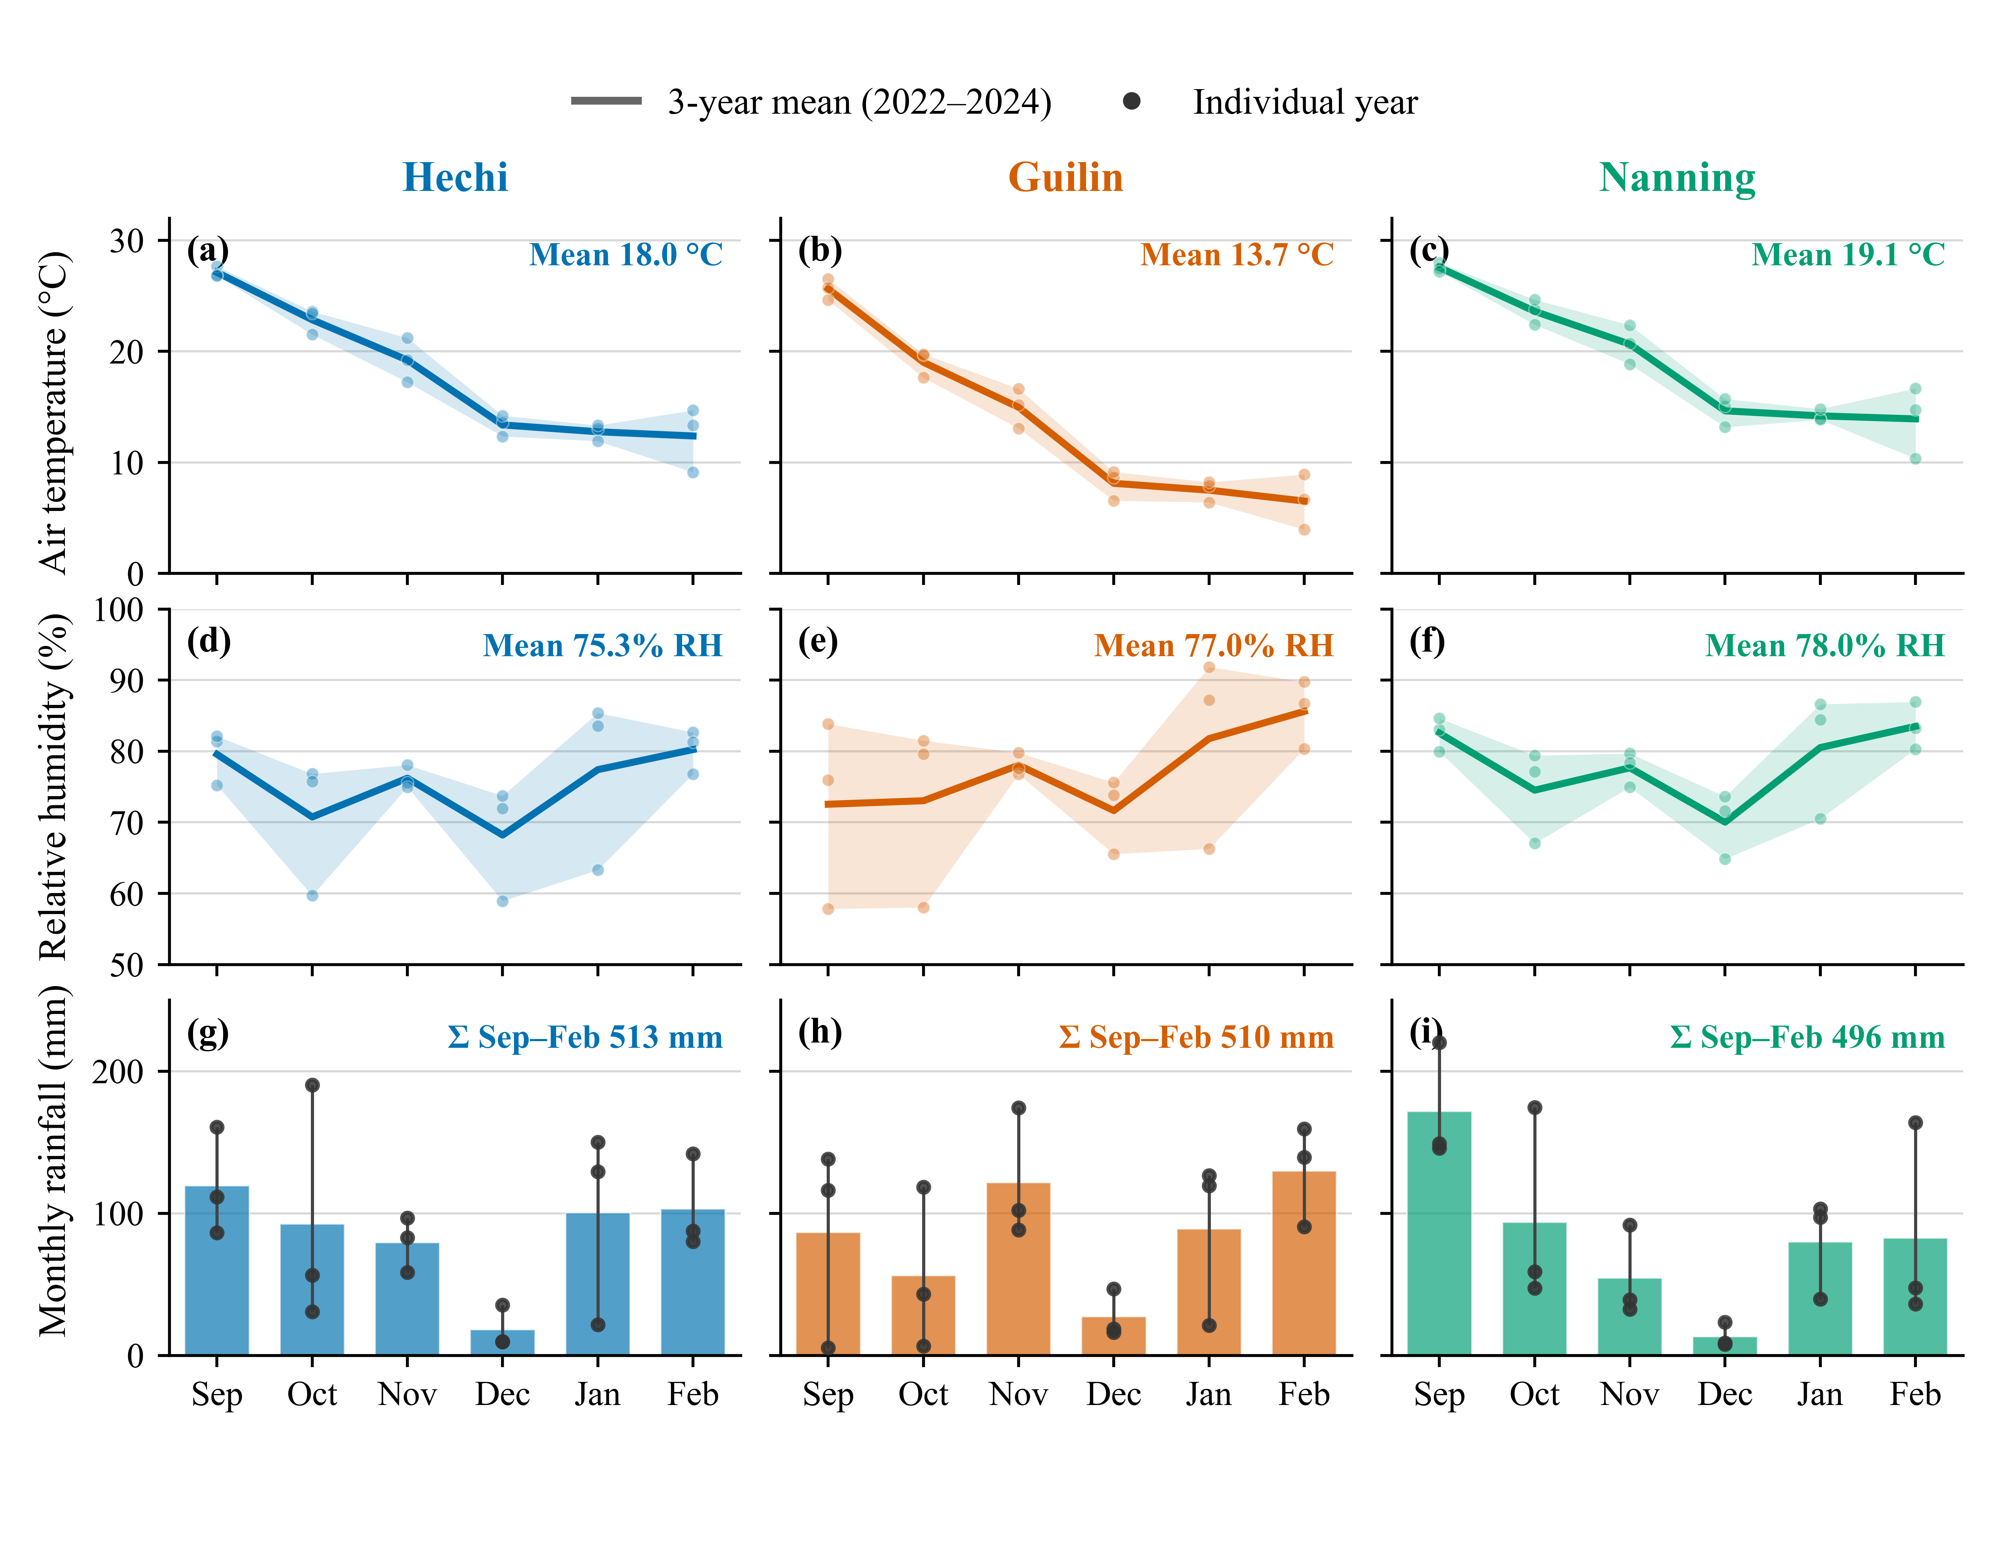
Figure 3: Monthly autumn–winter air temperature, relative humidity, and rainfall at the three study sites in Guangxi, China, summarized from 2022–2024 observations.

2.2.2 Disease and phenology data collection
Grapevine phenological development and downy mildew progression were monitored throughout the growing season following a standardized field observation protocol. All assessments were conducted in situ by trained technicians and recorded using a dedicated WeChat-based mobile data collection system (“Nong Qing Zhu Shou”), which provided structured interfaces for the extended Biologische Bundesanstalt, Bundessortenamt and Chemische Industrie (BBCH) scale,¹⁷ lesion annotation, automatic time-stamping, GPS geolocation, and image capture. Records were uploaded directly to a cloud database, allowing continuous checks of data completeness and internal consistency.
Observation frequency was adjusted according to developmental stage: surveys were conducted weekly from BBCH 00 to BBCH 13 (dormancy to three unfolded leaves), and every three days thereafter as vines entered the susceptible period for downy mildew. Suspected lesions were photographed and centrally reviewed; the first confirmed oil spot in any observation plot defined the first symptom-onset date (Figure 4b).
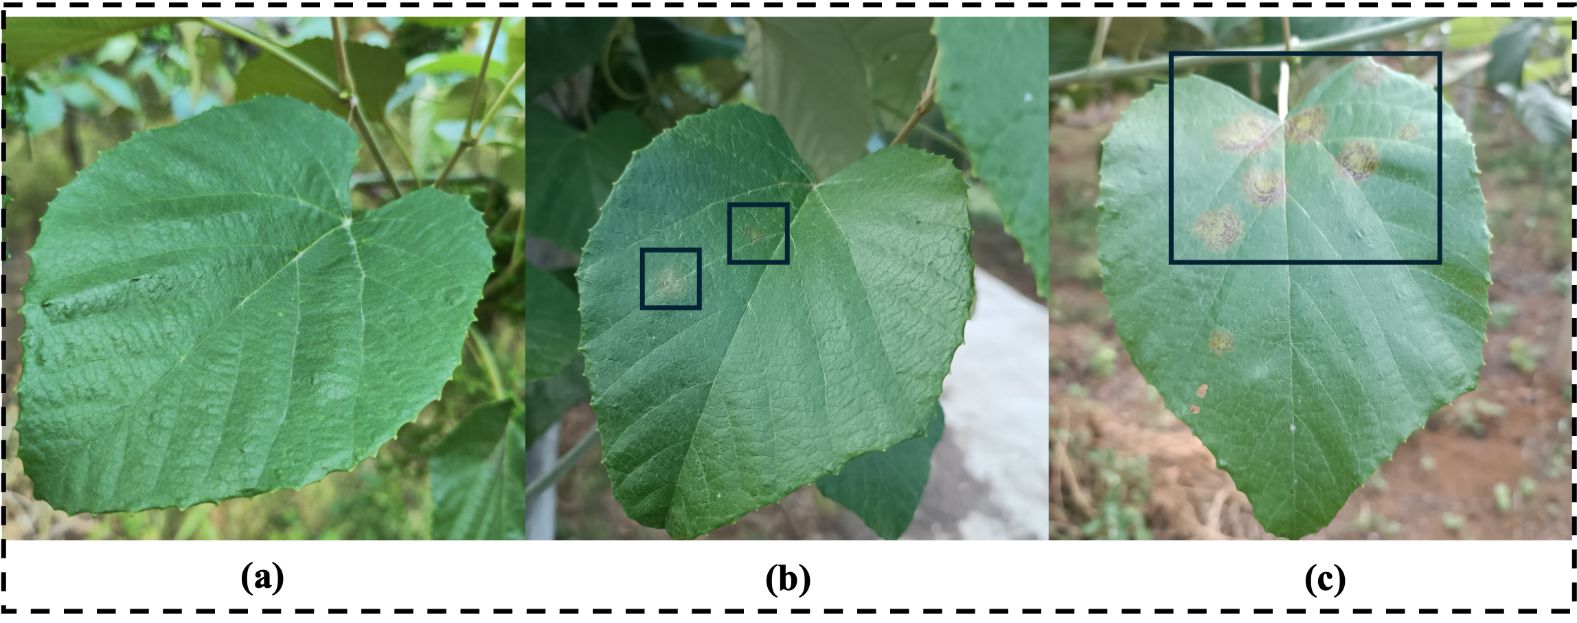
Figure 4: Downy mildew lesion emergence and development on Yeniang No. 2 (MPT) leaves in the Du’an experimental vineyard, Hechi. Panels show severity levels from a single-leaf perspective: (a) healthy; (b) 1% (post-incubation visible lesion); (c) 5%. Photos by team member Qi Tian (2023).

2.2.3 Airborne sporangia monitoring
At each vineyard, one passive spore trap (model TPBZ1, Zhejiang Top Cloud-Agri Technology Co., Ltd., China) was installed adjacent to CK-1, the fungicide-free control plot, to monitor the airborne dispersal of P. viticola sporangia. The air inlet was positioned approximately 1.5 m above ground level, matching the average grapevine canopy height. The device sampled sporangia through natural ambient airflow without powered air suction.
Sporangia were collected on glass slides coated with a thin layer of Vaseline, which were replaced every three days. Samples were sealed and transported to the laboratory of the Guangxi Academy of Agricultural Sciences for quantitative analysis. For microscopic observation, each slide was rinsed with 300 $μ$L of sterile water, and five 30 $μ$L subsamples were collected from different depths of the rinse solution to minimize bias associated with particle sedimentation (Figure 5b–d). Subsamples were transferred to concave glass slides for microscopic observation and imaging.
Images and resulting counts were independently verified by two trained laboratory technicians before being used in model calibration and validation (Figure 5c).
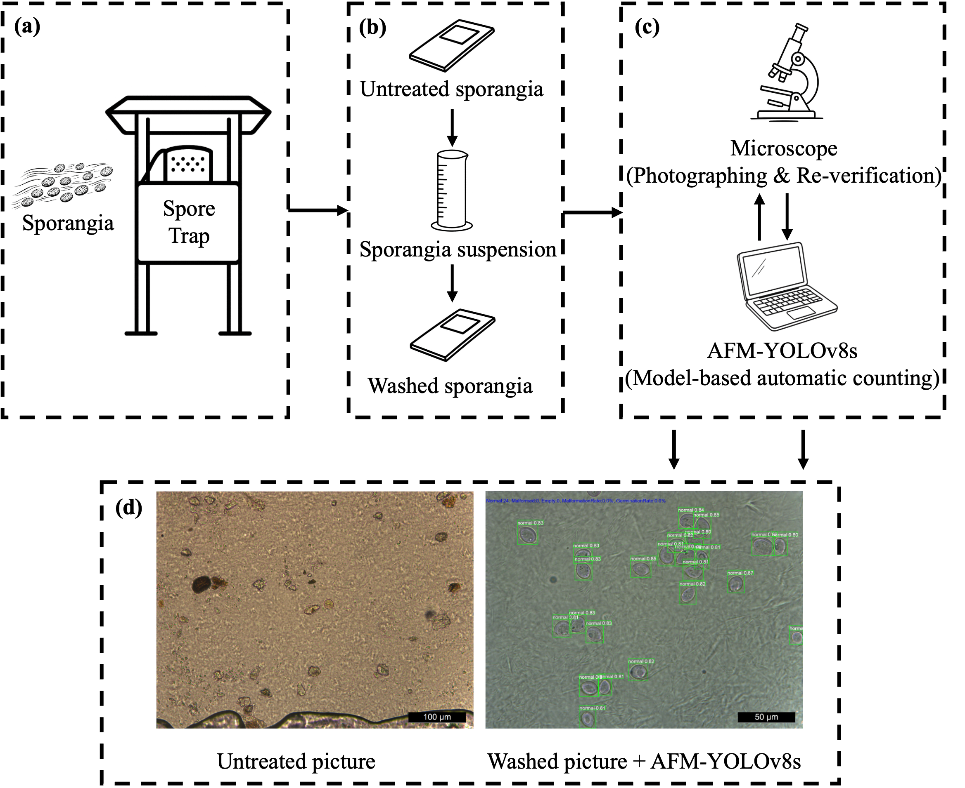
Figure 5: Schematic illustration of sporangia collection and processing in the vineyard experiment. (a) Schematic of dynamic monitoring of sporangia; (b) schematic of laboratory preprocessing; (c) schematic of sporangia image and quantity acquisition; (d) representative sporangia images obtained from the untreated sporangia slide and the washed sporangia slide.

2.2.4 Meteorological data
Meteorological data were retrieved from the Open-Meteo platform (https://open-meteo.com/), which provides ERA5 reanalysis products with hourly temporal resolution.¹⁸ For each experimental orchard, geographic coordinates were used to extract site-specific time series of air temperature (T), relative humidity (RH), wind speed (W), dew-point temperature (T_{d}), and precipitation (R). Attached- and detached-state sporangial mortality used the empirical index $x=T(1-RH/100)$, which is distinct from physical vapour pressure deficit.¹⁰ Because direct leaf-wetness observations were unavailable, dew-point depression (DPD) was used as a leaf-wetness proxy.¹⁹ DPD was calculated as $DPD=T-T_{d}$; rainfall or DPD $<2.0$ °C indicated wetness, DPD $>3.8$ °C indicated drying, and intermediate values retained the previous wet/dry state.

2.3 Model structure and refinements

2.3.1 First Seasonal Infection Model (FSIM): baseline mechanistic framework
FSIM represents first-season symptom onset initiated by asexual sporangia under subtropical double cropping (Figure 6). Zoospore release and survival, infection, incubation and symptom expression follow the framework of Rossi et al.,⁸ with upstream sporulation and mortality relations from Brischetto et al.¹⁰ Simulations began on 1 February as a calculation convention within the regional December–February leaf-fall period; this date is not a measured biological activation date.
The adaptation represents recurrent sporangial supply as discrete cohorts tracked through attached and airborne survival, wind dispersal and rainfall-dependent deposition. A viable attached cohort disperses at the first hour $t_{i}^{w}$ with wind speed $W_{t}≥W_{min}$. Its surviving dose $A_{i}(t_{i}^{w})$ enters the airborne pool, where survival $B_{i}(t)$ and effective deposition $D_{i}(t)$ are
$\begin{matrix}B_{i}(t)=A_{i}(t_{i}^{w})max​\left(1-\sum_{u=t_{i}^{w}}^{t}{μ_{B}}(u), 0\right) t≥t_{i}^{w} \\ D_{i}(t)=\left\{\begin{matrix}B_{i}(t) & \text{if }i∈B(t), B_{i}(t)>0, R_{dep}≤R_{t}<R_{wash} \\ 0 & \text{otherwise}\end{matrix}\right.\end{matrix}$ (1)
where $μ_{B}$ is hourly detached-state mortality, $B(t)$ contains airborne cohorts, and $R_{t}$, $R_{dep}$ and $R_{wash}$ denote hourly rainfall, effective deposition and heavy-rain wash-off thresholds. Rain below $R_{dep}$ leaves viable cohorts airborne; rain at or above $R_{wash}$ removes them. These rainfall thresholds are operational assumptions of this study, not independently validated deposition or wash-off limits. Deposited cohorts proceed through infection and incubation, and the earliest complete symptom window is reported. Pre-symptomatic sporangial captures support this exposure route (Supplementary Figure S1d). Attached-state survival and hourly update rules are detailed in Supplementary Methods S1.

2.3.2 Spore-constrained refinement of the First Seasonal Infection Model (FSIM-S)
FSIM-S constrains inoculum supply using observed sporangium counts, converted to standardized and smoothed daily relative pressure $P(d)$. Numeric zero-count intervals suppress weather-generated cohorts, while positive pressure adds inoculum before dispersal:
$G_{i}^{S}=g(d_{i};β_{sp})G_{i}^{F}+β_{sp}max[P(d_{i}),0]$ (2)
where $G_{i}^{F}$ and $G_{i}^{S}$ are initial relative cohort doses, $d_{i}$ is the generation date, and $β_{sp}≥0$ scales the pressure contribution. The gate $g(d;β_{sp})$ equals zero during numeric zero-count intervals when $β_{sp}>0$, and one otherwise. At $β_{sp}=0$, both observation-based constraints are disabled and FSIM-S reduces exactly to FSIM. Missing entries are not treated as measured zeros and do not independently trigger either constraint. Subsequent processes follow FSIM (Figure 6); interval reconstruction, normalization and smoothing are detailed in Supplementary Methods S2.
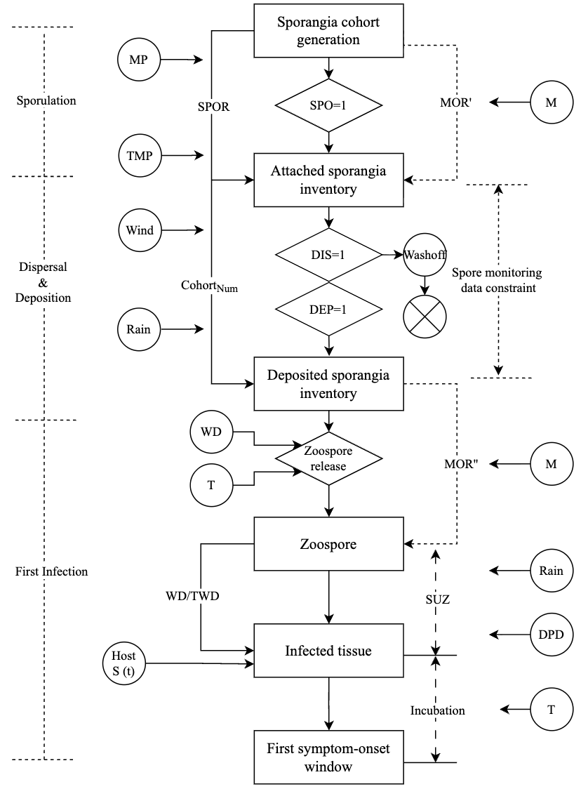
Figure 6: Conceptual framework of FSIM and FSIM-S. DPD, dew-point depression; M, mortality index; RH, relative humidity; W, wind speed; R, rainfall; T, air temperature.

2.4 Parameterization and sensitivity analysis
Global parameter influence was quantified for the sporangia-process route using variance-based Sobol sensitivity analysis.^{20–22} Six process parameters were screened across all six observed site–years in FSIM with the observation layer disabled; neither zero-count gating nor observed-pressure dose injection was applied. Inherited biological response functions were held fixed. First-, total- and second-order indices were estimated using SALib at base sample sizes $N=256$, 512 and 1024; rankings were compared across designs. The analysis informed parameter screening rather than calibration. Sampling domains, site–years, output definitions and confidence estimation are provided in Supplementary Methods S3 and Table S1.

2.5 Model calibration and evaluation
Both models used the same weather, observed phenology and host susceptibility modifier, reflecting developmental variation in susceptibility.^{23,24} The modifier is detailed in Supplementary Methods S5. FSIM-S additionally used observed relative spore pressure.

2.5.1 Calibration strategy
Six leave-one-site–year-out folds each used five site–years for calibration and one for evaluation. Sensitivity screening and manual perturbations informed the three fixed and three adjustable FSIM parameters (Table 2). Adjustable parameters were evaluated jointly using training interval errors and a missing-window penalty. Among near-optimal candidates, selection favoured proximity to their normalized median parameter vector. With FSIM parameters fixed, $β_{sp}$ was compared on the same training records using training MAE. All positive candidates had identical training MAE, RMSE and bias within each fold, and the smallest positive candidate, 0.005, was retained in all six folds. Thus, this coefficient represents a tied optimum on the tested grid rather than a uniquely identified estimate; the median-centre rule applied to FSIM process parameters only. Both configurations were then fixed for held-out evaluation; held-out disease-onset observations did not enter selection. Candidate grids, selection rules and fold aggregation are detailed in Supplementary Methods S4.

Table 2 Fixed and calibrated parameters for FSIM and FSIM-S. Space and step describe the candidate evaluation; values are the fixed settings or selected deployment values.
Model | Parameter | Space | Step | Value | Unit | Description
FSIM / FSIM-S | Wind-speed threshold (WTH) | Fixed | / | 0.5 | m s⁻¹ | Minimum wind speed for sporangial dispersal.
FSIM / FSIM-S | Heavy-rain wash-off threshold (HWR) | Fixed | / | 5 | mm h⁻¹ | Hourly rainfall at or above this threshold removes airborne cohorts.
FSIM / FSIM-S | Minimum moist hours (MMH) | Fixed | / | 7 | h | Minimum night-time moist duration for sporulation.
FSIM / FSIM-S | Infection degree-hour threshold (IDH) | 150–200 | 10 | 170 | °C h | Post-release infection requirement.
FSIM / FSIM-S | Effective deposition rainfall threshold (EDR) | 3.80–3.95 | 0.05 | 3.85 | mm h⁻¹ | Minimum rainfall for effective deposition.
FSIM / FSIM-S | Sporulation relative-humidity threshold (SRH) | 80–100 | 5 | 85 | % | Minimum relative humidity for sporulation initiation.
FSIM-S | Relative spore-pressure coefficient ($β_{sp}$) | 0–1 | Nonuniform candidates | 0.005 | 1 | Scales the positive relative spore-pressure dose.
Note: The wind-speed threshold, heavy-rain wash-off threshold and minimum moist hours were fixed based on local meteorological conditions and their effects on model structure.

2.5.2 Performance metrics
Visible disease-onset observations were interval-censored by the three-day survey schedule during the susceptible period. For site–year $i$, let $t_{i}^{-}$ be the last disease-negative survey date and $t_{i}^{+}$ the first disease-positive date, defining $O_{i}=[t_{i}^{-},t_{i}^{+}]$ with $t_{i}^{-}=t_{i}^{+}-3 d$. For the first complete simulated window ${\hat{O}}_{i}=[{\hat{t}}_{i}^{-},{\hat{t}}_{i}^{+}]$, signed error was
$e_{i}=\left\{\begin{matrix}0, & {\hat{t}}_{i}^{-}≤t_{i}^{+} and {\hat{t}}_{i}^{+}≥t_{i}^{-}, \\ {\hat{t}}_{i}^{-}-t_{i}^{+}, & {\hat{t}}_{i}^{-}>t_{i}^{+}, \\ {\hat{t}}_{i}^{+}-t_{i}^{-}, & {\hat{t}}_{i}^{+}<t_{i}^{-}.\end{matrix}\right.$ (3)
Overlapping windows have zero error; positive and negative errors denote late and early predictions. For complete predictions $C$,
MAE=1|C|i∈C​|ei|, RMSE=1|C|i∈C​ei2. (4)
Missing complete windows received a 60-day calibration penalty. Evaluation reported complete-window MAE, RMSE, signed mean error and coverage. Penalty and aggregation definitions are given in Supplementary Methods S4.

2.5.3 Selection of global parameter configuration
After validation, deployment parameters were obtained by fold consensus: identical values were retained; otherwise, the unique mode was selected, with the median used for tied modes. FSIM-S shared the FSIM process parameters, with $β_{sp}$ aggregated separately (Table 2; Supplementary Methods S4).

2.6 Regional simulation and disease-management scenario analysis
Regional simulations were conducted across Guangxi for 2000–2024 to assess the regional applicability of FSIM and its potential for disease management guided by predicted risk windows. Given the limited spatial coverage of field observations and the absence of a spatially explicit vineyard census layer, the analysis used hypothetical cultivation scenarios rather than a complete map of actual vineyard distribution. To represent differences in phenological progression and ripening among table and wine grape cultivars,²⁵ two scenarios were defined for retrospective comparison, assuming table grapes or wine grapes throughout the region, respectively. FSIM was driven by hourly ERA5 weather for 342 grid cells at ${0.25}^{∘}$ resolution and simulated phenology. The regional archive used existing Open-Meteo-derived ERA5 records; the 2004 records were rebuilt from the Google Earth Engine ERA5 hourly collection. All hourly series and daily aggregations used Beijing time (UTC+8). Regional onset summaries used the midpoint of the first complete symptom window, whereas the savings calculation used its start to define the timing threshold. Dates are expressed as day of year (DOY).
A fixed reference downy mildew fungicide programme was based on the 2022 records from the experimental vineyard in Du’an, Hechi (Figure 7). Potential reductions in early preventive applications were assessed retrospectively against this programme. A preventive application more than seven days before the start of the simulated first symptom window was classified as potentially avoidable. The seven-day buffer was a retrospective scenario assumption, informed by the lower end of recommended 7–10-day protectant spray intervals.²⁶ Infection precedes symptoms, so this rule does not identify the start of infection risk or establish that earlier protection can safely be omitted. For grid–years with no complete simulated symptom window (eight per scenario), all reference applications were counted as potentially avoidable under this assumption. The fixed programme is a comparison baseline, not a survey of regional practice. The mean annual number of potentially avoidable early applications and the corresponding proportion of the reference programme were calculated for each scenario.
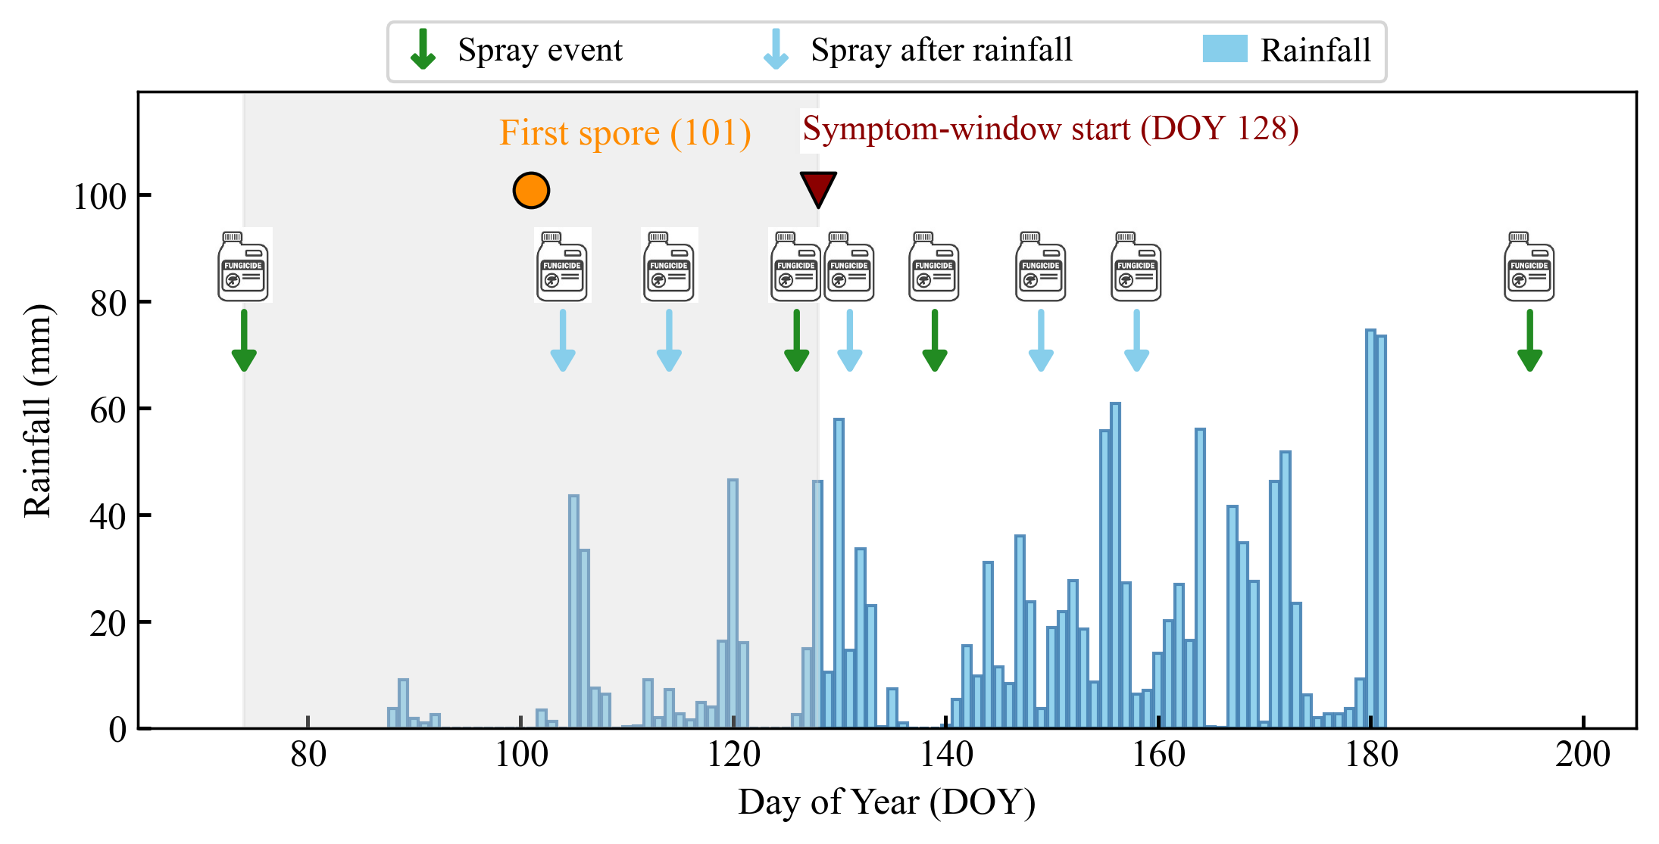
Figure 7: Illustration of the empirically executed fungicide application pattern, documented by field investigators immediately after each grower-implemented spray event in the experimental vineyard in Du’an, Hechi City, during the 2022 growing season. The management practice was characterized by preventive fungicide applications conducted after rainfall events and before the onset of first visible symptoms. The shaded region indicates the corresponding pre-symptomatic period of rainfall-triggered preventive sprays. DOY 128 is the start of the observed symptom-onset window (DOY 128–131); the first symptom-positive assessment was on DOY 131.

2.6.1 Phenology simulation
Regional phenology used separate table- and wine-grape thermal-time profiles calibrated against local stage targets, including assumed Nanning budburst dates. Daily growing degree days (GDD) were calculated as follows:²⁷
${GDD}_{d,g}=max({\overline{T}}_{d}-T_{b,g},0)$ (5)
where ${\overline{T}}_{d}$ is the Beijing-time daily mean temperature and $T_{b,g}$ the profile-specific base temperature. Accumulation began at the fitted start DOY and reset after BBCH09, 65 and 81. When unobserved, BBCH53 was assigned 30% of the BBCH09–65 forcing requirement as a fixed empirical interpolation. Calibration targets, profile comparison, stage thresholds and the basis of this auxiliary rule are given in Supplementary Methods S5 and Tables S2–S4.

3 RESULTS

3.1 Field observations of disease onset and spore dynamics
Across the six site–years, observed disease-onset windows spanned 19–22 April (Nanning 2024) to 27–30 May (Guilin 2022). Spore-positive collections recorded up to the corresponding onset dates spanned 30 March (Nanning 2023) to 30 May (Guilin 2022), with counts of 1–84 per collection (Figure 8). The earliest first disease-positive assessment occurred in Nanning 2024 (22 April), whereas the latest occurred in Guilin 2022 (30 May); the earliest and latest first spore-positive observations were in Nanning 2023 (30 March) and Guilin 2022 (17 April), respectively. The final spore-positive collection coincided with the first disease-positive assessment in four site–years, whereas it preceded that assessment by 9 days in Hechi 2022 and 3 days in Nanning 2023.
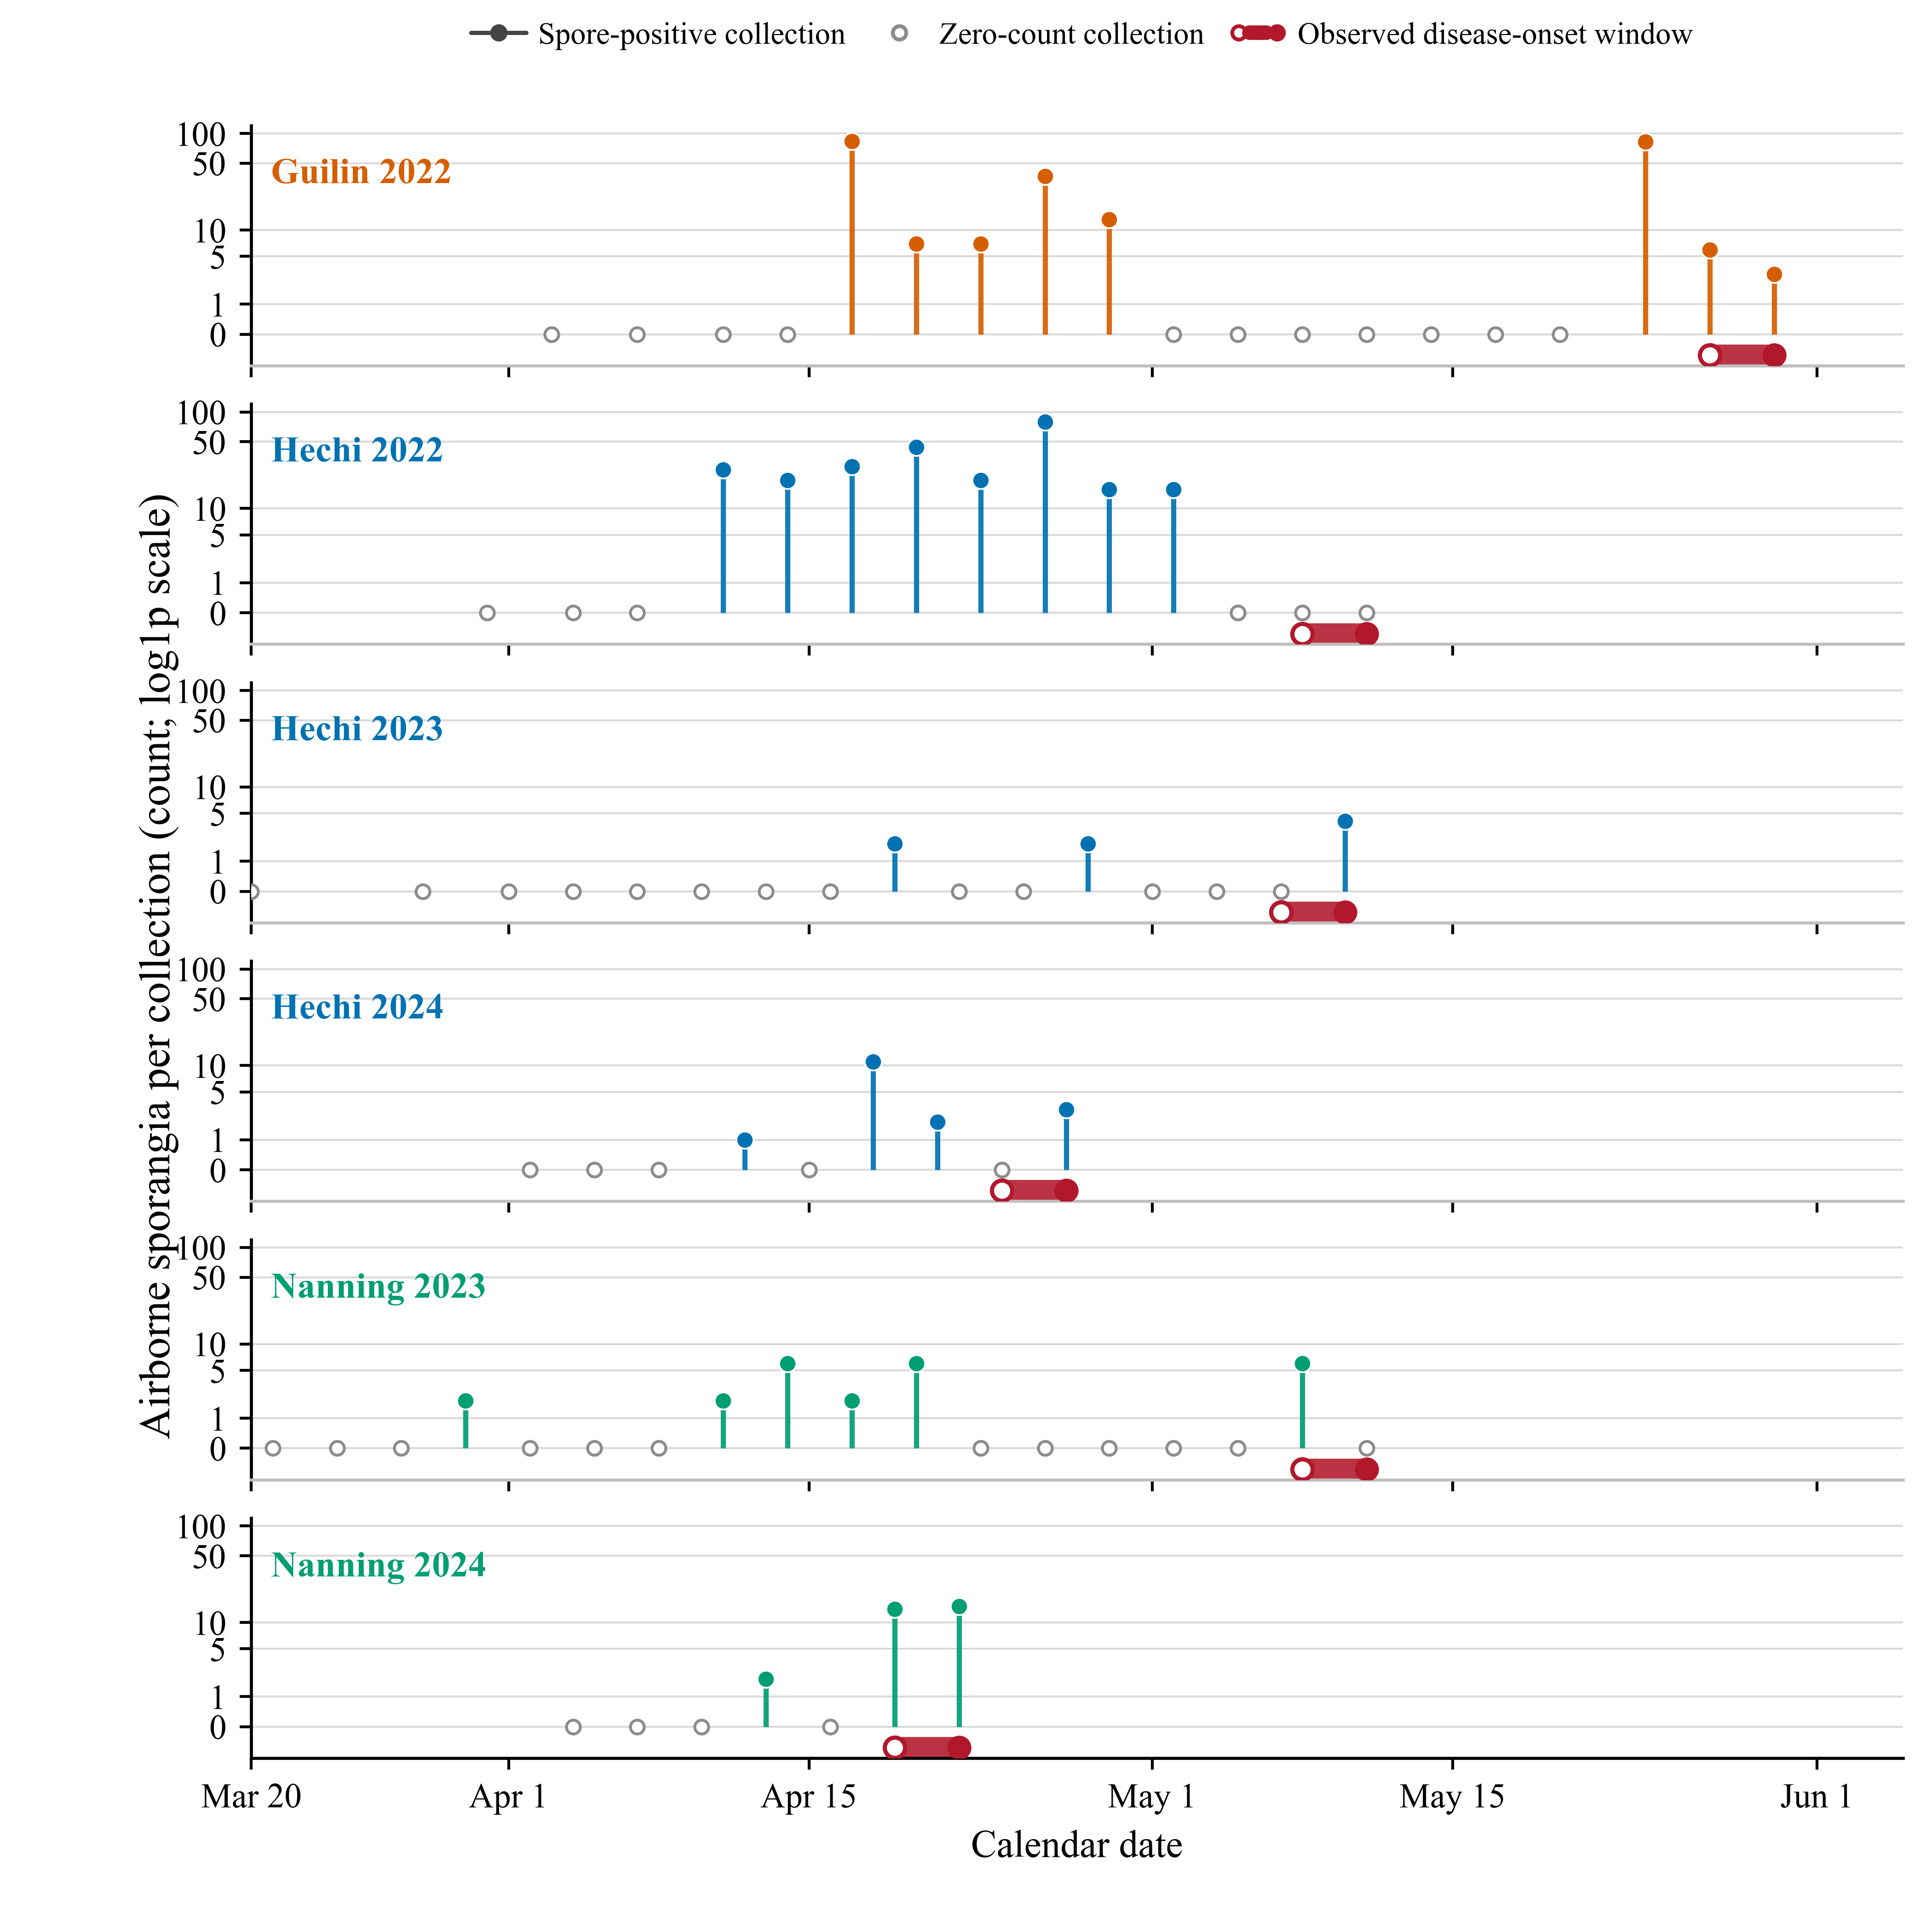
Figure 8: Experimental observations from Guangxi. Spore-positive and zero-count collections are shown on a common calendar axis; red bars denote disease-onset windows between the last negative and first positive assessments.

3.2 Sensitivity analysis
At $N=1024$, the total-order sensitivity ranking across six site–years was EDR > SRH > WTH > HWR > IDH > MMH (Figure 9). EDR dominated the variation in the censored mean first symptom-onset day, with $S_{1}$ = 0.740 and $S_{T}$ = 0.817. Total-order indices were 0.097 for SRH, 0.093 for WTH, 0.087 for HWR, 0.020 for IDH and 0.009 for MMH. Across $N=256$, 512 and 1024, EDR remained dominant ($S_{T}$ = 0.795–0.832) and SRH ranked second. WTH and HWR exchanged ranks, while IDH and MMH consistently had smaller effects. The overlapping 95% confidence intervals for SRH, WTH and HWR indicate that their relative ordering was less clearly resolved than EDR’s dominance.
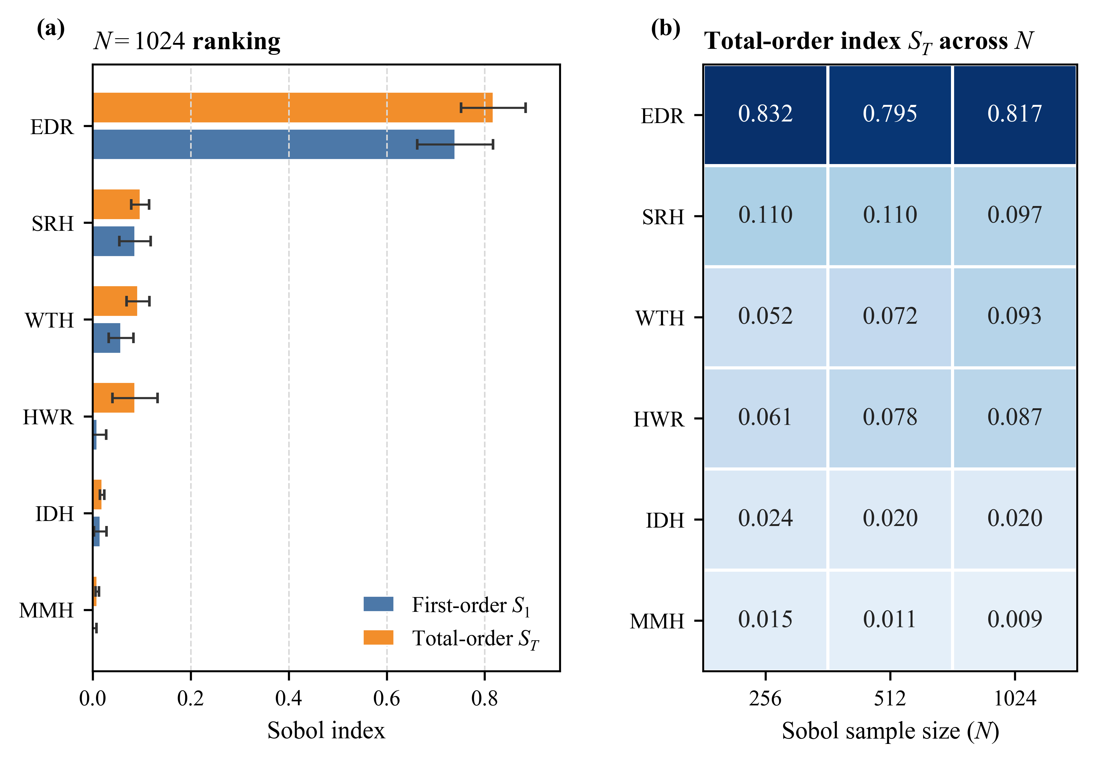
Figure 9: Sobol sensitivity of six FSIM parameters for the censored mean first symptom-onset day across six site–years. (a) First-order ($S_{1}$) and total-order ($S_{T}$) indices at $N=1024$; (b) total-order indices across $N=256$, 512, and 1024. Error bars show 95% bootstrap confidence intervals. Parameter abbreviations: EDR = effective deposition rainfall threshold; SRH = sporulation relative-humidity threshold; MMH = minimum moist-hour threshold; HWR = heavy-rain wash-off threshold; IDH = infection degree-hour threshold; WTH = minimum wind-speed threshold.

3.3 Model performance
FSIM had a training-set MAE of 5.67 days and RMSE of 7.18 days, and a validation-set MAE of 5.67 days and RMSE of 7.26 days (Figure 10).
FSIM-S had a training-set MAE of 3.83 days and RMSE of 5.99 days, and a validation-set MAE of 3.83 days and RMSE of 6.18 days. Relative to FSIM, MAE decreased by 32.4% in both sets; RMSE decreased by 16.6% in the training set and 14.9% in the validation set.
From FSIM to FSIM-S, the site–year errors changed as follows: Hechi 2024, 0 to 0 days; Hechi 2023, -6 to +4 days; Hechi 2022, -14 to -14 days; Nanning 2024, +4 to +4 days; Nanning 2023, +2 to +1 days; and Guilin 2022, -8 to 0 days (Figure 11). Zero error occurred for Hechi 2024 under both models and for Guilin 2022 under FSIM-S. The largest error magnitude was 14 days in Hechi 2022 and remained unchanged between models.
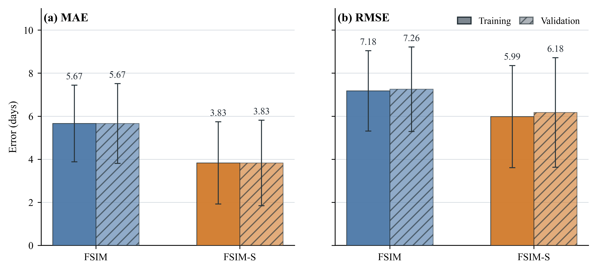
Figure 10: Aggregate first symptom-onset errors for FSIM and FSIM-S. (a) Mean absolute error (MAE); (b) root mean square error (RMSE). Training values are means across six outer folds; validation values summarize the six held-out predictions. Error bars indicate $±$ one bootstrap standard error from site–year resampling with fitted models held fixed. Values are in days.
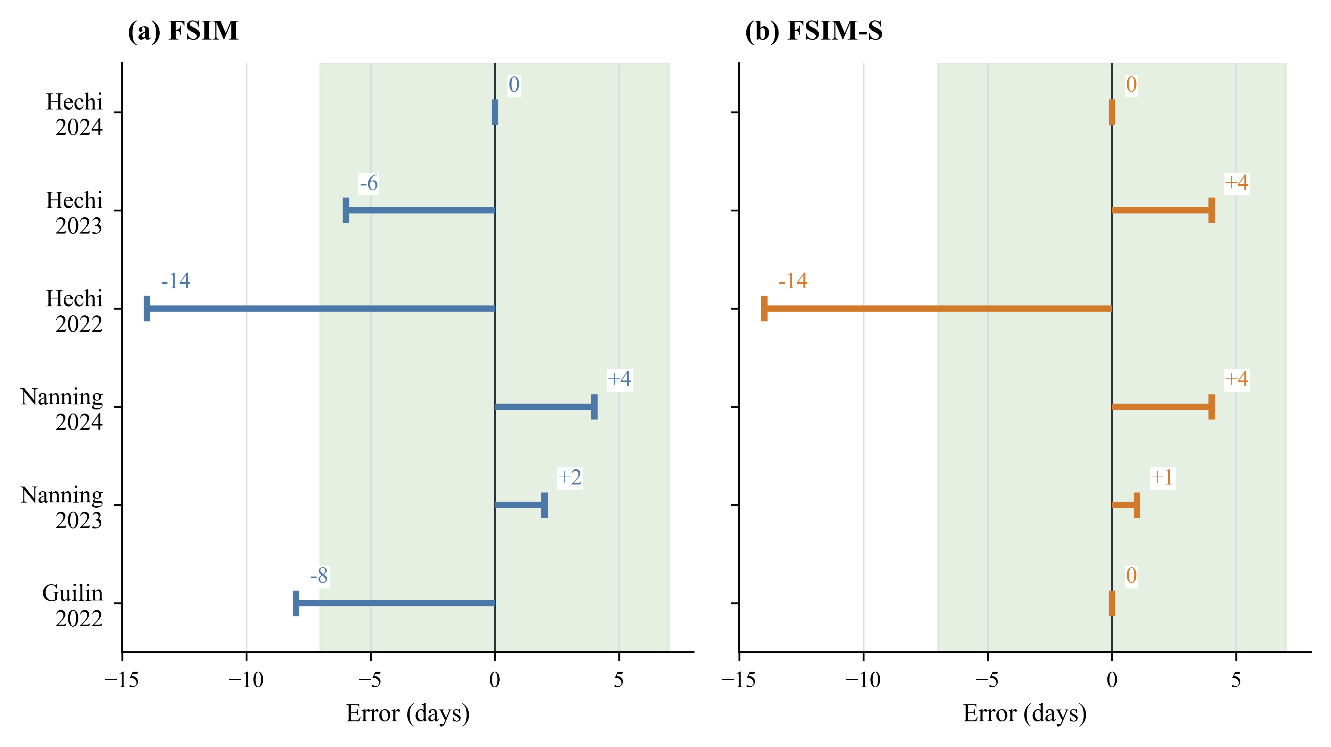
Figure 11: Site–year interval-based errors in first symptom-onset timing for FSIM and FSIM-S. The shaded region indicates signed distances between the simulated and observed windows within $±7$ days; overlapping windows have zero error.

3.4 Spatial distribution of first symptom onset across Guangxi (2000–2024)
During 2000–2024, mean spring temperature was generally higher in southern than northern Guangxi. Cumulative spring precipitation was higher in the east, particularly the northeast, and lower in the west. Nighttime high-humidity duration was generally longer in the southeast and shorter in the northwest (Figure 12a–c).
Across Guangxi, the grid-cell mean first symptom-window midpoints for 2000–2024 averaged DOY 130.4 under the table-grape scenario and DOY 136.3 under the wine-grape scenario, a difference of 5.9 days (Figure 13a,b). Both scenarios showed earlier onset in eastern and southeastern Guangxi and later onset in western Guangxi, particularly the northwest.
The distribution of grid-cell mean onset dates was shifted towards later dates under the wine-grape scenario. The most frequent interval was DOY 120–130 for table grapes and DOY 130–140 for wine grapes (Figure 13c,d). Annual regional mean symptom-window midpoints ranged from DOY 115.7 to 145.6 for table grapes and from DOY 122.8 to 147.8 for wine grapes (Supplementary Figures S2 and S3).
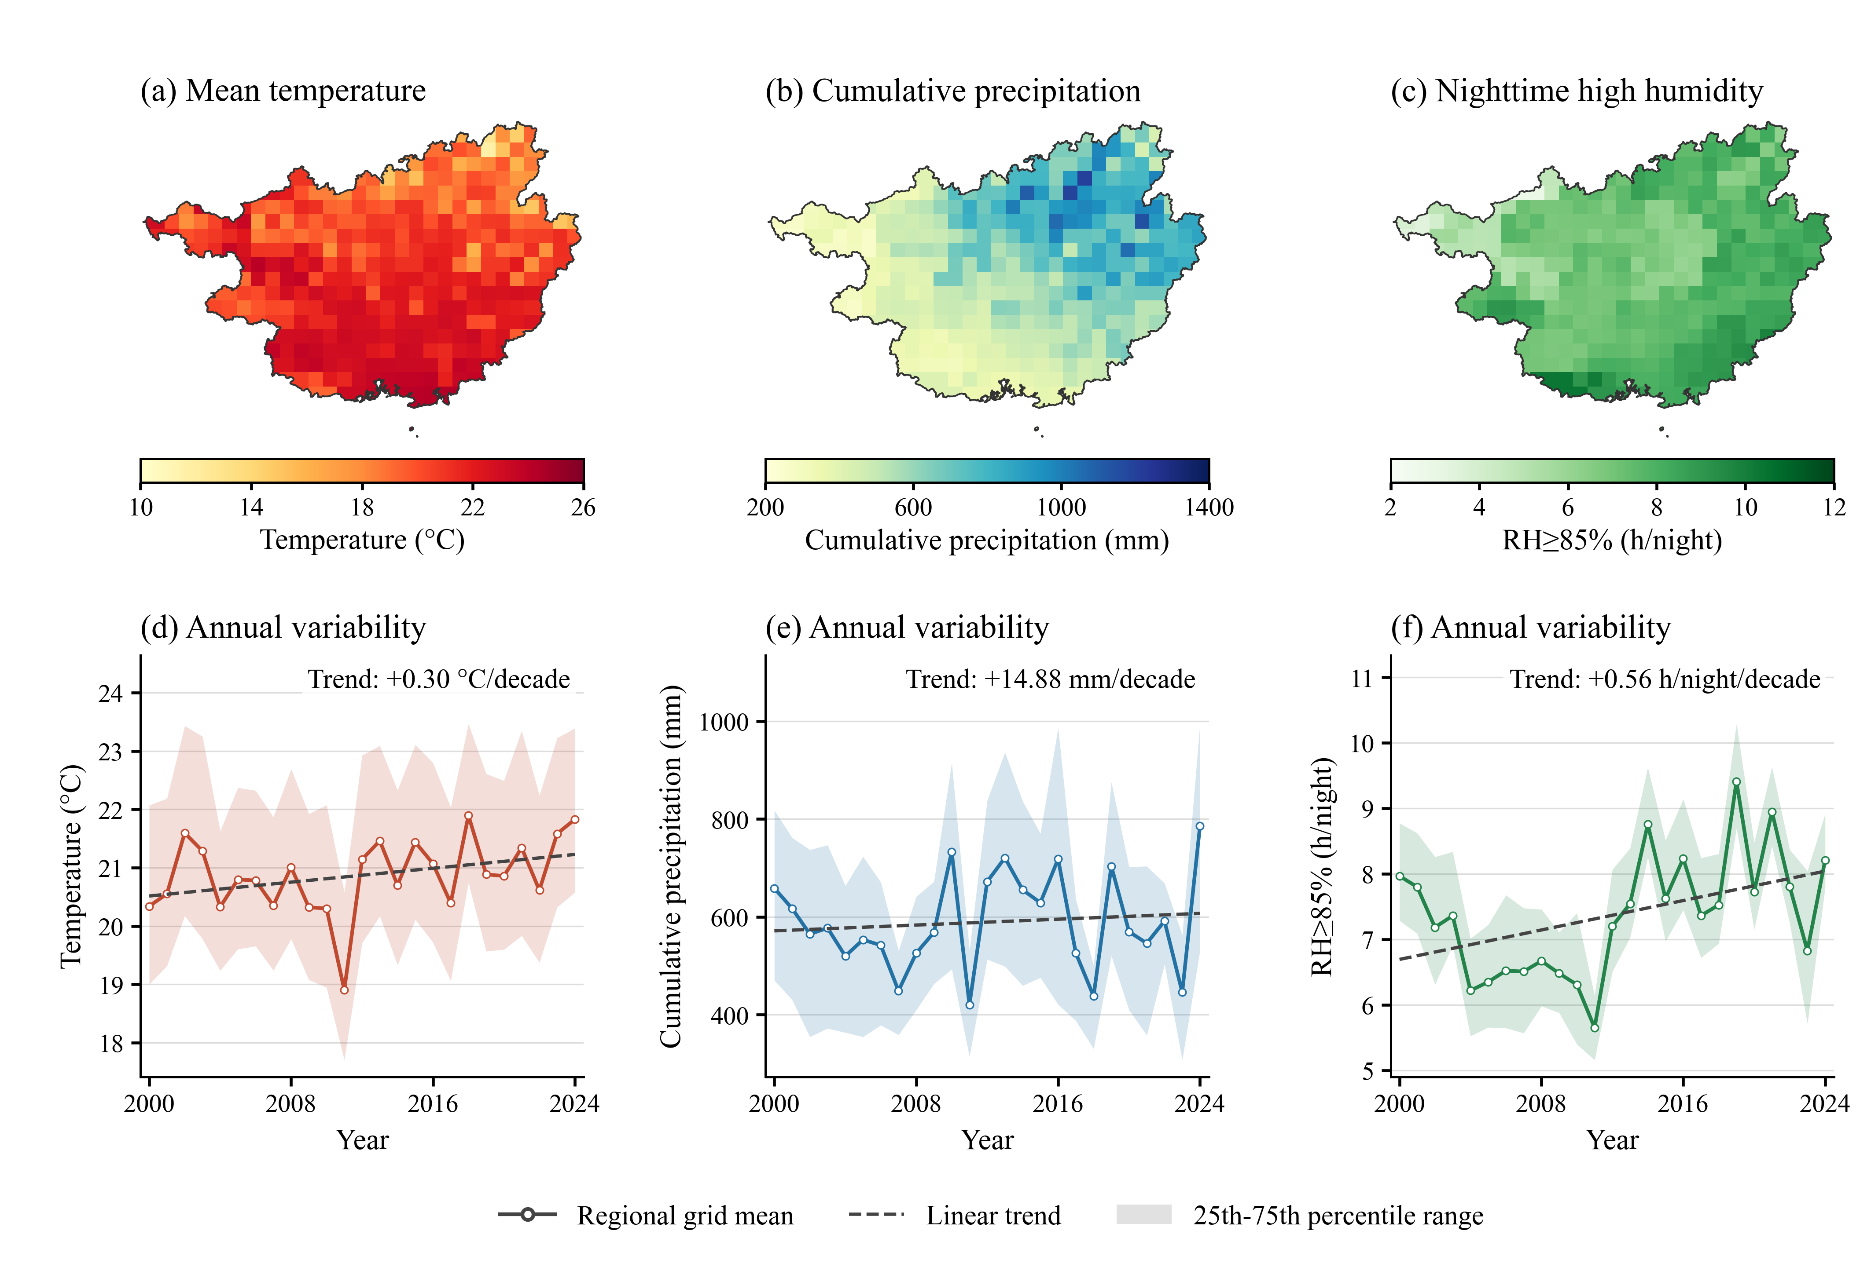
Figure 12: Spring meteorological conditions in Guangxi during 2000–2024 (March–May). (a–c) Grid-cell means for temperature, cumulative precipitation and nighttime high-humidity duration (relative humidity $≥85\%$; 20:00–07:59 local time). (d–f) Annual regional grid means; shading indicates spatial 25th–75th percentile ranges and dashed lines indicate descriptive linear trends.
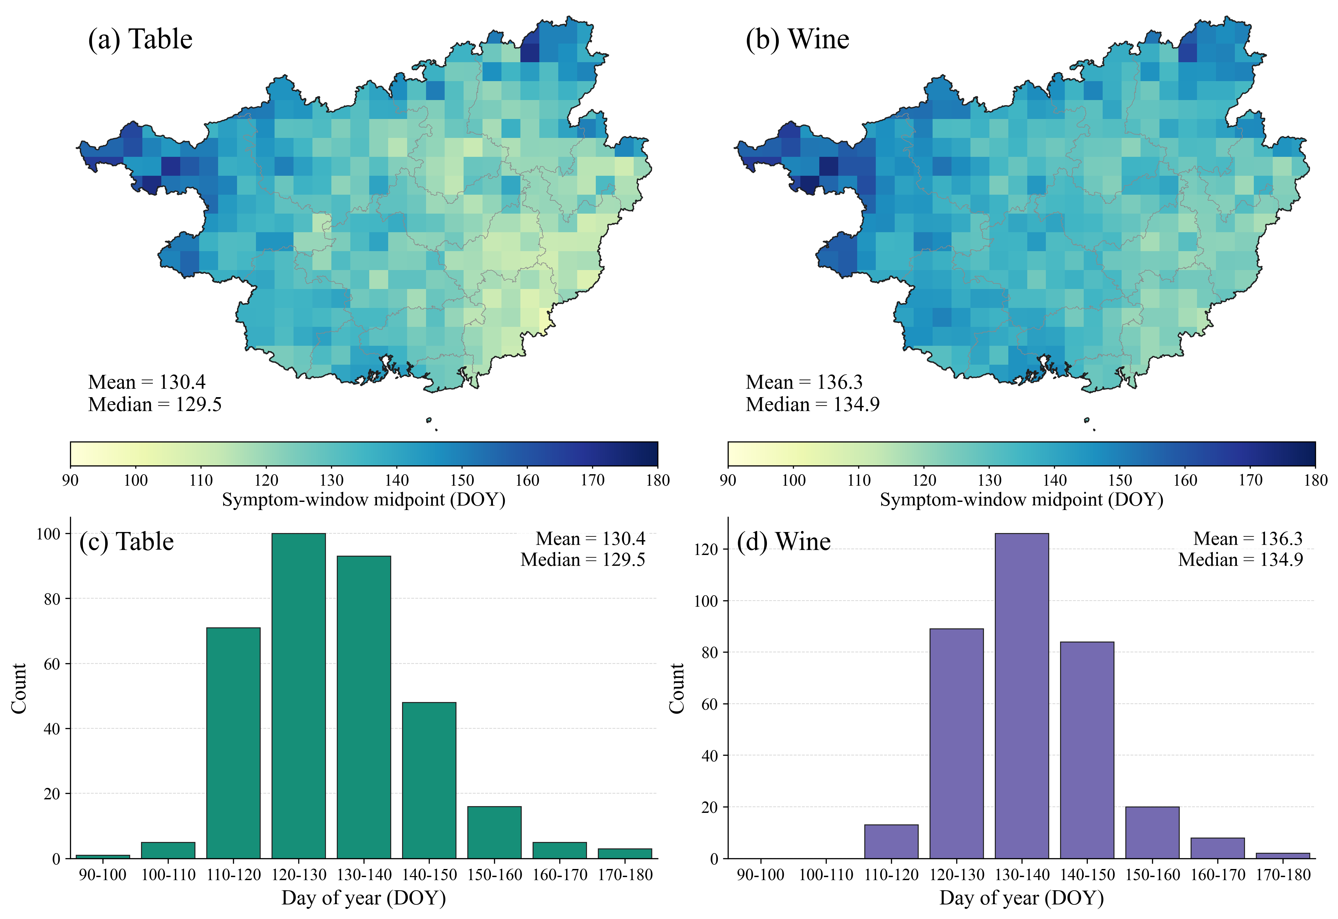
Figure 13: Mean first symptom-window midpoint (day of year, DOY) per grid cell in Guangxi during 2000–2024 under the table- and wine-grape scenarios.

3.5 Regional potential for fungicide savings (2000–2024)
Across Guangxi, the grid-cell mean potential fungicide savings for 2000–2024 averaged approximately 3.5 applications per season under the table-grape scenario and 4.0 under the wine-grape scenario, a difference of 0.5 applications (Figure 14a,b). Both scenarios showed higher saving potential in western Guangxi, particularly the northwest, and lower potential in eastern and southeastern Guangxi.
The distribution of grid-cell mean savings was shifted towards higher values under the wine-grape scenario. The most frequent category was centred on three applications for table grapes and four applications for wine grapes (Figure 14c,d). Annual regional mean potentially avoidable applications ranged from 2.30 to 4.82 under the table-grape scenario and from 2.72 to 5.17 under the wine-grape scenario (Supplementary Figures S4 and S5).
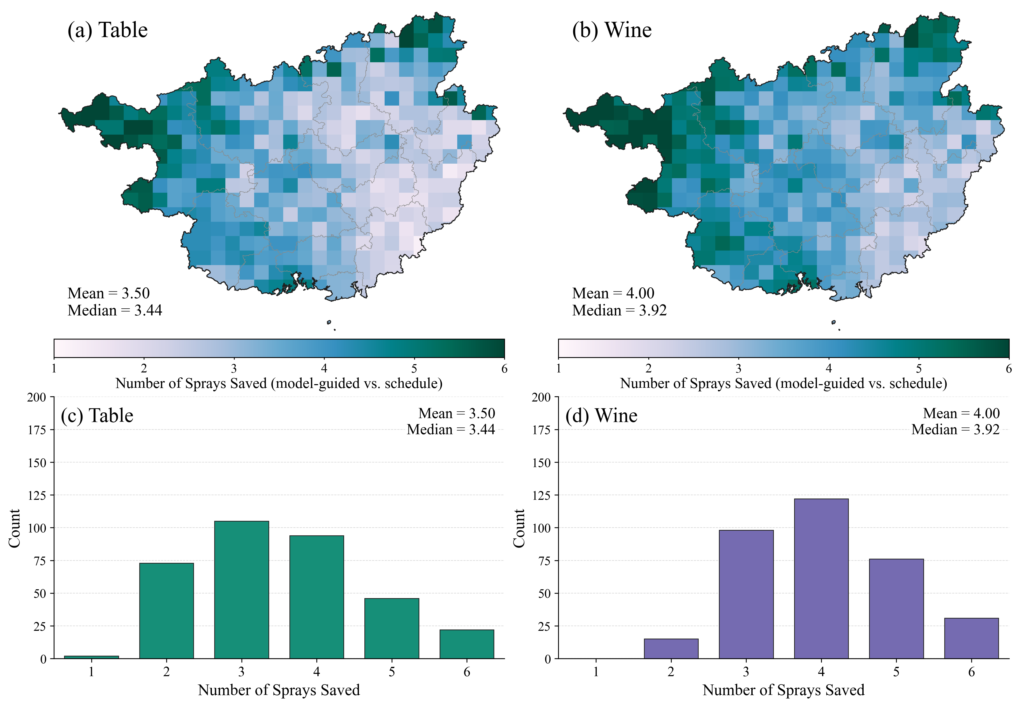
Figure 14: Mean potential fungicide savings (applications per season) per grid cell in Guangxi during 2000–2024 under the table- and wine-grape scenarios. Note: The display range is restricted to 1–6 applications. Eight table-grape grids and 16 wine-grape grids exceed six applications and are treated as outlying events; their values beyond six are not displayed. Figure statistics use values bounded to the display range; the regional means reported in the text include all original values.

4 DISCUSSION

4.1 Airborne inoculum and first seasonal symptom onset under double cropping
In temperate vineyards, winter dormancy interrupts the availability of green host tissue, and overwintered oospores provide an important source of initial inoculum.⁴ In subtropical double-cropping regions, however, successive production cycles can maintain green tissues in neighbouring vineyards even when an individual vineyard undergoes leaf fall. This can allow input of asexually produced sporangia before lesions appear in the new growing season, consistent with the importance of asexual infection reported in warm viticultural regions.^{13,15} Sporangia were captured before the first symptom-positive assessment in all six site–years (Figure 8), confirming the widespread occurrence of external sporangial input across the monitored site-years. However, this study did not trace the source vineyards of the captured sporangia, and a potential contribution from oospores cannot be entirely excluded. A limited role for oospores under these conditions remains possible, given evidence of their formation and germination in southern Brazil.²⁸
Earlier sporangial detection did not consistently precede earlier disease onset. Nanning 2023 had earlier capture but later symptoms than Nanning 2024, with detection-to-assessment intervals of 42 and 9 days, respectively; Guilin 2022 showed a 43-day interval. In Hechi, similar symptom dates in 2022 and 2023 followed different capture timing and counts, whereas similar first capture dates in 2022 and 2024 preceded symptom assessments two weeks apart. These contrasts indicate that neither first detection nor maximum captured count alone can explain symptom onset; interpretation must also account for weather conditions and host susceptibility, consistent with the classical disease triangle framework.⁶

4.2 Model performance and improvement
FSIM achieved good predictive performance, with a cross-validated mean absolute error of 5.67 d. Incorporating spore-pressure dynamics into FSIM-S further reduced the error to 3.83 d, a reduction of 32.4% (Figure 10). Because both models retain the same infection-to-symptom core framework, these results indicate that inoculum availability carries information beyond meteorological suitability alone and can improve predictive performance.⁹
The main methodological advance is the representation of seasonal initiation when the inoculum source is not synchronized with the local crop cycle. Models beginning with germinating oospores or visible lesions encode different starting conditions,^{8,10} whereas FSIM permits recurrent sporangial exposure before symptoms appear in the target vineyard. Tracking each cohort through attached survival, dispersal, airborne survival and deposition preserves the distinction between inoculum supply and successful infection. FSIM-S then constrains supply at cohort generation rather than shifting symptom dates after simulation. This structure gives the monitoring signal an explicit biological role and retains weather-dependent infection and incubation as separate filters. Its value in double-cropping systems is therefore the ability to represent a regional inoculum supply that may persist while susceptibility develops anew within an individual vineyard.
The error pattern indicates that observation constraints reduce some timing mismatches without resolving all causes of premature onset. Validation RMSE decreased by 14.9%, less than the 32.4% decrease in MAE, and the 14-day early error in Hechi 2022 persisted. The remaining large error warrants targeted examination of inoculum viability, local wetness and host susceptibility, rather than assuming that more sporangial detections necessarily improve prediction. Furthermore, the three-day assessment schedule sets the resolution of the observed onset windows: zero interval error establishes temporal compatibility, not exact daily agreement. Prospective tests should therefore pair spore monitoring with direct leaf-wetness measurements and frequent symptom assessments to determine whether the improvement reflects better identification of infectious exposure and remains useful at the timescale of management decisions.
The distinction between airborne detection and effective inoculum is central to interpreting this gain. Brischetto et al.⁹ found that sporangium counts adjusted for weather-dependent survival were more closely associated with infection than total captured counts, and were particularly useful for identifying periods without infection. Thus, monitoring is most informative when interpreted together with the conditions governing survival and infection. In FSIM-S, the suppression associated with zero captures and the increase associated with positive spore pressure provide complementary constraints on inoculum availability, while subsequent biological processes remain weather dependent. These results demonstrate the value of deploying spore traps and maintaining continuous monitoring to further refine the model for early-season disease prevention.^{9,29} However, zero captures indicate non-detection rather than confirmed absence, and captured sporangia are not necessarily viable. Relative pressure derived from passive traps should therefore not be interpreted as an absolute concentration of infectious inoculum or assigned thresholds established with volumetric samplers.
Recent developments strengthen the case for connecting sporangium monitoring with disease models. Muthukumar et al.²⁹ detected airborne P. viticola using impaction traps and qPCR 10–14 days before visible symptoms. Malvessi Cattani et al.³⁰ used automated air-flow cytometry, although agreement with reference measurements was weaker during early leaf development and flowering than later in the season. These findings highlight both the opportunity for earlier biological information and the difficulty of measuring sparse early-season inoculum. FSIM-S connects this measurable exposure signal with survival, dispersal, deposition, infection and symptom development, adding observation-based constraints on inoculum availability to predict first onset in subtropical double-cropping vineyards.

4.3 Regional implications for disease management
The mean east–west contrast in symptom onset under both cultivation scenarios (Figure 13) indicates that a single province-wide onset date would obscure locally different disease trajectories. Earlier eastern and southeastern onset broadly coincided with greater spring rainfall and longer nighttime high-humidity duration (Figure 12a–c). Humid nights support recurrent sporulation and sporangial survival, while suitable rain events enable deposition and subsequent infection.^{8,10} Lower western rainfall may delay the coincidence of viable inoculum, leaf wetness and susceptible host tissue. These results show that FSIM can use hourly weather data and host development information to simulate differences in symptom onset across space and time, indicating potential for broader application and further validation.
These spatial patterns are best interpreted as the outcome of sequential biological filters rather than a response to a single climatic variable. The effective deposition rainfall threshold dominated the sensitivity analysis, while the sporulation humidity, wind-speed and heavy-rain wash-off thresholds had smaller total-order effects (Figure 9), highlighting the roles of inoculum deposition, humid-night sporulation and dispersal in simulated onset. Within the model, rainfall can enable deposition or remove airborne cohorts under the assumed wash-off rule; seasonal totals alone therefore cannot identify individual infection opportunities. Similarly, higher southern temperatures need not produce the earliest symptoms if moisture or host susceptibility is limiting. These mechanisms provide a coherent explanation for the spatial contrasts in symptom onset, indicating that FSIM can effectively capture the effects of spatiotemporal variation in influential variables.
Annual reconstructions show that the timing and spatial extent of early symptom expression vary among seasons under both cultivation scenarios (Supplementary Figures S2 and S3). The long-term mean maps therefore provide a regional background for surveillance, while seasonal decisions also depend on the timing of individual weather events and host development. The interannual meteorological variability in Figure 12d–f provides context for these differences, although the contributions of individual drivers were not separated. Because the process framework is evaluated hourly at each grid, current-season weather and meteorological forecasts could support repeated updates of regional onset windows and season-specific surveillance, subject to forecast uncertainty and operational evaluation.
The spatial correspondence between later symptom onset and greater potential spray savings has a clear disease-management basis. Compared with a fixed calendar-based fungicide programme, later symptom onset in western and northwestern Guangxi leaves more early applications potentially avoidable (Figure 14). Full-grid means of 3.5 and 4.0 applications are scenario estimates, not measured reductions or vineyard-area-weighted totals. The annual maps further show that the spatial extent of high saving potential changes among years (Supplementary Figures S4 and S5); the multi-year means should therefore not be treated as fixed annual reduction targets. Together, these results highlight FSIM’s potential to guide reductions in fungicide applications under regional cultivation scenarios.
For the grape industry, this spatial and annual differentiation could support earlier surveillance and protection readiness in zones with earlier onset, while identifying where routine early applications warrant closer reassessment. Regional warning services could combine a common weather-driven framework with local observations to prioritize scouting, technical advice and application resources. The practical aim is to concentrate protection around locally relevant infection periods while limiting poorly timed inputs, rather than applying a uniform reduction target across the province.

4.4 Limitations and future directions
This initial framework relies on observations from two commercial vineyards and one experimental vineyard over three growing seasons. Additional regions, cultivars and management systems would broaden calibration and evaluation. Guilin 2022, with relatively low April humidity and uneven rainfall, illustrates conditions that may delay or suppress infection establishment and help test whether the model distinguishes inoculum presence from conditions permitting infection.
FSIM-S uses a deterministic structure coupling weather and spore-pressure dynamics, favouring stability, interpretability and transparent biological assumptions. Probabilistic extensions could quantify uncertainty from rainfall variability, spore sampling error and fine-scale atmospheric heterogeneity. The regional analysis also represents scenarios rather than vineyard-specific operational risk, using simplified vineyard, canopy and cultivar assumptions. Vineyard land-use layers, cultivar distribution, remote-sensing information and canopy microclimate observations would support more spatially resolved deployment.

5 CONCLUSION
FSIM provides a process-based framework for predicting first-season grapevine downy mildew symptom onset under subtropical double cropping, linking airborne sporangial inoculum, weather and host development. Across six site–years in Guangxi, its validation mean absolute error was 5.67 days. Incorporating observed spore pressure in FSIM-S reduced this error to 3.83 days, a 32.4% improvement, demonstrating the additional predictive value of spore monitoring within the mechanistic framework.
Regional FSIM simulations for 2000–2024 showed earlier mean symptom onset in eastern and southeastern Guangxi and later onset in western and northwestern areas. Mean onset was 5.9 days later in the wine-grape scenario than in the table-grape scenario. Relative to the reference spray programme, estimated potential savings averaged 3.5 early applications per season for table grapes and 4.0 for wine grapes. These spatial and phenological differences support adapting early-season protection to local disease risk and crop development. Prospective field trials are needed to establish whether the estimated savings can be achieved while maintaining disease control. Together, these findings provide a basis for risk-based preventive programmes that use weather and phenology, supplemented by spore monitoring where available, to reduce unnecessary fungicide use in subtropical double-cropping vineyards.

Acknowledgements
This work was funded by Guangxi Key R&D Program Project (Grant No. Gui Ke AB24010121, AB21076001) and the Key Research and Development Program of Shaanxi (Grant No. 2023-ZDLNY-64). We gratefully acknowledge Mr. Yunlong Chen and Mr. Yaokang Liang, local growers in Guilin and Hechi, for their valuable assistance in fieldwork.

Conflict of Interest
The authors declare that they have no known competing financial interests or personal relationships that could have appeared to influence the work reported in this paper.

CRediT authorship contribution statement
Linjia Yao: Investigation, Writing – original draft, Visualization, Software, Methodology, Formal analysis, Conceptualization. Bin Chen: Investigation, Writing – original draft, Formal analysis, Writing – review & editing. Vittorio Rossi: Formal analysis, Writing – review & editing. Ling Yin: Funding acquisition, Writing – review & editing. Shumei Wei: Investigation. Qi Tian: Investigation. Changqing Yan: Writing – review & editing. Hui Wang: Writing – review & editing. Antonio Fernandes Nogueira Júnior: Writing – review & editing. Yu Huang: Investigation. Qiang Yu: Conceptualization, Supervision. Junjie Qu: Funding acquisition. Gang Zhao: Software, Methodology, Conceptualization, Supervision.

Data Availability
The model structure, code, and data supporting the findings of this study are available from the corresponding author upon reasonable request (gang.zhao@nwafu.edu.cn (Gang Zhao)).

Supporting information
Supporting information may be found in the online version of this article.

References
1 Koledenkova K, Esmaeel Q, Jacquard C, Nowak J, Clément C and Ait Barka E, Plasmopara viticola, the causal agent of downy mildew of grapevine: From its taxonomy to disease management. Front Microbiol 13:889472. https://doi.org/10.3389/fmicb.2022.889472 (2022).
2 Peng J, Wang X, Wang H, Li X, Zhang Q, Wang M et al., Advances in understanding grapevine downy mildew: From pathogen infection to disease management. Mol Plant Pathol 25:e13401. https://doi.org/10.1111/mpp.13401 (2024).
3 Nogueira Júnior AF, Ribeiro RV, Marcos FCC and Amorim L, Virtual lesions and photosynthetic damage caused by Plasmopara viticola in Vitis labrusca. Eur J Plant Pathol 155:545–555. https://doi.org/10.1007/s10658-019-01791-2 (2019).
4 Gessler C, Pertot I and Perazzolli M, Plasmopara viticola: A review of knowledge on downy mildew of grapevine and effective disease management. Phytopathol Mediterr 50:3–44. https://www.jstor.org/stable/26458675 (2011).
5 Caffi T, Rossi V and Bugiani R, Evaluation of a warning system for controlling primary infections of grapevine downy mildew. Plant Dis 94:709–716. https://doi.org/10.1094/PDIS-94-6-0709 (2010).
6 Scholthof K-BG, The disease triangle: pathogens, the environment and society. Nat Rev Microbiol 5:152–156. https://doi.org/10.1038/nrmicro1596 (2007).
7 Caffi T, Rossi V, Cossu A and Fronteddu F, Empirical vs. mechanistic models for primary infections of Plasmopara viticola. EPPO Bull 37:261–271. https://doi.org/10.1111/j.1365-2338.2007.01120.x (2007).
8 Rossi V, Caffi T, Giosuè S and Bugiani R, A mechanistic model simulating primary infections of downy mildew in grapevine. Ecol Model 212:480–491. https://doi.org/10.1016/j.ecolmodel.2007.10.046 (2008).
9 Brischetto C, Bove F, Languasco L and Rossi V, Can spore sampler data be used to predict Plasmopara viticola infection in vineyards? Front Plant Sci 11:1187. https://doi.org/10.3389/fpls.2020.01187 (2020).
10 Brischetto C, Bove F, Fedele G and Rossi V, A weather-driven model for predicting infections of grapevines by sporangia of Plasmopara viticola. Front Plant Sci 12:636607. https://doi.org/10.3389/fpls.2021.636607 (2021).
11 Chen W-K, Bai X-J, Cao M-M, Cheng G, Cao X-J, Guo R-R et al., Dissecting the variations of ripening progression and flavonoid metabolism in grape berries grown under double cropping system. Front Plant Sci 8:1912. https://doi.org/10.3389/fpls.2017.01912 (2017).
12 Lu H-C, Chen W-K, Wang Y, Bai X-J, Cheng G, Duan C-Q et al., Effect of the seasonal climatic variations on the accumulation of fruit volatiles in four grape varieties under the double cropping system. Front Plant Sci 12:809558. https://doi.org/10.3389/fpls.2021.809558 (2022).
13 Camargo MP, Hong CF, Amorim L and Scherm H, Cryptic species and population genetic structure of Plasmopara viticola in São Paulo State, Brazil. Plant Pathol 68:719–726. https://doi.org/10.1111/ppa.12993 (2019).
14 Vercesi A, Toffolatti SL, Zocchi G, Guglielmann R and Ironi L, A new approach to modelling the dynamics of oospore germination in Plasmopara viticola. Eur J Plant Pathol 128:113–126. https://doi.org/10.1007/s10658-010-9635-8 (2010).
15 Koopman T, Linde CC, Fourie PH and McLeod A, Population genetic structure of Plasmopara viticola in the Western Cape Province of South Africa. Mol Plant Pathol 8:723–736. https://doi.org/10.1111/j.1364-3703.2007.00429.x (2007).
16 Killigrew BX, Sivasithamparam K and Scott ES, Absence of oospores of downy mildew of grape caused by Plasmopara viticola as the source of primary inoculum in most Western Australian vineyards. Plant Dis 89:777. https://doi.org/10.1094/PD-89-0777C (2005).
17 Lorenz DH, Eichhorn KW, Bleiholder H, Klose R, Meier U and Weber E, Growth stages of the grapevine: Phenological growth stages of the grapevine (Vitis vinifera L. ssp. vinifera)—Codes and descriptions according to the extended BBCH scale. Aust J Grape Wine Res 1:100–103. https://doi.org/10.1111/j.1755-0238.1995.tb00085.x (1995).
18 Hersbach H, Bell B, Berrisford P, Hirahara S, Horányi A, Muñoz-Sabater J et al., The ERA5 global reanalysis. Q J R Meteorol Soc 146:1999–2049. https://doi.org/10.1002/qj.3803 (2020).
19 Huber L and Gillespie TJ, Modeling leaf wetness in relation to plant disease epidemiology. Annu Rev Phytopathol 30:553–577. https://doi.org/10.1146/annurev.py.30.090192.003005 (1992).
20 Sobol IM, Global sensitivity indices for nonlinear mathematical models and their Monte Carlo estimates. Math Comput Simul 55:271–280. https://doi.org/10.1016/S0378-4754(00)00270-6 (2001).
21 Wang H, Zhang W, Bregaglio S, Yu S, Li X, Li Y et al., Adoption of Sobol’s analysis method improved the application of a coupled primary and secondary infection grape downy mildew model in northern China. Comput Electron Agric 199:107154. https://doi.org/10.1016/j.compag.2022.107154 (2022).
22 Iooss B and Lemaître P, A review on global sensitivity analysis methods, in Uncertainty Management in Simulation-Optimization of Complex Systems, ed. by Dellino G and Meloni C. Springer, Boston, MA, pp. 101–122. https://doi.org/10.1007/978-1-4899-7547-8_5 (2015).
23 Kennelly MM, Gadoury DM, Wilcox WF, Magarey PA and Seem RC, Seasonal development of ontogenic resistance to downy mildew in grape berries and rachises. Phytopathology 95:1445–1452. https://doi.org/10.1094/PHYTO-95-1445 (2005).
24 Reuveni M, Relationships between leaf age, peroxidase and $β$-1,3-glucanase activity, and resistance to downy mildew in grapevines. J Phytopathol 146:525–530. https://doi.org/10.1111/j.1439-0434.1998.tb04615.x (1998).
25 Karabektaşoğlu Ş, Köse B and Svyantek A, Investigation of the phenological and climate indices of some table and wine grapes and their growing status in the Samsun-Bafra Plain (Türkiye). Anadolu J Agric Sci 39:143–162. https://doi.org/10.7161/omuanajas.1394670 (2024).
26 Hu M and Fiola J, Downy mildew management. University of Maryland Extension. https://extension.umd.edu/resource/downy-mildew-management (2024) [accessed 9 October 2026].
27 Wang X, Li H and García De Cortázar Atauri I, Assessing grapevine phenological models under Chinese climatic conditions. OENO One 54:637–656. https://doi.org/10.20870/oeno-one.2020.54.3.3195 (2020).
28 Bitencourt C, Perazzoli V, de Freitas FR, Soldi C, da Silva AL and Welter LJ, Sexual reproduction of Plasmopara viticola in wine regions of southern Brazil, climatic suitability, oospore formation and germination. Plant Pathol 75:e70175. https://doi.org/10.1111/ppa.70175 (2026).
29 Muthukumar G, Kamalakannan A, Johnson I, Kamaraj P, Muthuvel I, Varanavasiappan S et al., Early detection and quantification of airborne inocula of Plasmopara viticola causing grapevine downy mildew using impaction spore trap. Physiol Mol Plant Pathol 139:102842. https://doi.org/10.1016/j.pmpp.2025.102842 (2025).
30 Malvessi Cattani A, Zeder Y, Graf E, Schwendimann A, Coronelli R, Smit-Sadki T et al., Automated air-flow cytometry enables real-time monitoring of Plasmopara viticola sporangia in vineyards. Appl Environ Microbiol 92:e02152-25. https://doi.org/10.1128/aem.02152-25 (2026).

