Supplementary methods and results
Process-based modelling of grapevine downy mildew symptom onset and potential fungicide savings in subtropical double-cropping vineyards
This supplement describes the hourly cohort rules, spore-pressure preprocessing, sensitivity analysis, calibration and evaluation procedures, and phenological inputs used in FSIM and FSIM-S. Sections S1–S5 provide the implementation details accompanying the corresponding methods in the main article. Section S6 presents annual regional maps complementing the multi-year summaries in Figs 13 and 14.

S1 Sporangial cohorts and hourly process rules
FSIM combines the infection-to-symptom processes of Rossi et al.¹ with the sporulation and sporangial survival relations of Brischetto et al.² Zoospore release and survival, infection establishment, incubation and symptom expression follow the former framework; sporangial production and temperature- and humidity-dependent mortality follow the latter. The adaptation arranges these relations around recurrent sporangial input, with discrete attached and airborne cohorts, wind-triggered dispersal, rainfall-dependent deposition and heavy-rain wash-off. The hybrid process sequence and its thresholds are study assumptions; the model is not an unchanged implementation of either published framework.

Sporangial production
All process times are in Beijing time (UTC+8). Source-region sporulation is approximated by weather at the target vineyard. The computational night extends from 20:00 on the preceding day to 07:59 on the production day. An hour is moist when relative humidity reaches SRH or rainfall is positive; measured leaf wetness exceeding 30 min would also qualify if available, but was unavailable in these site–years. Let $m$ be the number of moist night hours and $T$ their mean temperature. Weather-generated dose is positive only when $m≥MMH$ and $10<T<30$ °C, and is calculated from the fixed Richards response:
$$\begin{matrix}q(T,m)=a(T)\{1−exp[b(T)+mc(T)]\}^{2}, \\ a(T)=−823164+114369T−2828T^{2}, \\ b(T)=−8.96+1.16T−0.029T^{2}, \\ c(T)=1.51−0.20T+0.0049T^{2}.\end{matrix}$$
The response is set to zero if $a(T)≤0$ or $b(T)+mc(T)≥0$. Under the production conditions above, $G_{i}^{F}=min\{1,max[q(T,m)/q(20,24),0]\}$; otherwise it is zero. The normalization follows Brischetto et al.² A positive daily dose becomes available at 08:00 and creates one cohort. The initial night uses only 1 February 00:00–07:00, excluding the preceding evening. No arbitrary initial inoculum is injected, and simulated lesions do not feed back into source production. Recurrent source input represents unknown regional sources rather than a known mother lesion with a measured sporulation history.

Hourly survival and transfer
For this study, simulations begin on 1 February under a scientific assumption based on the regional leaf-fall period (December–February). The target vineyard is assumed to be dormant during this period, so this convention does not affect simulation of early events. Each sporulation event creates a cohort $i$ at hour $τ_{i}$ with initial relative dose $G_{i}$. Its surviving attached dose and the total viable attached pool are
Ai(t)=Gimax1−u=τit−1μA(u),0,A(t)=i∈A(t)​Ai(t). (S1)
Here, $μ_{A}(u)$ is the hourly attached-state mortality fraction and $A(t)$ contains cohorts not yet dispersed or removed. The sum is empty at cohort formation, so $A_{i}(τ_{i})=G_{i}$. The maximum operator prevents negative doses. Mortality is accumulated additively as implemented, rather than as a product of hourly survival probabilities.
The hourly mortality fractions in equations S1 and S3 use the fixed empirical relation
$$x(t)=T_{t}(1−{RH}_{t}/100), μ_{s}(t)=\frac{1}{24[c_{0,s}−c_{1,s}x(t)+c_{2,s}x(t)^{2}]}, s∈\{A,B\}.$$
Here, $T_{t}$ is hourly air temperature in °C and ${RH}_{t}$ is relative humidity in percent. The coefficient triplets $(c_{0},c_{1},c_{2})$ are $(9.27,1.12,0.04)$ for attached sporangia and $(5.67,0.47,0.02)$ for detached sporangia. The factor 24 converts the empirical daily relation to hourly fractions. The empirical index $x$ is distinct from physical vapour-pressure deficit. These fixed relations are inherited from the sporangial-survival framework;² they were not estimated from local viability observations.
Wind dispersal is governed by
$F_{i}(t)=\left\{\begin{matrix}1, & i∈A(t), A_{i}(t)>0, W_{t}≥W_{min}, \\ 0, & \text{otherwise}.\end{matrix}\right.$ (S2)
The first hour satisfying this rule defines $t_{i}^{w}$. The surviving dose $A_{i}(t_{i}^{w})$ is transferred to the airborne pool with a unit transfer fraction and removed from the attached pool. Wind transfer precedes the attached-state mortality update in that hour; cohorts remaining attached receive that update. A transferred cohort instead receives its first detached-state update, so the same hour is not charged to both states. Dispersal cannot occur after attached-state viability has been exhausted.
Detached-state mortality starts in the dispersal hour. Airborne survival and effective deposition are
$B_{i}(t)=A_{i}(t_{i}^{w})max\left(1−\sum_{u=t_{i}^{w}}^{t}{μ_{B}}(u),0\right), t≥t_{i}^{w}.$ (S3)
$D_{i}(t)=\left\{\begin{matrix}B_{i}(t), & i∈B(t), B_{i}(t)>0, R_{dep}≤R_{t}<R_{wash}, \\ 0, & \text{otherwise}.\end{matrix}\right.$ (S4)
Here, $μ_{B}(u)$ is the detached-state mortality fraction, $B(t)$ contains airborne cohorts awaiting deposition or removal, and $R_{t}$ is hourly rainfall. Both mortality fractions depend on temperature and relative humidity following Brischetto et al.² Surviving dose is updated before rainfall is evaluated in each hour. Rain below $R_{dep}$ leaves viable cohorts airborne; rain at or above $R_{wash}$ removes airborne cohorts without effective deposition. Cohorts that die, deposit or undergo heavy-rain wash-off leave $B(t)$ before the next hourly step. Detached-state mortality continues after deposition until zoospore release. The removal rule represents rainfall scavenging that can restrict airborne dispersal.³

Leaf wetness and infection
After deposition, detached mortality continues until zoospore release, including the release hour. The deposition-hour update has already occurred in equation S3 and is not repeated. Downstream leaf wetness uses a separate weather proxy: rainfall above zero sets the surface wet; otherwise dew-point depression below 2.0 °C sets it wet, above 3.8 °C sets it dry, and intermediate values retain the previous state. The initial state is dry. Input dew point is used when available; otherwise it is reconstructed from temperature and relative humidity using the Buck saturation-vapour relation. This proxy is distinct from the source-region moist-night criterion and follows the use of atmospheric moisture variables as leaf-wetness indicators in plant-disease epidemiology.¹⁰
Starting in the deposition hour, consecutive wet hours and their mean temperature are accumulated for release. Dryness resets this pre-release wet run. A viable cohort releases zoospores when ${\overline{T}}_{w}>0$ and $WD≥exp[(−1.022+19.634)/{\overline{T}}_{w}]$, where WD counts consecutive wet hours and ${\overline{T}}_{w}$ is their mean temperature. The relation is borrowed from Rossi et al.¹ After release, the ratio of elapsed hours to subsequent wet hours must remain at most one; a zero denominator with positive elapsed time implies death. Consequently, the first dry hour after release irreversibly terminates the cohort.
Infection is evaluated on wet hours from the release hour $t_{r}$, inclusively. Let $S(t)$ denote the current host-susceptibility coefficient defined in S5. The effective infection index is
$$I(t)=S(t)\sum_{u=t_{r}}^{t}{1_{wet}}(u)T_{u} Δt, Δt=1 h.$$
Infection occurs at the first wet hour when $I(t)≥IDH$. The current $S(t)$ multiplies the accumulated wet-hour temperature sum; susceptibility is not accumulated separately over earlier hours. Relative cohort dose determines whether viable inoculum remains, but is not multiplied into this threshold or interpreted as an infection probability.

Incubation and censoring
From the infection hour, both hourly incubation rates are accumulated independently until each reaches one:
$$v_{1}(T)=\frac{1}{24(45.1−3.45T+0.073T^{2})}, v_{2}(T)=\frac{1}{24(59.9−4.55T+0.095T^{2})}.$$
These fixed temperature responses follow Rossi et al.¹ The earlier and later crossing times define the symptom-window bounds. A window is complete only if both crossings occur within the available weather record. Cohorts still airborne, awaiting release or infection, or with incomplete incubation at weather-record end are censored; dead or washed-off cohorts never restart. The model reports the earliest complete symptom-onset window across cohorts. Treatment of missing complete windows in calibration and sensitivity summaries is specified separately in S3 and S4.
Airborne sporangia could be captured before visible lesions appeared (Fig. S1d), supporting the view that persistent green host tissue under the subtropical orchard’s characteristic cropping system can sustain inoculum across seasons. This is consistent with research on grapevine downy mildew epidemiology in warm regions.¹¹ It also supports representing exposure as present before local symptom expression in the model. However, this study did not identify the source vineyard of the captured sporangia and cannot exclude a potential contribution from oospores.
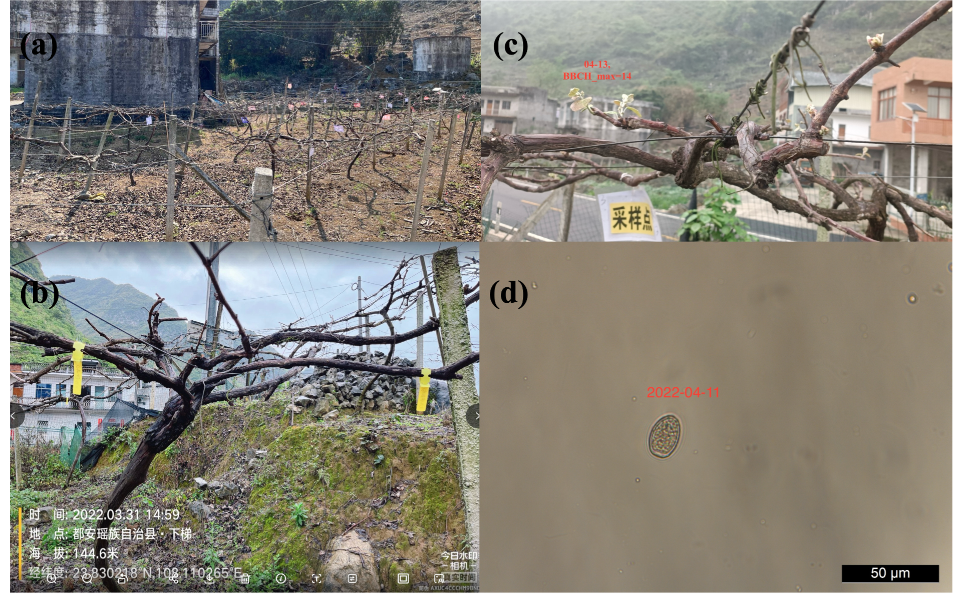
Fig. S1. Field and microscopic records supporting the presence of airborne asexual sporangia before visible downy mildew symptoms at the Du’an experimental vineyard, Hechi, in 2022. (a) Overview of the experimental plot on 31 March. (b) Dormant vines observed on 31 March. (c) Leaf expansion on 13 April, with a maximum recorded stage of BBCH14. (d) A particle captured by the spore trap, showing morphology consistent with a Plasmopara viticola sporangium; the micrograph is dated 11 April 2022. Scale bar: 50 μm. This capture predates the first confirmed visible symptoms at the site; morphology alone does not establish viability or the source of the captured sporangium.

S2 Spore observations and relative pressure
FSIM-S retains the FSIM process sequence and introduces two observation-based constraints on inoculum supply: suppression of weather-generated cohorts during numeric zero-count collection intervals, and an additional relative dose when centred spore pressure is positive. Spore counts represent relative capture amounts in the air.
For successive collection dates $b_{k−1}$ and $b_{k}$, a numeric count $C_{k}$ is converted to a daily capture rate $r(d)=C_{k}/(b_{k}−b_{k−1})$ for $b_{k−1}<d≤b_{k}$. Dates are expressed in Beijing time. When the first collection has no preceding collection date, its exposure interval is taken as three days. Duplicate numeric counts on a collection date are averaged before pressure-field construction. Missing counts are excluded from the measured-count series and are not replaced by observed zero counts.
Daily rates are standardized over days represented by numeric measurements, using the population standard deviation. Raw rates outside that period are filled with zero for field construction, without treating these dates as measured non-detections. A centred three-day moving mean is then applied, with available days used at the ends of the series, and a reference level of 0.5 is subtracted:
$z(d)=\frac{r(d)−\overline{r}}{s_{r}}, P(d)={MA}_{3}[z(d)]−0.5.$ (S5)
When $s_{r}=0$, the standardized field is set to zero before subtracting the reference. The daily pressure value is assigned to the corresponding hourly timestamps. Let $Z$ contain the days covered by numeric zero-count intervals. The cohort-production gate and additional dose are
$g(d;β_{sp})=\left\{\begin{matrix}0, & d∈Z \text{and} β_{sp}>0, \\ 1, & \text{otherwise},\end{matrix}\right. G_{i}^{S}=g(d_{i};β_{sp})G_{i}^{F}+β_{sp}max[P(d_{i}),0].$ (S6)
$G_{i}^{F}$ and $G_{i}^{S}$ denote the initial relative dose under FSIM and FSIM-S, respectively, and $β_{sp}≥0$ scales the observed-pressure contribution. The gate acts on weather-generated production; positive pressure adds inoculum before dispersal. Zero-count gating and pressure preprocessing are separate operations, so smoothing does not redefine which intervals are measured zeros. Missing entries independently trigger neither a zero-count gate nor an observed-dose increment. Inter-collection days are assigned the measurement covering the reconstructed collection interval.
The value $β_{sp}=0$ is a structural reference case: both zero-count gating and observed-dose injection are disabled, so $G_{i}^{S}=G_{i}^{F}$ and FSIM-S reduces exactly to FSIM. Positive grid values activate both constraints. Thus, the comparison with zero changes both the gating state and dose contribution; it does not isolate their individual effects.
Subsequent mortality, dispersal, deposition, infection and incubation follow FSIM. Non-detection does not establish biological absence, and captured sporangia need not be viable.

S3 Sobol sensitivity analysis
Variance-based Sobol analysis quantified the influence of six sporangial-process parameters in FSIM.^{4,5} The observation layer was disabled: neither zero-count gating nor observed-pressure dose injection was applied. Inherited biological response functions were fixed. Sensitivity indices were used for exploratory parameter screening, not parameter fitting.
Table S1. Parameter domains used for exploratory Sobol sampling.
Parameter | Abbreviation | Sampling domain | Unit
Infection degree-hour requirement | IDH | 60–240 | °C h
Minimum dispersal wind speed | WTH | 1–5 | m s⁻¹
Effective deposition rainfall threshold | EDR | 1–5 | mm h⁻¹
Sporulation relative-humidity threshold | SRH | 80–100 | %
Minimum moist duration | MMH | 1–8 | h
Heavy-rain wash-off threshold | HWR | 6–15 | mm h⁻¹
The above domains were used for sensitivity exploration; based on the results, the parameter ranges were fixed and narrowed in main-article Table 2.
All sampling designs included the six observed site–years. Identical weather, observed phenology and host-susceptibility settings were retained across sampling designs. Spore observations were not inputs to this FSIM sensitivity analysis.
SALib generated Sobol designs with base sizes $N=256$, 512 and 1024, with first-, total- and second-order effects enabled. For six parameters, each design contained $N(2×6+2)$ parameter vectors: 3584, 7168 and 14336, respectively. The recorded sampling seed was 20261004. Indices used 100 bootstrap resamples and 95% confidence intervals.
The primary output shown in main-article Fig. 9 was the mean first symptom-window start DOY across the six site–years. If no complete window occurred, its start was assigned the day immediately after the end of that calendar year (DOY366 in a common year or DOY367 in a leap year) for this censored timing summary. This assignment is distinct from the 60-day missing-window penalty used in the error objective. Additional outputs retained complete-window mean onset, window coverage, missing-window count, complete-window and penalized MAE, signed mean error and interval distance. At the largest base sample size, 28 of the 86016 site–year evaluations lacked a complete symptom window and were retained using the above censoring rule.
Outputs containing nonfinite values or having zero variance were not decomposed. Stability was assessed by comparing indices and parameter rankings across the three base sample sizes. Larger designs increase numerical sampling resolution; they do not provide additional independent biological replicates.

S4 Calibration and interval-censored evaluation

Disease model calibration
Disease-model evaluation used six leave-one-site–year-out folds covering Nanning 2023 and 2024, Hechi 2022–2024, and Guilin 2022. In each fold, the five training site–years were used to choose FSIM process parameters; $β_{sp}$ was then selected on the same training records with the FSIM process vector fixed. Both model configurations were fixed before predicting the held-out site–year. Held-out disease-onset observations were excluded from parameter selection. Weather and observed phenology were common inputs, while held-out spore measurements supplied FSIM-S inputs only during evaluation.
Wind speed, heavy-rain wash-off and minimum moist duration were fixed at 0.5 m s⁻¹, 5 mm h⁻¹ and 7 h, respectively. Three adjustable parameters were jointly evaluated over the finite Cartesian grid reported in main-article Table 2: IDH150–200 °C h in steps of 10, EDR3.80–3.95 mm h⁻¹ in steps of 0.05, and SRH80–100% in steps of 5. Thus, the FSIM grid contained 120 combinations. The subsequent FSIM-S comparison used $β_{sp}∈\{0,0.005,0.01,0.025,0.05,0.1,0.125,0.25,0.5,1\}$.
FSIM process parameters were estimated by exhaustive joint evaluation of the 120 candidate combinations in each training fold. Selection used a hierarchical criterion combining prediction coverage, timing accuracy and the geometry of the near-optimal parameter region. First, candidates were restricted to those producing the fewest missing complete symptom windows, thereby retaining the highest available training coverage. Within this subset, the minimum penalized training MAE, $L_{min}$, was calculated using equation S9. Candidates satisfying $L(θ)≤L_{min}+δ$, with $δ=0.5$ days, formed the near-optimal set $N$. This numerical tolerance is smaller than the three-day assessment interval and allows similarly performing configurations to be considered together.
Each parameter was then mapped to its unit search interval, $z_{j}(θ)=(θ_{j}−l_{j})/(u_{j}−l_{j})$, where $l_{j}$ and $u_{j}$ are its search bounds. This normalization gives the three parameters comparable weight despite their different physical units. The component-wise median of the normalized vectors in $N$ defined a robust centre $m$, and the retained candidate was
$$θ^{*}=\underset{θ∈N}{arg min}\sum_{j=1}^{3}{[}z_{j}(θ)−m_{j}]^{2}.$$
The centre is derived from the training solutions, and selection remains restricted to evaluated candidates. This criterion represents the central near-optimal region while bounding the permitted loss of training accuracy. Equal distances were resolved sequentially by lower penalized training MAE, preference for non-positive signed mean error, smaller absolute signed mean error and lexicographic parameter order. The bias preference favours timely warnings when timing accuracy and distance are equal. All selection quantities were calculated within the training fold; the held-out disease observations and the subsequent cross-fold deployment summary did not enter this step.
With the selected FSIM process vector fixed, the FSIM-S spore-pressure coefficient $β_{sp}$ was selected by minimizing training MAE over the candidate grid. Positive candidates from 0.005 to 1 produced the same training MAE, RMSE and signed mean error within each fold, with complete training windows throughout. The smallest positive candidate, 0.005, was retained consistently in all six folds, providing the minimum observation-dose contribution among equally performing positive candidates.
For deployment after cross-validation, each adjustable parameter was summarized across the six selected fold values. An identical value was retained; otherwise, the unique mode was used, with the median of all six values when modes were tied. The same rule was applied separately to $β_{sp}$. The resulting configuration is given in main-article Table 2. Deployment aggregation did not replace fold-specific configurations during validation.
Training summaries pool the repeated training predictions from all folds, whereas validation summaries contain one held-out prediction per site–year. Repeated training predictions are not independent observations. The evaluation is internal and exploratory: calibration choices were refined after earlier cross-validation results had been inspected, and the six folds do not constitute independent external validation.

Observed windows and error definitions
Let $t_{i}^{+}$ be the first disease-positive assessment and $t_{i}^{−}=t_{i}^{+}−3 d$ the preceding disease-negative assessment. The observed window is $O_{i}=[t_{i}^{−},t_{i}^{+}]$. The prediction ${\hat{O}}_{i}=[{\hat{t}}_{i}^{−},{\hat{t}}_{i}^{+}]$ is the first complete simulated symptom-onset window. Signed interval error is
$e_{i}=\left\{\begin{matrix}0, & {\hat{t}}_{i}^{−}≤t_{i}^{+} and {\hat{t}}_{i}^{+}≥t_{i}^{−}, \\ {\hat{t}}_{i}^{−}−t_{i}^{+}, & {\hat{t}}_{i}^{−}>t_{i}^{+}, \\ {\hat{t}}_{i}^{+}−t_{i}^{−}, & {\hat{t}}_{i}^{+}<t_{i}^{−}.\end{matrix}\right.$ (S7)
Overlap therefore gives zero error, which denotes compatibility with the observed interval rather than an exact prediction of an unobserved onset date. Positive error denotes late prediction and negative error denotes early prediction. For the set $C$ of complete predicted windows,
MAE=1|C|i∈C​|ei|, RMSE=1|C|i∈C​ei2. (S8)
Signed mean error is |C|−1i∈C​ei, and coverage is $|C|/n$, where $n$ is the number of evaluated site–years. A missing complete window receives 60 days in the calibration objective:
MAEpen=i∈C​|ei|+(n−|C|) 60 dn. (S9)
Missing-window penalties are not included as artificial observations in complete-window MAE or RMSE. Coverage is reported alongside those metrics.

S5 Phenology profiles and host susceptibility

Thermal time progression
The study included locally representative table-grape and wine-grape cultivars; regional phenology was therefore simulated separately for these two cultivation profiles. Given the limited local observation series, a parsimonious thermal-time formulation was used to constrain a small set of stage thresholds. Its purpose was to supply the developmental-stage background required for retrospective regional reconstruction of disease timing. Daily means are calculated in Beijing time (UTC+8). Forcing follows a thermal-time approach used for grapevine phenology:⁶
$f_{g}(d)=max({\overline{T}}_{d}−T_{b,g},0).$ (S10)
The first stage accumulates from the profile start DOY $s_{g}$, inclusively: day 20 for table grapes and day 44 for wine grapes. For BBCH09, 65 and 81, the stage date is the first day on which accumulated forcing reaches its incremental requirement. Accumulation resets after each stage, with the next stage beginning on the following day; excess forcing on the crossing day is not carried forward:
$\begin{matrix}t_{09,g}=min\left\{d:\sum_{u=s_{g}}^{d}{f_{g}}(u)≥H_{09,g}\right\}, \\ t_{65,g}=min\left\{d:\sum_{u=t_{09,g}+1}^{d}{f_{g}}(u)≥H_{09→65,g}\right\}, \\ t_{81,g}=min\left\{d:\sum_{u=t_{65,g}+1}^{d}{f_{g}}(u)≥H_{65→81,g}\right\}.\end{matrix}$ (S11)
Table S2. Final thermal-time parameters for regional cultivation profiles.
Parameter or stage | Accumulation basis | Table grapes | Wine grapes
Base temperature | °C | 10.00 | 3.00
BBCH09 | Start to budburst, °C d | 294.96 | 701.61
BBCH53 | After BBCH09, °C d | 111.05 | 291.13
BBCH65 | After BBCH09, full flowering requirement, °C d | 370.15 | 970.42
BBCH81 | After BBCH65, veraison requirement, °C d | 761.69 | 1323.00
Values are rounded to two decimals for reporting; simulations use the unrounded configuration values. BBCH53 follows an assumed interpolation rule informed by the published developmental sequence and local observational experience.^{6,7} It lies within the BBCH09-to-BBCH65 interval and does not reset accumulation; the BBCH65 requirement is the full increment after BBCH09. The rule is specified below.

Local targets and profile selection
Table-grape profiles were fitted to the measured phenological observations from Nanning in 2023 and 2024, and wine-grape profiles to those from Hechi in 2022–2024. The Guilin cultivar was excluded from regional profile calibration because its earlier development would distort the representative profile and it is not widely cultivated commercially in the region. Each phenological observation was paired with the corresponding daily temperature series. The measured Nanning BBCH09 dates were 6 March 2023 and 18 March 2024 (Table S3).
Table S3. Local phenological targets used for the regional profiles.
Profile and site | Year | BBCH09 | BBCH65 | BBCH81
Table, Nanning | 2023 | 6 March | 11 April | 29 May
Table, Nanning | 2024 | 18 March | 16 April | 2 June
Wine, Hechi | 2022 | 5 April | 26 May | ≥26 May
Wine, Hechi | 2023 | 1 April | 20 May | ≥1 June
Wine, Hechi | 2024 | 2 April | 18 May | ≥9 July
Exact targets were scored by absolute date error. Interval targets had zero error inside their bounds and distance to the nearest bound outside; one-sided targets constrained only the recorded boundary. The Hechi BBCH81 entries therefore provide lower bounds, not observed veraison dates.
Candidate structures included linear forcing with fixed base temperatures of 0, 3, 5, 8 or 10°C, a fitted base restricted to 0–10°C, and normalized beta responses with fixed or fitted cardinal temperatures. Start date was either 1 January or fitted within DOY1–75. Fixed beta cardinal temperatures were 0, 25.4 and 35°C; fitted lower, optimum and upper temperatures used bounds of −2–10, 15–32 and 30–45°C, respectively, with strictly ordered cardinals. Linear incremental requirements were searched over 100–2200, 100–1800 and 100–1800 °C d for BBCH09, 65 and 81; beta requirements used 5–180, 5–180 and 5–240 response-days.
Differential evolution used two initializations (seeds 20261008 and 20261009), a maximum of 75 iterations, population multiplier 8, tolerance ${10}^{−5}$ and local polishing. BBCH09, 65 and 81 received objective weights of 1.0, 1.25 and 0.35, respectively, multiplied by target-quality weights. A common local-observation multiplier of 4 applied to these targets and does not change their relative weights. Unattained stages received a 180-day penalty in this phenology objective, distinct from the disease-model penalty.
Within each profile, one site–year was omitted in turn and parameters were refitted using the remaining year or years. Structures were ranked by mean held-out error for BBCH09 and 65, with exact-target error as a secondary criterion; the selected structure was then fitted to all profile targets. Selected-profile errors were 3.0 days for both BBCH09 and 65 in table grapes, and 1.0 and 2.0 days, respectively, in wine grapes. Table-grape BBCH81 MAE was 3.5 days. Wine-grape BBCH81 predictions met the available lower bounds, yielding zero boundary error without validating veraison dates. Because structure selection used the same small set of omitted-year predictions, these errors describe internal model comparison rather than an independent test.

BBCH53 stage interpolation
The BBCH developmental sequence places visible inflorescences (53) between budburst (09) and full flowering (65), while thermal-time models provide a framework for interpolating progress between these stages.^{6,7} Together with local stage observations, this literature informed the assumed BBCH53 interpolation rule used in the regional profiles.
Local BBCH53 observations comprised a 14–21 March interval for Nanning 2023, 4 April for Nanning 2024, 8 April for Hechi 2023 and 10 April for Hechi 2024, with a broader interval for Hechi 2022. To represent this stage with no additional fitted threshold, BBCH53 was assigned the first date reaching 30% of the fitted BBCH09-to-BBCH65 thermal requirement:
$t_{53,g}=min\left\{d>t_{09,g}:\sum_{u=t_{09,g}+1}^{d}{f_{g}}(u)≥0.30H_{09→65,g}\right\}.$ (S12)
The fraction refers to accumulated thermal forcing between BBCH09 and BBCH65. It is a model assumption informed by literature and local observations. BBCH53 was retained for checking stage progression but did not enter the three-stage fitting objective. When an observed BBCH53 date is available, it takes precedence over the interpolation rule.

Link to the hourly disease model
Disease-model evaluation uses observed phenological anchors for all six site–years, while regional scenarios use the corresponding table or wine thermal-time profile. The observed-anchor procedure takes the first survey at or above each susceptibility node. Consequently, such anchors can occur later than the true stage transition and are distinct from the exact or censored targets used for thermal-time fitting. A separate thermal-time fallback supplies unavailable local anchors and forcing progression; the regional profile calibration does not replace observed dates in the disease-model comparison.
Table S4. Fixed coefficients linking phenological nodes to host susceptibility.
BBCH node | Developmental stage | Coefficient
09 | Budburst | 0.00
53 | Inflorescence emergence | 0.60
65 | Flowering | 0.70
81 | Veraison | 0.90
89 | Post-veraison | 0.50
The host-susceptibility coefficients in Table S4 were specified jointly from local phenology and disease observations, regional experience of disease development, and published evidence of developmental variation in susceptibility. Leaf-age experiments show greater susceptibility in younger leaves than in older leaves.⁹ Wang et al. linked the onset of downy mildew infections to flowering-stage development in a model evaluated in northern China.¹² Inoculation studies also demonstrate that susceptibility of inflorescences, berries and rachises changes with phenological stage and organ age.^{8,13} These findings provide a biological basis for allowing host susceptibility to vary over the growing season.
The specified values are effective coefficients for infection establishment at the canopy scale. They combine seasonal availability of susceptible green tissue with the locally observed course of disease development; they do not represent the infection probability of an individual leaf or berry. The numerical values were set for this study by integrating the above evidence and were shared by FSIM and FSIM-S. In particular, the coefficient at veraison describes the effective canopy state, including remaining foliage, rather than the susceptibility of ripening berries alone.
Between adjacent available anchors, $S(t)$ is interpolated linearly using accumulated forcing divided by the configured stage requirement, with progression clipped to 0–1. The BBCH09-to-BBCH65 requirement is split into 30% and 70% for the intervals separated by BBCH53. Hourly forcing is converted from degree-hours to degree-days by division by 24. Observed anchor dates define the local stage intervals; the thermal-time profiles provide stage progression for the regional reconstruction.

S6 Annual regional reconstruction
FSIM reconstructed annual outcomes for 342 grid cells at 0.25° resolution across Guangxi during 2000–2024 under separate table- and wine-grape phenology scenarios. Historical spore measurements were unavailable. Figs S2–S5 show the year-specific patterns underlying the multi-year summaries in main-article Figs 13 and 14.
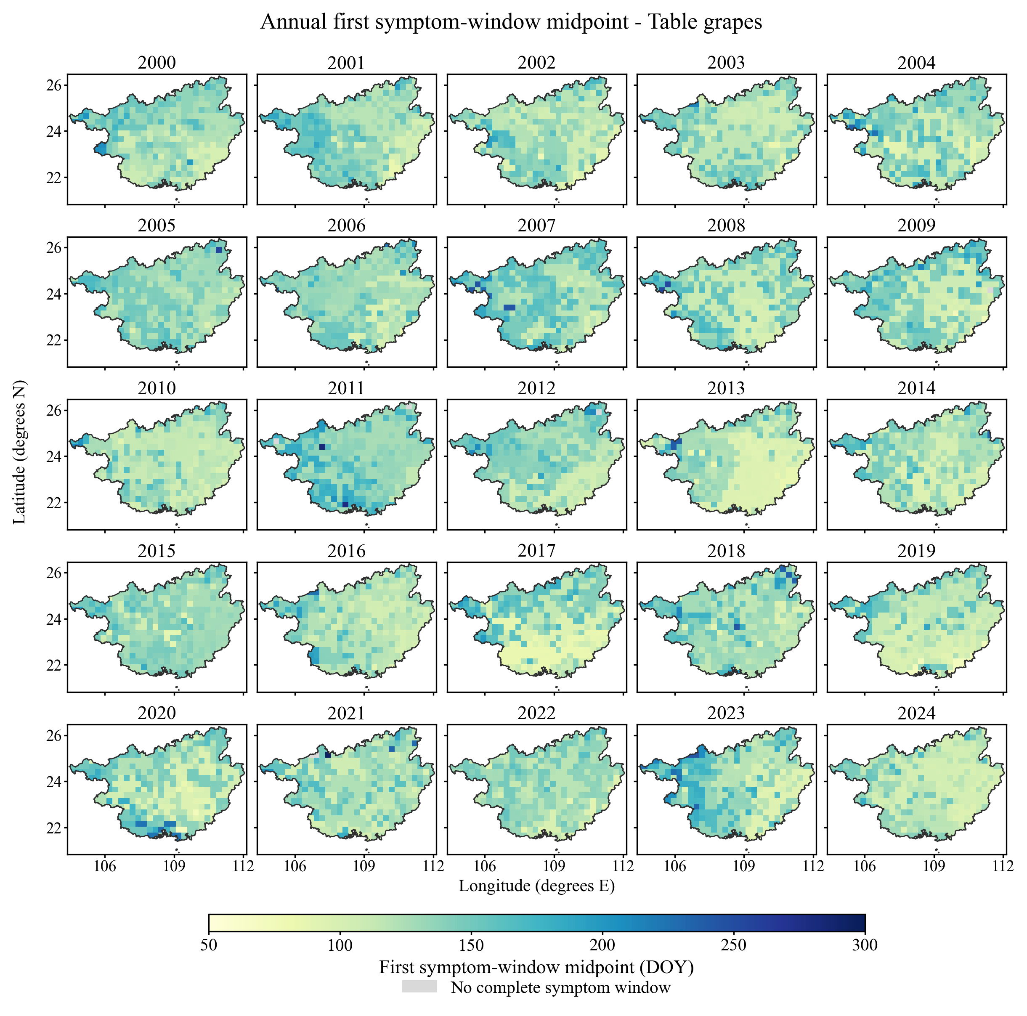
Fig. S2. Annual first symptom-window midpoints under the table-grape scenario across Guangxi during 2000–2024. Each panel represents one calendar year; colours show the midpoint of the first complete simulated symptom-onset window as day of year (DOY). The 50–300 DOY colour scale is shared with Fig. S3. Grey denotes grid–years without a complete window (eight over the full period). Nearest-neighbour extensions to the provincial boundary serve only to complete the map outline and do not enter the reported statistics.
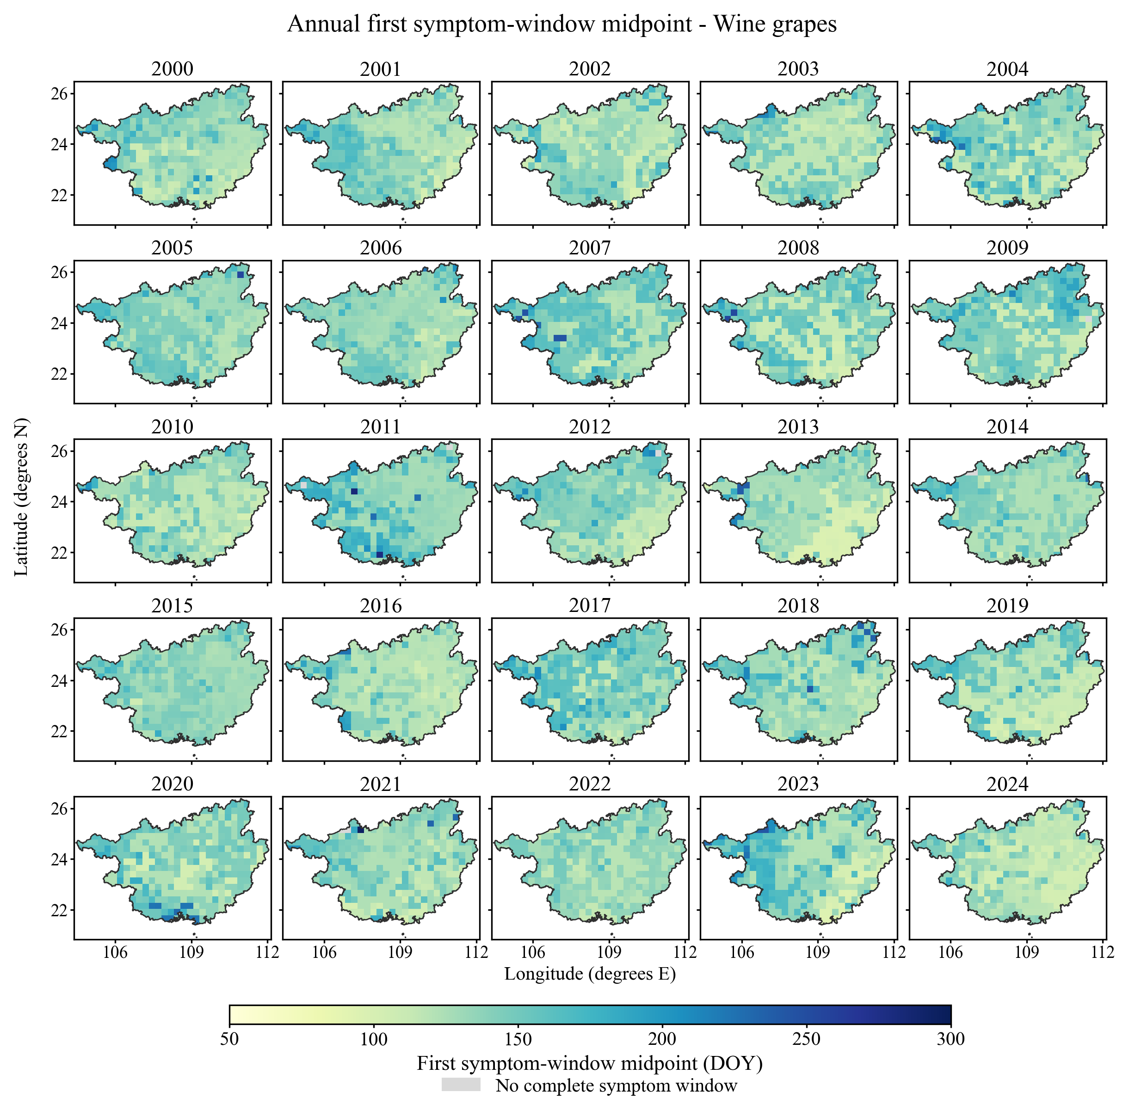
Fig. S3. Annual first symptom-window midpoints under the wine-grape scenario across Guangxi during 2000–2024. Each panel represents one calendar year; colours show the midpoint of the first complete simulated symptom-onset window as day of year (DOY). The 50–300 DOY colour scale is shared with Fig. S2. Grey denotes grid–years without a complete window (eight over the full period). Nearest-neighbour extensions to the provincial boundary serve only to complete the map outline and do not enter the reported statistics.
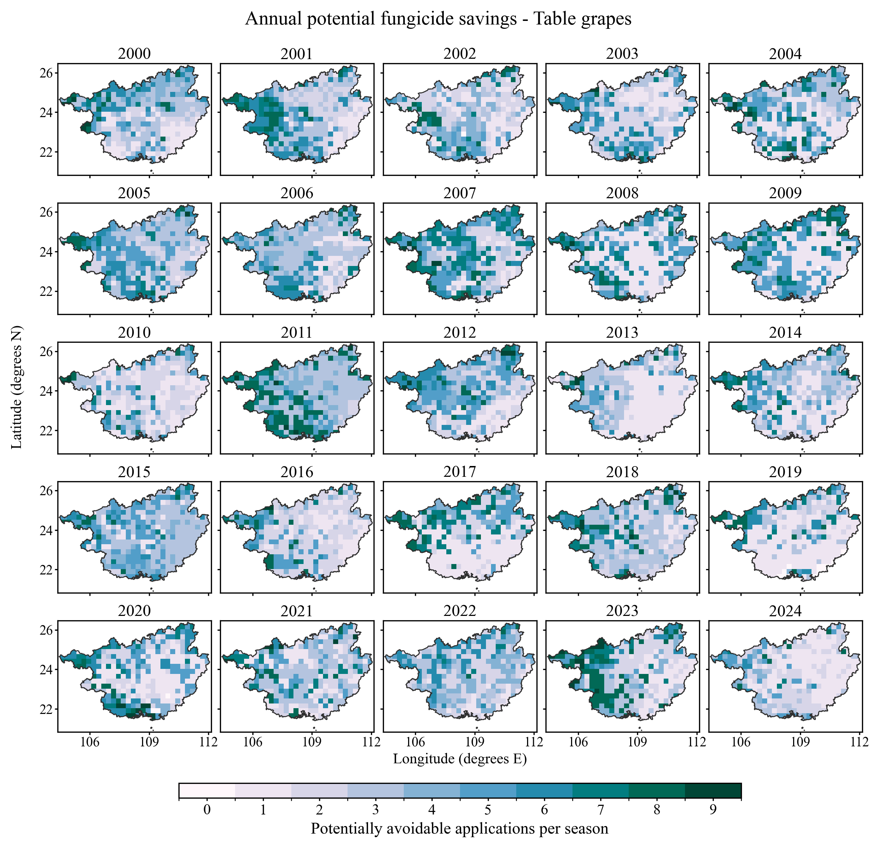
Fig. S4. Annual potential fungicide savings under the table-grape scenario across Guangxi during 2000–2024. Colours show potentially avoidable applications relative to the fixed nine-application reference programme recorded at Du’an in 2022. Applications more than seven days before the start of the first simulated symptom window are counted as potentially avoidable. For eight grid–years without a complete window, all nine applications are counted under the scenario assumption. The 0–9 scale is shared with Fig. S5. Boundary extensions are for display only. Values are scenario estimates, not measured reductions or evidence that earlier protection can safely be omitted.
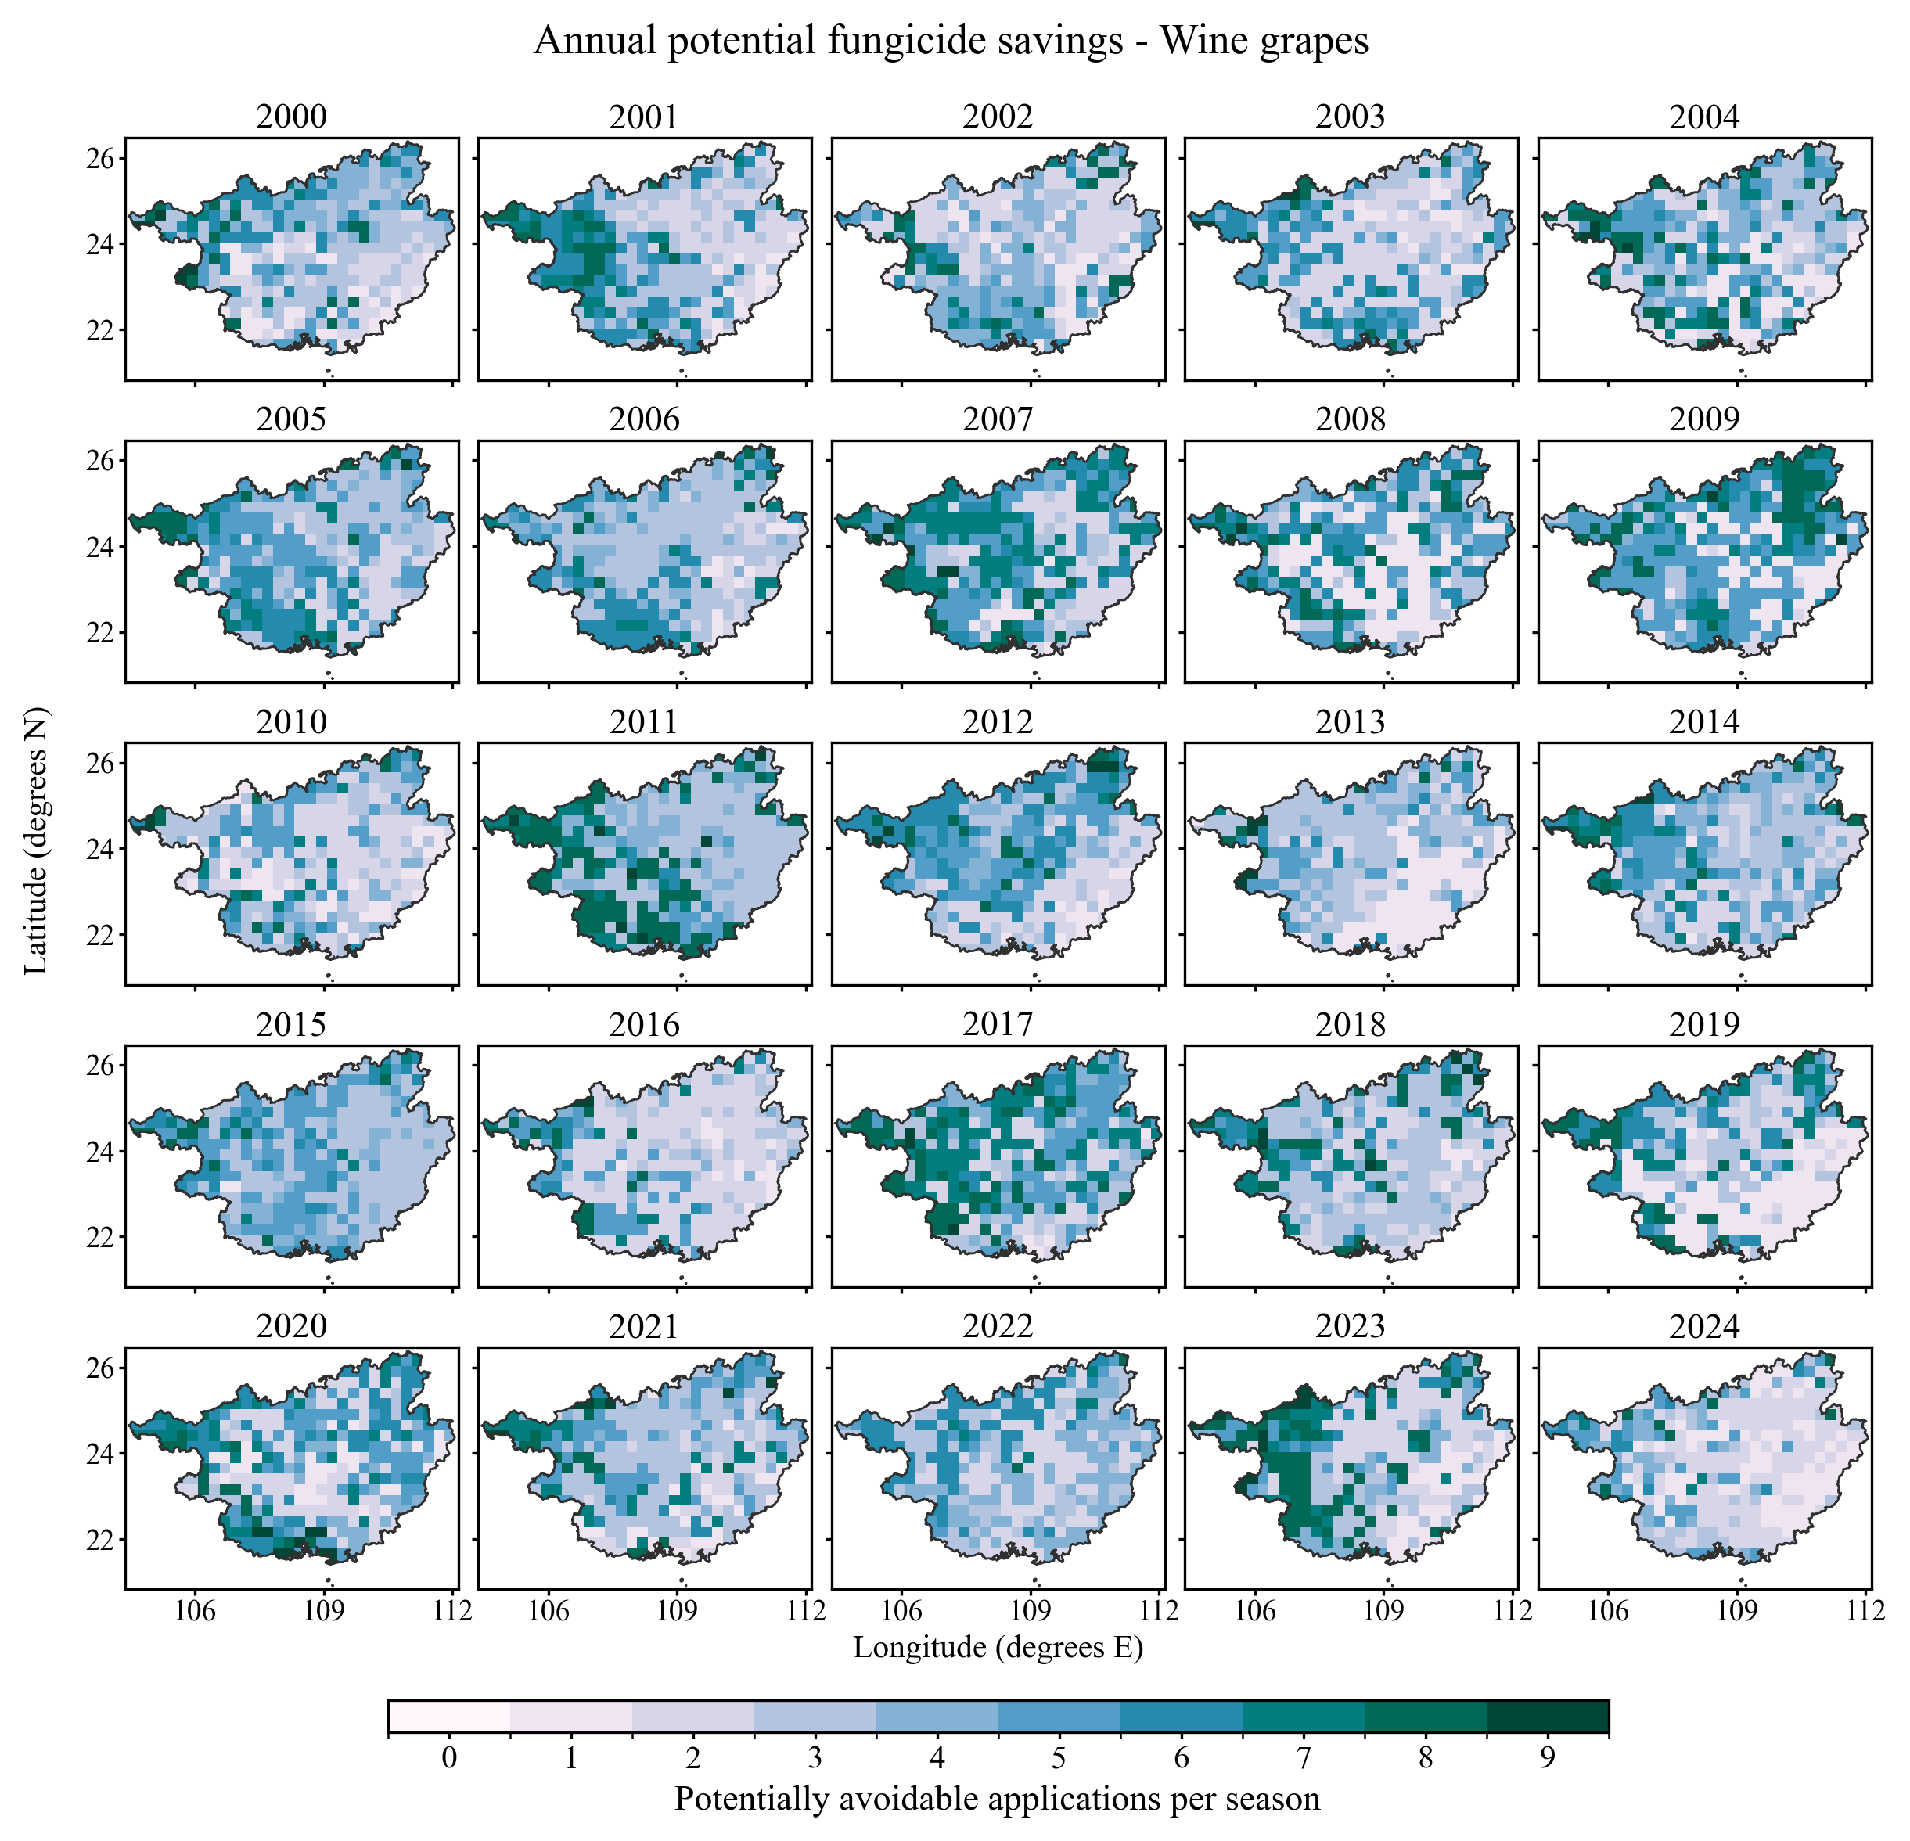
Fig. S5. Annual potential fungicide savings under the wine-grape scenario across Guangxi during 2000–2024. Colours show potentially avoidable applications relative to the fixed nine-application reference programme recorded at Du’an in 2022. Applications more than seven days before the start of the first simulated symptom window are counted as potentially avoidable. For eight grid–years without a complete window, all nine applications are counted under the scenario assumption. The 0–9 scale is shared with Fig. S4. Boundary extensions are for display only. Values are scenario estimates, not measured reductions or evidence that earlier protection can safely be omitted.

Supplementary references
1 Rossi V, Caffi T, Giosuè S, Bugiani R. A mechanistic model simulating primary infections of downy mildew in grapevine. Ecol. Model. 212:480–491. doi:10.1016/j.ecolmodel.2007.10.046 (2008).
2 Brischetto C, Bove F, Fedele G, Rossi V. A weather-driven model for predicting infections of grapevines by sporangia of Plasmopara viticola. Front. Plant Sci. 12:636607. doi:10.3389/fpls.2021.636607 (2021).
3 Gobbin D, Jermini M, Loskill B, Pertot I, Raynal M, Gessler C. Importance of secondary inoculum of Plasmopara viticola to epidemics of grapevine downy mildew. Plant Pathol. 54:522–534. doi:10.1111/j.1365-3059.2005.01208.x (2005).
4 Sobol IM. Global sensitivity indices for nonlinear mathematical models and their Monte Carlo estimates. Math. Comput. Simul. 55:271–280. doi:10.1016/S0378-4754(00)00270-6 (2001).
5 Iooss B, Lemaître P. A review on global sensitivity analysis methods. In: Dellino G, Meloni C, editors. Uncertainty Management in Simulation-Optimization of Complex Systems. Springer, Boston, MA, pp. 101–122. doi:10.1007/978-1-4899-7547-8_5 (2015).
6 Wang X, Li H, García De Cortázar Atauri I. Assessing grapevine phenological models under Chinese climatic conditions. OENO One 54:637–656. doi:10.20870/oeno-one.2020.54.3.3195 (2020).
7 Lorenz DH, Eichhorn KW, Bleiholder H, Klose R, Meier U, Weber E. Growth stages of the grapevine: Phenological growth stages of the grapevine (Vitis vinifera L. ssp. vinifera): Codes and descriptions according to the extended BBCH scale. Aust. J. Grape Wine Res. 1:100–103. doi:10.1111/j.1755-0238.1995.tb00085.x (1995).
8 Kennelly MM, Gadoury DM, Wilcox WF, Magarey PA, Seem RC. Seasonal development of ontogenic resistance to downy mildew in grape berries and rachises. Phytopathology 95:1445–1452. doi:10.1094/PHYTO-95-1445 (2005).
9 Reuveni M. Relationships between leaf age, peroxidase and β-1,3-glucanase activity, and resistance to downy mildew in grapevines. J. Phytopathol. 146:525–530. doi:10.1111/j.1439-0434.1998.tb04615.x (1998).
10 Huber L, Gillespie TJ. Modeling leaf wetness in relation to plant disease epidemiology. Annu. Rev. Phytopathol. 30:553–577. doi:10.1146/annurev.py.30.090192.003005 (1992).
11 Bitencourt C, Perazzoli V, de Freitas FR, Soldi C, da Silva AL, Welter LJ. Sexual reproduction of Plasmopara viticola in wine regions of southern Brazil, climatic suitability, oospore formation and germination. Plant Pathol. 75:e70175. doi:10.1111/ppa.70175 (2026).
12 Wang H, Zhang W, Bregaglio S, Yu S, Li X, Li Y, Liang C, Yan J. Adoption of Sobol’s analysis method improved the application of a coupled primary and secondary infection grape downy mildew model in northern China. Comput. Electron. Agric. 199:107154. doi:10.1016/j.compag.2022.107154 (2022).
13 Gindro K, Schnee S, Lecoultre N, Michellod E, Zufferey V, Spring JL, Viret O, Dubuis PH. Development of downy mildew in grape bunches of susceptible and resistant cultivars: infection pathways and limited systemic spread. Aust. J. Grape Wine Res. 28:572–580. doi:10.1111/ajgw.12560 (2022).

