Spore-informed agroclimatic modelling improves the timing of grapevine downy mildew management in subtropical vineyards
Linjia Yao ^{a #}, Bin Chen ^{b #}, Vittorio Rossi ^{c}, Ling Yin ^{d}, Shumei Wei ^{d}, Qi Tian ª, Changqing Yan ^{e}, Hui wang ^{f}, Antonio Fernandes Nogueira Júnior ^{g}, Yu Huang ^{h}, Qiang Yu ^{b *}, Junjie Qu ^{d *}, Gang Zhao ^{b *}
ª College of Natural Resources and Environment, Northwest A & F University, Yangling 712100, China
^{b} State Key Laboratory of Soil and Water Conservation and Desertification Control, College of Soil and Water Conservation Science and Engineering, Northwest A&F University, Yangling, Shaanxi 712100, China
^{c} Research centre on Plant Health Modelling (PHEM), Università Cattolica del Sacro Cuore, Piacenza, Italy
^{d} Guangxi Crop Genetic Improvement and Biotechnology Key Lab, Guangxi Academy of Agricultural Sciences, Nanning 530007, China
^{e} College of Intelligent Equipment, Shandong University of Science and Technology, Taian 271019, China
^{f} Institute of Plant Protection Beijing Academy of Agriculture and Forestry Sciences, 100097 Beijing, China
^{g} KWS SAAT SE & Co. KGaA, Einbeck, Germany
^{h} Grape and Wine Research Institute, Guangxi Academy of Agricultural Sciences, Nanning, Guangxi 530007, China
* Corresponding author: Prof. Qiang Yu, E-mail: yuq@nwafu.edu.cn; Prof. Junjie Qu, E-mail: qujunjie@gxaas.net; Prof. Gang Zhao, E-mail: gang.zhao@nwafu.edu.cn
# These authors contributed equally to this work.

Abstract
BACKGROUND: Preventive control of grapevine downy mildew requires joint consideration of inoculum availability, susceptible host tissue and favourable weather. Temperate-vineyard models commonly represent primary infections initiated by overwintered oospores, whereas recurrent green tissue and airborne sporangia captured before local symptom appearance suggest that lesion-borne asexual inoculum may contribute substantially to early-season risk in humid subtropical production. We developed a process-based model for this setting and tested whether observed airborne spore pressure improved disease-onset estimation.
RESULTS: The First Seasonal Infection Model (FSIM) tracks cohorts through potential lesion-borne sporangium production and loss, dispersal, deposition, zoospore release, infection, incubation and symptom appearance. Its spore-informed extension, FSIM-S, incorporates a site-year-specific field describing relative airborne spore pressure. Both models were evaluated against the observed date of the first confirmed visible symptoms in six site-years in Guangxi, China. FSIM-S reduced validation mean absolute error from 9.3 to 6.3 days and root mean square error from 10.6 to 6.5 days relative to FSIM. Regional simulations for 2000–2024 placed most estimated disease-onset dates between day of year 180 and 210. Under a retrospective scenario based on representative calendar schedules, 2–5 early fungicide applications per season were classified as potentially avoidable.
CONCLUSION: Incorporating observed spore pressure improved retrospective disease-onset estimation within the six study site-years. The framework provides an epidemiologically grounded basis for investigating risk-informed fungicide timing in subtropical vineyards, but prospective field comparisons are required before pesticide-use reduction, maintained disease control or operational benefit can be claimed.
Keywords: Agroclimatic modelling; Spore-pressure dynamics; Fungicide timing; Subtropical viticulture; Smart agriculture

Introduction
Humid subtropical grape-growing regions in China are highly favourable to grapevine downy mildew, caused by Plasmopara viticola. Warm, rainfall-prone conditions often coincide with the development of susceptible leaves and inflorescences, and severe epidemics can impair canopy photosynthesis, induce flower and fruit rot and abscission, and cause major yield loss (Nogueira Júnior et al., 2019; Mouafo-Tchinda et al., 2022; Koledenkova et al., 2022; Peng et al., 2024). Control therefore relies heavily on preventive fungicides. Where application timing is guided mainly by calendars, grower experience or weather cues, treatments may be poorly synchronized with actual infection risk, increasing costs, selection pressure and environmental burdens without necessarily improving protection (García-Esparza et al., 2006; Yin et al., 2023).
The main early-season challenge is to identify when preventive protection is biologically justified. Infection requires the concurrence of viable inoculum, susceptible host tissue and suitable weather, but the infection event itself is latent and cannot be observed directly during routine vineyard surveillance. Successive assessments instead bracket disease onset between the last disease-negative and first disease-positive observations, with the date of the first confirmed oil spots providing the observed endpoint. Models intended to inform early protection must therefore reconstruct the preceding infection process and translate it into a disease-onset window that can be compared with symptom observations. Empirical rules such as the ‘3–10 rule’ and EPI use weather conditions as proxies for infection risk (Baldacci, 1947; Strizyk, 1983; Caffi et al., 2007), but do not explicitly resolve the availability, dispersal and fate of inoculum.
Rossi et al. (2008) provided a mechanistic framework for oospore-driven primary infections in temperate vineyards. Their cohort-based model follows seasonal oospore maturation and germination, zoospore release, dispersal, infection and incubation, and predicts the interval in which oil spots should appear. In this pathway, each germinating oospore produces a macrosporangium that remains attached to the oosporic germ tube near the soil surface; the released zoospores are transported to susceptible tissues mainly by rain splash (Rossi and Caffi, 2012). The model was evaluated against the first seasonal symptoms observed in vineyards rather than against directly observed infection events, and subsequent field use demonstrated the management value of simulating this biological sequence (Caffi et al., 2010). It thus provides the mechanistic foundation for linking inoculum development and infection to symptom onset under an alternative early-season inoculum regime.
A complementary modelling line describes infections initiated by asexual sporangia produced on existing lesions. These detachable sporangia enter the vineyard air, survive and disperse according to weather, deposit on susceptible surfaces and release zoospores under wet conditions. Airborne spore abundance, particularly estimated viable spore abundance, has been related to the infection potential of asymptomatic leaves collected from vineyards (Brischetto et al., 2020). Brischetto et al. (2021) subsequently represented lesion-borne sporangium production, survival, dispersal, deposition and infection in a weather-driven model initiated from the first visible seasonal lesion. Together, these studies establish the relevant processes for lesion-borne infection cycles, but they do not address how such processes should be used to estimate the first disease onset of a new production cycle when airborne inoculum may already be present.
That situation is plausible in subtropical production landscapes with mild winters, short or variable dormancy and asynchronous pruning or cropping systems. Extended green-tissue availability in surrounding vineyards may permit recurrent asexual cycles and replenish a regional airborne inoculum pool. Predominantly clonal populations or limited oospore occurrence have been reported in subtropical São Paulo, South Africa and most surveyed vineyards in Western Australia (Camargo et al., 2019; Koopman et al., 2007; Killigrew et al., 2005). Conversely, oospore formation in highland southern Brazil shows that sexual reproduction cannot be excluded from subtropical viticulture (Bitencourt et al., 2021). In Guangxi, the capture of airborne sporangia before the first locally observed lesions, together with the near-soil dispersal pathway of oospore-derived macrosporangia, motivates the working hypothesis that lesion-borne asexual sporangia make an important, and potentially predominant, contribution to early-season airborne inoculum. These observations do not identify the source of every infection and do not exclude oospore-derived infections; rather, they indicate that an exclusively oospore-driven seasonal reset should not be assumed.
This epidemiological setting creates a specific modelling gap. Existing process models separately describe the oospore-driven route to primary infection and lesion-borne sporangial cycles, whereas early-season management in Guangxi requires the infection sequence to be reconstructed from a potentially recurrent airborne sporangium pool. We therefore developed the First Seasonal Infection Model (FSIM) by reorganizing established components from the Rossi and Brischetto frameworks into a cohort sequence extending from potential lesion-borne sporangium production and loss through dispersal, deposition, zoospore release, infection and incubation to symptom appearance (Rossi et al., 2008; Brischetto et al., 2021). FSIM uses ‘first seasonal infection’ chronologically for the earliest infection event affecting susceptible tissue in a new growth cycle, without assigning that event a sexual origin. Because this event is not directly observable, the model propagates successful infection cohorts through incubation to produce a predicted disease-onset window, which is evaluated against the first confirmed visible symptoms.
We further developed FSIM-S to test the incremental value of measured inoculum information within the same process framework. FSIM-S retains the FSIM infection chain but uses an observation-derived, site-year-specific spore-pressure field to adjust the effective infection threshold; this field represents relative background airborne inoculum pressure rather than an absolute viable-spore count. Using six site-years from Guangxi, we asked: (i) how accurately can a process-based model representing airborne sporangia as early-season inoculum estimate disease-onset timing; (ii) to what extent does incorporating observed airborne spore pressure improve onset estimation relative to the base model; and (iii) under retrospective evaluation, can model-derived infection-risk periods identify opportunities to improve the timing of early-season fungicide applications? The management analysis is accordingly interpreted as a timing scenario, not as evidence of pesticide reduction, maintained disease control or operational readiness.

Materials and methods

Study design and overall workflow
This study was designed as a three-year, multi-site, field-based agronomic modelling study in two commercial vineyards and one experimental orchard under subtropical conditions. The workflow combined field observations, process-based modelling, and regional simulation to characterize the mechanisms governing first seasonal infection of grapevine downy mildew and to evaluate the potential of the proposed framework for improving disease-management timing (Fig 1). The overall design comprised three main stages: (1) multi-site field monitoring to capture airborne inoculum dynamics, grapevine phenology, management records, and the timing of first seasonal infection; (2) development of a biologically consistent First Seasonal Infection Model (FSIM), followed by stepwise evaluation, optimization, and calibration; and (3) regional-scale simulations driven by long-term meteorological data to assess infection risk and disease-management scenarios.
Field experiments were conducted from 2022 to 2024 in two commercial vineyards and one experimental orchard located in Nanning, Guilin, and Hechi, Guangxi Province. Observations included: (i) continuous monitoring of airborne P. viticola inoculum, (ii) dates of first visible downy mildew lesions of the season, which were used to determine first seasonal infection timing, (iii) grapevine phenological stages, and (iv) agronomic management records. Historical hourly meteorological data for the period 2000–2024 were obtained from the ERA5 reanalysis dataset and used to provide meteorological forcing for model simulations (Hersbach et al., 2020).
At the modelling stage, the newly developed FSIM was first systematically evaluated to examine its ability to represent the timing of first seasonal infection under subtropical conditions in Guangxi. Subsequently, field-based spore monitoring data were incorporated to characterize inoculum pressure and to constrain infection processes, resulting in an observation-informed framework (FSIM-S).
The models were parameterized and cross-validated using multi-site field observations (2022–2024). The optimized framework was then applied in regional simulations covering 2000–2024 to quantify long-term spatial variability in infection risk and to assess the management implications of model-informed decision support (Zhao et al., 2024).
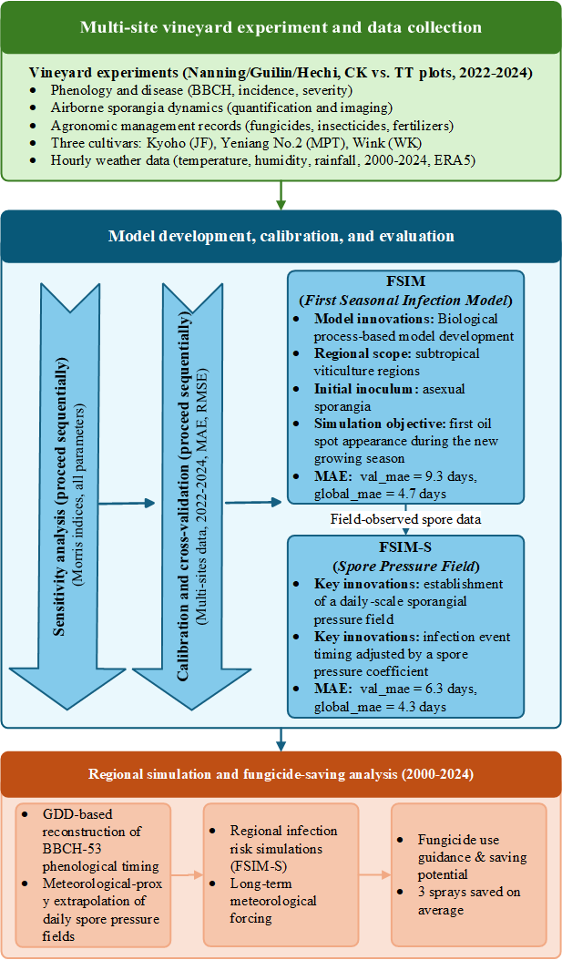
Figure 1. Overall workflow of this study. CK indicates control plots without fungicide applications, whereas TT denotes plots managed under conventional fungicide schedules.

Field experiments and data collection

Site description, climate, vineyard layout
Field experiments were conducted from 2022 to 2024 in two commercial vineyards and one experimental orchard located in the humid subtropical zone of the Guangxi Zhuang Autonomous Region, southern China, specifically in Xing’an (Guilin), Du’an (Hechi), and Jiangnan (Nanning) (Table 1; Fig 2a,b). These sites span a pronounced mesoscale gradient in thermal and moisture conditions and collectively characterize the early-season climatic context of the study region. Over the three-year study period, the mean air temperature across sites was 21.0 °C, and relative humidity remained persistently high (mean 75.9%). Rainfall was abundant and frequent, with a multi-year mean annual total of 2,134 mm and an average of 149 rainy days per year. Rainy days were defined as days with daily precipitation >0.2 mm, consistent with the resolution of the meteorological dataset used (Fig 3).
Compared with temperate viticultural regions of central Europe, winter conditions at the study sites were characterized by relatively high temperature and humidity and typically did not include severe cold events (Fig 3). In addition, the adoption of a secondary cropping system at some vineyards resulted in delayed leaf senescence, with natural leaf fall extending into January–February in certain years, while budburst of the subsequent growth cycle generally occurred in March–April. As a consequence, the dormancy period was short and phenologically discontinuous (Table 1).
To reflect representative grape production systems in southern China, each experimental site was planted with a locally widespread and commonly cultivated variety: ‘Wink’ in Guilin, ‘Yeniang No. 2’ in Hechi, and ‘Kyoho’ in Nanning. Detailed site characteristics, including planting year, vine spacing, and cropping system (including the presence or absence of secondary cropping), are summarized in Table 1.
At each vineyard, two management treatments were established to distinguish natural infection dynamics from management-modified disease pressure: a traditional treatment (TT), in which fungicides were applied following local management calendars, and a no-spray control (CK), in which no fungicides were applied. A completely randomized design was used, with three replicates per treatment, resulting in six observation plots per vineyard. Each plot consisted of six uniformly growing vines, which were used for subsequent phenological and disease monitoring.

Table 1. Characteristics of experimental vineyard sites in Guangxi, China.
City/County | Lat, Lon | Cultivar | Leaf fall period | Planting year | Row $×$ Spacing (m)
Xing’an, Guilin | 25.45°N, 110.80°E | Wink (WK) | December | 2018 | 2.5$×$2.5
Du’an, Hechi | 23.83°N, 108.11°E | Yeniang No. 2 (MPT) | February (following year) | 2015 | 2.5$×$2.5
Jiangnan, Nanning | 22.61°N, 108.23°E | Kyoho (JF) | January (following year) | 2020 | 3.2 $×$3.0
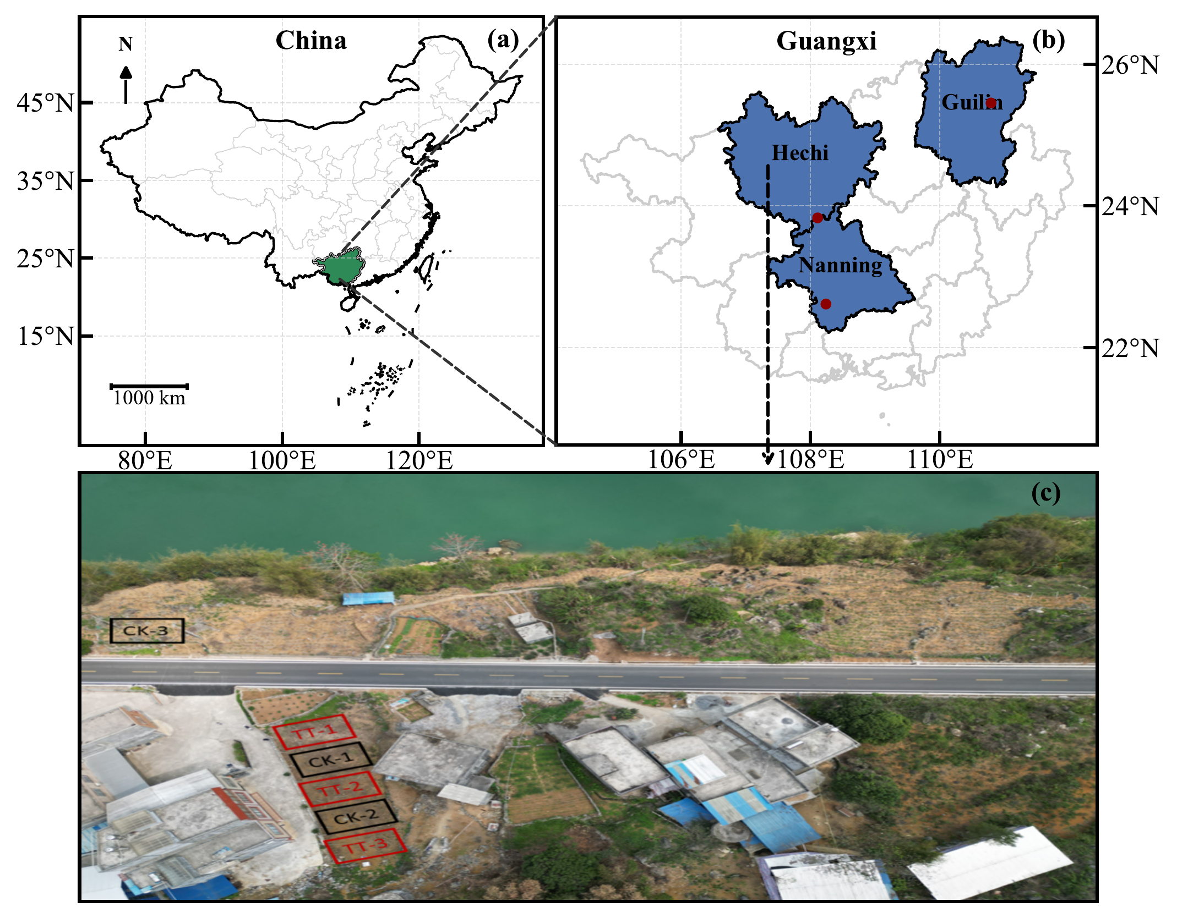
Figure 2. Study sites and field layout. (a) Location of Guangxi within China. (b) Spatial distribution of the three field experiment sites (Guilin, Hechi, and Nanning) in Guangxi Province; red circles indicate the locations of the experimental orchards. (c) Plot layout at the Du’an site in Hechi City, where black rectangles denote the three untreated control plots (CK).
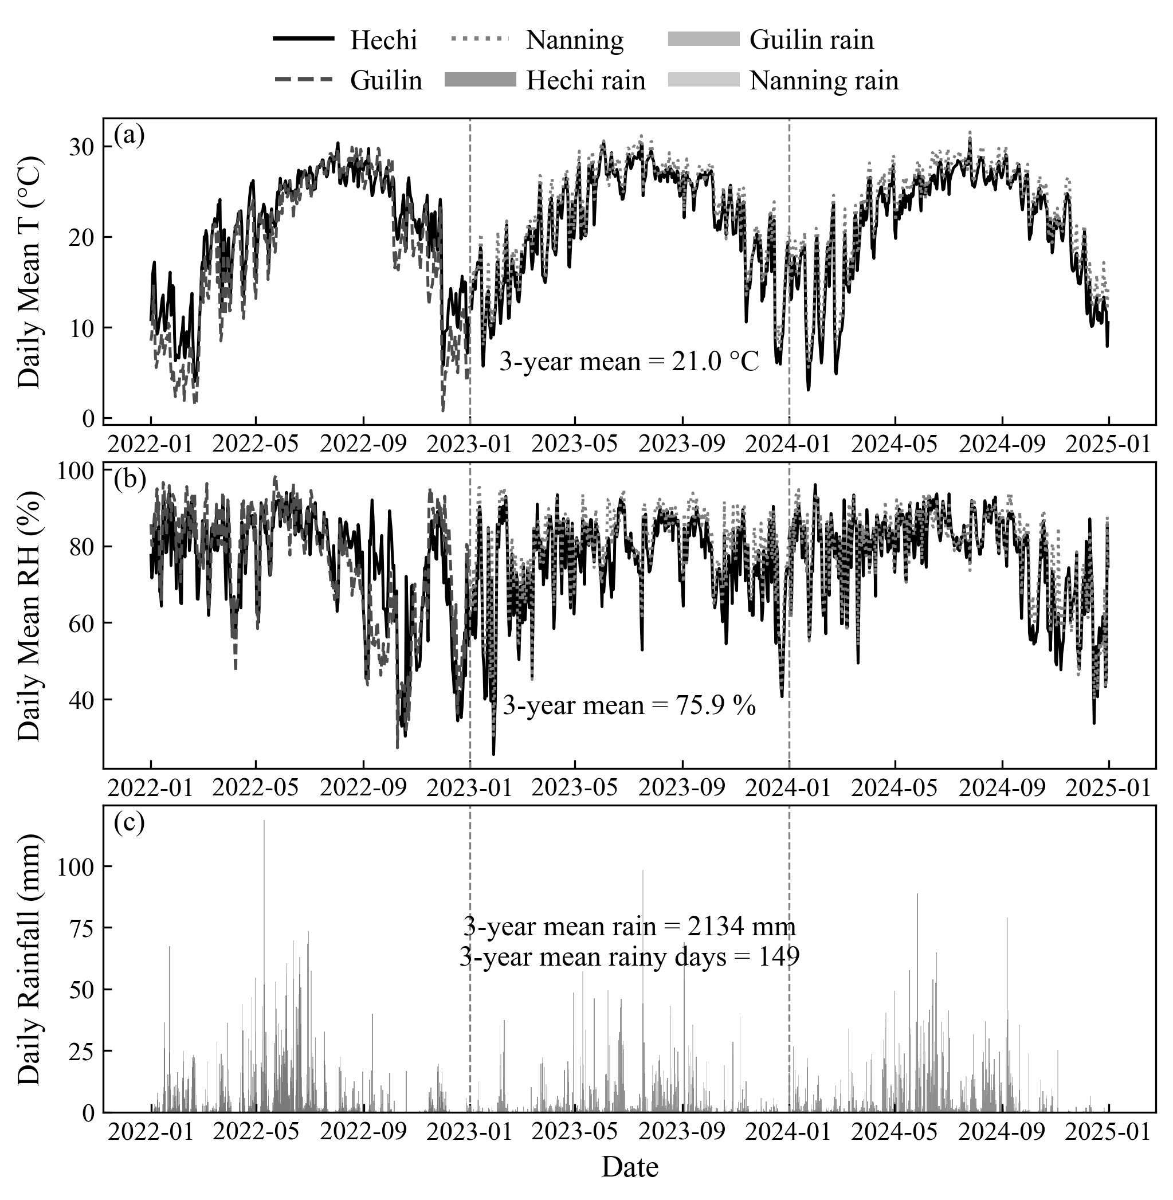
Figure 3. Daily mean temperature, daily mean relative humidity, and daily rainfall recorded at the experimental vineyards in Hechi, Guilin, and Nanning during 2022–2024. The numerical values shown in each panel denote the 3-year means of the corresponding variable across all sites, providing an overview of the background meteorological conditions within the experimental region.

Disease and phenology data collection
Grapevine phenological development and downy mildew progression were monitored throughout the growing season following a standardized field observation protocol. All assessments were conducted in situ by trained technicians and recorded using a dedicated WeChat-based mobile data collection system (“Nong Qing Zhu Shou”), which provided structured interfaces for extended BBCH coding, lesion annotation, automatic time-stamping, GPS geolocation, and image capture. Records were uploaded directly to a cloud database, allowing continuous checks of data completeness and internal consistency.
Phenological development was recorded according to the extended BBCH scale for grapevine (Lorenz et al., 1995), from BBCH 00 (dormancy) to BBCH 99 (harvest). Observation frequency was adjusted according to developmental stage: from BBCH 00 to BBCH 13 (dormancy to three unfolded leaves), surveys were conducted weekly; thereafter, as vines entered the susceptible period for downy mildew and meteorological conditions became more favourable for infection, inspection frequency increased to once every two days. In each observation plot, two vines were permanently tagged as repeated observation units. Leaves along the main shoots were systematically inspected from lower to upper canopy positions, with both adaxial and abaxial surfaces inspected for characteristic symptoms.
When suspected lesions were observed, high-resolution images were captured and centrally reviewed for confirmation. For each vineyard, the calendar date on which the first oil spot was confirmed in any observation plot was defined as the timing of first seasonal infection (Fig 4b). In addition to first seasonal infection timing, disease incidence (proportion of symptomatic leaves) and severity were subsequently assessed on the same tagged vines to characterize seasonal disease development. For model development and validation, only confirmed first seasonal infection dates were used, whereas the full phenological and disease datasets were retained for complementary analyses of within-season epidemic dynamics.
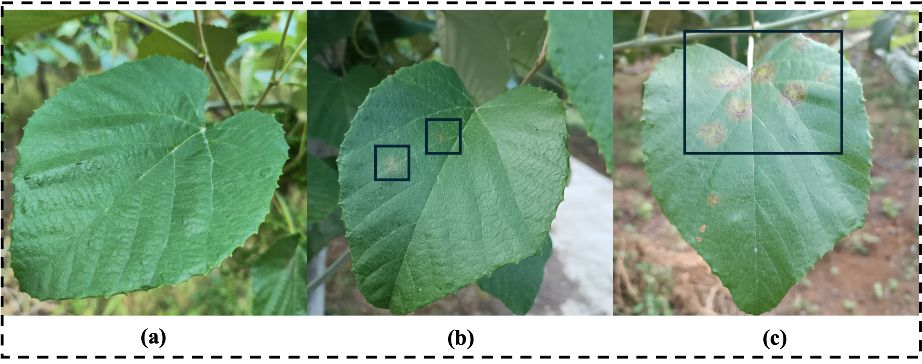
Figure 4. Downy mildew lesion emergence and development on Yeniang No. 2 (MPT) leaves in the Du’an experimental vineyard, Hechi. Panels show severity levels from a single-leaf perspective: (a) healthy; (b) 1% (post-incubation visible lesion); (c) 5%. Photos by team member Qi Tian (2023).

Airborne sporangia monitoring
At each vineyard, one passive spore trap (model TPBZ1, Zhejiang Top Cloud-Agri Technology Co., Ltd., China) was installed adjacent to the fungicide-free control (CK) plot to monitor the natural airborne dispersal of P. viticola sporangia. Trap placement avoided potential chemical interference, and the air inlet was positioned approximately 1.5 m above ground level, corresponding to the average grapevine canopy height.
Sporangia were collected on glass slides coated with a thin layer of Vaseline, which were replaced every two days. Samples were sealed and transported to the laboratory of the Guangxi Academy of Agricultural Sciences for quantitative analysis. To improve counting accuracy, two microscopic observation procedures were applied: (i) direct imaging, in which untreated slides were examined directly under a microscope (Fig 5b–d); and (ii) wash imaging, in which each slide was rinsed with 300 $μ$L of sterile water, and five 30 $μ$L subsamples were collected from different depths of the rinse solution to minimize bias associated with particle sedimentation (Fig 5b–d). Subsamples were transferred to concave glass slides for microscopic observation and imaging.
Images obtained from wash imaging were processed using a sporangia recognition platform developed by our research team (http://116.10.197.212:9060/spore/#/) to support efficient screening and counting. The platform uses a detection model trained for P. viticola sporangia recognition (Yan et al., 2024). Because the present study focuses on field-based inoculum monitoring and agroclimatic disease modelling rather than image-analysis development, all automatically detected results were independently verified by two trained laboratory technicians before being used in model calibration and validation (Fig 5c).
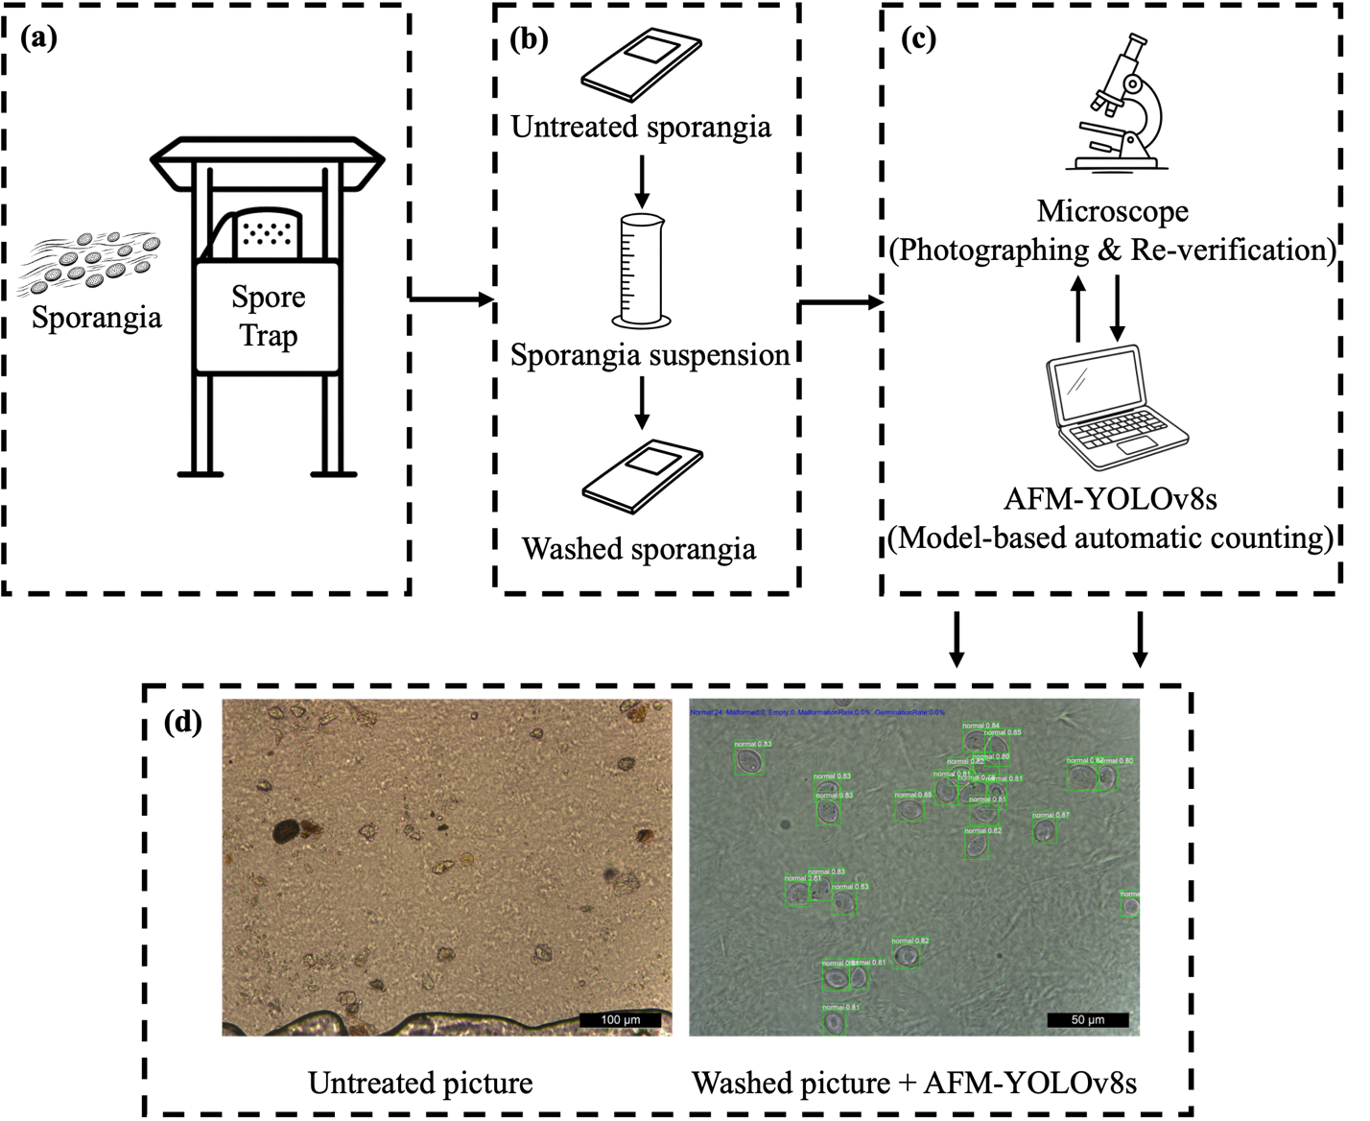
Figure 5. Schematic illustration of sporangia collection and processing in the vineyard experiment. (a) Schematic of dynamic monitoring of sporangia; (b) schematic of laboratory preprocessing; (c) schematic of sporangia image and quantity acquisition; (d) representative sporangia images obtained from the untreated sporangia slide and the washed sporangia slide.

Meteorological data
Meteorological data were retrieved from the Open-Meteo platform (https://open-meteo.com/), which provides ERA5 reanalysis products with hourly temporal resolution (Hersbach et al., 2020). For each experimental orchard, geographic coordinates were used to extract site-specific time series of air temperature (T), relative humidity (RH), and precipitation (R). To meet the requirements of the disease prediction model, additional variables—including vapor pressure deficit (VPD) and leaf wetness duration (LWD)—were derived from temperature and humidity data using the established formulations described by Rossi et al. (2008).

Model structure and refinements

First Seasonal Infection Model (FSIM): baseline mechanistic framework
In this study, the first visible infection event of a new growing season, primarily driven by asexual sporangia, is defined as the “First Seasonal Infection” event (Fig. S2). Based on this epidemiological context, a First Seasonal Infection Model (FSIM) was developed to simulate the timing of initial infection events in subtropical vineyards in Guangxi, China.
Unlike conventional primary infection models that typically initiate simulations on January 1, the present study used BBCH53 (flowering stage) of the new growing season as the simulation starting point under subtropical conditions (Hui et al., 2022). BBCH53 dates were obtained from field phenological observations and applied as a temporal gating condition to define the onset of infection simulations.
The FSIM was constructed through structural integration and process reorganization of the Rossi primary infection model and secondary infection risk frameworks (Brischetto et al., 2021; Rossi et al., 2008).
Infection-development processes retained from the Rossi model include zoospore release and survival, infection establishment, incubation, and symptom expression, which constitute the mechanistic backbone of the infection chain. The secondary infection risk module was positioned upstream to describe the production of sporangia, followed by the infection chain derived from the Rossi model, including zoospore release and survival, infection establishment, incubation, and symptom expression. In this restructuring, the probability-accumulation formulation of the original secondary infection model was reformulated into a cohort-based representation describing spore production, accumulation, depletion, and release. Dispersal mechanisms were distinguished into rainfall-driven and wind-driven pathways. Apart from process reordering and structural adjustments, the original mathematical formulations were retained where applicable.
To represent dispersal dynamics, a cohort-based dispersal–deposition mechanism was introduced (Rossi et al., 2008). The model first updates the attached sporangia pool $A_{t}$, which decays during daytime as a function of vapor pressure deficit (VPD). When $A_{t}$ falls below a minimum threshold $A_{min}$, no dispersal occurs. A dispersal event is triggered when hourly rainfall $R_{t}$ exceeds the rainfall threshold $R_{min}$ or wind speed $W_{t}$ exceeds the wind threshold $W_{min}$. A single dispersal event is assumed to fully transfer the attached sporangia pool into the airborne compartment:
$B_{t_{0}}=A_{t_{0}}, A_{t_{0}}→0$ (1)
where $t_{0}$ denotes the dispersal time and $B_{t_{0}}$ the initial airborne sporangia amount.
Two dispersal scenarios are distinguished:
Rainfall-driven dispersal: sporangia are assumed to deposit rapidly on plant surfaces approximately one hour after dispersal:
$t_{d}=t_{0}+1\text{ h}, D=B_{t_{0}}$ (2)
Wind-driven dispersal: sporangia remain airborne and decay exponentially during daytime:
$B_{t+1}=B_{t}exp(-λ_{t})$ (3)
where $λ_{t}$ is a VPD-dependent decay rate. Subsequent rainfall events exceeding the deposition threshold $R_{min}$ trigger deposition, with deposited inoculum given by:
$D=B(t_{d}^{-})$ (4)
If the deposited amount falls below the minimum spore threshold, the cohort is considered inactive and does not contribute to subsequent infection processes.
Field monitoring indicated that airborne pathogen structures captured prior to the appearance of visible lesions were predominantly sporangia (Fig 5d), providing observational support for the sporulation, dispersal, and deposition modules included in the FSIM.

Spore-constrained refinement of the First Seasonal Infection Model (FSIM-S)
An extended model (FSIM-S) was developed while maintaining the mechanistic process chain of FSIM. The suffix “-S” denotes the incorporation of airborne sporangia observations. A daily sporangia pressure field $S(d)$ was constructed from field monitoring data. After temporal interpolation, normalization, and smoothing, the resulting signal represented relative inoculum pressure conditions. Hourly spore pressure was defined as a three-day rolling average:
$P_{t}=\frac{1}{3}\sum_{k=0}^{2}{ } S(d_{t}-k)$ (5)
In the baseline FSIM, infection occurrence was determined by:
$WD_{t}⋅TWD_{t}≥IC$ (6)
where $IC$ denotes the infection threshold parameter. In FSIM-S, this fixed threshold was replaced by a pressure-adjusted effective threshold $IC_{t}^{*}$:
$IC_{t}^{*}=\left\{\begin{matrix}IC⋅exp(-α_{pos}P_{t}), & P_{t}≥0, \\ IC⋅exp(α_{neg}(-P_{t})), & P_{t}<0\end{matrix}\right.$ (7)
and infection was considered to occur when:
$WD_{t}⋅TWD_{t}≥IC_{t}^{*}$ (8)
where $α_{pos}$ and $α_{neg}$ are calibration parameters controlling threshold adjustments under high and low inoculum pressure, respectively. Apart from this infection-threshold adjustment, all meteorological drivers and physiological process formulations remained identical to those in FSIM. The conceptual structure of the baseline and spore-constrained models is summarized in Fig 6.
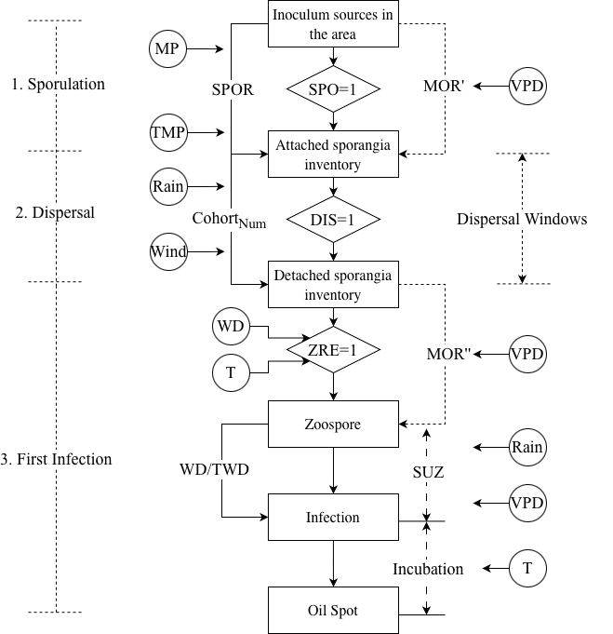
Figure 6. Conceptual diagram of the model. The figure illustrates the mechanistic framework of first seasonal infection by Plasmopara viticola in subtropical Guangxi (FSIM). Red text indicates the incorporation of an observed spore-pressure field during the infection stage, representing the refined model denoted as FSIM-S.

Parameterization and sensitivity analysis
To identify key parameters and compare parameter response patterns before and after incorporation of spore information, global sensitivity analyses were conducted for both the baseline First Seasonal Infection Model (FSIM) and the spore-constrained enhanced model (FSIM-S). Considering the relatively high dimensionality of model parameters and computational cost, a Morris global sensitivity analysis framework (Morris, 1991; Iooss and Lemaître, 2015) adopted to evaluate the relative influence of parameters on model outputs and to detect potential nonlinear and interaction effects. Parameter sampling and sensitivity index estimation were implemented using the SALib toolkit. The number of sampling levels was set to six, and 256–512 trajectories were generated to balance computational efficiency and stability of sensitivity estimates. Model performance was evaluated based on the difference in day-of-year (DOY) between observed first lesion appearance and the simulated oil-spot occurrence window, using mean absolute error (MAE) as the primary metric. When no effective infection event was simulated, a fixed penalty error (120 d) was applied to maintain statistical consistency. The penalty value was selected to exceed the biologically plausible infection window within a single growing season.
Let $x=(x_{1},…,x_{k})$ denote the parameter vector and $f(x)$ the model output. Following the Morris method, the elementary effect of the $i$-th parameter at sampling point $x$ is defined as:
$EE_{i}(x)=\frac{f(x_{1},…,x_{i}+Δ,…,x_{k})-f(x)}{Δ}$ (9)
Here, $Δ$ denotes the step size in the normalized parameter space, determined by the predefined number of sampling levels. Based on $N$ elementary effects, three sensitivity statistics were calculated:
$μ_{i}=\frac{1}{N}\sum_{j=1}^{N}{ } EE_{i,j}, { μ}_{i}^{*}=\frac{1}{N}\sum_{j=1}^{N}{ } |EE_{i,j}|$ (10)
$σ_{i}=\sqrt{\frac{1}{N-1}\sum_{j=1}^{N}{ } {(EE_{i,j}-μ_{i})}^{2}}$ (11)
Among these, $μ_{i}^{*}$ represents the overall influence magnitude of a parameter and serves as the primary indicator for identifying key parameters; $μ_{i}$ reflects the directional effect (advancing or delaying infection timing); and $σ_{i}$ captures nonlinear effects and parameter interactions. Parameters were ranked according to $μ_{i}^{*}$ to support parameter screening and subsequent model calibration.
Regarding parameterization, the FSIM parameter set (Table 2) largely inherits biologically interpretable parameters from established grapevine downy mildew mechanistic models, with selected parameter ranges adjusted based on subtropical vineyard observations. The FSIM-S model further introduces spore-pressure adjustment parameters (Table 2) to account for dynamic modulation of infection triggering thresholds by airborne inoculum pressure. Comparing sensitivity structures under a unified analytical framework enables quantitative assessment of how incorporation of spore information modifies parameter control patterns and supports subsequent model refinement and calibration.

Table 2. Model parameters under the FSIM and FSIM-S frameworks. FSIM denotes the baseline model, whereas FSIM-S represents the extended version incorporating regulation by an observed spore-pressure field.
Parameter | Abbreviation | FSIM | FSIM-S | Unit | Description
Mp_tmp__rh_wet_night | MTWN | 87.5894 | 83.6223 | % | Night-time relative humidity threshold used to define wet-night conditions for sporulation initiation.
Sporulation__MP_min | SMMI | 4.3106 | 5.1741 | hours | VPD threshold representing Minimum cumulative wet-night hours required to trigger sporulation.
Sporulation__Tmin | STMI | 13.9426 | 11.8061 | °C | Lower temperature limit for sporulation response.
Sporulation__Topt | STOP | 25.4161 | 19.3980 | °C | Optimum temperature for sporulation intensity.
Sporulation__Tmax | STMX | 35.2136 | 35.0492 | °C | Upper temperature limit for sporulation response.
Dispersal__rain_min | DIRM | 12.4525 | 12.3417 | mm | Rainfall threshold triggering rain-driven sporangial dispersal.
Dispersal__wind_min | DIWM | 6.4975 | 6.2638 | m/s | Wind-speed threshold triggering wind-driven sporangial dispersal.
Deposition__rain_min | DERM | 5.1413 | 6.0721 | mm | Rainfall threshold controlling deposition/washout of airborne propagules.
Zoospore_alive__rain | ZARA | 4.0835 | 5.3267 | mm | Rainfall condition threshold used in zoospore survival gating.
Zoospore_alive__vpd | ZVPD | 1.9396 | 1.9674 | kPa | Vapor pressure deficit threshold used in zoospore survival gating.
Infection__infection_condition | IC | 25.4409 | 81.4294 | / | Infection requirement threshold.
Incubation__spl_spores | ISED | 1.1063 | 0.9361 | / | Cumulative incubation progress threshold for visible oil-spot onset.
Thresholds__min_spores | TMSO | 0.0431 | 0.1016 | / | Minimum viable spore amount retained for process continuity.
Spore__alpha_pos | SAP | / | 1.2849 | / | Positive spore-pressure coefficient; decreases effective infection threshold under favourable spore pressure.
Spore__alpha_neg | SAN | / | 0.6306 | / | Negative spore-pressure coefficient; increases effective infection threshold under suppressive spore pressure.

Model calibration and evaluation
To assess the temporal predictive capability and applicability of the First Seasonal Infection Model (FSIM) and its spore-constrained extension (FSIM-S) under humid subtropical vineyard conditions, parameter calibration and model evaluation were conducted within a unified methodological framework. Both models employed identical calibration strategies and evaluation metrics, while FSIM-S additionally incorporated a spore-pressure field derived from airborne sporangia observations together with associated adjustment parameters, allowing quantitative assessment of the effect of incorporating inoculum information into the infection simulation process.

Calibration strategy
Model parameters were optimized using Bayesian optimization based on the Tree-structured Parzen Estimator (TPE) approach (Bergstra et al., 2011), which enables efficient exploration of high-dimensional parameter spaces through probabilistic modelling. The optimization objective was defined as minimization of the mean absolute error (MAE) in predicted first-infection timing. Given the relatively large parameter space and the potential multimodality of the objective function, extensive parameter exploration was performed (approximately $2×{10}^{4}$ trials for the baseline model and $3×{10}^{4}$ trials for the spore-constrained model).
To enhance robustness of parameter selection, approximately the top 5% of high-performing candidate parameter sets identified during optimization were retained for subsequent comparative evaluation. This strategy reduces the risk of overfitting and avoids overlooking near-optimal solutions.
Compared with the baseline FSIM, the FSIM-S model maintains the same mechanistic infection framework while incorporating a daily airborne spore-pressure field derived from field observations. Additional parameters were introduced to dynamically adjust infection-triggering thresholds according to inoculum pressure. Apart from these spore-related parameters, both models used identical meteorological drivers, biological process formulations, and calibration procedures to ensure comparability of predictive performance. Parameter ranges were constrained based on biologically plausible values derived from previous mechanistic studies and field observations to maintain ecological realism.

Performance metrics
Model performance was primarily evaluated using temporal prediction error metrics. Mean absolute error (MAE) and root mean square error (RMSE) were calculated to quantify overall prediction accuracy and sensitivity to large deviations:
$MAE=\frac{1}{n}\sum_{i=1}^{n}{ } \left|y_{i}-{\hat{y}}_{i}\right|$ (12)
$RMSE=\sqrt{\frac{1}{n}\sum_{i=1}^{n}{ } {\left(y_{i}-{\hat{y}}_{i}\right)}^{2}}$ (13)
where $y_{i}$ and ${\hat{y}}_{i}$ denote observed and simulated first-infection dates expressed as day-of-year (DOY), respectively, and $n$ is the number of observations.
When no effective infection event was simulated or numerical anomalies occurred, a fixed penalty error of 120 days was assigned. This value substantially exceeds the plausible temporal range for first seasonal infection within a single growing season and was applied to ensure consistent penalization of missed infection events during statistical comparison.

Cross-validation and robustness assessment
To avoid bias associated with fixed training–validation splits, a three-fold cross-validation scheme was applied in which site-year datasets were randomly partitioned into three subsets, each serving once as validation data while the remaining subsets were used for calibration.
To ensure reproducibility of parameter optimization, a fixed random seed (seed = 42) was used for data partitioning and optimization initialization. Final model performance was summarized using fold-averaged MAE and RMSE values, with corresponding standard deviations reported to reflect predictive stability and cross-site generalizability.

Selection of global parameter configuration
To obtain a single deterministic model configuration for site–year simulations, the fold-specific best parameter sets (those achieving the lowest validation MAE within each fold) were evaluated on the full dataset. The configuration yielding the lowest overall MAE was selected as the final global parameter set. Direct averaging of parameters across folds was avoided, as it led to substantial error inflation due to the non-convex nature of the objective function and the presence of multiple near-optimal parameter regions.

Regional simulation and disease-management scenario analysis
To evaluate the applicability of the FSIM-S model at the regional scale and its potential value for risk-based disease management, regional simulations were conducted across Guangxi Province for the period 2000–2024. Given the limited spatial coverage of field observations and the lack of a spatially explicit vineyard census layer, the regional analysis was framed as a scenario-based assessment rather than as a complete mapping of actual vineyard distribution. Three cultivar scenarios were constructed to ensure comparability across the region, assuming that vineyards were uniformly planted with Wink, Yeniang No. 2, or Kyoho cultivars, respectively. The model was driven by the hourly meteorological dataset described previously (Fig 3).
Considering that growers in the region commonly adopt similar preventive spraying schedules through peer-to-peer technical exchange, chemical disease management was represented using a schedule derived from the 2022 Du’an (Hechi) experimental vineyard (Fig 7) (Chavas and Nauges, 2020; Huffman, 2020; Norton and Alwang, 2020). The potential to avoid early preventive treatments was evaluated relative to this baseline schedule, whereby any preventive fungicide application conducted more than seven days before the simulated first-infection onset was classified as potentially avoidable. The seven-day buffer was used to remain consistent with the protection window commonly expected for vineyard fungicide applications and to avoid classifying near-risk sprays as redundant. Based on this criterion, the multi-year average number of potentially avoidable early applications and the corresponding reduction proportion were calculated.
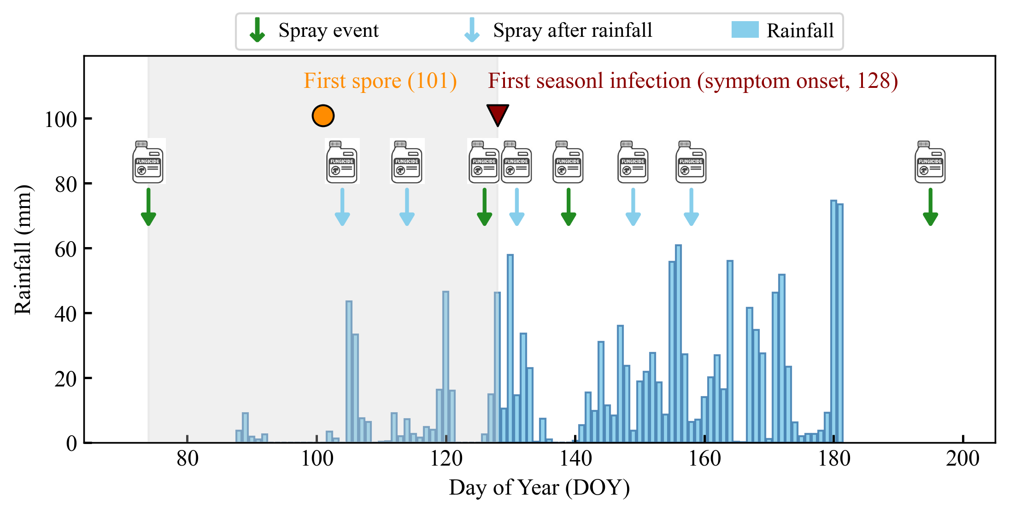
Figure 7. Illustration of the empirically executed fungicide application pattern, documented by field investigators immediately after each grower-implemented spray event in the experimental vineyard in Du’an, Hechi City, during the 2022 growing season. The management practice was characterized by preventive fungicide applications conducted after rainfall events and prior to the onset of first seasonal infection. The shaded region indicates the period of such pre-infection, rainfall-triggered preventive sprays.

Reconstruction of flowering dates (BBCH53)
Because continuous observations of the BBCH53 phenological stage (flowering) were unavailable for most years during 2000–2024, while the FSIM-S disease model requires this stage as a phenological gate for infection activation, a meteorology-driven BBCH53 reconstruction module was developed and calibrated to provide consistent phenological inputs for regional simulations (Hui et al., 2022).
Phenological development was represented using accumulated thermal time derived from hourly air temperature. Effective growing degree days (GDD) for each hour $h$ were calculated as:
$GDD_{h}=\frac{max(T_{h}-T_{base},0)}{24}$ (14)
where $T_{h}$ denotes hourly air temperature and $T_{base}$ is the base temperature. Accumulated thermal time from the starting date $t_{0}$(defined by start_doy) was then computed as:
$AGDD(t)=\sum_{h=t_{0}}^{t}{ } GDD_{h}$ (15)
The BBCH53 date was defined as the first day satisfying both a cumulative thermal threshold and a short-term heat constraint:
$AGDD(t)≥θ_{AGDD}, RGDD_{7d}(t)≥θ_{RGDD}$ (16)
where $RGDD_{7d}(t)$ represents the 7-day running sum of daily GDD, introduced to reduce premature triggering caused by short-term temperature anomalies.
To account for cultivar differences, thermal thresholds and starting dates were cultivar-adjusted. The effective thermal threshold was expressed as:
$θ_{eff}=θ_{AGDD}(1+δ_{v}+k_{MPT}z_{y})$ (17)
where $δ_{v}$ denotes cultivar-specific threshold offsets (Wink, Yeniang No. 2, and Kyoho), and $k_{MPT}z_{y}$ represents an additional year-type adjustment derived from winter temperature conditions. The effective starting date was adjusted as:
$start_doy_{eff}=start_doy+s_{v}$ (18)
where $s_{v}$ is the cultivar-specific offset.
Parameter calibration followed a Bayesian optimization framework combined with cross-validation to improve robustness of parameter selection. Calibration was conducted in two stages: first optimizing general thermal parameters (e.g., base temperature, thermal thresholds, and starting date), and subsequently estimating cultivar adjustment parameters based on the best-performing candidates. Given the limited availability of phenological observations, calibration emphasized obtaining stable and reusable phenological estimates for disease-model input rather than achieving maximal phenological prediction accuracy.
The final parameter set was used to reconstruct gridded BBCH53 dates across Guangxi for 2000–2024, and these reconstructed phenological dates were subsequently used as standardized inputs for regional FSIM-S disease simulations.

Reconstruction of spore pressure fields
Because continuous airborne spore observations were unavailable for the historical period (2000–2024), while the FSIM-S model requires inoculum pressure information to regulate infection triggering, a meteorology-driven spore-pressure reconstruction module was developed. Field spore monitoring data collected during 2022–2024 were used for parameter calibration, after which spatially explicit spore pressure time series were reconstructed to drive historical simulations.
The module follows a “potential inoculum reservoir–pressure index” dynamic framework, in which meteorological effects on spore production and loss are represented as source and loss terms:
$A_{t}=max\left(0,ρA_{t-1}+Source_{t}-Loss_{t}\right)$ (19)
where $A_{t}$ denotes the latent inoculum state. After logarithmic normalization and smoothing, the resulting daily spore pressure index $S_{t}$ was used as an input variable for infection triggering in FSIM-S.
To ensure consistency with the disease process model, meteorological drivers used in pressure reconstruction share the same physical interpretation as those controlling infection processes in FSIM-S. However, the pressure module employs a simplified inoculum reservoir dynamic that is independently calibrated, enabling robust forcing input under conditions lacking long-term spore observations. Calibration was performed using Bayesian optimization with cross-validation, and the resulting parameters were applied to reconstruct gridded spore pressure fields for 2000–2024, which were subsequently coupled to FSIM-S through infection-threshold adjustment mechanisms.

Results

Field observations of disease onset and spore dynamics
Among the six datasets collected from Guilin, Hechi, and Nanning between 2022 and 2024, the first detection of airborne P. viticola sporangia occurred between March 30 and April 20, while first seasonal infection symptoms were observed between April 20 and May 30 (Fig 8). An exception was noted in the Nanning vineyard in 2023, where symptom onset was delayed until June. In both Hechi and Nanning, symptom appearance in 2023 was later than in 2022 and 2024. The interval between initial sporangia detection and symptom onset varied substantially across sites and years, ranging from 9 days in Nanning (2024) to 72 days at the same site in 2023, indicating marked interannual variability in epidemic development.
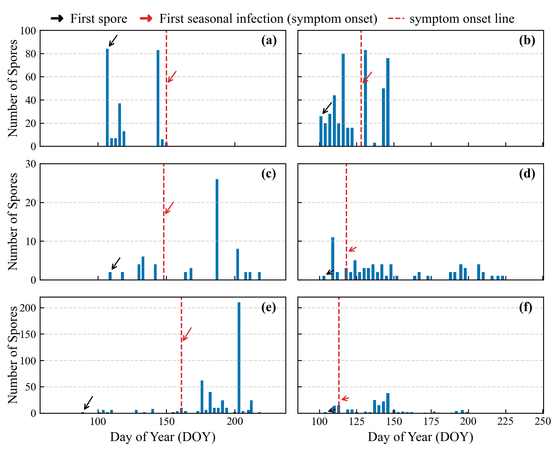
Figure 8. Timing of first seasonal infection and sporangia dynamics of grape downy mildew (Plasmopara viticola) in the experimental vineyard from 2022 to 2024: (a) Guilin, 2022; (b) Hechi, 2022; (c) Hechi 2023; (d) Hechi, 2024; (e) Nanning, 2023; (f) Nanning, 2024.

Sensitivity analysis
To quantify the relative contribution of model parameters to simulation outputs and assess the impact of incorporating spore-pressure dynamics, a global sensitivity analysis was performed using the Morris method. Parameter influence magnitude and direction were represented by the absolute mean effect ($μ^{*}$) and the signed mean effect ($μ$), respectively (Fig 9, Fig 10).
In the baseline FSIM model, ZVPD exhibited the highest sensitivity ($μ^{*}$ = 17.23), followed by DIRM (15.13), TMSO (13.25), and IC (12.67), which collectively dominated model output (Fig 9a).
The signed effects revealed distinct directional differentiation: IC exerted the strongest positive influence ($μ=20.23$), whereas ZVPD showed a pronounced negative effect ($μ=-20.17$) (Fig 10a).
Following the incorporation of spore-pressure dynamics in FSIM-S, the overall sensitivity ranking remained largely consistent, with ZVPD ($μ^{*}$ = 16.67), DIRM (13.42), IC (13.34), and TMSO (12.93) continuing to rank as the four most influential parameters (Fig 9b). Among the newly introduced spore-related parameters, SAP exhibited moderate sensitivity ($μ^{*}=4.63$), surpassing several existing environmental and dispersal-related parameters (e.g., STMI, DERM, SMMI), whereas SAN showed low sensitivity ($μ^{*}=1.27$). The signed effects in FSIM-S (Fig 10b) maintained similar directional patterns: IC remained the strongest positive driver ($μ=18.74$), ZVPD the strongest negative driver ($μ=-16.59$), while SAP displayed a clear negative effect ($μ=-7.05$).
Overall, the sensitivity analysis confirms that the dominant model drivers remain stable after the incorporation of spore-pressure dynamics, while the moderate sensitivity of SAP supports the biological relevance of the spore-pressure formulation in influencing infection timing.
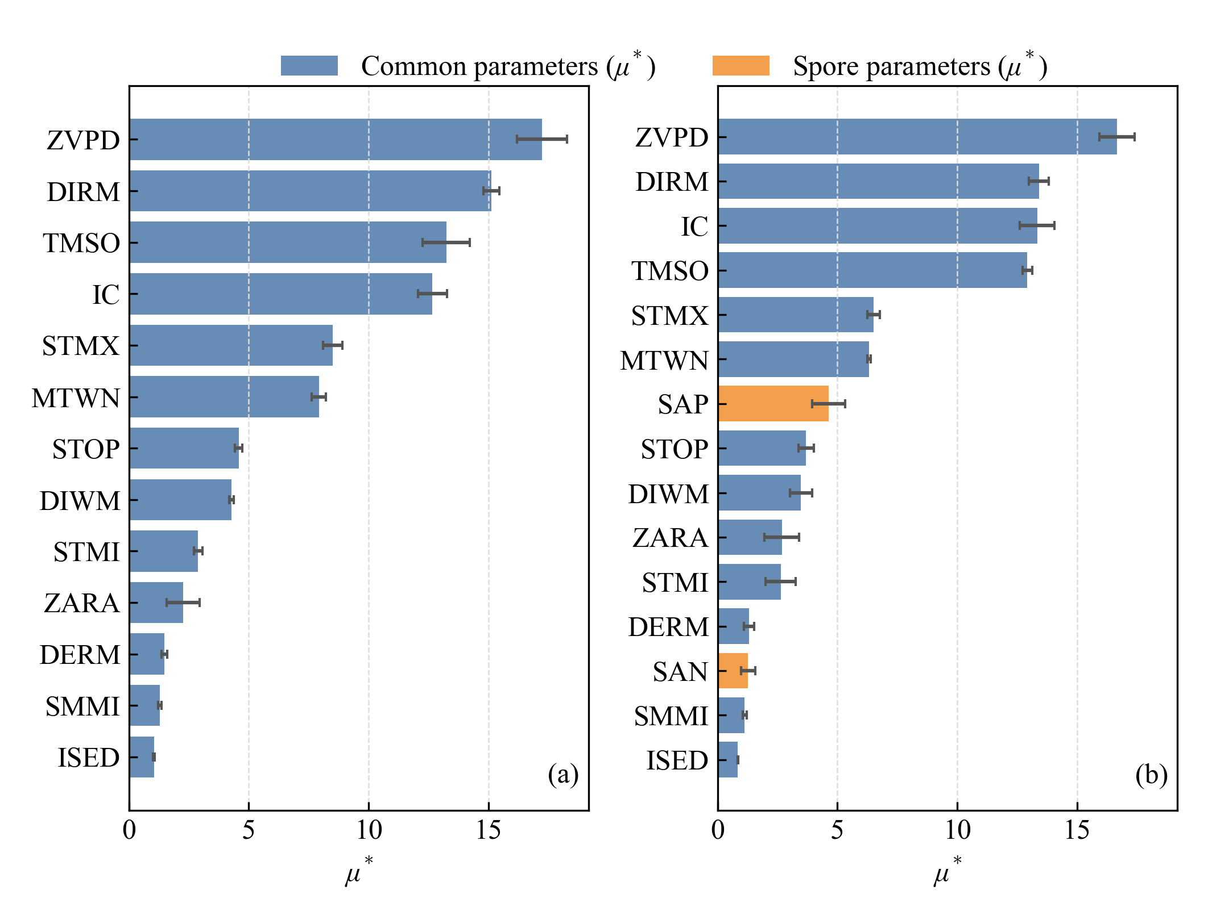
Figure 9. Global parameter sensitivity based on the Morris method expressed as absolute mean effects () for the baseline FSIM model (a) and the extended FSIM-S model incorporating the spore-pressure formulation (b). Parameters are ranked by decreasing , representing their overall influence magnitude on model output aggregated across multiple random seeds. Parameter abbreviations: ZVPD = zoospore_alive__vpd; DIRM = dispersal__rain_min; IC = infection__infection_condition; TMSO = thresholds__min_spores; STMX = sporulation__Tmax; MTWN = mp_tmp__rh_wet_night; DIWM = dispersal__wind_min; STOP = sporulation__Topt; STMI = sporulation__Tmin; ZARA = zoospore_alive__rain; DERM = deposition__rain_min; SMMI = sporulation__MP_min; ISED = incubation__spl_end; SAP = spore__alpha_pos; SAN = spore__alpha_neg. Error bars indicate variability across aggregated runs.
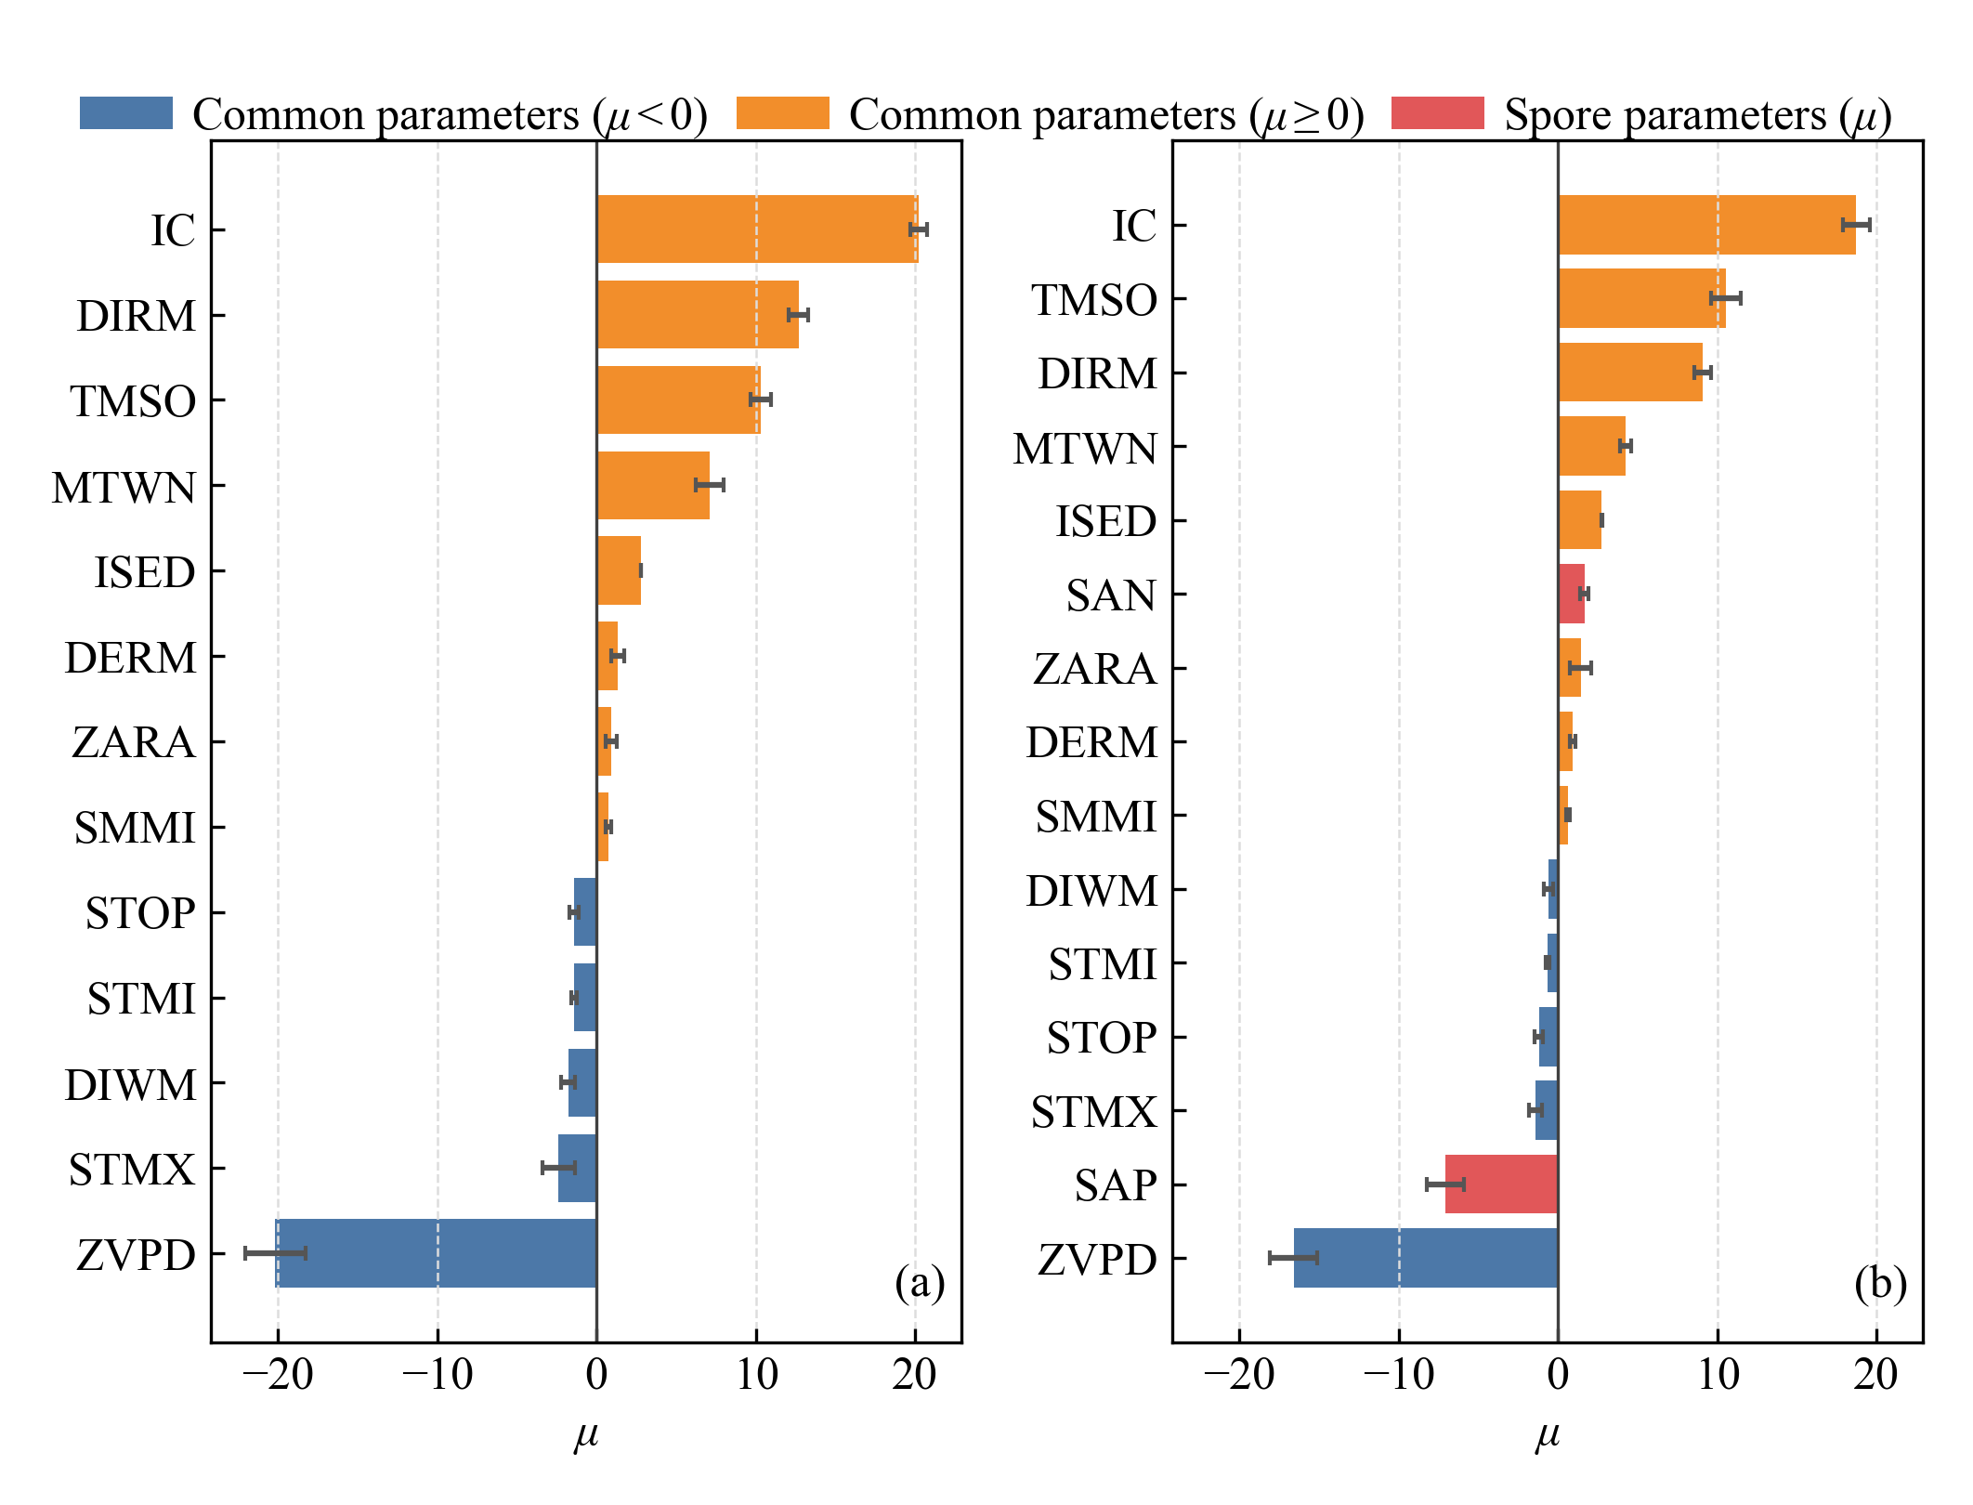
Figure 10. Signed mean effects () from the Morris global sensitivity analysis for the baseline FSIM model (a) and the extended FSIM-S model (b). Positive and negative values indicate the direction of parameter influence on model output, while bar length reflects effect magnitude. Results are aggregated across multiple random seeds, with error bars representing variability among runs.

Model performance
The predictive performance of FSIM and FSIM-S for first seasonal infection onset was evaluated using mean absolute error (MAE) and root mean square error (RMSE) under a three-fold cross-validation framework (Fig 11). On the training sets, FSIM achieved MAE and RMSE values of 6.8 and 8.1 days, respectively, whereas FSIM-S reduced these to 4.0 and 4.0 days, corresponding to reductions of 41.5% and 50.3%. On the validation sets, FSIM yielded MAE of 9.3 days and RMSE of 10.6 days, while FSIM-S achieved 6.3 and 6.5 days, representing reductions of 32.1% and 38.9% (Fig 11). Notably, FSIM-S also exhibited lower variability across cross-validation folds, indicating improved predictive stability.
The simulated first seasonal infection onset windows for each site–year combination are presented in Table 3. Both models generally reproduced the observed onset patterns, with FSIM-S achieving comparable or slightly improved accuracy across most cases. Errors varied by location and year: the largest deviation occurred in Guilin 2022, where both models predicted onset approximately 13 days earlier than observed; in contrast, both models achieved zero error for Hechi 2023. For Hechi 2022 and Nanning 2023–2024, FSIM-S yielded smaller temporal deviations than FSIM, while maintaining comparable prediction windows.
Overall, the incorporation of spore-pressure dynamics into the model framework resulted in consistent improvements in both prediction accuracy and stability, with FSIM-S outperforming FSIM across training and validation datasets and demonstrating enhanced precision across site–year combinations.

Table 3. Simulated first seasonal infection onset windows and corresponding deviations (Error) from observed symptom appearance across sites and years for FSIM and FSIM-S. Negative Error values indicate that the simulated onset occurred earlier than observed. “Simulated Onset” denotes the model-estimated oil-spot appearance window representing first seasonal infection expression. Results shown correspond to the final global parameter configuration selected from cross-validation folds (see Section 2.5.4).
Model | Site | Year | Simulated Onset (Month-Day) | Error (days)
FSIM | Guilin | 2022 | May 15–17 | -13.0
 | Hechi | 2022 | May 14–15 | +6.0
 | Hechi | 2023 | May 28–30 | +0.0
 | Hechi | 2024 | Apr 25–26 | -1.0
 | Nanning | 2023 | Jun 15–16 | +5.0
 | Nanning | 2024 | Apr 25–26 | +3.0
FSIM-S | Guilin | 2022 | May 15–17 | -13.0
 | Hechi | 2022 | May 13–14 | +5.0
 | Hechi | 2023 | May 28–29 | +0.0
 | Hechi | 2024 | Apr 24–25 | -2.0
 | Nanning | 2023 | Jun 14–15 | +4.0
 | Nanning | 2024 | Apr 24–25 | +2.0
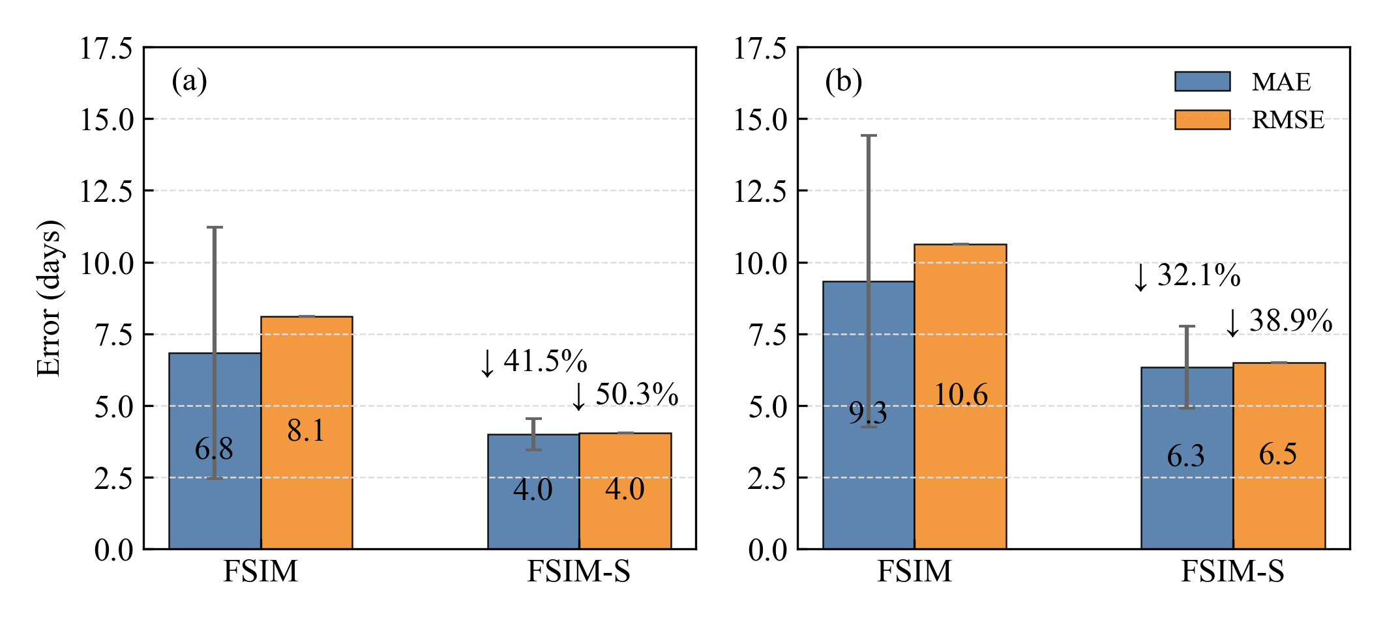
Figure 11. Model performance comparison based on mean absolute error (MAE) and root mean square error (RMSE): (a) training set and (b) test set. Bars show mean errors (days) ± standard deviations across folds. The percentages denote relative error reductions compared with the baseline FSIM model.

Spatial distribution of first-infection onset across Guangxi (2000–2024)
Based on historical ERA5 meteorological data, the spatial distribution of first-infection onset across Guangxi from 2000 to 2024 was reconstructed using FSIM-S, simulated under three variety-specific phenology scenarios: Wink (WK), Kyoho (JF), and Yeniang No. 2 (MPT) (Fig 12).
Multi-year mean onset dates were similar across varieties, with WK and JF averaging DOY 195 and MPT DOY 198 (median: 196, 196, and 199, respectively). Spatially, earlier onset dates were consistently simulated in central–southern and parts of southwestern Guangxi, whereas later onset occurred in northern and northeastern areas (Fig 12a–c). This spatial gradient was consistent across all three varieties.
Frequency distributions (Fig 12d) showed that the majority of onset dates fell within DOY 180–210 across all varieties, with peak frequencies concentrated around DOY 190–200. The overall distribution structures were highly similar among varieties.
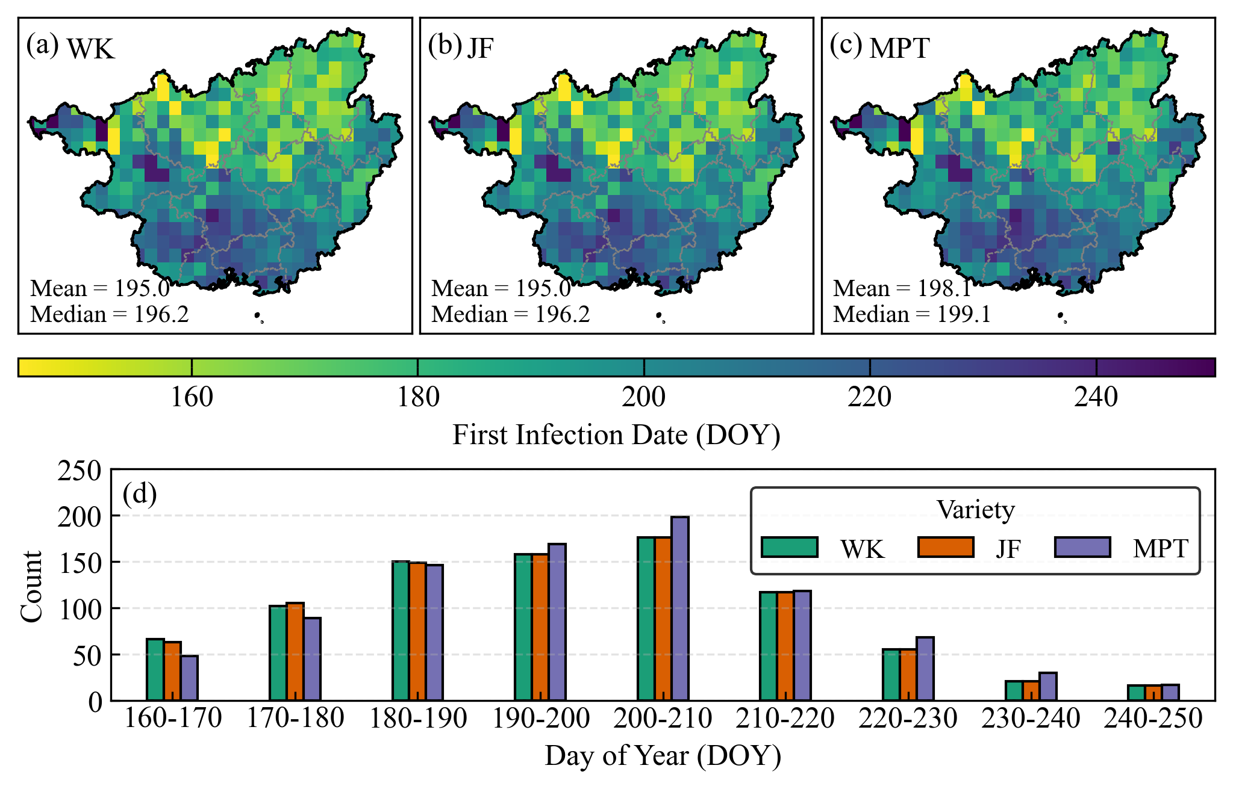
Figure 12. Simulated mean onset dates (day of year, DOY) of first seasonal infection under the FSIM-S model for three varieties: (a–c) spatial distributions of the Wink (WK), Kyoho (JF), and Yeniang No. 2 (MPT), and (d) their DOY frequency distributions.

Regional disease-management implications (2000–2024)
The potential to improve early disease-management timing across Guangxi from 2000 to 2024 was evaluated by comparing the FSIM-S-derived timing of first seasonal infection with a representative conventional fixed calendar programme (Fig 13). Across the three grapevine varieties, the model-guided strategy identified approximately three potentially avoidable early preventive applications per season on average (mean: 3.0 sprays; median: 2.7 sprays), with minimal variation among varieties. This result indicates that the main management value of FSIM-S lies in delaying unnecessary pre-risk sprays while retaining protection near the simulated infection window.
Spatially, higher saving potential was concentrated in central–southern and southwestern Guangxi, where simulated first-infection onset tended to occur later relative to the representative calendar programme, whereas northern and northeastern areas showed relatively lower savings (Fig 13a–c). This spatial pattern was consistent across all three varieties.
The frequency distribution (Fig 13d) showed that spray savings were predominantly two to four applications per season, with two or three sprays being the most common. Higher savings ($≥$5 sprays) occurred less frequently but were present in certain locations. The overall distribution structures were highly similar among varieties, suggesting that spatial climatic variability exerted a stronger influence on early-season management timing than the simplified variety scenarios considered here.
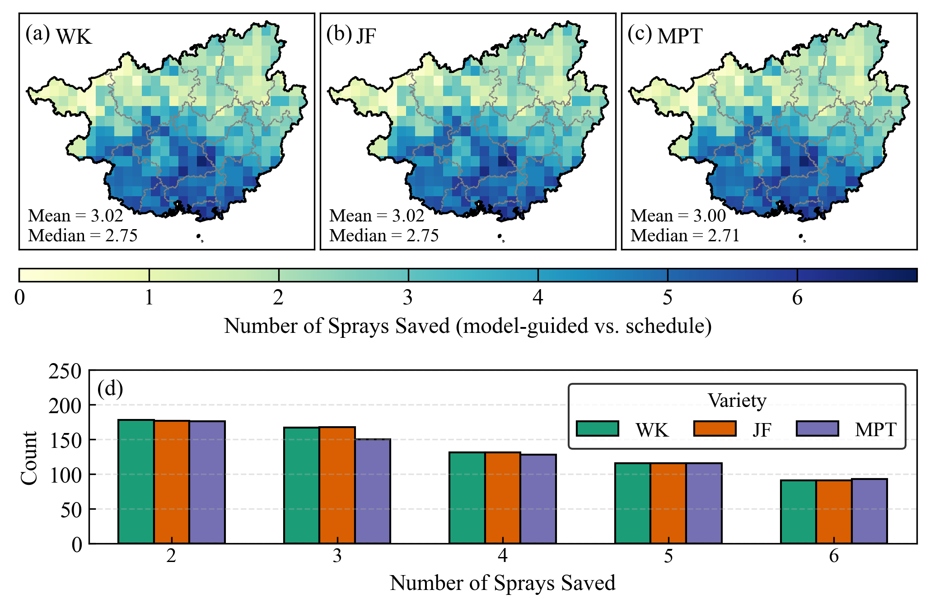
Figure 13. Spatial distribution and frequency of model-guided spray savings under the FSIM-S model: (a–c) multi-year mean number of sprays saved per grid cell for the Wink (WK), Kyoho (JF), and Yeniang No. 2 (MPT), and (d) frequency distribution of spray savings.

Discussion
This study addressed a key agronomic challenge in subtropical viticulture: improving early-season grapevine downy mildew management when viable inoculum may be present before weather and crop conditions become jointly favourable for infection. By reconstructing Rossi’s primary and secondary infection formulations into a First Seasonal Infection Model (FSIM), and then incorporating observation-based spore-pressure dynamics (FSIM-S), the study linked on-farm inoculum monitoring with agroclimatic process modelling.
Across multiple site–year datasets from Guangxi, China, FSIM-S improved prediction accuracy and stability compared with FSIM while retaining the dominant influence of meteorological drivers. These results support the use of FSIM-S as a region-adapted mechanistic framework for field-based downy mildew decision support in subtropical vineyards, rather than as an empirical model fitted only to symptom dates.

Inoculum dynamics and the drivers of first seasonal infection timing
In temperate systems, seasonal epidemics are typically initiated by overwintering oospores after a distinct climatic break. In contrast, the continuous presence of airborne sporangia during the early growing season (Fig 5, Fig 8) indicates that inoculum in the studied subtropical vineyards is not restricted to a discrete primary infection event. This distinction has direct implications for model structure, because frameworks centred on oospore-driven primary infection may not fully represent systems in which asexual inoculum is recurrently available.
Despite this continuous inoculum presence, the timing of first seasonal infection varied substantially across sites and years (Fig 8). This variability is consistent with interannual differences in early-season meteorological conditions. Temperature, relative humidity, and leaf wetness duration regulate infection initiation (Rossi and Caffi, 2012; Yi et al., 2019; Yu et al., 2022), whereas sustained rainfall can promote sporangial production, release and dispersal from vineyard inoculum sources (Orlandini et al., 2008). Accordingly, climate variability affects disease onset through both infection suitability and inoculum dynamics, explaining why first seasonal infection cannot be inferred from weather suitability alone.
The temporal decoupling between sporangia detection and symptom onset provides further evidence for this interpretation. Across all datasets, the interval between first airborne sporangia detection and subsequent symptom appearance ranged from 9 to 72 days (Fig 8), indicating that the presence of inoculum is necessary but insufficient for successful infection. Infection establishment depends also on host phenological susceptibility (Hui et al., 2022) and on sufficient inoculum pressure to support effective deposition and infection (Scholthof, 2007; Van der Plank, 2013; Zhang et al., 2025). This decoupling indicates that inoculum pressure should be represented as a dynamic constraint on infection triggering, rather than treated as a static prerequisite.

Model enhancement and evidence from sensitivity analysis
The incorporation of spore-pressure dynamics into FSIM-S improved predictive performance relative to the baseline FSIM, with validation MAE reduced to 6.3 days (32% reduction) (Fig 11). The improvement suggests that first seasonal infection tends to occur within comparatively narrow windows in which environmental suitability coincides with sufficient pathogen pressure, consistent with the disease triangle concept (Van der Plank, 2013). The model therefore adds process information beyond weather-only infection suitability while retaining direct biological interpretability.
Simulations using the final global parameter configuration revealed site-specific performance patterns (Table 3). The larger deviation in Guilin occurred in the single available season for that site and may reflect local epidemiological conditions that were less represented in the calibration dataset. By contrast, the stable multi-year performance in Hechi—including zero error in 2023—shows that FSIM-S can reproduce infection timing when observations provide adequate constraints on the relationship between inoculum dynamics and weather suitability (Yi et al., 2019). In Nanning, the modest positive bias in 2023–2024 suggests that local microclimate, cultivation practices, or cultivar resistance may further refine model transfer across sites (Kiefer et al., 2002; Gessler et al., 2011).
Sensitivity analysis clarified the relative contribution of model drivers (Fig 9, Fig 10). In both models, moisture-related conditions (ZVPD) exerted the strongest negative influence, reflecting the critical role of humidity in zoospore release and leaf surface wetness (Yu et al., 2021; Hui et al., 2023). In FSIM-S, the newly introduced spore-pressure regulation parameter SAP exhibited a moderate negative directional effect, indicating that higher inoculum pressure facilitates earlier attainment of infection thresholds (Brischetto et al., 2021). Notably, SAP did not alter the dominant sensitivity ranking of environmental drivers, suggesting that inoculum pressure acts primarily as an infection-trigger amplifier rather than replacing meteorological drivers.
Overall, FSIM provides a mechanistic representation of first seasonal infection processes in subtropical vineyards where recurrent sporangia production is a major inoculum source. FSIM-S further integrates an observation-derived spore-pressure field, improving responsiveness to infection timing variability while preserving the core biological processes inherited from mechanistic infection modelling. This balance between biological structure and field observation is important for developing transferable early-warning tools under variable subtropical conditions.

Agronomic implications for climate-smart vineyard disease management
The regional simulations provide an agronomic interpretation of when model-guided protection would be most relevant across Guangxi. FSIM-S predicted a mean first-infection onset between DOY 195 and 198, with a high-frequency window spanning DOY 180–210 (Fig 12). This period overlaps with the regional flowering–fruit-set stage, when young tissues are particularly susceptible (Wang et al., 2020; Cheng et al., 2022), and with the Meiyu season, characterized by warm, humid conditions and intermittent rainfall (Song et al., 2021; Tian et al., 2022). Thus, the regional results are not only spatial reconstructions of infection timing; they also identify the seasonal context in which downy mildew decisions are most consequential for vineyard production.
Within this context, the management implication of FSIM-S is to translate infection biology and agroclimatic variability into a time-explicit risk signal. This signal can support decisions on early scouting, spore monitoring intensity, protection timing and chemical intervention. When model outputs were compared with conventional calendar-based programmes, the model-guided scenario avoided an average of approximately three early preventive sprays per season (range: 2–5), equivalent to a 20–50% reduction in the simulated early-season programme (Gisi and Sierotzki, 2008; Rossi et al., 2008; Rossin et al., 2015; Koledenkova et al., 2022). This result should be interpreted as a timing benefit rather than as a generic fungicide-reduction claim: the model delays pre-risk sprays while retaining protection near the simulated infection window.
The climate-smart value of this framework therefore lies in shifting subtropical downy mildew management from fixed calendar schedules toward risk-informed decision support. FSIM-S does not imply that early protection can be omitted; rather, it identifies periods when host susceptibility, spore-pressure dynamics and agroclimatic suitability converge. Such information can improve the biological justification of interventions, increase pesticide-use efficiency, and support more sustainable viticulture under humid subtropical conditions (Russell, 1995; Zubrod et al., 2019; Zhang et al., 2020).

Limitations and future directions
First, model parameterization used observations from two commercial vineyards and one experimental orchard over three growing seasons. This provides multi-site and multi-year evidence under realistic subtropical production conditions, while additional observations across more regions, cultivars and management systems would further broaden the calibration domain. The 2022 Guilin season, for example, provided a useful contrast because unusually low early-season humidity and irregular rainfall (Fig 3) may have delayed or suppressed infection establishment. Such contrasting cases are valuable for testing model behaviour, but wider datasets would support more explicit cultivar- or region-specific parameterization (Bellin et al., 2009; Gessler et al., 2011; Koledenkova et al., 2022).
Second, FSIM-S currently uses a deterministic mechanistic structure to describe the coupling between meteorological conditions and spore-pressure dynamics. This formulation favours stability, interpretability and transparent biological assumptions at the regional scale. Future probabilistic extensions could complement this structure by quantifying uncertainty associated with rainfall variability, spore sampling error and fine-scale atmospheric heterogeneity, particularly when the model is applied to operational warning systems or climate scenario analysis.
Finally, the regional analysis was designed as a scenario-based assessment rather than a vineyard-by-vineyard operational map. It therefore used simplified assumptions about vineyard distribution, canopy structure and cultivar allocation. These assumptions are appropriate for evaluating broad regional patterns and management windows, but finer-scale implementation would benefit from vineyard land-use layers, cultivar distribution data, remote-sensing information and canopy microclimate observations (Tesic et al., 2007; Perria et al., 2022). Such additions would extend the framework from regional risk assessment toward more spatially resolved disease-management support.

Conclusion
This study developed FSIM-S, a spore-informed and process-based agroclimatic modelling framework for timing grapevine downy mildew management under subtropical conditions. By incorporating field-observed sporangia data through a dynamic spore-pressure field, the model links inoculum dynamics, dispersal processes and meteorological drivers within a field-tested decision-support framework. Multi-year and multi-site validation demonstrated that FSIM-S reproduced first seasonal infection timing with a mean absolute error of 6.3 days and a root mean square error of 6.5 days. Long-term regional simulations (2000–2024) captured realistic spatial patterns of infection onset and indicated that model-guided timing could avoid 2–5 early preventive sprays per season compared with a conventional calendar-based programme. Overall, FSIM-S provides a data-integrated basis for climate-smart, model-guided disease management and more sustainable fungicide use in subtropical viticulture.

CRediT authorship contribution statement
Linjia Yao: Investigation, Writing – original draft, Visualization, Software, Methodology, Formal analysis, Conceptualization. Bin Chen: Investigation, Writing – original draft, Formal analysis. Writing -review & editing. Vittorio Rossi: Formal analysis, Writing -review & editing. Ling Yin: Funding acquisition, Writing -review & editing. Shumei Wei: Investigation. Qi Tian: Investigation. Changqing Yan: Writing -review & editing. Hui Wang: Writing -review & editing. Antonio Fernandes Nogueira Júnior: Writing -review & editing. Yu Huang: Investigation. Qiang Yu: Conceptualization, Supervision. Junjie Qu: Funding acquisition. Gang Zhao: Software, Methodology, Conceptualization, Supervision.

Declaration of competing interest
The authors declare that they have no known competing financial interests or personal relationships that could have appeared to influence the work reported in this paper.

Acknowledgements
This work was funded by Guangxi Key R&D Program Project (Grant No. Gui Ke AB24010121, AB21076001) and the Key Research and Development Program of Shaanxi (Grant No. 2023-ZDLNY-64). We gratefully acknowledge Mr. Yunlong Chen and Mr. Yaokang Liang, local growers in Guilin and Hechi, for their valuable assistance in fieldwork.

Data Availability
The model structure, code, and data supporting the findings of this study are publicly available at: https://github.com/SmartAG-Team/grape_disease.git. The repository includes (i) field observations of first seasonal infection (symptom onset), (ii) airborne sporangia monitoring data, (iii) site–year meteorological data used for model calibration and validation, and (iv) code for model implementation, calibration, and figure generation. Additional materials may be available from the corresponding author upon reasonable request (gang.zhao@nwafu.edu.cn (Gang Zhao)).
References
Baldacci, E., 1947. Epifitie di Plasmopara viticola (1941-46) nell’oltrepò pavese ed adizione del calendario di incubazione come strumento di lotta.
Barrett, J., 1939. Overwintering mycelium of Plasmopara viticola (B. & C.) Berl. & de T. in the California wild grape, Vitis californica Benth.
Bellin, D., Peressotti, E., Merdinoglu, D., Wiedemann-Merdinoglu, S., Adam-Blondon, A.-F., Cipriani, G., Morgante, M., Testolin, R., Di Gaspero, G., 2009. Resistance to Plasmopara viticola in grapevine ‘bianca’ is controlled by a major dominant gene causing localised necrosis at the infection site. Theor. Appl. Genet. 120, 163–176. https://doi.org/10.1007/s00122-009-1167-2
Bergstra, J., Bardenet, R., Bengio, Y., Kégl, B., 2011. Algorithms for hyper-parameter optimization, in: Advances in Neural Information Processing Systems 24. Curran Associates, Inc.
Bitencourt, C., Pierre, P.M.O., Pinto, F.A.M.F., Fermino-Junior, P.C.P., Gomes, B.R., De Morais, A.C., Dias, J.M., Welter, L.J., 2021. First report of oospore formation in Plasmopara viticola, the causal agent of grapevine downy mildew, in highland regions of southern Brazil. Plant Pathol. 70, 1897–1907. https://doi.org/10.1111/ppa.13431
Brischetto, C., Bove, F., Languasco, L., Rossi, V., 2020. Can spore sampler data be used to predict Plasmopara viticola infection in vineyards? Front. Plant Sci. 11, 1187. https://doi.org/10.3389/fpls.2020.01187
Brischetto, C., Bove, F., Fedele, G., Rossi, V., 2021. A weather-driven model for predicting infections of grapevines by sporangia of Plasmopara viticola. Front. Plant Sci. 12, 636607. https://doi.org/10.3389/fpls.2021.636607
Caffi, T., Rossi, V., Bugiani, R., 2010. Evaluation of a warning system for controlling primary infections of grapevine downy mildew. Plant Dis. 94, 709–716. https://doi.org/10.1094/PDIS-94-6-0709
Caffi, T., Rossi, V., Cossu, A., Fronteddu, F., 2007. Empirical vs. mechanistic models for primary infections of Plasmopara viticola *. EPPO Bull. 37, 261–271. https://doi.org/10.1111/j.1365-2338.2007.01120.x
Camargo, M.P., Hong, C.F., Amorim, L., Scherm, H., 2019. Cryptic species and population genetic structure of Plasmopara viticola in São Paulo State, Brazil. Plant Pathol. 68, 719–726. https://doi.org/10.1111/ppa.12993
Carisse, O., 2016. Development of grape downy mildew (plasmopara viticola) under northern viticulture conditions: Influence of fall disease incidence. Eur. J. Plant Pathol. 144, 773–783. https://doi.org/10.1007/s10658-015-0748-y
Carisse, O., Van Der Heyden, H., Tremblay, D.M., Hébert, P.O., Delmotte, F., 2021. Evidence for differences in the temporal progress of Plasmopara viticola Clades riparia and aestivalis airborne inoculum monitored in vineyards in eastern Canada using a specific multiplex quantitative PCR assay. Plant Dis. 105, 1666–1676. https://doi.org/10.1094/PDIS-06-20-1164-RE
Chavas, J., Nauges, C., 2020. Uncertainty, Learning, and Technology Adoption in Agriculture. Appl. Econ. Perspect. Policy 42, 42–53. https://doi.org/10.1002/aepp.13003
Chen, M., Brun, F., Raynal, M., Makowski, D., 2019. Timing of grape downy mildew onset in Bordeaux vineyards. Phytopathology 109, 787–795. https://doi.org/10.1094/PHYTO-12-17-0412-R
Chen, M., Brun, F., Raynal, M., Makowski, D., 2020. Forecasting severe grape downy mildew attacks using machine learning. PLOS ONE 15, e0230254. https://doi.org/10.1371/journal.pone.0230254
Cheng, X., Sun, S., Liu, Z., Yang, X., 2022. Drought analysis during the growth stages of grape in the main grape-growing regions in China. Theor. Appl. Climatol. 149, 1497–1507. https://doi.org/10.1007/s00704-022-04070-z
García-Esparza, M., Capri, E., Pirzadeh, P., Trevisan, M., 2006. Copper content of grape and wine from Italian farms. Food Addit. Contam. 23, 274–280. https://doi.org/10.1080/02652030500429117
Gessler, C., Pertot, I., Perazzolli, M., 2011. Plasmopara viticola: A review of knowledge on downy mildew of grapevine and effective disease management. Phytopathol. Mediterr. 50, 3–44. https://www.jstor.org/stable/26458675
Gisi, U., Sierotzki, H., 2008. Fungicide modes of action and resistance in downy mildews. Eur. J. Plant Pathol. 122, 157–167. https://doi.org/10.1007/s10658-008-9290-5
Gobbin, D., Jermini, M., Loskill, B., Pertot, I., Raynal, M., Gessler, C., 2005. Importance of secondary inoculum of Plasmopara viticola to epidemics of grapevine downy mildew. Plant Pathol. 54, 522–534. https://doi.org/10.1111/j.1365-3059.2005.01208.x
Gobbin, D., Rumbou, A., Linde, C.C., Gessler, C., 2006. Population genetic structure of Plasmopara viticola after 125 years of colonization in European vineyards. Mol. Plant Pathol. 7, 519–531. https://doi.org/10.1111/j.1364-3703.2006.00357.x
Hersbach, H., Bell, B., Berrisford, P., Hirahara, S., Horányi, A., Muñoz-Sabater, J., Nicolas, J., Peubey, C., Radu, R., Schepers, D., Simmons, A., Soci, C., Abdalla, S., Abellan, X., Balsamo, G., Bechtold, P., Biavati, G., Bonavita, M., et al., 2020. The ERA5 global reanalysis. Q. J. R. Meteorol. Soc. 146, 1999–2049. https://doi.org/10.1002/qj.3803
Hill, G., 1990. Plasmopara risk oppenheim–a deterministic computer model for the viticultural extension service. Not. Sulle Mal. Delle Piante 111, 231–238.
Huffman, W.E., 2020. Human capital and adoption of innovations: Policy implications. Appl. Econ. Perspect. Policy 42, 92–99. https://doi.org/10.1002/aepp.13010
Hug, F., 2005. Genetic structure and epidemiology of Plasmopara viticola populations from Australian grape-growing regions 54 S. https://doi.org/10.3929/ETHZ-A-004997559
Hui, W., Shuyi, Y., Wei, Z., Junbo, P., Haiyun, T., Chunhao, L., Jiye, Y., 2023. Modeling the dynamic changes in Plasmopara viticola sporangia concentration based on LSTM and understanding the impact of relative factor variability. Int. J. Biometeorol. 67, 993–1002. https://doi.org/10.1007/s00484-022-02419-7
Hui, W., Wei, Z., Bregaglio, S., Shuyi, Y., Xinghong, L., Yonghua, L., Chunhao, L., Jiye, Y., 2022. Adoption of Sobol’s analysis method improved the application of a coupled primary and secondary infection grape downy mildew model in northern China. Comput. Electron. Agric. 199, 107154. https://doi.org/10.1016/j.compag.2022.107154
Iooss, B., Lemaître, P., 2015. A review on global sensitivity analysis methods. Uncertain. Manag. Simul.-Optim. Complex Syst. Algorithms Appl. 101–122. https://doi.org/10.1007/978-1-4899-7547-8_5
Kiefer, B., Riemann, M., Büche, C., Kassemeyer, H.-H., Nick, P., 2002. The host guides morphogenesis and stomatal targeting in the grapevine pathogen Plasmopara viticola. Planta 215, 387–393. https://doi.org/10.1007/s00425-002-0760-2
Killigrew, B., Sivasithamparam, K., Scott, E., 2005. Absence of oospores of downy mildew of grape caused by Plasmopara viticola as the source of primary inoculum in most Western Australian vineyards. Plant Dis. 89, 777. https://doi.org/10.1094/PD-89-0777C
Kocsis, I., Petróczy, M., Markó, G., 2024. Bridging boundaries: Exploring vineyard, management and variety characteristics influencing long-term infection of grapevine pathogens. OENO One 58. https://doi.org/10.20870/oeno-one.2024.58.1.7677
Koledenkova, K., Esmaeel, Q., Jacquard, C., Nowak, J., Clément, C., Ait Barka, E., 2022. Plasmopara viticola, the causal agent of downy mildew of grapevine: From its taxonomy to disease management. Front. Microbiol. 13, 889472. https://doi.org/10.3389/fmicb.2022.889472
Koopman, T., Linde, C.C., Fourie, P.H., Mcleod, A., 2007. Population genetic structure of Plasmopara viticola in the Western Cape Province of South Africa. Mol. Plant Pathol. 8, 723–736. https://doi.org/10.1111/j.1364-3703.2007.00429.x
Lorenz, D.H., Eichhorn, K.W., Bleiholder, H., Klose, R., Meier, U., Weber, E., 1995. Growth stages of the grapevine: Phenological growth stages of the grapevine (Vitis vinifera L. ssp. vinifera)—Codes and descriptions according to the extended BBCH scale. Aust. J. Grape Wine Res. 1, 100–103. https://doi.org/10.1111/j.1755-0238.1995.tb00085.x
Morris, M.D., 1991. Factorial sampling plans for preliminary computational experiments. Technometrics 33, 161–174. https://doi.org/10.1080/00401706.1991.10484804
Mouafo-Tchinda, R.A., Fall, M.L., Beaulieu, C., Carisse, O., 2022. Competition between Plasmopara viticola Clade riparia and Clade aestivalis : A race to lead grape downy mildew epidemics. Plant Dis. 106, 2866–2875. https://doi.org/10.1094/PDIS-11-21-2465-RE
National Bureau of Statistics of China, 2024. China statistical yearbook 2024. China Statistics Press.
Nogueira Júnior, A.F., Ribeiro, R.V., Marcos, F.C.C., Amorim, L., 2019. Virtual lesions and photosynthetic damage caused by Plasmopara viticola in Vitis labrusca. Eur. J. Plant Pathol. 155, 545–555. https://doi.org/10.1007/s10658-019-01791-2
Norton, G.W., Alwang, J., 2020. Changes in agricultural extension and implications for farmer adoption of new practices. Appl. Econ. Perspect. Policy 42, 8–20. https://doi.org/10.1002/aepp.13008
Orlandini, S., Massetti, L., Marta, A.D., 2008. An agrometeorological approach for the simulation of Plasmopara viticola. Comput. Electron. Agric. 64, 149–161. https://doi.org/10.1016/j.compag.2008.04.004
Peng, J., Wang, X., Wang, H., Li, X., Zhang, Q., Wang, M., Yan, J., 2024. Advances in understanding grapevine downy mildew: From pathogen infection to disease management. Mol. Plant Pathol. 25, e13401. https://doi.org/10.1111/mpp.13401
Perria, R., Ciofini, A., Petrucci, W.A., D’Arcangelo, M.E.M., Valentini, P., Storchi, P., Carella, G., Pacetti, A., Mugnai, L., 2022. A study on the efficiency of sustainable wine grape vineyard management strategies. Agronomy 12, 392. https://doi.org/10.3390/agronomy12020392
Puelles, M., Arbizu-Milagro, J., Castillo-Ruiz, F.J., Peña, J.M., 2024. Predictive models for grape downy mildew (Plasmopara viticola) as a decision support system in Mediterranean conditions. Crop Prot. 175, 106450. https://doi.org/10.1016/j.cropro.2023.106450
Ramanathan, N., Sivapalan, A., 1988. Some observations on the downy mildew disease of grapevine caused by Plasmopara viticola in Jaffna. J. Natl. Sci. Found. Sri Lanka 16.
Rossi, V., Caffi, T., 2012. The role of rain in dispersal of the primary inoculum of Plasmopara viticola. Phytopathology® 102, 158–165. https://doi.org/10.1094/PHYTO-08-11-0223
Rossi, V., Caffi, T., Giosuè, S., Bugiani, R., 2008. A mechanistic model simulating primary infections of downy mildew in grapevine. Ecol. Model. 212, 480–491. https://doi.org/10.1016/j.ecolmodel.2007.10.046
Rossin, G., Villalta, D., Martelli, P., Cecconi, D., Polverari, A., Zoccatelli, G., 2015. Grapevine downy mildew Plasmopara viticola infection elicits the expression of allergenic pathogenesis-related proteins. Int. Arch. Allergy Immunol. 168, 90–95. https://doi.org/10.1159/000441792
Rumbou, A., Gessler, C., 2006. Particular structure of Plasmopara viticola populations evolved under Greek island conditions. Phytopathology® 96, 501–509. https://doi.org/10.1094/PHYTO-96-0501
Russell, P., 1995. Fungicide resistance: Occurrence and management. J. Agric. Sci. 124, 317–323. https://doi.org/10.1017/S0021859600073275
Scholthof, K.-B.G., 2007. The disease triangle: pathogens, the environment and society. Nat. Rev. Microbiol. 5, 152–156. https://doi.org/10.1038/nrmicro1596
Song, K., Liu, X., Gao, T., 2021. Real-time rainfall estimation using microwave links: A case study in east China during the plum rain season in 2020. Sensors 21, 858. https://doi.org/10.3390/s21030858
Strizyk, S., 1983. Modèle d’état potentiel d’infection: Application à Plasmopara viticola. Assoc. Coord. Tech. Agric. Maison Natl. Elev. 1–46.
Taylor, A., 2018. Genetic structure, survival mechanisms and spread of downy mildew in Western Australian and Australian vineyards.
Tesic, D., Keller, M., Hutton, R.J., 2007. Influence of vineyard floor management practices on grapevine vegetative growth, yield, and fruit composition. Am. J. Enol. Vitic. 58, 1–11. https://doi.org/10.5344/ajev.2007.58.1.1
Tian, Y., Yao, R., Zhao, E., Yao, Q., Pan, X., 2022. The space conceptual models and water vapor characteristics of typical rainstorms during plum rain season. Adv. Meteorol. 2022, 6971110. https://doi.org/10.1155/2022/6971110
Van der Plank, J.E., 2013. Plant diseases: Epidemics and control. Elsevier.
Wang, X., Li, H., García De Cortázar Atauri, I., 2020. Assessing grapevine phenological models under Chinese climatic conditions. OENO One. https://doi.org/10.20870/oeno-one.2020.54.3.3195
Yan, C., Liang, Z., Yin, L., Wei, S., Tian, Q., Li, Y., Cheng, H., Liu, J., Yu, Q., Zhao, G., et al., 2024. AFM-YOLOv8s: An accurate, fast, and highly robust model for detection of sporangia of Plasmopara viticola with various morphological variants. Plant Phenomics 6, 0246. https://doi.org/10.34133/plantphenomics.0246
Yi, T., Hong, Y., Li, M., Li, X., 2019. Examination and characterization of key factors to seasonal epidemics of downy mildew in native grape species Vitis davidii in southern China with the use of disease warning systems. Eur. J. Plant Pathol. 154, 389–404. https://doi.org/10.1007/s10658-018-01663-1
Yin, Y., Miao, J., Shao, W., Liu, X., Zhao, Y., Ma, Z., 2023. Fungicide resistance: Progress in understanding mechanism, monitoring, and management. Phytopathology® 113, 707–718. https://doi.org/10.1094/PHYTO-10-22-0370-KD
Yu, S., Li, B., Guan, T., Liu, L., Wang, H., Liu, C., Zang, C., Huang, Y., Liang, C., 2022. A comparison of three types of vineyard management and their effects on the structure of Plasmopara viticola populations and epidemic dynamics of grape downy mildew. Plants 11, 2175. https://doi.org/10.3390/plants11162175
Yu, S., Li, B., Wang, H., Liu, L., Guan, T., Liu, C., 2021. Study on estimation model for grape downy mildew prediction based on airborne sporangium concentration of Plasmopara viticola in field. Mag. Publ. House. https://doi.org/10.13925/j.cnki.gsxb.20210164
Zhang, C., Zhou, T., Xu, Y., Du, Z., Li, B., Wang, Jinhua, Wang, Jun, Zhu, L., 2020. Ecotoxicology of strobilurin fungicides. Sci. Total Environ. 742, 140611. https://doi.org/10.1016/j.scitotenv.2020.140611
Zhang, Z., Niu, Z., Chen, Z., Zhao, Y., Yang, L., 2025. Review of the pathogenic mechanism of grape downy mildew (Plasmopara viticola) and strategies for its control. Microorganisms 13, 1279. https://doi.org/10.3390/microorganisms13061279
Zhao, G., Zhao, Q., Webber, H., Johnen, A., Rossi, V., Nogueira Junior, A.F., 2024. Integrating machine learning and change detection for enhanced crop disease forecasting in rice farming: A multi-regional study. Eur. J. Agron. 160, 127317. https://doi.org/10.1016/j.eja.2024.127317
Zubrod, J.P., Bundschuh, M., Arts, G., Brühl, C.A., Imfeld, G., Knäbel, A., Payraudeau, S., Rasmussen, J.J., Rohr, J., Scharmüller, A., et al., 2019. Fungicides: an overlooked pesticide class? Environ. Sci. Technol. 53, 3347–3365. https://doi.org/10.1021/acs.est.8b04392

Appendix A. Supplementary material
Supplementary data associated with this article can be found in the online version.

