13 September 2026
Editors
European Journal of Agronomy
Dear Editors,
Please consider our manuscript, “Beyond thermal accumulation: improving cross-regional grapevine phenology prediction with terrain-aware forcing and residual learning”, by Linjia Yao, Qiang Yu and Gang Zhao, for publication as a research article in European Journal of Agronomy.
Reliable phenology estimates connect crop development with the seasonal conditions relevant to vineyard monitoring and management. This study examines a practical model-selection question: whether improved temperature inputs and machine-learning residual correction provide additional value when combined, and how their contributions depend on process structure and developmental stage. The focus on crop development, environmental variation and the agronomic interpretation of model performance aligns with the journal’s interests in crop physiology and modelling.
The analysis includes 74,618 grapevine observations from 3,169 monitoring sites in 11 European countries, covering budburst, flowering, veraison and maturity/harvest. Ten process structures are crossed with raw or elevation-corrected temperature and the absence or presence of residual learning, giving 40 configurations per stage. Calibration and testing keep overlapping locations and shared weather cells together, and residual learners use nested, out-of-fold process predictions. Paired correction comparisons use the same 15,105 observations at 633 test sites.
Elevation correction with threshold recalibration reduces mean absolute error by 1.06 days (95% group-bootstrap interval: 0.70–1.39 days). Residual learning under raw forcing gives a larger reduction of 4.10 days (3.56–4.63 days), whereas adding elevation correction to the hybrids yields only 0.12 days (−0.10 to 0.31 days). These results show that the gains from the two corrections are not additive. They support joint evaluation of weather inputs and residual learning, with final stage-specific error and developmental attainment informing model selection. Veraison and maturity/harvest remain more difficult to predict than budburst and flowering.
The estimates concern retrospective date prediction; operational forecasting and downstream management outcomes were not evaluated. Late or unattained veraison and maturity receive a fixed 4 November date for scoring only. Screening and calibration changed during model development, and independent confirmation is needed before extending the findings to unobserved regions or climates.
Thank you for considering this manuscript.
Yours sincerely,
Gang Zhao
Corresponding author
State Key Laboratory of Soil and Water Conservation and Desertification Control
College of Soil and Water Conservation Science and Engineering
Northwest A&F University, Yangling, Shaanxi 712100, China
gang.zhao@nwafu.edu.cn

Highlights
- Forty configurations compare grapevine phenology across four developmental stages.
- Elevation correction lowers process-model mean absolute error by 1.06 days.
- Residual learning lowers mean absolute error by 4.10 days under raw forcing.
- Elevation correction adds only 0.12 days of improvement after residual learning.
- Phenology model selection requires joint assessment of both corrections.

Graphical abstract
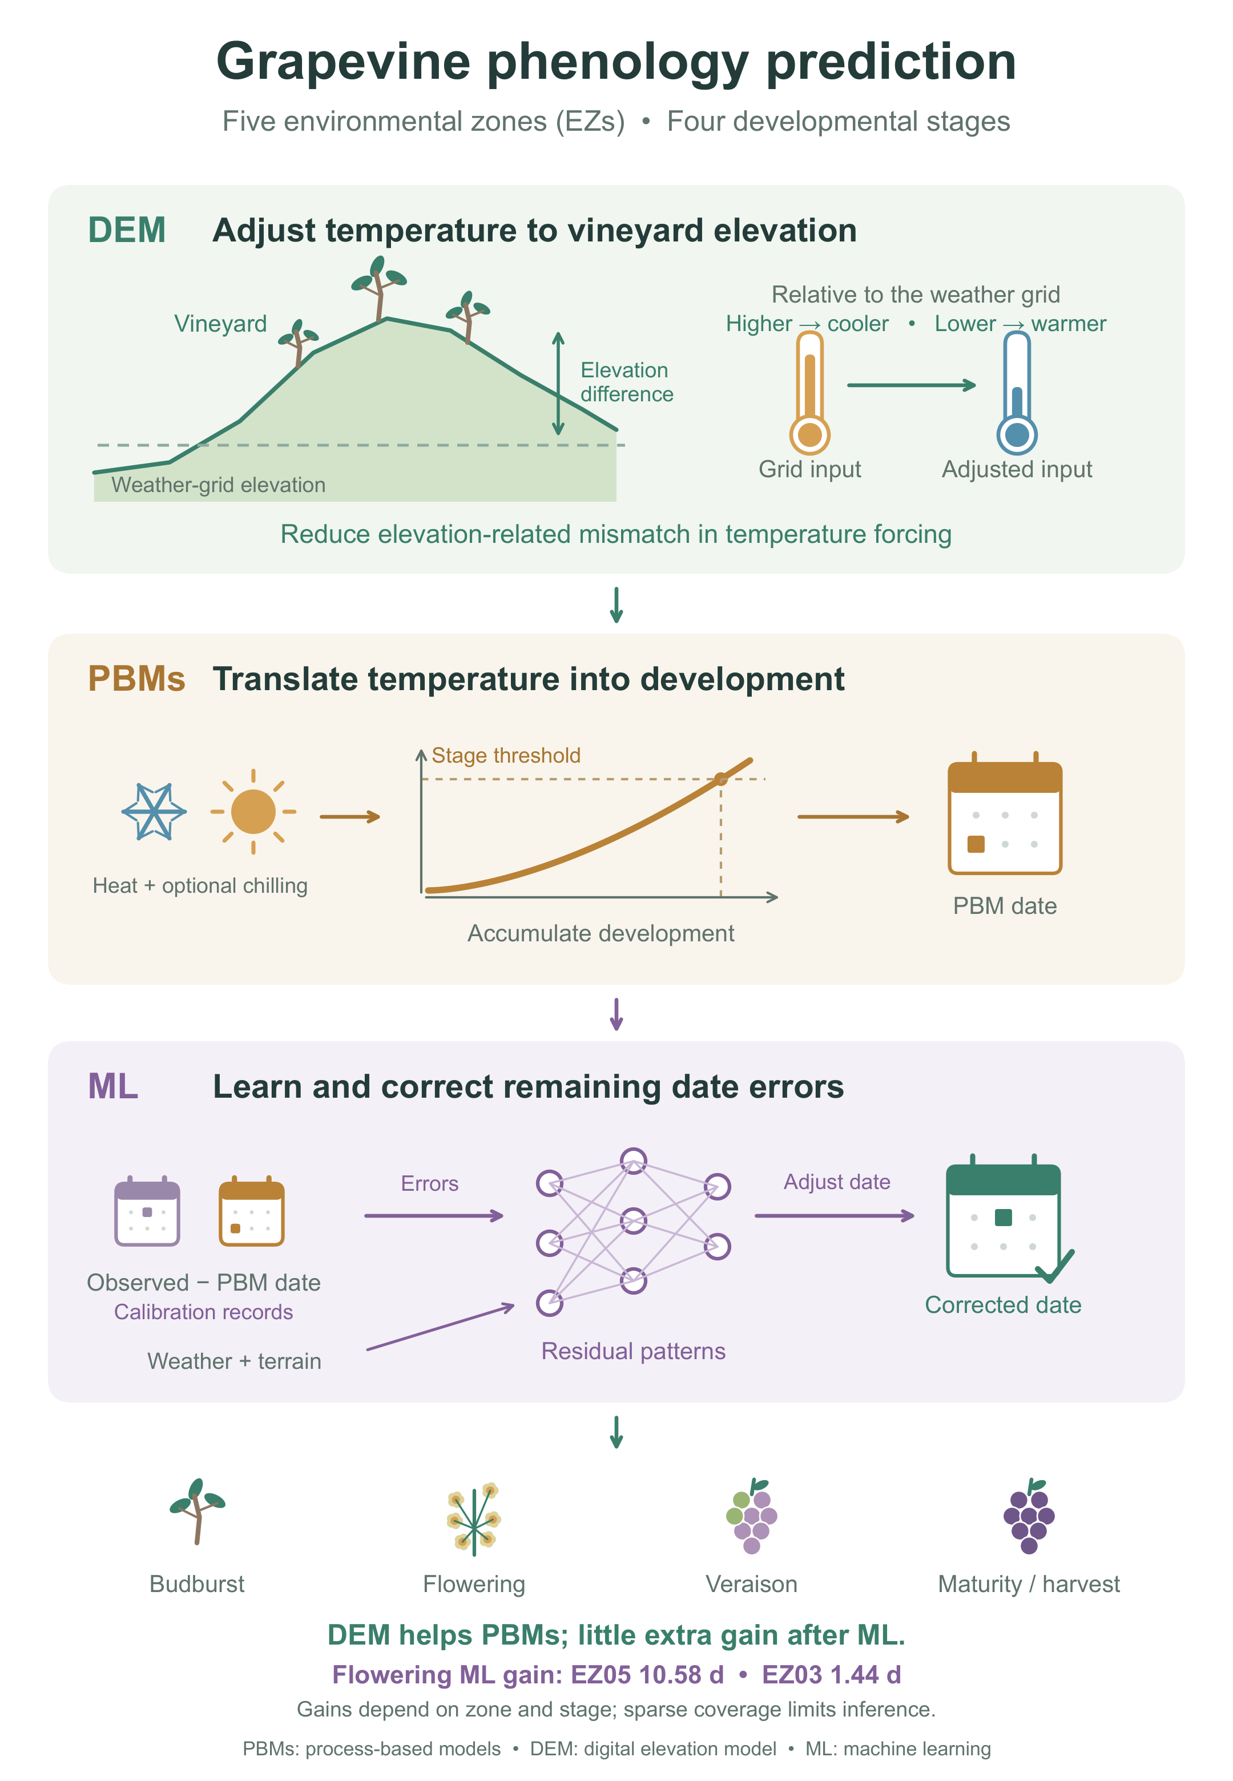

Beyond thermal accumulation: improving cross-regional grapevine phenology prediction with terrain-aware forcing and residual learning
Linjia Yaoª, Qiang Yu^{b}, Gang Zhao^{b,*}
ª College of Natural Resources and Environment, Northwest A&F University, Yangling 712100, China
^{b} State Key Laboratory of Soil and Water Conservation and Desertification Control, College of Soil and Water Conservation Science and Engineering, Northwest A&F University, Yangling, Shaanxi 712100, China
* Corresponding author: Gang Zhao, E-mail: gang.zhao@nwafu.edu.cn

Abstract
Applying process-based models (PBMs) of grapevine phenology across large regions is challenging because gridded weather can miss local conditions and alternative model formulations may incompletely represent crop responses to environmental variation. We addressed these data and model limitations by comparing ten PBM structures, correcting temperature inputs using a digital elevation model (DEM), and applying residual machine learning (rML) to remaining prediction errors. Evaluation used 74,618 observations of budburst, flowering, veraison and maturity/harvest from 11 European countries, with grouped site holdouts within five temperature-defined environmental zones (EZs) and a fixed late-season scoring cutoff. Under the tested parameterization, linear forcing and sequential chilling–forcing produced lower errors than beta forcing and parallel interaction, respectively. DEM correction with recalibration reduced mean absolute error by 1.06 d (95% interval: 0.70–1.39 d). Without elevation correction, rML reduced error from 12.58 to 8.49 d; adding DEM correction to these hybrids yielded only a further 0.12 d reduction ($−0.10$ to 0.31 d). Flowering rML gains were 10.58 d in the warmest zone (EZ05) versus 1.44 d in EZ03, with sparse zone–stage coverage limiting regional inference. Joint evaluation of process formulations, environmental inputs and residual learning provides a basis for scaling crop phenology models across heterogeneous landscapes. Improved estimates of developmental timing can strengthen regional phenology reconstructions and assessments of crop exposure to climatic stress, supporting global-change research and agricultural adaptation planning.
Keywords: Vitis vinifera; Phenology; Crop modelling; Temperature response; Terrain; Residual learning

1 Introduction
Grapevine phenology determines when vegetative growth, flowering and fruit ripening encounter seasonal weather, connecting temperature variability with frost exposure, water demand and vineyard operations. Long-term records document shifts towards earlier development in European vineyards and earlier maturity across Australian growing regions (Tomasi et al., 2011; Webb et al., 2011). The consequences depend on the stage: frost risk reflects the timing of susceptible buds relative to freezing events, whereas earlier ripening changes the thermal and moisture conditions experienced by berries (Sgubin et al., 2018; Cook and Wolkovich, 2016). Cultivar diversity and management provide opportunities to adjust these seasonal relationships, but their effectiveness depends on local growing conditions (Morales-Castilla et al., 2020; Van Leeuwen et al., 2024). Accurate predictions across the developmental sequence are therefore relevant to both vineyard monitoring and assessment of environmental exposure.
Temperature accumulation provides a practical basis for such predictions, although developmental responses differ among stages and cultivars. The Grapevine Flowering Veraison model predicts flowering and veraison through heat accumulation above a base temperature (Parker et al., 2011), and cultivar-specific thermal requirements organize substantial variation in their timing (Parker et al., 2013). Later development involves additional uncertainty. Experiments reveal stage-dependent responses to warming and source–sink conditions, while historical analyses associate earlier ripening with temperature, water availability and possible management contributions (Sadras and Moran, 2013; Webb et al., 2012). Moreover, a date of harvest and a date of attainment of a specified berry sugar concentration describe different endpoints (Parker et al., 2020). Comparisons spanning budburst, flowering, veraison and maturity/harvest must therefore preserve stage definitions and distinguish shared temperature dependence from biological and observational heterogeneity.
Process-based models differ in how they translate temperature into development and represent the transition from winter dormancy to active growth. Forcing-only models accumulate heat from a prescribed or calibrated origin; chilling–forcing models also represent cold exposure, with forcing either following chilling completion or overlapping with chilling accumulation (Chuine, 2000; Chuine and Régnière, 2017). Linear and nonlinear response functions add a separate dimension of structural choice. Grapevine comparisons have found limited gains from greater model complexity, and the choice of base temperature can be more consequential than explicit dormancy representation (García de Cortázar-Atauri et al., 2009; Fila et al., 2014). However, growth-room calibration and field calibration can produce similar historical accuracy while yielding different responses outside the calibration conditions (Fila et al., 2012). Recent Australian and Bordeaux evaluations also show that the relative performance of response functions depends on the population and modelling formulation (Thomas et al., 2026; de Rességuier et al., 2026). These findings motivate controlled comparisons of forcing, chilling and their interaction, rather than attributing a complete-model ranking to complexity alone.
Residual machine learning offers a further approach by estimating systematic errors remaining in process-model predictions. Hybrid Earth-system modelling combines mechanistic structure with statistical flexibility (Reichstein et al., 2019); implementations range from learned process components in evaporation models to integration of crop simulations and observed phenology (Koppa et al., 2022; Ou et al., 2025). Residual date correction retains the simulated developmental sequence as a predictive input and uses environmental covariates to adjust its event dates. This flexibility may capture repeatable discrepancies associated with temperature inputs, shared physiological requirements or omitted environmental factors, without identifying their individual mechanisms. If elevation correction and residual learning address some of the same discrepancies, their combined gain may be smaller than their separate gains. Evaluating both factors across the same process structures and observations is necessary to assess this potential overlap.
Validation determines whether these apparent improvements support prediction beyond the calibration records. Repeated observations, nearby sites and shared weather grids introduce dependence that random observation-level splits can preserve across training and testing (Roberts et al., 2017). In ecological mapping, spatial validation has exposed substantially weaker predictive performance than nonspatial validation suggested (Ploton et al., 2020). Phenology experiments likewise show that unusually warm seasons can challenge models that perform well under comparable calibration and evaluation conditions (Fernandez et al., 2022). Holding out independent site groups within represented temperature regimes tests a different application from extrapolation to unobserved regions or climates. Residual-model evaluation additionally requires process predictions generated without the target observations entering their calibration.
The temperature supplied to a model introduces another source of uncertainty. Gridded weather products provide spatially consistent meteorological forcing over long periods, but represent conditions at a coarser scale than individual vineyard terrain (Muñoz-Sabater et al., 2021). Vineyard measurements reveal meteorological variation across fields, canopy positions and management treatments (Matese et al., 2014), while phenology applications show the importance of local temperature information (de Rességuier et al., 2026). More generally, weather aggregation can affect crop simulations differently across heterogeneous landscapes (Zhao et al., 2015). A digital elevation model permits a transparent correction for site-to-grid elevation differences, but elevation alone cannot represent all sources of local temperature variation. Consequently, the predictive value of this correction requires paired evaluation across terrain conditions, including sites where accuracy deteriorates.
The central question is whether process structure, elevation correction and residual learning provide additional predictive value when evaluated together across grapevine developmental stages. A factorial comparison crosses ten process structures, two temperature inputs and the absence or presence of residual learning. Its objectives are to (i) compare forcing and chilling functions and their sequential or parallel interaction at held-out sites; (ii) quantify the contribution of DEM-based elevation correction and its variation across stages, terrain and temperature-defined environmental zones; and (iii) determine how residual learning changes final prediction errors and the additional benefit of elevation correction. All configurations use the same calibration–test allocation, with complete groups of colocated or weather-grid-sharing sites held out within temperature zones. These contrasts inform phenology model selection within sampled European growing environments; their interpretation concerns retrospective estimation rather than operational forecasting or transfer to unobserved regions.

2 Materials and methods

2.1 Overall workflow
The factorial design crosses ten process structures, RAW or DEM-corrected temperature, and absent or present TabM residual learning, yielding forty configurations for each of BBCH07, BBCH65, BBCH81 and BBCH89 (Fig. 1). Phenology, weather and terrain matching (panel a) precede the paired temperature inputs (panel b) and model combinations (panel c). Calibration and testing preserve complete independence groups within five temperature-profile environmental zones (panel d). Early-stage thresholds are fitted jointly, maturity requirements follow an equal-site weighted median, and residual learners use grouped out-of-fold process predictions with nested refits. Locked predictions retain raw dates and attainment flags separately from the fixed late-season scoring convention. The resulting errors support process-accuracy summaries, structural and spatial comparisons, DEM benefits across terrain conditions, RAW residual-learning gains across models and zones, and DEM effects within hybrids (panel e).
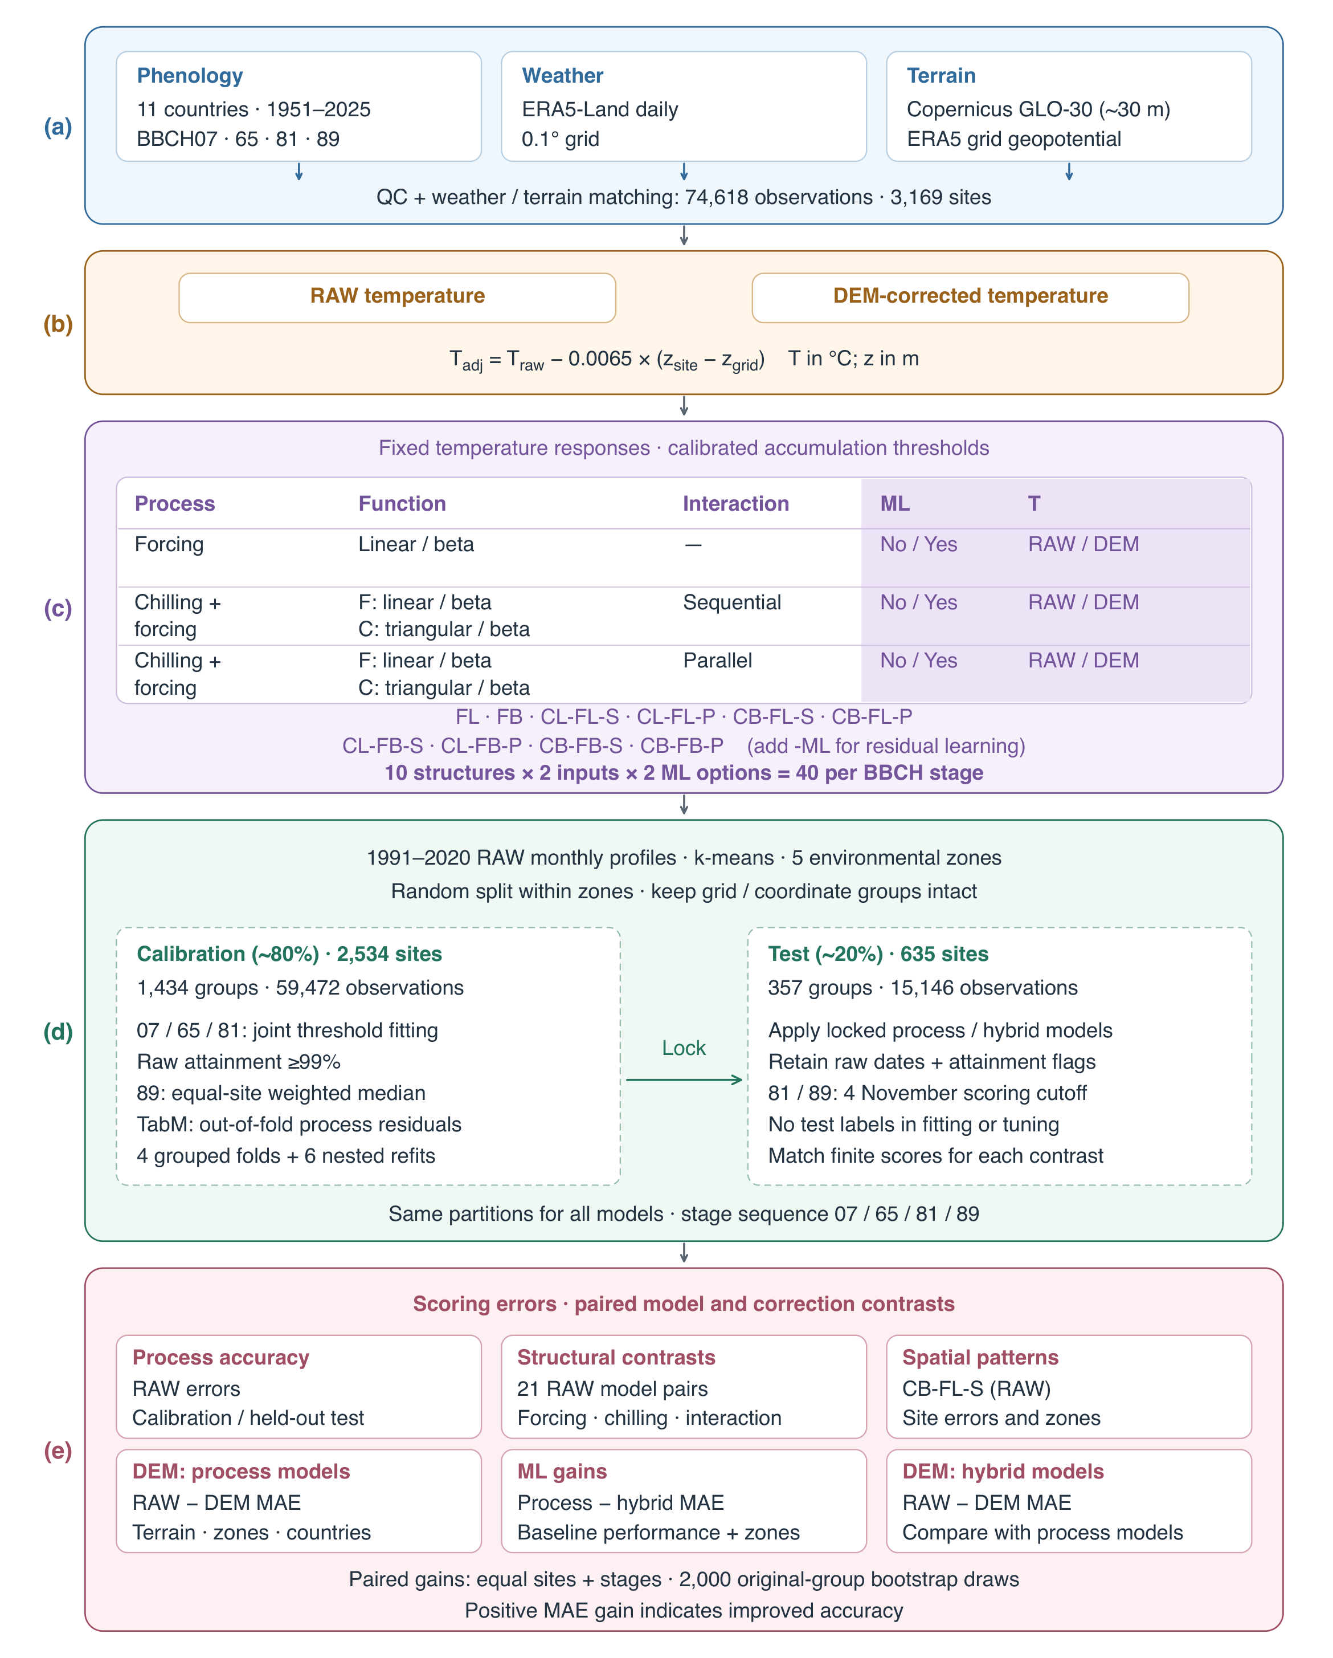
Fig. 1. Workflow underlying the grapevine phenology results. (a) Matched observation, weather and terrain cohort. (b) RAW and elevation-corrected temperatures. (c) Fully crossed process structures, temperature inputs and residual-learning options. (d) Group-preserving calibration and testing within five environmental zones; TabM uses four ordinary out-of-fold process refits and six additional refits excluding pairs of folds. The calibration-defined 4 November scoring cutoff applies to late or unattained BBCH81/89 predictions. (e) Process accuracy, structural and spatial contrasts, and paired DEM and residual-learning benefits. Paired gains use common finite-scoring observations and original-group bootstrap uncertainty; calibration accuracy is apparent performance. DEM, digital elevation model; ML, machine learning; MAE, mean absolute error.

2.2 Study area
The observation domain spans eleven European countries, from 38.10 to 59.15$​^{∘}$N and 4.20$​^{∘}$W to 22.43$​^{∘}$E (Fig. 2). Atlantic, continental and Mediterranean settings provide contrasting thermal regimes. Lowlands, river valleys and hills provide different environmental settings within this domain; local temperature variation is relevant to phenological prediction (de Rességuier et al., 2026). The domain is defined by eligible monitoring records, not by a representative sample of European vineyard area.
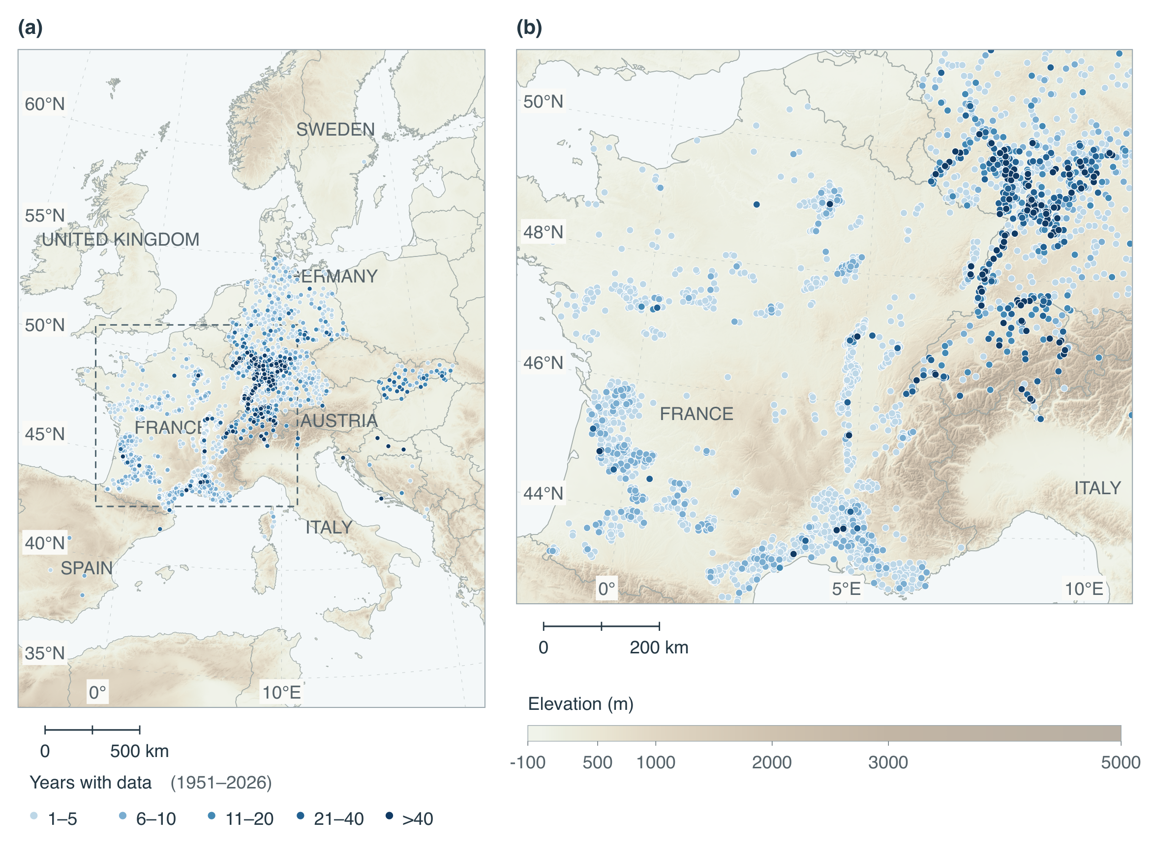
Fig. 2. Geographic coverage and duration of the historical phenology-only inventory, before final observation screening and weather matching. (a) European overview of 3,171 source-qualified sites in 11 countries; the outlined region is enlarged in (b). The inventory contains 74,341 observations of BBCH07, BBCH65, BBCH81 or BBCH89 during 1951–2026. Blue marker colours indicate distinct years containing at least one target-stage observation, pooled across varieties. Coincident sites overlap, with longer records drawn last. Background colours show Copernicus GLO-30 elevation, resampled to an approximately 500-m plotting grid and combined with northwest hillshade. The background provides geographic context; site-scale terrain predictors use the native DEM. Boundaries are from Natural Earth through the geo-countries dataset.

2.3 Data

2.3.1 Phenology observations
Observations came from TEMPO (Maury et al., 2023), DWD (Kaspar et al., 2014) and PEP725 (Templ et al., 2018). Data were provided by the members of the PEP725 project; its extract was accessed on 1 July 2026. One canonical representation of each source preserved provider identities and licences. Records retained source-qualified site identifiers, reported variety, country, WGS84 coordinates, calendar date and directly recorded BBCH code. Inferred stage conversions and observations before 1951 were excluded. BBCH07 and BBCH09 remained distinct (Lorenz et al., 1995).
Exact duplicates required agreement of all seven fields. Different accepted dates or variety labels remained separate; dates were neither aggregated nor repaired. Missing varieties and DWD maturity classes did not imply cultivar or individual-plant identity. Source-qualified sites can share physical locations and were grouped conservatively for validation.
The active four-target screen was reconstructed from the original source tables after exact deduplication, independently of the earlier full-inventory screen. Source-quality checks and annual-report reconciliation preceded calendar and interval screening (Supplementary Methods S6). For DWD records, quality at the highest available control level determined whether incorrect or doubtful dates were excluded; a quality-controlled annual report took precedence over a conflicting lower-control immediate report only when the declared object and phase identifiers also agreed. Equally controlled alternatives and records without quality metadata retained their ambiguity.
Inclusive calendar windows were applied separately to the four target stages (Table 2). Within each source-qualified site, exact reported variety label and year, every record required at least one compatible date at every other observed target stage under the six interval bounds in Table 3. Unsupported records were removed simultaneously and the checks repeated until stable. If neither endpoint had support, both stage groups were quarantined. Missing stages imposed no constraint, non-target stages did not constrain this reassessment, and dates and BBCH codes were neither repaired nor inferred. The bounds are project screening choices, not universal physiological limits or constraints on model predictions. Original fields, provenance and exclusion evidence remain recoverable.
The revised inventory contains 75,738 retained target observations and 1,575 quarantined observations. Matching retained the previously established weather-complete site–years, exact numeric coordinates, country and calibration/test assignments; 1,120 target observations failed these unchanged eligibility requirements. Relative to the earlier 74,311-record modelling cohort, 503 observations were removed and 810 restored, yielding 74,618 observations at 3,169 source-qualified sites and 26,443 site–years during 1951–2025 (Table 1). No surviving site changed partition. Screening was revised after preliminary model outputs became available, although its numerical rules do not use residuals. Historical and final results consequently differ in both eligibility and calibration procedures (Supplementary Section S5 and Table S4).
A site or year can contribute any target stage; complete developmental sequences and a minimum record length are not required. BBCH89 remains a source-dependent maturity/harvest endpoint because harvest can reflect management decisions. Country–stage counts for the active population appear in Supplementary Section S1 and Table S1. Figure 2 describes the earlier phenology-only inventory; the active modelling population and its unchanged environmental-zone assignments appear in Fig. 4.
Table 1. Observation populations underlying the final results. The historical weather cohort supplies the unchanged site–year eligibility and partition assignments; the revised four-target inventory supplies observation eligibility. Calibration and testing partition the final matched population. Counts refer to observation records, not weather files.
Population | Records | Scope
Historical weather-complete cohort | ,311 | ,170 sites and 26,460 site–years; eligibility and allocation reference
Revised four-target inventory | ,738 | Direct-source BBCH07, 65, 81 and 89 after source-quality and timing checks
Outside unchanged weather and identity eligibility | ,120 | Excluded from the revised target inventory before modelling
Final matched population | ,618 | ,169 sites and 26,443 site–years, 1951–2025
Calibration subset | ,472 | ,534 sites in 1,434 independence groups
Test subset | ,146 | sites in 357 independence groups
Table 2. Inclusive calendar windows used to screen the active four-target population. Month–day comparisons preserve leap years. These project screening choices do not constrain model predictions.
BBCH | Phenological stage | Eligible dates
07 | Beginning of budburst | 1 February–15 June
65 | Full flowering | 1 April–31 July
81 | Beginning of ripening (veraison) | 1 June–15 October
89 | Maturity/harvest | 15 July–15 November
Table 3. Inclusive stage-pair intervals used in the active four-target screen. Cross-stage intervals are sums of adjacent bounds and remain testable when an intermediate stage is absent. Only directly observed endpoints enter the checks.
Earlier stage | Later stage | Inclusive interval (d)
BBCH07 | BBCH65 | 20–120
BBCH65 | BBCH81 | 30–120
BBCH81 | BBCH89 | 10–90
BBCH07 | BBCH81 | 50–240
BBCH65 | BBCH89 | 40–210
BBCH07 | BBCH89 | 60–330

2.3.2 Temperature data
Daily mean 2-m air temperature from ERA5-Land (Muñoz-Sabater et al., 2021; Copernicus Climate Change Service, 2019a) provides the meteorological forcing at its native 0.1$​^{∘}$ grid. Stored temperatures are expressed in degrees Celsius. Point-to-grid assignments follow the actual native sampling transform, including points on grid boundaries. Available daily values are retained with their extraction provenance; missing dates are not interpolated or replaced by values from nearby sites.
Every retained site–year has finite daily temperatures from 4 June of the preceding year through 31 December of the observation year. This common window covers preceding-season chilling and the 90-day weather histories used by residual learners. Duplicate dates, nonfinite values, coordinate agreement and the elevation-correction equation are checked before model fitting. Eligibility is determined by site–year, so incomplete seasons are excluded while other qualifying seasons remain. All process structures, temperature treatments and residual-learning variants use the same retained observations (Supplementary Section S2).

2.3.3 Digital elevation model
Site elevation and terrain characteristics are based on the Copernicus GLO-30 digital surface model (European Space Agency and Airbus, 2022). Site elevation is sampled from the containing native pixel. Slope and aspect use a 3$×$3-pixel neighbourhood; local elevation variability is the population standard deviation of finite elevations in an 11$×$11-pixel neighbourhood. Northness and eastness encode aspect. Incomplete neighbourhoods at tile edges retain missing derivatives or fewer valid variability pixels, with the valid-pixel count recorded. Missing numerical terrain predictors are handled within residual-model training folds. ERA5-Land grid elevation is derived from its invariant geopotential using a gravitational acceleration of 9.80665 m s$​^{−2}$. This elevation represents the terrain used by the weather model and is distinct from the mean GLO-30 elevation within a grid cell. Elevations reported by the observation networks are retained for comparison, while GLO-30 provides a common terrain dataset across countries.

2.3.4 DEM-based temperature correction
Each model is evaluated with raw and elevation-corrected daily mean temperature:
$$T_{DEM,d}=T_{RAW,d}−0.0065\left(z_{site}−z_{grid}\right),$$ (1)
where temperature is expressed in $​^{∘}$C, $z_{site}$ is the GLO-30 site elevation and $z_{grid}$ is the ERA5-Land grid elevation, both in metres. A lapse rate of 6.5 $​^{∘}$C km$​^{−1}$ gives a $−0.65 ^{∘}$C adjustment for a site 100 m above the grid elevation. The fixed lapse rate is applied uniformly across sites and days; local inversions and seasonal variation in vertical temperature gradients are not represented. Forcing and chilling requirements are recalibrated separately for raw and corrected temperatures using the same observations, while temperature-response parameters remain identical. The comparison therefore assesses prediction after threshold recalibration, rather than the temperature correction alone. Improved phenology predictions would not, by themselves, demonstrate greater accuracy of the corrected temperatures.

2.4 Models

2.4.1 Process-based phenology models
The ten structures comprise linear or beta forcing alone (FL, FB) and four chilling–forcing combinations with sequential (-S) or parallel (-P) interaction (Table 4). All ten enter the comparisons; no preliminary best-model selection precedes the temperature or residual contrasts. Temperature responses are fixed wherever a component is shared, and accumulation requirements are calibrated separately for each structure and temperature arm.
Linear forcing accumulates $max(T−0,0)$ degree-days. Its 0 $​^{∘}$C base follows GFV, with application beyond flowering and veraison treated as an adaptation (Parker et al., 2011). Beta forcing is zero outside 0–35 $​^{∘}$C, peaks at one at 25.4 $​^{∘}$C, and follows Fila et al.’s normalized response (Fila et al., 2014). Triangular (CL) and beta (CB) chilling are bounded between zero and one and share minimum, optimum and maximum temperatures of $−1.7$, 1.7 and 13.2 $​^{∘}$C. The triangular shape follows a forest-tree formulation (de Wergifosse et al., 2020), while its cardinals are transferred from Fila et al.’s grapevine beta-chilling parameterization. These fixed responses are comparison controls, not universal physiological constants (Fig. 3; Supplementary Methods S7).
For stage $s∈\{07,65,81,89\}$, occurrence is the first date when accumulated effective forcing reaches its requirement:
$${\hat{D}}_{s}=min\left\{t≥τ_{s}:\sum_{u=τ_{s}}^{t}{w_{s,u}}R_{f,s}(T_{u})≥H_{s}\right\}.$$ (2)
Forcing-only models start on 1 January, including that day’s forcing. After each predicted stage, accumulation resets to zero and the next stage begins on the following day; threshold overshoot is discarded. Observed dates never initialize later stages. Simulation ends on 31 December, and unattained stages and all subsequent stages remain unpredicted. Previous-year predictions remain visible under calendar-date arithmetic.
Chilling begins on 1 September of the preceding year. Sequential budburst forcing starts the day after chilling reaches $C_{crit}$. Parallel chilling and budburst forcing start together; daily forcing is multiplied by
$$K_{t}=0.2+0.8min\{C(t−1)/C_{crit},1\},$$ (3)
using chilling accumulated before that day. This competence formulation adapts Liu et al. (2018); the minimum of 0.2 is a project control. Parallel budburst can precede full chilling competence. Chilling does not modify forcing after budburst, and later-stage weights equal one under every structure. Full response equations and implementation conventions are in Supplementary Methods S7.
Stage-specific forcing requirements are shared across sites, years and reported varieties. Chilling models add one shared chilling requirement. Linear forcing requirements range from 0.001 to 3000 $​^{∘}$C d; beta forcing and chilling requirements range from 0.001 to 200 daily response units (Supplementary Section S4 and Table S3). Temperature-response cardinals, calendar origins and parallel minimum competence remain fixed. These numerical search ranges are not physiological limits.
Calibration separates early-stage fitting from maturity estimation. For $s∈\{07,65,81\}$, let $A_{s}$ and $B_{s}$ denote mean absolute error and signed bias after averaging within each site and then equally across sites. The early-stage objective is
$$L_{early}(θ)=\frac{A_{07}+A_{65}+A_{81}}{3}, |B_{s}|≤1 d,$$ (4)
subject to at least 99% raw prediction attainment both across records and in the mean of site-specific attainment fractions for each early stage. The coverage constraint always uses unassigned process dates. A first search minimizes the largest excess of absolute early-stage bias over one day; when the bias target is feasible, a second search minimizes Eq. 4 while preserving the bias and coverage constraints. If the bias target remains unmet within the search budget, the best coverage-admissible candidate is retained with its unmet bias target recorded. BBCH89 contributes neither to this objective nor to its bias or attainment constraints.
For scoring, 4 November of each observation year is the fixed administrative cutoff. It is the latest calibration BBCH89 month–day and is not recalculated within cross-fitting folds. A raw BBCH81 or BBCH89 date after the cutoff, or an unattained date, receives the cutoff as its scoring date. Assignment of BBCH81 also assigns BBCH89 for scoring. Early fitting uses the scoring date for BBCH81, while its raw attainment constraint remains unchanged. These assignments never enter thermal accumulation or replace a process date, and historical observation-screening bounds never clip model predictions.
After early fitting, $H_{07}$, $H_{65}$, $H_{81}$ and any chilling requirement are frozen. Each valid calibration BBCH89 observation supplies the accumulated maturity forcing from the day after its raw predicted BBCH81 through its observed date. Requirements must be positive and finite, with an attained preceding stage and an observed date inside the weather record. Each eligible record receives weight equal to the reciprocal of the number of eligible maturity observations at its site. The lower weighted median, clipped only to the numerical requirement bounds, defines the common $H_{89}$. Raw predictions of the first three stages remain identical before and after this step. No full-attainment constraint is imposed on maturity.
Differential evolution uses seeds 20260907–20260909, population multiplier 15, an initial limit of 300 generations, relative tolerance 0.001 and no local polishing. A calibration-only extension permits up to 600 generations with the same seeds and bounds when the search requires a retry. The selected candidate, restart diagnostics, raw attainment and bias-target status are retained separately. Each temperature treatment and process structure receives its own calibrated thresholds.
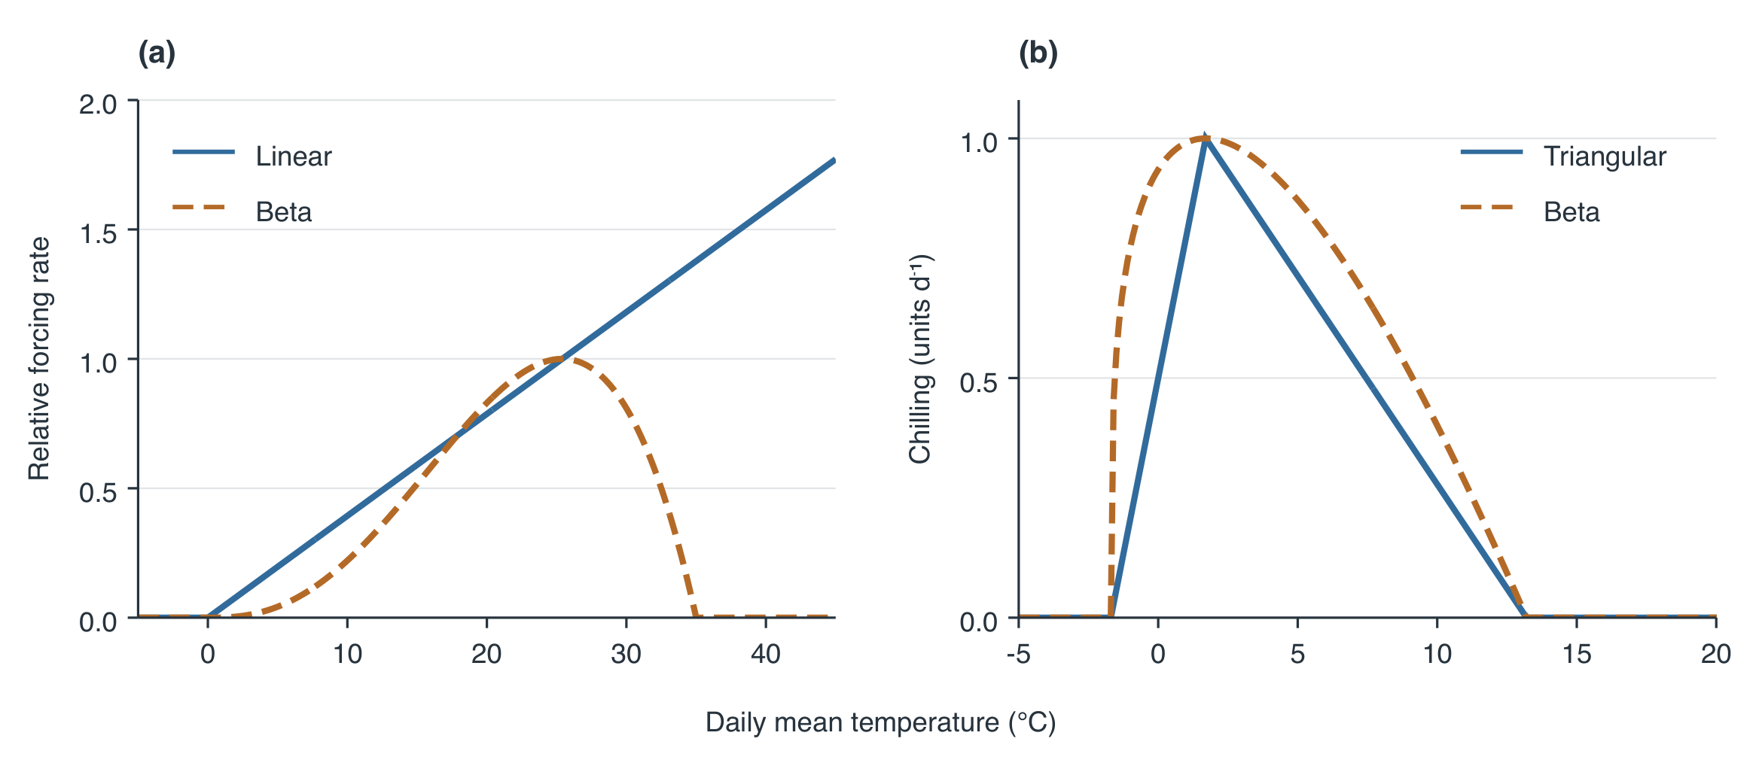
Fig. 3. Fixed temperature-response functions: (a) linear forcing with a 0 $​^{∘}$C base (Parker et al., 2011) and beta forcing with cardinals of 0, 25.4 and 35 $​^{∘}$C; (b) triangular and beta chilling with identical cardinals of $−1.7$, 1.7 and 13.2 $​^{∘}$C. Forcing curves are displayed as $R(T)/R(25.4 ^{∘}C)$, so both equal one at 25.4 $​^{∘}$C; linear forcing remains uncapped. This display-only normalization does not change model equations or threshold units. Chilling retains native daily response units. Beta parameters follow Fbeta5* and CF10* in Fila et al. (2014); transfer to the triangular function of de Wergifosse et al. (2020) is an adaptation. Temperature-axis ranges differ between panels. Accumulation thresholds are calibrated separately and are not shown.

2.4.2 Residual machine learning
A stage-specific TabM regressor estimates observed-minus-process calendar-day residuals (Gorishniy et al., 2025). The preliminary hybrid date is
$${\tilde{D}}_{i}={\hat{D}}_{proc,i}+{round}_{even}({\hat{r}}_{i}).$$ (5)
Half-day ties round to the nearest even integer. A subsequent ordering step requires each attained corrected stage to follow the preceding attained corrected stage by at least one day. Unattained stages remain missing. Unconstrained corrected dates and order adjustments support a separate sensitivity analysis; observation-screening bounds never clip predictions.
Residual targets are observed dates minus raw, unassigned out-of-fold process dates. Four grouped calibration folds generate four ordinary process refits, each excluding its prediction fold. Six additional refits exclude each unordered pair of folds. During neural validation in fold $h$, a residual-training observation from fold $k$ uses the process fit excluding both $h$ and $k$; validation observations use the fit excluding $h$. Thus neither a target observation nor the corresponding neural-validation fold supplies labels to its residual-training process fit. All refits repeat the early-stage and median-maturity procedure with the fixed 4 November cutoff. Their initialization uses the fixed responses and predeclared small thresholds, without parameters fitted using the excluded folds.
Imputation, standardization and numerical embedding construction use the corresponding neural-training fold. Four inner validation folds select training duration. Final learners use all ordinary out-of-fold calibration residuals and are combined with the previously locked process-based model fitted to the full calibration population. Unattained process stages supply no residual target and receive no learned correction. Both components remain fixed during testing.
The twenty candidate numerical predictors comprise the process-predicted day index relative to 1 January of the target year and inclusive phase duration; mean, standard deviation, minimum and maximum daily-mean temperature over preceding 7-, 30- and 90-day windows; day length; elevation, slope, northness, eastness and local elevation variability. Weather windows end on process-predicted dates, never observed validation dates. Predictions are retrospective estimates conditional on realized weather, with no fixed advance forecast issue date.
TabM uses numerical embeddings with up to 16 bins and dimension 16, two 128-unit blocks, 16 ensemble members and dropout 0.1. AdamW uses learning rate 0.002, weight decay 0.0003 and batches of 256. Training and validation give equal weight to sites within each stage. Training minimizes site-weighted mean squared residual error across ensemble members; validation uses site-weighted MAE of their mean prediction in days. For each of three seeds (20260907–20260909), four inner folds select training duration from at most 300 epochs with patience 30; final duration is their nearest-even rounded median. Predictions average ensemble members and the three final seeds. Inner-fold scores support epoch selection and are not unbiased test estimates. Supplementary Methods S8 gives the residual training details.
Table 4. Catalogue of the 20 grapevine phenology models evaluated for each stage. F, forcing; C, chilling; ML, residual machine learning. For C + F models, Function gives the forcing / chilling response, in that order. Triangular chilling is the bounded piecewise-linear response in Supplementary Methods S7. Model codes use L for linear (triangular for chilling), B for beta, S for sequential and P for parallel. The -ML suffix denotes residual correction.
Process | Function | Interaction | ML | Model name
Forcing | Linear | — | No | FL
Forcing | Linear | — | Yes | FL-ML
Forcing | Beta | — | No | FB
Forcing | Beta | — | Yes | FB-ML
C + F | Linear / triangular | Sequential | No | CL-FL-S
C + F | Linear / triangular | Sequential | Yes | CL-FL-S-ML
C + F | Linear / triangular | Parallel | No | CL-FL-P
C + F | Linear / triangular | Parallel | Yes | CL-FL-P-ML
C + F | Linear / beta | Sequential | No | CB-FL-S
C + F | Linear / beta | Sequential | Yes | CB-FL-S-ML
C + F | Linear / beta | Parallel | No | CB-FL-P
C + F | Linear / beta | Parallel | Yes | CB-FL-P-ML
C + F | Beta / triangular | Sequential | No | CL-FB-S
C + F | Beta / triangular | Sequential | Yes | CL-FB-S-ML
C + F | Beta / triangular | Parallel | No | CL-FB-P
C + F | Beta / triangular | Parallel | Yes | CL-FB-P-ML
C + F | Beta / beta | Sequential | No | CB-FB-S
C + F | Beta / beta | Sequential | Yes | CB-FB-S-ML
C + F | Beta / beta | Parallel | No | CB-FB-P
C + F | Beta / beta | Parallel | Yes | CB-FB-P-ML

2.5 Model evaluation
The evaluation population comprised 74,618 observations from 3,169 source-qualified sites in 11 countries and 26,443 site–years during 1951–2025. Calibration contained 59,472 observations at 2,534 sites in 1,434 independence groups; testing contained 15,146 observations at 635 sites in 357 groups. The test-stage counts were 5,073 for BBCH07, 5,469 for BBCH65, 3,754 for BBCH81 and 850 for BBCH89. All process structures, temperature inputs and residual-learning variants used these same partitions (Supplementary Section S3 and Table S2).
Germany contributed 55,732 observations (74.7%) and France 13,897 (18.6%). France supplied 4,097 of the 4,371 maturity/harvest observations (93.7%); Germany supplied none. Test observations represented seven countries, with 21 populated country–stage combinations; eleven combinations had fewer than ten eligible independence groups. These differences constrain regional precision and stage comparisons independently of model performance (Supplementary Section S10; Tables S1, S2 and S6).

2.5.1 Calibration and test partitioning
The primary split assigns approximately 80% of sites to calibration and 20% to testing within environmental zones. Twelve monthly mean RAW temperatures for 1991–2020 (Copernicus Climate Change Service, 2019b) are standardized across the 1,792 unique ERA5-Land cells and clustered using $k$-means with five clusters, 20 initializations and seed 20260909. Each cell contributes once to clustering, irrespective of the number of monitoring sites it contains. Labels are ordered by annual mean centroid temperature. Environmental zones in this study are defined by these monthly temperature profiles. The shared zones are defined before partitioning from climate covariates alone, without phenology dates, country labels or prediction errors.
Transitive groups join sites sharing a weather-grid cell, identical coordinates or coordinates rounded to four decimal places. Groups spanning multiple cells are assigned to the nearest cluster centre using their mean standardized unique-cell profile. Five zones satisfy the prespecified requirement of at least five groups per zone. Seeded within-zone allocation targets a 20% test-site fraction while preserving intact groups and collective four-stage support, yielding 2,535 calibration sites and 635 test sites in the original allocation. Revised screening retains 2,534 calibration sites in 1,434 independence groups and all 635 test sites in 357 groups; no surviving site changes partition. Four grouped, environmental-zone-balanced inner folds contain observations of every stage; ordinary and nested cross-fitting exclude complete groups. Identical partitions apply to every model structure, residual-learning variant and temperature input. The geographic distribution of environmental zones, their temperature profiles and the primary site allocation are shown in Fig. 4.
The primary split assesses predictions at held-out sites within the sampled climatic domain. Process calibration, residual training and epoch selection use calibration observations only. Regional and environmental-zone summaries use subsets of this same held-out population; they are not leave-region-out tests. Separate spatial-block, warm-year, warm-site and unstratified protocols remain historical design or sensitivity products and do not supply performance estimates for the final median-cutoff and residual-learning comparison.
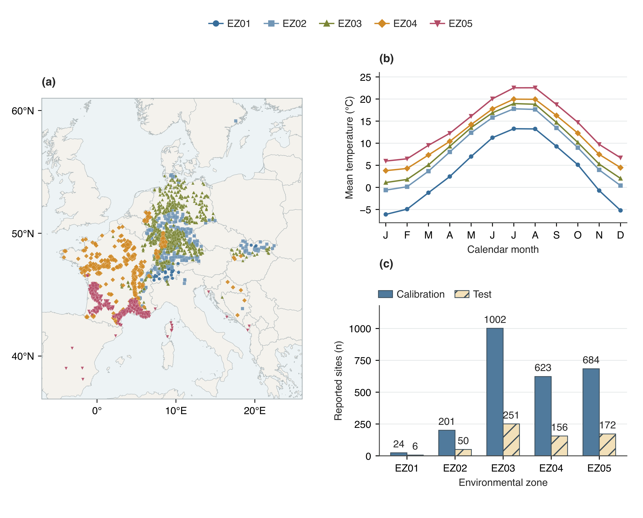
Fig. 4. Environmental zones and the primary calibration–test split. (a) Geographic distribution of the 3,169 retained modelling sites, coloured and marked by their frozen environmental-zone assignments. Coincident sites overlap; the map does not interpolate zone boundaries between sites. Boundaries are from Natural Earth through geo-countries. (b) Monthly centroid temperatures from five clusters of 1991–2020 RAW ERA5-Land profiles; each of the original 1,792 unique weather-grid cells contributes once to clustering. Labels EZ01–EZ05 are ordered by annual mean centroid temperature, with identical zone colours and symbols in (a) and (b). (c) Reported site counts in calibration and testing within each zone, totalling 2,534 and 635 sites, respectively, in the active cleaned cohort under the unchanged original assignments. Transitive groups sharing grid cells or coordinates remain together. Reported sites can share physical locations, and zone size reflects the observed collection rather than European vineyard area.

2.5.2 Terrain effects
Terrain effects on predictive accuracy are assessed using paired predictions at the same held-out sites, years and stages. For each process structure and residual-learning option, the difference in mean absolute error (MAE) between original and DEM-corrected temperature quantifies the contribution of elevation correction; positive values of $MAE_{RAW}−MAE_{DEM}$ indicate improved accuracy. Each temperature treatment is calibrated independently on the same calibration observations, so the contrast evaluates correction within the fitted prediction workflow rather than changing temperature while holding process parameters fixed. The correction benefit is compared between process-only and residual-learning models to assess whether the two approaches are complementary.
Terrain strata use the local standard deviation of DEM elevation and the absolute site-minus-weather-grid elevation difference. Global cutpoints are the one-third and two-thirds empirical quantiles across calibration sites, with each site contributing once even when values coincide. Quantiles use linear interpolation between ordered values. The same cutpoints apply to calibration, testing, countries and environmental zones. Low values satisfy $x≤q_{1/3}$, middle values satisfy $q_{1/3}<x≤q_{2/3}$, and high values exceed $q_{2/3}$. Missing terrain values retain a separate category; tied cutpoints are retained even if the middle category is empty. Test observations and prediction errors do not determine class boundaries.
For the process-based-model DEM summary, one common set of finite scoring errors is required across all ten structures and both temperature inputs. Model-specific absolute and signed errors are averaged separately across the ten fixed structures, within each site, and across equally weighted sites; the four stages receive equal weight. Signed elevation mismatch, elevation, slope, northness and eastness provide additional exploratory contrasts. Regional terrain heterogeneity is examined using supported spherical-semivariogram sills at a declared 20-km spatial support, separately from native local elevation variability (Supplementary Methods S13). Landscape heterogeneity provides a rationale for spatially differentiated weather-data requirements (Zhao et al., 2015); the present experiment assesses elevation correction at a fixed weather-grid resolution.
Paired correction benefits are summarized by these terrain strata, the frozen environmental zones and country. High-minus-low terrain contrasts use the same group-bootstrap draws for both strata, with at least ten contributing groups per stage in each stratum required for an interval. Sensitivities exclude the coldest zone, exclude every observation receiving a cutoff assignment in any process temperature arm, or weight independence groups equally after averaging within sites and groups. Exclusion sensitivities change the evaluated population; they do not refit thresholds or learners. These analyses describe variation in predictive performance rather than causal terrain effects. Improved phenology predictions alone do not establish that corrected temperatures are more accurate; that conclusion requires independent temperature observations.

2.5.3 Predictive performance and uncertainty
All adjustable parameters are estimated from the calibration set and remain fixed during testing. Temperature input is a separate experimental factor: each of the 20 models in Table 4 is evaluated with original and DEM-corrected temperature, yielding 40 configurations per stage. Paired comparisons use four treatments: process-based models with raw temperature, hybrid models with raw temperature, process-based models with corrected temperature and hybrid models with corrected temperature. The paired DEM contrasts with and without residual learning describe whether temperature-correction benefits differ between these fitted workflows. Test observations are used only for performance assessment and subsequent model rankings.
Individual process-model accuracy summaries use all finite scoring dates for that configuration, with raw attainment and missingness reported separately. These model-specific populations differ from the common populations required for paired factorial summaries.
Controlled structural summaries use raw-temperature process predictions and the twenty-one pairs in Supplementary Section S9 and Table S5. Four families compare linear versus beta forcing (five pairs), triangular versus beta chilling (four), sequential versus parallel interaction (four), and absent versus present chilling (eight). Within a family, every constituent model must have a finite scoring error for an observation to contribute. Absolute and signed errors are averaged separately across equally weighted fixed pairs, then within sites and across equally weighted sites. This estimates average component-level performance without averaging predictions into an ensemble or treating alternative models as independent replicates. Four-stage summaries weight stages equally. Paired uncertainty concerns the aggregate family contrast, with right-minus-left MAE changes distinguished from positive improvement measures used for DEM and residual learning.
Residual-learning contrasts compare RAW process and RAW hybrid predictions, whereas the DEM-with-ML contrast compares RAW and DEM hybrids fitted separately. Each contrast requires finite scoring errors in both arms for all ten structures; individual-model contrasts use the same common mask as the ten-model summary. The process-only DEM, RAW residual-learning and hybrid DEM comparisons each retain 15,105 observations at 633 sites in 355 groups. Their observation identities coincide in the final outputs, permitting a paired comparison of DEM benefits across the two workflows. Model-specific absolute and signed errors are averaged across the ten fixed structures before the site and stage averages; no ensemble prediction is constructed and model structures are not resampled.
For process-only (P) and hybrid (H) predictions, the decrease in DEM benefit is
$$ΔG=(MAE_{P,RAW}−MAE_{P,DEM})−(MAE_{H,RAW}−MAE_{H,DEM}).$$ (6)
Positive values indicate a smaller DEM benefit after residual learning. Identical group multiplicities are applied to both benefits in every bootstrap draw, so intervals are estimated from the paired difference rather than differences between marginal confidence limits. Percentage gains divide each workflow’s gain by its own RAW MAE. Baseline error, final hybrid error and their difference describe residual-learning performance across structures; the baseline–gain relationship is descriptive because gain contains baseline error arithmetically.
Spatial summaries describe CB-FL-S, identified as the lowest-MAE raw-temperature process-based model in the primary test comparison. Stage-specific distributions display each site’s mean absolute scoring error, with the median and interquartile range across contributing sites. Quartiles use linear interpolation between ordered site values; these descriptive ranges are distinct from confidence intervals around zone means. Environmental-zone estimates weight sites equally within stage and retain the original group allocation. Sparse zones retain descriptive estimates and their observation, site and group counts; missing stages preclude four-stage averages. This analysis characterizes the selected model within the same test population and provides no separate validation of model selection. No zone-specific process calibration is performed.
Predictive performance is summarized by mean absolute error (MAE) and signed bias, both in days. For stage $s$, let $e_{ijs}={\hat{D}}_{ijs}−D_{ijs}$ be the calendar-day error of observation $i$ at site $j$, with $n_{js}$ contributing observations at each of $J_{s}$ sites. Equal-site weights are $w_{ijs}=1/(J_{s}n_{js})$, giving
MAEs=j,i​wijs|eijs|, Biass=j,i​wijseijs. (7)
Signed bias is the mean signed error: positive values indicate predictions later than the observations, and negative values indicate earlier predictions. MAE measures the magnitude of individual errors, whereas bias measures their average direction; opposing errors can cancel in the bias. Overall MAE and bias are arithmetic means of the four stage estimates, with every overall estimate requiring all four stages.
Calendar-date differences preserve cross-year offsets and leap days. Primary stage summaries average absolute or signed errors within each site and then equally across sites. Counts of records, sites and contributing independence groups accompany comparisons. Raw-date summaries use attained predictions, while scoring-date summaries apply the fixed 4 November rule to BBCH81 and BBCH89. Administrative assignment is reported separately from raw attainment and attainment by the cutoff. Calibration summaries from the final models describe apparent training performance; they are not out-of-fold accuracy estimates.
Paired contrasts preserve identical observations within the compared arms. Scoring-date comparisons retain administratively assigned BBCH81 and BBCH89 records where applicable. Four-stage summaries give each stage equal weight. Independent-group bootstrap resampling with 2,000 replicates (seed 20260913 for the paired structural, DEM and residual-learning analyses) preserves all sites within a sampled group and equal site weights multiplied by group resampling frequency. A stage interval requires at least ten contributing original groups; an overall four-stage interval requires this support separately in every stage. Percentile limits at 2.5 and 97.5% are reported only when at least 95% of resamples yield finite estimates. Intervals are pointwise and lack multiplicity adjustment. Calibration intervals concern apparent fitted-model comparisons; test intervals concern the primary held-out population. Smaller groups of observations receive descriptive estimates. Country and environmental-zone summaries describe the sampled primary holdout rather than independent regional-transfer experiments.

3 Results

3.1 Process-based models under raw forcing
Across the ten process-based models (PBMs) driven by raw ERA5-Land temperature, held-out MAE averaged equally over the four target stages ranged from 11.31 to 14.74 d (Fig. 5a). CB-FL-S had the lowest four-stage MAE (11.31 d), followed by CL-FL-S (11.72 d), whereas the forcing-only models FL and FB had MAEs of 13.17 and 13.41 d, respectively. The parallel chilling–beta-forcing structures CB-FB-P and CL-FB-P had the largest MAEs, at 14.36 and 14.74 d. Apparent calibration MAE ranged from 11.19 to 14.66 d; the test-minus-calibration difference in four-stage MAE remained between $−0.16$ and $+0.25$ d across structures. These descriptive rankings characterize performance on the primary held-out sites; they do not establish statistically significant differences between models.
Prediction accuracy varied among stages (Fig. 5b–e). Test MAE ranged from 9.31 to 14.35 d for budburst (BBCH07), 10.05 to 13.63 d for flowering (BBCH65), 12.33 to 15.20 d for veraison (BBCH81), and 12.62 to 15.78 d for maturity/harvest (BBCH89). Thus, even the lowest model-specific errors exceeded 12 d at the two late-season stages. The stage samples differ in their geographic and observational composition, so these ranges do not isolate an effect of developmental stage alone.
Small overall calibration–test differences coexisted with systematic stage-specific bias (Supplementary Section S11 and Fig. S1). All ten PBMs predicted veraison too early at held-out sites, with mean signed errors from $−8.40$ to $−1.23$ d. The five linear-forcing structures met the early-stage calibration bias target at all three stages; none of the five beta-forcing structures did so.
Maturity/harvest bias was closer to zero, ranging from $−1.84$ to $+0.12$ d, although MAE remained 12.62–15.78 d. This combination indicates that a small mean signed error can coexist with substantial individual timing errors. Under the fixed 4 November scoring convention, 1.81–4.14% of test maturity records received an assigned cutoff date after equal-site weighting. Actual process attainment by that date ranged from 95.86 to 98.19%, rising to 97.31–99.17% by 31 December. For veraison, cutoff assignment affected 0–1.36% of test records after equal-site weighting. These assigned dates support a common error calculation but do not establish attainment of a physiological event; BBCH89 also includes an operational harvest endpoint.
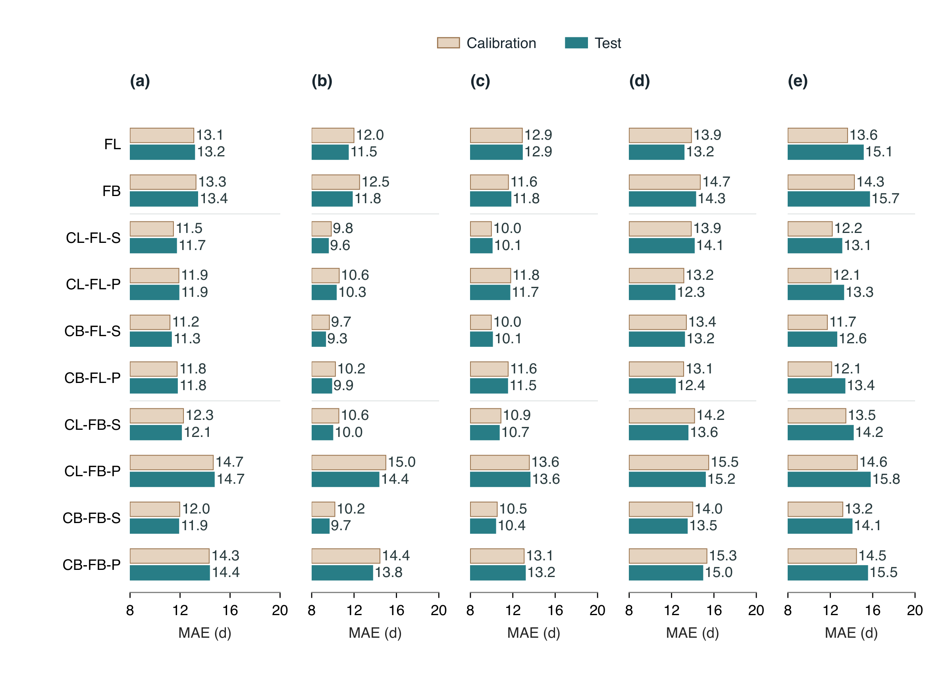
Fig. 5. Mean absolute error of process-based models (PBMs) driven by raw ERA5-Land temperature. Panel (a) shows overall performance, with equal weight for BBCH07, BBCH65, BBCH81 and BBCH89; panels (b–e) show the four stages separately, in that order. Light brown bars denote apparent calibration performance and blue bars denote held-out test performance. Numbers give MAE in days, rounded to one decimal place. Errors are averaged within sites and then equally across sites. Bars extend from 8 d to the annotated MAE, with identical 8–20 d axes; the displayed lengths represent error above 8 d. Model order follows the catalogue. BBCH81 and BBCH89 errors use the fixed 4 November scoring convention for late or unattained predictions. Values are descriptive point estimates without confidence intervals. Signed bias is shown in Supplementary Fig. S1.

3.2 Predictive performance across model components
Aggregating controlled model pairs revealed larger differences for forcing response and process interaction than for chilling-response shape (Fig. 6). With raw ERA5-Land forcing, overall MAE was 11.96 d for linear forcing and 13.21 d for beta forcing, averaged equally over five matched pairs and four stages. The beta-minus-linear difference was $+1.26$ d (pointwise 95% independence-group bootstrap interval, $+0.96$ to $+1.57$ d). Sequential models likewise had lower MAE than parallel models, at 11.72 versus 13.14 d across four matched pairs; the parallel-minus-sequential difference was $+1.41$ d ($+1.12$ to $+1.67$ d). This difference was largest for budburst ($+2.45$ d) and flowering ($+2.10$ d), whereas the veraison difference was small and its interval crossed zero ($+0.10$ d; $−0.53$ to $+0.61$ d).
Beta chilling reduced overall MAE by 0.29 d relative to triangular chilling (12.28 versus 12.57 d; beta-minus-triangular interval, $−0.40$ to $−0.21$ d). Across eight matched pairs, including chilling reduced MAE from 13.21 to 12.43 d, a difference of $−0.78$ d ($−0.99$ to $−0.57$ d). Its largest stage-specific reduction occurred for maturity/harvest ($−1.43$ d), while veraison showed little change ($−0.08$ d; $−0.39$ to $+0.28$ d). Each family retained 99.38–100% of eligible stage observations on a common finite-scoring population. These aggregate contrasts are conditional on the fixed temperature responses and fitted thresholds; they do not imply that every individual model pair has the same advantage.
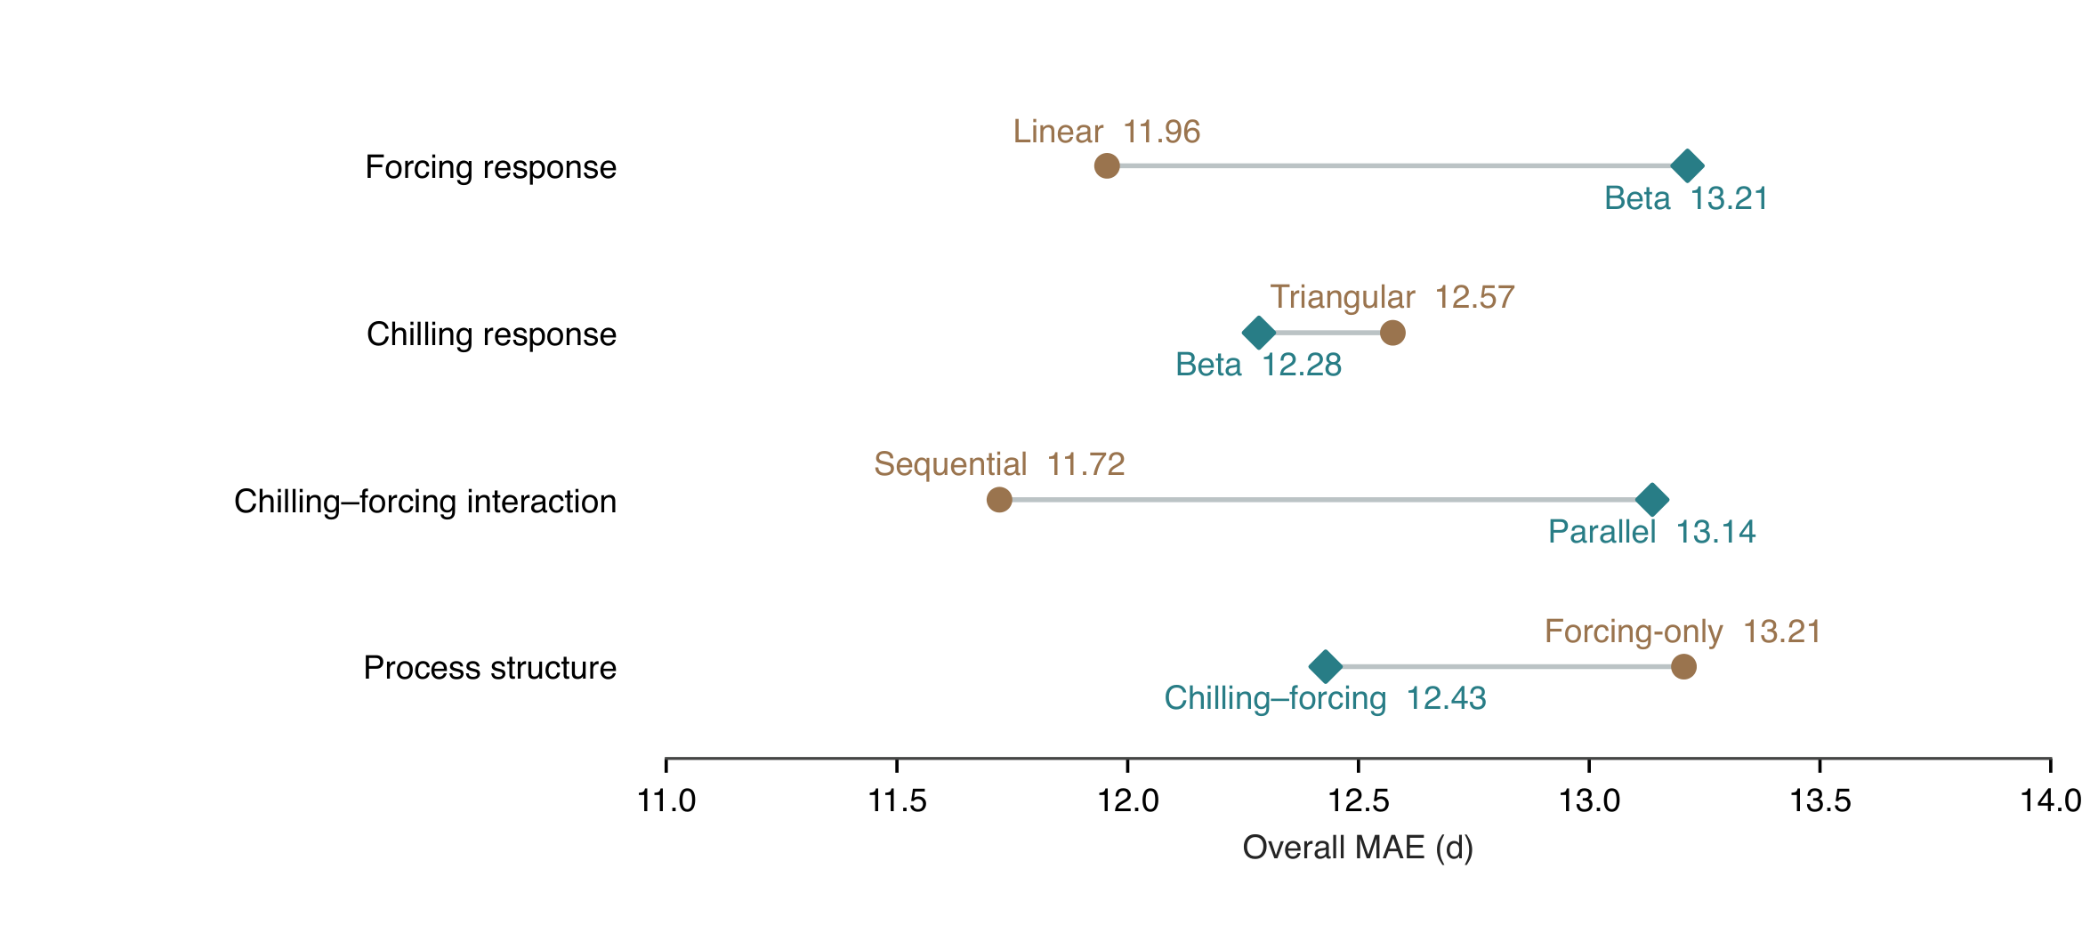
Fig. 6. Overall held-out MAE across process-based model components under raw ERA5-Land forcing. Connected points compare the forcing response (linear versus beta; five matched model pairs), chilling response (triangular versus beta; four pairs), chilling–forcing interaction (sequential versus parallel; four pairs), and process structure (forcing-only versus chilling–forcing; eight pairs). Response functions and process structures follow the definitions in Sect. 2.4. Labels give component-level MAE in days. Absolute errors are averaged equally across fixed constituent pairs, within sites and across equally weighted sites; the overall summary gives equal weight to BBCH07, 65, 81 and 89. Values are point estimates on family-wide common finite-scoring observations. Paired bootstrap intervals are reported in the text.

3.3 CB-FL-S performance across environmental zones
CB-FL-S, the process-based model with the lowest four-stage test MAE under raw ERA5-Land forcing, showed substantial variation in error among sites and environmental zones (Fig. 7). Median site MAE was 7.99 d for budburst, 7.42 d for flowering, 10.23 d for veraison and 11.00 d for maturity/harvest. Individual-site maxima reached 46.00, 81.64, 75.75 and 41.32 d, respectively. These distributions characterize the primary held-out population for a model identified from the same comparison and provide no additional independent validation of model selection.
Environmental-zone differences depended on stage. Median site MAE for flowering was 12.88 d in EZ02, compared with 6.50–8.50 d in EZ03–EZ05. For veraison, the median was 14.37 d in EZ03, compared with 8.67 d in EZ04 and 8.14 d in EZ05; their respective interquartile ranges were 10.42–22.69, 5.67–17.83 and 5.38–12.06 d. The primary equal-site mean MAE, reported separately from these distributional medians, also varied across zones (Supplementary Table S7). EZ04 and EZ05 supported group-bootstrap intervals at every stage; their four-stage mean MAEs were 9.78 d (pointwise 95% interval, 8.89–10.85 d) and 10.76 d (9.69–11.90 d), respectively. Zone summaries reflect their observed mixtures of sites, years and reported varieties and do not isolate environmental effects.
Sparse stage coverage limited interpretation in the other zones (Supplementary Section S12, Fig. S2 and Table S7). EZ01 contained flowering observations only: five of six eligible sites had finite predictions, with median site MAE of 69.00 d. The remaining site’s three observations had no finite flowering date. Median site MAE for maturity/harvest was 27.50 d in EZ02 and 22.25 d in EZ03, but these estimates represented only one and six sites, respectively. Their contributing group counts were below the threshold for reporting confidence intervals around zone means. Four-stage comparisons involving these zones therefore have substantially weaker support than the aggregate model ranking.
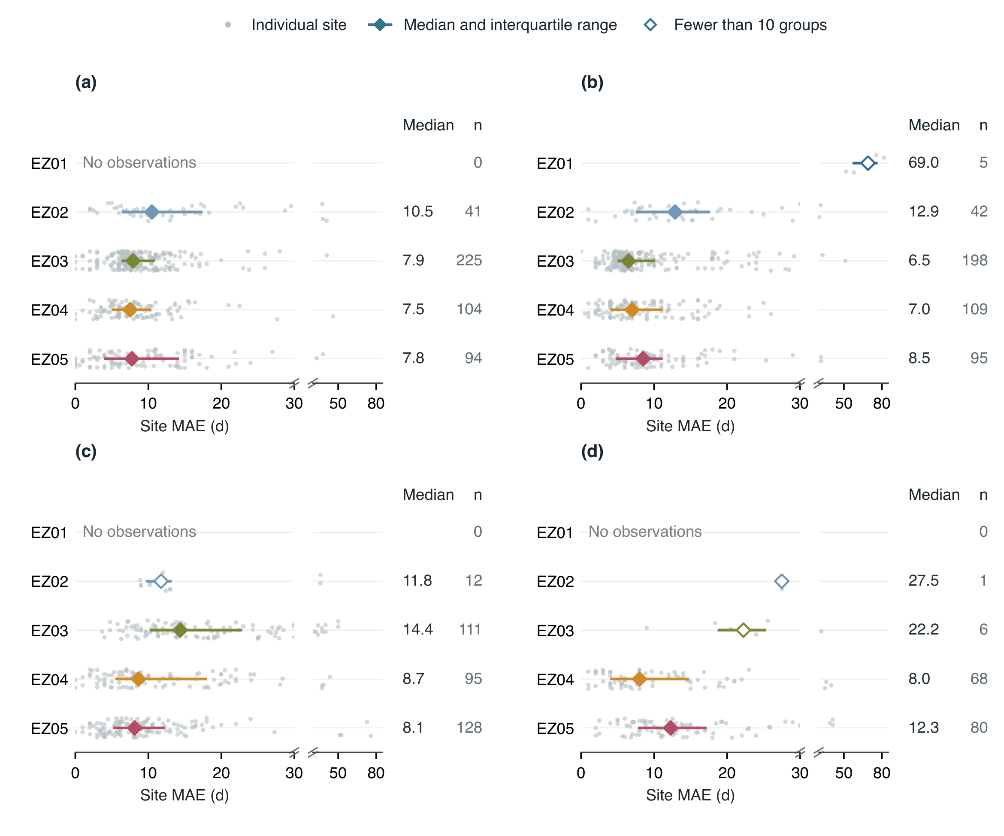
Fig. 7. Distribution of held-out CB-FL-S site MAEs across environmental zones under raw ERA5-Land forcing. Panels (a–d) show BBCH07, 65, 81 and 89. Grey dots represent individual sites; vertical jitter separates overlapping values and has no quantitative meaning. Coloured diamonds mark the median site MAE, and horizontal lines span the 25th–75th percentiles across sites. These ranges describe site variability, not confidence intervals. Open diamonds identify samples with fewer than ten contributing independence groups. Columns give the median in days and the number of contributing sites ($n$). Each panel expands the 0–30 d range and retains larger errors in a narrower 30–85 d strip; slashes mark the change in horizontal scale, with no values omitted. No observations denotes absent stage records. Observation coverage is shown in Supplementary Fig. S2; zone mean MAEs and their bootstrap intervals are reported in Supplementary Table S7. The 4 November scoring convention applies to BBCH81/89.

3.4 Benefits and terrain dependence of elevation correction
DEM-based elevation correction reduced held-out MAE across all ten PBMs after forcing and chilling thresholds were recalibrated within the original calibration partition (Fig. 8). On the common cohort of 15,105 observations with finite scoring dates in every RAW and DEM configuration, the equal-model, equal-site and equal-stage MAE decreased from 12.58 to 11.53 d. The paired reduction was 1.06 d (pointwise 95% group-bootstrap interval, 0.70–1.39 d), equivalent to 8.4% of the RAW MAE. Model-specific reductions ranged from 0.46 d for CB-FL-S to 1.79 d for CL-FB-P, with positive interval bounds for all ten structures. These contrasts concern the fitted temperature-input workflows; they include threshold recalibration and do not isolate the temperature adjustment with parameters held constant.
Flowering showed the largest average improvement, 1.61 d (1.04–2.25 d), compared with 0.73 d for budburst, 0.91 d for veraison and 0.97 d for maturity/harvest. Positive average effects coexisted with local deterioration: the mean absolute error across the ten PBMs decreased at 64%, 66%, 61% and 63% of sites for BBCH07, 65, 81 and 89, respectively. Changes in signed bias were less uniform (Supplementary Section S14 and Fig. S4). Veraison bias moved from $−4.04$ to $−1.72$ d, but maturity/harvest bias became more negative, from $−0.78$ to $−1.34$ d, despite its lower MAE. Lower absolute error therefore did not require a smaller magnitude of mean bias at every stage.
The direction of the site-to-grid elevation difference distinguished correction benefits more clearly than its magnitude alone. Sites at least 41.7 m below the weather-grid elevation had an overall MAE reduction of 2.18 d (1.26–3.07 d), compared with 0.51 d (0.24–0.73 d) in the middle signed-difference class and 0.58 d ($−0.07$ to 1.19 d) in the highest class. The high-minus-low difference in benefit was $−1.60$ d ($−2.74$ to $−0.40$ d). This asymmetry was especially marked for maturity/harvest: its MAE reduction was 4.07 d in the lowest signed-difference class, but $−0.72$ d in the highest class, whose interval included zero. The highest absolute-mismatch class had a larger estimated overall benefit than the lowest class (1.80 versus 0.72 d), although their contrast remained uncertain: 1.09 d ($−0.09$ to 2.13 d). Terrain classes describe the observed site population and do not isolate causal effects of elevation.
Greater terrain heterogeneity did not consistently imply a larger benefit from elevation correction (Fig. 8d; Supplementary Fig. S3). The overall MAE reduction decreased from 1.37 d in the lowest local-elevation-variability class to 0.59 d in the highest class; the high-minus-low contrast was $−0.78$ d ($−1.49$ to $−0.11$ d). Regional semivariogram sills provided a distinct, scale-dependent measure of terrain heterogeneity, but the specified fitting criteria supported a sill at only 475 of 1,791 weather cells, including 149 of 635 test sites. Each sill class contained fewer than ten contributing maturity/harvest groups, precluding four-stage confidence intervals. Its class estimates showed no monotonic increase in benefit and were insufficient to establish a reliable sill–benefit relationship. Regional relief and local terrain variability consequently cannot be treated as interchangeable proxies for the temperature correction required at an individual site.
Environmental-zone contrasts further showed that the correction benefit depended on stage (Supplementary Table S8). Flowering MAE decreased by 1.41 d in EZ04 and 3.16 d in EZ05, whereas the corresponding veraison changes were a deterioration of 0.59 d and an improvement of 2.22 d. The overall reduction remained positive when EZ01 was omitted (0.93 d), when original independence groups received equal weight (1.03 d), and when every observation assigned the 4 November date in any configuration was removed (1.10 d). The last comparison changes the scoring population and serves only as a sensitivity analysis. Together, these results support modest, widespread predictive gains from elevation correction, with their magnitude and occasional reversal depending on stage and environmental setting.
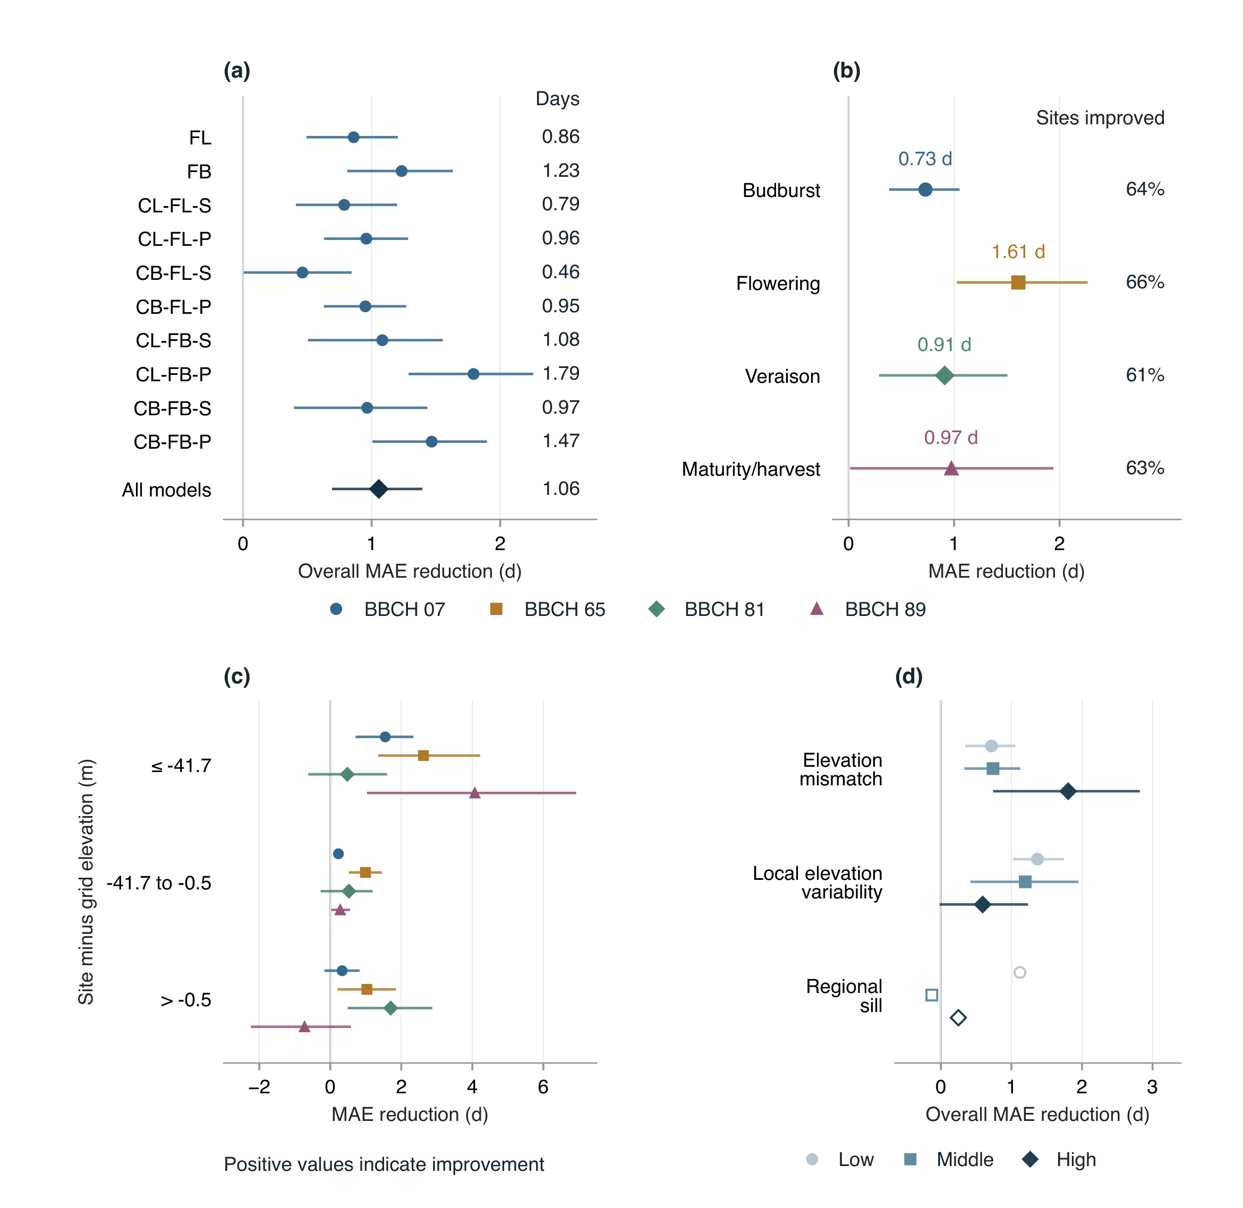
Fig. 8. Held-out benefits of DEM-based elevation correction for PBMs. Positive values indicate a reduction in MAE relative to RAW forcing. (a) Equal-stage benefits for each of the ten models and their fixed-model average. (b) Stage-specific benefits averaged across models; percentages give the share of sites whose average model MAE decreased. (c) Stage-specific benefits by signed site-minus-grid elevation difference. (d) Overall benefits by absolute elevation mismatch, local elevation variability and regional semivariogram sill. Class boundaries are calibration-site tertiles; displayed boundaries are rounded, with exact values retained in the analysis tables. Local variability is the native 11$×$11-pixel elevation standard deviation; regional sill is estimated from smoothed GLO-30 elevations in a 20-km window (Supplementary Methods S13). All panels use the same twenty-arm finite-scoring cohort, with 4 November assignments retained for BBCH81/89. Points summarize errors within sites and then across equally weighted sites; overall values give the four stages equal weight. Lines are pointwise 95% intervals from 2,000 original-group bootstrap draws. Open markers indicate insufficient stage-wise group support for an interval; unsupported sill fits remain missing. These fitted-workflow contrasts include separate threshold recalibration under each temperature input.

3.5 Predictive gains from residual learning
Under raw temperature forcing, residual TabM correction reduced held-out MAE in all forty model–stage comparisons (Fig. 9a). Four-stage gains ranged from 2.87 to 6.08 d across the ten hybrids, with all ten pointwise 95% intervals excluding zero (Fig. 9b). The fixed-model average gain was 4.10 d (95% interval: 3.56–4.63 d). Stage-specific average gains were 3.90, 4.89, 3.38 and 4.21 d for budburst, flowering, veraison and maturity/harvest, respectively. These comparisons used a common finite-scoring population of 15,105 observations at 633 held-out sites in 355 independence groups.
Larger ML gains generally accompanied larger errors in the original process model. Across the ten structures, four-stage process-model MAE ranged from 11.27 to 14.61 d, whereas hybrid MAE occupied the much narrower range of 8.30–8.75 d. The highest-error process model, CL-FB-P, improved from 14.61 to 8.53 d, a gain of 6.08 d; the lowest-error process model, CB-FL-S, improved from 11.27 to 8.40 d, a gain of 2.87 d. Thus, the larger correction did not produce the lower final error. The lowest hybrid MAE was 8.30 d for CB-FL-P-ML, whose gain was 3.49 d. Residual learning consequently narrowed differences among process structures, while the ranking by improvement differed from the ranking by final hybrid accuracy.
ML gains varied across environmental zones (Fig. 9c). Flowering gains were 10.58 d (9.12–11.99 d) in EZ05 and 1.44 d (0.89–1.99 d) in EZ03. These gains reduced process-model MAE from 15.12 to 4.54 d in EZ05 and from 9.06 to 7.62 d in EZ03 (Fig. 9d), reversing their relative error levels. Large corrections therefore did not necessarily leave large remaining errors. The 59.85 d flowering gain in EZ01 reduced an initial MAE of 72.76 d to 12.90 d but was supported by only five groups; no other target stage was observed there. Maturity/harvest evidence in EZ02 and EZ03 comprised only one and four groups, respectively. These sparse estimates have no bootstrap interval, and environmental-zone summaries describe subsets of the primary site holdout rather than independent zone-transfer tests. Signed-bias diagnostics are reported in Supplementary Section S15 and Fig. S5.
Calibration hybrid scores are apparent performance after fitting on calibration-only out-of-fold residuals. Held-out sites supplied neither process calibration targets nor neural epoch-selection targets. Residual learning adjusted dates only where the raw process-based model supplied a prediction. The underlying thermal attainment remained unchanged; BBCH81 and BBCH89 could still receive the common administrative scoring date after hybrid correction.
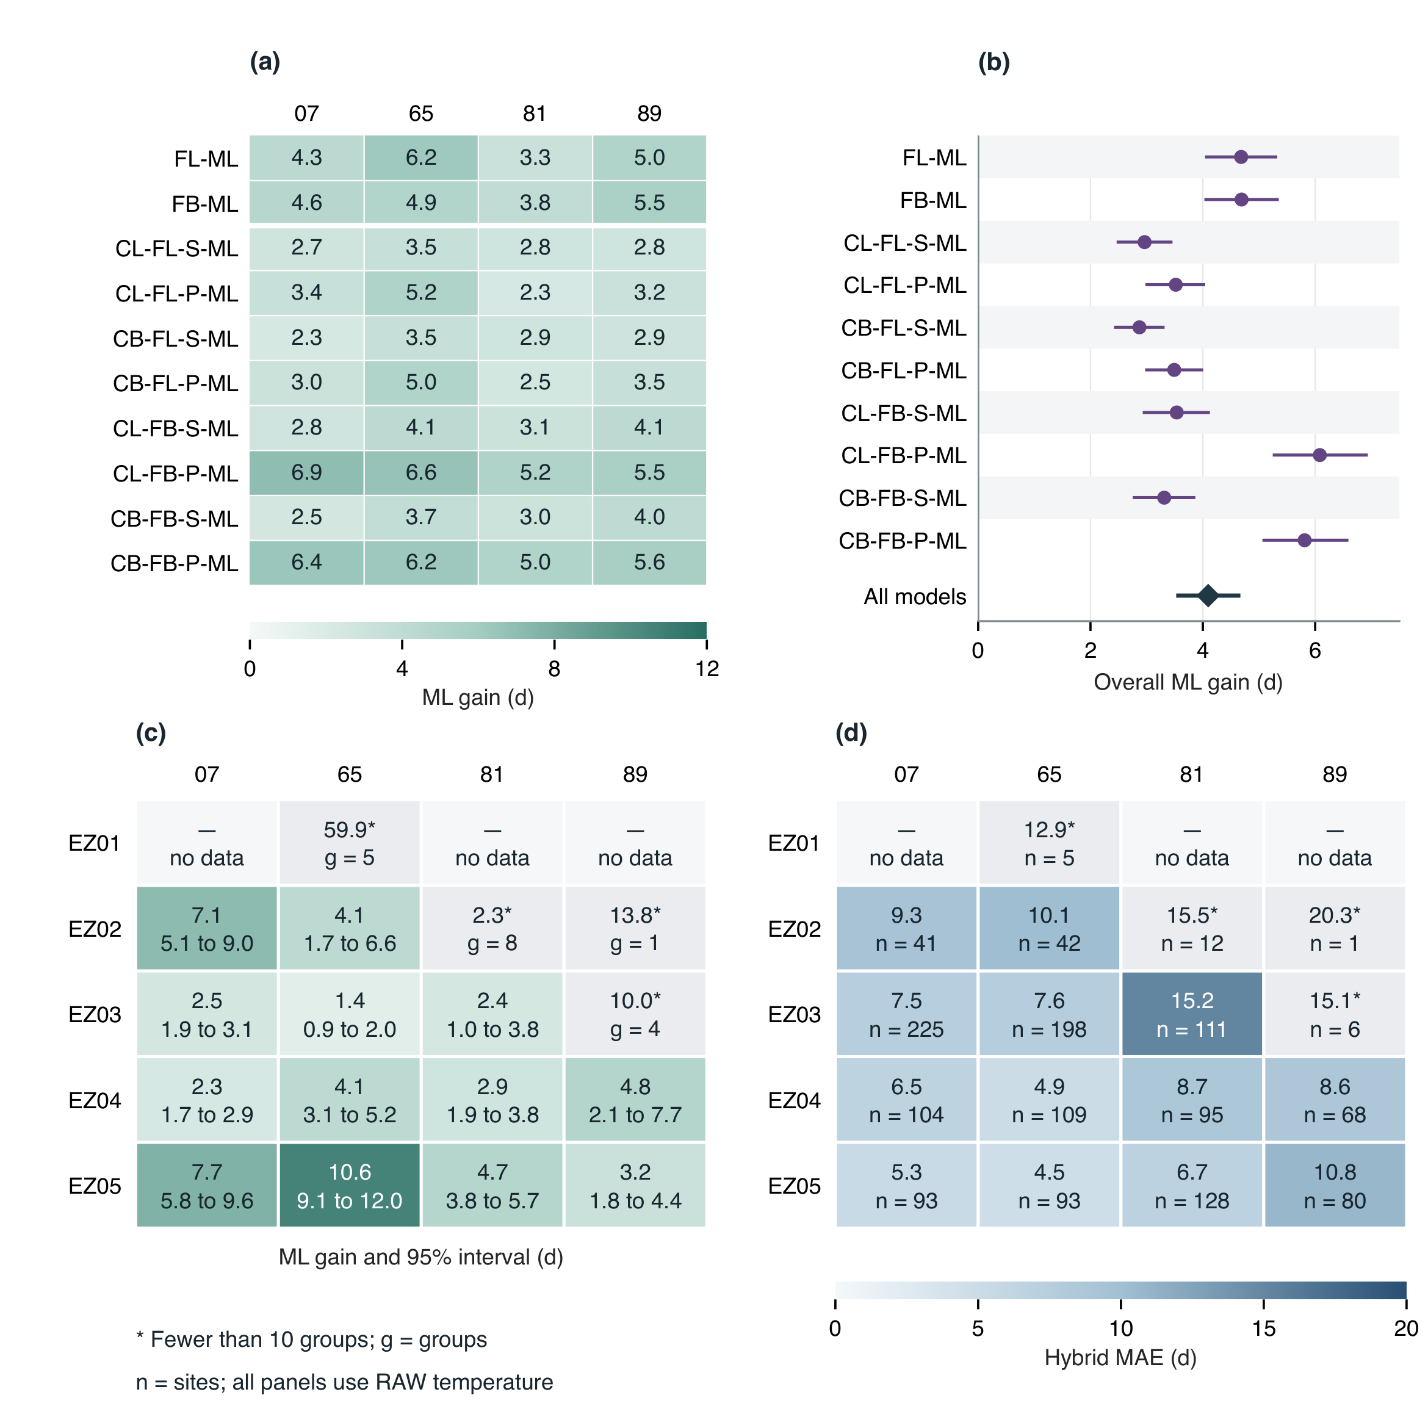
Fig. 9. Residual-learning gains overall and across environmental zones under RAW temperature forcing. (a) Paired stage-specific MAE reductions for each hybrid. (b) Four-stage gains and pointwise 95% group-bootstrap intervals; the diamond summarizes the ten fixed models. (c) Zone-specific gains, with pointwise 95% intervals below each estimate. Panels (a,c) share a colour scale. (d) Remaining hybrid MAE by zone, with contributing site counts ($n$). Grey starred cells have fewer than ten independence groups; $g$ gives group support when no interval is available. Dashes indicate absent observations. Positive gain denotes smaller MAE after adding ML. Absolute errors are averaged across fixed models for aggregate summaries, within sites and then equally across sites; overall gains give the four stages equal weight. All panels use common finite-scoring observations across the ten RAW process–hybrid pairs, with 2,000 original-group bootstrap draws. BBCH81/89 retain the fixed 4 November scoring convention.

3.6 DEM correction within residual-learning hybrids
DEM correction yielded a small additional average gain after residual learning: 0.12 d (95% interval: $−0.10$ to 0.31 d; Fig. 10a). Model-specific four-stage gains ranged from $−0.13$ to 0.34 d. The average budburst gain was 0.21 d (0.04–0.39 d), whereas the intervals for flowering, veraison and maturity/harvest included zero. Across these stages, 56%, 55%, 54% and 59% of sites had lower fixed-model average MAE under DEM forcing, respectively (Fig. 10b).
On the identical observation population, the DEM gain was smaller for hybrids than for process-only models (0.12 versus 1.06 d). The paired decrease in DEM benefit was 0.94 d (95% interval: 0.64–1.24 d), estimated by resampling the same independence groups for both contrasts. This decrease was positive at every stage, with all four pointwise intervals excluding zero, and was largest at flowering (1.47 d; 0.94–2.10 d). Relative to each workflow’s RAW MAE, DEM correction reduced error by 1.4% for hybrids and 8.4% for process-only models.
Zone-specific effects were heterogeneous and generally small (Fig. 10c). In EZ04, average gains were 0.42 d (0.04–0.76 d) for budburst and 0.32 d (0.03–0.59 d) for flowering. All four stage-specific intervals included zero in EZ05. The large maturity/harvest contrasts in EZ02 and EZ03 remained unsupported by sufficient independent groups. This comparison pairs RAW and DEM hybrid errors on a common finite-scoring population across all ten structures. Both process thresholds and residual learners were fitted separately for each temperature input; the contrast measures the difference between fitted hybrid workflows.
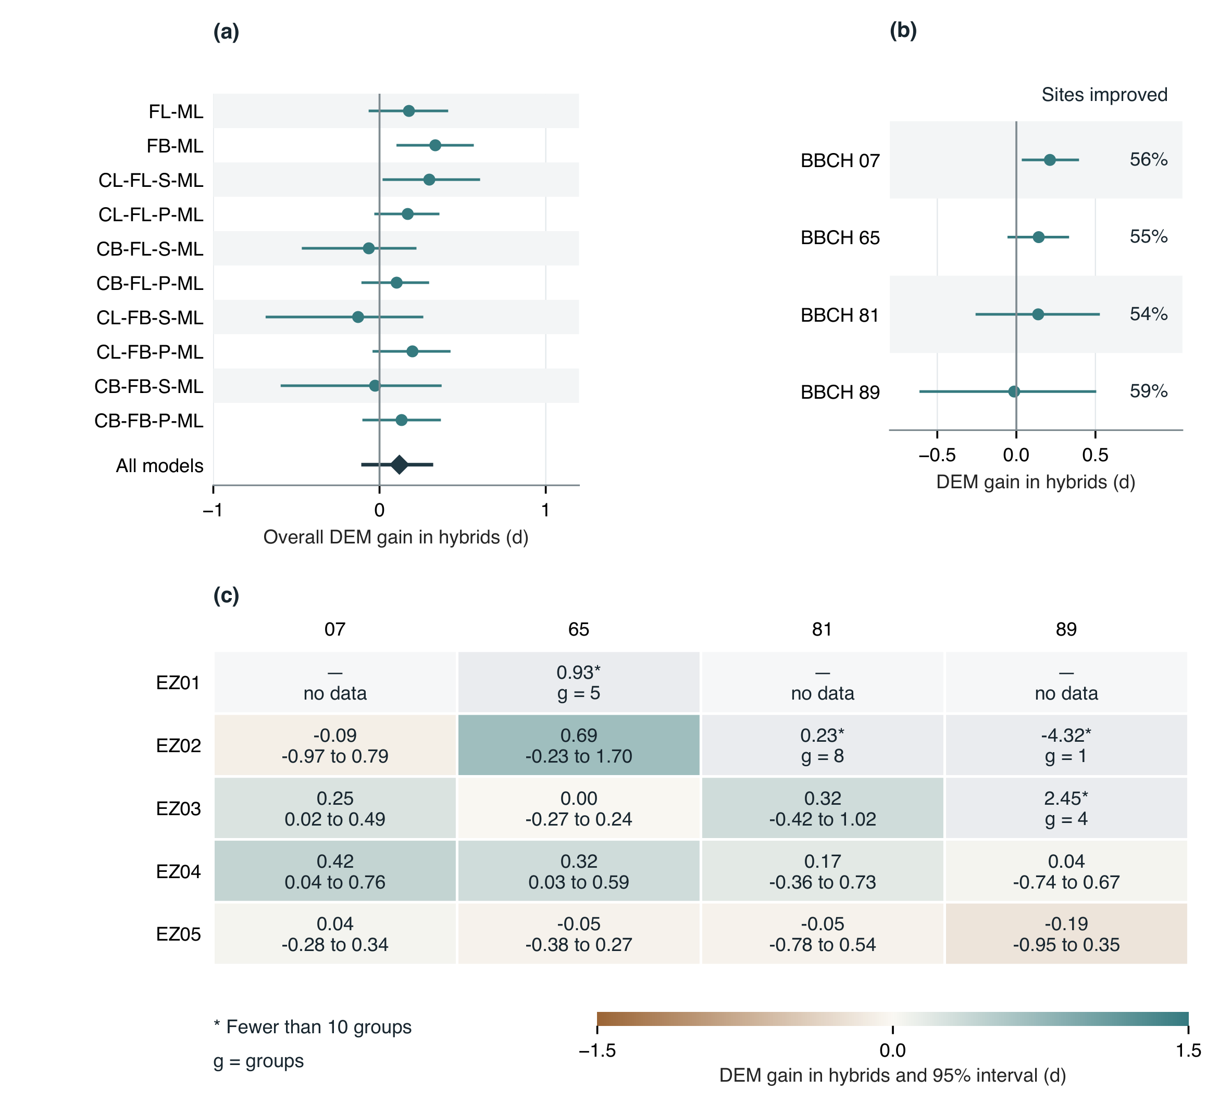
Fig. 10. Effects of DEM temperature correction within residual-learning hybrids. Positive gain is RAW-hybrid MAE minus DEM-hybrid MAE. (a) Four-stage gains for each hybrid and the fixed-model average (diamond). (b) Stage-specific average gains; percentages give the share of sites with lower average hybrid MAE under DEM forcing. (c) Gains across environmental zones, with pointwise 95% intervals below estimates. Grey starred cells have fewer than ten contributing groups ($g$); dashes indicate absent observations. Intervals use 2,000 original-independence-group bootstrap draws. All panels use common finite-scoring observations across the ten RAW–DEM hybrid pairs. Fixed-model, site and stage weights match Fig. 9; BBCH81/89 retain the 4 November scoring convention. The comparison includes separately fitted process thresholds and residual learners under each temperature input.

4 Discussion
Process formulation, temperature input and residual learning made different contributions to grapevine phenology prediction. Controlled structural contrasts favoured linear forcing and sequential chilling–forcing, while elevation correction produced a modest average improvement with substantial variation among sites. Residual learning yielded larger gains, and DEM correction added little to average hybrid accuracy. Together, these results indicate that representing additional processes and reducing systematic prediction errors are distinct routes to improved performance. Their relative value depends on the phenological stage and the environments represented during calibration and testing.

4.1 Predictive value of process structure
The advantages of linear forcing and sequential interaction, averaging 1.26 and 1.41 d in the controlled comparisons, were larger than the effect of chilling-response shape (Fig. 6). Thus, distinguishing the timing and temperature dependence of accumulation was more consequential for these predictions than choosing between the two tested chilling curves. The comparison also shows why a ranking of complete models provides an incomplete account of structural performance: an advantage averaged over matched components can coexist with weak or reversed differences at individual stages. Veraison, for example, showed little response to the sequential–parallel contrast despite larger differences at budburst and flowering.
The favourable performance of simpler forcing agrees with the limited benefits of increasing complexity reported by Fila et al. (2014), but does not establish a universally preferable temperature response. Field warming experiments revealed nonlinear grapevine phenological responses and interactions with source–sink conditions (Sadras and Moran, 2013). More recently, Thomas et al. (2026) found advantages for nonlinear or temperature-limited functions in Australian vineyards, while local Merlot models in Bordeaux showed slightly better accuracy with curvilinear responses (de Rességuier et al., 2026). These differences are consistent with dependence on the sampled temperature range, cultivar composition and formulation. Nonlinearity in a developmental interval is also not equivalent to the particular daily beta response tested here.
Fixed cardinal temperatures and seasonal origins constrain the interpretation of these contrasts. Recalibrating accumulation requirements allows each structure to accommodate the observations without testing the full flexibility of its response family. The beta-forcing structures did not meet all early-stage bias targets within the calibration search, so their ranking also reflects the achieved fit under the constrained objective. Likewise, the sequential advantage is conditional on the implemented parallel competence function and its minimum value of 0.2. Predictive differences under these controls provide evidence for choosing among the tested formulations, rather than identifying the physiological timing of dormancy release. Growth-room experiments provide a complementary means of constraining chilling and forcing: Fila et al. (2012) obtained comparable field prediction accuracy from experimental and field calibration despite differences in parameter consistency and extrapolated responses. Similar event-date accuracy can therefore conceal different biological representations. Independent dormancy observations or controlled temperature treatments would help distinguish compensating parameter choices from transferable developmental responses.

4.2 Stage dependence and the limits of thermal accumulation
Late-season prediction remained difficult: even the lowest RAW process-model MAEs exceeded 12 d for veraison and maturity/harvest, and residual correction did not eliminate their greater remaining errors relative to the early stages. Differences in stage populations prevent attribution of this pattern to development alone. Nevertheless, later predictions inherit the timing of preceding simulated events, so uncertainty in budburst or flowering can change the temperatures encountered during subsequent accumulation. The resulting error need not increase monotonically, because later conditions can amplify or compensate for an earlier timing difference. In this implementation, chilling affects forcing directly only before budburst; an apparent chilling benefit at maturity can therefore arise through the simulated sequence without a direct late-season chilling effect.
Observed variation in phenological intervals supports treating these dependencies explicitly. Cameron et al. (2022) found that the budburst-to-flowering interval was more temperature-sensitive than subsequent intervals and that its response varied among cultivars. Varietal classifications also demonstrate substantial differences in thermal requirements for flowering and veraison (Parker et al., 2013). A common requirement across sites and reported varieties necessarily averages over this diversity. The cultivar-specific phenology and suitability analysis of Morales-Castilla et al. (2020) further demonstrates that intraspecific variation matters for environmental matching. In a pooled monitoring collection, a regional error pattern can consequently reflect changing cultivar composition as well as changing weather. This makes cultivar-resolved evaluation particularly relevant before interpreting zone differences as a temperature-response failure. Cultivar composition, pruning and water conditions are consequently plausible contributors to remaining errors, but their separate contributions cannot be estimated from the available predictors and incomplete biological identities.
Maturity/harvest poses an additional problem of endpoint definition. A harvest record reflects the timing of an operation as well as fruit development, whereas models fitted to a specified sugar concentration predict a more narrowly defined trait. Parker et al. (2020) characterized cultivar requirements for explicit sugar targets; their prediction errors are therefore not directly comparable with errors for heterogeneous BBCH89 observations. Historical harvest dates also show relationships with both temperature and moisture conditions, with those relationships changing through time (Cook and Wolkovich, 2016). Australian time series similarly document widespread advancement of maturity (Webb et al., 2011); attribution analysis associates that trend with warming and declining soil water, with possible contributions from yield and management changes (Webb et al., 2012). These studies concern historical changes in particular vineyards, rather than the causes of residuals in the present collection. They nevertheless identify plausible omitted dimensions for late-season prediction. Neither a small maturity bias nor an improved harvest-date estimate demonstrates accurate prediction of fruit composition, wine quality or yield.

4.3 Asymmetric benefits of elevation correction
The 1.06 d average reduction in process-model MAE, equivalent to 8.4%, indicates that site-to-grid elevation differences contain useful information for phenological prediction (Fig. 8). The largest mean benefit occurred at flowering, although improvement reached only 61–66% of sites across stages. This combination of a positive aggregate effect and local deterioration is compatible with a correction that addresses one component of temperature representativeness. Local grapevine studies show that temperature and phenology can vary substantially within a production area (de Rességuier et al., 2026); a uniform elevation adjustment captures only part of that variation. Measurements at vineyard, field, treatment and vine scales also show that radiation and humidity vary with canopy position and pruning (Matese et al., 2014). Those differences are not represented by a constant adjustment to daily mean air temperature. The spatial and management dependence emphasized by Neethling et al. (2019) therefore remains relevant even where site elevation is accurately known.
The direction of elevation mismatch was more informative than a simple expectation that larger mismatch or rougher terrain should yield greater gains. Under the specified lapse rate, sites below the weather-grid elevation receive warmer temperatures, while sites above it receive cooler temperatures. The greater benefit in the lowest signed-difference class therefore identifies an asymmetric response to these fitted temperature-input treatments. Its physiological explanation remains unresolved because temperature shifts affect chilling, forcing and the dates of later accumulation differently. Terrain classes can also differ in their country, cultivar and environmental-zone composition. The association cannot establish a causal benefit of lower elevation or justify applying a larger adjustment wherever prediction error is high.
Terrain heterogeneity describes variation around a site or across a region, whereas elevation mismatch describes the offset at the sampled location. This distinction helps explain why greater local variability did not consistently increase correction benefits. Zhao et al. (2015) showed that weather aggregation errors in simulated wheat yield were related to spatial heterogeneity, supporting attention to environmental scale. That finding concerns a different crop, outcome and aggregation operation, and does not imply that a single lapse-rate adjustment should perform best in the roughest vineyards. Sparse support for regional semivariogram sills further limits comparisons between local and regional relief. Independent temperature measurements are needed to evaluate seasonal lapse rates and inversions: lower phenological error after separate threshold recalibration cannot by itself establish that the corrected daily temperatures are more accurate.

4.4 Residual learning and its overlap with temperature correction
Residual learning reduced RAW four-stage MAE by an average of 4.10 d, with positive gains in all forty model–stage comparisons (Fig. 9). These improvements show that useful predictive information remained after calibration of the shared thermal requirements. Process dates and recent weather histories describe the simulated seasonal state, while terrain and day length provide additional environmental context. Their joint use can accommodate systematic discrepancies that a single set of accumulation thresholds cannot represent. The hybrid modelling perspective of Reichstein et al. (2019) provides a rationale for this combination of process structure and statistical flexibility. In a different hybrid architecture, Koppa et al. (2022) embedded a learned transpiration-stress component within a process-based evaporation model. That approach changes an internal process representation, whereas residual phenology correction adjusts the final event date. Improved predictive skill under either architecture therefore provides different evidence about the underlying process equations. Crop-phenology applications also demonstrate benefits from integrating process simulations with observations through machine learning, although approaches such as the maize framework of Ou et al. (2025) differ from residual date correction.
The dependence of ML gain on the original process error is central to interpreting these improvements. Residual learning compressed the four-stage MAE range across process structures from 11.27–14.61 to 8.30–8.75 d, so weaker process baselines generally offered more scope for correction. However, gain is defined as process MAE minus hybrid MAE and therefore contains the baseline error arithmetically. This descriptive relationship does not establish that a less accurate process model is intrinsically a better input to residual learning. A large gain can reflect substantial correction of a weak baseline while leaving a hybrid less accurate than one with a smaller gain. Comparisons of hybrid systems consequently require final error and remaining stage-specific limitations alongside the size of the correction.
The smaller DEM benefit within hybrids indicates limited additional predictive value from elevation correction after residual learning in the sampled domain (Fig. 10). DEM correction reduced process-model MAE by 1.06 d but hybrid MAE by only 0.12 d, with a paired decrease in benefit of 0.94 d (0.64–1.24 d). The difference persisted relative to the respective RAW errors: 8.4% for process models and 1.4% for hybrids. Thus, the decrease in DEM benefit remained evident after normalizing for the lower starting error of the hybrids.
This pattern is consistent with partial overlap in the prediction errors addressed by the two approaches. Residual learners already receive terrain and weather information and may absorb repeatable discrepancies associated with site-to-grid temperature representativeness, reducing the scope for an additional elevation adjustment. Remaining hybrid errors may also reflect cultivar differences, management and endpoint uncertainty that a lapse-rate correction does not address. These explanations remain hypotheses: separately fitted process thresholds and learners change both process dates and residual targets, and no feature-ablation or independent local-temperature comparison identifies the mechanism. Small additional DEM gains therefore do not demonstrate that the learner reconstructs local temperature, that RAW and DEM hybrids are equivalent, or that elevation correction lacks value outside the sampled environments.
Learning an association with terrain or temperature cannot identify whether the original discrepancy arose from forcing, physiology, cultivar composition or management. The correction changes dates only for attained process stages and leaves thermal attainment unchanged. It can therefore improve an event-time estimate without repairing an underlying failure to simulate development. The distinct responses of MAE and signed bias further show that removing average offsets is insufficient to characterize predictive improvement.

4.5 Environmental-zone dependence of predictive performance
Environmental-zone contrasts reveal limitations concealed by an overall model ranking. For CB-FL-S, the lowest-MAE RAW process model, median site error for veraison was 14.37 d in EZ03 but 8.67 and 8.14 d in EZ04 and EZ05, respectively (Fig. 7). Flowering showed a different pattern, with higher median error in EZ02 than in EZ03–EZ05. Predictive difficulty therefore varied jointly with stage and environmental setting. Because the zones summarize monthly temperature profiles and also differ in their observed sites, years and reported varieties, these contrasts cannot distinguish thermal-response limitations from population composition or management.
Zone-specific corrections further changed the spatial pattern of error. RAW residual learning reduced flowering MAE by 10.58 d in EZ05 but only 1.44 d in EZ03, leaving final errors of 4.54 and 7.62 d, respectively (Fig. 9). The reversal of their relative error levels shows that a zone with poorer process predictions can support more accurate hybrids. Elevation correction also depended on the zone–stage combination: veraison MAE improved by 2.22 d in EZ05, whereas the point estimate in EZ04 indicated a 0.59 d deterioration, with its interval spanning zero (Supplementary Table S8). After residual learning, additional DEM gains were small: EZ04 retained positive intervals for budburst and flowering, while all four stage intervals included zero in EZ05 (Fig. 10). These patterns support assessing final error and the incremental value of each correction within well-supported zone–stage combinations. They do not establish a monotonic relationship between zone temperature and correction benefit.
Sparse observations at environmental margins constrain regional interpretation. The large flowering errors and corrections in the coldest zone concern a small sample with no other target stages, while maturity evidence in several zones is similarly limited. These estimates identify gaps in coverage but cannot support general rankings of climatic suitability. Evidence from other European perennials shows that chilling formulations can misrepresent relationships between winter conditions and subsequent heat requirements (Wang et al., 2020). Experimental apple phenology likewise exposed difficulties under unusually warm winters (Fernandez et al., 2022). Conversely, restricting forest-tree calibration to smaller or climatically similar regions did not consistently improve prediction (Picornell et al., 2025). These studies concern other perennial species, but together show why neither broad geographic coverage nor local calibration alone guarantees transfer. Dedicated warm-year and independent regional tests remain necessary before extrapolating grapevine model rankings.

4.6 Implications for phenology model selection and vineyard applications
For estimation at sites within the sampled domain, the paired comparisons support evaluating temperature input and residual learning jointly. Elevation correction retained predictive value for process-only models, particularly at flowering, whereas its small additional mean benefit within hybrids provides little support for assuming that combining both corrections will give a further improvement. This is a comparison of fitted workflows rather than evidence that fine-scale temperature information is unnecessary. The narrow range of final hybrid errors also makes the magnitude of ML gain an unsuitable standalone selection criterion. Model choice requires remaining error by stage and environment, the frequency of unattained stages and performance at independent sites, alongside the data and computational requirements of the workflow.
For crop modelling, an additional distinction concerns the role of the predicted date. The residual learner corrects the reported stage date after the process simulation; it does not alter the simulated thermal state or repair failure to reach a developmental requirement. Coupling these corrected dates to models of canopy development, water demand or crop protection would require an explicit and separately evaluated coupling rule. Improved date accuracy alone cannot establish improvement in those downstream outcomes. The present results identify which components improve event-time estimation and where further biological information is most needed, particularly for veraison and the heterogeneous maturity/harvest endpoint.
The grouped split evaluates a useful but bounded prediction task: estimating phenology at withheld monitoring sites within represented temperature regimes. Keeping shared weather cells and overlapping locations together reduces a source of dependence between calibration and test observations. As emphasized by Roberts et al. (2017), validation must reflect both data dependence and the intended prediction setting. The forest-biomass analysis of Ploton et al. (2020) illustrates how shared spatial structure can sustain apparent prediction skill without strong transfer beyond the observed neighbourhood. Grouping shared cells and coordinates addresses part of this dependence here, but nearby groups can still share environmental and management conditions. Small calibration–test differences under the present split do not imply equally small errors in a region or climate absent from calibration. Environmental-zone summaries describe variation within the primary holdout, rather than additional transfer experiments.
Improved phenological estimates have potential value for directing field observations and anticipating seasonal vineyard operations. Their practical usefulness depends on local error, stage and the advance notice required for a decision. Viticultural adaptation also depends on microclimatic opportunities and management constraints that regional climate summaries can overlook (Mosedale et al., 2016). Here, predictions use realized weather through the process-predicted date, so retrospective accuracy does not establish operational forecast performance. Evaluation at fixed issue dates, using only weather information available at issuance, is necessary before claims about timely frost protection, treatment scheduling or harvest logistics. Independent vineyard observations would also allow errors to be assessed against the timing tolerances of those decisions. Frost applications additionally require the timing and severity of freezing events, since a budburst-date error is only one component of exposure estimation (Sgubin et al., 2018). A reduction in phenological MAE therefore cannot be translated directly into avoided frost damage or a management benefit.

4.7 Limitations and priorities for independent validation
The observation population is geographically and biologically uneven. Germany supplies nearly three quarters of the records, while France supplies almost all maturity/harvest observations. Equal-site weighting limits the influence of long records but does not balance countries or create evidence for missing country–stage combinations. Reported varieties, maturity classes and repeated dates may represent different plants or management conditions, and monitoring identifiers do not guarantee independent vineyards. Shared requirements consequently summarize a heterogeneous population. More complete cultivar and plant identities, together with consistent endpoint definitions, are needed to separate biological variation from observation and management effects.
Model accuracy also depends on the calibration and scoring conventions. The early-stage bias target is not guaranteed at test sites, and the raw attainment floor does not apply to maturity. Administrative assignment of 4 November to late or unattained veraison and maturity changes the quantity measured by their reported errors: it evaluates a common end-of-season scoring convention rather than an attained physiological date. Raw attainment and assignment frequencies therefore remain essential alongside MAE and bias. The cutoff is specific to the calibration collection, and historical observation-screening bounds cannot establish valid limits for model predictions. Pointwise intervals additionally describe individual contrasts without correcting for the many comparisons.
Screening and weather eligibility delimit the evaluated population and can exclude genuine extremes as well as questionable observations. Screening and calibration procedures were revised after preliminary model results became available. Although final process fitting and neural tuning exclude test labels, the complete development process therefore lacks a prospectively untouched evaluation cohort. Comparisons with historical runs combine changed eligibility and calibration methods and cannot isolate a cleaning benefit. Independent observations, prespecified screening sensitivities and tests in unusually warm seasons are priorities for assessing the stability of the reported gains. Within the evaluated domain, improved forcing and residual correction strengthen prediction; broader application requires independent evidence rather than an extrapolation from retrospective accuracy to future climate, yield or management outcomes.

5 Conclusions
Across the evaluated European monitoring sites, grapevine phenology accuracy depended on process structure, temperature representativeness and systematic residual errors. Controlled comparisons favoured linear forcing and sequential chilling–forcing under the fixed response functions and calibration constraints. DEM-based elevation correction reduced process-model MAE by 1.06 d on average, but benefits varied across stages and sites and were not consistently greater in more heterogeneous terrain. RAW residual learning produced a larger average reduction of 4.10 d, while veraison and maturity/harvest retained higher errors than budburst and flowering.
Elevation correction added only 0.12 d to average hybrid accuracy, with an interval spanning zero. Its benefit was 0.94 d smaller after residual learning in the paired comparison, indicating limited additional predictive value within this domain. The pattern is consistent with overlapping correction of systematic errors, although it does not identify their physical or biological causes. Final hybrid error, raw stage attainment and the operational meaning of harvest dates remain essential to assessing performance alongside the size of an improvement.
For phenology model selection, the main implication is that improvements in weather forcing and residual correction require joint assessment: gains measured separately do not necessarily persist when the approaches are combined. Final stage-specific error and developmental attainment provide more useful selection criteria than the size of a correction alone. Applicability remains bounded by the sampled climates, retrospective weather inputs and the screening and scoring conventions. Independent vineyard observations, cultivar-resolved endpoints and evaluation in withheld regions and unusually warm seasons are needed to establish transfer and practical forecasting value.

Acknowledgements
We acknowledge the TEMPO network and its contributing data providers for access to phenological observations through the TEMPO data portal (https://data.pheno.fr/). The temperature adjustments contain modified Copernicus Climate Change Service information (2026). The European Commission and ECMWF bear no responsibility for subsequent uses of these data.

References
W. Cameron, P.R. Petrie, and E.W.R. Barlow. The effect of temperature on grapevine phenological intervals: Sensitivity of budburst to flowering. Agricultural and Forest Meteorology, 315: 108841, March 2022. ISSN 01681923. doi: https://doi.org/10.1016/j.agrformet.2022.108841.
Isabelle Chuine. A Unified Model for Budburst of Trees. Journal of Theoretical Biology, 207 (3): 337–347, December 2000. ISSN 00225193. doi: https://doi.org/10.1006/jtbi.2000.2178.
Isabelle Chuine and Jacques Régnière. Process-based models of phenology for plants and animals. Annual Review of Ecology, Evolution, and Systematics, 48: 159–182, 2017. doi: https://doi.org/10.1146/annurev-ecolsys-110316-022706.
Benjamin I. Cook and Elizabeth M. Wolkovich. Climate change decouples drought from early wine grape harvests in france. Nature Climate Change, 6 (7): 715–719, 2016. doi: https://doi.org/10.1038/nclimate2960.
Copernicus Climate Change Service. ERA5-Land hourly data from 1950 to present, 2019a. URL https://cds.climate.copernicus.eu/datasets/reanalysis-era5-land?tab=overview.
Copernicus Climate Change Service. ERA5-Land monthly averaged data from 1950 to present, 2019b. URL https://cds.climate.copernicus.eu/datasets/reanalysis-era5-land-monthly-means.
Laure de Rességuier, Amber K. Parker, Théo Petitjean, Iñaki García de Cortázar-Atauri, and Cornelis van Leeuwen. Modeling grapevine phenology at local scale in the context of climate change: An example in the bordeaux area. Agricultural and Forest Meteorology, 376: 110831, 2026. doi: https://doi.org/10.1016/j.agrformet.2025.110831.
Laetitia de Wergifosse, Frédéric André, Nicolas Beudez, François de Coligny, Hugues Goosse, François Jonard, Quentin Ponette, Hugues Titeux, Caroline Vincke, and Mathieu Jonard. HETEROFOR 1.0: A spatially explicit model for exploring the response of structurally complex forests to uncertain future conditions—part 2: Phenology and water cycle. Geoscientific Model Development, 13: 1459–1498, 2020. doi: https://doi.org/10.5194/gmd-13-1459-2020.
European Space Agency and Airbus. Copernicus DEM, 2022. URL https://doi.org/10.5270/ESA-c5d3d65. GLO-30 instance.
Eduardo Fernandez, Katja Schiffers, Carsten Urbach, and Eike Luedeling. Unusually warm winter seasons may compromise the performance of current phenology models—predicting bloom dates in young apple trees with PhenoFlex. Agricultural and Forest Meteorology, 322: 109020, 2022. doi: https://doi.org/10.1016/j.agrformet.2022.109020.
Gianni Fila, Bruno Di Lena, Massimo Gardiman, Paolo Storchi, Diego Tomasi, Oriana Silvestroni, and Andrea Pitacco. Calibration and validation of grapevine budburst models using growth-room experiments as data source. Agricultural and Forest Meteorology, 160: 69–79, July 2012. ISSN 01681923. doi: https://doi.org/10.1016/j.agrformet.2012.03.003.
Gianni Fila, Massimo Gardiman, Paolo Belvini, Franco Meggio, and Andrea Pitacco. A comparison of different modelling solutions for studying grapevine phenology under present and future climate scenarios. Agricultural and Forest Meteorology, 195–196: 192–205, September 2014. ISSN 01681923. doi: https://doi.org/10.1016/j.agrformet.2014.05.011.
Iñaki García de Cortázar-Atauri, Nadine Brisson, and Jean Pierre Gaudillere. Performance of several models for predicting budburst date of grapevine (Vitis vinifera L.). International Journal of Biometeorology, 53 (4): 317–326, July 2009. ISSN 0020-7128, 1432-1254. doi: https://doi.org/10.1007/s00484-009-0217-4.
Yury Gorishniy, Akim Kotelnikov, and Artem Babenko. Tabm: Advancing tabular deep learning with parameter-efficient ensembling. In International Conference on Learning Representations, 2025.
F. Kaspar, K. Zimmermann, and C. Polte-Rudolf. An overview of the phenological observation network and the phenological database of Germany’s national meteorological service (Deutscher Wetterdienst). Advances in Science and Research, 11: 93–99, 2014. doi: https://doi.org/10.5194/asr-11-93-2014.
Akash Koppa, Dominik Rains, Petra Hulsman, Rafael Poyatos, and Diego G. Miralles. A deep learning-based hybrid model of global terrestrial evaporation. Nature Communications, 13 (1): 1912, 2022. doi: https://doi.org/10.1038/s41467-022-29543-7.
Qiang Liu, Yongshuo H. Fu, Yongwen Liu, Ivan A. Janssens, and Shilong Piao. Simulating the onset of spring vegetation growth across the northern hemisphere. Global Change Biology, 24 (3): 1342–1356, 2018. doi: https://doi.org/10.1111/gcb.13954.
D.H. Lorenz, K.W. Eichhorn, H. Bleiholder, R. Klose, U. Meier, and E. Weber. Growth Stages of the Grapevine: Phenological growth stages of the grapevine (Vitis vinifera L. ssp. vinifera)—Codes and descriptions according to the extended BBCH scale. Australian Journal of Grape and Wine Research, 1 (2): 100–103, July 1995. ISSN 1322-7130, 1755-0238. doi: https://doi.org/10.1111/j.1755-0238.1995.tb00085.x.
Alessandro Matese, Alfonso Crisci, Salvatore Filippo Di Gennaro, Jacopo Primicerio, Diego Tomasi, Patrick Marcuzzo, and Silvia Guidoni. Spatial variability of meteorological conditions at different scales in viticulture. Agricultural and Forest Meteorology, 189-190: 159–167, 2014. doi: https://doi.org/10.1016/j.agrformet.2014.01.020.
Olivier Maury, Marie-Claude Quidoz, Iñaki Garcia de Cortazar Atauri, Isabelle Chuine, Mohamed El Hasnaoui, and Louis Tromel. Portail de données phénologiques du réseau TEMPO / TEMPO Data Portal. Recherche Data Gouv, 2023. URL https://doi.org/10.57745/NQ9HRV.
Ignacio Morales-Castilla, Iñaki García de Cortázar-Atauri, Benjamin I. Cook, Thierry Lacombe, Amber Parker, Cornelis van Leeuwen, Kimberly A. Nicholas, and Elizabeth M. Wolkovich. Diversity buffers winegrowing regions from climate change losses. Proceedings of the National Academy of Sciences, 117 (6): 2864–2869, 2020. doi: https://doi.org/10.1073/pnas.1906731117.
Jonathan R. Mosedale, Kirsten E. Abernethy, Richard E. Smart, Robert J. Wilson, and Ilya M. D. Maclean. Climate change impacts and adaptive strategies: Lessons from the grapevine. Global Change Biology, 22 (11): 3814–3828, November 2016. ISSN 13541013. doi: https://doi.org/10.1111/gcb.13406.
Joaquín Muñoz-Sabater, Emanuel Dutra, Anna Agustí-Panareda, Clément Albergel, Gabriele Arduini, Gianpaolo Balsamo, Souhail Boussetta, Margarita Choulga, Shaun Harrigan, Hans Hersbach, Brecht Martens, Diego G. Miralles, Maria Piles, Nemesio J. Rodríguez-Fernández, Ervin Zsoter, Carlo Buontempo, and Jean-Noël Thépaut. ERA5-Land: A state-of-the-art global reanalysis dataset for land applications. Earth System Science Data, 13 (9): 4349–4383, 2021. doi: https://doi.org/10.5194/essd-13-4349-2021.
Etienne Neethling, Gérard Barbeau, Cécile Coulon-Leroy, and Hervé Quénol. Spatial complexity and temporal dynamics in viticulture: A review of climate-driven scales. Agricultural and Forest Meteorology, 276–277: 107618, 2019. doi: https://doi.org/10.1016/j.agrformet.2019.107618.
Junji Ou, Fangzheng Chen, Min Zhang, William David Batchelor, Bin Wang, Dingrong Wu, Xiaodong Ma, Zengguang Zhang, Kelin Hu, and Puyu Feng. A continuous learning framework based on physics-guided deep learning for crop phenology simulation. Agricultural and Forest Meteorology, 368: 110562, 2025. doi: https://doi.org/10.1016/j.agrformet.2025.110562.
A.K. Parker, I.G. De Cortázar-Atauri, C. Van Leeuwen, and I. Chuine. General phenological model to characterise the timing of flowering and veraison of Vitis vinifera L.: Grapevine flowering and veraison model. Australian Journal of Grape and Wine Research, 17 (2): 206–216, June 2011. ISSN 13227130. doi: https://doi.org/10.1111/j.1755-0238.2011.00140.x.
Amber Parker, Inaki Garcia de Cortázar-Atauri, Isabelle Chuine, Gérard Barbeau, Benjamin Bois, Jean-Michel Boursiquot, Jean-Yves Cahurel, Marion Claverie, Thierry Dufourcq, Laurence Gény, Guy Guimberteau, Rainer W. Hofmann, Olivier Jacquet, Thierry Lacombe, Christine Monamy, Hernan Ojeda, Laurent Panigai, Jean-Christophe Payan, Begoña Rodriquez Lovelle, Emmanuel Rouchaud, Christophe Schneider, Jean-Laurent Spring, Paolo Storchi, Diego Tomasi, William Trambouze, Michael Trought, and Cornelis van Leeuwen. Classification of varieties for their timing of flowering and veraison using a modelling approach: A case study for the grapevine species Vitis vinifera L. Agricultural and Forest Meteorology, 180: 249–264, October 2013. ISSN 01681923. doi: https://doi.org/10.1016/j.agrformet.2013.06.005.
Amber K. Parker, Iñaki García de Cortázar-Atauri, Laurence Gény, Jean-Laurent Spring, Agnès Destrac, Hans Schultz, Daniel Molitor, Thierry Lacombe, Antonio Graça, Christine Monamy, Manfred Stoll, Paolo Storchi, Mike C. T. Trought, Rainer W. Hofmann, and Cornelis van Leeuwen. Temperature-based grapevine sugar ripeness modelling for a wide range of Vitis vinifera L. cultivars. Agricultural and Forest Meteorology, 285–286: 107902, 2020. doi: https://doi.org/10.1016/j.agrformet.2020.107902.
A. Picornell, L. Caspersen, and E. Luedeling. The influence of calibration data diversity on the performance of temperature-based spring phenology models for forest tree species in central europe. Agricultural and Forest Meteorology, 360: 110302, 2025. doi: https://doi.org/10.1016/j.agrformet.2024.110302.
Pierre Ploton, Frédéric Mortier, Maxime Réjou-Méchain, Nicolas Barbier, Nicolas Picard, Vivien Rossi, Carsten Dormann, Guillaume Cornu, Gaëlle Viennois, Nicolas Bayol, Alexei Lyapustin, Sylvie Gourlet-Fleury, and Raphaël Pélissier. Spatial validation reveals poor predictive performance of large-scale ecological mapping models. Nature Communications, 11 (1): 4540, 2020. doi: https://doi.org/10.1038/s41467-020-18321-y.
Markus Reichstein, Gustau Camps-Valls, Bjorn Stevens, Martin Jung, Joachim Denzler, Nuno Carvalhais, and Prabhat. Deep learning and process understanding for data-driven earth system science. Nature, 566 (7743): 195–204, 2019. doi: https://doi.org/10.1038/s41586-019-0912-1.
David R. Roberts, Volker Bahn, Simone Ciuti, Mark S. Boyce, Jane Elith, Gurutzeta Guillera-Arroita, Severin Hauenstein, José J. Lahoz-Monfort, Boris Schröder, Wilfried Thuiller, David I. Warton, Brendan A. Wintle, Florian Hartig, and Carsten F. Dormann. Cross-validation strategies for data with temporal, spatial, hierarchical, or phylogenetic structure. Ecography, 40 (8): 913–929, 2017. doi: https://doi.org/10.1111/ecog.02881.
V.O. Sadras and M.A. Moran. Nonlinear effects of elevated temperature on grapevine phenology. Agricultural and Forest Meteorology, 173: 107–115, May 2013. ISSN 01681923. doi: https://doi.org/10.1016/j.agrformet.2012.10.003.
Giovanni Sgubin, Didier Swingedouw, Gildas Dayon, Iñaki García de Cortázar-Atauri, Nathalie Ollat, Christian Pagé, and Cornelis van Leeuwen. The risk of tardive frost damage in French vineyards in a changing climate. Agricultural and Forest Meteorology, 250-251: 226–242, 2018. doi: https://doi.org/10.1016/j.agrformet.2017.12.253.
Barbara Templ, Elisabeth Koch, Kjell Bolmgren, Markus Ungersböck, Anita Paul, Helfried Scheifinger, This Rutishauser, Montserrat Busto, Frank-M. Chmielewski, Lenka Hájková, Sabina Hodzić, Frank Kaspar, Barbara Pietragalla, Ramiro Romero-Fresneda, Anne Tolvanen, Višnja Vučetič, Kirsten Zimmermann, and Ana Zust. Pan european phenological database (PEP725): a single point of access for European data. International Journal of Biometeorology, 62: 1109–1113, 2018. doi: https://doi.org/10.1007/s00484-018-1512-8. URL https://pep725.eu. Dataset accessed 1 July 2026.
Dane S. Thomas, Wendy Cameron, Peter T. Hayman, Marcos Bonada, Victor O. Sadras, Joanna M. Gambetta, Jessica Y. C. Jolley, and Paul R. Petrie. Developing and testing of a winegrape phenology model for australian conditions. Agricultural and Forest Meteorology, 382: 111131, 2026. doi: https://doi.org/10.1016/j.agrformet.2026.111131.
Diego Tomasi, Gregory V. Jones, Mirella Giust, Lorenzo Lovat, and Federica Gaiotti. Grapevine Phenology and Climate Change: Relationships and Trends in the Veneto Region of Italy for 1964–2009. American Journal of Enology and Viticulture, 62 (3): 329–339, September 2011. ISSN 0002-9254. doi: https://doi.org/10.5344/ajev.2011.10108.
Cornelis Van Leeuwen, Giovanni Sgubin, Benjamin Bois, Nathalie Ollat, Didier Swingedouw, Sébastien Zito, and Gregory A. Gambetta. Climate change impacts and adaptations of wine production. Nature Reviews Earth & Environment, 5 (4): 258–275, March 2024. ISSN 2662-138X. doi: https://doi.org/10.1038/s43017-024-00521-5.
Huanjiong Wang, Chaoyang Wu, Philippe Ciais, Josep Peñuelas, Junhu Dai, Yongshuo Fu, and Quansheng Ge. Overestimation of the effect of climatic warming on spring phenology due to misrepresentation of chilling. Nature Communications, 11 (1): 4945, 2020. doi: https://doi.org/10.1038/s41467-020-18743-8.
L. B. Webb, P. H. Whetton, and E. W. R. Barlow. Observed trends in winegrape maturity in Australia. Global Change Biology, 17 (8): 2707–2719, 2011. doi: https://doi.org/10.1111/j.1365-2486.2011.02434.x.
L. B. Webb, P. H. Whetton, J. Bhend, R. Darbyshire, P. R. Briggs, and E. W. R. Barlow. Earlier wine-grape ripening driven by climatic warming and drying and management practices. Nature Climate Change, 2 (4): 259–264, 2012. doi: https://doi.org/10.1038/nclimate1417.
Gang Zhao, Stefan Siebert, Andreas Enders, Ehsan Eyshi Rezaei, Changqing Yan, and Frank Ewert. Demand for multi-scale weather data for regional crop modeling. Agricultural and Forest Meteorology, 200: 156–171, 2015. doi: https://doi.org/10.1016/j.agrformet.2014.09.026.

