Beyond thermal accumulation: selecting process structures and learning residual errors for regional grapevine phenology prediction
Linjia Yaoª, Bin Chen^{b}, Yuxuan Li^{b}, Amit Kumar Srivastava^{c,d}, Linchao Li^{e}, Xuefei Wang^{f}, Simone Bregaglio^{g}, Hao Feng^{b}, Qiang Yu^{b,*}, Gang Zhao^{b,*}
ª College of Natural Resources and Environment, Northwest A&F University, Yangling 712100, China
^{b} State Key Laboratory of Soil and Water Conservation and Desertification Control, College of Soil and Water Conservation Science and Engineering, Northwest A&F University, Yangling, Shaanxi 712100, China
^{c} Institute of Crop Science and Resource Conservation, University of Bonn, Katzenburgweg 5, 53115 Bonn, Germany
^{d} Leibniz-Centre for Agricultural Landscape Research (ZALF), Eberswalder Straße 84, 15374 Müncheberg, Germany
^{e} State Key Laboratory of Water Engineering Ecology and Environment in Arid Area, Inner Mongolia Agricultural University, Hohhot 010018, China
^{f} College of Enology, Northwest A&F University, Yangling 712100, Shaanxi Province, China
^{g} CREA - Council for Agricultural Research and Economics, Research Centre for Agriculture and Environment, GeoModel lab, Italy
* Corresponding authors: Qiang Yu, E-mail: yuq@nwafu.edu.cn; Gang Zhao, E-mail: gang.zhao@nwafu.edu.cn

Abstract
Grapevine phenology shapes the seasonal conditions experienced during growth and ripening, providing a basis for assessing environmental exposure and supporting vineyard management. However, regional predictions remain constrained by uncertainty over which process structures best represent development across environments and by the limited ability of gridded temperature inputs to resolve local thermal conditions. Ten process-based structures with alternative forcing and chilling responses and sequential or parallel chilling–forcing interactions were evaluated to identify the best-performing structure for regional grapevine phenology prediction. Terrain-based temperature correction and a newly developed process-guided residual model were then assessed for further improvement across all ten structures. The residual model integrates simulated developmental states, recent weather, photoperiod, and terrain information to correct predicted event dates. Evaluation used 74,618 observations of budburst, flowering, veraison, and maturity/harvest from 3,169 sites in 11 European countries, with grouped site holdouts within five temperature-defined environmental zones. A common administrative scoring cutoff applied to late or unattained veraison and maturity predictions. Under the tested parameterization and calibration constraints, the sequential beta-chilling–linear-forcing structure achieved the lowest four-stage mean absolute error (MAE) under raw temperature inputs, at 11.31 days. Controlled comparisons favoured linear forcing and sequential interaction by 1.26 and 1.41 days, respectively. On a common population of 15,105 held-out observations, terrain-based temperature correction with recalibration reduced mean process-model MAE by 1.06 days (95% interval: 0.70–1.39). Residual learning reduced mean MAE from 12.58 to 8.49 days and narrowed the range across structures from 11.27–14.61 to 8.30–8.75 days. Additional terrain correction within the hybrids yielded only a further 0.12-day reduction (−0.10 to 0.31). These results support selecting a suitable process structure as the foundation for regional grapevine phenology estimation and evaluating terrain correction and residual modelling for additional gains. Their benefits require joint assessment because improvements from individual corrections are not simply additive within the sampled environments.
Keywords: Grapevine phenology; Crop modelling; Temperature response; Terrain; Residual learning

1 Introduction
Grapevine phenology determines the seasonal timing of vegetative growth and reproduction and the environmental conditions experienced during development. Accurate estimates provide a temporal basis for vineyard monitoring and regional assessments of environmental exposure. Long-term observations document earlier development in European vineyards and earlier maturity in Australian growing regions (Tomasi et al., 2011; Webb et al., 2011). The consequences vary among stages: budburst timing affects exposure to spring frost, whereas shifts in ripening alter the temperature and moisture conditions experienced by berries (Sgubin et al., 2018; Cook and Wolkovich, 2016). These relationships motivate regional phenology prediction; frost damage, water demand and management outcomes are distinct endpoints requiring additional evaluation.
Thermal accumulation provides a practical basis for predicting developmental dates. The Grapevine Flowering Veraison model uses heat accumulation above a base temperature to predict flowering and veraison (Parker et al., 2011), with cultivar-specific requirements accounting for substantial timing differences (Parker et al., 2013). Veraison and maturity/harvest also reflect source–sink conditions, water availability and management (Sadras and Moran, 2013; Webb et al., 2012). Harvest dates and attainment of a specified berry sugar concentration represent different endpoints (Parker et al., 2020). Regional models must therefore accommodate both developmental responses and heterogeneity in the observed stages.
Selecting an appropriate process structure is a prerequisite for regional prediction. Forcing-only models accumulate heat from a prescribed origin, whereas chilling–forcing models represent winter cold exposure followed by, or overlapping with, forcing (Chuine, 2000; Chuine and Régnière, 2017). Linear and nonlinear temperature responses provide another structural choice. Greater complexity has not consistently improved grapevine predictions (Fila et al., 2014), and recent Australian and Bordeaux evaluations show that response-function rankings depend on the sampled environments and model formulation (Thomas et al., 2026; de Rességuier et al., 2026). Controlled component comparisons are consequently needed to identify useful regional structures and distinguish forcing, chilling and interaction effects.
Temperature representativeness provides a separate opportunity for improvement. Gridded weather supports spatially consistent regional modelling but resolves terrain more coarsely than individual vineyards (Muñoz-Sabater et al., 2021). Vineyard measurements reveal spatial variability in meteorological conditions (Matese et al., 2014), and local phenology applications demonstrate the value of spatially resolved temperature inputs (de Rességuier et al., 2026; Fonseca et al., 2025). A digital elevation model (DEM) permits a transparent adjustment for site-to-grid elevation differences. Its predictive benefit nevertheless requires evaluation after model recalibration because a fixed lapse rate cannot represent inversions, seasonal gradients or other sources of local temperature variation.
Residual learning offers further improvement by estimating systematic errors that remain after process simulation. Hybrid modelling combines mechanistic structure with statistical flexibility (Reichstein et al., 2019), with applications in terrestrial evaporation and crop phenology (Koppa et al., 2022; Ou et al., 2025). The residual model developed here combines simulated developmental states, recent temperature histories, photoperiod and terrain to adjust predicted event dates. This design provides environmental context beyond shared thermal requirements while retaining the process model as the developmental baseline. It may also capture discrepancies related to temperature representativeness, so its gains need not add to those from DEM correction. Evaluation across the same structures and observations can establish the extra predictive value of each correction without attributing residuals to specific biological or physical mechanisms.
Validation must match the regional prediction task. Repeated observations and sites sharing weather cells can create dependence between calibration and testing (Roberts et al., 2017). Holding out complete site groups evaluates prediction at unobserved sites within represented thermal environments. This setting supports retrospective estimation with realized weather; independent regional transfer and operational forecasting require separate tests.
The objectives were to identify the best-performing process structure for regional grapevine phenology prediction, quantify further improvement from DEM-based temperature correction, and evaluate the new residual model and its combined benefit with temperature correction. Ten process structures, two temperature inputs and the presence or absence of residual learning were evaluated on common calibration–test partitions. Both improvements were assessed across all ten structures, allowing process-model selection, final hybrid accuracy and overlapping correction gains to be distinguished.

2 Materials and methods

2.1 Overall workflow
The study compares ten process structures for budburst (BBCH07), flowering (BBCH65), veraison (BBCH81) and maturity/harvest (BBCH89). Every structure is evaluated with RAW and DEM-corrected temperature, with and without residual learning, giving 40 configurations per stage (Fig. 1). Matched phenology, weather and terrain data support group-preserving calibration and testing within five temperature-defined environmental zones. A newly designed residual model combines process states, recent weather, day length and terrain information using the existing TabM regression architecture. Paired comparisons quantify structural differences and the separate and combined gains from temperature correction and residual learning.
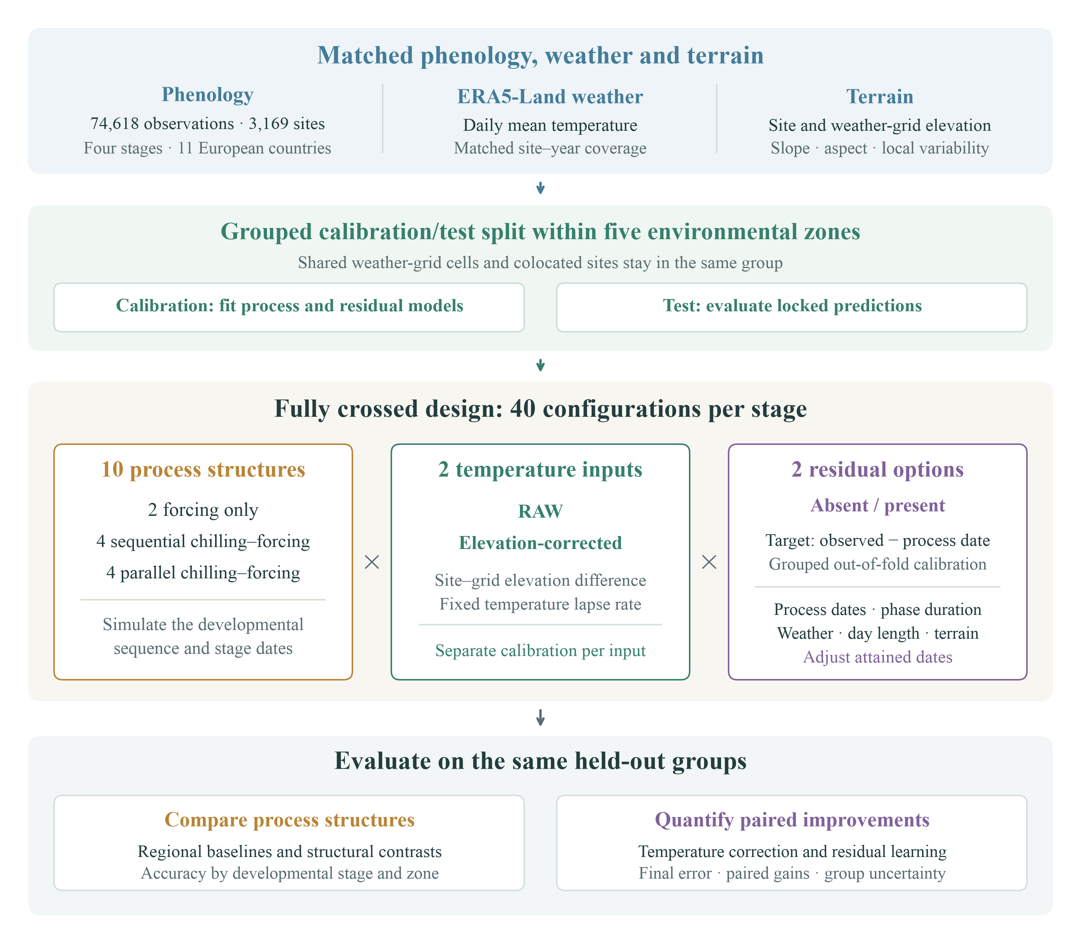
Fig. 1. Fully crossed workflow for regional grapevine phenology prediction. Matched phenology, weather and terrain data support evaluation of ten process structures under RAW or DEM-corrected temperature, each with or without residual learning. Group-preserving calibration and testing within five temperature-defined environmental zones support structural comparisons and paired correction benefits. Raw stage attainment remains separate from the 4 November scoring rule for late or unattained BBCH81/89 predictions. DEM, digital elevation model; ML, machine learning; MAE, mean absolute error.

2.2 Study area
Eligible monitoring records span eleven European countries, from 38.10 to 59.15°N and 4.20°W to 22.43°E, covering Atlantic, continental and Mediterranean thermal settings (Fig. 2). Lowlands, river valleys and hills provide local temperature contrasts relevant to phenology (de Rességuier et al., 2026). This observation domain is not a representative sample of European vineyard area.
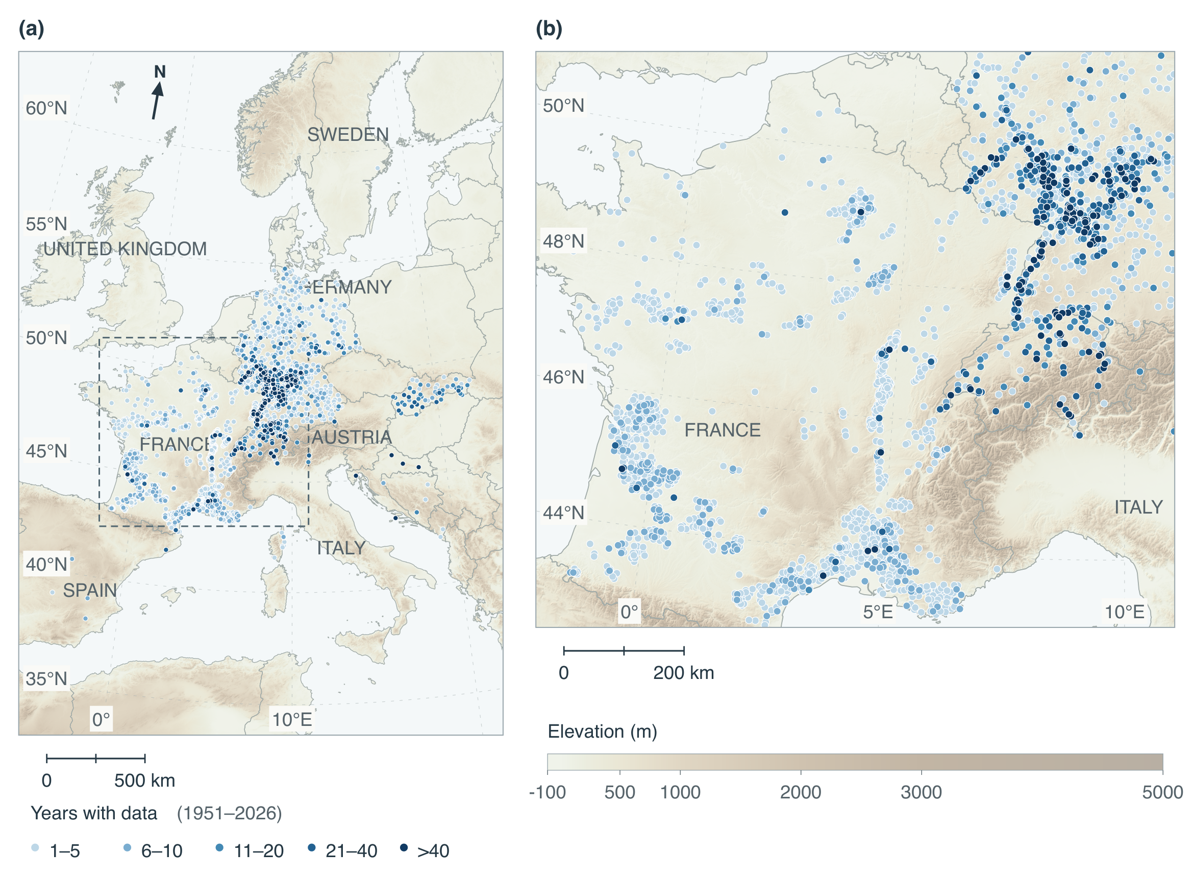
Fig. 2. Geographic coverage and duration of the historical phenology-only inventory, before final observation screening and weather matching. (a) European overview of 3,171 source-qualified sites in 11 countries; the outlined region is enlarged in (b). The inventory contains 74,341 observations of BBCH07, BBCH65, BBCH81 or BBCH89 during 1951–2026. Blue marker colours encode the number of distinct years with at least one observation of any of the four target stages at each site, pooled across reported varieties and target stages. From lightest to darkest blue, the five classes are 1–5, 6–10, 11–20, 21–40 and >40 years; darker blue denotes more years with observations, not later calendar years or greater marker density. Coincident sites overlap, with longer records drawn last. Background colours show Copernicus GLO-30 elevation, resampled to an approximately 500-m plotting grid and combined with northwest hillshade. The background provides geographic context; site-scale terrain predictors use the native DEM. Boundaries are from Natural Earth through the geo-countries dataset.

2.3 Data

2.3.1 Phenology observations
Phenology observations came from TEMPO (Maury et al., 2023), the Deutscher Wetterdienst (DWD; Deutscher Wetterdienst, n.d.) and PEP725 (PEP725, n.d.; accessed 1 July 2026). PEP725 project members provided its data. Records retain source-qualified site, reported variety, country, WGS84 coordinates, calendar date and directly recorded BBCH code, with source identities and licences preserved. Inferred stages and observations before 1951 are excluded; BBCH07 and BBCH09 remain distinct (Lorenz et al., 1995).
Exact seven-field duplicates are removed, while different accepted dates or variety labels remain separate. Missing varieties and DWD maturity classes do not establish cultivar or plant identity. Sites sharing locations are grouped conservatively for validation.
Source-quality checks and reconciliation of DWD annual and immediate reports precede calendar and interval screening. Higher-control reports take precedence only for matching object and phase identifiers; equally controlled alternatives and records without quality metadata retain their ambiguity (Supplementary Methods S6).
The four target stages are screened against inclusive calendar windows and six interval bounds (Tables 2 and 3). Within each source-qualified site, exact variety label and year, each record requires a compatible date at every other observed target stage. Unsupported records are removed simultaneously until the checks stabilize; missing and non-target stages impose no constraint. Dates and codes are neither repaired nor inferred. These project screening bounds do not constrain model predictions (Supplementary Methods S6).
The revised inventory contains 75,738 retained and 1,575 quarantined target observations. Matching to unchanged weather eligibility and site assignments yields 74,618 observations at 3,169 sites and 26,443 site–years during 1951–2025 (Table 1). No surviving site changes partition. Screening was revised after preliminary model outputs became available, although its numerical rules do not use residuals. Historical comparisons therefore combine changes in eligibility and calibration procedures (Supplementary Sections S5–S6; Table S4).
Complete developmental sequences and minimum record lengths are not required. BBCH89 is a source-dependent maturity/harvest endpoint that may reflect management. Country–stage counts appear in Supplementary Table S1. Figure 2 depicts the earlier phenology-only inventory; Fig. 4 depicts the active modelling population and its unchanged environmental-zone assignments.
Table 1. Observation populations underlying the final results. The historical weather cohort supplies the unchanged site–year eligibility and partition assignments; the revised four-target inventory supplies observation eligibility. Calibration and testing partition the final matched population. Counts refer to observation records, not weather files.
Population | Records | Scope
Historical weather-complete cohort | 74,311 | 3,170 sites and 26,460 site–years; eligibility and allocation reference
Revised four-target inventory | 75,738 | Direct-source BBCH07, 65, 81 and 89 after source-quality and timing checks
Outside unchanged weather and identity eligibility | 1,120 | Excluded from the revised target inventory before modelling
Final matched population | 74,618 | 3,169 sites and 26,443 site–years, 1951–2025
Calibration subset | 59,472 | 2,534 sites in 1,434 independence groups
Test subset | 15,146 | 635 sites in 357 independence groups
Table 2. Inclusive calendar windows used to screen the active four-target population. Month–day comparisons preserve leap years. These project screening choices do not constrain model predictions.
BBCH | Phenological stage | Eligible dates
07 | Beginning of budburst | 1 February–15 June
65 | Full flowering | 1 April–31 July
81 | Beginning of ripening (veraison) | 1 June–15 October
89 | Maturity/harvest | 15 July–15 November
Table 3. Inclusive stage-pair intervals used in the active four-target screen. Cross-stage intervals are sums of adjacent bounds and remain testable when an intermediate stage is absent. Only directly observed endpoints enter the checks.
Earlier stage | Later stage | Inclusive interval (d)
BBCH07 | BBCH65 | 20–120
BBCH65 | BBCH81 | 30–120
BBCH81 | BBCH89 | 10–90
BBCH07 | BBCH81 | 50–240
BBCH65 | BBCH89 | 40–210
BBCH07 | BBCH89 | 60–330

2.3.2 Temperature data
Daily mean 2-m ERA5-Land temperature at its native 0.1° grid supplies forcing in degrees Celsius (Muñoz-Sabater et al., 2021; Copernicus Climate Change Service, 2019a). Point assignments follow the native sampling transform. Missing dates are neither interpolated nor replaced by nearby-site values (Supplementary Section S2).
Every retained site–year has finite daily temperatures from 4 June of the preceding year through 31 December of the observation year, covering chilling and 90-day residual-model weather histories. Incomplete seasons are excluded. All model configurations share the retained observations; matching and temperature-consistency checks are detailed in Supplementary Section S2. Duplicate dates, nonfinite values, coordinate agreement and the correction equation were checked before fitting.

2.3.3 Digital elevation model
Copernicus GLO-30 supplies elevation from the containing native pixel, slope and aspect from a 3×3-pixel neighbourhood, and local elevation variability as the population standard deviation within an 11×11 neighbourhood (European Space Agency and Airbus, 2022). Northness and eastness encode aspect. Incomplete neighbourhoods retain missing derivatives or reduced pixel support; missing predictors are handled within residual-training folds. ERA5-Land grid elevation is invariant geopotential divided by 9.80665 m s⁻², distinct from mean GLO-30 elevation within a grid cell (Supplementary Section S2). Observation-network elevations are retained for comparison only.

2.3.4 DEM-based temperature correction
The DEM correction adjusts RAW daily temperature for the site–grid elevation difference using a fixed lapse rate of 0.0065 °C m⁻¹. This conventional gradient is not estimated locally (Rolland, 2003):
$T_{DEM,d}=T_{RAW,d}-0.0065\left(z_{site}-z_{grid}\right),$ (1)
where $T_{DEM,d}$ and $T_{RAW,d}$ are corrected and raw daily mean temperatures (°C), and $z_{site}$ and $z_{grid}$ are GLO-30 site and ERA5-Land grid elevations (m), respectively (Muñoz-Sabater et al., 2021; European Space Agency and Airbus, 2022). Local inversions and seasonal lapse-rate variation are not represented. Forcing and chilling requirements are recalibrated separately under each temperature input on identical observations; response parameters remain fixed. The contrast measures prediction after recalibration and does not independently establish local temperature accuracy.

2.4 Models

2.4.1 Process-based phenology models
The ten structures combine linear or beta forcing alone (FL, FB) with four chilling–forcing combinations under sequential (-S) or parallel (-P) interaction (Table 4). All ten enter both temperature and residual-learning comparisons. Shared temperature-response components remain fixed, while accumulation requirements are calibrated by structure and temperature input.
Linear forcing accumulates $max(T-0,0)$ degree-days. Its 0 °C base follows GFV, with extension beyond flowering and veraison treated as an adaptation (Parker et al., 2011). Normalized beta forcing is zero outside 0–35 °C and peaks at one at 25.4 °C (Fila et al., 2014). Triangular (CL) and beta (CB) chilling share cardinals of −1.7, 1.7 and 13.2 °C and responses bounded by zero and one. The triangular shape follows de Wergifosse et al. (2020), with cardinals transferred from Fila et al. (2014). These fixed functions control the structural comparison; they are not universal physiological constants (Fig. 3; Supplementary Methods S7).
For stage $s∈\{07,65,81,89\}$, occurrence is the first date when accumulated effective forcing reaches its requirement:
${\hat{D}}_{s}=min\left\{t≥τ_{s}:\sum_{u=τ_{s}}^{t}{w_{s,u}}R_{f,s}(T_{u})≥H_{s}\right\}.$ (2)
In Eq. 2, Ds is the predicted date of stage s, τs its accumulation start, ws,u the competence weight, Rf,s(Tu) the forcing response to daily temperature Tu, and Hs the calibrated requirement; t is the first day when the sum over days u reaches Hs. Forcing-only models start on 1 January. Accumulation resets after each predicted stage and resumes the next day, discarding overshoot; observed dates never initialize later stages. Simulation ends on 31 December, leaving unattained and subsequent stages unpredicted (Supplementary Methods S7).
Chilling begins on 1 September of the preceding year. Sequential budburst forcing starts the day after chilling reaches $C_{crit}$. Parallel chilling and budburst forcing start together; daily forcing is multiplied by
$K_{t}=0.2+0.8min\{C(t-1)/C_{crit},1\},$ (3)
In Eq. 3, Kt is forcing competence on day t, C(t−1) is chilling accumulated through the preceding day and Ccrit is the fitted chilling requirement. The formulation adapts Liu et al. (2018), with minimum competence fixed at 0.2. Parallel budburst can precede full chilling competence. Later-stage weights equal one in every structure (Supplementary Methods S7).
Stage-specific forcing requirements and the additional chilling requirement are shared across sites, years and reported varieties. Numerical bounds are 0.001–3000 °C d for linear forcing and 0.001–200 daily response units for beta forcing and chilling. Response cardinals, calendar origins and minimum parallel competence remain fixed (Supplementary Table S3; Methods S7).
Calibration separates early-stage fitting from maturity estimation. For $s∈\{07,65,81\}$, let $A_{s}$ and $B_{s}$ denote mean absolute error and signed bias after averaging within each site and then equally across sites. The early-stage objective is
$L_{early}(θ)=\frac{A_{07}+A_{65}+A_{81}}{3}, |B_{s}|≤1 d,$ (4)
In Eq. 4, θ is the vector of calibrated requirements; As and Bs are equal-site MAE and signed bias for stage s. The objective averages As across BBCH07, BBCH65 and BBCH81, subject to at least 99% raw attainment both across records and in the mean of site attainment fractions for each stage. A first search minimizes the largest absolute-bias excess above one day. If feasible, a second search minimizes Eq. 4 while preserving bias and attainment constraints; otherwise, the best coverage-admissible candidate retains its recorded unmet bias target. BBCH89 enters neither the objective nor these constraints.
Scoring uses 4 November of each observation year, the latest calibration BBCH89 month–day, frozen across cross-fitting folds. Late or unattained raw BBCH81/89 predictions receive this administrative scoring date; BBCH81 assignment also assigns BBCH89. Early fitting uses scored BBCH81 dates while its attainment constraint uses raw dates. Assignment never restarts accumulation or replaces raw predictions, and observation-screening bounds never clip predictions.
After early fitting, $H_{07}$, $H_{65}$, $H_{81}$ and any chilling requirement are frozen. Eligible calibration BBCH89 observations supply positive finite forcing sums from the day after raw predicted BBCH81 to observed maturity within the weather record. Each receives reciprocal within-site eligible-record weight. The lower weighted median, clipped to numerical bounds, defines $H_{89}$. Early-stage raw predictions remain unchanged; maturity has no full-attainment constraint (Supplementary Methods S7).
Differential evolution calibrates each structure and temperature treatment independently. Search settings, calibration-only retries, initialization and diagnostics are specified in Supplementary Methods S7; optimizer convergence, raw attainment and bias-target feasibility are recorded separately.
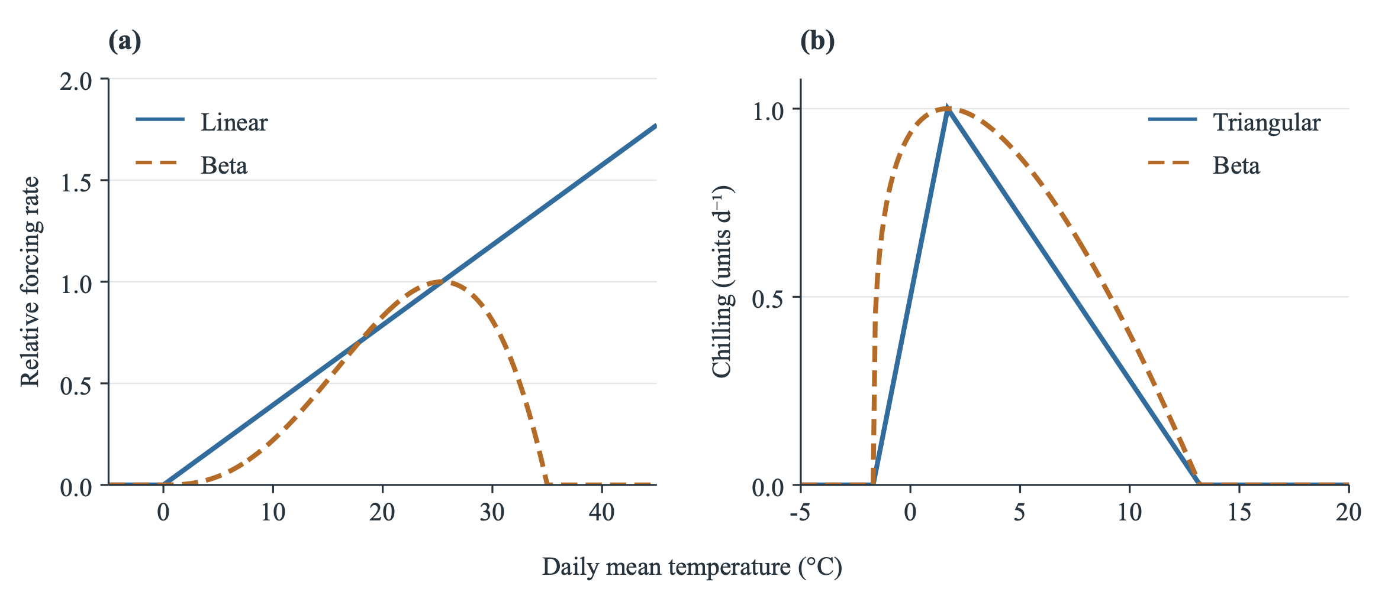
Fig. 3. Fixed temperature-response functions: (a) linear forcing with a 0 °C base (Parker et al., 2011) and beta forcing with cardinals of 0, 25.4 and 35 °C; (b) triangular and beta chilling with identical cardinals of −1.7, 1.7 and 13.2 °C. Forcing curves are displayed as $R(T)/R(25.4 °C)$, so both equal one at 25.4 °C; linear forcing remains uncapped. This display-only normalization does not change model equations or threshold units. Chilling retains native daily response units. Beta parameters follow Fbeta5* and CF10* in Fila et al. (2014); transfer to the triangular function of de Wergifosse et al. (2020) is an adaptation. Temperature-axis ranges differ between panels. Accumulation thresholds are calibrated separately and are not shown.

2.4.2 Residual machine learning
The residual model combines process-predicted timing and phase duration with recent weather, day length and terrain to estimate remaining stage-specific errors. This design uses the existing TabM architecture (Gorishniy et al., 2025) to learn observed-minus-process calendar-day residuals. The preliminary hybrid date is
${\tilde{D}}_{i}={\hat{D}}_{proc,i}+{round}_{even}({\hat{r}}_{i}).$ (5)
In Eq. 5, D̃i is the preliminary hybrid date, D̂proc,i the raw process date and r̂i the predicted residual for observation i. Residuals round to integer days, with half-day ties rounded to the nearest even integer. Each attained corrected stage must follow its preceding attained corrected stage by at least one day; unattained stages remain missing. Unconstrained dates and ordering adjustments support sensitivity analysis. Observation-screening bounds never clip predictions, and the same 4 November scoring rule applies after correction and ordering.
Targets use raw, unassigned out-of-fold process dates. Four grouped calibration folds generate four ordinary refits excluding one fold and six nested refits excluding each unordered pair. For neural validation fold $h$, training observations in fold $k$ use the process fit excluding $h$ and $k$; validation observations use the fit excluding $h$. Thus neither the target observation nor neural-validation labels enter its residual-training process fit. Every refit repeats early calibration and median-maturity estimation with the frozen cutoff, initialized from fixed responses and predeclared small thresholds rather than excluded-fold estimates (Supplementary Methods S7–S8).
Imputation, standardization and numerical embeddings use neural-training data only. Four inner folds select training duration. Final learners use all ordinary out-of-fold calibration residuals and the locked full-calibration process model. Unattained stages supply no residual targets or learned corrections. Both components remain fixed during testing.
The twenty numerical predictors are process-predicted day index and inclusive phase duration; temperature mean, standard deviation, minimum and maximum over preceding 7-, 30- and 90-day windows; day length; and elevation, slope, northness, eastness and local elevation variability. Weather windows end on predicted dates, never observed validation dates. Estimates are retrospective, conditional on realized weather, without a fixed advance forecast issue date.
Training minimizes site-weighted squared residual error, whereas epoch selection minimizes site-weighted MAE of the TabM ensemble mean. Final predictions average ensemble members and three seeds. Architecture, optimizer settings and epoch selection are detailed in Supplementary Methods S8; inner-fold scores support tuning rather than unbiased performance estimation.
Table 4. Catalogue of the 20 grapevine phenology models evaluated for each stage. F, forcing; C, chilling; ML, residual machine learning. For C + F models, Function gives the forcing / chilling response, in that order. Triangular chilling is the bounded piecewise-linear response in Supplementary Methods S7. Model codes use L for linear (triangular for chilling), B for beta, S for sequential and P for parallel. The -ML suffix denotes residual correction.
Process | Function | Interaction | ML | Model name
Forcing | Linear | — | No | FL
Forcing | Linear | — | Yes | FL-ML
Forcing | Beta | — | No | FB
Forcing | Beta | — | Yes | FB-ML
C + F | Linear / triangular | Sequential | No | CL-FL-S
C + F | Linear / triangular | Sequential | Yes | CL-FL-S-ML
C + F | Linear / triangular | Parallel | No | CL-FL-P
C + F | Linear / triangular | Parallel | Yes | CL-FL-P-ML
C + F | Linear / beta | Sequential | No | CB-FL-S
C + F | Linear / beta | Sequential | Yes | CB-FL-S-ML
C + F | Linear / beta | Parallel | No | CB-FL-P
C + F | Linear / beta | Parallel | Yes | CB-FL-P-ML
C + F | Beta / triangular | Sequential | No | CL-FB-S
C + F | Beta / triangular | Sequential | Yes | CL-FB-S-ML
C + F | Beta / triangular | Parallel | No | CL-FB-P
C + F | Beta / triangular | Parallel | Yes | CL-FB-P-ML
C + F | Beta / beta | Sequential | No | CB-FB-S
C + F | Beta / beta | Sequential | Yes | CB-FB-S-ML
C + F | Beta / beta | Parallel | No | CB-FB-P
C + F | Beta / beta | Parallel | Yes | CB-FB-P-ML

2.5 Model evaluation
The matched population contains 74,618 observations at 3,169 sites in 11 countries and 26,443 site–years (1951–2025). Calibration contains 59,472 observations at 2,534 sites in 1,434 groups; testing contains 15,146 observations at 635 sites in 357 groups. Test-stage counts are 5,073, 5,469, 3,754 and 850 for BBCH07, BBCH65, BBCH81 and BBCH89, respectively (Supplementary Table S2). All configurations share these partitions.
Germany contributes 74.7% of observations and France 18.6%; France supplies 93.7% of maturity/harvest observations and Germany none. Testing covers seven countries and 21 country–stage combinations, eleven with fewer than ten eligible groups. This imbalance limits regional precision and stage comparisons (Supplementary Section S10; Tables S1, S2 and S6).

2.5.1 Calibration and test partitioning
Approximately 80% of sites are assigned to calibration and 20% to testing within five environmental zones. Zones derive from $k$-means clustering (five clusters, 20 initializations; seed 20260909) of standardized monthly RAW temperature profiles for 1991–2020 (Copernicus Climate Change Service, 2019b), with each of 1,792 unique ERA5-Land cells represented once. Labels follow annual mean centroid temperature. Climate covariates alone define zones before partitioning, without phenology dates, country labels or errors (Supplementary Section S3).
Transitive groups connect sites sharing a weather cell, exact coordinates or coordinates rounded to four decimal places. Multi-cell groups are assigned to the nearest centroid using their mean standardized unique-cell profile. Each zone contains at least five groups. Seeded within-zone allocation targets 20% test sites while preserving whole groups and collective four-stage support; revised screening leaves surviving assignments unchanged. Four group-preserving, zone-balanced calibration folds contain every stage and govern ordinary and nested cross-fitting. Figure 4 shows the zones and primary allocation; detailed allocation settings appear in Supplementary Section S3.
The primary split evaluates held-out sites within sampled climatic conditions. Calibration, residual training and epoch selection exclude test labels. Country and zone summaries describe subsets of this holdout, not independent regional-transfer tests. Historical spatial-block, warm-year, warm-site and unstratified protocols do not evaluate the final median-cutoff and residual-learning models.
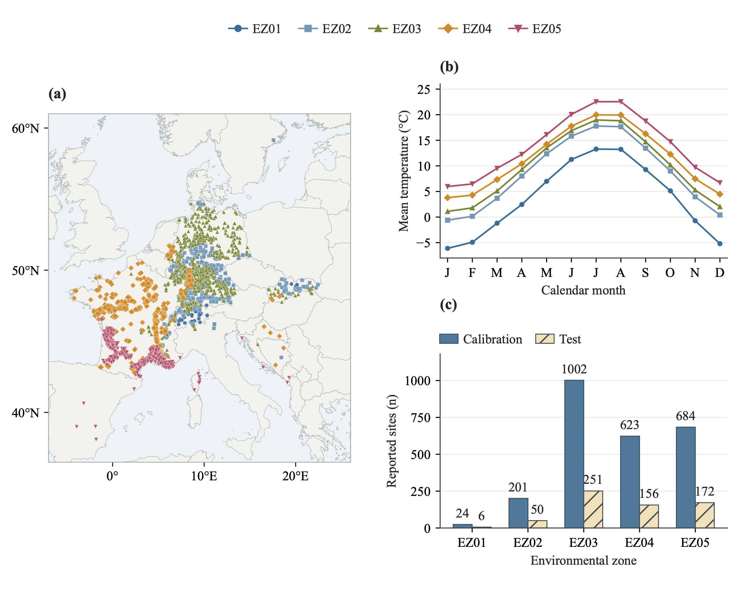
Fig. 4. Environmental zones and the primary calibration–test split. (a) Geographic distribution of the 3,169 retained modelling sites, coloured and marked by their frozen environmental-zone assignments. Coincident sites overlap; the map does not interpolate zone boundaries between sites. Boundaries are from Natural Earth through geo-countries. (b) Monthly centroid temperatures from five clusters of 1991–2020 RAW ERA5-Land profiles; each of the original 1,792 unique weather-grid cells contributes once to clustering. Labels EZ01–EZ05 are ordered by annual mean centroid temperature, with identical zone colours and symbols in (a) and (b). (c) Reported site counts in calibration and testing within each zone, totalling 2,534 and 635 sites, respectively, in the active cleaned cohort under the unchanged original assignments. Transitive groups sharing grid cells or coordinates remain together. Reported sites can share physical locations, and zone size reflects the observed collection rather than European vineyard area.

2.5.2 Terrain effects
For each process structure and residual-learning option, $MAE_{RAW}-MAE_{DEM}$ measures elevation-correction benefit on paired held-out observations; positive values indicate improvement. Each temperature arm is calibrated separately on identical observations. Comparing this benefit between process-only and hybrid models assesses their combined predictive contribution.
Terrain strata use local elevation standard deviation and absolute site–grid elevation mismatch. One-third and two-thirds quantiles across calibration sites, each represented once, define common cutpoints. With linearly interpolated quantiles, low values satisfy $x≤q_{1/3}$, middle values $q_{1/3}<x≤q_{2/3}$, and high values x>$q_{2/3}$. Missing values form a separate category; tied cutpoints remain unchanged. Test data and errors never determine boundaries.
The process DEM comparison requires common finite scoring errors across all ten structures and both inputs. Losses are averaged across fixed structures, within sites, equally across sites and equally across four stages. Additional exploratory contrasts use signed elevation mismatch, elevation, slope, northness and eastness. Supported regional semivariogram sills describe terrain at 20-km support, separately from local variability (Supplementary Methods S13). These comparisons evaluate elevation correction at fixed weather resolution (Zhao et al., 2015).
High-minus-low terrain contrasts use identical group-bootstrap draws and require ten contributing groups per stage in each stratum. Sensitivities exclude the coldest zone or any observation assigned a cutoff in a process temperature arm, or give groups equal weight after within-site and within-group averaging. They change scoring populations or weights without refitting. Terrain associations describe predictive differences, not causal effects or independent temperature accuracy.

2.5.3 Predictive performance and uncertainty
All calibrated parameters remain fixed during testing. Paired factorial comparisons distinguish RAW and DEM process-only predictions from RAW and DEM hybrids across all ten structures. Test observations support performance assessment and subsequent rankings.
Individual process-model summaries use each configuration’s finite scoring dates, with raw attainment and missingness reported separately. Paired factorial summaries instead require common finite populations.
Structural comparisons use RAW process predictions in 21 fixed pairs: linear versus beta forcing (five), triangular versus beta chilling (four), sequential versus parallel interaction (four), and absent versus present chilling (eight). Each family requires finite scoring errors for every constituent model. Losses are averaged across equal-weight pairs, within sites and equally across sites and stages. Right-minus-left MAE changes describe aggregate component contrasts; models are neither independent replicates nor an ensemble prediction (Supplementary Section S9; Table S5).
RAW residual-learning contrasts compare RAW process and hybrid predictions; hybrid DEM contrasts compare separately fitted RAW and DEM hybrids. Both arms must have finite scoring errors in all ten structures. These contrasts and the process DEM contrast share 15,105 observations at 633 sites in 355 groups, enabling paired comparison of DEM benefits. Individual-model contrasts retain the same mask; aggregate losses average across the ten fixed structures before site and stage averaging (Supplementary Section S15).
For process-only (P) and hybrid (H) predictions, the decrease in DEM benefit is
$ΔG=(MAE_{P,RAW}-MAE_{P,DEM})-(MAE_{H,RAW}-MAE_{H,DEM}).$ (6)
In Eq. 6, P and H denote process-only and hybrid predictions, and RAW and DEM denote temperature inputs. Positive ΔG indicates a smaller DEM benefit after residual learning. The same group multiplicities enter both benefits in each bootstrap draw; intervals derive from their paired difference. Percentage gains use each workflow’s own RAW MAE. Baseline–gain associations are descriptive because gains contain baseline error arithmetically.
Spatial summaries describe CB-FL-S, the lowest-MAE RAW process model in the primary test comparison. Site-error medians and interquartile ranges describe distributions; zone means weight sites equally within stage. Sparse zones retain descriptive estimates and support counts, while missing stages preclude overall averages. This analysis supplies no independent validation of model selection or zone-specific calibration (Supplementary Section S9).
The stage metrics used in Section 2.4.1 are computed with equal weight per site. For stage $s$, let $e_{ijs}={\hat{D}}_{ijs}-D_{ijs}$ be the calendar-day error of observation $i$ at site $j$, with $n_{js}$ contributing observations at each of $J_{s}$ sites. Equal-site weights are $w_{ijs}=1/(J_{s}n_{js})$, giving
$MAE_{s}=\sum_{j,i}{w_{ijs}}|e_{ijs}|, {Bias}_{s}=\sum_{j,i}{w_{ijs}}e_{ijs}.$ (7)
In Eq. 7, sums extend over observations i and sites j within stage s; ei,j,s is predicted-minus-observed calendar-day error and wi,j,s gives equal total weight to each site. Positive bias indicates late predictions and negative bias early predictions. MAE measures error magnitude; bias can conceal opposing errors. Overall MAE and bias average all four stage estimates equally.
Calendar-date differences preserve cross-year offsets and leap days. Record, site and group counts accompany comparisons. Raw-date summaries use attained predictions; scoring summaries apply the 4 November rule to BBCH81/89, with assignment, raw attainment and attainment by cutoff reported separately. Full-calibration summaries describe apparent training performance, not out-of-fold accuracy.
Paired intervals use 2,000 bootstrap draws of original independence groups (seed 20260913), retaining all member sites and multiplying equal-site weights by group draw frequency. Stage intervals require at least ten contributing groups; overall intervals require this support in every stage. Pointwise 95% percentile intervals require at least 95% finite draws and have no multiplicity adjustment. Smaller samples retain descriptive estimates. Calibration intervals concern apparent fitted-model differences; test intervals concern the primary held-out population.

3 Results

3.1 Process-based models under raw forcing
CB-FL-S was the best-performing RAW process structure, with a held-out four-stage MAE of 11.31 d, followed by CL-FL-S at 11.72 d (Fig. 5a). Across the ten structures, MAE ranged from 11.31 to 14.74 d; forcing-only FL and FB scored 13.17 and 13.41 d, and parallel beta-forcing CB-FB-P and CL-FB-P scored 14.36 and 14.74 d. These model-specific finite-scoring populations support descriptive rankings. Apparent calibration MAE ranged from 11.19 to 14.66 d, with test-minus-calibration differences of −0.16 to +0.25 d.
Errors were greater at the late-season stages (Fig. 5b–e): model-specific test MAE ranged from 9.31 to 14.35 d for budburst, 10.05 to 13.63 d for flowering, 12.33 to 15.20 d for veraison and 12.62 to 15.78 d for maturity/harvest. The stage populations differ geographically and observationally, precluding attribution of these differences to development alone.
All ten structures predicted veraison early, with signed errors of −8.40 to −1.23 d (Supplementary Section S11 and Fig. S1). All five linear-forcing structures met the calibration bias target at each of the first three stages; none of the beta-forcing structures did so. Maturity/harvest bias was smaller (−1.84 to +0.12 d), despite substantial absolute errors.
Under the 4 November scoring rule, 1.81–4.14% of test maturity records received an assigned cutoff date after equal-site weighting. Process attainment was 95.86–98.19% by the cutoff and 97.31–99.17% by 31 December; veraison assignment affected 0–1.36%. Assigned scoring dates do not establish physiological attainment, and BBCH89 includes an operational harvest endpoint.
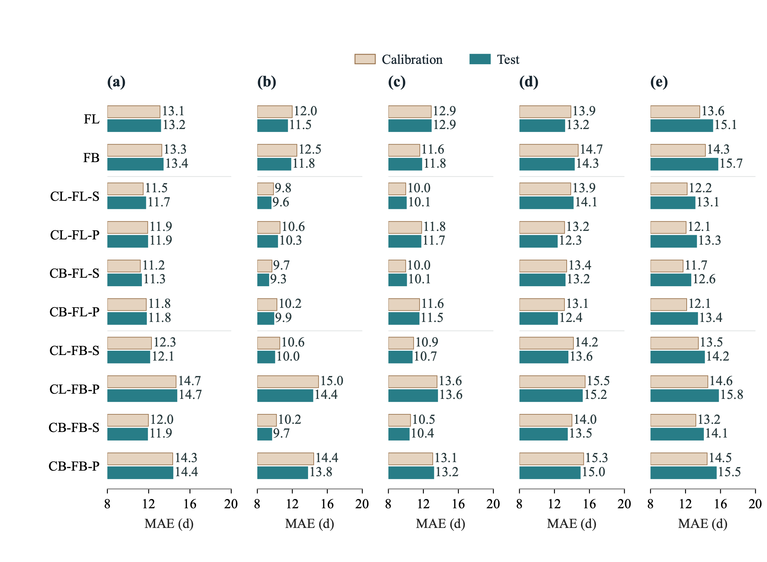
Fig. 5. Mean absolute error of process-based models (PBMs) driven by raw ERA5-Land temperature. Panel (a) shows overall performance, with equal weight for BBCH07, BBCH65, BBCH81 and BBCH89; panels (b–e) show the four stages separately, in that order. Light brown bars denote apparent calibration performance and blue bars denote held-out test performance. Numbers give MAE in days, rounded to one decimal place. Errors are averaged within sites and then equally across sites. Bars extend from 8 d to the annotated MAE, with identical 8–20 d axes; the displayed lengths represent error above 8 d. Model order follows the catalogue. BBCH81 and BBCH89 errors use the fixed 4 November scoring convention for late or unattained predictions. Values are descriptive point estimates without confidence intervals. Signed bias is shown in Supplementary Fig. S1.

3.2 Predictive performance across model components
Controlled contrasts favoured linear forcing and sequential interaction (Fig. 6). Across five matched pairs, RAW MAE was 11.96 d for linear and 13.21 d for beta forcing: a beta-minus-linear difference of +1.26 d (pointwise 95% group-bootstrap interval, +0.96 to +1.57 d). Across four pairs, sequential and parallel MAEs were 11.72 and 13.14 d, respectively, differing by +1.41 d (+1.12 to +1.67 d). The sequential advantage was largest at budburst (+2.45 d) and flowering (+2.10 d), but small at veraison (+0.10 d; −0.53 to +0.61 d).
Beta chilling reduced MAE by 0.29 d relative to triangular chilling (12.28 versus 12.57 d; difference interval, −0.40 to −0.21 d). Including chilling reduced MAE from 13.21 to 12.43 d across eight pairs, a difference of −0.78 d (−0.99 to −0.57 d), strongest at maturity/harvest (−1.43 d) and weak at veraison (−0.08 d; −0.39 to +0.28 d). Common finite-scoring populations retained 99.38–100% of eligible observations. These average component contrasts remain conditional on the fixed responses and fitted thresholds.
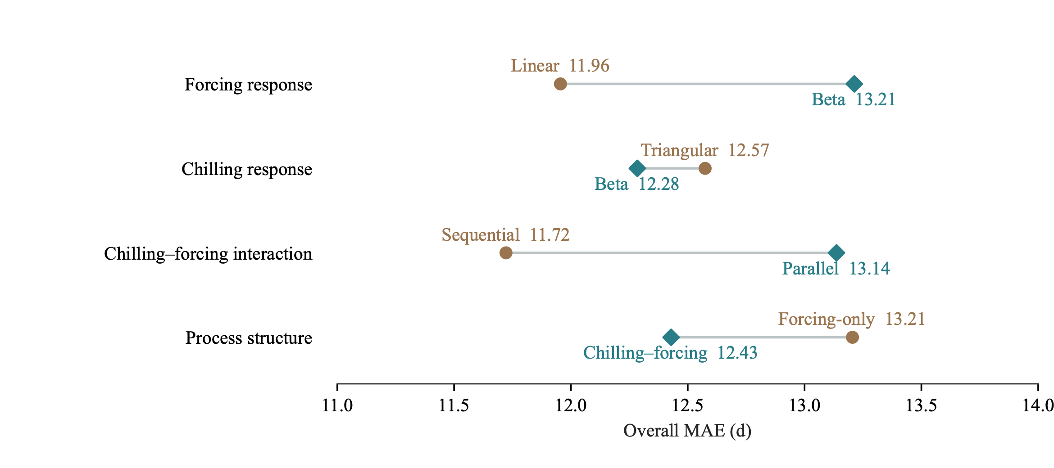
Fig. 6. Overall held-out MAE across process-based model components under raw ERA5-Land forcing. Connected points compare the forcing response (linear versus beta; five matched model pairs), chilling response (triangular versus beta; four pairs), chilling–forcing interaction (sequential versus parallel; four pairs), and process structure (forcing-only versus chilling–forcing; eight pairs). Response functions and process structures follow the definitions in Sect. 2.4. Labels give component-level MAE in days. Absolute errors are averaged equally across fixed constituent pairs, within sites and across equally weighted sites; the overall summary gives equal weight to BBCH07, 65, 81 and 89. Values are point estimates on family-wide common finite-scoring observations. Paired bootstrap intervals are reported in the text.

3.3 CB-FL-S performance across environmental zones
CB-FL-S errors varied substantially among held-out sites (Fig. 7). Median site MAEs were 7.99, 7.42, 10.23 and 11.00 d for budburst, flowering, veraison and maturity/harvest, respectively; maxima reached 46.00, 81.64, 75.75 and 41.32 d. These distributions describe the population used to identify the best RAW structure, rather than additional validation of its selection.
Zone differences depended on stage. Median flowering MAE was 12.88 d in EZ02 versus 6.50–8.50 d in EZ03–EZ05; median veraison MAE was 14.37 d in EZ03 versus 8.67 and 8.14 d in EZ04 and EZ05. Separately, equal-site four-stage mean MAEs were 9.78 d (95% interval, 8.89–10.85 d) in EZ04 and 10.76 d (9.69–11.90 d) in EZ05, the two zones supporting intervals at every stage (Supplementary Table S7). These contrasts reflect differing mixtures of sites, years and reported varieties.
Other zones had sparse stage coverage (Supplementary Section S12, Fig. S2 and Table S7). EZ01 contained only flowering: five of six eligible sites had finite predictions, with median MAE 69.00 d; three observations at the remaining site had no finite date. Maturity/harvest medians of 27.50 d in EZ02 and 22.25 d in EZ03 represented only one and six sites. Insufficient group support precluded intervals for these zone means.
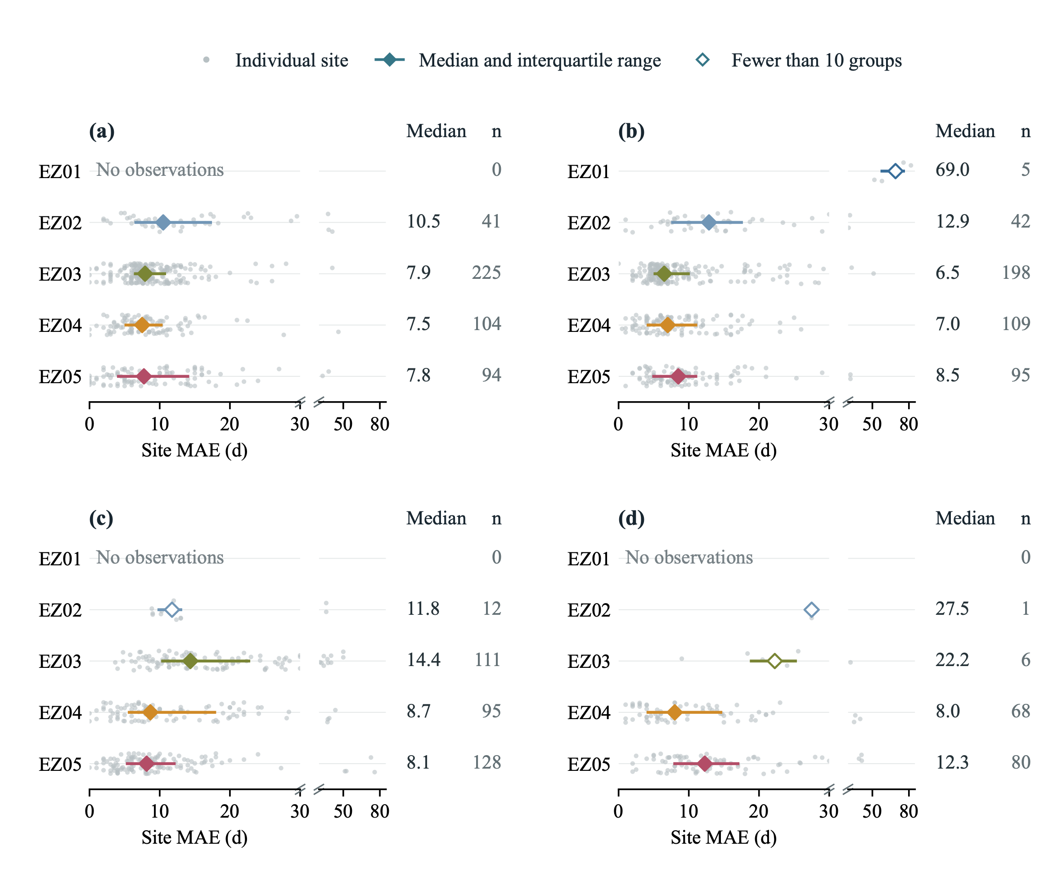
Fig. 7. Distribution of held-out CB-FL-S site MAEs across environmental zones under raw ERA5-Land forcing. Panels (a–d) show BBCH07, 65, 81 and 89. Grey dots represent individual sites; vertical jitter separates overlapping values and has no quantitative meaning. Coloured diamonds mark the median site MAE, and horizontal lines span the 25th–75th percentiles across sites. These ranges describe site variability, not confidence intervals. Open diamonds identify samples with fewer than ten contributing independence groups. Columns give the median in days and the number of contributing sites ($n$). Each panel expands the 0–30 d range and retains larger errors in a narrower 30–85 d strip; slashes mark the change in horizontal scale, with no values omitted. No observations denotes absent stage records. Observation coverage is shown in Supplementary Fig. S2; zone mean MAEs and their bootstrap intervals are reported in Supplementary Table S7. The 4 November scoring convention applies to BBCH81/89.

3.4 Benefits and terrain dependence of elevation correction
DEM correction improved all ten process structures after separate threshold recalibration (Fig. 8). Across 15,105 common finite-scoring observations, equal-model, equal-site and equal-stage MAE decreased from 12.58 to 11.53 d: a paired gain of 1.06 d (95% group-bootstrap interval, 0.70–1.39 d), or 8.4%. Model-specific gains ranged from 0.46 d for CB-FL-S to 1.79 d for CL-FB-P, with positive interval bounds throughout. The contrasts include recalibration under each temperature input.
Flowering benefited most (1.61 d; 1.04–2.25 d), followed by maturity/harvest (0.97 d), veraison (0.91 d) and budburst (0.73 d). Site-level average error decreased at 64%, 66%, 61% and 63% of sites for the four stages, respectively. Signed bias responded differently: veraison bias changed from −4.04 to −1.72 d, while maturity/harvest bias became more negative (−0.78 to −1.34 d) despite lower MAE (Supplementary Section S14 and Fig. S4).
Signed elevation mismatch distinguished benefits more clearly than mismatch magnitude. Sites at least 41.7 m below the weather grid gained 2.18 d (1.26–3.07 d), compared with 0.51 d (0.24–0.73 d) in the middle class and 0.58 d (−0.07 to 1.19 d) in the highest class. The high-minus-low contrast was −1.60 d (−2.74 to −0.40 d). Maturity/harvest gains were 4.07 d in the lowest signed-mismatch class and −0.72 d in the highest, whose interval included zero. By absolute mismatch, the highest and lowest classes gained 1.80 and 0.72 d, but their contrast remained uncertain (1.09 d; −0.09 to 2.13 d).
Rougher terrain did not consistently yield larger gains. Improvement declined from 1.37 to 0.59 d between the lowest and highest local-elevation-variability classes (contrast, −0.78 d; −1.49 to −0.11 d). Regional semivariogram estimates showed no monotonic pattern and lacked sufficient maturity/harvest group support for four-stage intervals (Supplementary Fig. S3).
Benefits also differed by zone and stage (Supplementary Table S8): flowering improved by 1.41 d in EZ04 and 3.16 d in EZ05, whereas veraison deteriorated by 0.59 d in EZ04 and improved by 2.22 d in EZ05. Overall gains persisted after excluding EZ01 (0.93 d), weighting independence groups equally (1.03 d), or excluding all records assigned the cutoff in any configuration (1.10 d). The exclusion analyses use altered scoring populations.
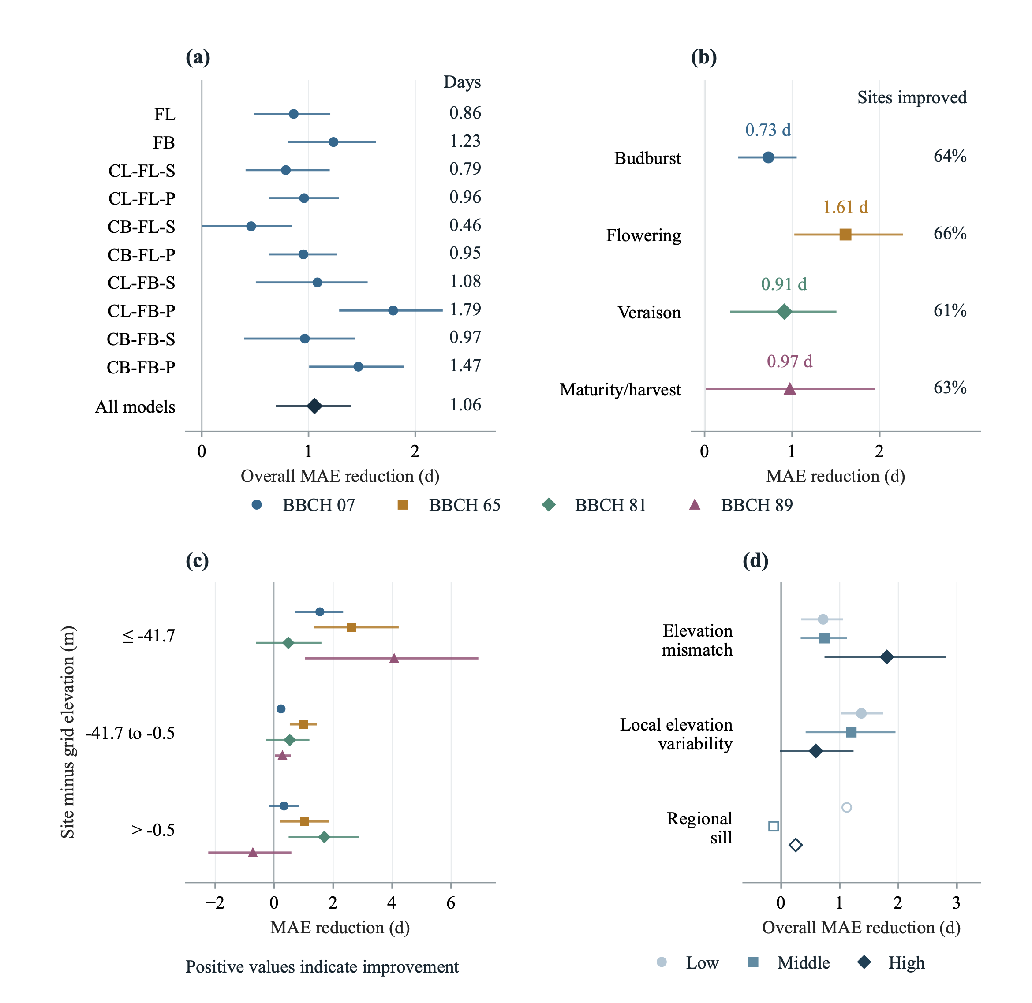
Fig. 8. Held-out benefits of DEM-based elevation correction for PBMs. Positive values indicate a reduction in MAE relative to RAW forcing. (a) Equal-stage benefits for each of the ten models and their fixed-model average. (b) Stage-specific benefits averaged across models; percentages give the share of sites whose average model MAE decreased. (c) Stage-specific benefits by signed site-minus-grid elevation difference. (d) Overall benefits by absolute elevation mismatch, local elevation variability and regional semivariogram sill. Class boundaries are calibration-site tertiles; displayed boundaries are rounded, with exact values retained in the analysis tables. Local variability is the native 11×11-pixel elevation standard deviation; regional sill is estimated from smoothed GLO-30 elevations in a 20-km window (Supplementary Methods S13). All panels use the same twenty-arm finite-scoring cohort, with 4 November assignments retained for BBCH81/89. Points summarize errors within sites and then across equally weighted sites; overall values give the four stages equal weight. Lines are pointwise 95% intervals from 2,000 original-group bootstrap draws. Open markers indicate insufficient stage-wise group support for an interval; unsupported sill fits remain missing. These fitted-workflow contrasts include separate threshold recalibration under each temperature input.

3.5 Predictive gains from residual learning
The process-guided residual model improved all forty RAW model–stage combinations (Fig. 9a). Four-stage gains ranged from 2.87 to 6.08 d, with all ten intervals excluding zero; the fixed-model average was 4.10 d (95% interval, 3.56–4.63 d). Average gains were 3.90, 4.89, 3.38 and 4.21 d for budburst, flowering, veraison and maturity/harvest. These paired comparisons retained 15,105 observations at 633 held-out sites in 355 groups.
Residual learning narrowed the four-stage MAE range from 11.27–14.61 d for process models to 8.30–8.75 d for hybrids. CL-FB-P improved from 14.61 to 8.53 d (6.08 d gain), while CB-FL-S improved from 11.27 to 8.40 d (2.87 d gain). The 11.27 d CB-FL-S baseline uses the common paired population, whereas its 11.31 d score in Sect. 3.1 uses its own finite-scoring population. CB-FL-P-ML achieved the lowest final hybrid MAE (8.30 d), with a 3.49 d gain. Larger gains therefore did not necessarily imply lower final error.
Zone-specific improvements changed relative error levels (Fig. 9c,d). Flowering gains were 10.58 d (9.12–11.99 d) in EZ05 and 1.44 d (0.89–1.99 d) in EZ03, reducing MAE from 15.12 to 4.54 d and from 9.06 to 7.62 d, respectively. EZ01's 59.85 d flowering gain reduced MAE from 72.76 to 12.90 d but involved only five groups and no other stages. Maturity/harvest estimates in EZ02 and EZ03 involved only one and four groups. These sparse estimates lack intervals; zone summaries remain subsets of the primary holdout. Signed biases are reported in Supplementary Section S15 and Fig. S5.
Calibration hybrid scores represent apparent performance after training on calibration-only out-of-fold residuals. Test sites supplied neither process fitting nor neural epoch-selection targets. Correction required an attained raw process date and left thermal attainment unchanged; corrected late-season dates remained subject to the common scoring rule.
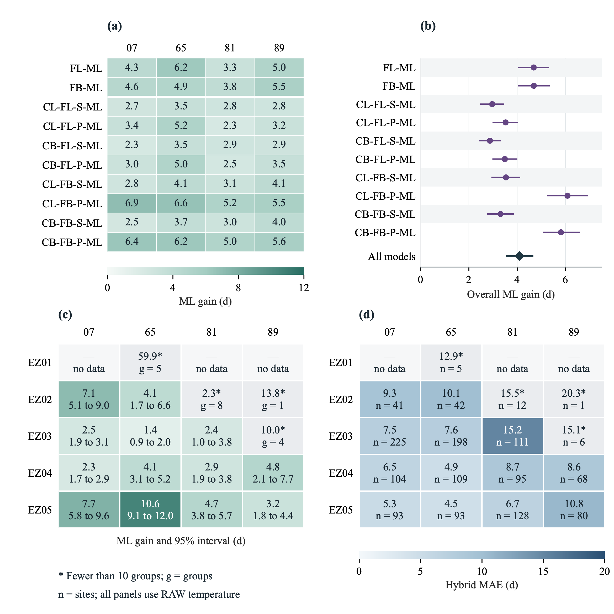
Fig. 9. Residual-learning gains overall and across environmental zones under RAW temperature forcing. (a) Paired stage-specific MAE reductions for each hybrid. (b) Four-stage gains and pointwise 95% group-bootstrap intervals; the diamond summarizes the ten fixed models. (c) Zone-specific gains, with pointwise 95% intervals below each estimate. Panels (a,c) share a colour scale. (d) Remaining hybrid MAE by zone, with contributing site counts ($n$). Grey starred cells have fewer than ten independence groups; $g$ gives group support when no interval is available. Dashes indicate absent observations. Positive gain denotes smaller MAE after adding ML. Absolute errors are averaged across fixed models for aggregate summaries, within sites and then equally across sites; overall gains give the four stages equal weight. All panels use common finite-scoring observations across the ten RAW process–hybrid pairs, with 2,000 original-group bootstrap draws. BBCH81/89 retain the fixed 4 November scoring convention.

3.6 DEM correction within residual-learning hybrids
DEM correction added only 0.12 d to average hybrid accuracy (95% interval, −0.10 to 0.31 d; Fig. 10a). Model-specific gains ranged from −0.13 to 0.34 d. Budburst improved by 0.21 d (0.04–0.39 d), while the other stage intervals included zero. Site-level average MAE decreased at 56%, 55%, 54% and 59% of sites for budburst, flowering, veraison and maturity/harvest, respectively.
On identical observations, DEM benefit was 0.94 d smaller for hybrids than for process models (95% interval, 0.64–1.24 d). This decrease was positive at every stage, with all intervals excluding zero, and largest at flowering (1.47 d; 0.94–2.10 d). Relative gains were 1.4% for hybrids and 8.4% for process models, indicating that the reduction in DEM benefit persisted after accounting for lower hybrid baseline error.
Additional hybrid gains in EZ04 were 0.42 d (0.04–0.76 d) for budburst and 0.32 d (0.03–0.59 d) for flowering; all stage intervals included zero in EZ05 (Fig. 10c). Maturity/harvest contrasts in EZ02 and EZ03 lacked sufficient group support. These paired comparisons span all ten structures and include separately fitted process thresholds and residual learners under each temperature input.
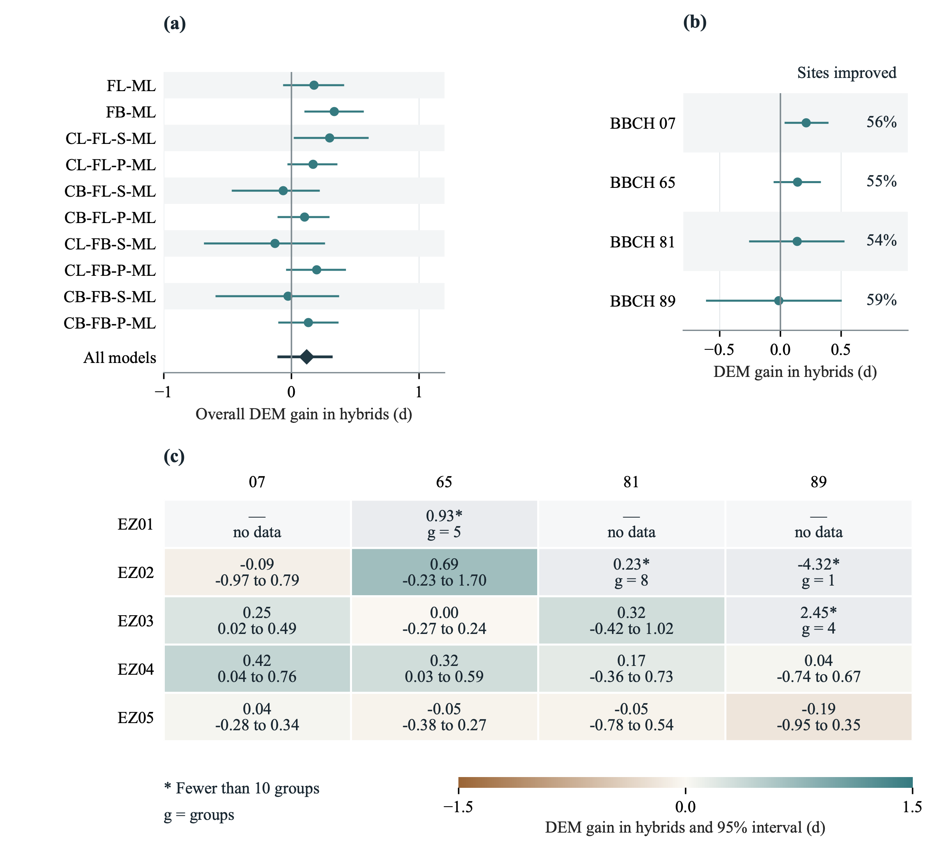
Fig. 10. Effects of DEM temperature correction within residual-learning hybrids. Positive gain is RAW-hybrid MAE minus DEM-hybrid MAE. (a) Four-stage gains for each hybrid and the fixed-model average (diamond). (b) Stage-specific average gains; percentages give the share of sites with lower average hybrid MAE under DEM forcing. (c) Gains across environmental zones, with pointwise 95% intervals below estimates. Grey starred cells have fewer than ten contributing groups ($g$); dashes indicate absent observations. Intervals use 2,000 original-independence-group bootstrap draws. All panels use common finite-scoring observations across the ten RAW–DEM hybrid pairs. Fixed-model, site and stage weights match Fig. 9; BBCH81/89 retain the 4 November scoring convention. The comparison includes separately fitted process thresholds and residual learners under each temperature input.

4 Discussion
Selecting CB-FL-S established the strongest RAW process baseline for regional grapevine phenology, but substantial predictable error remained. Across all ten structures, elevation correction reduced process-model MAE by 1.06 d and the process-guided residual model reduced RAW MAE by 4.10 d. The additional DEM gain within hybrids was only 0.12 d. Thus, process selection and subsequent correction address related prediction problems, and their individual gains cannot be assumed to add together.

4.1 Process structure and stage dependence
The controlled advantages of linear forcing and sequential interaction were larger than the effect of chilling-response shape. This supports prioritizing forcing response and the timing of chilling–forcing interaction when choosing among the tested formulations. The small sequential–parallel difference at veraison also shows that an overall ranking can obscure stage dependence. Limited benefits of greater complexity have previously been reported for grapevine models (Fila et al., 2014), whereas nonlinear responses have improved predictions under other experimental and climatic conditions (Sadras and Moran, 2013; Thomas et al., 2026). Such differences are compatible with dependence on temperature range, cultivar composition and the particular response function.
These rankings apply to fixed cardinal temperatures and seasonal origins with separately fitted accumulation thresholds. Beta-forcing structures failed to meet all early-stage calibration bias targets, so their poorer performance also reflects the fit achieved under the constrained objective. The sequential advantage is likewise conditional on the implemented parallel competence function and its minimum value of 0.2. Equal event-date accuracy need not imply equivalent physiological representations (Chuine and Régnière, 2017). Controlled temperature experiments and independent dormancy observations would help determine whether alternative parameterizations preserve these rankings.
Veraison and maturity/harvest remained harder to predict, although their different site and observation populations prevent attribution to development alone. Later simulated dates inherit preceding-stage timing, which changes the weather encountered during subsequent accumulation; later conditions can amplify or compensate for earlier errors. Chilling acts directly only before budburst in this implementation, so its apparent maturity benefit can arise through this sequence. Observed differences in interval sensitivity and cultivar thermal requirements support these dependencies (Cameron et al., 2022; Parker et al., 2013). Shared thresholds average over that diversity. BBCH89 additionally combines fruit development with harvest decisions, unlike a specified sugar-ripeness target (Parker et al., 2020). Relationships between harvest timing, temperature and moisture identify plausible missing information, but do not explain individual residuals in this collection (Cook and Wolkovich, 2016).

4.2 When elevation correction improves phenology prediction
DEM correction remains relevant because it improved every process structure and reduced their average MAE by 8.4%. Its value is clearest when process models are used without residual learning; the small hybrid increment answers a different question. Improvement at only 61–66% of sites across stages indicates that a uniform elevation adjustment addresses part of temperature representativeness. Vineyard measurements show spatial and canopy-related variation in meteorological conditions (Matese et al., 2014), while seasonal lapse rates and inversions can depart from a constant adjustment (Rolland, 2003). Consequently, elevation information alone cannot capture the full local temperature environment.
Sites below the weather-grid elevation benefited more than those above it. Under the specified lapse rate, the former receive warmer temperatures and the latter cooler temperatures. The observed asymmetry therefore concerns the direction of fitted temperature-input changes, rather than a general rule that larger mismatch requires greater correction. Temperature shifts can influence chilling, forcing and subsequent accumulation differently, and terrain classes also differ in cultivar, country and environmental composition. These explanations remain hypotheses. Likewise, local terrain variability and regional relief describe surrounding heterogeneity rather than the elevation offset at an individual site, explaining why they are not interchangeable guides to correction benefit.
The average gain persisted under alternative weighting and exclusion sensitivities, supporting its relevance within the sampled population. However, separate threshold recalibration is part of the treatment contrast: lower phenological error cannot establish that corrected daily temperatures are closer to observations. Independent site temperatures are needed to assess that claim and to test seasonally varying lapse rates. For hybrid applications, the near-zero average increment and local reversals support evaluating DEM correction against final stage-specific error rather than including it automatically. Its limited additional value here does not imply that finer-scale temperature information is unnecessary in other environments.

4.3 Residual learning and its overlap with temperature correction
Residual learning improved all forty model–stage combinations, demonstrating that information useful for date prediction remained beyond shared process thresholds. The design combines stage-specific observed-minus-process residuals with process-state and environmental predictors, using TabM as the regression architecture (Gorishniy et al., 2025). Process-predicted dates and phase durations summarize simulated seasonal progress and can distinguish situations in which the process model is systematically early or late. Temperature summaries over the preceding 7, 30 and 90 days describe recent conditions beyond the accumulated thermal requirement. Day length and terrain provide seasonal and spatial context that may help distinguish residual patterns under otherwise similar process states. This combination follows the broader rationale for integrating process understanding with flexible statistical prediction (Reichstein et al., 2019).
Residual targets come from observations excluded from their corresponding process fit, with grouped nested fitting also protecting neural validation from process-label reuse. This links learning to errors outside the fitted observations rather than merely reproducing apparent calibration residuals. Nevertheless, the predictive contribution of each feature group remains unresolved. Process-state, weather and terrain information can covary with cultivar composition, management and observation practice. Lower test MAE establishes their joint predictive usefulness under the evaluation design, without identifying a forcing, physiological or management mechanism. Feature-removal comparisons and independent temperature observations would be needed to distinguish these explanations.
Residual correction compressed the process-model MAE range from 11.27–14.61 to 8.30–8.75 d on the common population. This reduced sensitivity to process structure, but did not make gain alone a suitable selection criterion: the gain contains baseline error arithmetically, and the model with the largest correction did not have the lowest final MAE. The different process and hybrid winners also show why both correction approaches required evaluation across all ten structures. Date correction leaves thermal attainment unchanged, so it improves event-time estimates without repairing a process model's failure to reach a developmental requirement.
DEM benefit declined from 1.06 d for process models to 0.12 d for hybrids, a paired decrease of 0.94 d; relative benefits similarly declined from 8.4% to 1.4%. This is consistent with overlap in the errors addressed: terrain and weather predictors may help residual learners account for repeatable discrepancies associated with temperature representativeness. Other remaining errors may concern cultivar, management or endpoint heterogeneity beyond a lapse-rate adjustment. These interpretations are not identified mechanisms, because both process thresholds and residual learners were refitted under each temperature input. The evidence establishes limited additional average DEM value within the sampled domain, not reconstruction of local temperature by the learner or equivalence of RAW and DEM hybrids.

4.4 Scope and priorities for validation
The grouped holdout evaluates retrospective estimation at withheld sites within represented temperature regimes. Keeping shared weather cells and overlapping locations together reduces dependence, consistent with matching validation to the prediction setting (Roberts et al., 2017), but nearby groups can retain similar environments and management. Environmental-zone contrasts therefore describe heterogeneity within the primary holdout rather than independent regional transfer. Their changing error rankings after correction reinforce the importance of final stage-specific performance, while sparse flowering support in the coldest zone and limited maturity observations elsewhere prevent broad climatic conclusions.
Geographic and endpoint imbalance further constrain interpretation. Germany contributes nearly three quarters of the observations, whereas France supplies almost all maturity/harvest records. Equal-site weighting limits dominance by long records but does not balance countries or supply missing country–stage combinations. Incomplete cultivar and plant identities, repeated dates and mixed harvest endpoints limit separation of biological variation from management and observation effects. The 4 November assignment also makes late-season scores a measure under a common administrative convention; raw attainment and assignment frequencies remain necessary alongside MAE. Pointwise intervals concern individual contrasts without adjustment for multiple comparisons.
Screening and calibration procedures were revised after preliminary model results became available. Final process fitting and neural tuning exclude test labels, but the full development process lacks a prospectively untouched evaluation cohort. Screening and weather eligibility may also exclude genuine extremes, and comparisons with historical runs cannot isolate a cleaning effect because eligibility and calibration changed together. Independent observations with prespecified screening, consistent endpoints and cultivar identities are therefore priorities, alongside withheld-region and unusually warm-season tests of ranking stability.
Predictions use realized weather through process-predicted dates. Their retrospective accuracy does not establish performance at an advance forecast issue date, which requires evaluation using only information available at issuance. Similarly, corrected dates are external adjustments to the simulated thermal state; coupling them to canopy, water-demand or crop-protection models requires an explicit, separately tested rule. More accurate phenological dates may support vineyard decisions, but effects on frost damage, fruit composition, yield or management outcomes remain unevaluated.

5 Conclusions
Regional grapevine phenology was evaluated through comparison of ten process structures and further improvement with terrain-based temperature correction and a process-guided residual model, using observations from 3,169 sites in 11 countries. CB-FL-S achieved the lowest RAW process MAE, 11.31 d on its model-specific finite-scoring population and 11.27 d on the common paired population. Across all ten structures, DEM correction reduced process MAE by 1.06 d, while RAW residual learning reduced it by 4.10 d and narrowed final hybrid MAE to 8.30–8.75 d.
DEM correction added only 0.12 d to average hybrid accuracy, with an interval spanning zero. Thus, gains from temperature correction and residual learning were not additive. Model selection requires final stage-specific error and process attainment alongside correction magnitude. These results support structure selection followed by joint evaluation of correction options for retrospective estimation within the sampled environments; independent validation is needed to establish regional transfer and operational forecasting performance.

CRediT authorship contribution statement
Linjia Yao: Data curation, Methodology, Writing – original draft. Gang Zhao: Methodology, Funding acquisition, Writing – original draft, Writing – review & editing. Qiang Yu: Funding acquisition, Supervision. Bin Chen, Yuxuan Li, Amit Kumar Srivastava, Linchao Li, Xuefei Wang, Simone Bregaglio and Hao Feng: Writing – review & editing.

Declaration of Competing Interest
The authors declare that they have no known competing financial interests or personal relationships that could have appeared to influence the work reported in this paper.

Appendix A. Supporting information
Supporting information is provided in the accompanying supplementary information file.

Data availability
Phenological observations are available through TEMPO, the DWD Climate Data Center and PEP725 under the respective providers’ access and licence conditions. ERA5-Land and Copernicus DEM are available from the cited repositories. Data supporting the findings will be made available on request, subject to these conditions.

Acknowledgements
We acknowledge the TEMPO network and its contributing data providers for access to phenological observations through the TEMPO data portal (https://data.pheno.fr/). The temperature adjustments contain modified Copernicus Climate Change Service information (2026). The European Commission and ECMWF bear no responsibility for subsequent uses of these data.

References
Cameron, W., Petrie, P.R., Barlow, E.W.R., 2022. The effect of temperature on grapevine phenological intervals: Sensitivity of budburst to flowering. Agric. For. Meteorol. 315, 108841. https://doi.org/10.1016/j.agrformet.2022.108841.
Chuine, I., 2000. A unified model for budburst of trees. J. Theor. Biol. 207, 337–347. https://doi.org/10.1006/jtbi.2000.2178.
Chuine, I., Régnière, J., 2017. Process-based models of phenology for plants and animals. Annu. Rev. Ecol. Evol. Syst. 48, 159–182. https://doi.org/10.1146/annurev-ecolsys-110316-022706.
Cook, B.I., Wolkovich, E.M., 2016. Climate change decouples drought from early wine grape harvests in France. Nat. Clim. Change 6, 715–719. https://doi.org/10.1038/nclimate2960.
[dataset] Copernicus Climate Change Service, 2019a. ERA5-Land hourly data from 1950 to present. Copernicus Climate Change Service (C3S) Climate Data Store (CDS). https://doi.org/10.24381/cds.e2161bac. Accessed 11 September 2026.
[dataset] Copernicus Climate Change Service, 2019b. ERA5-Land monthly averaged data from 1950 to present. Copernicus Climate Change Service (C3S) Climate Data Store (CDS). https://doi.org/10.24381/cds.68d2bb30. Accessed 11 September 2026.
de Rességuier, L., Parker, A.K., Petitjean, T., García de Cortázar-Atauri, I., van Leeuwen, C., 2026. Modeling grapevine phenology at local scale in the context of climate change: An example in the Bordeaux area. Agric. For. Meteorol. 376, 110831. https://doi.org/10.1016/j.agrformet.2025.110831.
de Wergifosse, L., André, F., Beudez, N., de Coligny, F., Goosse, H., Jonard, F., Ponette, Q., Titeux, H., Vincke, C., Jonard, M., 2020. HETEROFOR 1.0: A spatially explicit model for exploring the response of structurally complex forests to uncertain future conditions—part 2: Phenology and water cycle. Geosci. Model Dev. 13, 1459–1498. https://doi.org/10.5194/gmd-13-1459-2020.
[dataset] Deutscher Wetterdienst, n.d. Phenological observations in Germany. https://opendata.dwd.de/climate_environment/CDC/observations_germany/phenology/
[dataset] European Space Agency, Airbus, 2022. Copernicus DEM. European Space Agency. GLO-30 instance. https://doi.org/10.5270/ESA-c5d3d65. Accessed 11 September 2026.
Fila, G., Gardiman, M., Belvini, P., Meggio, F., Pitacco, A., 2014. A comparison of different modelling solutions for studying grapevine phenology under present and future climate scenarios. Agric. For. Meteorol. 195–196, 192–205. https://doi.org/10.1016/j.agrformet.2014.05.011.
Fonseca, A., Cruz, J., Fraga, H., Andrade, C., Valente, J., Alves, F., Neto, C., Flores, R., Santos, J.A., 2025. Enhancing climate change impact assessment in viticulture by resolving microclimates. Eur. J. Agron. 170, 127740. https://doi.org/10.1016/j.eja.2025.127740.
Gorishniy, Y., Kotelnikov, A., Babenko, A., 2025. TabM: Advancing tabular deep learning with parameter-efficient ensembling. In: International conference on learning representations. https://openreview.net/forum?id=Sd4wYYOhmY.
Koppa, A., Rains, D., Hulsman, P., Poyatos, R., Miralles, D.G., 2022. A deep learning-based hybrid model of global terrestrial evaporation. Nat. Commun. 13, 1912. https://doi.org/10.1038/s41467-022-29543-7.
Liu, Q., Fu, Y.H., Liu, Y., Janssens, I.A., Piao, S., 2018. Simulating the onset of spring vegetation growth across the Northern Hemisphere. Glob. Change Biol. 24, 1342–1356. https://doi.org/10.1111/gcb.13954.
Lorenz, D.H., Eichhorn, K.W., Bleiholder, H., Klose, R., Meier, U., Weber, E., 1995. Growth stages of the grapevine: phenological growth stages of the grapevine (Vitis vinifera L. ssp. vinifera)—Codes and descriptions according to the extended BBCH scale. Aust. J. Grape Wine Res. 1, 100–103. https://doi.org/10.1111/j.1755-0238.1995.tb00085.x.
Matese, A., Crisci, A., Di Gennaro, S.F., Primicerio, J., Tomasi, D., Marcuzzo, P., Guidoni, S., 2014. Spatial variability of meteorological conditions at different scales in viticulture. Agric. For. Meteorol. 189-190, 159–167. https://doi.org/10.1016/j.agrformet.2014.01.020.
[dataset] Maury, O., Quidoz, M.-C., Garcia de Cortazar Atauri, I., Chuine, I., El Hasnaoui, M., Tromel, L., 2023. Portail de données phénologiques du réseau TEMPO / TEMPO Data Portal. Recherche Data Gouv. https://doi.org/10.57745/NQ9HRV.
Muñoz-Sabater, J., Dutra, E., Agustí-Panareda, A., Albergel, C., Arduini, G., Balsamo, G., Boussetta, S., Choulga, M., Harrigan, S., Hersbach, H., Martens, B., Miralles, D.G., Piles, M., Rodríguez-Fernández, N.J., Zsoter, E., Buontempo, C., Thépaut, J.-N., 2021. ERA5-Land: A state-of-the-art global reanalysis dataset for land applications. Earth Syst. Sci. Data 13, 4349–4383. https://doi.org/10.5194/essd-13-4349-2021.
Ou, J., Chen, F., Zhang, M., Batchelor, W.D., Wang, B., Wu, D., Ma, X., Zhang, Z., Hu, K., Feng, P., 2025. A continuous learning framework based on physics-guided deep learning for crop phenology simulation. Agric. For. Meteorol. 368, 110562. https://doi.org/10.1016/j.agrformet.2025.110562.
Parker, A.K., De Cortázar-Atauri, I.G., Van Leeuwen, C., Chuine, I., 2011. General phenological model to characterise the timing of flowering and veraison of Vitis vinifera L.: Grapevine flowering and veraison model. Aust. J. Grape Wine Res. 17, 206–216. https://doi.org/10.1111/j.1755-0238.2011.00140.x.
Parker, A., de Cortázar-Atauri, I.G., Chuine, I., Barbeau, G., Bois, B., Boursiquot, J.-M., Cahurel, J.-Y., Claverie, M., Dufourcq, T., Gény, L., Guimberteau, G., Hofmann, R.W., Jacquet, O., Lacombe, T., Monamy, C., Ojeda, H., Panigai, L., Payan, J.-C., Lovelle, B.R., Rouchaud, E., Schneider, C., Spring, J.-L., Storchi, P., Tomasi, D., Trambouze, W., Trought, M., van Leeuwen, C., 2013. Classification of varieties for their timing of flowering and veraison using a modelling approach: A case study for the grapevine species Vitis vinifera L. Agric. For. Meteorol. 180, 249–264. https://doi.org/10.1016/j.agrformet.2013.06.005.
Parker, A.K., García de Cortázar-Atauri, I., Gény, L., Spring, J.-L., Destrac, A., Schultz, H., Molitor, D., Lacombe, T., Graça, A., Monamy, C., Stoll, M., Storchi, P., Trought, M.C.T., Hofmann, R.W., van Leeuwen, C., 2020. Temperature-based grapevine sugar ripeness modelling for a wide range of Vitis vinifera L. cultivars. Agric. For. Meteorol. 285–286, 107902. https://doi.org/10.1016/j.agrformet.2020.107902.
[dataset] PEP725, n.d. Pan European Phenology database. https://pep725.eu/ Accessed 1 July 2026.
Reichstein, M., Camps-Valls, G., Stevens, B., Jung, M., Denzler, J., Carvalhais, N., Prabhat, 2019. Deep learning and process understanding for data-driven Earth system science. Nature 566, 195–204. https://doi.org/10.1038/s41586-019-0912-1.
Roberts, D.R., Bahn, V., Ciuti, S., Boyce, M.S., Elith, J., Guillera-Arroita, G., Hauenstein, S., Lahoz-Monfort, J.J., Schröder, B., Thuiller, W., Warton, D.I., Wintle, B.A., Hartig, F., Dormann, C.F., 2017. Cross-validation strategies for data with temporal, spatial, hierarchical, or phylogenetic structure. Ecography 40, 913–929. https://doi.org/10.1111/ecog.02881.
Rolland, C., 2003. Spatial and seasonal variations of air temperature lapse rates in Alpine regions. J. Clim. 16, 1032–1046. https://doi.org/10.1175/1520-0442(2003)016<1032:SASVOA>2.0.CO;2.
Sadras, V.O., Moran, M.A., 2013. Nonlinear effects of elevated temperature on grapevine phenology. Agric. For. Meteorol. 173, 107–115. https://doi.org/10.1016/j.agrformet.2012.10.003.
Sgubin, G., Swingedouw, D., Dayon, G., García de Cortázar-Atauri, I., Ollat, N., Pagé, C., van Leeuwen, C., 2018. The risk of tardive frost damage in French vineyards in a changing climate. Agric. For. Meteorol. 250-251, 226–242. https://doi.org/10.1016/j.agrformet.2017.12.253.
Thomas, D.S., Cameron, W., Hayman, P.T., Bonada, M., Sadras, V.O., Gambetta, J.M., Jolley, J.Y.C., Petrie, P.R., 2026. Developing and testing of a winegrape phenology model for Australian conditions. Agric. For. Meteorol. 382, 111131. https://doi.org/10.1016/j.agrformet.2026.111131.
Tomasi, D., Jones, G.V., Giust, M., Lovat, L., Gaiotti, F., 2011. Grapevine phenology and climate change: relationships and trends in the Veneto region of Italy for 1964–2009. Am. J. Enol. Vitic. 62, 329–339. https://doi.org/10.5344/ajev.2011.10108.
Webb, L.B., Whetton, P.H., Barlow, E.W.R., 2011. Observed trends in winegrape maturity in Australia. Glob. Change Biol. 17, 2707–2719. https://doi.org/10.1111/j.1365-2486.2011.02434.x.
Webb, L.B., Whetton, P.H., Bhend, J., Darbyshire, R., Briggs, P.R., Barlow, E.W.R., 2012. Earlier wine-grape ripening driven by climatic warming and drying and management practices. Nat. Clim. Change 2, 259–264. https://doi.org/10.1038/nclimate1417.
Zhao, G., Siebert, S., Enders, A., Rezaei, E.E., Yan, C., Ewert, F., 2015. Demand for multi-scale weather data for regional crop modeling. Agric. For. Meteorol. 200, 156–171. https://doi.org/10.1016/j.agrformet.2014.09.026.

