DATA SCIENCE FUNDAMENTALS ASSESSMENT
Task 1 — Data Analyst Internship
YuvaIntern | Candidate: Ganesh
Candidate Name | Ganesh
Internship Role | Data Analyst
Task | Task 1 — Data Science Fundamentals Assessment
Dataset | Synthetic student-performance dataset created for demonstration

Executive Summary
This assessment demonstrates foundational data-science skills through concise explanations, reproducible Python examples, worked statistical calculations, and an exploratory analysis of a small synthetic dataset. The analysis includes data-quality issues deliberately inserted into a raw CSV, documented cleaning decisions, descriptive summaries, visualizations, and limitations. The data are synthetic and are used only to demonstrate the workflow; they are not evidence about real students.

1. Objectives
- Explain core Python types, data structures, conditional logic, loops, and functions.
- Calculate and interpret descriptive statistics and a simple probability.
- Inspect, clean, validate, and summarize tabular data with Pandas and NumPy.
- Use visualizations and correlation carefully, distinguishing association from causation.
- Document assumptions, limitations, privacy, and reproducibility practices.

2. Python Fundamentals
Python variables refer to objects. Common built-in types include int, float, str, and bool. Lists are ordered and mutable; tuples are ordered and immutable; sets contain unique values; dictionaries map keys to values. Conditional statements support decisions, loops repeat operations, and functions package reusable logic.
candidate = "Ganesh"
hours = 4.5
scores = [45, 48, 52, 56, 60]
profile = {"candidate": candidate, "hours": hours}
def classify_score(score):
if not isinstance(score, (int, float)):
raise TypeError("score must be numeric")
if not 0 <= score <= 100:
raise ValueError("score must be between 0 and 100")
if score >= 85:
return "High"
elif score >= 60:
return "Pass"
return "Needs improvement"
for score in scores:
print(score, classify_score(score))
Expected classifications: 45 and 48 are Needs improvement; 52 and 56 are Needs improvement; 60 is Pass. The function also checks invalid input rather than silently accepting non-numeric or out-of-range scores.

3. Worked Statistical Example
Consider the sample [10, 12, 12, 14, 17]. The sum is 65 across 5 observations, so the mean is 65/5 = 13. The sorted middle value is 12, so the median is 12. The mode is 12 because it appears most often. The range is 17 − 10 = 7.
For sample variance, squared deviations from the mean 13 are 9, 1, 1, 1, and 16. Their sum is 28. Dividing by n − 1 = 4 gives sample variance 7. The sample standard deviation is √7 ≈ 2.646. Using population formulas instead would divide variance by n; the correct formula depends on whether the data are treated as a sample or an entire population.
Measure | Result | Interpretation
Mean | 13 | Arithmetic average
Median | 12 | Middle observation
Mode | 12 | Most frequent value
Range | 7 | Maximum minus minimum
Sample variance | 7 | Squared spread using n − 1
Sample standard deviation | 2.646 | Spread in original units

4. Probability Example
If 3 of 10 equally likely tickets are winning tickets, the probability of selecting a winning ticket in one fair draw is P(win) = 3/10 = 0.30 = 30%. This result depends on the assumption that all 10 tickets are equally likely to be selected.

5. Dataset and Data-Quality Audit
The attached raw CSV contains 17 rows: 16 constructed student records plus one intentionally duplicated row. Three numeric cells are intentionally missing. This makes it possible to demonstrate duplicate detection, missing-value inspection, and a documented cleaning strategy.
- Raw shape: 17 rows × 5 columns.
- Expected exact duplicate rows: 1.
- Intentional missing cells: Attendance_Pct, Quiz_Score, and Final_Score each contain one missing value.
- The clean dataset removes exact duplicates and fills the demonstration's missing numeric values with each column's median.
Median imputation is a demonstration choice, not a universal rule. In real work, first investigate why values are missing and whether missingness is systematic. Preserve the raw source, document transformations, and compare alternatives when the choice affects conclusions.

6. Cleaning and Validation Code
raw = pd.read_csv("student_performance_raw.csv")
print(raw.shape)
print(raw.isna().sum())
print("Duplicates:", raw.duplicated().sum())
clean = raw.drop_duplicates().copy()
for col in ["Attendance_Pct", "Quiz_Score", "Final_Score"]:
clean[col] = clean[col].fillna(clean[col].median())
assert clean["Attendance_Pct"].between(0, 100).all()
assert clean["Quiz_Score"].between(0, 100).all()
assert clean["Final_Score"].between(0, 100).all()
After cleaning, the expected shape is 16 rows × 5 columns, with no remaining missing values or exact duplicate rows. Range assertions check that percentage and score fields remain between 0 and 100.

7. Exploratory Data Analysis
The constructed clean dataset has an average final score of 70.06. 12 of 16 records have a final score of at least 60, giving a threshold-based share of 75.0%. This is a descriptive result for this dataset only.
The Pearson correlation between study hours and final score is 1.000; between attendance and final score it is 0.995. These values indicate strong positive association in the constructed data. Because the dataset was deliberately designed with increasing values, this pattern is not an independent discovery and must not be treated as evidence of a real-world causal effect.
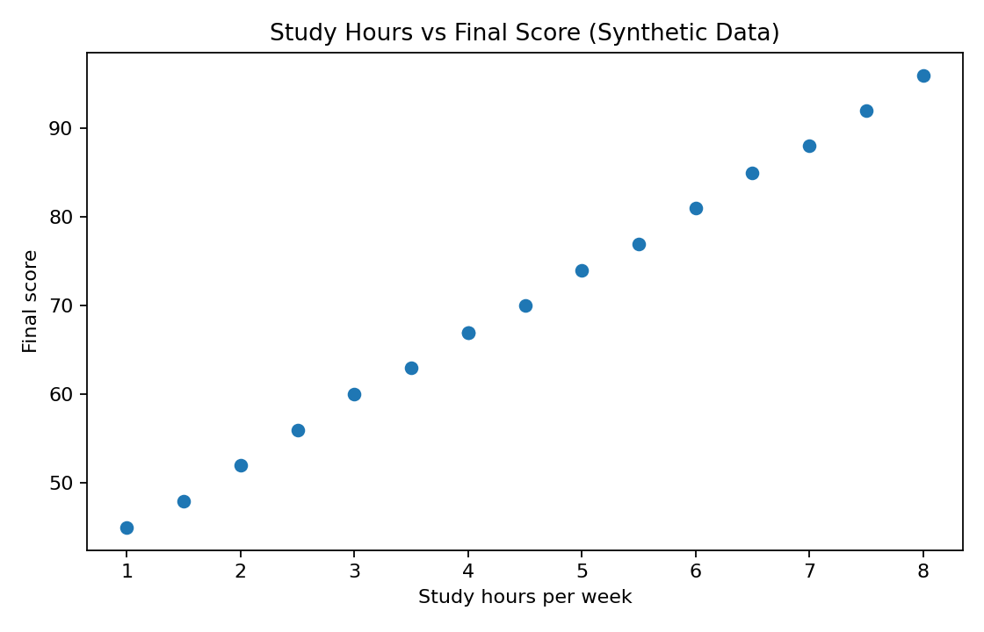
Figure 1. Relationship between study hours and final score in the synthetic dataset.
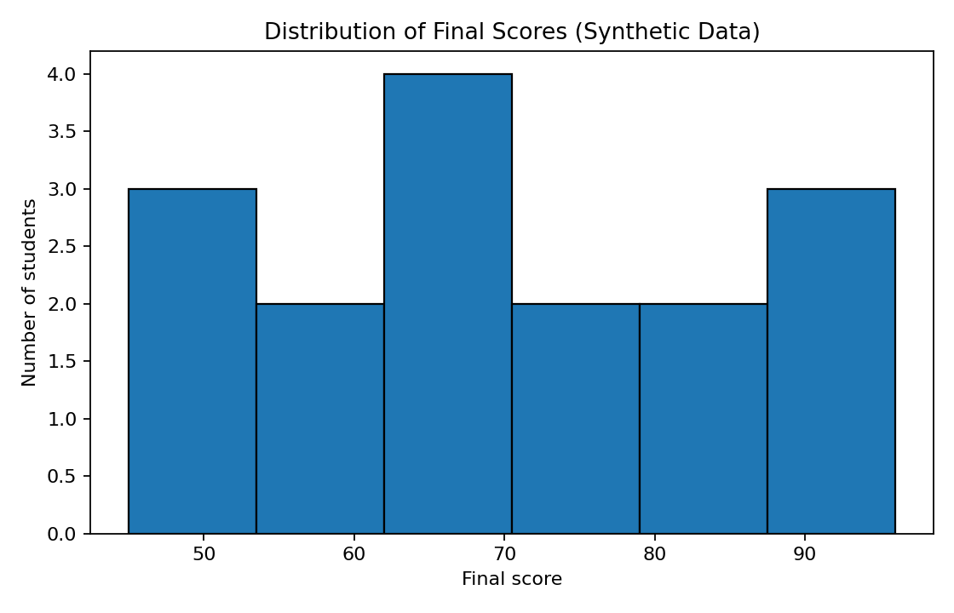
Figure 2. Distribution of final scores in the synthetic dataset.
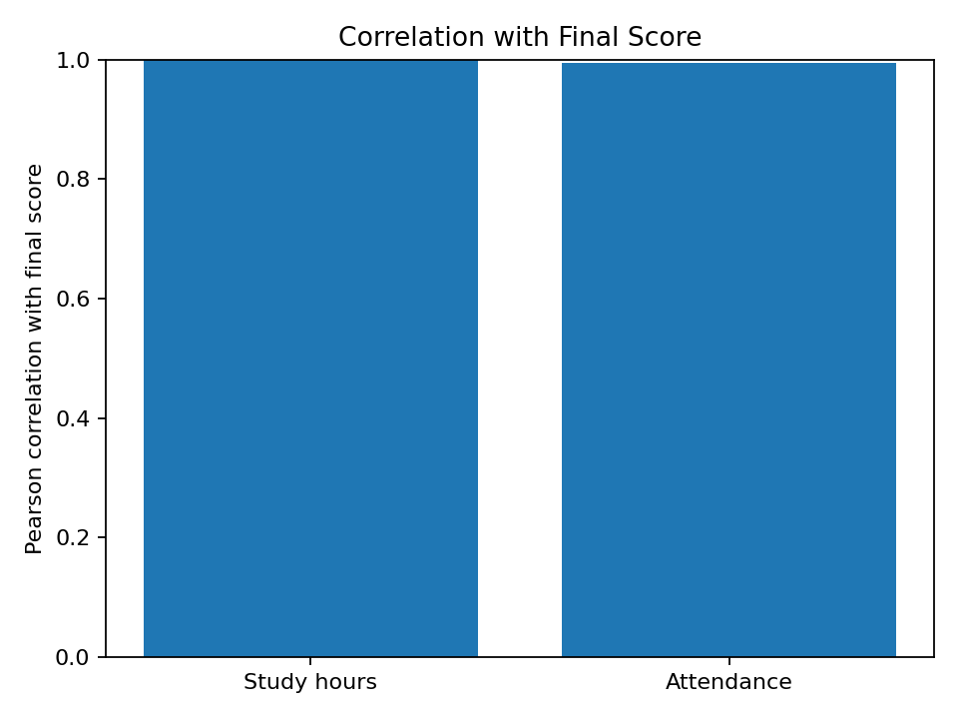
Figure 3. Correlations with final score; correlation does not establish causation.

8. Interpretation, Risks, and Limitations
- The dataset is small and synthetic; its results cannot be generalized to real students.
- Correlation describes association and does not establish causation or rule out confounding variables.
- Median imputation can reduce the apparent variability and may bias results if missingness is not random.
- The threshold of 60 is used as an illustrative rule, not a universal definition of passing.
- Before applying these methods to real data, verify data provenance, representativeness, definitions, and collection quality.

9. Data Science Best Practices
- Keep raw data unchanged; save processed data as a separate file.
- Check missingness, duplicates, data types, valid ranges, and inconsistent categories.
- Use readable names, reusable functions, and reproducible notebooks.
- Label charts clearly and avoid visual choices that exaggerate results.
- Record assumptions, cleaning decisions, and limitations.
- Protect personal information and only use data for an authorized purpose.
- Use version control and include the data source and environment details.

10. Conclusion
This assessment demonstrates Python fundamentals, statistical reasoning, probability, data cleaning, validation, EDA, visualization, and responsible interpretation. The included notebook and CSV files allow the work to be reproduced. The next improvement would be to repeat the workflow with a genuine, well-documented dataset if the task instructions require real-world data, and to compare findings against a clearly defined analytical question.

Submission Description (200+ words)
This report presents my work for Task 1 — Data Science Fundamentals Assessment as part of the YuvaIntern Data Analyst Internship. It demonstrates my understanding of Python programming, statistical foundations, data quality, exploratory data analysis, visualization, and data-science best practices. The practical section uses Python, NumPy, and Pandas to show variables, data structures, conditional statements, loops, reusable functions, descriptive statistics, and probability calculations. A worked statistical example explains mean, median, mode, range, sample variance, and sample standard deviation using explicit values and formulas. The report also includes a small synthetic student-performance dataset created for reproducible demonstration. The raw file intentionally contains missing values and a duplicate row so that data inspection, quality checks, cleaning decisions, and validation can be demonstrated. The analysis calculates summary measures, visualizes distributions and relationships, and reports correlations while clearly distinguishing association from causation. The notebook and CSV files make the workflow reproducible and can be run in Jupyter Notebook or Google Colab. The report documents the limitations of the synthetic dataset, the assumptions behind median imputation, and the need to validate data provenance before applying conclusions to real-world settings. Through this task, I practiced a structured workflow from data inspection and preparation to analysis, visualization, interpretation, and documentation. These foundations will support later internship work involving real datasets and business-oriented questions.

Appendix A — Files Included
- Task_1_Data_Science_Fundamentals_Ganesh.ipynb — runnable Jupyter notebook.
- student_performance_raw.csv — raw synthetic data with intentional quality issues.
- student_performance_clean.csv — constructed clean dataset for comparison.
- PNG figures — analysis visualizations included in the report.

