HANDS-ON DATA LAB IMPLEMENTATION
Task 2 — Data Analyst Internship
YuvaIntern | Candidate: Ganesh
Candidate Name | Ganesh
Internship Role | Data Analyst
Task | Task 2 — Hands-On Data Lab Implementation
Tools | Python, Jupyter/Google Colab, Pandas, NumPy, Matplotlib

Executive Summary
This report documents a reproducible hands-on data-analysis lab using Python and common data-science libraries. The project loads a CSV dataset, inspects its structure, detects missing values and a duplicate row, cleans and validates the data, recalculates revenue, summarizes performance by category/product/region, and visualizes the results. The dataset is synthetic and is provided for learning only.

1. Objectives
- Set up a Python data-analysis environment and import the required libraries.
- Load and inspect a structured CSV dataset.
- Perform data cleaning, validation, transformation, and aggregation.
- Use NumPy and Pandas for descriptive analysis.
- Create labelled visualizations and interpret findings responsibly.

2. Environment Setup
The notebook uses Python 3 with NumPy for numerical operations, Pandas for tabular data handling, and Matplotlib for visualization. It can be run in Jupyter Notebook or Google Colab. If a local environment does not have the libraries installed, run the following command in a terminal:
pip install numpy pandas matplotlib
import sys
import numpy as np
import pandas as pd
import matplotlib.pyplot as plt
print("Python:", sys.version.split()[0])
print("NumPy:", np.__version__)
print("Pandas:", pd.__version__)
The environment check confirms the interpreter and library versions so the analysis environment can be reproduced.

3. Dataset Description
The synthetic retail dataset contains 30 unique order records and fields for order ID, date, product, category, quantity, unit price, discount rate, revenue, and region. The raw file intentionally includes one duplicate record and three missing cells so that the lab can demonstrate data-quality checks. These records are constructed for training and do not represent actual company transactions.
- Rows in raw input: 31, including one duplicate.
- Unique orders after duplicate removal: 30.
- Missing values are present in Quantity, Unit_Price, and Region.
- Revenue is recalculated as Quantity × Unit Price × (1 − Discount Rate).

4. Data Inspection and Quality Checks
raw = pd.read_csv("retail_sales_raw.csv")
print(raw.shape)
print(raw.head())
print(raw.dtypes)
print(raw.isna().sum())
print("Duplicates:", raw.duplicated().sum())
Inspection should precede analysis. Shape and preview checks help detect unexpected input structure; data types reveal columns that may need conversion; missing-value and duplicate counts show data-quality issues requiring decisions.

5. Cleaning and Validation
sales = raw.drop_duplicates().copy()
sales["Quantity"] = pd.to_numeric(sales["Quantity"], errors="coerce")
sales["Unit_Price"] = pd.to_numeric(sales["Unit_Price"], errors="coerce")
sales["Discount_Rate"] = pd.to_numeric(sales["Discount_Rate"], errors="coerce").fillna(0)
sales["Quantity"] = sales["Quantity"].fillna(sales["Quantity"].median())
sales["Unit_Price"] = sales["Unit_Price"].fillna(sales["Unit_Price"].median())
sales["Region"] = sales["Region"].fillna(sales["Region"].mode()[0])
sales["Date"] = pd.to_datetime(sales["Date"], errors="coerce")
sales["Revenue"] = (sales["Quantity"] * sales["Unit_Price"] *
(1 - sales["Discount_Rate"])).round(2)
assert sales["Order_ID"].is_unique
assert sales["Quantity"].gt(0).all()
assert sales["Unit_Price"].ge(0).all()
assert sales["Discount_Rate"].between(0, 1).all()
assert sales["Revenue"].ge(0).all()
Cleaning decisions: exact duplicates are removed; missing numeric values are filled with the median; the missing region is filled with the most frequent category; dates are parsed; and revenue is recalculated from its components. These are transparent teaching choices. A real analysis should investigate the cause of missingness, assess whether imputation is justified, and preserve the raw data.
Validation checks ensure order IDs are unique, quantities are positive, prices and revenue are non-negative, and discount rates fall between 0 and 1. The cleaned output is saved separately so the original input remains available for audit.

6. Data Manipulation and Aggregation
sales["Month"] = sales["Date"].dt.to_period("M").astype(str)
category_summary = sales.groupby("Category").agg(
Orders=("Order_ID", "count"),
Units=("Quantity", "sum"),
Revenue=("Revenue", "sum")
).sort_values("Revenue", ascending=False)
product_summary = sales.groupby("Product")["Revenue"].sum().sort_values(ascending=False)
region_summary = sales.groupby("Region")["Revenue"].sum().sort_values(ascending=False)
Calculated total revenue is 893.60 across 30 unique orders, with average order revenue of 29.79. These totals use the cleaned data and the stated revenue formula.
Category | Orders | Units | Revenue
Accessories | 10 | 23.0 | 484.20
Home | 5 | 13.0 | 272.56
Stationery | 11 | 26.0 | 68.44
Electronics | 4 | 8.0 | 68.40

7. NumPy and Descriptive Statistics
values = sales["Revenue"].to_numpy()
print("Mean:", np.mean(values))
print("Median:", np.median(values))
print("Population standard deviation:", np.std(values))
print("Minimum:", np.min(values))
print("Maximum:", np.max(values))
On the cleaned synthetic dataset, mean order revenue is 29.79, median order revenue is 16.20, population standard deviation is 32.90, minimum is 1.93, and maximum is 133.00. Mean and median together help describe the typical order; standard deviation indicates how much order revenue varies.

8. Data Visualization
The charts below were generated from the cleaned dataset. They use explicit labels and titles to make comparisons understandable.
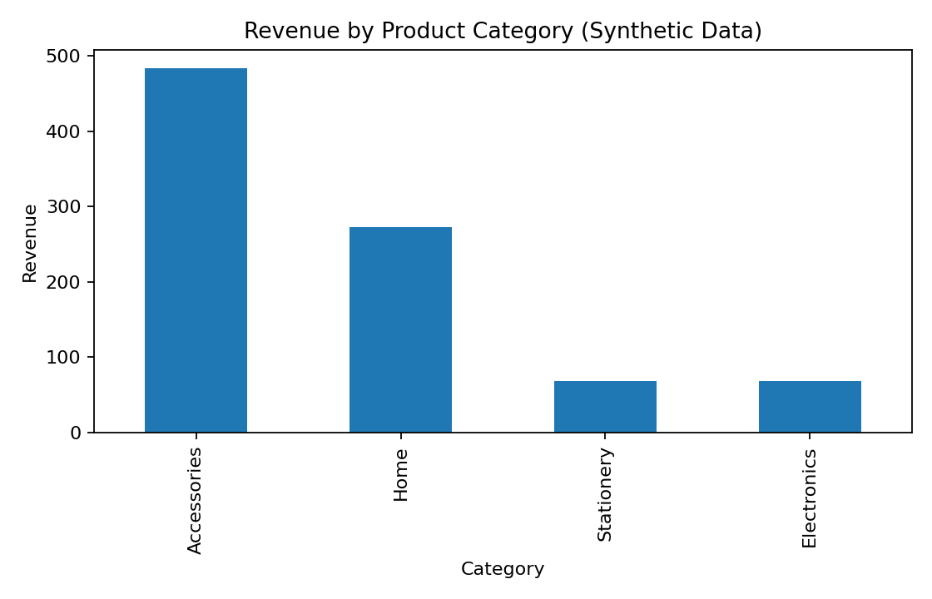
Figure 1. Total revenue by product category.
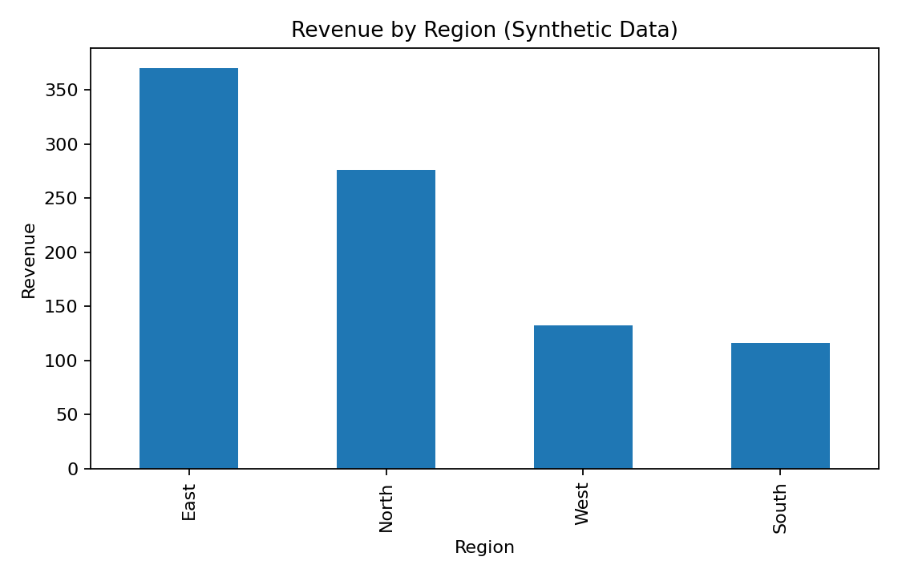
Figure 2. Total revenue by region.
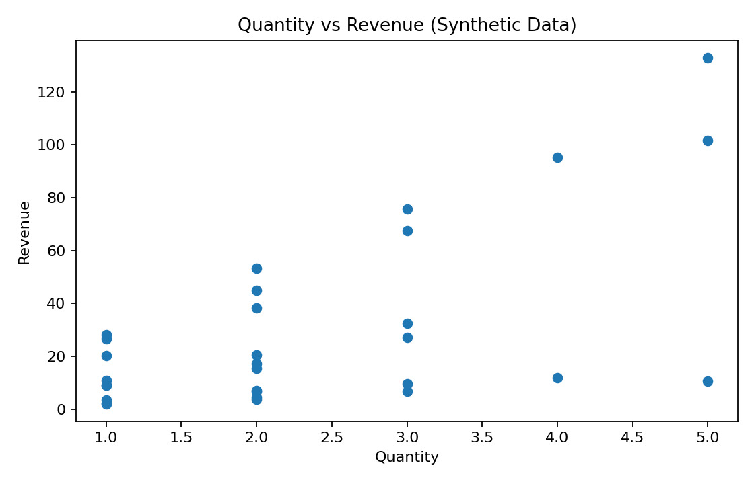
Figure 3. Quantity versus revenue for each order.

9. Findings and Interpretation
The highest-revenue category in this dataset is Accessories, while the highest-revenue product is Backpack and the highest-revenue region is East. These rankings are computed from the cleaned records rather than assumed in advance.
The correlation between quantity and revenue is 0.617. Quantity is one component of revenue, but the relationship is not perfectly determined by quantity because products have different unit prices and orders can have different discounts. Correlation is descriptive and should not be interpreted as causal evidence.
- Revenue is determined by quantity, price, and discount rate.
- Category and region groupings help identify where the synthetic dataset records the largest revenue totals.
- The small synthetic dataset is suitable for practicing analysis, not for making real business decisions.

10. Limitations and Best Practices
- Synthetic data do not reflect real market conditions or customer behavior.
- Median imputation is a simple teaching strategy and may be inappropriate if values are missing systematically.
- Keep raw data unchanged and document all transformations.
- Validate assumptions and business definitions before reporting KPIs.
- Use clear visual labels and avoid claiming causation from correlation.
- Protect confidential data and use only authorized datasets.
- Record software versions and maintain reproducible notebooks.

11. Conclusion
This lab demonstrates the practical workflow of setting up a Python environment, loading and inspecting CSV data, identifying and treating data-quality issues, validating fields, creating derived values, aggregating results with Pandas, computing statistics with NumPy, and visualizing findings with Matplotlib. The notebook and CSV files make the work reproducible. The next step for a real business project would be to replace the synthetic data with an approved, well-documented dataset and validate the analytical questions with stakeholders.

Report Description (200+ words)
This report presents my work for Task 2 — Hands-On Data Lab Implementation as part of the YuvaIntern Data Analyst Internship. The objective of this task was to set up a practical Python data-analysis environment and complete exercises involving data manipulation, visualization, and basic analysis. I used Python with Pandas, NumPy, and Matplotlib to work through a structured retail-sales dataset created for demonstration. The notebook checks the environment and library versions, loads the raw CSV, inspects data types and descriptive statistics, and identifies missing values and duplicate records. I then applied documented cleaning steps, including duplicate removal, numeric type conversion, median imputation for missing numerical values, mode imputation for a missing region, date parsing, and revenue recalculation using quantity, unit price, and discount rate. Validation checks were used to confirm that order identifiers are unique and that quantities, prices, discounts, and revenue fall within expected ranges. I grouped the cleaned data by category, product, and region, calculated summary statistics using NumPy and Pandas, and created labelled charts to compare revenue and explore the relationship between quantity and revenue. The report includes computed results, visual evidence, interpretation, and limitations. The dataset is synthetic and does not represent a real company, so its results are used only to demonstrate the analytical workflow. This task strengthened my practical understanding of data preparation, transformation, aggregation, visualization, reproducibility, and responsible interpretation.

Appendix — Deliverables
- Task_2_Hands_On_Data_Lab_Ganesh.ipynb — runnable notebook.
- retail_sales_raw.csv — raw synthetic data with deliberate quality issues.
- retail_sales_cleaned.csv — cleaned data output.
- retail_sales_reference_clean.csv — generated reference records for audit.
- PNG charts — visualizations included in this report.

